Title: Pop Goes Profanity: Vulgarity Trends in English Chart Hits from 2000 to 2024

Short title: Vulgarity goes Pop

Authors
Lara Fabienne Putensen*
(corresponding author)
Universität Bonn
Address: Department of English, American and Celtic Studies,
University of Bonn, Rabinstraße 8, 53111 Bonn, Germany
Phone: +49 ???
Email: lara.von.pn@gmail.com
ORCID: ???

Martin Schweinberger
The University of Queensland
Address: School of Languages and Cultures, Gordon Greenwood Building, Union Road,
The University of Queensland, St Lucia, QLD 4072, Australia
Phone: +61 7 3365-6374
Email: m.schweinberger@uq.edu.au
ORCID: 0000-0003-1923-9153

Word count (excluding title page and Appendix):
XXXX words

Acknowledgements
The study is part of a collaborative project that has received seed funding from the University of Queensland Centre for Digital Cultures and Societies and the Language Data Commons of Australia (LDaCA). The Language Data Commons of Australia has received co-investment from the Australian Research Data Commons (ARDC) (https://doi.org/10.3565/kq2v-9g52), which is funded by the National Collaborative Research Infrastructure Strategy (NCRIS).

Statements and declarations
Ethical considerations
Ethics approval to undertake this data collection was granted by the Faculty of Humanities, Arts and Social Sciences LNR Ethics Committee at the University of Queensland (2022/HE001069).

Declaration of conflicting interest
The authors have no conflicts to declare.

Use of AI
In the preparation of this manuscript, the authors used ChatGPT, an AI-assisted tool developed by OpenAI, to improve the style and readability of the text. The content and interpretations of the work are solely our own, and the AI was used only for enhancing the clarity and coherence of text drafted by the authors. No AI technology was used in the development of the research methodology, data analysis, or conclusions. This statement is provided in compliance with the publisher’s guidelines on transparency in the use of AI-assisted technologies.

Data availability statement
Workflow scripts used to process data are available on request from the authors.

Pop Goes Profanity: Vulgarity Trends in English Chart Hits from 2000 to 2024

Abstract
Mainstream popular music offers a revealing lens on how language indexes social identities, stances, and cultural values. While debates about explicit lyrics are recurrent, little corpus-based research has systematically examined how vulgarity is patterned and recontextualised in mainstream music over time. This study investigates the presence and distribution of vulgar expressions in 2,476 Billboard Year-End Hot 100 singles released between 2000 and 2024, using a corpus-based approach that combines lexical detection, artist metadata, topic modelling, and inferential statistics. The analysis explores how the frequency of vulgarity vary across time, genre, topics, and artist demographics, and how such usage functions as a resource for stance-taking and identity work. Results show a sharp rise in both the frequency and strength of vulgar language over the 25-year period, particularly after 2015, with hip-hop emerging as the most consistently explicit genre. While male solo artists contribute the largest share of vulgar songs overall, recent years reveal higher intensity among female performers. Thematic clustering around street and gang-related discourse highlights how vulgarity becomes enregistered as a marker of authenticity, resistance, and cultural belonging. These developments reflect broader sociolinguistic processes: the colloquialisation of public discourse, the relaxation of censorship norms, and the influence of digital and streaming cultures in reshaping linguistic markets. By tracing how mainstream music negotiates the boundaries of linguistic acceptability, the study contributes to understanding how vulgarity indexes evolving social meanings and participates in wider processes of linguistic change as well as identity and image construction.

Keywords: swearing, vulgar language, pop music, music charts

Introduction
Vulgarity is a prominent and frequently debated feature of mainstream popular music. Songs that reach large audiences often provoke controversy when they include explicit or taboo expressions, particularly when these songs receive radio play or are promoted through algorithmic recommendation on streaming platforms. Public debates around such lyrics tend to centre on morality, generational values, and artistic freedom (McWhorter 2016; Nuzum 2001; Kubrin 2005). Yet, despite the visibility of these debates, systematic linguistic research on the frequency, distribution, and social meaning of vulgarity in popular music remains limited. This absence is striking given the cultural prominence of chart-topping songs and their role in reflecting – and potentially shaping – mainstream linguistic and social norms.
Sociolinguistic and psycholinguistic studies of swearing and taboo language have long shown that the use of vulgar words serves important expressive and interpersonal functions, ranging from emotional release to identity marking and solidarity building (Jay 1992; Dewaele 2015; Beers Fägersten 2012). Vulgar expressions are also deeply indexical, signalling stance, affect, and belonging to particular communities or cultural styles (Stapleton 2010; Kiesling 2018). Within media discourse, such expressions are not merely linguistic taboos but performative resources that contribute to the enregisterment of authenticity and resistance (Androutsopoulos 2009; Coupland 2007). This suggests that the increasing presence of vulgar language in popular music is sociolinguistically meaningful, offering insights into how speakers and performers negotiate boundaries of acceptability and identity in late-modern culture.
As Adams and Fuller (2006: 939) note, “music is a reflection of the cultural and political environment from which it is born.” Accordingly, vulgar language in lyrics can be viewed as shaped by broader socio-cultural and technological developments – including the rise of hip-hop as a dominant global genre, the affordances of streaming platforms, and evolving censorship practices in the recording industry (Nuzum 2001; Cameron 1995; Driscoll & Gregg 2010). Moreover, the increased informality of public communication, often described as colloquialisation or democratization (Mair 2024; Leech et al. 2012), provides a useful theoretical backdrop for understanding the apparent normalisation of vulgarity in mainstream discourse. These processes are intertwined with larger shifts in media language, where boundaries between private and public speech styles have blurred (Fairclough 1995; Androutsopoulos 2013).
Despite these broader developments, empirical research on vulgarity in popular music has largely focused on small-scale lyrical analyses, individual genres, or the social implications of explicit content (e.g. Armstrong 2001; Kubrin 2005; Conrad et al. 2009). Few studies have systematically investigated how vulgarity varies across genres, artists, and time, and none have applied a large-scale corpus-based approach to trace its diachronic development in mainstream chart hits.
The present study addresses this gap by analysing the presence and distribution of vulgar words in 2,476 Billboard Year-End Hot 100 singles released between 2000 and 2024. Using a quantitative corpus-linguistic framework that integrates regex-based lexical detection, artist-level metadata annotation, and topic modelling, the analysis examines three interrelated questions:
- How has the frequency of vulgar words in mainstream chart hits evolved over the past 25 years, and which words are most salient?
- How do artist demographics – such as gender, nationality, and group status – along with song characteristics (genre and chart performance) influence the occurrence and intensity of vulgarity?
- How do lyrical themes correlate with the presence of vulgar language, and what social meanings emerge from these associations?
While the study does not adopt a single overarching theoretical model, the discussion situates the findings within sociolinguistic research on colloquialisation, enregisterment, and stance. In doing so, it seeks to show how mainstream music participates in the wider transformation of public discourse, where forms once considered vulgar or transgressive have become increasingly normalised as stylistic and ideological resources for expressing authenticity, resistance, and affect in popular culture.

Theoretical Background
This chapter outlines the conceptual and theoretical foundations of the study. It first introduces how “bad language” has been defined and classified in linguistic research, with attention to the terminological ambiguity surrounding related notions such as swearing, profanity, and vulgarity (Section 2.1). Section 2.2 discusses the relationship between vulgarity and broader processes of language change, particularly colloquialisation. Section 2.3 turns to research on vulgarity in music, including censorship and prior empirical work. The chapter concludes with an overview of the study’s research aims and hypotheses (Section 2.4).

Defining bad language: Terms and concepts
Few linguistic phenomena are as culturally salient yet as inconsistently defined as so-called bad language. Speakers generally recognise what counts as offensive, but the overlapping use of terms such as swearing, profanity, obscenity, vulgarity, and taboo language indicates that this category lacks stable boundaries (Beers Fägersten 2012; Jay 2000). As Jay (2000: 10) notes, this conceptual vagueness reflects the topic’s taboo status rather than scholarly neglect: offensive language has historically been excluded from models of language use (Johnson & Fine 1985; Beers Fägersten 2007).
Despite its marginalisation, bad language appears to be a linguistic universal. Foote and Woodward (1973: 263–264) argue that expressions deemed obscene consistently involve a limited set of experiential domains – sex and excretion, religion, and social deviance. Jay’s (1992) typology expands this view, distinguishing among cursing, profanity, blasphemy, obscenity, taboo, vulgarity, slang, epithets, insults, slurs, and scatology. The same expression may shift across these categories depending on context and function, highlighting the importance of situational and pragmatic factors (Jay 1992; Ljung 2011; Dynel 2012).
In pragmatic and discourse-analytic research, swearing is the dominant term and is typically treated as a performative act expressing emotion, stance, or solidarity (Beers Fägersten 2012; Stapleton 2010). Ljung (2011: 4) defines swearing as the use of taboo words with non-literal, formulaic, and emotive functions. Beers Fägersten (2012: 3) similarly emphasises potential offensiveness rather than lexical content, suggesting that what counts as swearing depends on social context and hearer perception.
Other disciplines have addressed bad language from complementary perspectives. Psycholinguistic studies examine its emotional salience and cognitive processing, showing that swear words activate distinct affective and neurological pathways (Jay & Janschewitz 2008; Bergen 2016; Pinker 2007). Corpus linguistics, by contrast, has enabled large-scale quantitative descriptions of bad language in use (McEnery 2006; Love 2021; Schweinberger & Burridge, 2025; Schweinberger et al., in press), revealing that swearing is common in everyday English and not restricted to marginal speech situations. However, corpus analyses typically rely on lexical identification without contextual cues, which can obscure pragmatic distinctions between swearing, insult, and mere informality.
To address this methodological issue, the present study adopts vulgarity as its central analytical term (see also Schweinberger & Burridge, 2025; Schweinberger et al., in press). Vulgarity refers to lexically marked forms that are coarser or less polite than available neutral alternatives (Jay 1992: 6; Azzaro 2005: 3). It denotes social markedness rather than intent, making it well suited to corpus-based analysis where pragmatic information is limited. As Schweinberger and Burridge (2025: 2–3) note, vulgarity is not an inherent property of words but a socially mediated perception that varies across regions and generations. This relational view aligns with recent sociolinguistic work emphasising how offensiveness and taboo are negotiated and context-dependent (Dynel 2012; Burridge 2010; Beers Fägersten 2017).
Thus, while the term swearing highlights the performative and emotive functions of bad language, vulgarity provides a more neutral, lexically defined basis for systematic analysis. It captures expressions that are socially marked yet contextually flexible—an essential distinction when examining written song lyrics, where speaker intent and interactional framing are not directly observable.
As outlined above, vulgarity and swearing are closely related but operate on different analytical levels. Swearing is typically approached from a pragmatic perspective and identified through speaker intent and hearer perception (Beers Fägersten 2012: 3), whereas vulgarity is defined lexically, referring to the use of a socially marked or cruder term in place of a neutral equivalent (Jay 1992: 6; Cachola et al. 2018: 1). Despite this distinction, both are expressive forms of language that fulfil comparable communicative and social functions (Beers Fägersten 2012: 37; Bergen 2016: 29).
A defining feature of bad language is its operation on both denotative and connotative levels. Jay (1992: 10) notes that taboo expressions are often interpreted connotatively in emotionally charged contexts—for instance, this is fucked up is generally understood as this is wrong or unacceptable, not literally. The meaning and perceived offensiveness of such expressions are also shaped by sociocultural context. Words considered vulgar in one time or community may be viewed as mild or humorous in another (Jay 1992: 9–10; Stapleton 2010). Linguistic taboos are therefore fluid, shifting in response to changing cultural norms, generational attitudes, and the mediatization of language (Dynel 2012; Vingerhoets et al. 2013).
Vulgar and taboo expressions serve a wide range of pragmatic functions beyond aggression or insult. Ross (1969: 480) observed that swearing appears in both confrontational and friendly exchanges, while Beers Fägersten (2012: 37) distinguishes between social swearing, which reinforces solidarity and informality, and annoyance swearing, which conveys frustration or anger. Similarly, Holgate et al. (2018: 4405) identify aggression, group identity, and informality as key motivations for vulgar usage, and Cameron (1969: 101) notes that swearing may even signal intimacy or affection. Other studies add humour, emotional release, and emphasis as further functions (Jay & Janschewitz 2008; Pinker 2007; Bergen 2016).
As such, vulgarity performs diverse emotional, pragmatic, and social roles, including the expression of affect, the reinforcement of in-group identity, and the marking of informality (Holgate et al. 2018; Beers Fägersten 2012; Dynel 2012). While many of these overlap with swearing, the lexical focus of vulgarity enables systematic corpus-based analysis where contextual or intentional cues are unavailable. This makes vulgarity a particularly suitable category for examining lexical choices in popular music lyrics.

Vulgarity and language change: Colloquialisation
As Jay (1992) notes, understanding changes in taboo words requires attention to the forces driving language change. One such force is colloquialisation, the increasing incorporation of speech-like and informal features into writing and public discourse (Mair, 1998, 2006, 2015, 2024). This process reflects a stylistic shift in which written norms move closer to everyday language, with formality no longer the default and sometimes subverted for rhetorical effect (Mair, 2006).
Colloquialisation also mirrors broader sociocultural transformations. Informalisation accelerated from the 1960s onward, challenging hierarchies and blurring distinctions between elite and vernacular styles (Elias, 1989; Hobsbawm, 1994; Mair, 2015). Fairclough (1992) links this to discursive democratisation driven by the erosion of overt power markers, commodification of informal styles, and the technologisation of digital media. Social platforms further accelerate these trends by normalising directness and emotional expressivity (Coupland, 2007; Bös & Kleinke, 2017; Mair, 2024).
Empirical evidence supports a parallel relaxation of linguistic taboos. Twenge, VanLandingham, and Campbell (2017) document a sharp rise in swear words in American books (1950–2008), while Beers Fägersten and Bednarek (2022) report similar trends in television. Kaye and Sapolsky (2004) find increased mild vulgarities on primetime TV in the late 1990s–2000s, whereas Love (2021) observes changing patterns in informal British English, with fuck replacing bloody as the most frequent swear word. Music shows comparable shifts: Armstrong (2001) identifies increasing violent and misogynistic content in rap lyrics, and Cooper (1985) notes persistent gendered stereotypes in popular music. This suggests that the growing tolerance for explicit language across genres is part of broader linguistic informalisation (Leech et al., 2009; Mair, 2015). Though vulgarity has not been directly theorised through colloquialisation, stylistic, social, and technological changes indicate that the relaxation of linguistic taboos both reflects and drives ongoing shifts in public discourse.

Vulgarity in music
Censorship in popular music has long reflected questions of who is speaking rather than merely what is said. Suppression often targets artists, genres, or audiences perceived as disruptive, functioning less as moral regulation than as social control (Nuzum, 2001: 4–5). The assumption that music corrupts listeners has justified restrictions, despite little evidence that audiences adopt the values expressed in lyrics (Nuzum, 2001: 9). Nuzum defines censorship as “any discriminatory act that advocates or allows the suppression, control, or banning of music or music-related works against the wishes of its creator or intended audience” (2001: 7). Even in liberal contexts, direct state censorship is often replaced by self-censorship driven by commercial pressures (Grossman, 1990; Nielsen & Krogh, 2017). Industry-led mechanisms such as the 1985 Parental Advisory Label (PAL) exemplify this, where major retailers restricted labelled albums, prompting artists to release sanitised versions (Nuzum, 2001; Nielsen & Krogh, 2017).
In the streaming era, control has shifted to platform moderation and algorithmic governance (Kretschmer & Peukert, 2020; Radsch, 2023). Automated moderation, copyright enforcement, and recommendation algorithms incentivise “brand-safe” content, often leading artists to issue clean versions or avoid controversial themes (Radsch, 2023; Kretschmer & Peukert, 2020). Global platforms also propagate spillover censorship, applying restrictive standards across markets (Nielsen & Krogh, 2017), while European privacy and copyright frameworks, licensing disputes, and local broadcasting laws create uneven access (Radsch, 2023; Kretschmer & Peukert, 2020; Hesmondhalgh, 2020).
Explicit lyrics are generally protected under U.S. law (Cohen v. California, 1971, cited in Kasper, 2023), yet rap and hip-hop artists—predominantly Black—face disproportionate scrutiny (Corn-Revere, 2021; Kasper, 2023), echoing earlier policing of African American musical forms (Frith, 1996; Street, 2012). Economic pressures also shape content: in post-socialist Poland, market forces reinstated limits despite initial expressive freedom (Gajda, 2017). Traditional gatekeeping has thus been supplanted by algorithmic and commercial regulation, raising questions about how linguistic taboos are renegotiated digitally (Radsch, 2023; Kretschmer & Peukert, 2020; Nielsen & Krogh, 2017).
Research on explicit language has expanded, yet studies of vulgarity remain fragmented. While profanity, obscenity, and misogyny have been examined (Adams & Fuller, 2006; Armstrong, 2001; Frisby & Behm-Morawitz, 2019), few systematically distinguish vulgarity from other bad language (Allan & Burridge, 2006; Ljung, 2011), leading to inconsistent typologies (Stapleton, 2010; Jay, 2009). Historical concerns over indecent lyrics predate modern debates (Hutchings, 1934), and linguistic research shows taboos evolve with cultural norms and ideologies (Jay, 1992; Burridge, 2023). Vulgarity can thus index stance, identity, and resistance (West, 2022).
Recent studies operationalising vulgarity include Amdan and Shaari (2017), who found increasing frequency of explicit language in Billboard Hot 100 lyrics, particularly in hip-hop. Frisby and Behm-Morawitz (2019) highlight misogyny and violence alongside profanity, noting genre- and race-specific patterns (Adams & Fuller, 2006; Armstrong, 2001; Cooper, 1985; Street, 2012). Adams and Fuller (2006) show misogynistic rap lyrics reproduce historical stereotypes, linking vulgarity to discursive power and identity. Computational analyses (Hart & Day, 2019; Hunter & Grant, 2022) quantify sexual and emotional language across genres but face limitations in capturing pragmatic intent. Longitudinal and corpus-based approaches remain rare. The present study examines vulgarity as a linguistic index of norm transgression, tracking its diachronic evolution in popular music to illuminate the sociolinguistics of taboo, morality, and digital-era language change.

Research questions
The preceding sections have established vulgarity as a complex linguistic and cultural phenomenon, highlighting its communicative functions, evolving usage patterns, and prominent role in Western popular music. Although prior research has examined swearing in diverse communicative contexts (cf. Twenge et al. 2017; Beers Fägersten & Bednarek 2022; Kaye & Sapolsky 2004), no large-scale quantitative study has systematically analysed vulgarity in song lyrics. Research to date has been largely qualitative, focusing on thematic content analyses (cf. Amdan & Shaari 2017), discourse perspectives (cf. Adams & Fuller 2006), or case studies of specific artists or genres (cf. Armstrong 2001; Frisby & Behm-Morawitz 2019), rather than tracking longitudinal trends.
McEnery and Xiao (2004: 235) note that studies of explicit language often emphasise historical, lexicographical, psycholinguistic, or semantic perspectives, while sociolinguistic variables such as gender, age, and social class remain underexplored. This study addresses these gaps by analysing vulgar words in Billboard Hot 100 songs from 2000 to 2024, incorporating sociodemographic correlations, song performance indicators, genre, and thematic associations through statistical modelling.
Research questions
- How has the frequency of vulgar words in Billboard Year-End Hot 100 singles evolved from 2000 to 2024, and which words are most common?
- How do artist demographics (gender, nationality, solo/group status, age), song performance (peak chart position, weeks on chart), and genre influence the use and frequency of vulgar words?
- Do lyrical themes correlate with vulgar language, and if so, which themes are most strongly associated with it?

Data and Methodology
This study investigates vulgarity in popular music through a custom-built corpus of Billboard Year-End Hot 100 singles from 2000–2024. The corpus captures mainstream, commercially successful music across 25 years, offering a representative overview of English-language pop lyrics. This section outlines the data sources (Section 3.1), compilation procedures (Section 3.2), and data-cleaning and processing (Section 3.3), as well as quantitative methods (Section 3.4).

Billboard Data
Billboard is one of the most authoritative music charting systems, ranking songs based on sales, airplay, and, more recently, streaming metrics (Bradlow & Fader, 2001; Climent & Coll-Florit, 2020; Moloney & Sylva, 2020). Founded in 1894, Billboard evolved from an advertising trade magazine into a central institution for tracking music consumption (Kwame Harrison & Arthur, 2011). Its Hot 100 chart, introduced in 1958, remains the industry benchmark for measuring song popularity (Whitburn, 2010).
Billboard’s methodology has continuously adapted to technological shifts, incorporating Nielsen SoundScan data in 1991 to improve accuracy and reduce bias from self-reported sales (LANDR, 2025). Today, the Hot 100 integrates radio airplay, digital sales, and streaming activity. The Year-End Hot 100 charts, used here, aggregate cumulative annual performance rather than weekly fluctuations, providing a robust indicator of enduring popularity (Climent & Coll-Florit, 2020).
The dataset includes all songs from the Billboard Year-End Hot 100 charts (2000–2024), totalling 2,500 entries. Duplicate entries are retained if a song appeared in multiple years. Billboard charts are particularly suited for linguistic research, as they represent the most widely consumed and culturally visible music in the U.S. (Parker, 1991). As Climent and Coll-Florit (2020: 474) note, Billboard songs “can be considered representative of the most popular music in the USA, with sales in the millions and the greatest possible public impact.” Given Billboard’s global reach, this dataset also captures a transnational influence on popular discourse (Nielsen & Krogh, 2017).

Data Collection and Corpus Compilation
The corpus combines automation with manual verification. Song titles and artists were first compiled manually from the Billboard Year-End Hot 100 pages on Wikipedia (Wikipedia, n.d.), each assigned a unique identifier. Lyrics, release dates, and URLs were then retrieved via the Genius API. Genius, founded as Rap Genius in 2009, is a user-driven platform where lyrics and annotations are collaboratively transcribed and refined (Kehrer, 2016; Lim & Benson, 2021). Because Billboard-charting songs attract high traffic and frequent verification, their Genius entries are comparatively reliable (Kehrer, 2016).
Python scripts automated lyric extraction and cleaning, removing metadata, annotations, and structural markers (e.g., “[Chorus]”). Automated cleaning was followed by manual review to ensure textual integrity and accuracy. Lyrics were normalised for encoding, punctuation, and spacing. Release dates were cross-verified with multiple sources when missing or inconsistent.
Genre information was retrieved via API queries from Last.fm and MusicBrainz, merged for consistency, and reviewed manually. Last.fm, launched in 2002, categorises music through “scrobbling,” a process that aggregates user listening data (Antonelli, 2022; Perera, 2025). MusicBrainz, a non-profit community project, provides open-access metadata on artists and recordings (O’Brien, 2021). A standardised genre taxonomy was created, comprising 16 categories (e.g., Pop, Hip-Hop, Country, R&B, Rock).
Artist data were also standardised. Artists were classified as solo, group, or collaboration using automated keyword detection and subsequent manual correction. For solo artists, nationality, gender, and birth year were extracted via Last.fm and processed using spaCy (Explosion, 2024). For groups, formation year and origin were collected through web scraping with BeautifulSoup (Richardson, 2023). Manual validation ensured metadata reliability.
Song performance metrics – peak chart position and total weeks on the Hot 100 – were sourced from a public GitHub repository containing Billboard chart histories (Hollingshead, n.d.). Data were standardised and merged using additional Python scripts to reconcile naming inconsistencies.
Overall, corpus construction involved 16 Python scripts and one VBA macro. Automation accelerated data collection, but manual validation remained essential to address metadata inconsistencies, particularly for genre and release data. All scripts and documentation are openly available on GitHub (https://github.com/PurpleDandelio/Popsong-Vulgarity-MA)

Data Preprocessing
This section outlines how the lyrics corpus was cleaned, annotated, and prepared for analysis. It details (a) regex-based detection of vulgar expressions and (b) topic modelling to identify recurrent lyrical themes.
Identifying vulgar expressions across thousands of lyrics manually is impractical and inconsistent. Therefore, this study applies regular expressions (regex), a widely established technique in computational linguistics for pattern-based text detection (Friedl, 2006; Erwig & Gopinath, 2012). Regex enables systematic identification of lexical forms and variants through boundary matching, allowing for the inclusion of creative spellings (e.g., mafuckers for motherfuckers) while preventing overmatching (e.g., ass vs. assume). Though regex lacks semantic interpretation, it remains an efficient tool for large-scale corpus analysis (Guzmán, 2007).
Prior to applying regex, the lyrics were standardised to ensure matching accuracy. Two R scripts expanded contractions (e.g., ain’t → is not) and removed punctuation.
The regex lists were compiled from three sources:
- The List of Dirty, Naughty, Obscene, and Otherwise Bad Words (LDNOOBW) (Emerick, 2023), an open-source profanity lexicon.
- The Badwords dataset (Butler, n.d.; Wilkinson, n.d.), derived from Google’s What Do You Love project.
- A linguistically curated list of English vulgarity (Schweinberger & Burridge, 2025).
Each list was fetched or imported into R, converted to regex-compatible syntax, and applied to the cleaned lyrics dataset. Scripts extracted, counted, and consolidated all detected word forms. After merging the three sources, duplicates and non-vulgar items were manually removed. Ambiguous words (e.g., hoe) were checked in context to ensure accurate interpretation. While regex efficiently captures orthographic variants, it cannot resolve semantic ambiguity or detect implied vulgarity. However, given the corpus size and focus on explicit language, regex offers a reproducible and transparent approach for quantifying linguistic vulgarity in popular song lyrics (see also Grieve, 2021).

Topic Modelling and Lyrical Themes
To uncover recurrent lyrical themes, topic modelling was applied using Latent Dirichlet Allocation (LDA; Blei, Ng, & Jordan, 2003; Blei, 2012). LDA identifies statistically significant word co-occurrence patterns and infers topics as probabilistic distributions across documents, making it well suited for large, unstructured text corpora (Jelodar et al., 2018).
Recent advances, such as semi-supervised or seeded models, incorporate prior linguistic knowledge into topic assignment, improving interpretability (Watanabe & Baturo, 2024). Following Schweinberger (2024), the present study combines unsupervised and semi-supervised LDA implemented using the quanteda (Benoit et al., 2018) and topicmodels (Grün & Hornik, 2011) packages.
Before modelling, a language-identification script excluded songs with <50% English content. Duplicate chart entries were coded to avoid inflation of topic frequencies. Lyrics were tokenised and noise was reduced iteratively, removing high-frequency, semantically empty tokens (e.g., woah, yeah, uh-oh) and auxiliary verbs that decreased topic coherence (Schofield, Magnusson, & Mimno, 2017). Vulgar expressions identified earlier were excluded to prevent circularity between dependent and independent variables. After filtering, the vocabulary contained 9,690 unique tokens (reduced from 16,663).
Regarding the topic modelling procedure, unsupervised LDA models with k = 25, 10, 7, and 5 topics were compared for coherence and interpretability. The five-topic solution yielded the most distinct and semantically stable categories. These results informed a second, semi-supervised model, which used manually defined seed words to refine the themes derived from the unsupervised stage.
The five resulting themes were:
- Clubbing and partying (dance, party, tonight, music, club, fire),
- Gang and street culture (money, gang, hit, real, tryna, rack),
- Love, passion, and romance (love, babe, kiss, touch, need),
- Heartbreak and betrayal (heart, break, away, leave, said), and
- Home, belonging, and nostalgia (night, home, sky, dream, stay).

Each song was assigned a topic based on posterior probability scores derived from the LDA output, yielding confidence intervals between 0.27 and 0.99. Non-English or lyrically sparse entries were excluded from topic assignment.
Across the corpus, heartbreak and betrayal emerged as the most frequent theme, followed by street culture, love and romance, belonging, and partying. This distribution aligns with findings from previous studies on contemporary pop lyrics (de Wall, 2017; Werner, 2020), suggesting that emotional turmoil and social identity remain central to pop music discourse, even as explicit language increases.
Together, regex-based vulgarity detection and topic modelling provide a complementary methodological framework: regex offers precise lexical quantification of vulgarity, while LDA captures broader thematic contexts. This multi-layered approach enables a systematic examination of how vulgar language interacts with thematic content in mainstream pop music from 2000 to 2024.

Statistical Methods
This section outlines the statistical procedures used to analyse the data. The analysis, including data processing, visualization, tabulation, and statistical analysis were performed in R (version 2024.12.1; R Core Team, 2024). In addition to frequency tabulation, and to examine the factors governing vulgarity in English popular music, we employed two complementary statistical approaches: conditional inference trees and binomial logistic mixed-effects regression modelling. Both methods have become increasingly common in quantitative corpus linguistics for analysing complex, multidimensional language data (Gries, 2021; Levshina, 2023).

Conditional Inference Trees
In addition to traditional correlations and regressions, Conditional Inference Trees (CITs) were used to explore non-linear relationships and interaction effects in the data. Implemented via the partykit package (Hothorn & Zeileis, 2015), CITs belong to the family of recursive partitioning techniques. These models repeatedly split the dataset into increasingly homogeneous subsets based on statistically significant associations between predictor variables and the outcome variable – in our case, the presence or absence of profanity.
Unlike traditional decision-tree algorithms such as CART, conditional inference trees address well-known statistical issues including overfitting and variable selection bias, particularly when predictors vary in measurement scale or distribution (Hothorn et al., 2006). This makes them particularly suitable for sociolinguistic and corpus-based research, where predictors are often heterogeneous and assumptions of parametric models may be violated (Levshina, 2023; Gries, 2020). By providing an interpretable, visual method for detecting context-sensitive linguistic variation, CITs served as a robust complement to our regression models.

Binomial Logistic Mixed-Effects Regression Modelling
To model the probability of profanity in chart hits while accounting for both fixed and random sources of variation, we employed binomial logistic mixed-effects regression. Mixed-effects models are widely recognised as the gold standard for linguistic data with hierarchical or repeated-measures structures (Baayen et al., 2008; Winter, 2020). In this study, the binomial model estimated the likelihood that a lyric line contained profanity as a function of predictors such as year, artist gender, genre, and chart performance.
Crucially, mixed-effects models incorporate random effects, allowing us to account for non-independence among observations – for example, multiple lyric lines from the same artist or song. This helps avoid inflated significance estimates and yields more generalisable inferences about language use (Jaeger, 2008). Models were fit using the glmer() function from the lme4 package (Bates et al., 2015), employing maximum likelihood estimation with Laplace approximation.
Mixed-effects modelling allowed us not only to test hypotheses about the social and cultural correlates of profanity but also to estimate effect sizes, confidence intervals, and the relative contribution of each predictor. Together with conditional inference trees, this approach provides a comprehensive view of how linguistic and sociocultural factors jointly shape profanity usage in popular music.

Strengths and limitations of the analysis
As with any large-scale quantitative corpus study, this project involves methodological trade-offs alongside notable strengths. Lyrics were sourced from Genius, artist metadata from MusicBrainz, and popularity information from Last.fm. As collaborative platforms, these datasets may contain transcription inconsistencies or incomplete metadata (Kehrer, 2016; Climent & Coll-Florit, 2020). Nevertheless, they remain among the most comprehensive and transparent resources available for popular-music scholarship and enable reproducible large-scale corpus construction—an essential condition for computational sociolinguistic research (Nguyen et al., 2020).
Some official lyric transcriptions are censored or euphemised, which may lead to occasional under-counting of profanity. Given the scale of the corpus, exhaustive manual validation is impractical; however, the study focuses on relative patterns and longitudinal trends, so isolated omissions are unlikely to alter the overall findings. Restricting the dataset to English-language chart hits ensures linguistic comparability but excludes multilingual content and culturally specific profanity norms, limiting interpretation to Anglophone popular music (Burridge, 2023).
While model diagnostics guided analytical choices, naturalistic language data rarely meet all parametric assumptions (Baayen, 2008). Regression results are therefore interpreted cautiously and complemented by non-parametric conditional-inference trees, which can uncover non-linear and interaction effects, though sometimes at the expense of parsimony (Gries, 2020).
Despite these limitations, the study’s scale – nearly 2,500 songs with rich sociolinguistic and musical metadata – supports statistically robust analysis of linguistic variation in mainstream music (Grieve, 2021; De Clercq, 2021). The triangulation of frequency tabulation, mixed-effects regression, and conditional-inference trees enhances validity, balancing inferential rigour with interpretability and exploratory flexibility (Levshina, 2023; Winter, 2020). Together, these features enable a comprehensive and replicable account of how vulgarity patterns in popular music have evolved across time, genre, and artist characteristics.

Results
This chapter reports the results in relation to the study’s research questions. After filtering for English-language content (24 songs excluded), the dataset comprises 2,476 entries from the Billboard Year-End Hot 100 (2000-2024) (see Table 1).

Table 1: Overview of the final dataset (including duplicate entries).
Year | Songs (N) | Tokens (N) | Vulgar tokens (N) | Songs with vulgar tokens (%) | Vulgar tokens  (per 1,000 tokens) | Rate of vulgar tokens by song
2000 | 100 | 38,839 | 238 | 25.0 | 6.1 | 2.4
2001 | 100 | 41,261 | 259 | 32.0 | 6.3 | 2.6
2002 | 100 | 42,501 | 272 | 35.0 | 6.4 | 2.7
2003 | 100 | 45,750 | 398 | 52.0 | 8.7 | 4.0
2004 | 100 | 45,766 | 424 | 46.0 | 9.3 | 4.2
2005 | 100 | 43,545 | 421 | 50.0 | 9.7 | 4.2
2006 | 100 | 44,677 | 321 | 41.0 | 7.2 | 3.2
2007 | 100 | 43,493 | 278 | 50.0 | 6.4 | 2.8
2008 | 100 | 40,167 | 210 | 35.0 | 5.2 | 2.1
2009 | 100 | 39,093 | 226 | 41.0 | 5.8 | 2.3
2010 | 100 | 40,384 | 206 | 35.0 | 5.1 | 2.1
2011 | 100 | 41,082 | 272 | 40.0 | 6.6 | 2.7
2012 | 99 | 34,978 | 323 | 35.4 | 9.2 | 3.3
2013 | 99 | 36,051 | 300 | 32.3 | 8.3 | 3.0
2014 | 100 | 38,773 | 401 | 35.0 | 10.3 | 4.0
2015 | 99 | 39,331 | 414 | 41.4 | 10.5 | 4.2
2016 | 100 | 39,242 | 326 | 43.0 | 8.3 | 3.3
2017 | 99 | 41,708 | 583 | 55.6 | 14.0 | 5.9
2018 | 99 | 43,192 | 632 | 59.6 | 14.6 | 6.4
2019 | 98 | 38,694 | 688 | 58.2 | 17.8 | 7.0
2020 | 100 | 37,955 | 582 | 55.0 | 15.3 | 5.8
2021 | 100 | 37,250 | 531 | 61.0 | 14.3 | 5.3
2022 | 94 | 33,297 | 304 | 48.9 | 9.1 | 3.2
2023 | 91 | 32,742 | 491 | 58.2 | 15.0 | 5.4
2024 | 98 | 36,415 | 683 | 56.1 | 18.8 | 7.0
Total | 2476 | 996,186 | 9,783 | 44.9 | 9.9 | 4.0

According to Table 1, the use of vulgar language in popular music increased markedly and consistently between 2000 and 2024. Across the 2,476 songs analysed, almost one percent of all words were classified as vulgar, corresponding to roughly ten vulgar words per thousand tokens. On average, nearly half of all songs contained at least one vulgar expression, with about four vulgar words per song.
The data summarised in Table 1 and Figure 1 show a clear long-term rise in the use of explicit language. In the early 2000s, vulgar terms occurred about six to ten times per thousand words, but by the mid-2010s this rate had risen to around eight to ten, and by the late 2010s and early 2020s it peaked between fourteen and nineteen. This increase suggests a gradual normalization and mainstream acceptance of vulgar language in popular lyrics. The proportion of songs containing any vulgarity also grew steadily, from around a quarter to a third in the early 2000s to more than half after 2017, indicating that explicit language became a standard feature of popular songwriting.

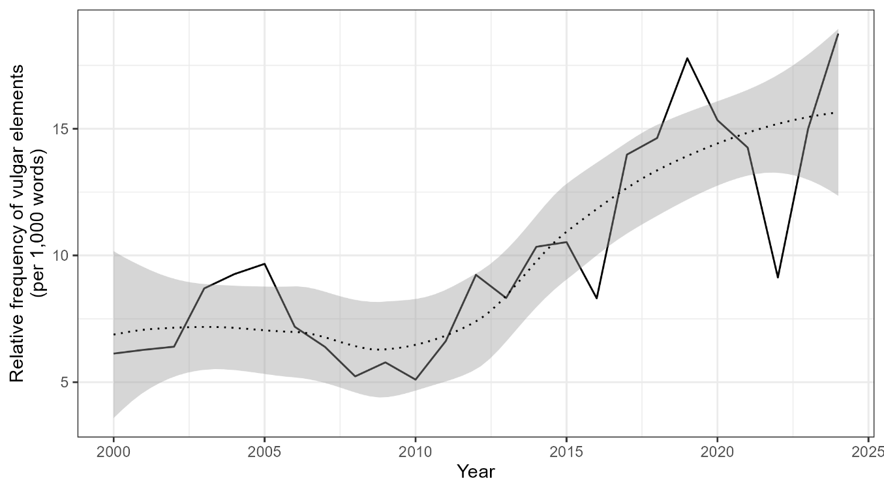
Figure 1: Relative frequency of vulgar elements in the data by year.

In Figure 1, two sharp increases are particularly notable. The first occurred between 2003 and 2005, likely reflecting the growing influence of explicit hip-hop and R&B in mainstream charts. The second and more dramatic surge began around 2017, coinciding with the streaming era and the dominance of trap, pop-rap, and related genres where profanity is common. After 2021, levels of vulgarity appeared to stabilize, fluctuating but remaining well above earlier decades, suggesting that the trend may have reached a plateau rather than continuing to escalate indefinitely.
The data point to a sustained and substantial increase in the prevalence and intensity of vulgar language in popular music over the past quarter century, reflecting broader cultural and technological changes such as the decline of broadcast censorship, the rise of streaming platforms, and shifting attitudes toward linguistic expressiveness and authenticity in popular culture. This is also confirmed by a simple linear regression (Intercept(year₂₀₀₀): 4.84 (CI 2.72-6.97), Estimate = 0.42 (CI 0.27-0.58), p < .001***) explains 59.3 % of the variance (R² (R² adjusted) = .593 (.575)) which reports a significantly positive correlation between the use of vulgar forms and year with the number of vulgar words increasing by 0.42 vulgar words per 1,000 words per year on average.
Figure 2 presents the relative frequency of vulgar lemmas in a corpus of English-language chart hits, showing which types of vulgar expressions dominate popular music between 2000 and 2024. The distribution is highly skewed, with a small number of lemmas accounting for the vast majority of all vulgar words.

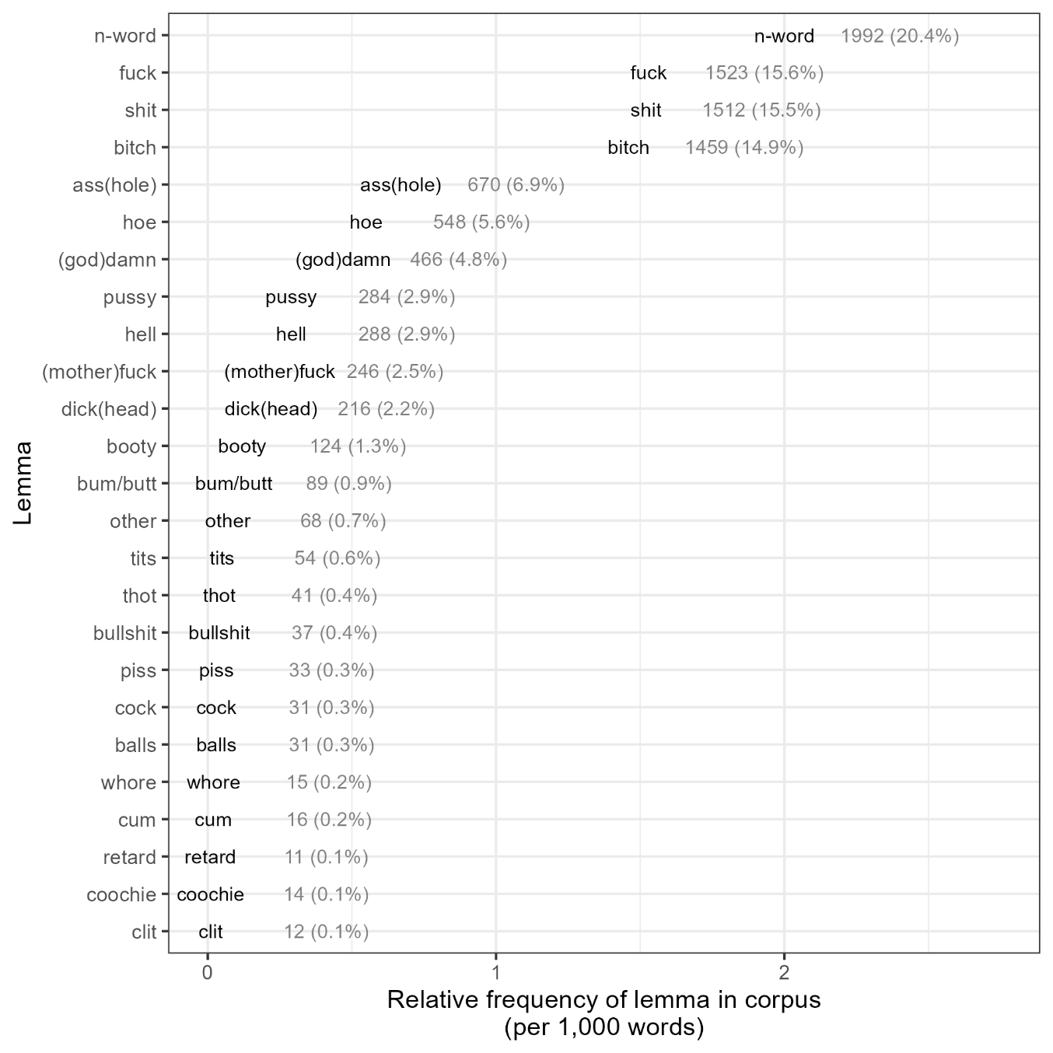
Figure 2: Overview of vulgar lemmas (only lemmas with a frequency of at least 10 shown; lemmas with lower frequency were collapsed into the category “other”). The category other contains the lemmas: bastard (9), fag/faggot (8), boobs (7), prick (5), skeet (5), dyke (4), slut (4), crap (3), hooker (3), nympho (3), shag (3), bimbo (2), doggystyle (2), homo (2), (nut)sack (1), cunt (1), dork (1), fart (1), honkey (1), knob (1), poop (1), scat (1).

The most frequent lemma by far is n-word, which represents 20.4% of all vulgar tokens in the corpus. It is followed by fuck (15.6%), shit (15.5%), and bitch (14.9%) – together making up over two-thirds of all vulgar word occurrences. These four lemmas clearly dominate the lexical field of vulgarity in chart lyrics, reflecting the central role of racial, sexual, and aggressive language in contemporary popular music.
A second tier of lemmas – such as ass(hole) (6.9%), hoe (5.6%), and (god)damn (4.8%) – appears with moderate frequency, while all remaining terms each contribute less than 3% to the total. Words like pussy, hell, (mother)fuck, and dick(head) occur occasionally but are much less common than the top cluster. At the lower end of the distribution, a wide range of lemmas – including bullshit, piss, cock, balls, whore, and others – appear rarely, each accounting for less than one percent of all vulgar tokens. As a general trend, Figure 2 reveals a highly concentrated vocabulary of vulgarity in popular music, dominated by a few recurrent terms. The prominence of n-word reflects both the influence of hip-hop and the cultural recontextualization of racial slurs within that genre. Meanwhile, the dominance of fuck, shit, and bitch underscores the enduring role of sexual and aggressive expressions in shaping the linguistic style and emotional tone of modern song lyrics.
Together, these results confirms the assumption of a long-term increase and support the broader sociolinguistic process of colloquialisation in which spoken-style features move into mediated registers (Mair, 2024).
Figure 3 illustrates the relative frequency of vulgar elements (per 1,000 words) across musical genres in Billboard chart hits from 2000 to 2024. Figure 3 shows a stark contrast between genres, with hip-hop standing out as the clear and consistent driver of vulgar language use in popular music: throughout the 25-year period, hip-hop maintains by far the highest frequency of vulgar expressions, fluctuating between about 15 and 40 vulgar elements per 1,000 words. After a relatively stable period in the early 2000s, hip-hop experiences a sharp rise around 2011–2013, followed by some variability, and then reaches its highest level in 2024, when vulgarity peaks above all previous years.

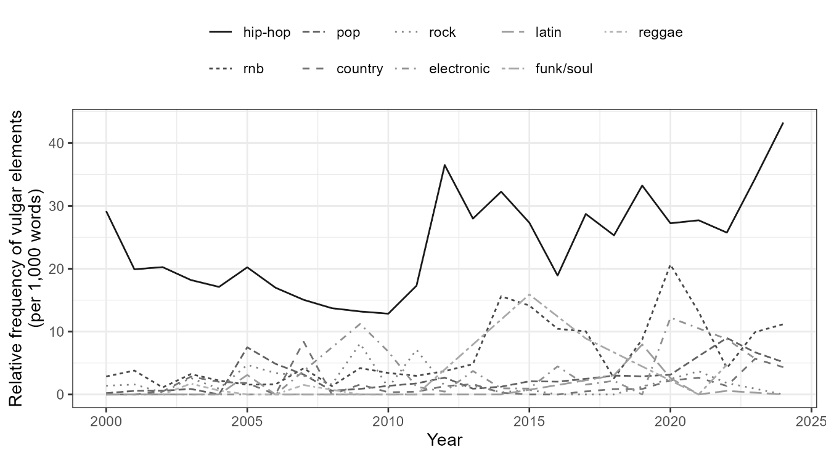
Figure 3: Overview of the relative frequency of vulgar elements by genre across time (only genres with vulgar elements shown; not shown: classical, folk, holiday, jazz, religious, soundtrack).

Figure 3 shows that after a relatively stable period in the early 2000s, hip-hop experiences a sharp rise around 2011–2013, followed by some variability, and then reaches its highest level in 2024, when vulgarity peaks above all previous years.
In contrast, other genres such as pop, R&B, and rock show only modest levels of vulgarity – generally between 2 and 10 per 1,000 words, depending on the year. While pop and R&B occasionally exhibit small increases (notably in the mid-2010s and around 2020), these spikes are minor compared to hip-hop’s dominance. Genres like country, electronic, latin, reggae, and funk/soul remain consistently near the bottom, with negligible or near-zero rates of vulgar language use across the entire timeframe.
Figure 4 plots the relative frequency of vulgar elements in lyrics by artist gender from 1999 to 2023. Overall, vulgarity increased substantially across the period for both female and male artists, consistent with the broader trend toward more explicit language in contemporary popular music.

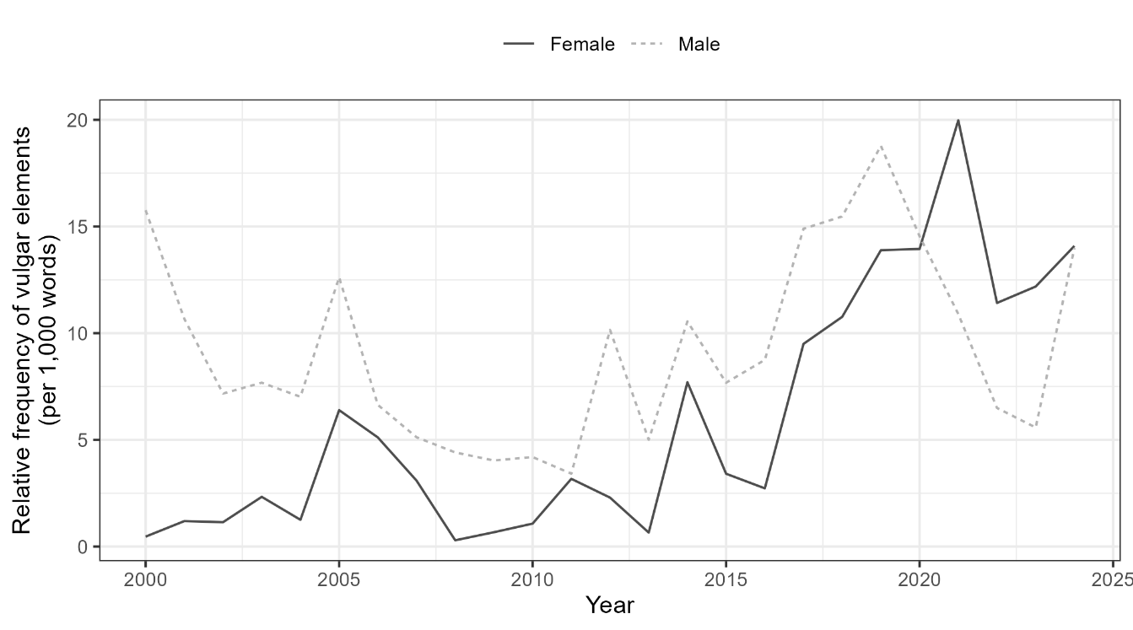
Figure 4: Overview of the relative frequency of vulgar elements by solo artists’ gender across time.

According to Figure 4, male artists consistently used more vulgar language than female artists throughout the entire timeframe. In the early 2000s, male artists displayed notably higher rates of vulgarity, peaking around 2000–2001 at nearly 15 vulgar elements per 1,000 words. However, male usage fluctuated over time, showing alternating increases and declines, with another rise beginning around 2016 before decreasing again after 2021.
Female artists, by contrast, started from near-zero levels in the early 2000s and showed a clearer upward trajectory. Their use of vulgarity increased steadily from around 2012, accelerating markedly after 2017 and reaching a peak around 2020 at nearly 20 vulgar elements per 1,000 words – briefly surpassing male artists. This pattern suggests a narrowing gender gap in the use of explicit language in popular music, driven primarily by rising vulgarity among female artists in the last decade. These results align with wider cultural shifts around female empowerment, genre crossover, and linguistic self-expression in mainstream music.

Results of the Conditional Inference Tree Analysis
A conditional inference tree was fitted to examine the factors predicting vulgarity in song lyrics. The final tree included eight internal nodes and nine terminal nodes, indicating a moderately complex decision structure. Genre emerged as the strongest predictor of vulgarity, forming the first split. Songs classified as hip-hop showed substantially higher probabilities of vulgar language compared to other genres.

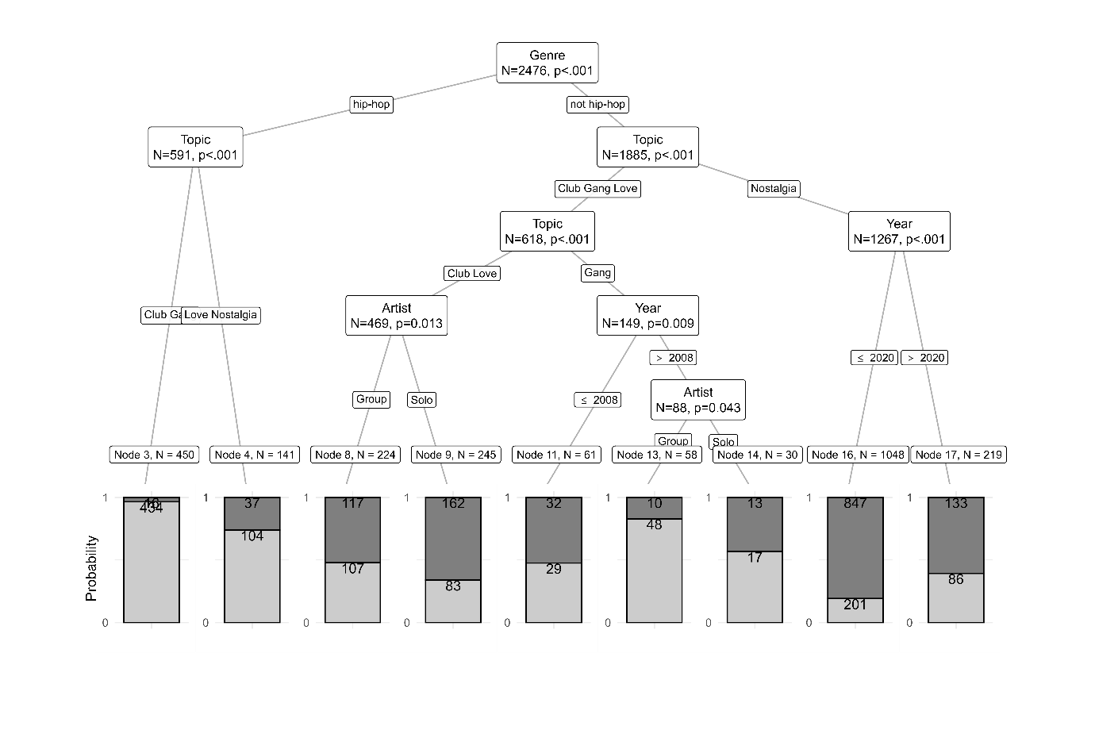
Figure 5: Results of the Conditional Inference Tree Analysis.

Within hip-hop, Topic further differentiated vulgarity levels: songs addressing Club or Gang themes exhibited the highest rates of vulgarity (Node 3; error = 3.6%), while songs about Love or Nostalgia also tended to be vulgar but with greater classification uncertainty (Node 4; error = 26.2%).
For non-hip-hop music, Topic again played an important role. Songs about Nostalgia were largely non-vulgar, particularly those released before 2021 (Node 16). Within Gang-themed non-hip-hop songs, Year and Artist type interacted: post-2008 group artists showed elevated vulgarity (Node 13), whereas solo artists in this category also exhibited higher but more variable vulgarity (Node 14).
Across the tree, hip-hop and songs dealing with clubbing or gang-related themes were the strongest predictors of vulgar content, while nostalgic themes and non-hip-hop genres were associated with low vulgarity probabilities. These results highlight distinct stylistic and thematic pathways that influence linguistic register in contemporary popular music.

Results of the Binomial Logistic Regression Analysis
In addition to the CIT, we also modelled the presence of vulgarity in song lyrics using a logistic mixed-effects regression with Artist type, Year, Nationality, and Topic as fixed effects and Genre as a random intercept. The model demonstrated substantial explanatory power (conditional R² = .41), indicating that both thematic factors and broader genre context contribute meaningfully to vulgarity in popular music. Fixed effects alone accounted for 16% of the variance (marginal R² = .16), showing that song-level predictors explain a meaningful portion of linguistic variation, while genre further strengthens predictive accuracy.

Table 2: Results of the Final Logistic Mixed-Effects Regression Model (interactions between predictors could not be included due to multicollinearity).
 | Vulgarity
Predictors | Odds Ratios | CI | p
(Intercept) | 0 | - 0.00 | <0.001
Artist [Solo] | 0.4 | 0.28 – 0.58 | <0.001
Year | 1.05 | 1.04 – 1.07 | <0.001
Nationality [NonAmerican] | 0.49 | 0.34 – 0.71 | <0.001
Topic [Gang] | 3.13 | 2.01 – 4.88 | <0.001
Topic [Love] | 1.22 | 0.82 – 1.82 | 0.331
Topic [Nostalgia] | 0.48 | 0.34 – 0.69 | <0.001
Random Effects
σ² | 3.29
τ_{00Genre} | 1.42
ICC | 0.3
N_{Genre} | 2
Observations | 2476
Marginal R² / Conditional R² | 0.155 / 0.410

Several predictors showed statistically significant effects. Solo artists were less likely than groups to use profanity (β=−0.91, 95% CI[−1.28,−0.54], p<.001). Year showed a positive association with profanity (β=0.05, 95% CI[0.04,0.06], p<.001), indicating a steady increase in vulgar language over time. Non-American artists were significantly less likely to use profanity than American artists (β=−0.71, 95% CI[−1.08,−0.34], p<.001).
Topic also played a substantial role. Songs with gang-related themes were more likely to contain profanity than club-themed songs (β=1.14, 95% CI[0.70,1.58], p<.001), whereas nostalgia-themed songs were less likely to use profanity (β=−0.73, 95% CI[−1.09,−0.38], p<.001). Love-themed songs did not significantly differ from club-themed songs in profanity use (p=.331).
Figure 6 visualises the main effects of the model and confirms the increase of vulgarity over time, the higher rates of vulgarity in hip-hop compared with non-hip-hop genres, the effect of nationality with American artists tending to use more vulgarity and the differences in vulgarity across topics.

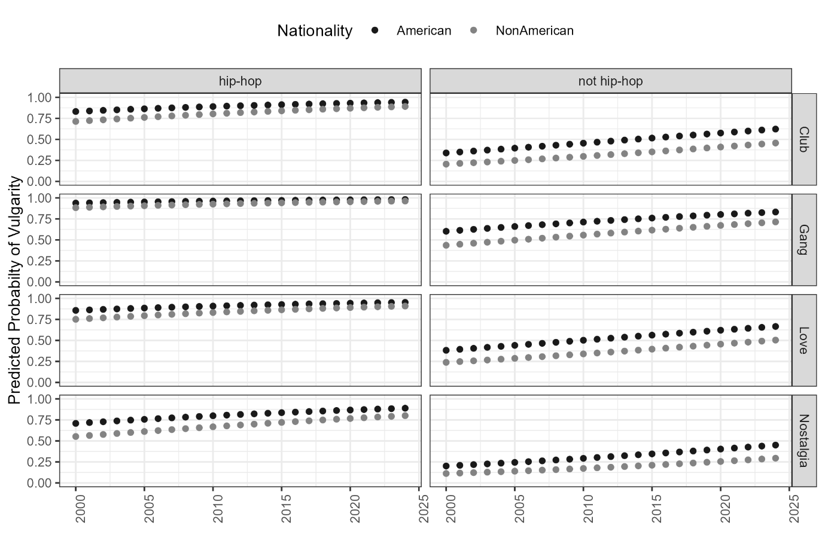
Figure 6: Results of the Logistic Mixed-Effects Regression Analysis.

There are notable differences between the results obtained from the tree-based analysis and those from the mixed-effects regression modelling. Such discrepancies are expected, as these approaches embody distinct analytical logics: conditional inference trees identify data-driven, non-linear splits and interaction structures without strong distributional assumptions, whereas regression models rely on parametric estimation and require explicit specification of interaction terms (Hothorn et al., 2006; Levshina, 2023). In this study, the most salient difference concerns interaction effects. The regression model ultimately reported no interactions, despite exploratory models indicating potential interactions between year and nationality and year and topic. These interactions could not be retained because they generated multicollinearity and model-convergence issues, which are common challenges when modelling sociolinguistic data with multiple correlated predictors (Baayen et al., 2008; Winter, 2020). As a result, a simplified, more stable model that satisfied assumptions and provided reliable estimates was selected. In contrast, the tree-based approach was able to capture complex interaction patterns without being constrained by these parametric and convergence limitations. Taken together, the two approaches offer complementary insights: regression modelling provides interpretable effect estimates and hypothesis-driven inference, while conditional inference trees offer a flexible, non-parametric means of exploring interaction structures and non-linear trends in the data (Gries, 2021; Nguyen et al., 2020).
After the quantitative analysis, we will now turn to a closer, qualitative inspection of vulgarity in song lyrics to contextualise the quantitative findings.

Qualitative insights: Censorship and commercial influence
A brief qualitative review shows that vulgarity in chart music is not merely a question of explicit wording but is shaped by censorship practices, platform policies, and commercial strategy. Artists frequently employ euphemisms, double entendres, and partial substitutions that allow suggestive meaning while maintaining broadcast acceptability, reflecting longstanding notions of “anticipated censorship,” where creators self-regulate in advance of institutional intervention (Grossman, 1990; Nuzum, 2001). Such practices align with wider media-industry dynamics in which market logics, rather than formal bans, govern linguistic limits (Berlant, 2011; Hesmondhalgh, 2019). Like research on media governance and streaming culture suggests, platform gatekeeping and content-moderation frameworks shape not only distribution but also stylistic choices (Morris & Powers, 2015; Meier & Manzerolle, 2020). For instance, in Chingy, Ludacris & Snoop Dogg, “Holidae In” (2003), “balls” functions as a sexual double-entendre, maintaining suggestive content while softening delivery.
- Just play a little “D” and I'll make ya mouth dribble / Bits and Kibbles, got ‘em all after the pickle / I swing it like a bat, but these balls are not Wiffle
Chingy, Ludacris & Snoop Dogg, ‘Holidae In’, released 15.07.2003, charted in 2003 at #76 and in 2004 at #8782
Similarly, GAYLE’s “abcdefu” (2021) encodes profanity through the phrase “F you,” rendering the expression emotionally direct yet formally indirect. These examples illustrate the strategic balancing act between rebelliousness and mass-market appeal.
- A-B-C-D-E, F you / And your mom and your sister and your job / And your broke-ass car and that shit you call art
GAYLE, ‘abcdefu’, released 13.08.2021, charted in 2022 at #1783

Commercial optimisation is also visible through parallel “explicit” and “clean” versions. CeeLo Green’s “Fuck You” / “Forget You” (2010) exemplifies this dual-release approach: while the explicit version foregrounds shock value, the radio edit enabled mainstream exposure, echoing findings that censorship increasingly operates through commercial filtering rather than direct prohibition (Trust, 2014; Nuzum, 2001).
- I see you drivin’ ‘round town with the girl I love / And I’m like, “Fuck you” (Ooh-ooh-ooh) / I guess the change in my pocket wasn’t enough / I’m like, “Fuck you and fuck her too”
CeeLo Green, ‘Fuck You’, released 19.08.2010, charted in 2011 at #786
- I see you drivin’ ‘round town with the girl I love / And I’m like, “Forget you” (Ooh-ooh-ooh) / I guess the change in my pocket wasn’t enough / I’m like, “Forget you and forget her too”
CeeLo Green, ‘Forget You’, released 19.08.201087
Likewise, Cardi B & Megan Thee Stallion’s “WAP” (2020) underwent multiple edits before radio and streaming publication (Sisario, 2020), demonstrating how even highly explicit hits are shaped by behind-the-scenes moderation.
- I’m talkin’ wap, wap, wap, that’s some wet-ass pussy
Cardi B & Megan Thee Stallion, ‘WAP’, released 07.08.2020, charted in 2020 at #2492
These patterns suggest that rising profanity in popular music co-exists with nuanced self-censorship shaped by commercial incentives rather than strict regulatory pressure. This complements the quantitative finding that profanity has no consistent negative effect on chart performance; decisions around lyrical sanitisation appear driven less by demonstrated audience backlash than by assumed platform and market expectations. Thus, vulgarity in contemporary English-language pop emerges not simply as artistic expression, but as a negotiated cultural and economic practice structured by genre norms, industry strategy, and streaming-era governance. The examples provided above portray how censorship of vulgarity in popular music works not as a fixed rule but likely as something negotiated case by case.

Discussion

Change over time
The results demonstrate a sustained and substantial rise in vulgarity in English-language popular music between 2000 and 2024, confirming previous research indicating the same trajectory (Metallinos Log, 2022). Across 2,476 charting songs, nearly one percent of all tokens were classified as vulgar – equating to roughly ten vulgar expressions per thousand words – and almost half of all songs contained at least one explicit term. These findings support a long-term intensification of taboo language in popular lyrical production. Early-2000s hits contained relatively few such expressions, but by the late 2010s and early 2020s explicit language had become a stylistic norm, with usage rates more than doubling. This pattern aligns with broader sociocultural shifts toward decreasing institutional censorship (McLeod, 2011), greater tolerance of informal language (Mair, 2024), and the expansion of media platforms that encourage expressive authenticity over broadcast-safe linguistic norms (Nakar, 2023; Wikström, 2020).
Two periods of particularly pronounced growth – 2003–2005 and 2017 onward – correspond with genre-market shifts and technological change. The mid-2000s saw the mainstreaming of hip-hop aesthetics, while the streaming-era acceleration reflects algorithm-driven consumption, reduced gatekeeping, and an audience increasingly shaped by platform culture rather than radio-broadcast standards (Morris & Powers, 2015). Rather than a linear “moral decline” narrative, these patterns are better understood through sociolinguistic processes of colloquialisation, commodification of authenticity, and the cultural capital of transgressive language in youth-oriented media (Eckert & McConnell-Ginet, 2013; Liles, 2021). The recent stabilisation suggests the phenomenon may be reaching saturation rather than escalating indefinitely.
A simple linear regression analysis as well as the results of the binomial logistic mixed-effects regression model confirm this steady upward trend, with year emerging as a significant positive predictor of vulgarity. These results validate the assumption that there has been in increase in vulgarity in pop musing and they show that contemporary popular music increasingly normalises linguistic directness, affective intensity, and stylised aggression as markers of artistic identity and genre-specific credibility.

Lexical Patterns and Cultural Meaning
The lexicon of vulgarity in chart lyrics is highly concentrated: four lemmas – nigga, fuck, shit, and bitch – account for over two-thirds of all occurrences. This distribution reflects both linguistic economies of taboo usage and cultural-stylistic factors tied to hip-hop’s dominance. The prevalence of nigga in particular illustrates the genre-internal reappropriation of racialised language, a phenomenon extensively analysed in sociolinguistics and hip-hop studies as part of identity negotiation and symbolic boundary-work (Alim, 2006; Cutler, 2014; Rahman, 2012). Meanwhile, the prominence of fuck and shit aligns with cross-register patterns of swearing in English, where terms associated with sexuality and bodily functions retain high expressive potency (Jay & Janschewitz, 2008). Musical examples across decades – from Ludacris to Nicki Minaj – illustrate continuity in the pragmatic functions of vulgar language: emphasis, aggression, self-assertion, and in-group solidarity.
These trends reinforce evidence that pop culture increasingly mirrors speech-based norms of informality, emotional immediacy, and linguistic realism (Tagliamonte, 2016). They also highlight the aesthetic role of taboo forms as tools for stance-taking and identity performance, particularly in genres anchored in authenticity, resistance, or hyper-stylised persona construction (Richardson & Pihlaja, 2021).

Sociolinguistic Variables: Genre and Gender
Genre emerged as a dominant explanatory factor which mirrors results of other recent studies that analyse vulgarity across discourse domains (e.g., Schweinberger et al., in press). Hip-hop displays the highest frequency and density of vulgar expressions, consistent with ethnographically documented communicative norms of verbal competition, stylised aggression, and linguistic innovation in rap culture (Morgan, 2009; Adams & Fuller, 2006). Other genres – including pop and R&B – show lower rates, though cross-genre diffusion of hip-hop registers has increased since the 2010s (Hess, 2020). Chart performance itself does not predict vulgarity in a straightforward manner, highlighting the importance of multivariate, interaction-based modelling. Conditional inference trees reveal intersections between artist type, genre, and topic that shape explicitness—supporting multidimensional accounts of media language behaviour (Lev-Ari & Keysar, 2018).
Gender patterns show both continuity and transformation. Male artists historically dominate in vulgar usage (McEnery, 2006; Schweinberger, 2018), reflecting established associations between masculinity, aggression, and taboo speech (Kiesling, 2005; Jay, 2009). However, female artists—particularly in hip-hop—display pronounced growth from 2017 onward, briefly surpassing male artists. This shift corresponds with feminist reappropriation of sexual and aggressive language as a strategic challenge to traditional gendered speech norms (Weidhase, 2019; Candelaria, 2021). Female artists increasingly use vulgarity to assert agency, economic power, and sexual autonomy, echoing developments in digital feminist discourses and hip-hop feminism (Morgan, 2015). The narrowing gender gap thus signals both stylistic convergence and transformational agency in contemporary musical culture.

Conclusion
This study provides the first large-scale quantitative account of vulgar language use in English-language Billboard chart hits from 2000–2024, combining corpus methods, topic modelling, and sociolinguistic analysis. Results show a marked and statistically robust increase in explicit language, driven largely by hip-hop’s influence and the evolving media environment. Vulgarity is socially patterned, linked to genre, gender dynamics, and thematic content, rather than being randomly distributed. The findings illuminate broader linguistic, cultural, and technological developments, including colloquialisation, streaming-driven authenticity norms, and shifting gendered language ideologies.
Limitations include a U.S.-chart focus and reliance on surface-form detection; future research could extend to cross-linguistic corpora, audience reception studies, and industry-level analyses of censorship and platform mediation. Overall, this research contributes to sociolinguistics, media studies, and popular-music scholarship by demonstrating how linguistic expression in lyrics serves as a site of cultural negotiation and identity performance in the streaming era.

References
Adams, T. M., & Fuller, D. (2006). The words have changed but the ideology remains the same: Misogynistic lyrics in rap music. Journal of Black Studies, 36(6), 938–957.
Alim, H. S. (2006). Roc the mic right: The language of hip hop culture. Routledge.
Allan, K., & Burridge, K. (2006). Forbidden words: Taboo and the censoring of language. Cambridge University Press.
Androutsopoulos, J. (2009). Language and the media. In N. Coupland & A. Jaworski (Eds.), The new sociolinguistics reader (pp. 671–682). Palgrave.
Androutsopoulos, J. (2013). Online data collection. In C. Mallinson, B. Childs, & G. Van Herk (Eds.), Data collection in sociolinguistics (pp. 236–249). Routledge.
Antonelli, L. (2022). The streaming self: Digital music consumption and identity. Routledge.
Armstrong, E. G. (2001). Gangsta misogyny: A content analysis of the portrayals of violence against women in rap music, 1987–1993. Journal of Criminal Justice and Popular Culture, 8(2), 96–126.
Azzaro, G. (2005). Linguistic taboo revisited: Novel insights from cognitive linguistics. Peter Lang.
Baayen, R. H. (2008). Analyzing linguistic data: A practical introduction to statistics using R. Cambridge University Press.
Baayen, R. H., Davidson, D. J., & Bates, D. M. (2008). Mixed-effects modeling with crossed random effects for subjects and items. Journal of Memory and Language, 59(4), 390–412. https://doi.org/10.1016/j.jml.2007.12.005
Batistella, E. L. (2005). Bad language: Are some words better than others? Oxford University Press.
Bates, D., Mächler, M., Bolker, B., & Walker, S. (2015). Fitting linear mixed-effects models using lme4. Journal of Statistical Software, 67(1), 1–48. https://doi.org/10.18637/jss.v067.i01
Beers Fägersten, K. (2007). A sociolinguistic analysis of swear word offensiveness. Journal of Pragmatics, 39(9), 1–16.
Beers Fägersten, K. (2012). Who’s swearing now? The social aspects of conversational swearing. Cambridge University Press.
Beers Fägersten, K. (2017). Swearing in English as a lingua franca. Journal of English as a Lingua Franca, 6(2), 1–25.
Beers Fägersten, K., & Bednarek, M. (2022). Swearing in television catchphrases. In A. Ensslin & I. Piazza (Eds.), Swearing in English (pp. 211–228). Routledge.
Benoit, K., Watanabe, K., Wang, H., Nulty, P., Obeng, A., Müller, S., & Matsuo, A. (2018). quanteda: An R package for the quantitative analysis of textual data. Journal of Open Source Software, 3(30), 774.
Bergen, B. K. (2016). What the F.* Basic Books.
Blei, D. M. (2012). Probabilistic topic models. Communications of the ACM, 55(4), 77–84.
Blei, D. M., Ng, A. Y., & Jordan, M. I. (2003). Latent Dirichlet allocation. Journal of Machine Learning Research, 3, 993–1022.
Bourdieu, P. (1984). Distinction. Harvard University Press.
Bradlow, E. T., & Fader, P. S. (2001). A Bayesian lifetime model for the “Hot 100.” Journal of the American Statistical Association, 96(454), 368–381.
Burridge, K. (2010). Taboo, euphemism and political correctness. In L. Brinton (Ed.), Oxford handbook of the history of English. Oxford University Press.
Burridge, K. (2023). Taboo: The hidden architecture of English. Cambridge University Press.
Butler, C. (n.d.). Badwords dataset [Data set]. GitHub.
Cameron, D. (1995). Verbal hygiene. Routledge.
Candelaria, L. (2021). Explicit femininity: Sexual self-representation in rap. Feminist Media Studies, 21(6), 998–1015.
Climent, S., & Coll-Florit, M. (2020). Corpus design in music studies. Digital Scholarship in the Humanities, 35(2), 471–479.
Conrad, K., Dixon, T., & Zhang, Y. (2009). Controversial lyrics in rap: A content analysis. Media Psychology, 12(2), 154–172.
Cooper, W. E. (1985). Women in popular music: A content analysis. Sex Roles, 13(7–8), 499–506.
Corn-Revere, R. (2021). The mind of the censor. Cambridge University Press.
Coupland, N. (2007). Style: Language variation and identity. Cambridge University Press.
Cutler, C. (2014). White hip-hop artists and AAE. In M. Bucholtz & K. Hall (Eds.), Language and identity in popular culture (pp. 150–172). Oxford University Press.
de Wall, A. (2017). Lyrics in popular music. Popular Music and Society, 40(3), 456–473.
Dewaele, J.-M. (2015). Sociolinguistic and psycholinguistic perspectives on swearing. Palgrave.
Driscoll, C., & Gregg, M. (2010). Youth cultures and representation. Cultural Studies Review, 16(2), 39–55.
Dynel, M. (2012). Swearing methodologically. Journal of Language Aggression and Conflict, 1(1), 110–133.
Eckert, P., & McConnell-Ginet, S. (2013). Language and gender (2nd ed.). Cambridge University Press.
Emerick, C. (2023). List of dirty, naughty, obscene, and otherwise bad words [Data set]. GitHub.
Erwig, M., & Gopinath, R. (2012). The essence of regex. Science of Computer Programming, 78(1), 1–20.
Fairclough, N. (1992). Discourse and social change. Polity.
Fairclough, N. (1995). Media discourse. Edward Arnold.
Foote, N., & Woodward, K. (1973). A sociological theory of obscene language. Social Forces, 51(3), 263–272.
Frisby, C. M., & Behm-Morawitz, E. (2019). Sexism in music lyrics. Journal of Broadcasting & Electronic Media, 63(1), 119–135.
Friedl, J. E. F. (2006). Mastering regular expressions (3rd ed.). O’Reilly.
Frith, S. (1996). Performing rites: On the value of popular music. Oxford University Press.
Gajda, P. (2017). Censorship and vulgarity in Polish music. Kultura Popularna, 3(53), 255–272.
Gries, S. T. (2020). Exploring variability in corpus and experimental data. Corpus Linguistics and Linguistic Theory, 16(3), 637–665.
Gries, S. T. (2021). Statistics for linguistics with R (3rd ed.). De Gruyter Mouton.
Grieve, J. (2021). Quantitative text analysis for linguistics. Routledge.
Grün, B., & Hornik, K. (2011). topicmodels: An R package. Journal of Statistical Software, 40(13), 1–30.
Guzmán, J. (2007). Introduction to regular expressions. ACM Press.
Hart, K., & Day, E. (2019). Sexual language and emotion in lyrics. Psychology of Music, 47(4), 521–534.
Hesmondhalgh, D. (2020). The cultural industries (4th ed.). SAGE.
Hess, M. (2020). Rap and hip-hop culture (2nd ed.). Routledge.
Hollingshead, A. (n.d.). Billboard Hot 100 historical data repository [Data set]. GitHub.
Hothorn, T., & Zeileis, A. (2015). partykit: A modular toolkit. Journal of Machine Learning Research, 16, 3905–3909.
Hunter, D., & Grant, S. (2022). Limits of computational categorisation. Journal of Language and Social Psychology, 41(1), 1–12.
Hutchings, A. (1934). Vulgarity and public taste. Music & Letters, 15(4), 500–506.
Jaeger, T. F. (2008). Categorical data analysis. Journal of Memory and Language, 59(4), 434–446.
Jay, T. (1992). Cursing in America. John Benjamins.
Jay, T. (2000). Why we curse. John Benjamins.
Jay, T. (2009). The utility and ubiquity of taboo words. Perspectives on Psychological Science, 4(2), 153–161.
Jay, T., & Janschewitz, K. (2008). The pragmatics of swearing. Journal of Politeness Research, 4(2), 267–288.
Jelodar, H., et al. (2018). Topic modelling: Future directions. Applied Sciences, 8(12), 2193.
Johnson, F., & Fine, G. A. (1985). Dirty words: A sociological study of swearing. Social Forces, 64(1), 1–20.
Kasper, E. T. (2023). Censorship and the First Amendment. Rowman & Littlefield.
Kehrer, L. (2016). The lyrics genius. Popular Music and Society, 39(5), 517–531.
Kiesling, S. (Ed.). (2018). Handbook of language, gender, and sexuality (2nd ed.). Wiley-Blackwell.
Kiesling, S. (2005). Homosocial desire in men’s talk. Language in Society, 33(5), 696–726.
Kubrin, C. E. (2005). Gangstas, thugs, and hustlas. Social Problems, 52(3), 360–378.
Kwame Harrison, A., & Arthur, C. (2011). Reading Billboard. Popular Music History, 6(3), 309–327.
LANDR. (2025). How Billboard charts work. LANDR Blog.
Leech, G., Hundt, M., Mair, C., & Smith, N. (2009). Change in contemporary English. Cambridge University Press.
Levshina, N. (2023). How to do linguistics with R (2nd ed.). John Benjamins.
Lim, K., & Benson, R. (2021). Platforms and participation. Media, Culture & Society, 43(2), 367–383.
Liles, C. (2021). Branding authenticity in the streaming era. Journal of Popular Music Studies, 33(4), 125–140.
Ljung, M. (2011). Swearing: A cross-cultural linguistic study. Palgrave Macmillan.
Love, R. (2021). Swearing in British English. Lingua, 252, 102961.
Mair, C. (1998). Corpora and the study of the major varieties of English: Issues and results. In The major varieties of English: Papers from MAVEN (Vol. 97, pp. 139–157).
Mair, C. (2006). Twentieth-century English: History, variation and standardization. Cambridge University Press.
Mair, C. (2015). Parallel corpora: A real-time approach to the study of language change in progress. Diachronia, (1), 1–9.
Mair, C. (2024). Colloquialisation: Twenty-five years on. Journal of Historical Pragmatics, 25(2), 193–214. https://doi.org/10.1075/jhp.00073.mai
McEnery, T. (2006). Swearing in English. Routledge.
McEnery, A., & Xiao, Z. (2004). Swearing in modern British English: the case of fuck in the BNC. Language and Literature, 13(3), 235-268.
McLeod, K. (2011). Freedom of expression: Resistance and censorship in rock music. Greenwood.
McWhorter, J. (2016). Words on the move. Henry Holt.
Metallinos Log, F. N. (2022). On swear words and rap music: A diachronic study of the changes in the use of swear words in rap music from the 1970s to the 2010s (Bachelor’s thesis, Dalarna University, Sweden). Dalarna University, DiVA Open Access. https://www.diva-portal.org/
Morgan, J. (2015). When chickenheads come home to roost. Simon & Schuster.
Morgan, M. (2009). The real Hiphop. Duke University Press.
Morris, J., & Powers, D. (2015). Streaming, curation and music. Creative Industries Journal, 8(2), 106–122.
MusicBrainz. (n.d.). About MusicBrainz. https://musicbrainz.org
Nakar, E. (2023). Platformisation and musical language. International Journal of Communication, 17, 457–475.
Nielsen, R. K., & Krogh, T. (2017). Spillover censorship. International Journal of Communication, 11, 345–349.
Nuzum, E. (2001). Parental advisory: Music censorship in America. HarperCollins.
Pinker, S. (2007). The stuff of thought. Viking.
R Core Team. (2024). R: A language and environment for statistical computing. R Foundation.
Radsch, C. (2023). Automating freedom. Article 19.
Rahman, J. (2012). The N word. Journal of English Linguistics, 40(2), 137–171.
Richardson, J., & Pihlaja, S. (2021). Swearing and identity in music. Language and Literature, 30(1), 24–46.
Schofield, A., Magnusson, M., & Mimno, D. (2017). Stopword removal. Proceedings of EACL, 432–436.
Schweinberger, M. (2018). Swearing in Irish English: A corpus-based quantitative analysis of the sociolinguistics of swearing. Lingua, 209, 1–20. https://doi.org/10.1016/j.lingua.2018.03.008
Schweinberger, M. (2024). Seeded topic modeling as a more appropriate alternative to unsupervised standard topic models [Commentary on the discussion paper “Topic modelling in corpus-based discourse analysis: Uses and critiques” by M. Bednarek]. Discourse Studies, 27(4), 675–678. https://doi.org/10.1177/14614456241293895
Schweinberger, M., & Burridge, K. (2025). Vulgarity in online discourse around the English-speaking world. Lingua, 321, 103946. https://doi.org/10.1016/j.lingua.2025.103946
Schweinberger, M., Laitinen, M., Haugh, M., Rautionaho, P., Fatemi, M., Hames, S., & Takahashi, M. (in press). F%$# Twitter: A corpus-based analysis of vulgar language on Twitter. Corpora, 22(1).
Stapleton, K. (2010). Swearing. In M. A. Locher & S. L. Graham (Eds.), Interpersonal pragmatics (Vol. 6, pp. 289–305). De Gruyter Mouton.
Street, J. (2012). Music and politics. Polity.
Tagliamonte, S. (2016). Teen talk. Cambridge University Press.
Twenge, J. M., VanLandingham, H., & Campbell, W. K. (2017). Swearing in books. SAGE Open, 7(3).
Watanabe, K., & Baturo, A. (2024). Seeded sequential LDA. Political Analysis, 32(2), 224–240.
Weidhase, N. (2019). Feminist branding in pop. Feminist Media Studies, 19(5), 732–748.
Werner, A. (2020). Pop lyrics as discourse. Music & Letters, 101(3), 432–449.
Werner, V. (2023). Swear/taboo words in English rap lyrics: Linguistic analysis and implications for foreign language education. In C. Ludwig & T. Summer (Eds.), Taboos and controversial issues in foreign language education (pp. 103–112). Routledge.
West, L. (2022). Performing vulgarity. Language in Society, 51(3), 391–415.
Wikström, P. (2020). The music industry (3rd ed.). Polity Press.
Wilkinson, J. (n.d.). What Do You Love profanity dataset [Data set]. GitHub.
Winter, B. (2020). Statistics for linguists. Routledge.

When duplicates are removed the dataset contains 2,232 unique songs. Duplicates are retained when analysing temporal trends, and removed when analysing unique tracks.

