Select area
Click area you want to practice or create a new one. Click and hold to edit name, color, delete or rearrange list.

Menu-button top left appears in more than this screen. Displays a menu: select area (this screen), settings (set language, theme, sound..), feedback, about, log-out.

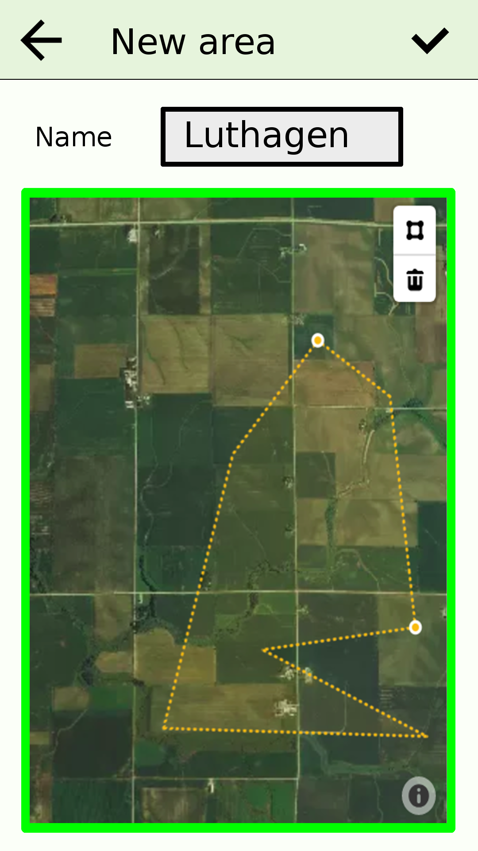

New area
Enter name and area. Use drawing tools of the embedded map. Only smaller areas allowed: if too zoomed out, drawing tools are disabled and border around map is red.

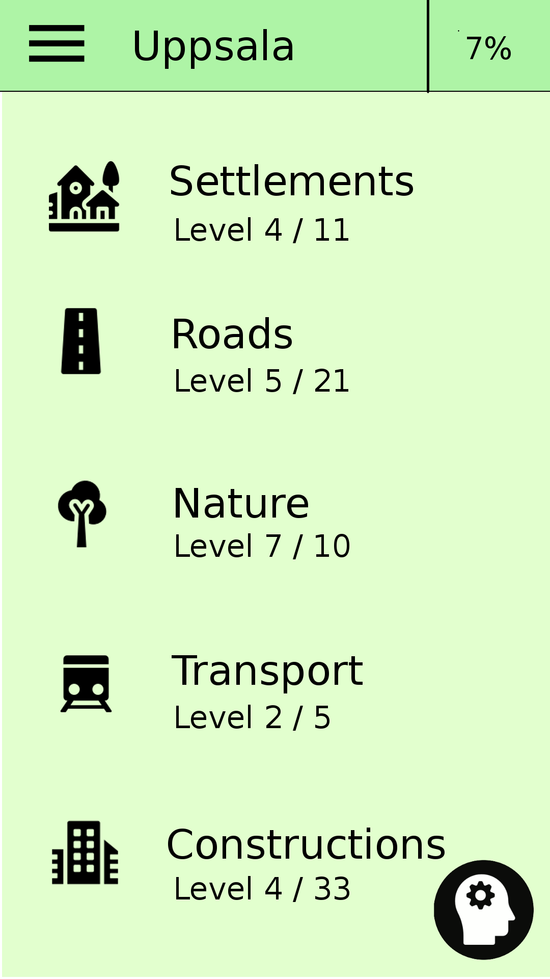

Area: Uppsala
Five categories with levels. All geo-objects in this area are put into one of the categories. Geo-object dimensions (alt popularity) decrease with level. Roads: level 1 has e.g motorways, level 21 has pedestrian paths.

Floating button down right is the global reminder button. Starts quiz with already seen objects.

Categories
- Settlements: towns, villages, suburbs, neighborhoods..
- Roads..
- Nature: parks, forests, rivers, lakes..
- Transport: Airports, train stations, bus stations..
- Constructions: Buildings and attractions.. schools, hospitals, libraries, monuments, stores..

Click on a category and there’s a popup with three buttons: 1) tapping, 2) level quiz, 3) category reminder quiz.

Tapping
Tap a drawn object in the embedded map (here dots) and there is a bubble-popup displaying the name for a little while before it fades away. Select to draw past level objects (none if on level 0) or next level objects (none if has completed all levels). Zoom and scroll the map as you like. Click top right button in map to reset to initial view. Outer blue border shows active area.
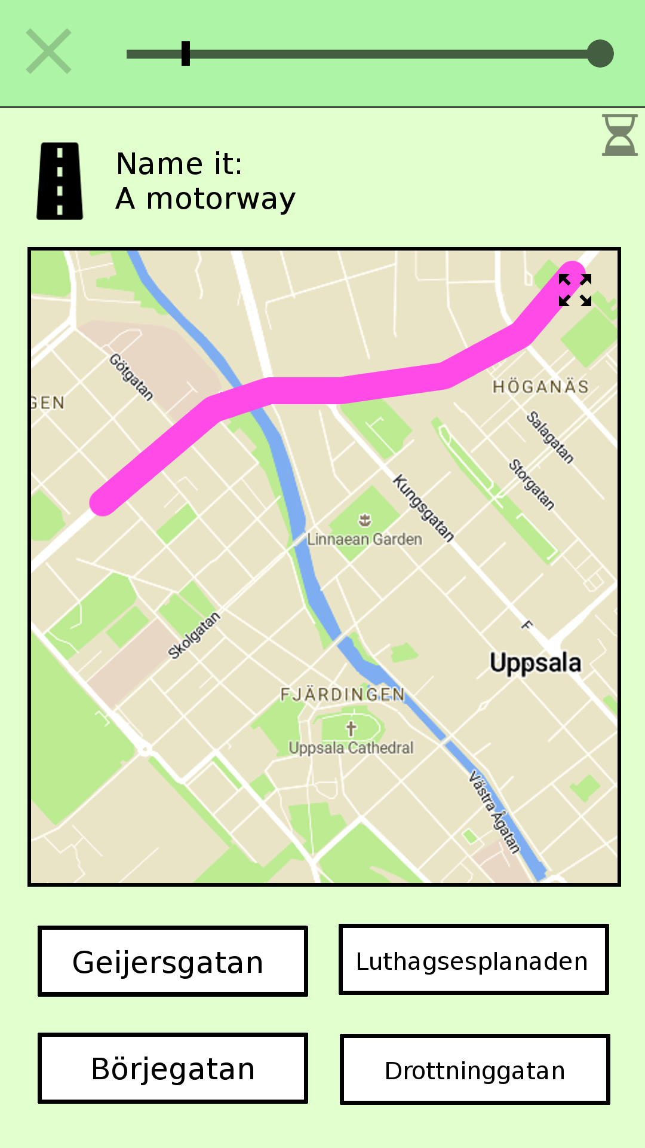

Quiz: Name it
If correct, moves on to next question. If incorrect, reveals answer before moving on. Ticking down hourglass in top right corner. Answer before time’s up; a stimulator. Progress bar at top. No road-labels are displayed in the map (image above isn’t correct here).

Quiz: Place it
In this case: construction – tap a dot. If a road-question – tap a line, if settlement tap an area (the border). No construction-labels in the map.

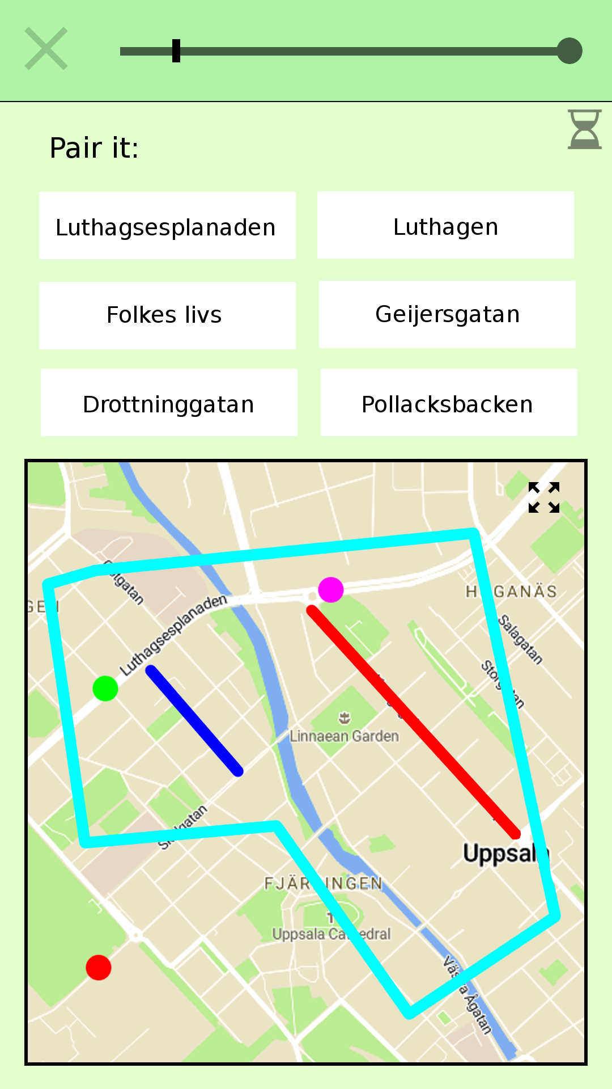

Quiz: Pair it
Pair name to drawn object by tapping a box and a an object in the map. Repeat for all.

Quiz
A quiz is made up of name-it, place-it and pair-it questions. A quiz handles around five objects, 3-5 questions each.

A level-quiz has the objects of a certain level. Passing this quiz with good score takes you to next level of this category.

A reminder-quiz has previously seen objects. Problematic and old (long time no see) objects are favored when selecting objects for such a quiz. You are required to take a reminder quiz (or a couple) now and then in order to open up a level-quiz, as seen below.

