|  |  |  |  |
| --- | --- | --- | --- |
| NAMES | ROLL NO  For: SYBCOM. | CONTACT NO | WORK IN PROJECT |
| MALIK GULAFSHAN IQBAL | C1920221 | 9136741002 | INTRODUCTION |
| MALINI KASIRAJA MENA | C1920222 | 9600302320 | CONCEPT |
| MANTIPELLI MAYURI MALLAYA | C1920223 | 7700093320 | OBJECTIVE |
| MARTIN JEYASEELAN STELLAMARY | C1920224 | 8424942001 | STRUCTURE |
| MUDALIAR PRAMOD PANNIER LAXMI | C1920225 | 9527164650 | CONCLUSION |

**C1920221-C1920225**

**TOPIC:UNION BUDGETING ANALYSIS FOR LAST**

**FIVE YEARS.**

**SUBJECT:BUSINESS EECONOMIC**

**INTRODUCTION**

**The Union Budget of India also called the general India budget is presented each year on the last working day of February. The budget is presented by the Finance Minister of India in Parliament. Budget is most economic event in the country which outlines all the economic planning of the Government of India for the next year. It is not only important for corporates but for individuals from all sections of the society.**

The **Fiscal Responsibility and Budget Management Act, 2003** (FRBMA) is an [Act](https://en.wikipedia.org/wiki/Act_of_Parliament) of the [Parliament of India](https://en.wikipedia.org/wiki/Parliament_of_India) to institutionalize financial discipline, reduce India's fiscal deficit, improve macroeconomic management and the overall management of the public fund2011, given the process of ongoing recovery, [Economic Advisory Council](https://en.wikipedia.org/wiki/Economic_Advisory_Council) publicly advised the [Government of India](https://en.wikipedia.org/wiki/Government_of_India) to reconsider reinstating the provisions of the FRBMA. [N. K. Singh](https://en.wikipedia.org/wiki/N._K._Singh) is currently the Chairman of the review committee for Fiscal Responsibility and Budget Management Act, 2003, under the [Ministry of Finance (India)](https://en.wikipedia.org/wiki/Ministry_of_Finance_(India)),

[Capital budgeting](https://www.investopedia.com/terms/c/capitalbudgeting.asp) involves choosing projects that add value to a company. The capital budgeting process can involve almost anything including acquiring land or purchasing fixed assets like a new truck or machinery. Corporations are typically required, or at least recommended, to undertake those projects which will increase profitability and thus enhance shareholders' wealth.

### KEY TAKEAWAYS

* Capital budgeting is the process by which investors determine the value of a potential investment project.
* The three most common approaches to project selection are payback period (PB), internal rate of return (IRR) and net present value (NPV).
* The payback period determines how long it would take a company to see enough in cash flows to recover the original investment.
* The internal rate of return is the expected return on a project. If the rate is higher than the cost of capital, it's a good project. If not, then it's not.
* The net present value shows how profitable a project will be versus alternatives, and is perhaps the most effective of the three methods.

**Concept of Capital Budgeting:**

Capital budgeting is a planning process that is used to determine the worth of long-term investments of an organization. The long- term investments of the organization can be made in purchasing a new machinery, plant, and technology.

In other words, capital budgeting is a method of identifying, evaluating, and selecting long-term investments. The concept of capital budgeting has a great importance in project selection as it helps in planning capital required for completing long-term projects. Selection of a project is a major investment decision for an organization.

Therefore, capital budgeting decisions are included in the selection of a project. In addition, capital budgeting helps in estimating costs and benefits involved in a particular project. A project is not worth investing, if it does not yield adequate return on invested capital.

**Some of the management experts have defined capital budgeting in the following ways:**

According to Charles T. Homgreen, “Capital Budgeting is long-term planning for making and financing proposed capital outlays.”

As per Richards and Greenlaw, “The capital budgeting generally refers to acquiring inputs and long-run returns.”

In the words of G. C. Philipattos, “Capital budgeting is concerned with the allocation of the firm’s scarce financial resources among the available market opportunities. The consideration of investment opportunities involves the comparison of the expected future streams of earnings from a project; with the immediate and subsequent stream of expenditures for it.”

According to Joel Dean, “Capital Budgeting is a kind of thinking that is necessary to design and carry through the systematic programme for investing stockholders’ money.”

From the aforementioned definitions, it can be concluded that capital budgeting is an important process for any organization

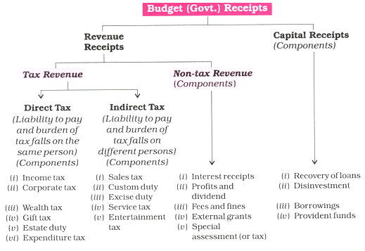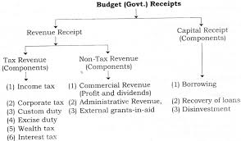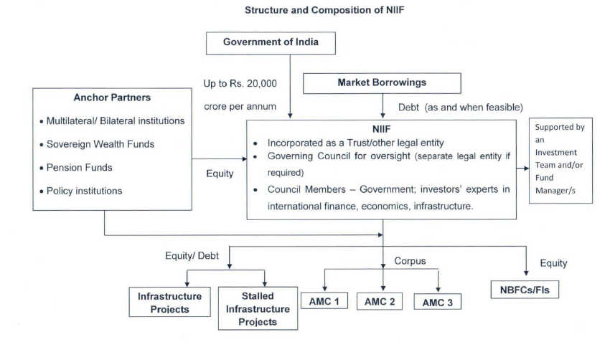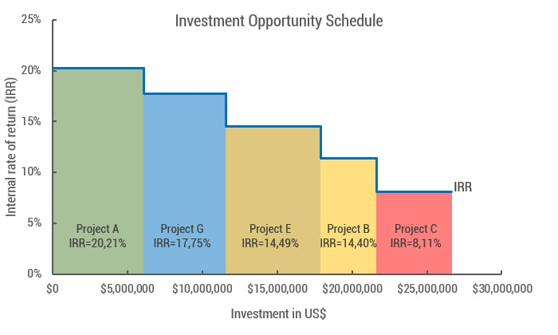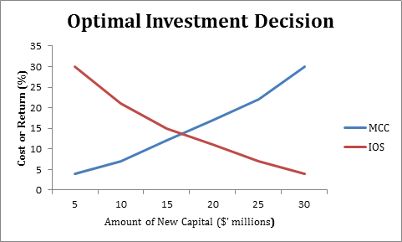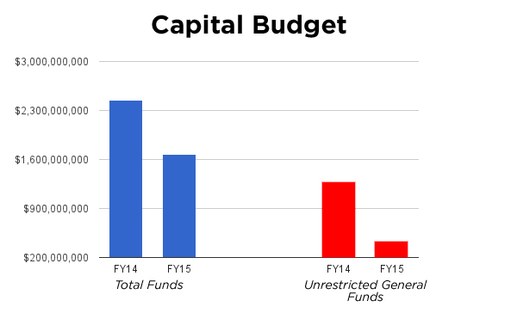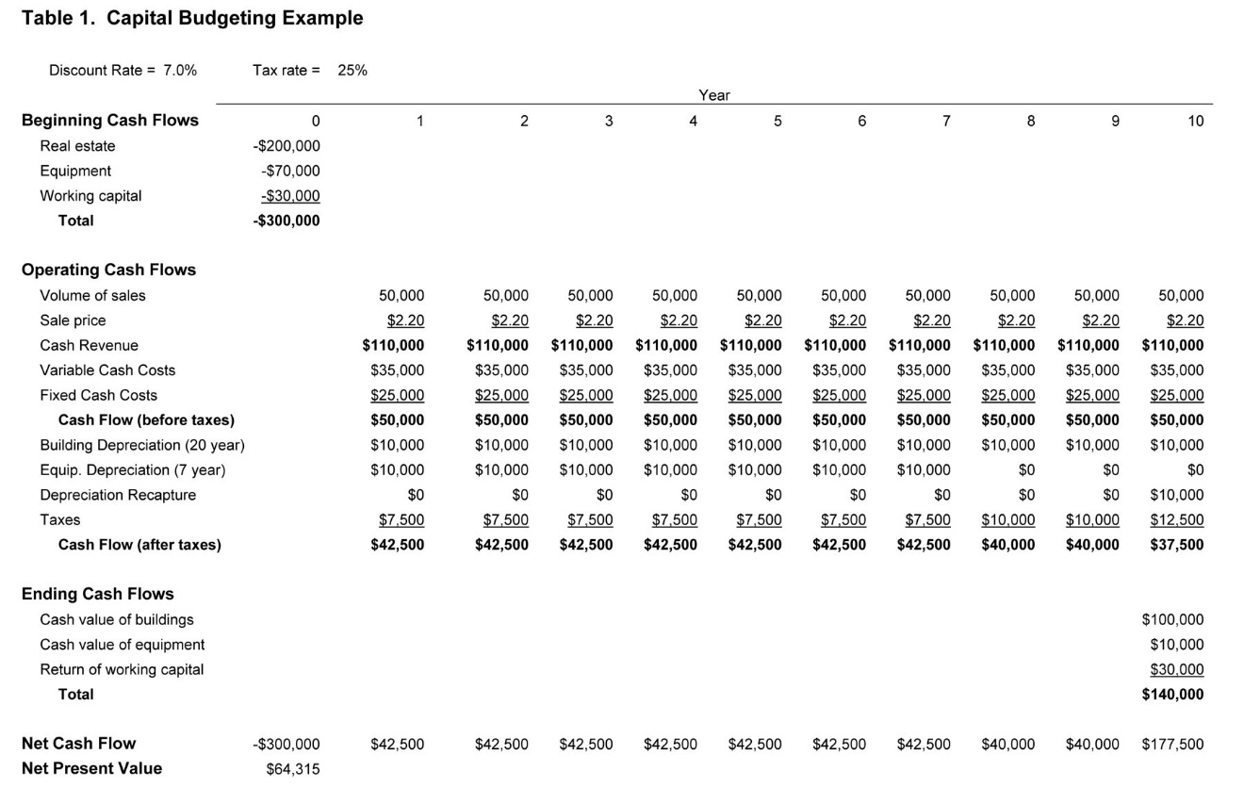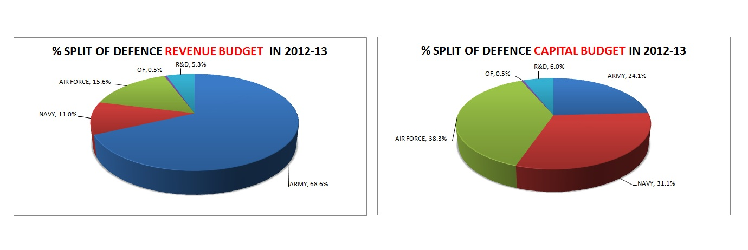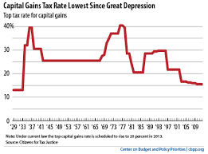

**OBJECTIVES OF CAPITAL BUDGETI**

The following are the objectives of capital budgeting.

1. To find out the profitable capital expenditure.

2. To know whether the replacement of any existing fixed assets gives more return than earlier.

3. To decide whether a specified project is to be selected or not.

4. To find out the quantum of finance required for the capital expenditure.

5. To assess the various sources of finance for capital expenditure.

6. To evaluate the merits of each proposal to decide which project is best.

## FEATURES OF CAPITAL BUDGETING:

## 

The features of capital budgeting are briefly explained below:

1. Capital budgeting involves the investment of funds currently for getting benefits in the future.

2. Generally, the future benefits are spread over several years.

3. The long term investment is fixed.

4. The investments made in the project is determining the[financial condition of business organization](https://accountlearning.com/identifying-your-capital-position-in-financial-situation/) in future.

5. Each project involves huge amount of funds.

6. Capital expenditure decisions are irreversible.

7. The profitability of the business concern is based on the quantum of investments made in the project.

## **LIMITATIONS OF CAPITAL BUDGETING**:

The following are the limitations of capital budgeting.

1. The economic life of the project and annual cash inflows are only an estimation. The actual economic life of the project is either increased or decreased. Likewise, the actual annual cash inflows may be either more or less than the estimation. Hence, [control over capital expenditure](https://accountlearning.com/5-techniques-control-capital-expenditure/) can not be exercised.

2. The application of capital budgeting technique is based on the presumed cash inflows and cash outflows. Since the future is uncertain, the presumed cash inflows and cash outflows may not be true. Therefore, the selection of profitable project may be wrong.

3. Capital budgeting process does not take into consideration of various non-financial aspects of the projects while they play an important role in successful and profitable implementation of them. Hence, true profitability of the project cannot be highlighted.

4. It is also not correct to assume that mathematically exact techniques always produce highly accurate results.

5. All the techniques of capital budgeting presume that various investment proposals under consideration are mutually exclusive which may not be practically true in some particular circumstances.

6. The [morale of the employee](https://accountlearning.com/methods-of-increasing-morale-of-employees/), goodwill of the company etc. cannot be quantified accurately. Hence, these can substantially influence capital budgeting decision.

7. Risk of any project cannot be presumed accurately. The project risk is varying according to the changes made in the business world.

8. In case of urgency, the capital budgeting technique cannot be applied.

9. Only known factors are considered while applying capital budgeting decisions. There are so many unknown factors which are also affecting capital budgeting decisions. The unknown factors cannot be avoided or controlled.

**RATIONALE OF CAPITAL BUDGETING DECISIONS**:

The rationale behind the [**capital budgeting**](https://accountlearning.com/capital-budgeting-reason-to-prepare-steps-lifespan/) decisions is efficiency. A firm has to continuously invest in new plant or machinery for expansion of its operations or replace worn out machinery for maintaining and improving efficiency. The main objective of the firm is to maximize profit either by way of increased revenue or by cost reduction. Broadly, there are two types of capital budgeting decisions which expand revenue or reduce cost.

### 1. Investment decisions affecting revenue

It includes all those [investment decisions](https://accountlearning.com/investment-decision-management-perspective/)which are expected to bring additional revenue by raising the size of firm’s total revenue. It is possible either by expansion of present operations or the development of new product in line. In both the cases fixed assets are required.

### 2. Investment decisions reducing costs

It includes all those decisions of the firms which reduces the total cost and leads to increase in its total earnings i.e. when an asset is worn out or becomes outdated, the firm has to decide whether to continue with it or replace it by new machine. For this, the firm evaluates the benefit in the form of reduction in operating costs and outlays that would be needed to replace old machine by new one. A firm will replace an asset only when it finds it beneficial to do so. The above decision could be followed decisions following alternative courses: i.e., **Tactical investment decisions** to **strategic investment decisions**, as briefly defined below

#### Tactical investment decisions:

It includes those **investment decisions** which generally involves a small amount of funds and does not constitute a major departure from what the firm has been doing in the past.

#### Strategic investment decisions:

Such decisions involve large sum of money and envisage major departure from what the company has been doing in the past. Acceptance of strategic investment will involve significant change in the company’s expected profits and the risk to which these profits will be subject. These changes are likely to lead stock-holders and creditors to revise their evaluation of the company.

**Fiscal Responsibility and Budget Management Act, 2003:**

The Fiscal Responsibility and Budget Management Act, 2003 (FRBMA) is an [Act](https://en.wikipedia.org/wiki/Act_of_Parliament) of the [Parliament of India](https://en.wikipedia.org/wiki/Parliament_of_India) to institutionalize financial discipline, reduce India's fiscal deficit, improve macroeconomic management and the overall management of the public funds by moving towards a [balanced budget](https://en.wikipedia.org/wiki/Balanced_budget) and strengthen fiscal [prudence](https://en.wikipedia.org/wiki/Prudence). The main purpose was to eliminate revenue deficit[[Note 1]](https://en.wikipedia.org/wiki/Fiscal_Responsibility_and_Budget_Management_Act,_2003#cite_note-1) of the country (building revenue surplus thereafter) and bring down the [fiscal deficit](https://en.wikipedia.org/wiki/Fiscal_deficit) to a manageable 3% of the GDP by March 2008. However, due to the [2007 international financial crisis](https://en.wikipedia.org/wiki/Financial_crisis_of_2007%E2%80%932008), the deadlines for the implementation of the targets in the act was initially postponed and subsequently suspended in 2009. In 2011, given the process of ongoing recovery, [Economic Advisory Council](https://en.wikipedia.org/wiki/Economic_Advisory_Council) publicly advised the [Government of India](https://en.wikipedia.org/wiki/Government_of_India) to reconsider reinstating the provisions of the FRBMA. [N. K. Singh](https://en.wikipedia.org/wiki/N._K._Singh) is currently the Chairman of the review committee for Fiscal Responsibility and Budget Management Act, 2003, under the [Ministry of Finance (India)](https://en.wikipedia.org/wiki/Ministry_of_Finance_(India)), [Government of India](https://en.wikipedia.org/wiki/Government_of_India).

## Enactment:

The Fiscal Responsibility and Budget Management *Bill* (FRBM Bill) was introduced in India by the then [Finance Minister](https://en.wikipedia.org/wiki/Finance_Minister) of India, Mr.[Yashwant Sinha](https://en.wikipedia.org/wiki/Yashwant_Sinha)[[1]](https://en.wikipedia.org/wiki/Fiscal_Responsibility_and_Budget_Management_Act,_2003#cite_note-Bill-2) in December 2000. Firstly, the bill highlighted the terrible state of government finances in India both at the Union and the state levels under the statement of objects and reasons.[[2]](https://en.wikipedia.org/wiki/Fiscal_Responsibility_and_Budget_Management_Act,_2003#cite_note-IE1-3) Secondly, it sought to introduce the fundamentals of fiscal discipline at the various levels of the government.The FRBM bill was introduced with the broad objectives of eliminating revenue deficit by 31 March 2006, prohibiting government borrowings from the [Reserve Bank of India](https://en.wikipedia.org/wiki/Reserve_Bank_of_India) three years after enactment of the bill, and reducing the fiscal deficit to 2% of GDP (also by 31 March 2006).[[2]](https://en.wikipedia.org/wiki/Fiscal_Responsibility_and_Budget_Management_Act,_2003#cite_note-IE1-3) Further, the bill proposed for the government to reduce liabilities to 50% of the estimated GDP by year 2011. There were mixed reviews among economists about the provisions of the bill, with some criticising it as *too drastic*.[[3]](https://en.wikipedia.org/wiki/Fiscal_Responsibility_and_Budget_Management_Act,_2003#cite_note-4) Political debate ensued in the country. Several revisions later, it resulted in a much relaxed and watered-down version of the bill[[4]](https://en.wikipedia.org/wiki/Fiscal_Responsibility_and_Budget_Management_Act,_2003#cite_note-Rediff1-5) (including postponing the date for elimination of revenue deficit to 31 March 2008) with some experts, like Dr Saumitra Chaudhuri of ICRA Ltd. (and now a member of [Prime Ministers' Economic Advisory Council](https://en.wikipedia.org/wiki/Economic_Advisory_Council)) commenting, "all teeth of the Fiscal Responsibility Bill have been pulled out and in the current form it will not be able to deliver the anticipated results."[[6]](https://en.wikipedia.org/wiki/Fiscal_Responsibility_and_Budget_Management_Act,_2003#cite_note-IE2-8) This bill was approved by the Cabinet of Ministers of the Union Government of India in February, 2003[[7]](https://en.wikipedia.org/wiki/Fiscal_Responsibility_and_Budget_Management_Act,_2003#cite_note-9) and following the due [enactment](https://en.wikipedia.org/wiki/Enactment_of_a_bill) process of Parliament, it received the assent of the [President of India](https://en.wikipedia.org/wiki/President_of_India) on 26 August 2003.[[8]](https://en.wikipedia.org/wiki/Fiscal_Responsibility_and_Budget_Management_Act,_2003#cite_note-Act-10) Subsequently, it became effective on 5 July 2004.[[9]](https://en.wikipedia.org/wiki/Fiscal_Responsibility_and_Budget_Management_Act,_2003#cite_note-BL2-11) This would serve as the *day of commencement of this Act*.

### **Fiscal management principles**:

The Central Government, by rules made by it, was to specify the following:

1. a plan to eliminate revenue deficit by 31 March 2008 by setting annual targets for reduction starting from day of commencement of the act.
2. reduction of annual fiscal deficit of the country
3. annual targets for assuming contingent liabilities in the form of guarantees and the total liabilities as a percentage of the GDP

### Borrowings from Reserve Bank of India:

The Act provided that the Central Government shall not borrow from the [Reserve Bank of India](https://en.wikipedia.org/wiki/Reserve_Bank_of_India)(RBI) except under exceptional circumstances where there is temporary shortage of cash in particular financial year. It also laid down rules to prevent RBI from trading in the primary market for Government securities. It restricted them to the trading of Government securities in the secondary market after an April, 2005, barring situations highlighted in exception*s* paragraph.

#### Exceptions:

National security, natural calamity or other exceptional grounds that the Central Government may specify were cited as reasons for not implementing the targets for fiscal management principles, prohibition on borrowings from RBI and fiscal indicators highlighted above, provided they were approved by both the Houses of the Parliament as soon as possible, once these targets had been exceeded.

## Measures to enforce compliance:

This was a particularly weak area of the act. It required the Finance Minister of India to only conduct quarterly reviews of the receipts and expenditures of the Government and place these reports before the Parliament. Deviations to targets set by the Central government for fiscal policy had to be approved by the Parliament.No other measures for failure of compliance have been specified.

**CONCLUSION:**

Conclusion As conclusion, capital budgeting is a process of a company used to determine whether the projects available are worth for pursuing in a long-term venture such as new machinery, replacement of machinery, new plants and new products for its business. Once a company has the calculations to analyse possible investment return they can make a decisions about the long-term investment of a company’s capital into operations. Hence, it is a very important aspect for a company’s financial managementin the long run .Besides that, capital structure is one of the important roles for a company’s financial management. Capital structure known as a mix of a company’s long-term debt, specific short-term debt, common equity and preferred equity. People usually look into a firm’s debt-to-equity ratio because it provided insight on the stability of accompany.

Conclusions about capital budgeting The decision process Before making capital budgeting decisions, finance professionals often generate, review, analyse, select, and implement long-term investment proposals that meet firm-specific criteria and are consistent with the firm's strategic goals.

**Bibliography:**

* [**http://www.eximguru.com/budgetmain.aspx**](http://www.eximguru.com/budgetmain.aspx)
* <https://images.app.goo.gl/dxdoAC7sWs3L9YYk6>
* <https://en.wikipedia.org/wiki/Fiscal_Responsibility_and_Budget_Management_Act,_2003>
* <https://economictimes.indiatimes.com/definition/Union%20Budget>