ETD – Educational Tower Defense

**02823 Computer Game Prototyping**

**Group members**

Martin Skytte Sørensen - s094096

Mike Berg Karstensen - s123237

Bruno Victor Harvey - s141429

Christian Westergaard Nicolaisen - s103053

**Project Description**

ETD (Educational Tower Defense) is an educational game that is based on the classic Tower Defense and “Bejeweled/Candy Crush” games.

The idea is to have the Tower Defense part be the motivating factor in the game and “Bejeweled” the educational part. Thus the player must solve simple mathematical equations by swapping blocks in “Bejeweled”, correct answers will be rewarded with credits for the Tower Defense.

The image below is a crude representation of the game’s layout.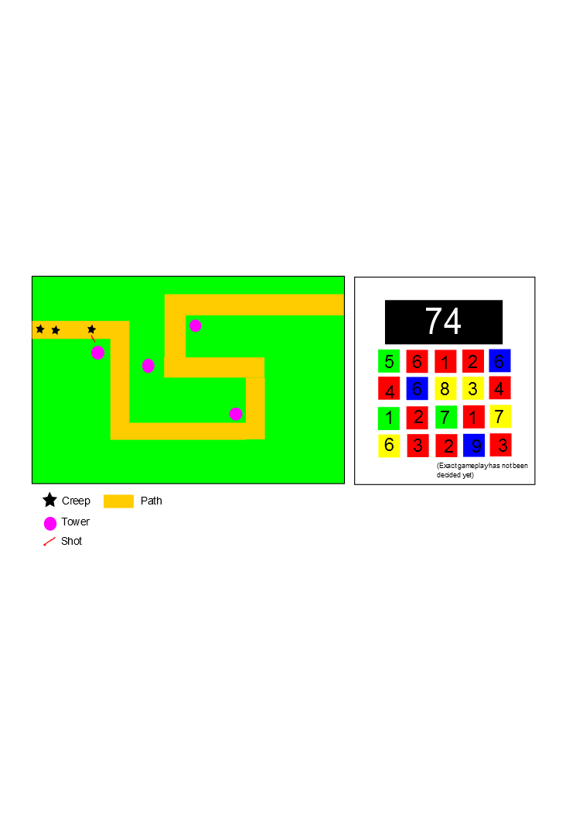

Figure 1: Game layout