Семинарска: Податочно Рударство

Тема: Влијанија на Covid_19

Изработиле:

# Влијание на Covid_19 врз каматните стапки

Datasets: **Covid_19** & **Euribor Europe Interest Rate**:

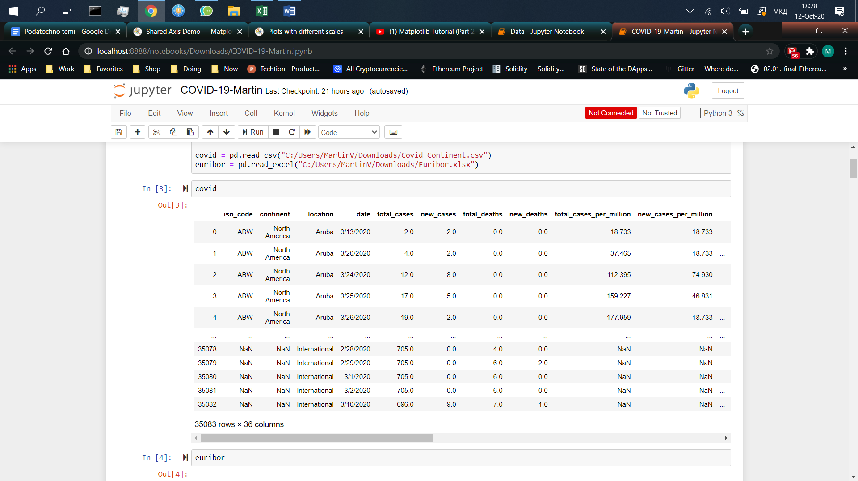

The first problem shows the correlation between number of Covid_19 cases and the interest rates for Europe.

Data preprocessing:

The Covid_19 dataset is reduced only for European countries and for time span of May to Aug 2020, so it can be matched with the Interest Rates dataset. Furthermore data rows containing NaN for the date column are removed. Data is grouped by countries

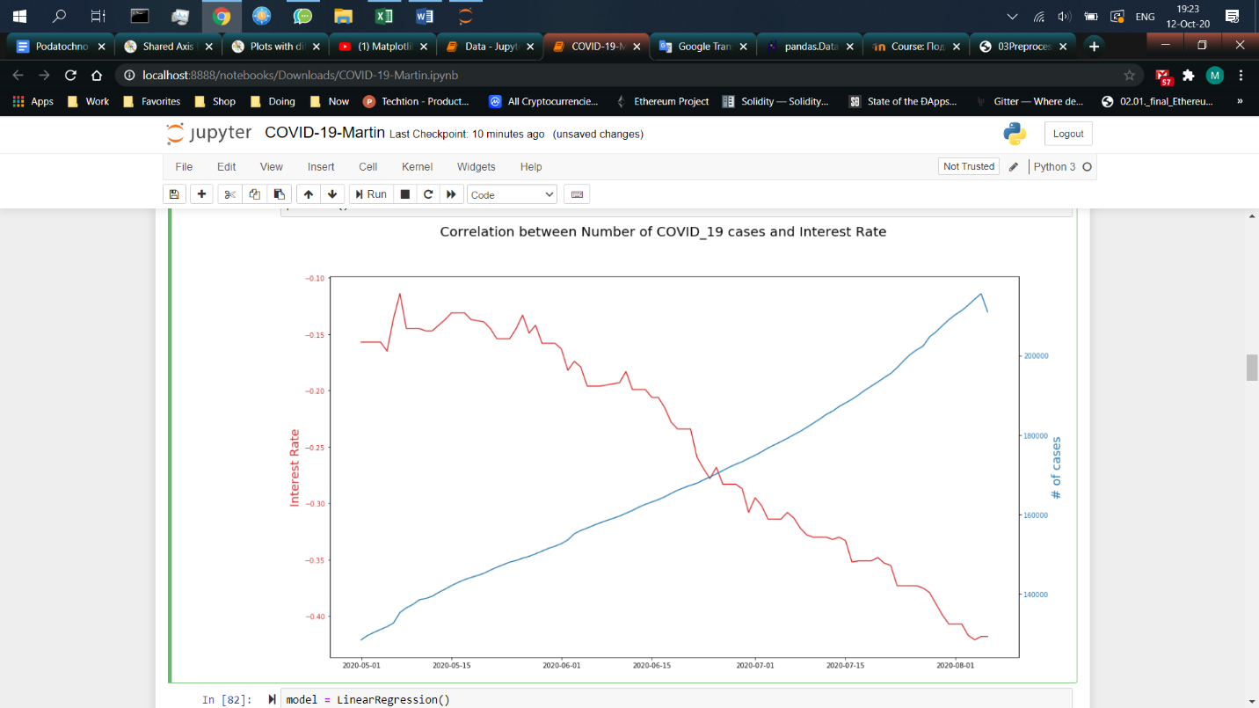Graph:

When the two data sets are intertwined we can see that the number of cases increases the interest rates fall.

Linear Regression:

Linear regression is used to predict the relationship between two variables or factors. The factor that is being predicted (the factor that the equation solves for) is called the dependent variable.

Notes:

koristime 2 mnozestvo zaradi state

binarizacija na 90 god za da ima asociacija

koleracija pomegu smrtnos I nad 90 god

arrowcy_curve: 100*0 nekolku 1 > prediction za sledni ke e 0 90%

testira na dr set

0.5

accuracy na ovoj set