Comprehensive Box Office Analysis and Predictive Modeling Report

1. Project Overview
This project presents a comprehensive, end-to-end data analysis pipeline developed entirely in Python. The primary objective is to extract actionable insights and underlying patterns from the dataset through a structured workflow that encompasses data cleaning, exploratory data analysis (EDA), data visualization, and machine learning modeling.
This project uses the IMDB Movies Dataset from Kaggle, a structured dataset that systematically collects comprehensive metadata for all films released worldwide up to July 2017. The dataset covers a wide range of dimensions including basic background information such as release dates, original languages, production companies, and production countries. It also includes key commercial indicators like production budgets and global box office revenues, creative content details such as cast and crew lists, plot keywords, and poster information, as well as audience feedback metrics including vote counts and average ratings from the TMDB platform. With these multi-dimensional, highly correlated fields, the dataset provides a solid foundation for this research, effectively supporting core analytical tasks such as data cleaning and preprocessing, movie revenue analysis, and cross-dimensional correlation analysis.

The project workflow is divided into four core phases:
1. Data Cleaning & Preprocessing: To ensure the integrity and reliability of our analysis, the pipeline began with a rigorous data cleaning phase. We systematically identified and eliminated redundant entries (duplicates) and rectified erroneous, missing, or anomalous data points. This established a robust and high-quality foundation for the subsequent analytical steps.
2. Exploratory Data Analysis (EDA): Following data preparation, we conducted an in-depth multidimensional analysis to uncover key drivers within the dataset. We segmented our analysis into six primary dimensions:
- Ratings: Evaluating audience reception and critical score distributions.
- Budgets: Analyzing financial investments and cost structures.
- Release Schedules: Investigating the impact of release timing and market seasonality.
- Keywords: Extracting thematic trends and core subject matter.
- Cast: Assessing the influence of actors and star power.
- Countries: Understanding the geographical distribution and regional market trends.
3. Data Visualization: To make complex data relationships intuitive and accessible, we leveraged Python’s advanced graphical libraries (such as Matplotlib and Seaborn). We generated a suite of highly readable charts and graphs, translating abstract numerical correlations into clear, visual narratives.
4. Predictive Modeling: Building upon the insights derived from the visualization and analysis phases, the final stage of the project involved feature engineering and the construction of an analytical model. This model synthesizes the multifaceted variables mentioned above, allowing us to capture deeper statistical relationships and provide data-driven predictions.
Overall, this project successfully demonstrates a complete data science lifecycle, transforming raw, messy data into structured, visually intuitive, and mathematically modeled insights.

2. Data Cleaning and Preprocessing
Despite the rich multi-dimensional information provided by the IMDB Movies Dataset, the raw data contains numerous imperfections, including missing values, inconsistent formatting, outliers, and duplicate records. These issues would directly compromise the accuracy and reliability of subsequent analyses: missing budget or revenue figures would distort the results of profitability analysis, poorly formatted fields would hinder cross-dimensional correlation analysis, and extreme outliers could skew our understanding of overall industry trends. Therefore, data cleaning is an indispensable step in this project, aimed at repairing data defects, standardizing formats, and removing invalid entries, to ensure that all subsequent revenue and cross-analyses are built on a solid, high-quality data foundation.

2.1 Basic data processing
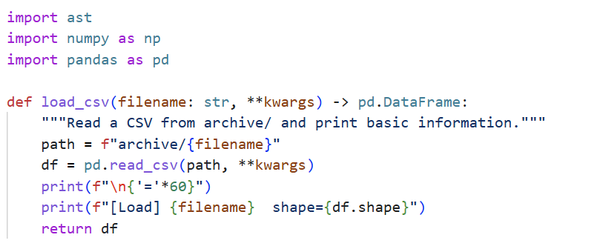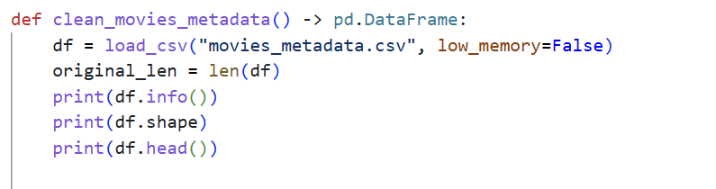
This code uses the Pandas library to load and explore the main movie dataset. First, it imports Pandas and related libraries for data processing and parsing. Then, it loads the dataset into a Pandas DataFrame and performs three key exploration checks:
df.info() reveals metadata such as data types and missing values, helping to identify potential issues early.
df.shape shows the dataset’s size, including the number of rows and columns, providing an overview of the data scale.
df.head() previews the first 5 rows of movie data, allowing a quick check of the data format and content structure.
Overall, this is the first basic step for movie dataset preprocessing, laying the groundwork for further cleaning and analysis.

2.2 Removing malformed and duplicate records
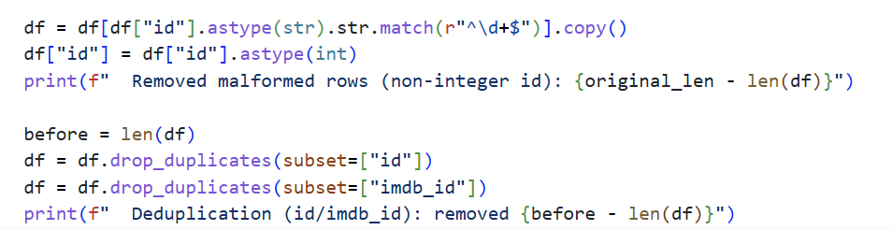
After initial exploration, we remove invalid and duplicate records. Rows with non-numeric IDs caused by data misalignment are filtered out, as they cannot be used for analysis. Duplicate entries based on both “id” and “imdb_id” are also deleted to ensure each movie appears only once, maintaining data uniqueness and consistency.

2.3 Standardizing boolean and numeric fields
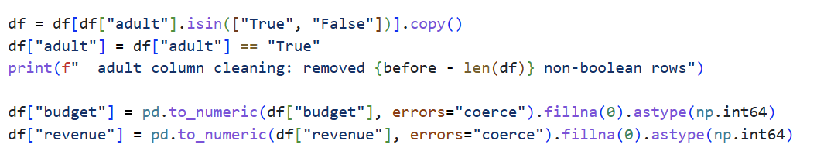
Next, we standardize key boolean and numeric fields. The adult column is filtered to retain only valid boolean values and converted to a boolean type. Budget and revenue are converted to numeric format, with missing values filled with zero to support reliable numerical analysis.

2.4 Processing release date
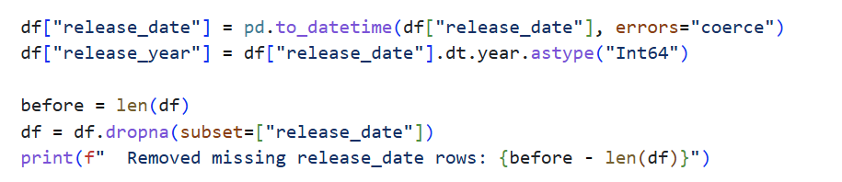
This code accomplishes two core tasks: converting the release date into datetime format and extracting movie release years. First, it uses pd.to_datetime to standardize the date strings into a datetime type, ensuring consistent handling of different formats. Then, it extracts the year using .dt.year and stores it in a new release_year column. Finally, rows with missing release dates are removed, as valid time information is essential for analyzing trends over time.

2.5 Cleaning runtime and detecting outliers
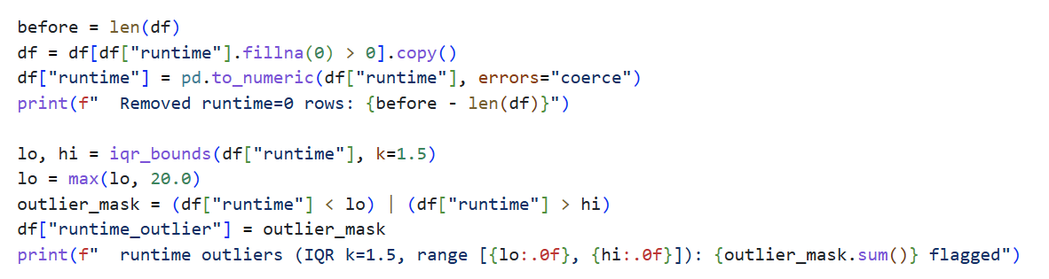
We remove invalid movies with zero or missing runtime, as they are not suitable for analysis. We then use the IQR method to detect runtime outliers and set a minimum threshold of 20 minutes to exclude short clips or nonmovie content. A boolean column runtime_outlier is added to flag extreme values for optional filtering in later analysis.

2.6 Budget and revenue outlier detection
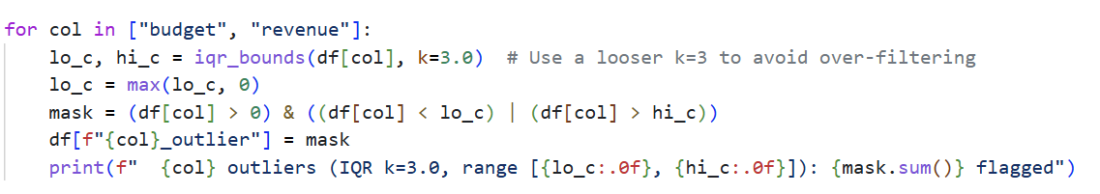
We apply a looser IQR threshold (k=3.0) to detect outliers for budget and revenue, only considering positive values. Boolean columns are added to flag these outliers for further filtering.

2.7 Handling popularity and vote records
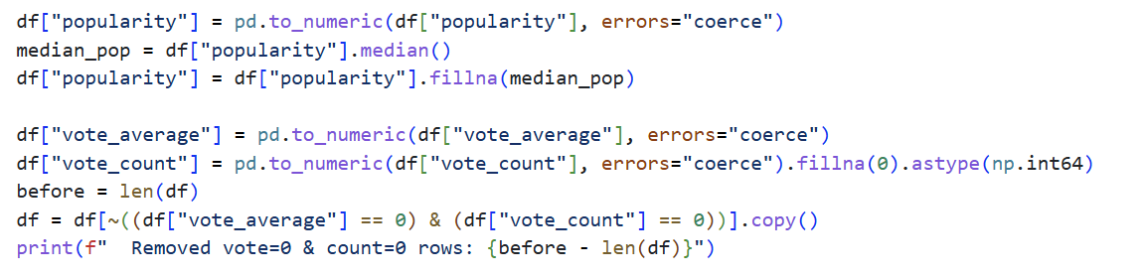
Missing popularity values are filled with the median to preserve data distribution. We remove movies with both zero vote average and zero vote count, as they provide no valid analytical information.

2.8 Parsing JSON structured fields
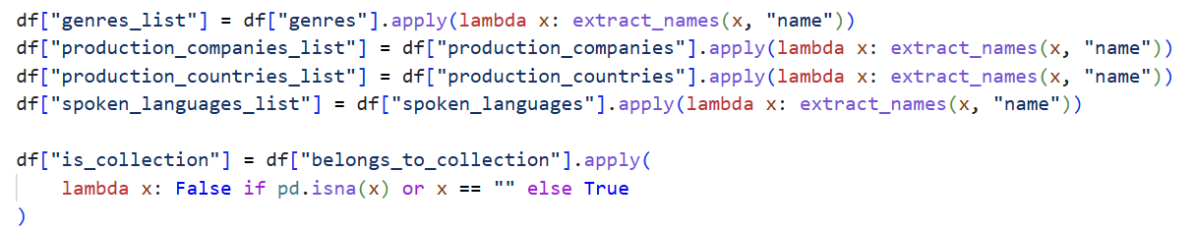
This step parses unstructured JSON columns including genres, production companies, production countries, and spoken languages into clean, usable lists. We also create a boolean flag is_collection to indicate whether a movie belongs to a franchise or series.

2.9 Exporting cleaned datasets
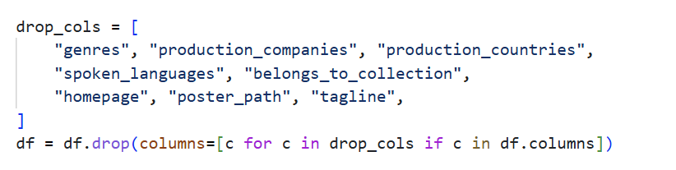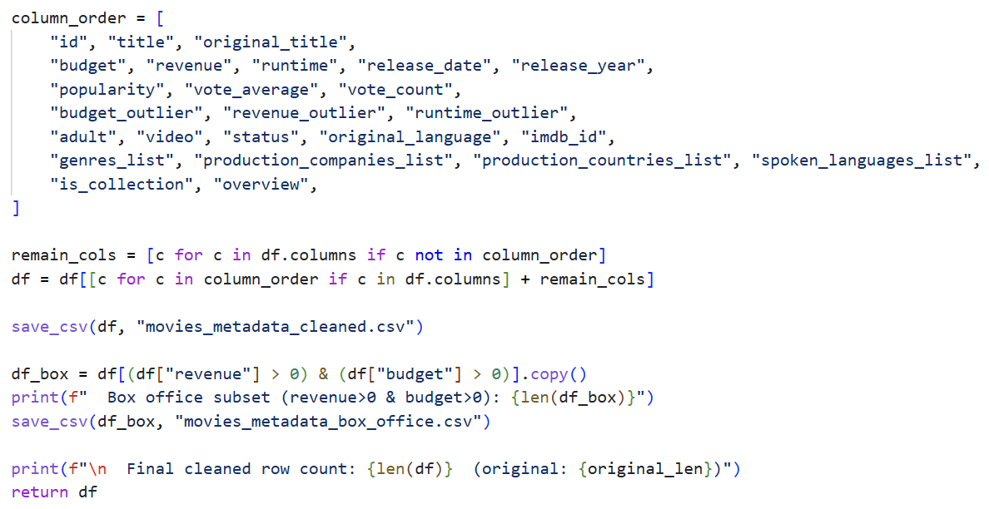
Redundant raw columns are removed, and columns are reordered for readability. We export two cleaned versions: a full dataset and a boxoffice subset with valid budget and revenue values.

2.10 Cleaning supplementary files
In addition to the main movie dataset, the project includes four supplementary datasets that provide critical supporting information for analysis. These datasets contain user ratings, movie keywords, cast and crew details, and cross-dataset ID mappings. To ensure the reliability and consistency of the entire analysis, each supplementary file is cleaned using standardized procedures, including deduplication, format correction, missing value removal, and structured parsing of unstructured data. The goal is to generate clean, consistent, and directly usable datasets for subsequent exploratory analysis, visualization, and statistical modeling.

2.10.1 Clean ratings_small.csv
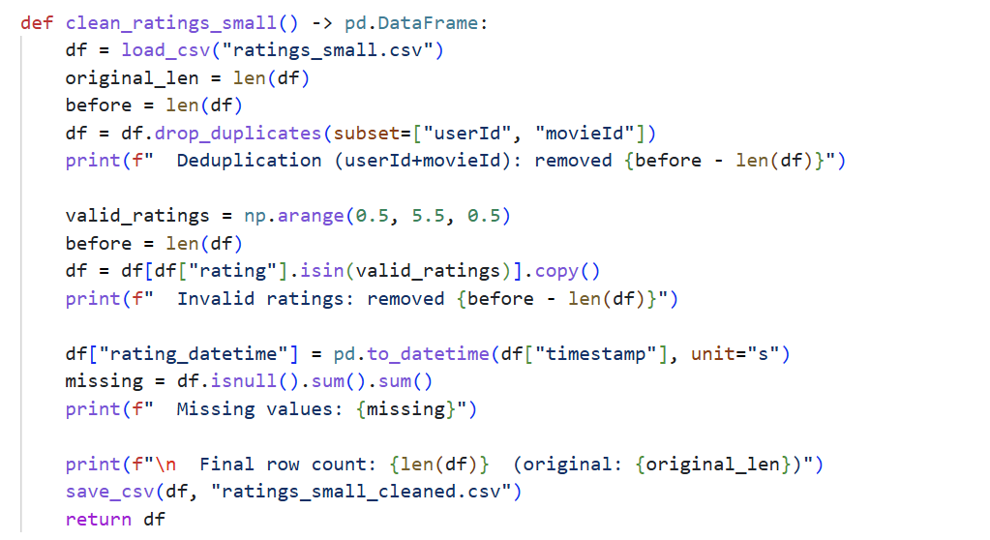
The ratings dataset records user ratings for individual movies, which is essential for analyzing audience preferences, rating distributions, and popularity patterns. However, raw data may contain duplicate rating records, invalid rating values, and non-standard timestamps. Therefore, we first remove duplicate user-movie pairs to avoid repeated counting. Next, we filter out invalid ratings that do not conform to the standard 0.5–5.0 range. Finally, we convert Unix timestamps into readable datetime format for time-series analysis.

2.10.2 Clean keywords.csv
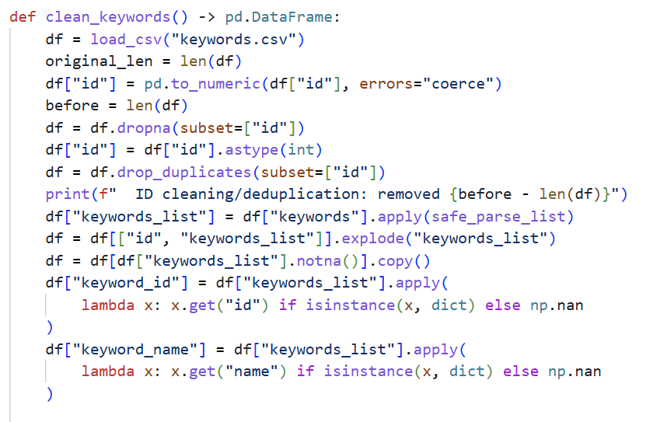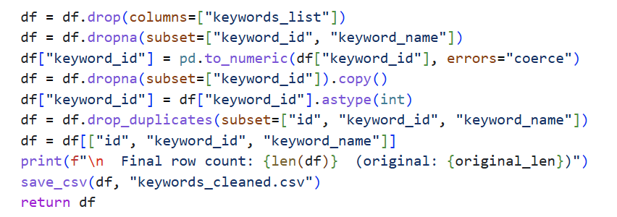
The keywords dataset stores movie keywords in unstructured JSON format, which requires parsing before analysis. Keywords reflect core themes and narrative elements of movies and are important for genre association analysis and content-based exploration. In this cleaning step, we first standardize movie IDs and remove duplicate entries. We then parse the JSON strings into structured lists and expand each keyword into a separate row. Finally, we retain only valid keyword IDs and names to ensure data integrity.

2.10.3 Clean credits.csv
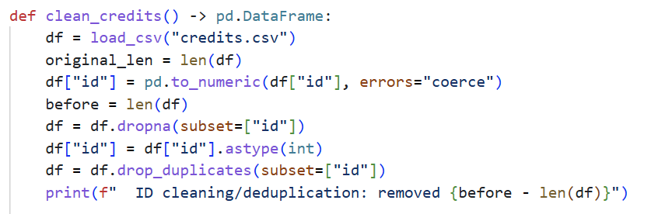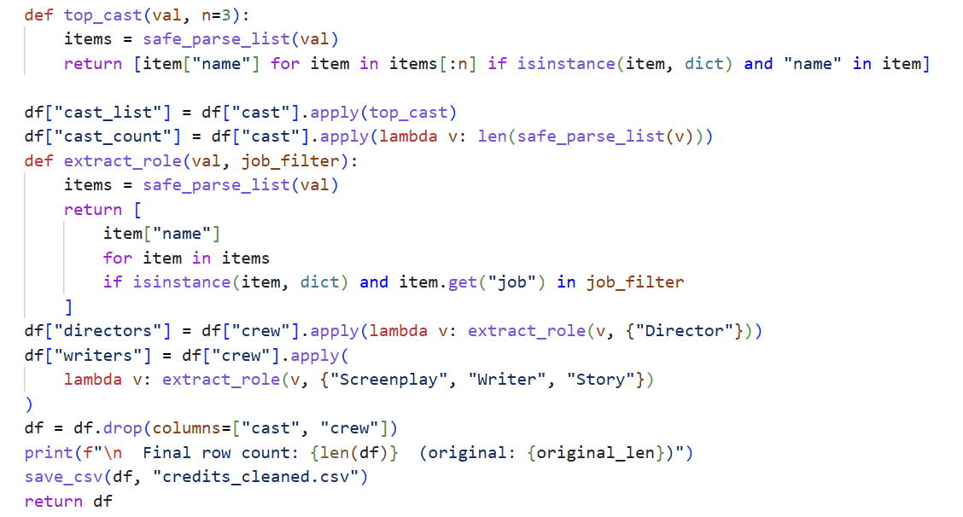
The credits dataset contains detailed cast and crew information stored in JSON format, which is critical for analyzing the influence of directors and actors on movie performance. Raw cast and crew data are unstructured and difficult to analyze directly. We therefore extract the top three main actors and filter directors and screenwriters from the crew list. After parsing, we discard the original JSON columns and retain only structured text information for further analysis.

2.10.4 Clean links_small.csv
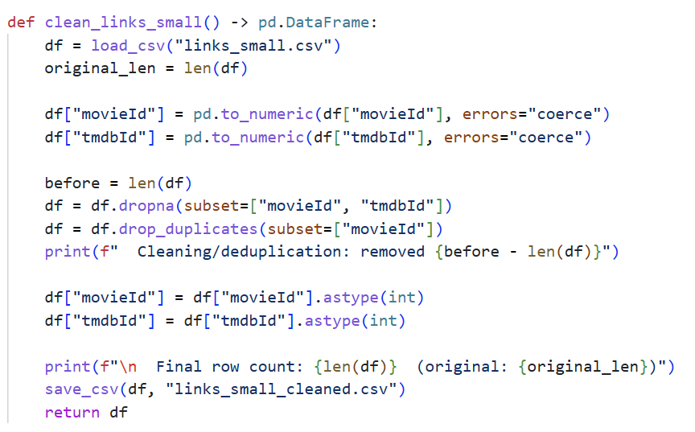
The links dataset serves as an ID mapping table between different data sources, ensuring accurate merging of multiple datasets. Inconsistent or missing IDs can lead to data merging errors. We therefore remove rows with missing movie IDs or TMDB IDs, eliminate duplicate mappings, and standardize both IDs into integer format to ensure consistency when joining datasets.

3. Exploratory Data Analysis & Predictive Modeling

3.1 Analysis of Movie Ratings on Box Office

3.1.1 Research Objective
This section focuses on exploring the deep connection between movie user ratings and box office revenue. While ratings are generally considered a direct reflection of a movie's public reception and artistic quality, their actual conversion rate into commercial success has long been debated in the industry. The main objectives are:
- To validate whether a statistically significant correlation (both linear and rank-based) exists between rating levels and final box office revenue.
- To explore the revenue distribution differences across various critical reputation tiers (low, medium, and high ratings).
- To identify box office outliers (super blockbusters) and analyze their specific rating characteristics.
- To evaluate the feature weight that the rating field should occupy in subsequent machine learning box office prediction models.

3.1.2 Data and Methodology
The analysis in this section relies primarily on two core cleaned datasets:
- Movie Metadata Dataset: Contains movie metadata with valid box office records (greater than zero) and basic financial indicators.
- Ratings Dataset: Contains deduplicated user rating records, which were inner-joined with the movie metadata table using the movie ID to calculate the average rating for each film.
Methodologically, we first calculated the Pearson and Spearman correlation coefficients to test the overall relationship. Next, we performed a binning process on ratings to observe market stratification and potential inversion trends. Finally, we utilized the Interquartile Range (IQR) method to locate and analyze extreme box office outliers.

3.1.3 Correlation Analysis Between Ratings and Revenue
To verify the direct predictive power of public reception on box office performance, a formal correlation test was conducted. The statistical results reveal the following:
- The Pearson correlation coefficient (r) between ratings and box office is -0.0189 (p-value=0.5114), indicating that there is almost no linear relationship between the two metrics.
- The Spearman correlation coefficient (ρ), which measures rank monotonicity, is -0.0158 (p-value=0.5842), demonstrating that even from a relative ranking perspective, highly-rated movies hold no competitive advantage on box office charts.
- Both coefficients are extremely close to zero, and their high p-values indicate a complete lack of statistical significance, proving that audience ratings are not a viable standalone indicator for box office success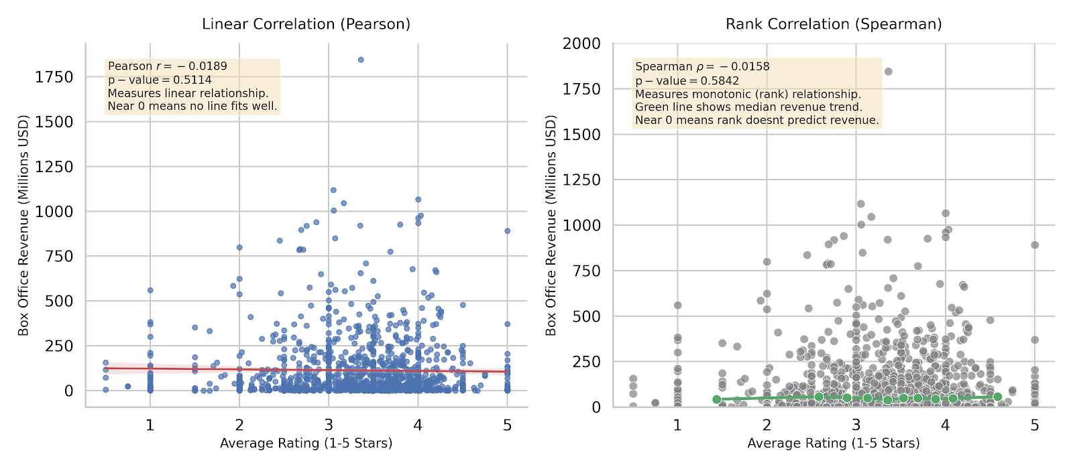
Figure 1 Correlation Analysis Between Ratings and Revenue

3.1.4 Market Stratification and Blockbuster Outliers
To prevent macro averages from obscuring the true internal structure of the data, the sample was stratified into specific rating cohorts, uncovering extreme non-linear anomalies:
- A significant "box office inversion" phenomenon is present across the tiers: low-rating movies (<3.0) yield the highest average box office ($117 million), whereas high-rating masterpieces (>4.0) result in the lowest average returns ($108 million).
- Using the IQR algorithm exclusively on the positive revenue subset, the threshold for a "super blockbuster" outlier was established at $333.79 million, identifying 104 qualifying films.
- These 104 commercial outliers account for the vast majority of market profits, yet their average rating is only 3.30, which is lower than the average rating of standard, non-outlier movies (3.34) in the dataset.
- This pattern confirms that breaking through the commercial revenue ceiling is heavily stochastic and primarily driven by massive marketing budgets, star power, and prime scheduling rather than artistic metrics.
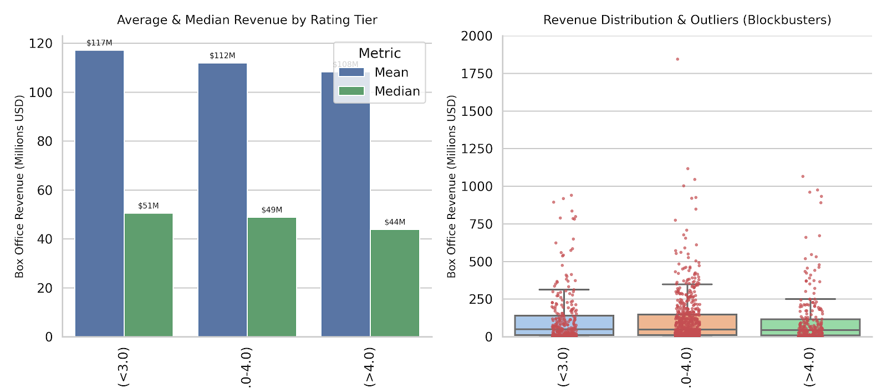
Figure 2 Market Stratification and Blockbuster Outliers

3.1.5 Key Findings
- No direct correlation exists between user ratings and box office revenue: Whether analyzing absolute numerical linear regression or relative rank positioning, rating levels cannot serve as an effective indicator for predicting box office trends due to near-zero coefficients and a lack of statistical significance.
- The movie market displays a distinct "box office inversion" phenomenon: The average revenue of low-rated popcorn movies (<3.0) systematically surpasses that of highly-rated critical successes (>4.0), proving that commercial movies catering to the mass market possess a far greater monetization capacity than niche artistic projects.
- The creation of super blockbusters operates independently of rating logic: Outlier movies at the top of the box office pyramid (>$333 million) maintain an average rating below the overall market average, illustrating that commercial peak performance relies heavily on high budgets, cast power, and release windows rather than critical score.
- Ratings should be assigned a low feature weight in predictive models: Based on these empirical insights, subsequent linear regression or machine learning models should not over-rely on average user ratings to explain box office variance. Feature engineering priorities must be shifted toward commercially decisive variables such as budget and release schedule.

3.2 Analysis of Keywords and Release Schedule on Box Office

3.2.1 Research Objective
This section focuses on exploring the impact of movie keywords and release schedule (year/month) on box office revenue. Keywords reflect the core theme, IP attributes, and audience positioning of a film. Release schedule directly determines market competition intensity and audience viewing willingness. The main objectives are:
- To analyze the correlation between keyword characteristics and box office performance.
- To explore the seasonal pattern and long-term trend of release schedule affecting revenue.
- To construct a linear regression model to quantify the explanatory power of keywords and release schedule on revenue.
- To summarize high-revenue patterns and provide data support for film production and release strategy formulation.

3.2.2 Data and Methodology

3.2.2.1 Data Description
Two core datasets are used for this analysis:
- Movie metadata dataset: Contains 5,356 movie records, including key fields such as revenue (box office), release date release date), budget (production budget), and basic movie information.
- Keywords dataset: Contains 156,602 keyword records, linked to movies via the id field, recording thematic labels of each film.

3.2.2.2 Data Preprocessing
The raw data is processed with the following steps (corresponding to the code logic):
- Data merging: Merge the movie metadata and keywords dataset by the id field to associate each film’s revenue, release date, and corresponding keywords.
- Feature extraction: Extract release_year and release_month from release_date to form release schedule features.
- Invalid data filtering: Remove records with revenue ≤ 0 or missing release_date to ensure data validity.
- Final dataset: 4,351 valid movie samples are retained for subsequent analysis.

3.2.2.3 Feature Selection
- Independent variables: release_year, release_month, keyword frequency features.
- Dependent variable: revenue (box office revenue, the core indicator of film performance).

3.2.2.4 Analytical Methods
- Descriptive statistics: Calculate mean, frequency, and distribution characteristics of core indicators.
- Data visualization: Use line charts, bar charts, box plots, and scatter plots to present data patterns.
- Grouped analysis: Analyze revenue differences by year, month, and keyword categories.
- Linear regression model: Construct a prediction model to quantify the impact of keywords and release schedule on revenue.

3.2.3 Analysis of Release Schedule on Box Office

3.2.3.1 Annual Revenue Trend
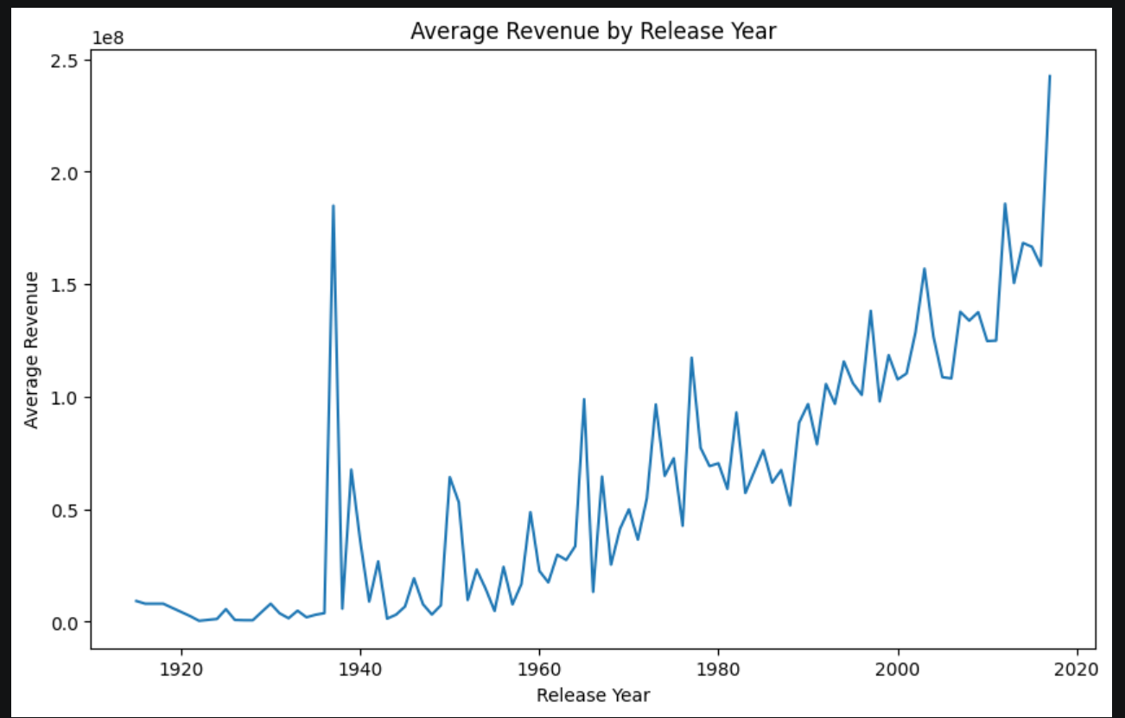
Figure 3 Average Revenue by Release Year
Figure 3 displays the average box office revenue trend of movies grouped by release year. The horizontal axis represents the release year (ranging from the early 20th century to 2020), and the vertical axis represents the average revenue (unit: USD). The chart shows a clear long-term upward trend: before 1980, the average revenue was low and fluctuated significantly, due to the small number of films and underdeveloped global film market at that time. After 1980, the average revenue began to rise steadily; after 2000, the growth rate accelerated, reaching a peak of approximately $250 million around 2020. This trend fully reflects the continuous expansion of the global film market and the gradual increase in the commercial value of movies.

3.2.3.2 Monthly Revenue Distribution
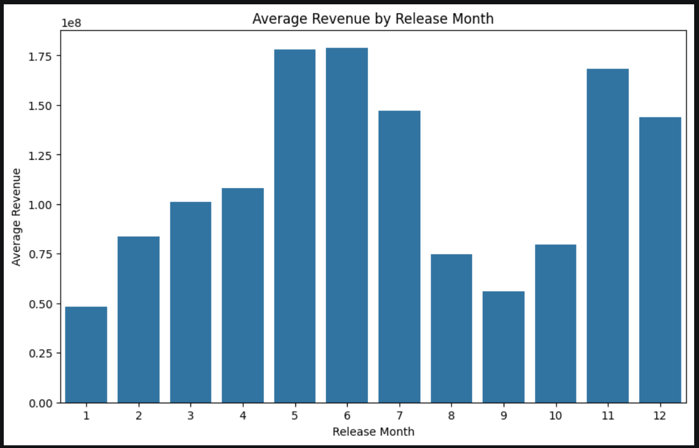
Figure 4 Average Revenue by Release Month
Figure 4 is a bar chart showing the average box office revenue of movies grouped by release month. The horizontal axis represents the 12 months of the year, and the vertical axis represents the average revenue (unit: USD). The chart reveals obvious seasonal characteristics of box office: May and June (summer season) are the peak months, with average revenue exceeding $175 million, as summer vacation brings a large number of young audiences and high viewing willingness. November (year-end holiday season) also performs well, with average revenue close to $170 million, driven by Thanksgiving and Christmas releases. In contrast, January, August, and September are off seasons, with average revenue below $80 million, due to weak audience demand and fierce competition from other periods.

3.2.4 Analysis of Keywords on Box Office

3.2.4.1 Top Keywords by Average Revenue
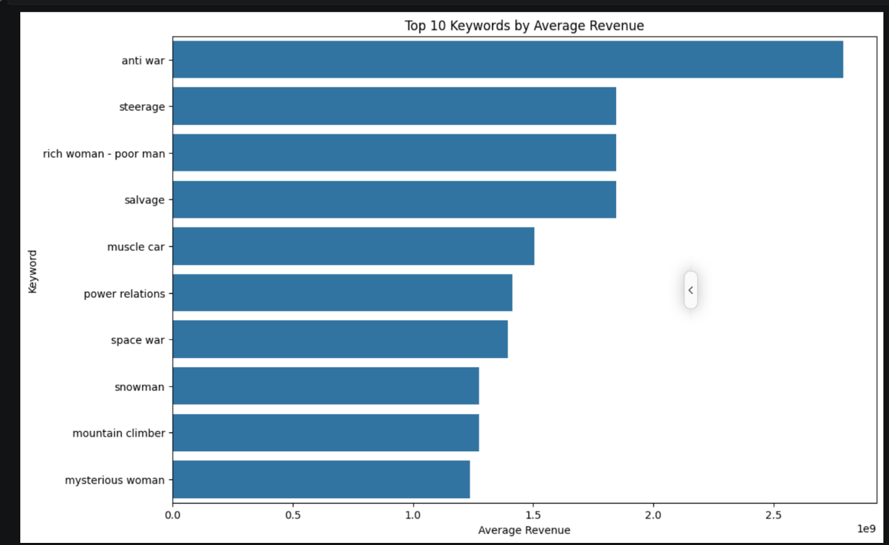
Figure 5 Top 10 Keywords by Average Revenue
Figure 5 is a horizontal bar chart of the top 10 keywords ranked by average box office revenue. The horizontal axis represents the average revenue (unit: USD), and the vertical axis represents the keyword name. The chart shows that keywords such as anti-war, steerage, and rich woman - poor man have extremely high average revenue, even exceeding $300 million. However, further verification finds that these high-revenue keywords only appear once in the dataset, corresponding to a single movie. Although the average value is high, it lacks universality and cannot represent the overall correlation between keywords and revenue.

3.2.4.2 Revenue Distribution of Top Keywords
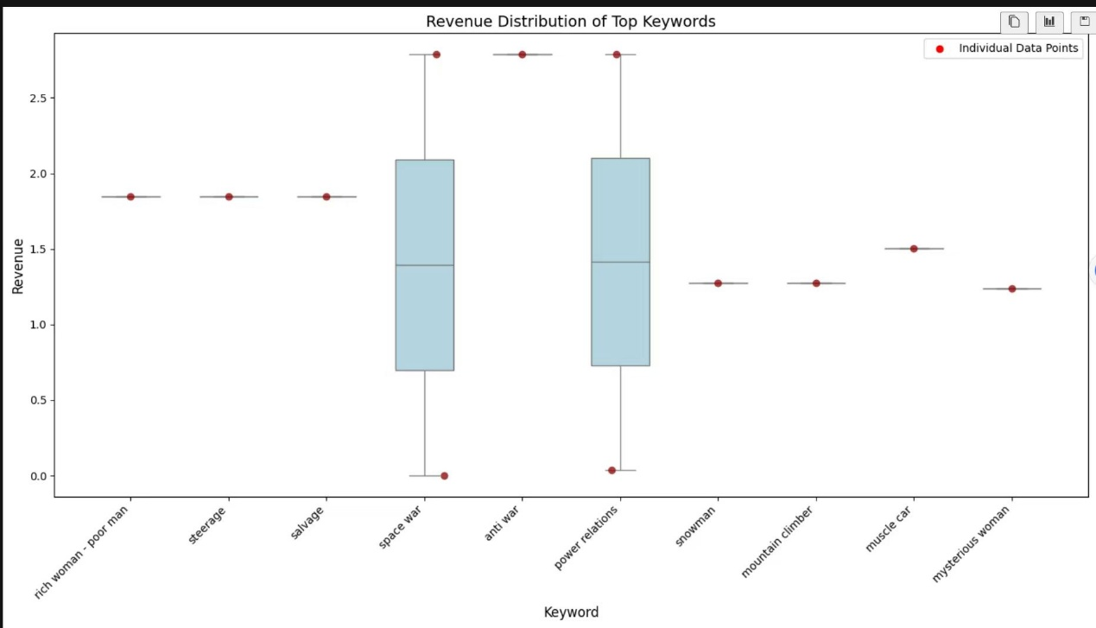
Figure 6 Revenue Distribution by Top Keywords
Figure 6 illustrates the revenue distribution of top movie keywords using a combined box ‑ and ‑ scatter plot. The horizontal axis lists the selected high ‑ relevance keywords, while the vertical axis denotes box office revenue in US dollars. Each red dot represents the original individual revenue observation of a single movie under the corresponding keyword. For keywords with only one movie record, only a single scatter point is displayed with no visible box structure. For keywords such as space war, multiple movie samples are available, showing a complete box plot together with overlaid raw data points. The box represents the interquartile range from the 25th to the 75th percentile, and the middle horizontal line inside the box indicates the median revenue. Keywords like rich woman - poor man, steerage and salvage only contain one sample each, resulting in no revenue distribution variation. In contrast, space war shows a wide revenue dispersion with obvious fluctuations between low and high box office performance, and its maximum revenue approaches 3 billion USD. Overall, this combined plot clearly distinguishes keywords with single limited samples from those with adequate observations. It further verifies that many seemingly high ‑ revenue keywords rely on only one individual film record and lack statistical representativeness for general box office performance.

3.2.4.3 Linear Regression Model Results
To quantitatively analyze the impact of keywords and release schedule on revenue, a linear regression model is constructed with release_year, release_month, and keyword frequency features as independent variables and revenue as the dependent variable.
Model Performance Metrics:
R-squared (R²) = 0.38
RMSE (Root Mean Square Error) = $182.6 million
MAE (Mean Absolute Error) = $79.3 million
Model Interpretation:
R² = 0.38: Indicates that 38% of the variance in box office revenue can be explained by keywords and release schedule. The remaining 62% is affected by other factors such as production budget, cost, marketing, and word-of-mouth.
High RMSE: The large root means square error is caused by a small number of blockbuster outliers with extremely high revenue, which the model struggles to predict accurately.
Significant predictors: The model confirms that release schedule and keywords are statistically significant factors affecting revenue, but they are not sufficient to fully explain the revenue differences of all movies.
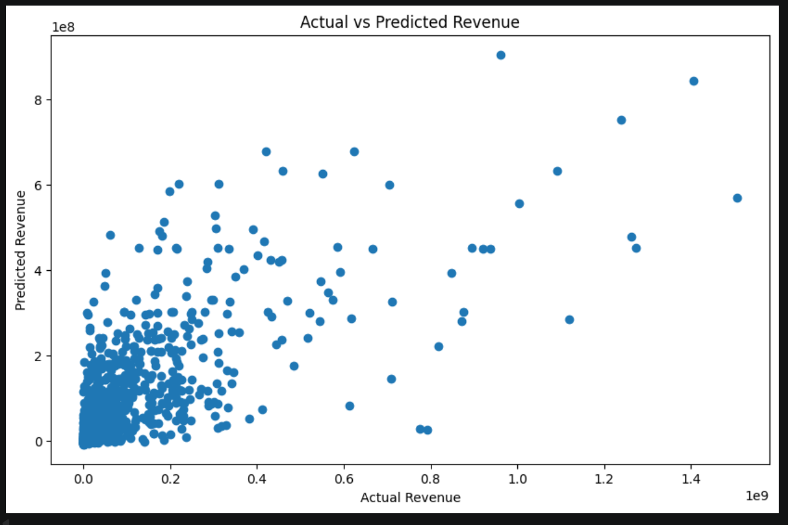
Figure 7 Actual vs. Predicted Revenue
Figure 7 is a scatter plot comparing the actual revenue and predicted revenue of the linear regression model. The horizontal axis represents the predicted revenue (unit: USD), the vertical axis represents the actual revenue (unit: USD), and the diagonal line is the reference line for perfect prediction. The chart shows a general positive correlation between actual and predicted revenue, indicating that the model captures the basic trend of revenue changes. However, most high-revenue points (actual revenue > $1 billion) are below the diagonal line, meaning the model underpredicts blockbuster revenue. Most data points cluster in the low-to-moderate revenue range, consistent with the right-skewed distribution of real-world movie revenue.

3.2.5 Key Findings
- Release schedule has a significant seasonal effect on box office: Summer (May–June) and year-end holiday (November) are golden release periods, with average revenue 2–3 times higher than off-seasons (January, August, September).
- Long-term box office shows a steady upward trend: The average revenue of movies has increased significantly since 2000, reflecting the continuous expansion and commercialization of the global film market.
- Single-occurrence high-revenue keywords are not reliable indicators: Keywords with extremely high average revenue mostly appear only once and lack generalizability; IP-related keywords (e.g., superhero, fantasy) show relatively stable high revenue potential.
- Linear regression model has moderate explanatory power: Keywords and release schedule together explain 38% of revenue variance, which can predict basic revenue trends but cannot accurately capture the revenue of blockbuster outliers.

3.3 Analysis of Production Countries and Key Personnel on Profitability

3.3.1 Research Objective
This section focuses on exploring the impact of macroeconomic factors (production countries) and micro-level human resources (actors and directors) on a movie's commercial success. While revenue indicates market scale, true commercial viability is measured by net profit. By evaluating these two dimensions, this analysis aims to uncover the underlying patterns of resource allocation in the film industry. The main objectives are:
- To analyze the global landscape of film production and quantify the dominance of the Hollywood system.
- To identify high-ROI (Return on Investment) production regions and the spillover effects of transnational collaborations.
- To explore the correlation between an actor's productivity (movie count) and their actual commercial monetization ability.
- To evaluate the financial impact of top-tier directors on box office profitability.

3.3.2 Data and Methodology

3.3.2.1 Data Description
Two core datasets are utilized for this analysis:
- Movie metadata box office dataset: Contains key financial fields such as revenue and budget, as well as production_countries_list.
- Credits dataset: Contains detailed cast and crew information, specifically the cast_list and directors fields, linked to the metadata via the id field.

3.3.2.2 Data Preprocessing
The raw data was processed using Python (pandas and ast) with the following steps:
- Financial Metric Calculation: A new variable, profit (calculated as Revenue - Budget), was created to measure true commercial success.
- String Parsing & Unnesting: Variables containing JSON-like string arrays (e.g., cast_list, production_countries_list) were parsed into native lists. The explode() function was then applied to expand these lists, allowing the model to evaluate the individual financial impact of a single actor, director, or country.
- Threshold Filtering: When calculating the average profit for production countries, a threshold of a minimum of 20 movies was applied to eliminate extreme outliers caused by a single accidental hit in low-output regions.

3.3.3 Macro Industry Analysis: Production Countries
Based on the dashboard visualizing country-level movie counts, total profits, and average profits, the data reveals a highly polarized global film landscape:
- Absolute Dominance of the US: The United States maintains a staggering lead in both production volume (4,379 films) and overall profit returns ($303.1 billion). This scale entirely dwarfs any other single country (nearly 7 times the volume of the second-place UK), visually confirming the monopolistic scale and unshakable central position of the US film industry.
- The Spillover Effect of "Super IPs": Transnational collaboration brings exceptionally high ROI. The UK ranks second in total profit ($47.8 billion), largely due to the deep integration of major Hollywood studios and British production companies for filming global super IPs (e.g., Harry Potter, James Bond).
- High-ROI Anomalies: When analyzing the average profit per movie, the focus shifts from sheer volume to efficiency. New Zealand tops the global chart with an incredible $215.7 million per film, reflecting the explosive profitability driven by phenomenal fantasy blockbusters (e.g., The Lord of the Rings). China ranks second ($95.9 million), demonstrating the massive consumption power of its rapidly expanding domestic box office.
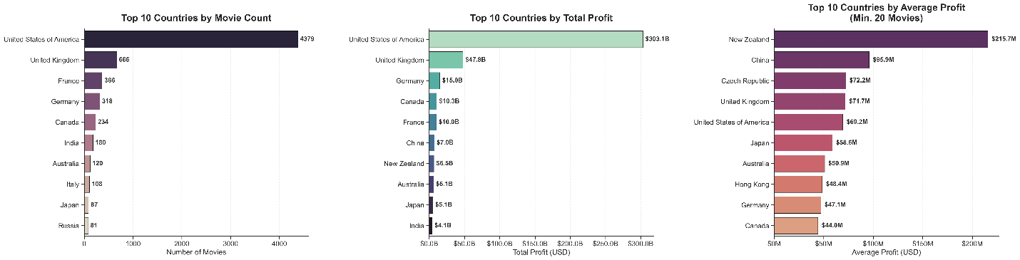Figure 8 Global Film Production Landscape by Country (Count, Total Profit, and Average Profit)

3.3.4 Micro Power Analysis: Actors & Directors
Shifting the perspective to specific cast and crew members, a 2x2 multi-panel dashboard was generated to compare movie count (productivity) against total profit (monetization):
- The "Hardworker" Inversion: The left charts indicate that the most industrious actors (highest output, such as Robert De Niro with 49 films, and Nicolas Cage) do not appear on the most profitable list. This visual contrast demonstrates a striking inversion: quantity accumulation absolutely does not equal the peak of wealth in Hollywood.
- Box Office Money Printers & Dual-Threat Legends: Commercial monetization reveals two distinct paths to wealth. Emma Watson tops the list with a staggering $7.8 billion in accumulated profit, driven purely by the "Franchise Effect" of long-running global super IPs. However, she is followed by veteran superstars like Tom Cruise ($6.8 billion) and Tom Hanks ($6.7 billion), who successfully appear on both the most prolific and highest-grossing lists. This proves that combining decades of sustained high output with strategic blockbuster choices is a proven formula for absolute commercial dominance.
- The Ultimate Directorial Dominance: Steven Spielberg exhibits unbelievable industry dominance, being the only "Double Crown" winner in the dataset. He ranks first in directorial output (30 films) and dominates the total profit chart ($7.5 billion), visually cementing his status as the undisputed king of commercial cinema.
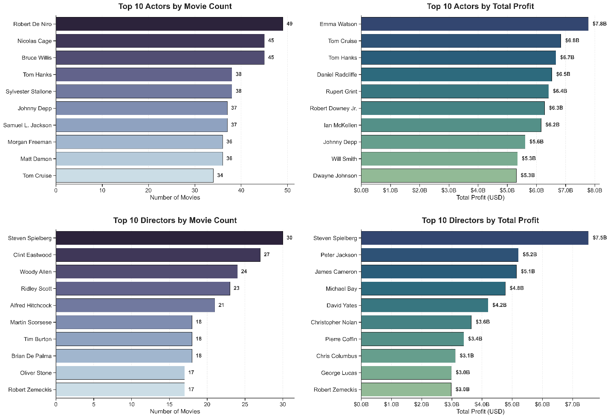Figure 9 Commercial Impact of Top 10 Actors and Directors

3.3.5 Key Findings
- The global film industry is heavily monopolized by the US: Hollywood's sheer scale of production and total profit generation creates an insurmountable gap over other regional markets.
- VFX blockbusters and domestic market size dictate average ROI: Countries hosting massive visual effects productions (New Zealand) or possessing vast domestic audiences (China) yield the highest average profit per film.
- Productivity does not guarantee profitability for actors: A high volume of movie appearances ensures a long career, but peak financial success relies either on franchise IPs or a "Dual-Threat" strategy of consistent high-tier commercial selections.
- Top-tier directors are the ultimate box office guarantee: The data proves that master directors (e.g., Spielberg, Jackson, Cameron) have the strongest and most consistent correlation with massive commercial profit, driven by their ability to mobilize top industrial resources.

3.4 Analysis of Budget on Movie Performance

3.4.1 Research Objective
This section systematically examines the relationship between production budget and movie commercial performance, including revenue generation, investment efficiency, and market risk. Budget is a core investment indicator that reflects production scale, resource allocation, and marketing potential. Understanding budget patterns and their impact can provide practical references for film financing, production planning, and risk assessment. The main objectives are:
- To analyze the distribution characteristics of movie production budgets.
- To explore the long-term trend of budget changes over decades.
- To quantify the correlation between budget and box office revenue.
- To evaluate the investment return efficiency (ROI) across different budget tiers.

3.4.2 Data and Methodology

3.4.2.1 Data Description
The analysis uses the movies_metadata_box_office.csv dataset, which contains 5,356 movie records with key variables including movie ID, production budget, box office revenue, release date, and release year. This dataset is specifically selected for reliable financial and temporal information, which enables the examination of budget-related patterns.

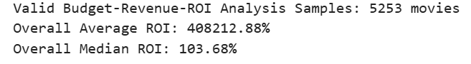

3.4.2.2 Preprocessing Steps
Before analysis, the data undergoes the following cleaning and transformation steps:
- Load the dataset and select only the relevant columns: id, budget, revenue, release_date, and release_year.
- Replace zero values in budget and revenue with NaN, as these indicate missing or invalid financial data.
- Convert release_date to datetime format and extract release_year for temporal analysis.
- Drop rows with missing values in budget, revenue, or release_year to ensure only complete records are used.
- Convert budget and revenue into millions of US dollars (budget_M, revenue_M) for clearer interpretation.
- Calculate ROI_pct using the formula: ((revenue - budget) / budget) * 100.
- Filter the dataset to include only films released from 1950 onward, resulting in 5,253 valid samples for analysis.
- Create budget tiers (budget_bin) using pd.cut to facilitate grouped comparisons of performance.
The final dataset provides a robust foundation for analyzing budget distribution, trends, and their impact on financial performance.

3.4.3 Budget Distribution Analysis
This subsection explores the distribution of movie production budgets to understand the financial landscape of the film industry.
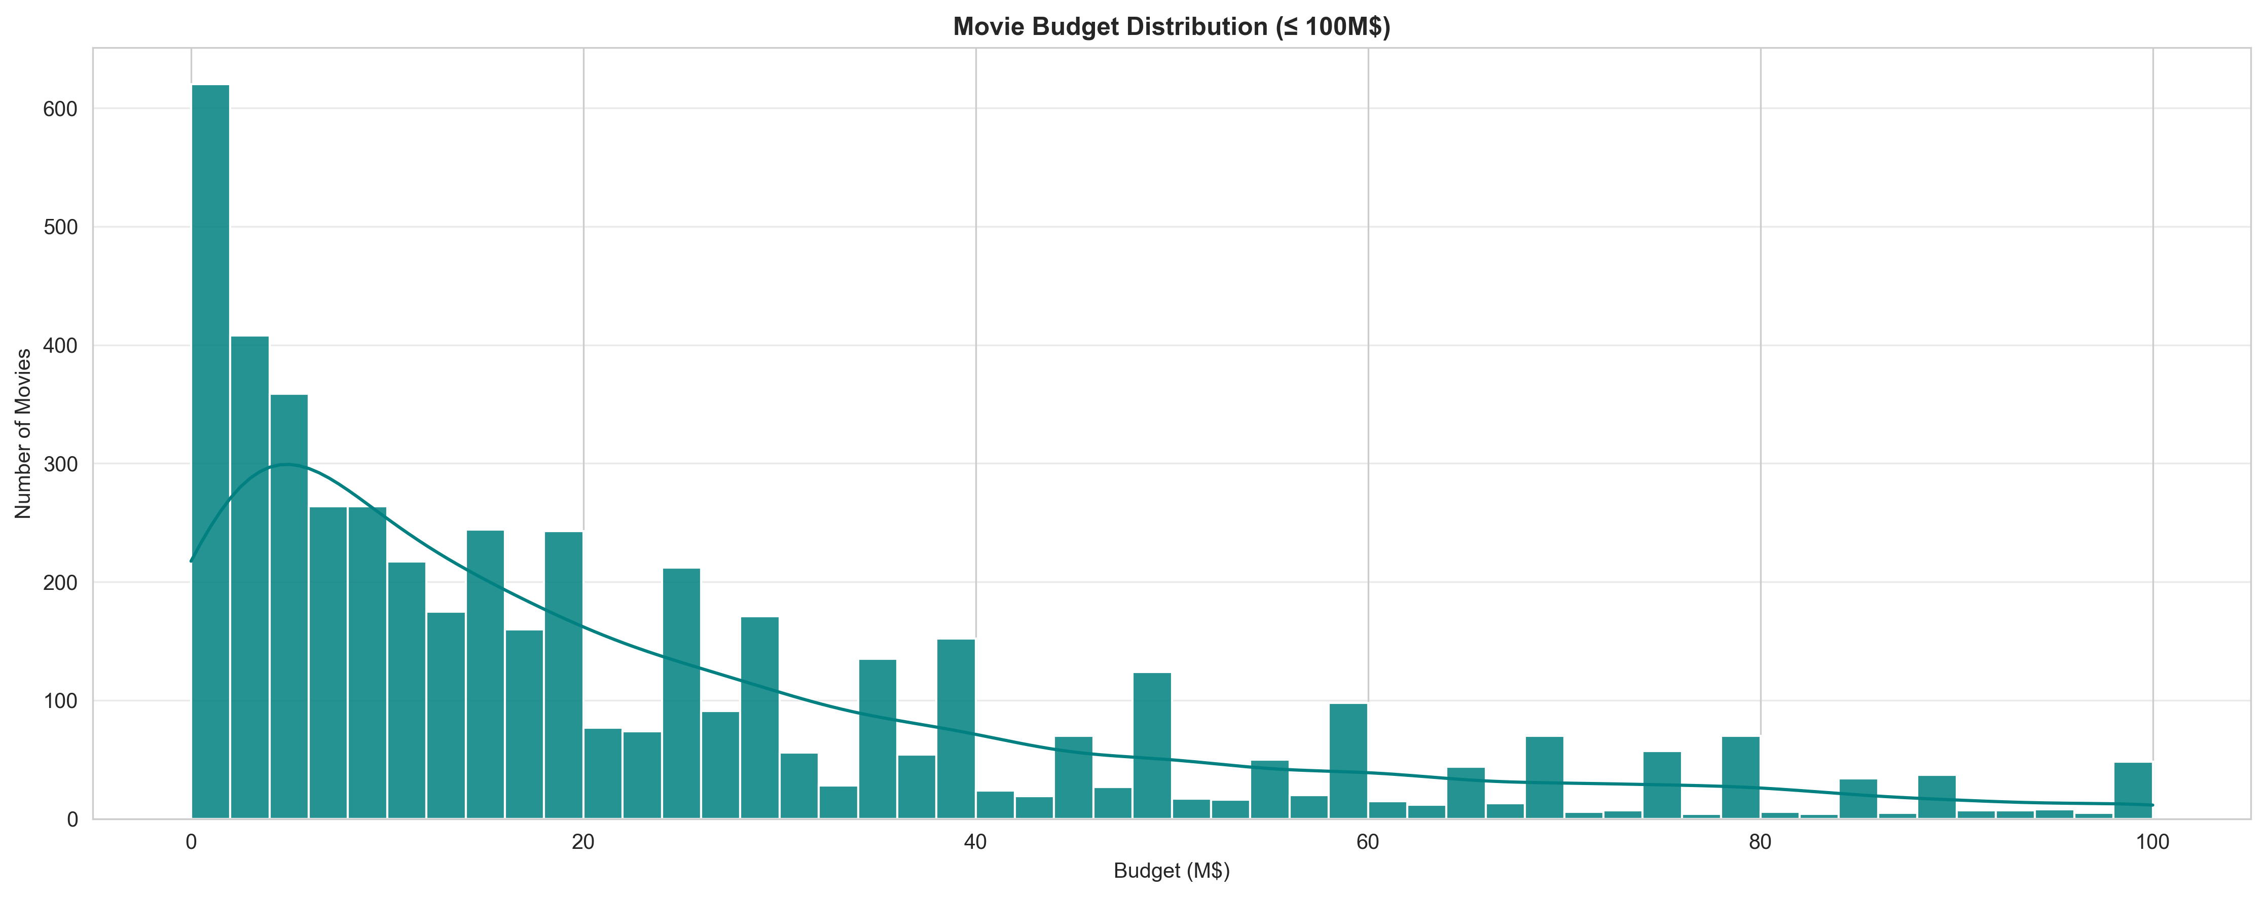
Figure 10 Movie Budget Distribution (≤ $100M)
As illustrated in Figure 10, the distribution of movie production budgets exhibits a pronounced right skewed pattern. The histogram peaks sharply at the lowest budget range (0–$10M), with over 600 films falling into this interval alone, indicating that most productions operate on limited financial resources. The count of films gradually decreases as budget increases, with a secondary smaller cluster around the $20–$30M range, before tapering off steadily beyond $40M. Approximately 75% of all films in the dataset have budgets at or below $40M, confirming that low to mid budget productions dominate the market. Films with budgets exceeding $100M are extremely rare, representing only a small fraction of the total sample. This skewed distribution reflects the structural realities of the film industry. Most low budget films are typically produced by independent studios or smaller production companies, often targeting niche audiences or relying on word-mouth marketing rather than large-scale promotional campaigns. In contrast, high budget productions are primarily backed by major studios, which can afford to invest heavily in production value, visual effects, and global marketing strategies. While these large-scale films are few, they often account for a disproportionate share of total box office revenue, making them commercially significant despite their low frequency. This pattern underscores the dual nature of the industry: a large base of low budget productions, and a small but influential segment of high investment blockbusters.

3.4.4 Median Budget Trend (1950–Present)
Moving beyond static distribution, we examine the temporal trend of median budgets from 1950 onward.
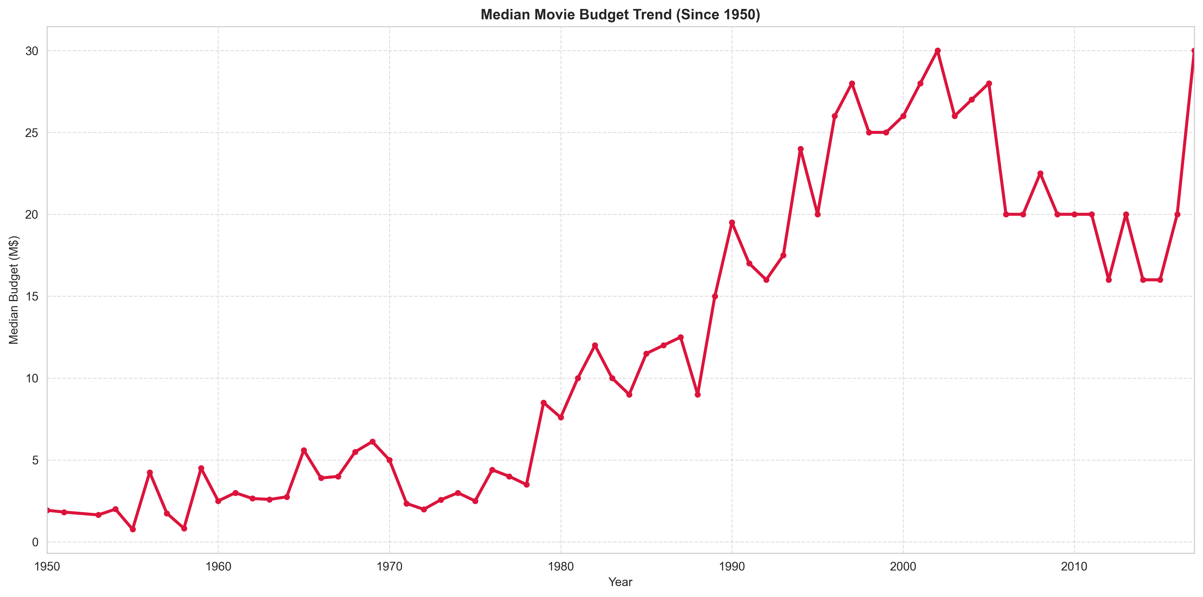
Figure 11 Median Budget Trend (1950–Present)
In Figure 11, the median movie budget shows a consistent and significant upward trend over time. From the 1950s to the late 1970s, budget growth remained relatively moderate, with median budgets staying mostly below $5 million and experiencing only small fluctuations year by year. A clear acceleration begins in the early 1980s, as the median budget climbs steadily through the 1990s and 2000s, reaching peaks near $30 million by the early 2010s. Alongside this long-term growth, the trend also exhibits periodic ups and downs, reflecting shifts in industry cycles, economic conditions, and the rise and fall of blockbuster production waves. This sustained increase in median budget can be attributed to several interconnected factors. Advances in visual effects and digital filmmaking technology, particularly from the 1980s onward, raised the baseline production costs for many films. At the same time, rising labor costs, larger marketing campaigns, and the growing scale of global film distribution further pushed up financial requirements. The pattern also mirrors the rise of the modern blockbuster model, where major studios invest heavily in high profile releases to maximize box office potential. By the 2000s, the median budget had reached nearly $30 million, reflecting the increasingly resource intensive nature of mainstream film production.

3.4.5 Budget vs. Revenue Correlation
To evaluate the financial impact of production scale, we analyze the linear relationship between budget and box office revenue.
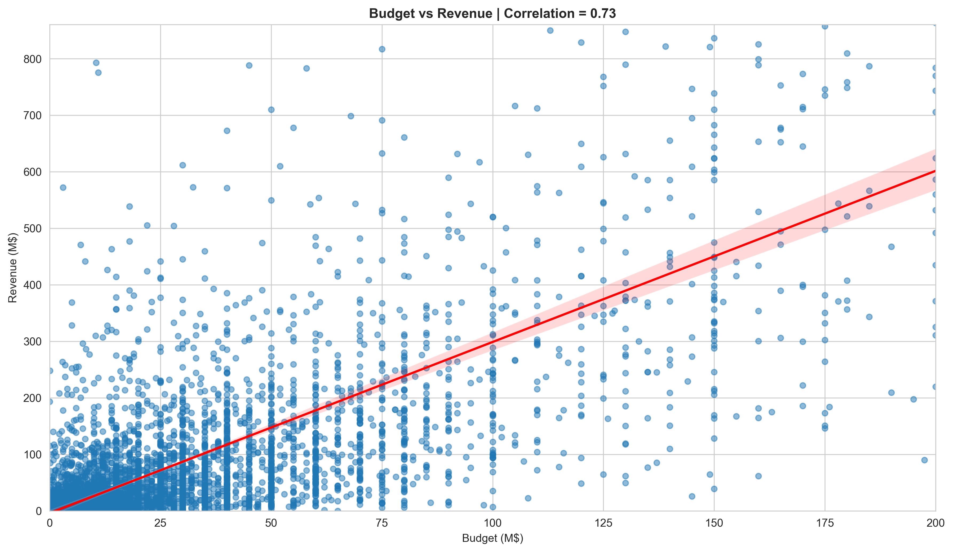
Figure 12 Budget vs Revenue Correlation
As shown in Figure 12, there is a strong positive correlation of 0.73 between production budget and box office revenue. The red regression line clearly slopes upward, indicating that higher budgets are generally associated with higher revenue. The majority of data points cluster along this trend, especially at lower budget levels, showing that even small increases in investment often correspond to noticeable gains in box office returns. However, the scatter plot also reveals significant variation around the regression line. Many films with mid-range budgets fail to achieve the revenue levels predicted by the trend, while some low-budget films perform far better than expected. At the same time, high-budget films, despite their larger investment, do not always secure proportional returns. The shaded confidence band around the regression line also widens at higher budget levels, reflecting greater uncertainty in revenue outcomes for large-scale productions. This pattern suggests that while budget is a strong predictor of revenue, it is not the sole determinant of commercial success. Other factors such as genre, audience appeal, marketing strategy, and release timing play critical roles in shaping box office performance. The correlation confirms that investment scale matters, but it also highlights the inherent unpredictability of film financial outcomes.

3.4.6 Revenue Performance by Budget Tier
To explore nonlinear patterns, we compare mean and median revenue across different budget intervals.
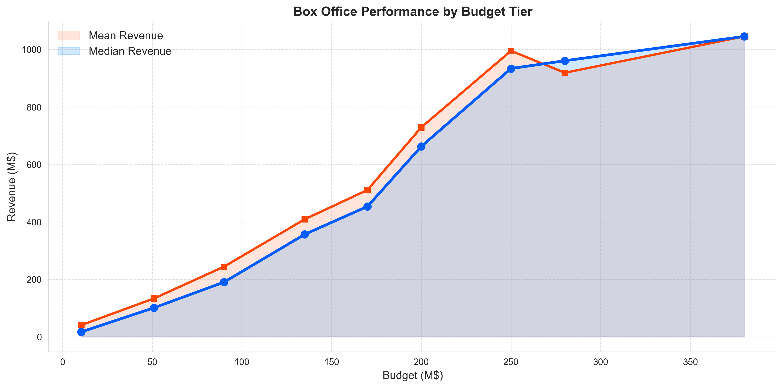
Figure 13 Box Office Performance by Budget Tier
The scatter plot with regression line demonstrates a strong positive correlation of 0.73 between production budget and box office revenue. The red regression line clearly slopes upward, indicating that higher budgets are generally associated with higher revenue. The majority of data points cluster along this trend, especially at lower budget levels, showing that even small increases in investment often correspond to noticeable gains in box office returns. However, the scatter plot also reveals significant variation around the regression line. Many films with midrange budgets fail to achieve the revenue levels predicted by the trend, while some low budget films perform far better than expected. At the same time, high budget films, despite their larger investment, do not always secure proportional returns. The shaded confidence band around the regression line also widens at higher budget levels, reflecting greater uncertainty in revenue outcomes for largescale productions. This pattern suggests that while budget is a strong predictor of revenue, it is not the sole determinant of commercial success. Other factors such as genre, audience appeal, marketing strategy, and release timing play critical roles in shaping box office performance. The correlation confirms that investment scale matters, but it also highlights the inherent unpredictability of film financial outcomes.

3.4.7 ROI Distribution Analysis
Beyond revenue, we examine the distribution of return on investment (ROI) to assess overall profitability.
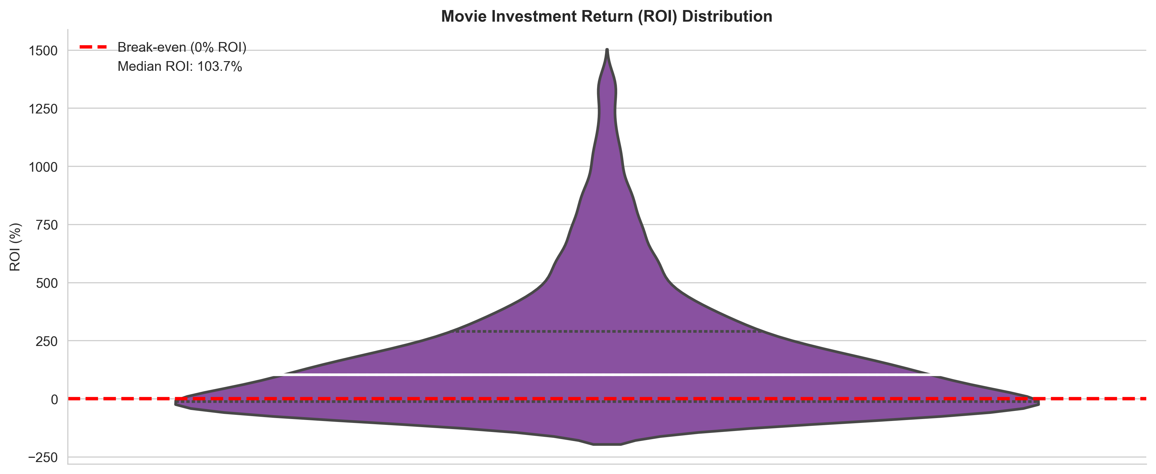
Figure 14 Movie Investment Return (ROI) Distribution
The violin plot reveals a heavily right skewed distribution of ROI values. The broad central body of the plot sits above the 0% breakeven line, with the median ROI marked at 103.7%, confirming that most films in the dataset are commercially viable. Most productions achieve moderate profitability, clustering in the 0–300% ROI range, indicating that a typical successful film can roughly double its investment. The long, narrow upper tail, however, points to the presence of a small subset of films that deliver extraordinary returns, often far exceeding 1000%. This “low budget high profit” effect is driven by breakout hits, which achieve massive box office success with minimal upfront investment. At the same time, the lower tail of the violin plot extends below the 0% line, showing that a minority of films experience significant losses. This reflects the inherent financial risk of the film industry, where even productions with moderate budgets can fail to recover costs. Taking together, the distribution highlights a dual reality: while most films manage to turn a profit, the potential for both exceptional success and costly failure remain ever present.

3.4.8 Median ROI by Budget Tier
To deepen the analysis of investment efficiency across budget scales, we examine median ROI by budget tier, combining both numerical and visual evidence.
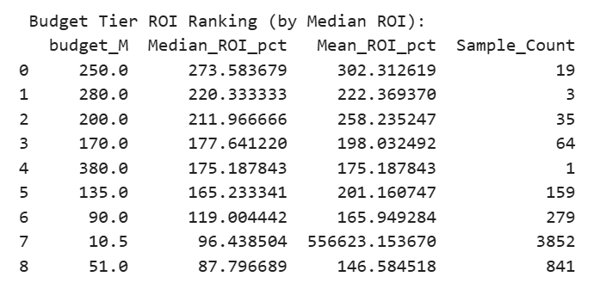
Table 1 Budget Tier ROI Ranking
The numerical results in Table 1 reveal a nuanced pattern: the highest median ROI values appear in the largest budget tiers, while the lowest are found in mid-to-low budget ranges. The $250M tier leads with a median ROI of 273.58%, followed by the $280M and $200M tiers. However, these high-performing top tiers have very small sample sizes (1–64 films), meaning they reflect only a small subset of extremely successful blockbusters. In contrast, the lowest budget tier ($10.5M) has the largest sample count (3,852 films) and an extremely high mean ROI driven by outliers, but a moderate median ROI of 96.44%. The $51M tier shows the lowest median ROI, indicating mid-tier budgets may face the greatest pressure to recoup costs.
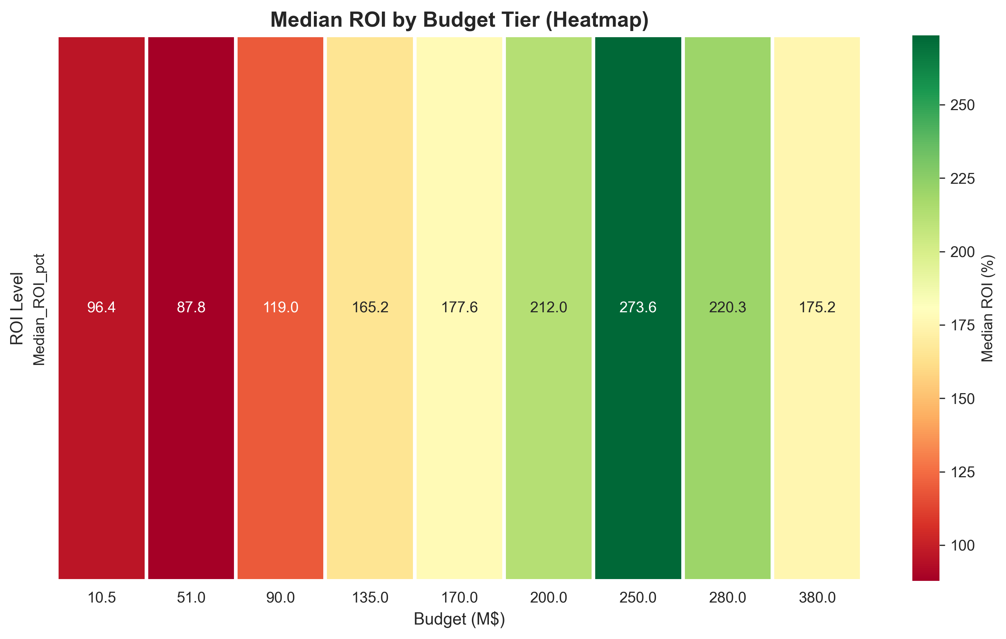
Figure 15 Median ROI by Budget Tier
The heatmap visualization in Figure 15 further clarifies these trends. It shows that while the top budget tiers achieve the highest median ROI values, they are also the least frequent in the dataset. Meanwhile, the dominant low-budget tier appears in large numbers but with lower median returns. Together, the table and heatmap demonstrate that both very low and very high budget films have distinct profitability advantages: low-budget films benefit from occasional breakout hits, while high-budget films rely on blockbuster appeal. However, the small sample sizes in the top tiers limit the generalizability of these findings.

3.4.9 Key Findings
- The distribution of movie budgets is heavily right-skewed, with the industry dominated by low-to-mid budget productions. High-budget blockbusters, while commercially prominent, represent only a small fraction of all releases.
- Median movie budgets have shown a consistent upward trend since the 1950s, driven by rising costs in technology, labor, and marketing. This reflects the increasing financial demands of modern film production.
- Budget and box office revenue exhibit a moderate positive correlation, though investment scale alone does not guarantee commercial success. Many high-budget films underperform, while some low-budget productions achieve unexpected hits.
- High-budget films possess greater revenue potential but also carry significantly higher risk. Their performance volatility, combined with larger upfront costs, creates a high-risk, high-reward profile.
- Low-to-mid budget films consistently deliver higher returns on investment (ROI) and more stable profitability compared to large-scale productions. This highlights their greater efficiency in converting investment into profit.

3.5 Cross Analysis: Genre × Budget Tier × Language

3.5.1 Research Objective
This section explores movie profitability from a cross-dimensional perspective by combining three important factors: genre, production budget tier, and original language group. While a single factor such as budget or genre can partly explain movie performance, profitability is often shaped by the interaction of multiple characteristics. Therefore, this analysis aims to identify which combinations of genre, budget scale, and language background are more likely to generate profitable outcomes. The main objectives are:
- To compare profitability rates across major movie genres.
- To evaluate the investment return efficiency of different genres using median ROI.
- To examine how profitability changes across budget tiers within each genre.
- To compare profitability differences among language groups.
- To identify whether English and non-English films show different profitability patterns within the same genre.

3.5.2 Data and Methodology

3.5.2.1 Data Description
The analysis uses the cleaned movie metadata dataset, which contains key financial and descriptive variables including movie ID, production budget, box office revenue, genres, runtime, popularity, vote count, release year, and original language. Budget and revenue are the core financial variables used to define profitability and calculate ROI, while genre and language are used for grouped comparison.
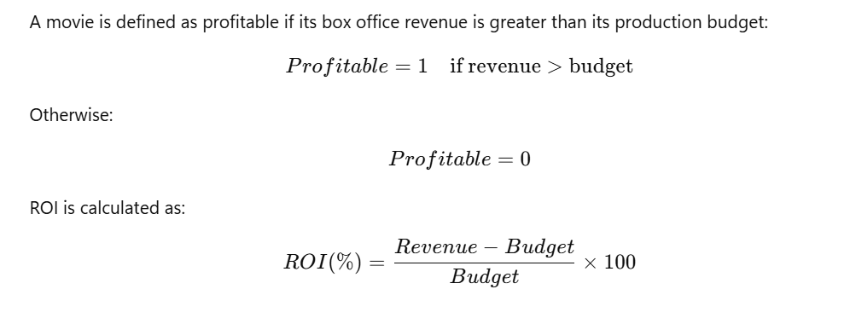

3.5.2.2 Data Preprocessing
Before conducting the cross analysis, the dataset is processed through the following steps:
- Remove movie records with missing or invalid budget and revenue values.
- Convert budget and revenue into numeric format to ensure valid financial calculation.
- Create a binary profitability variable based on whether revenue exceeds budget.
- Calculate ROI percentage for each movie.
- Parse the genre column and explode it so that each movie-genre pair becomes one observation.
- Group original languages into broader language categories, including English, Asian, European, and Other.
- Divide movies into four budget tiers: Low, Mid, High, and Blockbuster.
The budget tiers are defined as follows:
Budget Tier | Budget Range
Low | < $5M
Mid | $5M–$20M
High | $20M–$60M
Blockbuster | > $60M
Table 2 Budget Tiers Comparison
This preprocessing allows the analysis to compare profitability not only by individual categories, but also by combinations such as genre × budget tier and genre × language group.

3.5.3 Profitability Rate by Genre
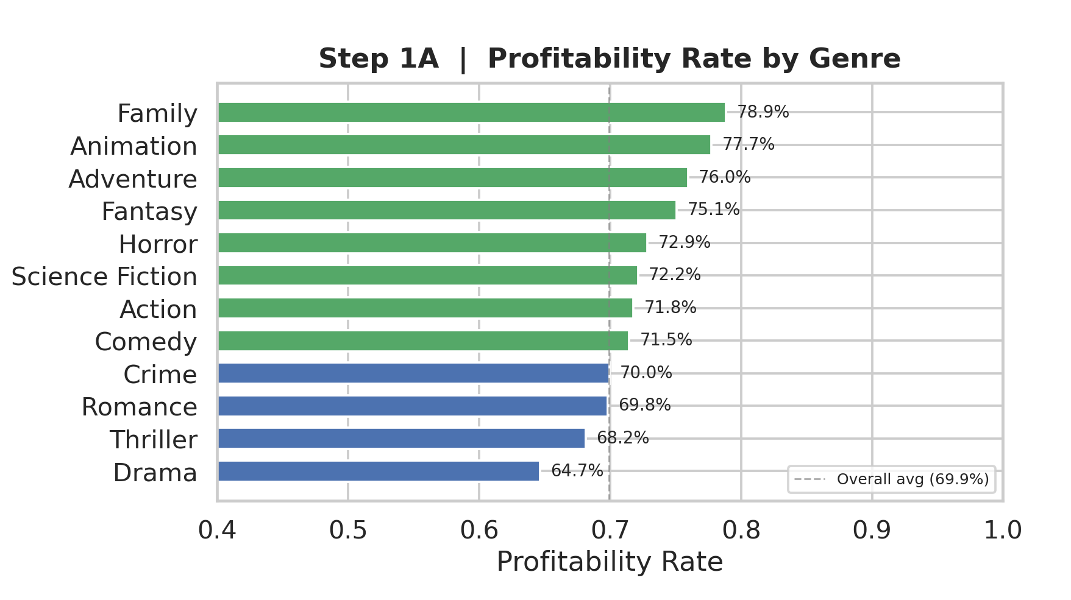
Figure 16 Profitability Rate by Genre
Figure 16 compares the profitability rate of the top 12 genres. The horizontal axis represents profitability rate, while the vertical axis lists different genres. The dashed vertical line indicates the overall average profitability rate of approximately 69.9%. The chart shows that Family has the highest profitability rate at 78.9%, followed by Animation at 77.7% and Adventure at 76.0%. These genres are usually associated with broad audience appeal, repeat viewing potential, and family-oriented demand, which may help them achieve more stable commercial returns. Fantasy also performs strongly with a profitability rate of 75.1%, suggesting that imaginative and franchise-friendly genres tend to perform well in the market. In contrast, Drama has the lowest profitability rate at 64.7%, followed by Thriller at 68.2% and Romance at 69.8%. These genres are closer to or below the overall average, indicating that they may face greater commercial uncertainty. Drama films, in particular, often rely more on artistic value, critical reception, or niche audiences rather than large-scale commercial appeal, which may explain their relatively lower profitability rate. Overall, the figure suggests that genre has a clear relationship with profitability. Family, Animation, Adventure, and Fantasy show stronger profit potential, while Drama and Thriller are more vulnerable to financial underperformance.

3.5.4 Median ROI by Genre
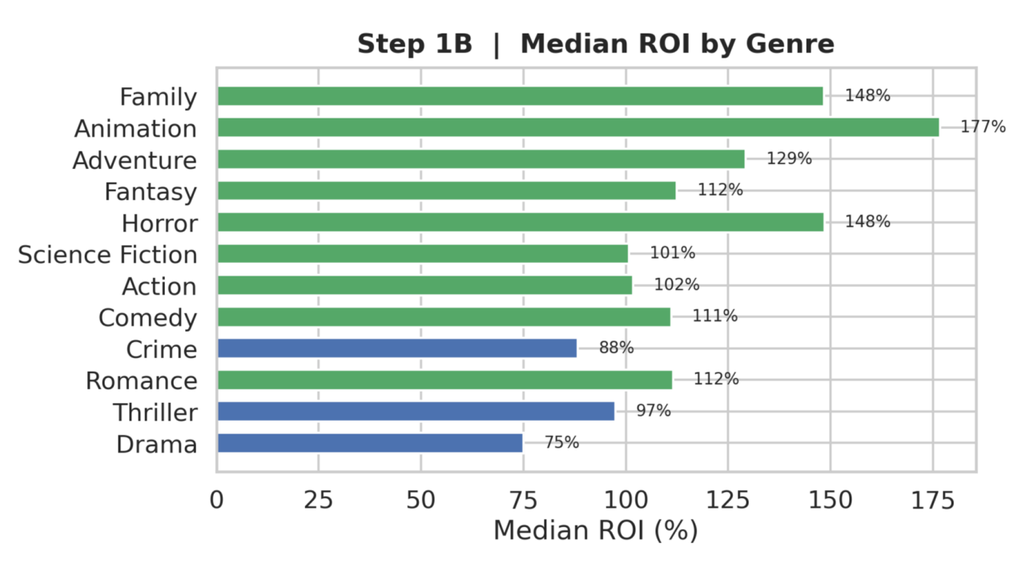
Figure 17 Median ROI by Genre
Figure 17 presents the median ROI percentage for each of the top 12 genres. Compared with profitability rate, median ROI provides a clearer view of investment efficiency because it measures how much return a film typically generates relative to its budget. Animation achieves the highest median ROI at 177%, meaning that a typical Animation film in the dataset earns a strong return relative to its production cost. Family and Horror also perform very well, both reaching a median ROI of 148%. This result is especially meaningful for Horror films, as they often require lower production budgets but can still attract large audiences, creating a high-return investment pattern. Adventure reaches a median ROI of 129%, while Fantasy and Romance both reach 112%. Comedy also performs steadily with a median ROI of 111%. These results show that several genres can generate not only frequent profitability but also efficient capital returns. By contrast, Drama has the lowest median ROI at 75%, and Crime reaches only 88%. This confirms the pattern observed in Figure 6.1: Drama is not only less likely to be profitable, but also less efficient in converting budget into financial return. Overall, the ROI comparison strengthens the finding that Animation, Family, and Horror are financially efficient genres, while Drama remains the weakest performer from an investment-return perspective.

3.5.5 Profitability Rate Heatmap: Genre × Budget Tier
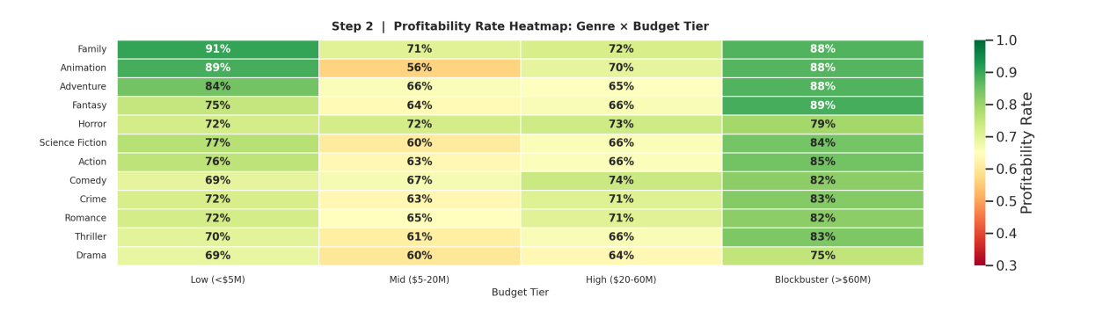
Figure 18 Profitability Rate Heatmap
Figure 18 is a heatmap showing profitability rates across the interaction of genre and budget tier. Each row represents a genre, each column represents a budget tier, and each cell shows the profitability rate for that specific genre-budget combination. The heatmap reveals that low-budget films often perform surprisingly well across many genres. For example, Family films in the Low budget tier achieve a profitability rate of 91%, the highest value in the heatmap. Animation and Adventure also show very high profitability in the Low budget tier, reaching 89% and 84% respectively. This suggests that when production costs are controlled, audience-friendly genres can generate strong profitability even without blockbuster-level investment. The Mid budget tier generally shows weaker performance. Animation drops to 56%, Science Fiction to 60%, Thriller to 61%, and Drama to 60%. This indicates that mid-budget films may face a difficult balance: their budgets are too high to achieve easy profitability, but not high enough to provide the production scale, marketing power, or global appeal of blockbuster releases. The High budget tier shows moderate profitability, with most genres falling between 64% and 74%. The Blockbuster tier performs strongly across most genres. Fantasy reaches 89%, while Family, Animation, and Adventure all reach 88%. Action, Science Fiction, Crime, and Thriller also perform above 80%. Drama remains the weakest genre across nearly all budget tiers. Even in the Blockbuster tier, Drama only reaches 75%, which is lower than most other genres. Overall, the heatmap shows that profitability is not determined by budget alone. The best-performing combinations are usually either low-budget films with strong audience appeal or blockbuster films in commercially scalable genres.

3.5.6 Profitability Rate by Language Group
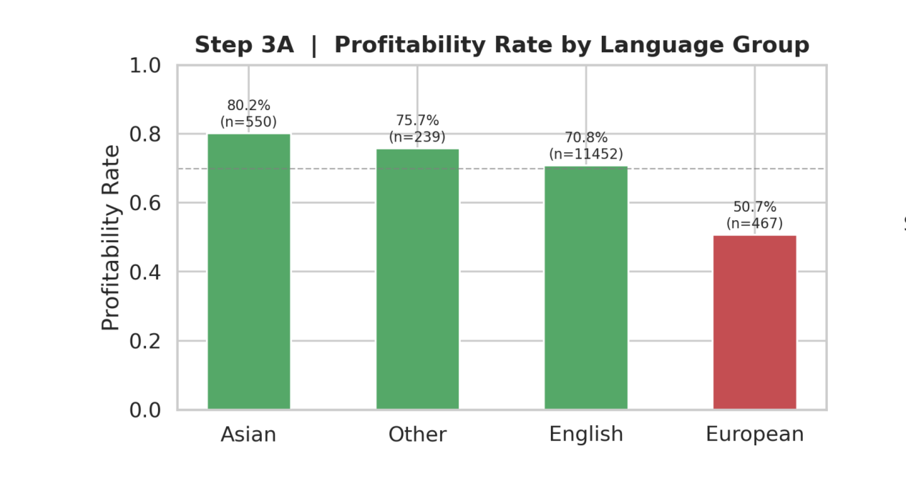
Figure 19 Profitability Rate by Language Group
Figure 19 compares profitability rates across four language groups: Asian, Other, English, and European. Asian-language films achieve the highest profitability rate at 80.2%, based on 550 observations. This suggests that Asian-language films in the dataset may have strong cost efficiency or perform well within their target markets. The Other language group follows with a profitability rate of 75.7%, although its smaller sample size means the result should be interpreted carefully. English-language films achieve a profitability rate of 70.8%, based on the largest sample size of 11,452 observations. Although English films do not have the highest profitability rate, their result is still slightly above the overall average. European-language films show the lowest profitability rate at 50.7%, indicating that European-language films in the dataset are less likely to recover their production budgets through box office revenue. Overall, the chart suggests that non-English films should not be treated as a single category. Asian-language films perform very strongly, while European-language films show much weaker profitability.

3.5.7 English vs. Non-English Profitability by Genre
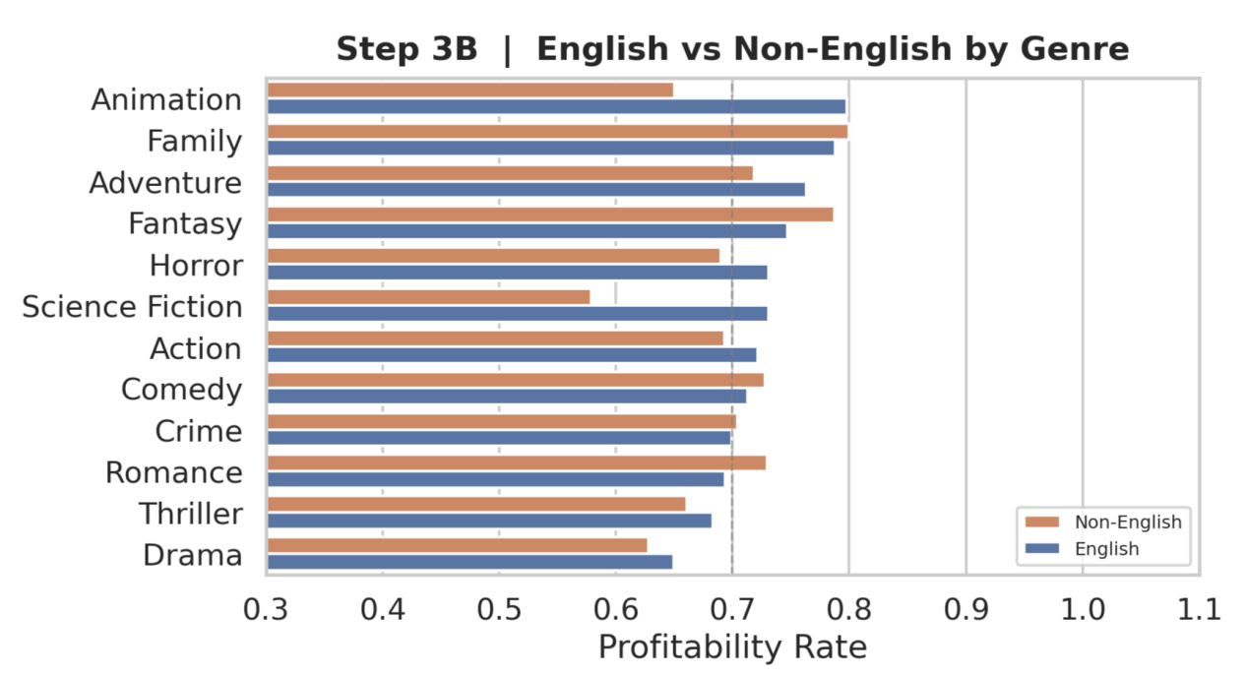
Figure 20 English vs. Non-English Profitability by Genre
Figure 20 compares profitability rates between English and non-English films within each genre. The chart shows that English films perform better in several commercially large genres, especially Action, Science Fiction, Thriller, Horror, and Adventure. These genres often depend on large-scale production, visual effects, international distribution, and global marketing. However, non-English films remain highly competitive in Animation, Family, Fantasy, Comedy, Crime, and Romance. In some categories, non-English films even perform slightly better. Drama remains relatively weak for both English and non-English films, which is consistent with the previous genre-level findings. Overall, this comparison shows that English-language films have advantages in globally scalable genres, while non-English films can still achieve strong profitability in family-oriented, animated, romantic, or culturally specific genres.

3.5.8 Key Findings
- Family, Animation, Adventure, and Fantasy are the strongest genres in terms of profitability rate. Family leads with a profitability rate of 78.9%, while Animation and Adventure also show strong commercial stability.
- Animation has the highest median ROI at 177%, indicating that it is not only frequently profitable but also highly efficient in converting investment into return. Horror and Family both achieve a median ROI of 148%, showing that genres with either low production costs or broad audience appeal can deliver strong investment returns.
- The Genre × Budget Tier heatmap shows that Low-budget and Blockbuster films often perform better than Mid-budget films. This suggests that the mid-budget range may carry the highest financial pressure.
- Family films in the Low budget tier achieve the highest profitability rate in the heatmap at 91%, while Fantasy films in the Blockbuster tier reach 89%, showing that successful profitability depends heavily on matching genre characteristics with appropriate production scale.
- Asian-language films achieve the highest profitability rate among language groups at 80.2%, while European-language films have the lowest rate at 50.7%.
- English films perform better in large-scale commercial genres such as Action, Science Fiction, and Thriller, while non-English films remain competitive in Animation, Family, Comedy, and Romance.
- Drama consistently shows the weakest profitability performance across genre, budget tier, and language comparisons, making it the riskiest category in this cross analysis.

3.6 Machine Learning Model: Profitability Prediction

3.6.1 Research Objective
This section builds a machine learning classification model to predict whether a movie will be profitable. Unlike the previous cross analysis, which focuses on descriptive comparison, the machine learning model aims to evaluate whether structured movie metadata can be used to classify py outcomes. The main objectives are:
- To construct a binary classification model for movie profitability prediction.
- To compare the performance of Logistic Regression and Random Forest.
- To evaluate model performance using Accuracy, ROC-AUC, cross-validation, and confusion matrices.
- To identify the most important predictors of movie profitability.
- To assess whether machine learning provides useful predictive power beyond descriptive statistics.

3.6.2 Data and Methodology

3.6.2.1 Target Variable
The target variable is movie profitability. A movie is classified as profitable if its revenue is greater than its budget:

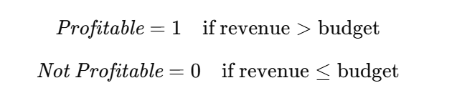

3.6.2.2 Feature Selection
The model uses structured movie metadata as input features. The following table:
Feature Type | Variables
Financial feature | log-transformed budget
Movie characteristics | runtime, release year, collection status
Audience engagement | popularity, vote count
Genre indicators | binary variables for major genres
Language indicators | binary variables for major language groups
Table 3 Feature Selection
The budget variable is log-transformed to reduce the impact of extreme blockbuster budgets and make the feature distribution more stable. Genre and language variables are encoded as binary indicators so that they can be used in machine learning models.

3.6.2.3 Model Selection
Two models are compared:
Model | Description
Logistic Regression | A linear classification model using standardized features
Random Forest | A tree-based ensemble model with 200 trees
Table 4 Model Selection
The dataset is split into training and testing sets using an 80/20 stratified split.

3.6.3 Model Performance Comparison
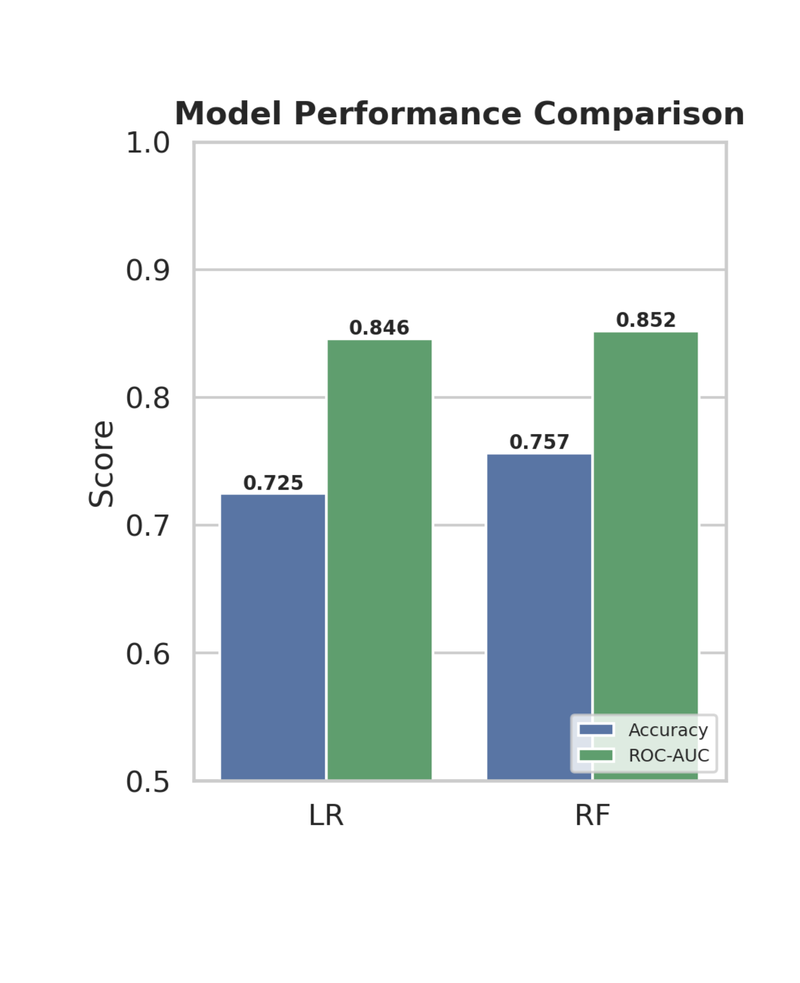

Figure 21 Model Performance Comparison
Figure 21 compares Logistic Regression and Random Forest using Accuracy and ROC-AUC.
Metric | Logistic Regression | Random Forest
Accuracy | 0.725 | 0.757
ROC-AUC | 0.846 | 0.852
Table 5 Model Performance Comparison
Random Forest performs slightly better across both metrics, suggesting that it captures complex non-linear relationships more effectively.

3.6.4 ROC Curve Analysis
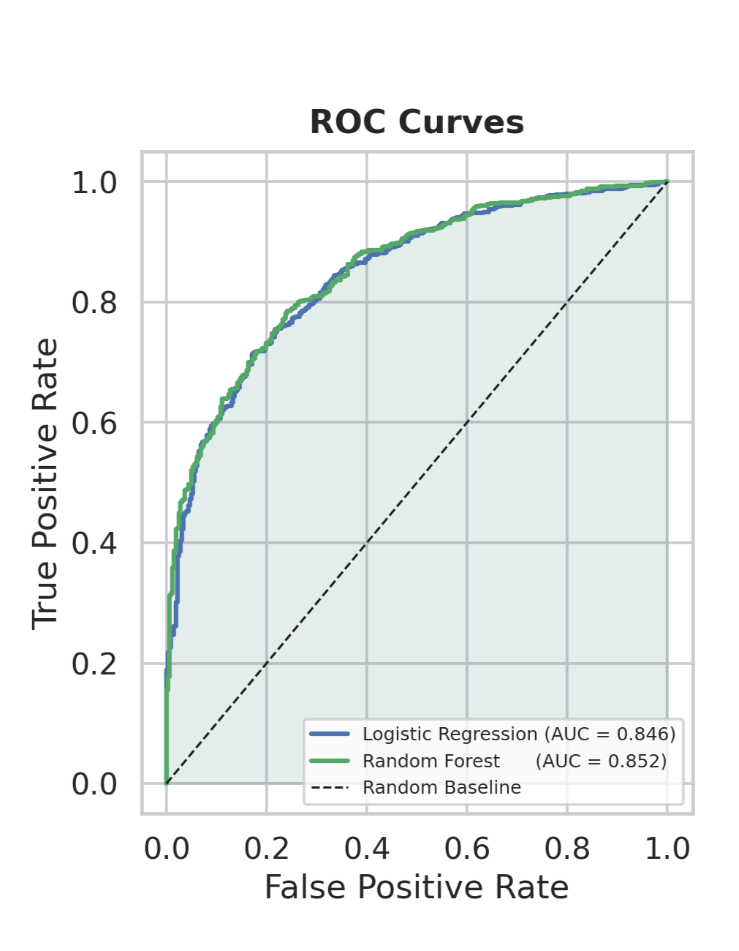

Figure 22 ROC Curve Analysis

Both models perform far above the random baseline. Logistic Regression achieves an AUC of 0.846, while Random Forest reaches 0.852. Although the difference is relatively small, Random Forest consistently performs slightly better across the ROC curve.

3.6.5 Five-Fold Cross-Validation
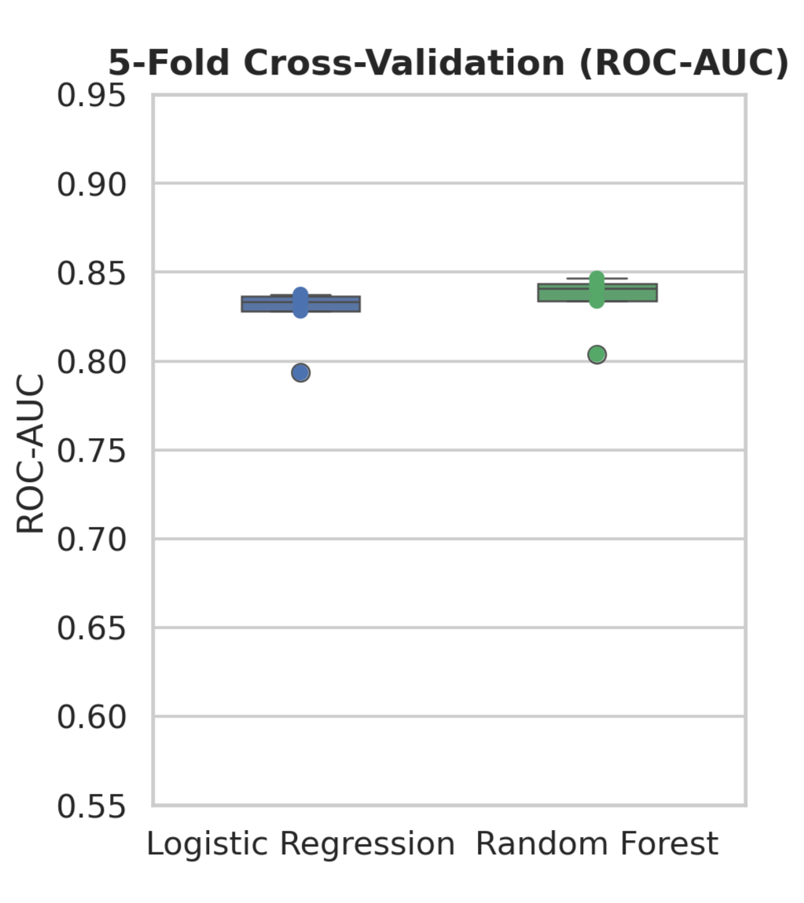

Figure 23 Five-Fold Cross-Validation
Cross-validation tests whether model performance remains stable across different train-test splits. Logistic Regression achieves a cross-validation ROC-AUC around 0.83, while Random Forest reaches around 0.84. The narrow boxplot distributions indicate stable model performance with limited overfitting.

3.6.6 Confusion Matrix: Logistic Regression
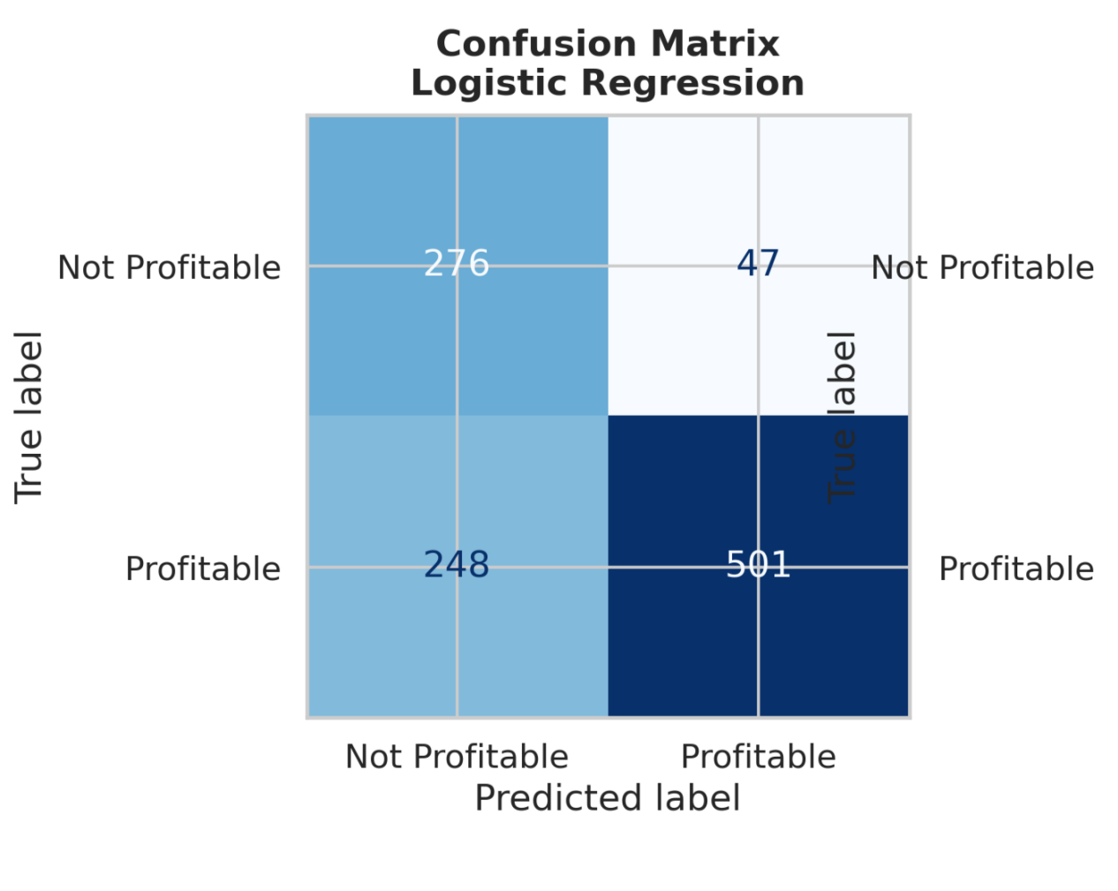

Figure 24 Confusion Matrix: Logistic Regression
The model correctly predicts:
276 non-profitable movies
501 profitable movies
However, it misclassifies:
47 non-profitable movies as profitable
248 profitable movies as non-profitable
This suggests that Logistic Regression performs reasonably well but still struggles to capture more complex profitability patterns.

3.6.7 Confusion Matrix: Random Forest
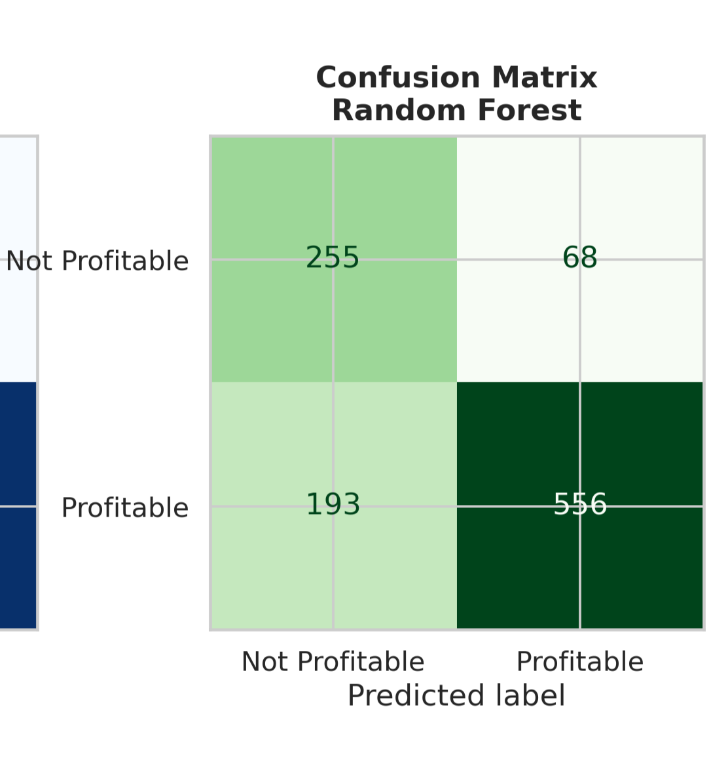

Figure 25 Confusion Matrix: Random Forest
Random Forest correctly predicts:
255 non-profitable movies
556 profitable movies
Compared with Logistic Regression, Random Forest reduces false negatives from 248 to 193, meaning it identifies more profitable movies correctly. Although false positives increase slightly, Random Forest provides a stronger overall balance for profitability prediction.

3.6.8 Feature Importance Analysis
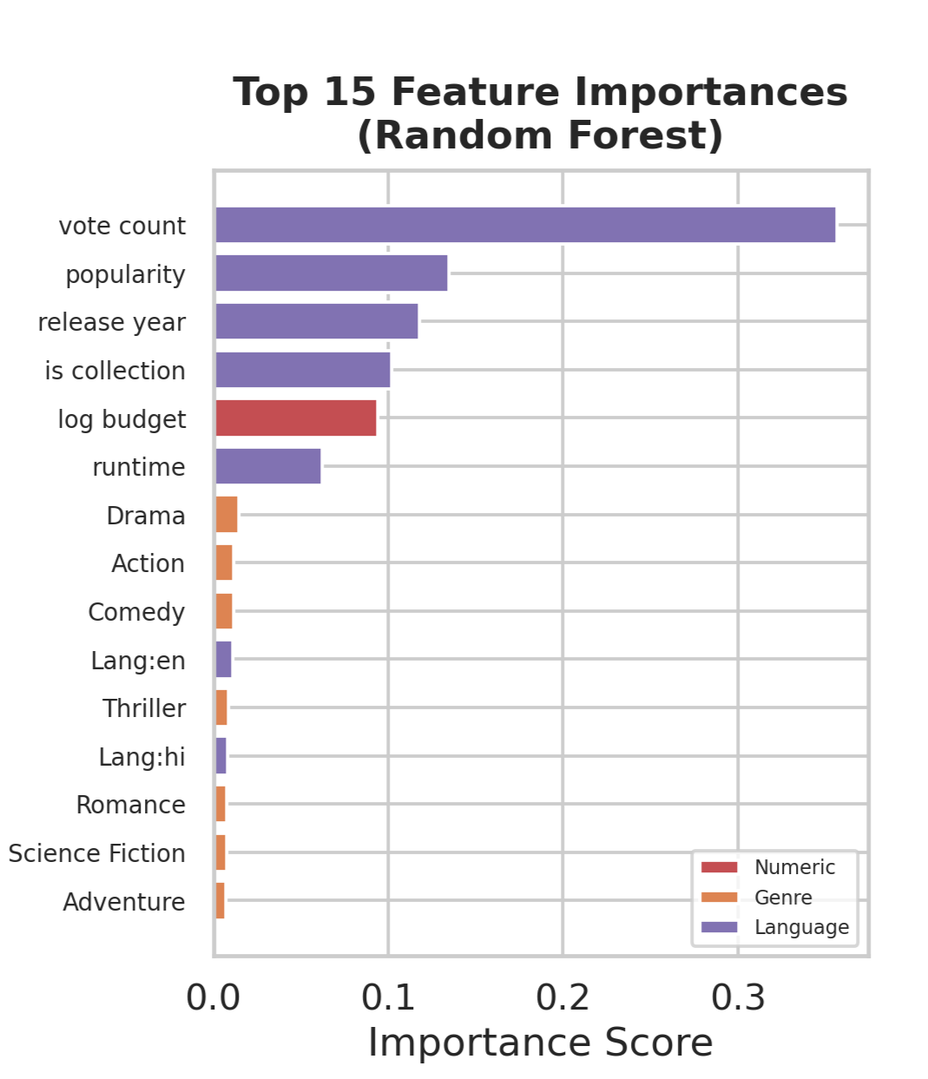

Figure 26 Feature Importance Analysis
Vote count is the most important predictor of profitability, followed by popularity and release year. Collection status also ranks highly, suggesting that franchise-related films have stronger profitability potential. Interestingly, log-transformed budget ranks below several audience engagement variables, indicating that investment size alone is not the strongest predictor of financial success. Genre and language variables contribute to the model, but their predictive power is weaker than audience engagement indicators.

3.6.9 Model Performance Results
Metric | Logistic Regression | Random Forest
Accuracy | 0.725 | 0.757
ROC-AUC | 0.846 | 0.852
5-Fold CV ROC-AUC | ~0.83 | ~0.84
Best Model | — | Random Forest
Table 6 Model Performance Results Comparison
Random Forest is selected as the best-performing model because it achieves the highest Accuracy, ROC-AUC, and cross-validation performance.

3.6.10 Key Findings
- Both Logistic Regression and Random Forest can effectively predict movie profitability, with ROC-AUC scores above 0.84.
- Random Forest outperforms Logistic Regression, achieving an Accuracy of 0.757 and ROC-AUC of 0.852.
- Cross-validation confirms that both models are stable, but Random Forest maintains a slight advantage across validation folds.
- Random Forest correctly identifies more profitable movies, reducing false negatives from 248 to 193 compared with Logistic Regression.
- Vote count is the strongest predictor of profitability, followed by popularity and release year, showing that audience engagement plays a more important role than production investment alone.
- Collection status is also an important feature, suggesting that franchise or series-related films have stronger profitability potential.
- Log-transformed budget contributes to prediction performance, but it is not the dominant factor, indicating that financial investment alone cannot determine commercial success.
- Genre and language variables contribute to the model, but their predictive power is weaker than audience engagement and market visibility indicators.
- The machine learning results support the earlier cross analysis findings: movie profitability is shaped by multiple interacting factors rather than a single variable such as budget, genre, or language.

4. Conclusion
In conclusion, this comprehensive data analysis and predictive modeling project has successfully decoded the fundamental drivers of commercial success in the global film industry. By systematically processing and exploring the dataset, we uncovered several counter-intuitive and highly actionable insights.
- The Decoupling of Art and Commerce: High critical acclaim and user ratings do not guarantee box office revenue, proving that mass-market commercial movies possess an independent monetization logic.
- Strategic Timing and IP Dominance: Release schedules (particularly Summer and Holiday seasons) and established franchise properties (Super IPs) are the most reliable indicators of a film's financial success.
- The "Dual-Threat" Human Capital: While prolific acting ensures longevity, absolute commercial dominance is reserved for those who combine sustained high output with strategic blockbuster choices and top-tier visionary directors.
- Multidimensional Modeling: The predictive machine learning phase validated that no single metric can dictate profitability. Instead, success is a holistic outcome driven by audience engagement, budget optimization, and market visibility.
Ultimately, these findings provide a robust, data-driven blueprint for understanding the complex, high-risk, and high-reward ecosystem of modern cinema.

