Observables are interesting to deal with asynchronous code

●true

○false

Observables have to be used in some specific situations only

○ true

● false

There are some similarities between promises and observables

●true

○false

An observable can be seen as a stream of events which provide values

● true

○ false

An operator can be applied to an observable stream to create a new observable stream

● true

○ false

It’s impossible to chain operators on observables

○ true

● false

To get values from a stream, I need to browse the stream with an index (as with arrays)

○ true

● false

Subscribe to a stream allows to be notified when a value is sent

● true

○ false

Hot observables are observables which have a high probability to produce an error

○ true

● false

Some observables produce their data only when they have at less one subscriber

● true

○ false

A standard observable can both observe an other observable and be observed

○ true

● false

The following operation

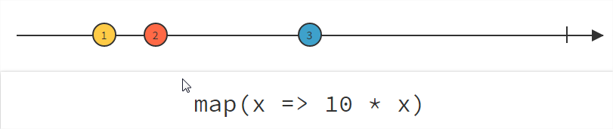

produces the following map:

{

1: 10,

2: 20,

3: 30

}

○ true

● false

From the following observable stream:

( 2 – 3 – 4 ),

Can produce this one?

( 1– 2 – 3 – 4 )

● yes

○ no