**London Housing Project Findings: Martin Wipf**

**House prices within all Boroughs of London have increased significantly from 1995-2020**

* 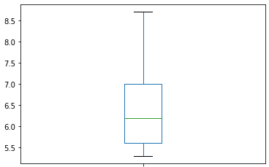Highest increase occurred in Hackney where prices increased by a factor of 8.7.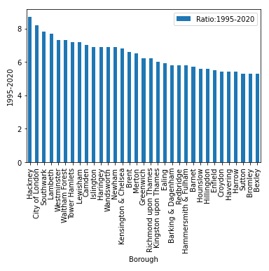
* Lowest increase occurred in Bexley where prices increased by a factor of 5.3

.

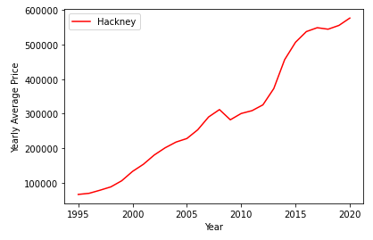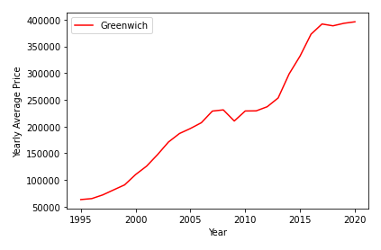Almost all boroughs show a minor drop 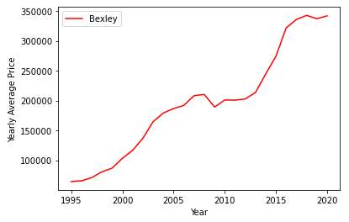in prices around in 2009 followed by almost flat prices until 2013 before prices started to increase again significantly. This pattern is independent of the absolut price of houses. In general boroughs towards the city center are more expensive and have seen a higher increase in price over the last 25 years.

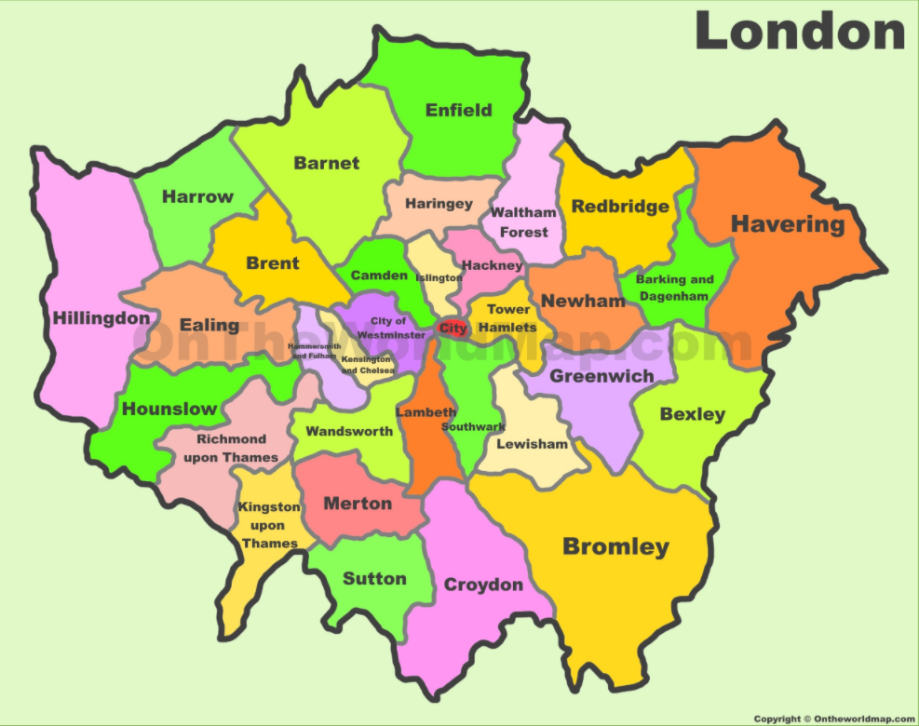

**Additional Open Questions:**

* The monthly data is a lot more noisy and could potentially show systematic seasonal changes of prices throughout a year. This quick look was done with averaged yearly data.
* It would also be interesting to see how the increase within a single borough through the time period would compare to other boroughs.