**Why the China-U.S. rivalry is at a crucial turning point—and what it means for business**

*(From Fortune)*

*As Chinese companies continue their rise in the Global 500, the competition between the two economic superpowers is intensifying.*

*BY GEOFF COLVIN*

*August 10, 2020 4:10 PM GMT+8*

1. Rarely do relations between great powers degenerate as quickly as they did when the U.S. and China **skirmished** in late July. When the U.S. ordered China to [close its consulate](https://fortune.com/2020/07/22/china-consulate-houston-us/) in Houston within 72 hours, it looked like punishment for alleged theft of COVID-19 research and other valuable information by Chinese hackers; the Justice Department had [announced charges](https://www.justice.gov/opa/pr/two-chinese-hackers-working-ministry-state-security-charged-global-computer-intrusion) that same day. Or perhaps it was a further response to Beijing’s crackdown on Hong Kong, for which the U.S. had [already revoked](https://www.bostonglobe.com/2020/07/14/nation/trump-signs-bill-order-hold-china-accountable-oppressive-actions-against-people-hong-kong/) the city’s special status in trade relations.

|  |  |
| --- | --- |
| **skirmish** n. | 小规模战斗; 小冲突 |

2. But the State Department said the real reason was what it asserted were years of “massive illegal spying and influence operations.” So why close the consulate at that moment? Virtually all analysts say the timing reflects the presidential election, as President Trump and former Vice President Joe Biden **vie** to appear the tougher man on China. Certainly this was not routine diplomacy theater. It was unprecedented. In the 41 years of formal relations between the two countries, the U.S. had never ordered the closure of a Chinese diplomatic facility.

**vie** v.激烈竞争; 争夺; 第三人称单数：[vies](http://www.baidu.com/link?url=u4CAaF3B6DUz8lDY-jBFN8VJhgZOU6k0Bph9DJTiTIwXz0LHeyw97VhvyMe4xybnHgqBfN0kdd2C90MF5duMajmnuOJAGuTLlXBPvdho74W" \t "_blank) 现在分词：[vying](http://www.baidu.com/link?url=ikqqBvt8w67LNJ54axZ_kgEEyT-CA3Bn1OSyvpX8muLwSACwetDoHC3UhmNmPG8-PerKfR4a4x30uX62Z4vgpQhkkbCZPX6bDB0y68vRJKW" \t "_blank) 过去式：[vied](http://www.baidu.com/link?url=u4CAaF3B6DUz8lDY-jBFN8VJhgZOU6k0Bph9DJTiTIwXz0LHeyw97VhvyMe4xybnHgqBfN0kdd2C90MF5duMagmDzxO4uGfqpg-MbNc_L-C" \t "_blank) 过去分词：[vied](http://www.baidu.com/link?url=u4CAaF3B6DUz8lDY-jBFN8VJhgZOU6k0Bph9DJTiTIwXz0LHeyw97VhvyMe4xybnHgqBfN0kdd2C90MF5duMagmDzxO4uGfqpg-MbNc_L-C" \t "_blank)

3. Both sides replaced **boilerplate** **umbrage** with **vituperation**. The U.S. “will not tolerate the PRC’s violations of our sovereignty and intimidation of our people,” [declared](https://thehill.com/homenews/administration/508456-us-orders-china-to-close-houston-consulate-beijing-vows-retalitation) a State Department spokeswoman. A Chinese foreign ministry [spokesperson shot back](https://www.fmprc.gov.cn/mfa_eng/xwfw_665399/s2510_665401/2511_665403/t1799871.shtml) that the shutdown was “an **outrageous** and unjustified move which will sabotage relations between the two countries.” A day later, Secretary of State Mike Pompeo said the U.S.-China relationship should be based on a principle of “distrust and **verify**” and dismissed “the old **paradigm** of blind engagement with China.” The day after that, China ordered the U.S. to [close its consulate](https://fortune.com/2020/07/24/beijing-orders-us-consulate-closed/) in Chengdu, a major business hub in southwest China, another unprecedented move.

**boilerplate** n.(可供模仿的) 样板文件，文件范例;

**umbrage**  n.树荫；（成荫的）簇叶;

|  |  |
| --- | --- |
| **vituperation** n. | 辱骂; 斥责; 责骂 |
| **outrageous** adj. | 骇人的; 无法容忍的; 反常的; 令人惊讶的; |
| **Verify** v. | 核实; 查对; 核准; 证明; 证实; |
| **Paradigm** n. | 典范; 范例; 样式; 词形变化表; |

4. And to think that just last December, when the U.S. and China signed a phase 1 deal to start **unwinding** the trade war, President Trump said the U.S.-China relationship “might be the best it’s been in a long, long time.”

|  |  |
| --- | --- |
| **unwinding** v. | 解开，打开，松开(卷绕之物); 放松; 轻松; |

5. The consulate confrontation marks a particularly clear and dramatic advance in a trend the whole world will feel: the intensifying competition between the world’s two largest economies. It adds heavily to a broader uncertainty, a combination of highly **consequential** unknowns that together will redirect our future. They’re **distill**ed in two big questions, both of which arose in the late-July collapse of relations: Where will the U.S.-China rivalry take us? Which country will emerge from the COVID-19 pandemic with the least long-term economic and social damage? Both questions, moreover, are intertwined with a third: Which of two **starkly** different presidential candidates will America choose? Together, their answers will mark a turning point in the world’s progress.

**consequential** adj.随之而来的; 相应发生的; 作为结果的; 重要的; 将产生重大结果的;

|  |  |
| --- | --- |
| **distill** v. | 蒸馏; 用蒸馏法提取; 用蒸馏法制造(酒等); 吸取…的精华; 提炼; 浓缩; |

**starkly** adv.完全，分明地，赤裸裸地

6. New data, presented in [Fortune’s 2020 Global 500](https://fortune.com/global500/2020) ranking of the world’s biggest corporations, reveals a landmark change in the U.S.-China rivalry. For the first time, there are more Global 500 companies based in mainland China, including Hong Kong, than in the U.S.—124 vs. 121. If you include Taiwan, the total for Greater China is 133.

7. The reversal of leadership reflects long-running trends. The number of U.S. companies in the ranking has been declining every year since 2002, when it was 197. The number of Chinese companies has been increasing every year since 2003, when mainland China placed 11 on the list.

8. Of the three questions in the triple turning point, the future of the U.S.-China relationship arguably holds the greatest world-historical significance. Harvard China expert Graham Allison frames the relationship as “an inherent, deep, structural rivalry,” a rising power threatening a solidly dominant power. The U.S.-China rivalry is dangerous, Allison tells Fortune, in large part because it’s deeply emotional, particularly for those Americans who feel that the nation’s rightful and only place is to be “No. 1” in the world order. Allison has famously called it “**Thucydides’s trap**” after the ancient Greek historian’s recounting of how Sparta’s response to the threat of Athens’s rise led to a 30-year war.

**Thucydides’s trap** “修昔底德陷阱”，指一个新崛起的大国必然要挑战现存大国，而现存大国也必然会回应这种威胁，这样[战争](https://baike.baidu.com/item/%E6%88%98%E4%BA%89/14004" \t "_blank)变得不可避免。此说法源自[古希腊](https://baike.baidu.com/item/%E5%8F%A4%E5%B8%8C%E8%85%8A/14206)著名历史学家[修昔底德](https://baike.baidu.com/item/%E4%BF%AE%E6%98%94%E5%BA%95%E5%BE%B7)，他认为，当一个崛起的大国与既有的统治霸主竞争时，双方面临的危险多数以战争告终。

9. While the U.S. and China are a long way from that, the current situation is bad and deteriorating fast. “Every topic that matters is getting worse,” says Ian Bremmer, founder and president of the Eurasia Group consulting firm. “Huawei, Hong Kong, the South China Sea, Taiwan, the U.S. withdrawal from the WHO over China, you name it.”

10. Most experts agree that over the past year the relationship has fallen into a self-reinforcing downward spiral. “I’m sitting in Washington, and it feels as if we’re in the center of this hurricane and there’s only one direction we’re heading in,” says Scott Kennedy, an expert on Chinese business and economics at the Center for Strategic and International Studies. As Beijing aggressively pushes territorial claims on the Indian border, over Taiwanese airspace, and in the South China Sea—actions intended as messages to the U.S., diplomats say—the U.S. has pressured allies to ban telecom equipment from Huawei ([No. 49 on the Global 500](https://fortune.com/company/huawei-investment-holding/global500/)) and has even pondered [banning U.S. travel](https://www.reuters.com/article/us-usa-china-travel/u-s-targets-all-chinese-communist-party-members-for-possible-travel-ban-source-idUSKCN24H2TQ) by members of the Chinese Communist Party and their families, an estimated 270 million people, including the CEOs of nearly every important Chinese company.

11. The shift in the Global 500 is significant because this rivalry is founded on economic might. Analysts can **quibble over** which country’s economy is biggest. The U.S. remains well ahead when the comparison is based on currency exchange rates, with 2019 U.S. GDP of $21.4 trillion vs. China’s $14.3 trillion. But based on purchasing power **parity**, a measure that adjusts for the countries’ differing price levels, China is slightly ahead of the U.S.—$21.4 trillion vs. $20.5 trillion as of 2018, the most recent year for which the [World Bank has data](https://data.worldbank.org/indicator/NY.GDP.MKTP.PP.CD). The gap is probably wider now and continuing to widen. That’s the measure that counts, says Allison, because it shows “who can build the most drones” or fund the most research.

* **quibble over** 争辩不休， **争辩琐事， 诡辩**

**parity** n. 平价；同等；相等；胎次；分娩

12. It also makes China the world’s largest market for increasing numbers of products and services. It “will be the first market where new products are launched,” says Kennedy, “so Chinese consumers will have a greater say in the direction of industries. The American market may not be large enough to be where products are **scaled up**.”

**scaled up** 按比例增加[提高]

13. For that and other reasons, U.S. companies will be highly unlikely to leave China. A billion prospering consumers cannot be **forsaken** by any business that hopes to remain globally competitive. In addition, few companies will want to remove China from their supply chains entirely. While trade tensions and the pandemic have shown many companies worldwide that they were too reliant on Chinese suppliers, Chinese companies often have manufacturing expertise that can’t be found elsewhere. Besides, foreign companies that ditch China—in favor of India and Vietnam, for example—may find that China becomes less welcoming when those companies want to sell to the Chinese market.

**forsaken *v.***放弃( forsake的过去分词 ); 弃绝; 抛弃; 摒弃

14. China’s economic strengths are **sobering**, but to understand this rivalry fully, GDP alone is too **gross** a measure. The critical field of conflict is technology, the foundation of economic growth and national security. Since the founding of the People’s Republic, Chinese leaders, including the President, have declared a national policy to “catch up and surpass” the developed world’s technology. For China’s leaders, “technological progress is not only a means to economic and military **prowess**,” [writes](https://www.foreignaffairs.com/articles/china/2019-08-27/chinas-long-march-technological-supremacy) Harvard’s Julian [Baird](https://fortune.com/company/baird/) Gewirtz, “but also an ideological end in itself—offering final proof of China’s restoration as a great power after decades of struggle.”

**sobering  *adj.*** 有节制的; 清醒的，冷静的; 朴素的，柔和的; 持重的

**gross *adj.***总的，毛的; 严重的; 令人不快的; 粗鲁的

**prowess**  *n.*英勇; 高超技艺

15. And tech is where the two countries are most noticeably decoupling. Huawei is the world’s No. 1 maker of 5G networking equipment and, as of this year’s second quarter, the [No. 1 maker of phones](https://fortune.com/2020/07/30/apple-samsung-smartphone-market-sales-q2-2020-huawei/). But its products are virtually outlawed in the U.S., and its CFO has been under house arrest in Canada for 18 months on U.S. charges of bank fraud, wire fraud, and theft of trade secrets, charges she and the company vigorously deny. For its part, China has effectively banned some of America’s most ubiquitous tech giants, including [Google](https://fortune.com/company/alphabet/) and [Facebook](https://fortune.com/company/facebook/). “We’ve gone from a more integrated world to a **Splinternet**,” says Bremmer. “Tech is by far the **crux** of the competition right now, the most important piece and the most dangerous.”

**Splinternet** **分裂网**The splinternet (also referred to as cyberbalkanization or Internet Balkanization) is a characterization of the Internet as splintering and dividing due to various factors, such as technology, commerce, politics, nationalism, religion, and interests.

**crux n.** **关键；难题；[天]十字座；坩埚**

16. The technology war is being fought on many fronts—A.I., 5G, voice recognition, facial recognition, fintech, and others. A.I. is the most important because it **turbocharg**es all the rest. [A recent article](https://nationalinterest.org/feature/china-beating-america-ai-supremacy-106861)coauthored by Allison and an anonymous U.S. tech industry leader argues that China is far more advanced in A.I. than the U.S. national security community realizes—noting the advantages China gains by having a population four times the size of the U.S. “In A.I., brainpower matters more than computing power,” they write, and China graduates 1.3 million STEM students annually vs. America’s 300,000, and 185,000 computer scientists vs. America’s 65,000. Even in the U.S., of every 10 computer science Ph.D.s graduating, three are American and two are Chinese; most Chinese postdocs will eventually return home.

**Turbocharge v. 用涡轮给增压， <非正式>快速增加**

17. But if China seems like an economic and technological **steamroller** about to **squash** the U.S., it isn’t. A closer look shows that despite China’s strengths, this rivalry’s future remains highly uncertain.

* **steamroller n.** **蒸气压路机；不可阻挡之势；一种带有内燃机的类似机械**

**v.** **压路；压垮；以不可阻挡之势前进**

* **squash vt.** **压制；压扁 vi.** **变扁；挤进**

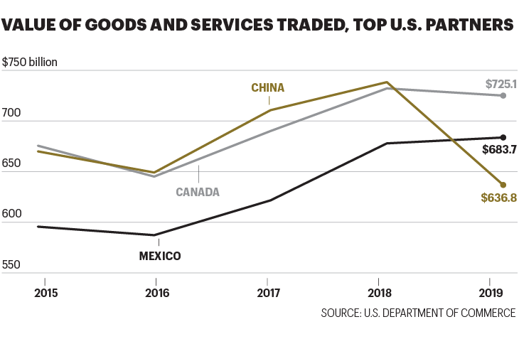

18. Start with those 124 mainland Chinese companies in the Global 500. Though they outnumber U.S. companies, they’re smaller, accounting for only 25% of total Global 500 revenue vs. America’s 30%. A large majority of the Chinese companies—68%—are state-owned enterprises; they didn’t get big by winning in the **rough-and-tumble** competition of open markets. While the list includes Chinese tech **behemoths** that compete internationally—Alibaba Group, Huawei, Lenovo—it also includes many purely domestic businesses; several are coal miners or electric utilities.

**rough-and-tumble adj.** **杂乱无章的；混乱的**

**behemoth n.** **巨兽；庞然大物；异常巨大的东西**

19. The nature of these companies makes a big difference to their power in the strategic rivalry. The key question is this: How have they grown so large? “Was it by innovation, smart managerial practices, and good corporate governance,” asks Kennedy, “or have they gotten there through the power of the Chinese **mercantilism** and **largesse** from Chinese state-owned banks?”

**mercantilism** **[mɜː'kæntɪlɪzəm]** **n.** **重商主义；商人本性。** 重商主义一种政治学说，强调保持国际收支盈余以积累黄金的重要性。并由此提倡政府严密控制经济政策，认为自由放任的政策可能会导致黄金的流失。

**largesse n.** **慷慨援助；施舍**

20. Even China’s eventual **accession** to the title of World’s Largest Economy may not be as inevitable, or at least not as imminent, as many people believe. If both countries were to continue to grow their GDP (calculated at market exchange rates) at their 2019 **nominal rates**, China wouldn’t pull even with the U.S. until about 2050, [writes](https://www.foreignaffairs.com/articles/united-states/2020-03-31/comeback-nation) Ruchir Sharma, [Morgan Stanley](https://fortune.com/company/morgan-stanley/) Investment Management’s chief global strategist, in a recent Foreign Affairs article. If China’s growth slowed by just one percentage point, it wouldn’t catch up until 2090, meaning “few Americans alive today are likely to be around to see the United States fall to second place.”

**accession n.** **到达；即位；加入**

**nominal rates**名义利率（相对于real interest rate实际利率），是[央行](https://wiki.mbalib.com/wiki/%E5%A4%AE%E8%A1%8C)或其它提供资金借贷的机构所公布的未调整通货膨胀因素的[利率](https://wiki.mbalib.com/wiki/%E5%88%A9%E7%8E%87)。

21. The most probable future is what some analysts are calling Cold War II. It won’t be like the first cold war; the USSR was a much weaker economy than the U.S. and scarcely trade outside Eastern Europe. But it’s a conflict, already underway, in which the adversaries **field** every weapon but bombs and bullets while also interacting civilly on some issues of mutually beneficial trade. “In commodities such as liquefied natural gas and agriculture,” says Bremmer, “the U.S. and China will be doing business with each other.” Just as they did last year, when the U.S. exported $13.8 billion of agricultural products and $3.1 billion of oil and gas to China.

**field vt.** **接球；派……上场；顺利处理**

A new look at the top

For the first 29 years that Fortune compiled our Global 500 ranking of the world’s biggest companies, the U.S. never failed to finish No. 1. Well, the winning streak is finally over. This year’s list features 124 companies based in mainland China, including Hong Kong. Add in Taiwan, and there are 133 in Greater China. The U.S. falls to No. 2, with 121.

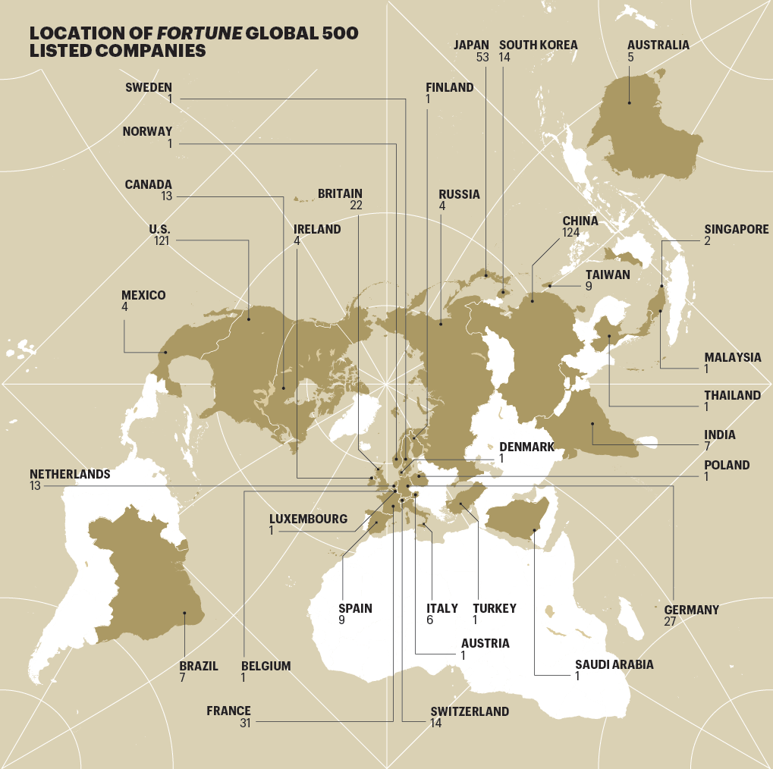

INFOGRAPHIC BY NICOLAS RAPP

22. The next front in the **standoff** may be the phase 1 trade deal. “Can it hold until the election?” Bremmer asks. “Trump will be blaming China an awful lot. It may be tempting to break the deal,” even though consumers, the finance industry, the agriculture industry, and others would suffer.

**standoff n.** **僵局；平局**

23. Which raises another of the great questions, the identity of the next President. Policy analysts agree that under a President Biden, the tone of the U.S.-China relationship would change. If he were able to lower the temperature, both sides could gain room to negotiate. He would also be more likely than Trump to enlist European and Asian allies, say Eurasia Group analysts, to present a united front in negotiations with China. At the same time, the U.S. policy **stance** would likely remain confrontational. Politically, says Bremmer, “the only policy issue on which there’s broad bipartisan agreement is that there should be a tougher line on China.”

**stance n.** **立场；态度；站立姿势**

24. At this triple turning point, we’re left without answers—only with the certainty of a less stable world. Relations between the two great powers are **fraying**, leading who knows where. But the **scenarios** aren’t all bad. Maybe China and the U.S., rationally pursuing self-interest, will manage their relationship as corporate-style competition. Multiple effective vaccines—from the U.S., China, and elsewhere—could **vanquish** COVID-19 in less than a year. In that scenario, economies would revive, people could hug each other again, and global anxiety would **unclench** at least a bit.

**fray**分崩离析，瓦解，开始崩溃

**scenario n.** **剧本；情节梗概，**局面，前景，预测

**vanquish v.** **征服；克服；击败**

**unclench v.** **弄开；撬开；松开**

25. In an unstable world, even the extreme scenarios—good and bad—seem **plausible**. Planning is harder; bets are riskier. In all of our lives, there’s less room for error.

**plausible adj.** **似真实合理的；动听的；看起来有道理的，貌似可信的**

***A version of this article appears in the***[***August/September 2020 issue***](https://fortune.com/packages/august-september-2020/)***of Fortune with the headline "And then there were two."***

<https://fortune.com/longform/us-china-relations-global-500-companies-trade-xi-trump-business/>