Do Public Environmental Narratives Reflect Waste Sector Climate Priorities? A Comparative EU and Non-EU Analysis

Martina Spirovska, Marija Stojcheva
Faculty of Computer Science and Engineering,
Ss. Cyril and Methodius University,
Skopje, Macedonia
e-mail: martina.spirovska@students.finki.ukim.mk; marija.stojcheva@finki.ukim.mk
Aleksandra Dedinec, Jana Prodanova, Aleksandar Dedinec,
Verica Taseska-Gjorgievska, Tatjana Dzambazova,
Emilija Mihajloska, Dejan Dimitriev,
Onur Amet, Ljupco Kocarev
Macedonian Academy of Sciences and Arts,
Skopje, Macedonia
e-mail: aleksandra.dedinec@manu.edu.mk; jprodanova@manu.edu.mk; dedinec@manu.edu.mk; verica@manu.edu.mk; tatjana.drangovska@manu.edu.mk; emilija.mihajloska@manu.edu.mk; denidimitriev@hotmail.com; onuramet144@gmail.com; lkocarev@manu.edu.mk

ABSTRACT
Whether public discourse reflects actual greenhouse gas priorities is a question with direct consequences for climate communication and policy. Comparative studies linking social media narratives to emission inventories remain scarce. This paper compares greenhouse gas inventories with social media narratives in Spain, an EU member state, and Macedonia, a non-EU transition economy. Applying transformer-based sentiment analysis and topic modeling to posts from the X platform, alongside national inventory analysis, we find that solid waste disposal accounts for approximately 80% of waste-sector emissions in Macedonia and approximately 70% in Spain, yet public responses diverge sharply. In Spain, discourse centers on circular economy and recycling, mirroring mitigation priorities. In Macedonia, discourse focuses on landfill fires and illegal dumping, reflecting reactive rather than strategic climate concern. These contrasting results show how governance context shapes the gap between public narrative and climate priority, and point to concrete targets for communication policy in transition economies.

Keywords: Waste sector, Greenhouse gas emissions, Social media intelligence, Sentiment analysis, Topic modeling, Mitigation pathways, Circular economy, EU and non-EU countries

1. INTRODUCTION
The Waste sector contributes significantly to global greenhouse gas emissions [1], with solid waste disposal the dominant source due to methane generation from landfilling [2] [3]. Reducing these emissions has become an essential policy objective, leading many countries to implement waste-collection improvements, landfill reduction, increased recycling, and circular economy practices [4]. The effectiveness of these measures depends not only on technical and institutional factors, but also on public awareness and engagement. Understanding how citizens perceive and discuss waste-related environmental challenges is therefore directly relevant to both policymakers and researchers.
Social media platforms have emerged as important channels through which citizens express environmental concerns, providing large volumes of publicly available data that can be analyzed in near real time. Advances in natural language processing have further expanded researchers' ability to study public attitudes through sentiment analysis and topic modeling.
Previous studies have applied social media analytics to environmental communication and climate change perception. However, limited attention has been given to examining whether public environmental narratives correspond to the climate priorities identified through greenhouse gas inventories and mitigation strategies. This study addresses that gap through a comparative analysis of Spain and Macedonia, an EU member state and a non-EU transition economy, which share the same dominant waste-sector emission source yet differ substantially in policy maturity, infrastructure development, and public discourse.
The study combines greenhouse gas inventory analysis, mitigation-priority assessment, sentiment analysis using BERTweet and Twitter-RoBERTa, and BERTopic topic modeling of X posts from both countries. The resulting public narratives are compared with identified climate priorities to assess the degree of alignment between discourse and mitigation needs. Section 2 reviews relevant literature, Section 3 describes the data, Section 4 presents the methodology, Section 5 reports the results, and Sections 6–7 discuss findings and conclusions.

2. RELATED WORK
Social media has become a primary source of environmental intelligence, enabling large-scale observation of public attitudes toward climate and sustainability issues. Studies analyzing X discourse on climate change have found that public engagement is largely event-driven and concentrated among a small number of active users [5] [6]. Sentiment patterns in climate-related posts have been shown to shift in response to specific environmental events [7], while information-sharing behavior varies significantly by source type [8]. Methodologically, transformer-based models including BERT [9], RoBERTa [10], and BERTweet [11] have substantially improved sentiment classification of informal social media texts, while BERTopic [12] has advanced topic modeling beyond traditional approaches such as Latent Dirichlet Allocation [13] by combining contextual embeddings with density-based clustering. Collectively, these studies demonstrate the value of social media as an environmental intelligence source but focus on describing public concerns rather than evaluating their correspondence to officially identified mitigation priorities.
Beyond social media research, waste-sector assessments have documented solid waste disposal as the dominant emission source across both developed and developing economies [14], establishing clear mitigation priorities. However, no study has integrated social media intelligence with greenhouse gas inventory analysis to evaluate the alignment between public narratives and sector-specific climate priorities. This gap is particularly significant in cross-national comparisons between EU and non-EU contexts, where countries may share similar emission structures while differing substantially in policy maturity and public environmental awareness.

3. DATA
To compare public narratives with emission priorities, the study combines social media data from X with greenhouse gas inventories for Spain and Macedonia.

3.1 Study context and country selection
Spain and Macedonia were selected as contrasting case studies: Spain is a European Union member state with mature waste-management policies, while Macedonia is a non-EU transition economy still developing its waste-management infrastructure. Both countries identify solid waste disposal as the dominant source of waste-sector greenhouse gas emissions, but differ substantially in policy maturity, mitigation priorities, and progress towards circular economy objectives.

3.2 Social media data collection
Social media data were obtained from X using the X API. Posts were retrieved using waste-management-related keywords in Macedonian and Spanish, covering waste, garbage, recycling, waste containers, landfills, and environmental pollution. The analysis covers the common observation period from 8 May 2024 to 6 October 2025.

3.3 Social media corpus
The collected datasets were filtered to remove reposts and duplicate content. Table 1 summarizes the number of posts retained after each stage of the collection and preprocessing process.
Table 1. Overview of the social media datasets used in the study.

Processing Stage | Macedonia | Spain
Initially collected posts | 23,872 | 7,662
After reposts removal | 10,780 | 3,231
After duplicate removal | 9,977 | 3,199
Final relevant corpus | 5,613 | 3,143

The final corpus consisted of 8,756 posts: 5,613 from Macedonia and 3,143 from Spain.

3.4 Greenhouse gas inventory data
Greenhouse gas inventory data were obtained for both countries to identify dominant waste-sector emission sources. For Macedonia, the National Greenhouse Gas Inventory (2025) covers the period 1990–2022 [15]; for Spain, the National Inventory Report (2026) submitted to the UNFCCC covers 1990–2024 [16]. Solid waste disposal is the dominant source in both countries, accounting for approximately 80% of total waste-sector greenhouse gas emissions in Macedonia and approximately 70% in Spain.

3.5 Climate priorities framework
Climate priorities were identified by combining greenhouse gas inventory results with mitigation pathway assessments and national policy documents. For Macedonia, the principal priority is the establishment of regional waste-management systems and standardized landfills [17]. For Spain, priorities focus on circular economy measures, waste prevention, increased recycling, and landfill reduction [18].

4. METHODS
The methodological framework integrates three components: (i) identification of waste-sector climate priorities through greenhouse gas inventories and mitigation assessments, (ii) extraction of public environmental narratives through sentiment analysis and topic modeling of X posts, and (iii) qualitative assessment of alignment between public discourse and climate priorities, defined as strong when discourse reflects the same interventions emphasized in national mitigation strategies, and partial when discourse focuses primarily on visible environmental problems. As illustrated in Figure 1, these components are applied sequentially to both Spain and Macedonia.
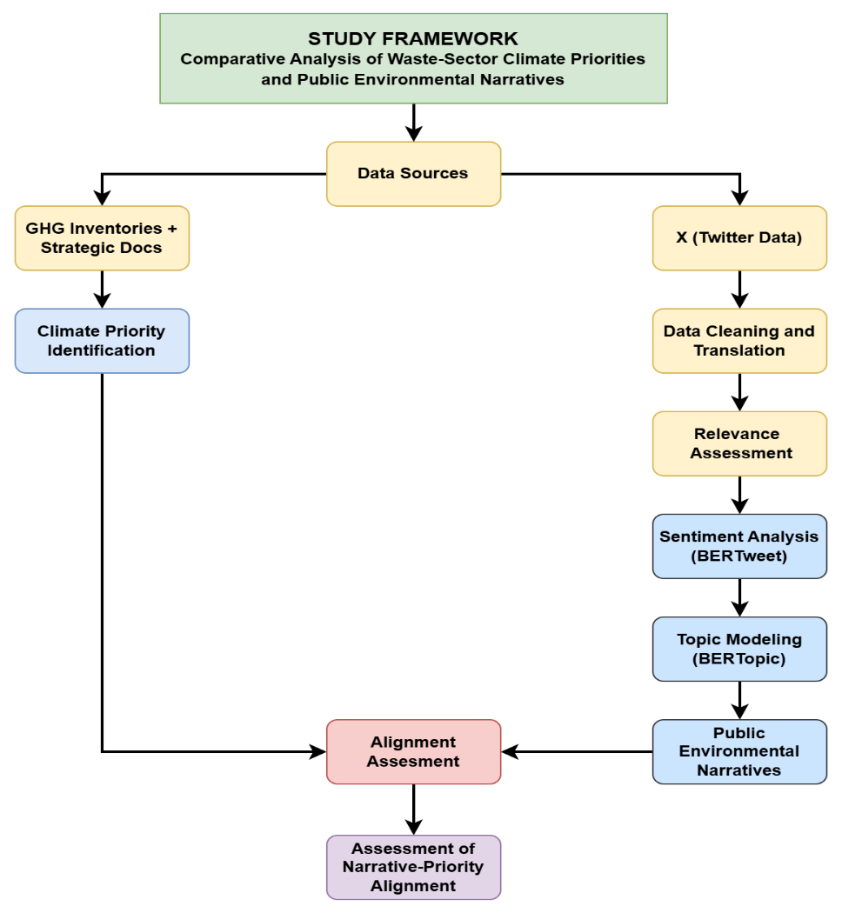
Figure 1. Overview of the methodological framework used in the study.

4.1 Preprocessing
X posts were filtered to remove reposts and duplicates. Posts in Macedonian and Spanish were translated to English using Google Translate. A manual relevance assessment was then applied to the translated corpus: posts discussing waste management, recycling, landfill operations, environmental pollution, illegal dumping, and circular economy initiatives were retained, while posts using waste-related keywords in derogatory or metaphorical contexts, or covering unrelated topics, were excluded.

4.2 Sentiment analysis
Sentiment analysis was performed using two transformer-based models pre-trained on social media text: BERTweet [11] and Twitter-RoBERTa [10]. Both models were applied to the translated post corpus, classifying each post as positive, neutral, or negative. For BERTweet, probability thresholds were applied to reduce excessive neutral classifications.
The two models exhibited approximately 85% agreement. BERTweet was selected as the primary model because its sentiment distributions more closely reflected patterns observed during manual inspection, particularly for Spain where RoBERTa over-classified posts as neutral.

4.3 Topic modeling
Topic modeling was performed using BERTopic [12] on the relevant post corpus. Separate analyses were conducted for the complete corpus and for sentiment-specific subsets to identify sentiment-dependent narrative structures.
Embeddings were generated using a transformer-based model, reduced with UMAP (five dimensions) [19], and clustered with HDBSCAN (minimum cluster size 40, minimum samples 6) [20]. The final model applied class-based TF-IDF weighting with n-grams of one to three words, constrained to ten topics per country to facilitate cross-country comparison.

5. RESULTS
This section presents the results of the three analytical components: waste-sector greenhouse gas inventory analysis, social media sentiment analysis and topic modeling, and alignment assessment between public narratives and climate priorities.

5.1 Waste-sector emission profiles
In Macedonia, waste-sector greenhouse gas emissions grew from approximately 517 kt CO₂-eq in 1990 to 831 kt CO₂-eq in 2022, as illustrated in Figure 2. Solid waste disposal is the dominant source throughout the period, accounting for approximately 80% of sectoral emissions [15]. The share of the waste sector in total national emissions rose from approximately 4% to 8%, representing an increase of more than 60% over the study period.

Figure 2. Waste-sector greenhouse gas emissions in Macedonia by source category during 1990–2022.
Spain shows a similar emission structure. As illustrated in Figure 3, solid waste disposal accounts for approximately 70% of waste-sector emissions throughout the observation period, with wastewater treatment as the second-largest source. Waste-sector emissions increased by approximately 30% between 1990 and 2024 [16]. Unlike Macedonia, the Spanish trajectory shows a pronounced peak around 2010 followed by stabilization and partial reduction, suggesting that Spain has interrupted the long-term growth trend in waste-sector emissions.
Figure 3. Waste-sector greenhouse gas emissions in Spain by source category during 1990–2024.

5.2 Climate priorities
Inventory analysis confirms that solid waste disposal is the dominant source of waste-sector emissions in both countries (Figures 2 and 3), accounting for approximately 80% of sectoral totals in Macedonia and approximately 70% in Spain. Despite this shared emission profile, identified mitigation priorities differ substantially. For Macedonia, the principal priority is the establishment of regional waste-management systems and standardized landfills [17]; for Spain, priorities center on circular economy measures, waste prevention, and landfill reduction [18].

5.3 Sentiment analysis
Sentiment analysis was performed using both BERTweet and Twitter-RoBERTa. This section presents the model comparison and the resulting sentiment distributions for each country.
5.3.1 Comparison of BERTweet and RoBERTa Results. Table 2 shows that both models produced consistent results for Macedonia. For Spain, RoBERTa assigned neutral sentiment to 54.8% of posts compared with 33.9% for BERTweet, resulting in a notably lower positive proportion. BERTweet was therefore selected as the primary model for subsequent analysis.

Table 2. Comparison of sentiment distributions obtained using BERTweet and RoBERTa.

Country | Model | Positive (%) | Neutral (%) | Negative (%)
Macedonia | BERTweet | 4.4 | 21.0 | 74.6
Macedonia | RoBERTa | 4.2 | 24.8 | 70.9
Spain | BERTweet | 57.9 | 33.9 | 8.2
Spain | RoBERTa | 38.0 | 54.8 | 7.2

5.3.2 Sentiment Distribution in Macedonia. As shown in Figure 4 (left), Macedonian discourse is strongly negative: 74.6% of posts were classified as negative, 21.0% as neutral, and only 4.4% as positive. The predominance of negative sentiment reflects public frustration regarding landfill fires, illegal dumping, environmental pollution, unpleasant odors, and perceived deficiencies in waste-management services.

5.3.3 Sentiment Distribution in Spain. As shown in Figure 4 (right), Spanish discourse is predominantly positive: 57.9% of posts were classified as positive, 33.9% as neutral, and only 8.2% as negative. This reflects discussions focused on recycling practices, sustainability initiatives, circular economy measures, and environmental awareness campaigns rather than acute waste-management failures.

Figure 4. Sentiment distribution of relevant waste-related posts from Macedonia (left) and Spain (right).

5.4 Topic modeling
BERTopic analysis identified distinct thematic structures in both datasets. In Macedonia, dominant topics reflect operational waste-management problems and visible environmental incidents, including landfill fires, smoke, illegal dumping, waste accumulation, and odors. In Spain, dominant narratives focus on circular economy principles, recycling, packaging sustainability, and resource recovery. Table 3 summarises the identified topics for both countries.
Table 3. Dominant waste-related topics identified through BERTopic analysis.

Macedonia | Spain
Landfill fires and smoke | Circular economy
Illegal dumping and waste accumulation | Recycling and resource recovery
Waste collection and public cleanliness | Sustainable packaging
Plastic disposal and waste containers | Environmental impact reduction
Odors and landfill-related pollution | E-waste and textile recycling
Nuclear waste discussions | Illegal dumping and hazardous waste

Topic frequencies were examined over time to investigate temporal dynamics. As shown in Figure 5, Macedonian discourse demonstrates pronounced event-driven behavior, with sharp peaks followed by rapid declines corresponding to landfill fires and localized environmental incidents. As shown in Figure 6, Spanish discourse exhibits a more stable thematic structure, with circular economy, recycling, and sustainability topics maintaining a persistent presence throughout the observation period.

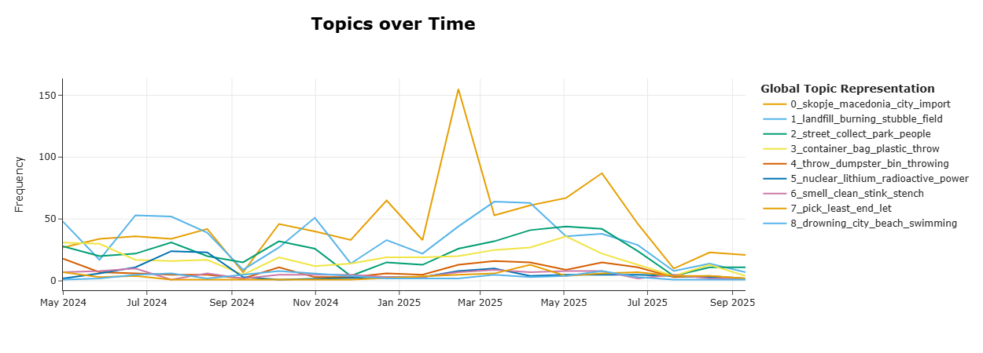
Figure 5. Temporal evolution of dominant waste-related discussion topics in Macedonia.
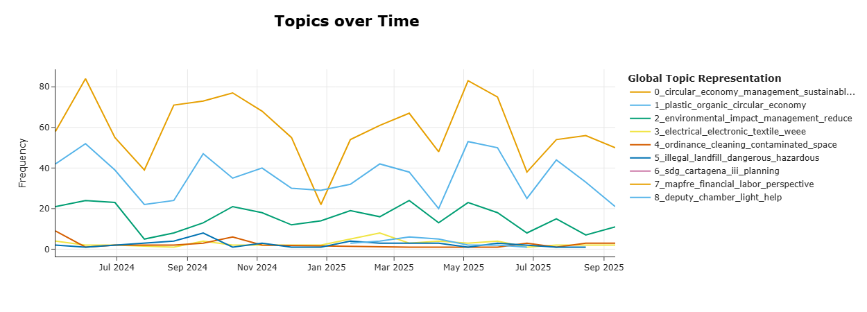
Figure 6. Temporal evolution of dominant waste-related discussion topics in Spain.

5.5 Alignment between public narratives and climate priorities
The alignment between public narratives and waste-sector climate priorities was assessed separately for each country and then compared.

5.5.1 Macedonia. The dominant Macedonian narratives focus on landfill fires, illegal dumping, odors, smoke emissions, and visible waste-management failures. These themes reflect real environmental concerns and are indirectly connected to the dominant emission source identified in the inventory. However, the discourse rarely addresses regional waste-management systems and standardized landfill infrastructure, which were identified as the principal mitigation interventions. Public attention is concentrated on the symptoms of waste-management deficiency rather than on long-term mitigation measures. Consequently, the relationship between public discourse and climate priorities in Macedonia can be characterized as partial alignment.
5.5.2 Spain. In Spain, public discourse is strongly centered on circular economy practices, recycling, sustainable packaging, resource recovery, and environmental responsibility. These themes closely correspond to national mitigation priorities and reflect the same interventions emphasized in national waste-management and climate strategies. Accordingly, the Spanish case demonstrates strong alignment between public environmental narratives and waste-sector climate priorities.

5.5.3 Comparative assessment. Although both countries share the same dominant emission source, solid waste disposal, their public narratives differ substantially. Spain demonstrates strong alignment, with discourse directed toward long-term mitigation objectives. In contrast, Macedonia exhibits only partial alignment, with discourse focused on visible environmental problems rather than strategic mitigation measures.

6. DISCUSSION
The results show that Macedonia and Spain exhibit substantially different public narratives despite sharing a similar waste-sector emission profile. In Macedonia, discourse is dominated by visible environmental problems, including landfill fires, illegal dumping, and waste accumulation, generating predominantly negative sentiment. These topics reflect public awareness of immediate challenges but do not correspond to the principal mitigation priority identified through inventory analysis. In Spain, discourse centers on circular economy practices and recycling, closely corresponding to national mitigation priorities and generating predominantly positive sentiment. The difference between the two countries appears to reflect their respective levels of waste-management development and policy maturity.

The comparison suggests that alignment between public narratives and climate priorities can serve as an indicator of policy maturity. Macedonia's discourse indicates that communication of long-term mitigation priorities has not reached the same level of public visibility as in Spain. These findings imply that improving infrastructure alone may be insufficient; effective communication of climate priorities is necessary to ensure that public attention and policy objectives evolve in parallel.

Several limitations should be acknowledged. The analysis relied exclusively on X, which may not fully represent broader public opinion. Sentiment classification was performed on translated text, which may introduce minor linguistic distortions. The relevance assessment involved a degree of subjectivity, and the alignment evaluation was qualitative rather than quantitative.

7. CONCLUSION
This study compared public environmental narratives on X with waste-sector greenhouse gas inventory data for Macedonia and Spain. Despite a near-identical emission profile in both countries, social media analysis reveals substantially different patterns of public discourse. Macedonia exhibits only partial alignment, with narratives focused on visible waste-management failures rather than strategic mitigation priorities. Spain demonstrates strong alignment, with discourse centered on circular economy practices and recycling, consistent with national mitigation strategies.

These findings suggest that alignment between public narratives and climate priorities reflects the level of waste-management development and the effectiveness of climate communication. Integrating social media intelligence with greenhouse gas inventory analysis provides a practical approach for identifying communication gaps and informing public engagement strategies. Future research could expand the framework to additional countries, incorporate multiple platforms, and develop quantitative methods for measuring discourse-priority alignment.

REFERENCES
[1] IPCC, Climate Change 2023: Synthesis Report, Intergovernmental Panel on Climate Change, Geneva, Switzerland, 2023.
[2] IPCC, 2006 IPCC Guidelines for National Greenhouse Gas Inventories, Volume 5: Waste, IGES, Hayama, Japan, 2006.
[3] UNEP, Global Methane Assessment: Benefits and Costs of Mitigating Methane Emissions, United Nations Environment Programme, Nairobi, Kenya, 2021.
[4] European Commission, A New Circular Economy Action Plan for a Cleaner and More Competitive Europe, Brussels, Belgium, 2020.
[5] Pearce, W., Holmberg, K., Hellsten, I., Nerlich, B., Climate Change on Twitter: Topics, Communities and Conversations about the 2013 IPCC Working Group 1 Report, PLoS ONE, Vol. 9, No. 4, 2014.
[6] Kirilenko, A., Stepchenkova, S., Public Microblogging on Climate Change: One Year of Twitter Worldwide, Global Environmental Change, Vol. 26, pp 171-182, 2014.
[7] Cody, E. M., Reagan, A. J., Mitchell, L., Dodds, P. S., Danforth, C. M., Climate Change Sentiment on Twitter: An Unsolicited Public Opinion Poll, PLoS ONE, Vol. 10, No. 8, 2015.
[8] Veltri, G. A., Atanasova, D., Climate Change on Twitter: Content, Media Ecology and Information Sharing Behaviour, Public Understanding of Science, Vol. 26, No. 6, pp 721-737, 2017.
[9] Devlin, J., Chang, M. W., Lee, K., Toutanova, K., BERT: Pre-training of Deep Bidirectional Transformers for Language Understanding, Proceedings of NAACL-HLT, Minneapolis, USA, 2019.
[10] Liu, Y., Ott, M., Goyal, N., et al., RoBERTa: A Robustly Optimized BERT Pretraining Approach, arXiv:1907.11692, 2019.
[11] Nguyen, D. Q., Vu, T., Nguyen, A. T., BERTweet: A Pre-trained Language Model for English Tweets, Proceedings of EMNLP, 2020.
[12] Grootendorst, M., BERTopic: Neural Topic Modeling with a Class-Based TF-IDF Procedure, arXiv:2203.05794, 2022.
[13] Blei, D. M., Ng, A. Y., Jordan, M. I., Latent Dirichlet Allocation, Journal of Machine Learning Research, Vol. 3, pp 993-1022, 2003.
[14] Kaza, S., Yao, L., Bhada-Tata, P., Van Woerden, F., What a Waste 2.0: A Global Snapshot of Solid Waste Management to 2050, World Bank, Washington DC, USA, 2018.
[15] Ministry of Environment and Physical Planning, National Greenhouse Gas Inventory Report of North Macedonia 2025, Skopje, North Macedonia, 2025.
[16] Ministry for Ecological Transition and Demographic Challenge, National Inventory Report Spain 2026, Madrid, Spain, 2026.
[17] Government of North Macedonia, National Waste Management Strategy of the Republic of North Macedonia, Skopje, North Macedonia, 2008.
[18] Government of Spain, España Circular 2030: Spanish Circular Economy Strategy, Madrid, Spain, 2020.
[19] McInnes, L., Healy, J., UMAP: Uniform Manifold Approximation and Projection for Dimension Reduction, arXiv:1802.03426, 2018.
[20] Campello, R. J. G. B., Moulavi, D., Sander, J., Density-Based Clustering Based on Hierarchical Density Estimates, PAKDD, 2013.

