**Views**

Create a table

-----------------------------------------

SSN NOT NULL VARCHAR2(20)

FNAME VARCHAR2(20)

LNAME VARCHAR2(20)

ADDRESS VARCHAR2(20)

SEX CHAR(1)

SALARY NUMBER(38)

ans:

create table employee(ssn varchar(20),fname varchar(20),lname varchar(20),address varchar(20),sex char(1),salary number(38));

insert into employee(ssn,fname,lname,address,sex,salary) values(1,'martin','abraham','oottukulathil','m',1000);

1 row created.

SQL> insert into employee(ssn,fname,lname,address,sex,salary) values(2,'james','joseph','thekedath','m',1010);

1 row created.

SQL> insert into employee(ssn,fname,lname,address,sex,salary) values(3,'sharafiya','illiyas','pullikal','f',1015);

1 row created.

SQL> insert into employee(ssn,fname,lname,address,sex,salary) values(4,'dona','thomas','thattam parambil','f',1030);

1 row created.

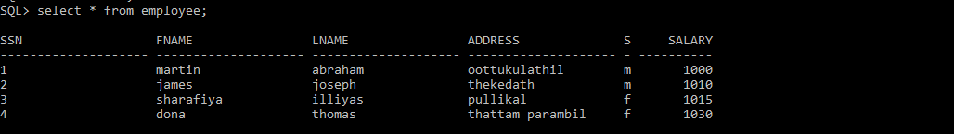

1. Creating Views (With and Without Check Option)

create view sales_staff as select fname,ssn from employee;

View created.

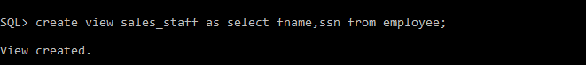

**2**. Selecting from a View

SQL> select * from sales_staff;

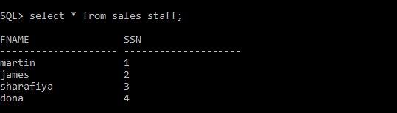

3. Drop View

SQL>DROP VIEW sales_staff;

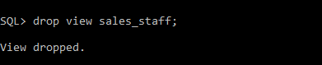

**Named PL SQL Procedure and Functions**

**1).**

**CREATE OR REPLACE PROCEDURE welcome_msg (p_name IN VARCHAR2)**

**IS**

**BEGIN**

**dbms_output.put_line ('Welcome '|| p_name);**

**END;**

**/**

**To execute procedure 'welocme_msg' -> EXEC welcome_msg ('Guru99');**

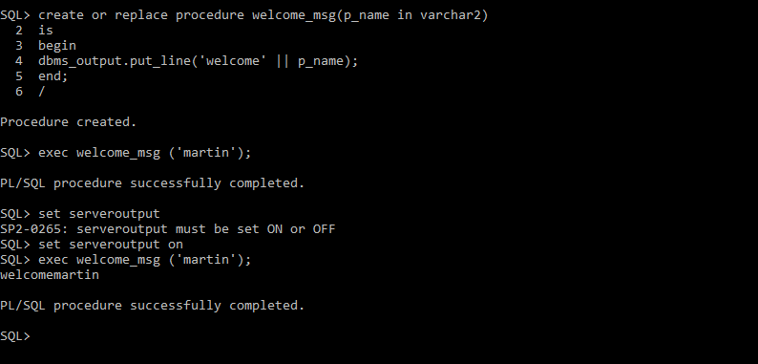

**2)**

**CREATE OR REPLACE FUNCTION welcome_msg_func ( p_name IN VARCHAR2) RETURN VARCHAR2**

**IS**

**BEGIN**

**RETURN ('Welcome '|| p_name);**

**END;**

**/**

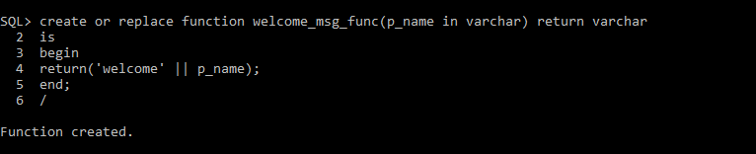

**we can call function in 2 ways :**

**i)**

**DECLARE**

**lv_msg VARCHAR2(250);**

**BEGIN**

**lv_msg := welcome_msg_func ('Guru99');**

**dbms_output.put_line(lv_msg);**

**END;**

**/**

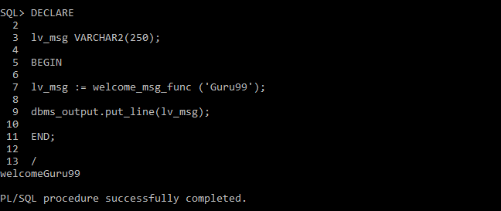

**ii)**

**SELECT welcome_msg_func('Guru99') FROM DUAL;**

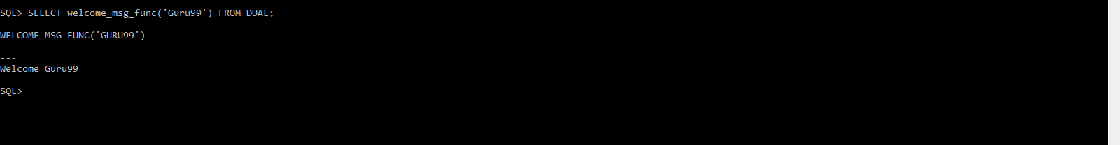

**3.**

**CREATE OR REPLACE FUNCTION welcome_msg_func ( p_name IN VARCHAR2,sal out number) RETURN VARCHAR2**

**IS**

**BEGIN**

**sal:=10000;**

**RETURN ('Welcome '|| p_name);**

**END;**

**/**

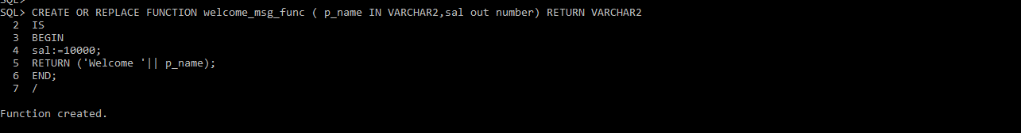

4.

**CREATE OR REPLACE PROCEDURE welcome_msg (p_name IN VARCHAR2, salary out number)**

**IS**

**BEGIN**

**salary:=10000;**

**dbms_output.put_line ('Welcome '|| p_name);**

**END;**

**/**

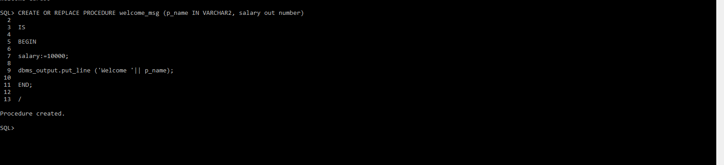

**To execute procedure 'welocme_msg' -> first declare a variable sal**

**var sal number;**

**EXEC welcome_msg ('Guru99',:sal);**

**print sal;**

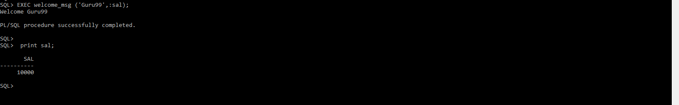

**PL/SQL Cursor , Triggor**

**1)**

create table stud_file(sid number, name varchar(20), m1 number, m2 number);

insert into stud_file values(1,'anu',40,45);

insert into stud_file values(2,'binu',48,45);

insert into stud_file values(3,'cini',30,45);

insert into stud_file values(4,'dini',30,25);

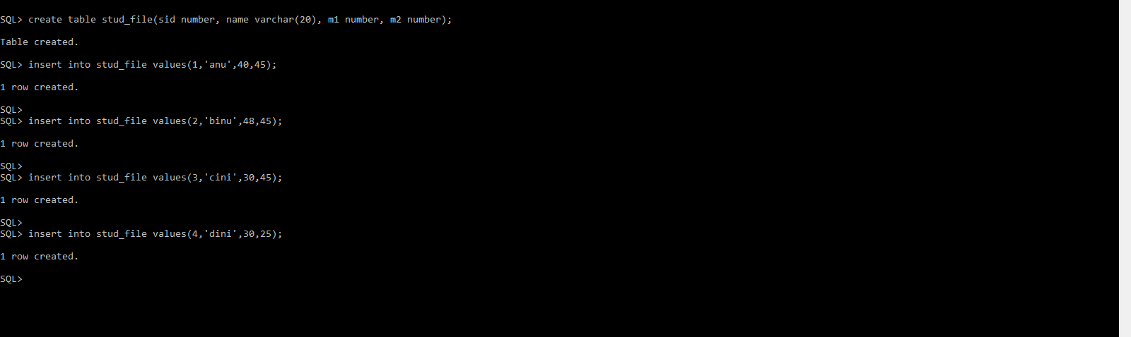

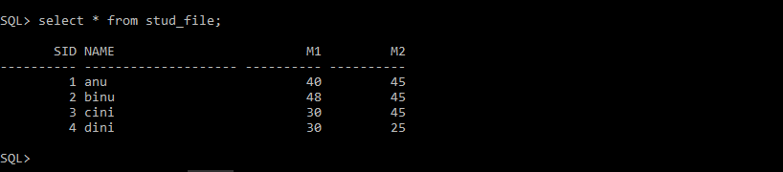

**2)**

declare

id constant number :=1;

sname stud_file.name%type;

mark1 stud_file.m1%type;

mark2 stud_file.m2%type;

total number:=0;

begin

select name,m1,m2 into sname,mark1,mark2 from stud_file where sid=id;

total:=mark1+mark2;

dbms_output.put_line('Total marks of student '||sname||' with id '||id||' is: '||total);

end;

/

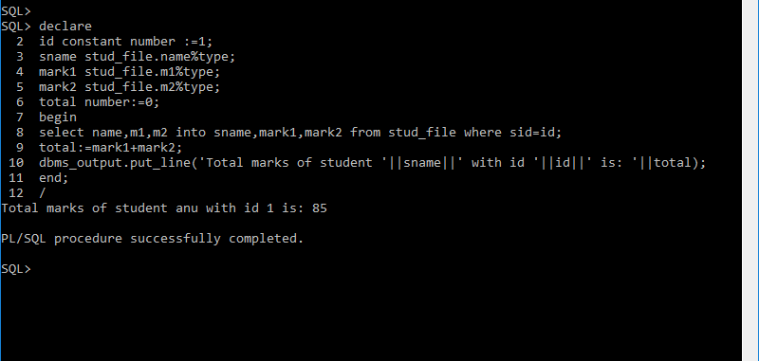

**3)**

declare

cursor stud_cursor is select * from stud_file;

stud_rec stud_cursor%rowtype;

total number:=0;

begin

open stud_cursor;

loop

fetch stud_cursor into stud_rec;

exit when stud_cursor%notfound or stud_cursor%rowcount>4;

total:=stud_rec.m1+stud_rec.m2;

dbms_output.put_line('Total marks of student '||[stud_rec.name](http://stud_rec.name/)||' is: '||total);

end loop;

end;

/

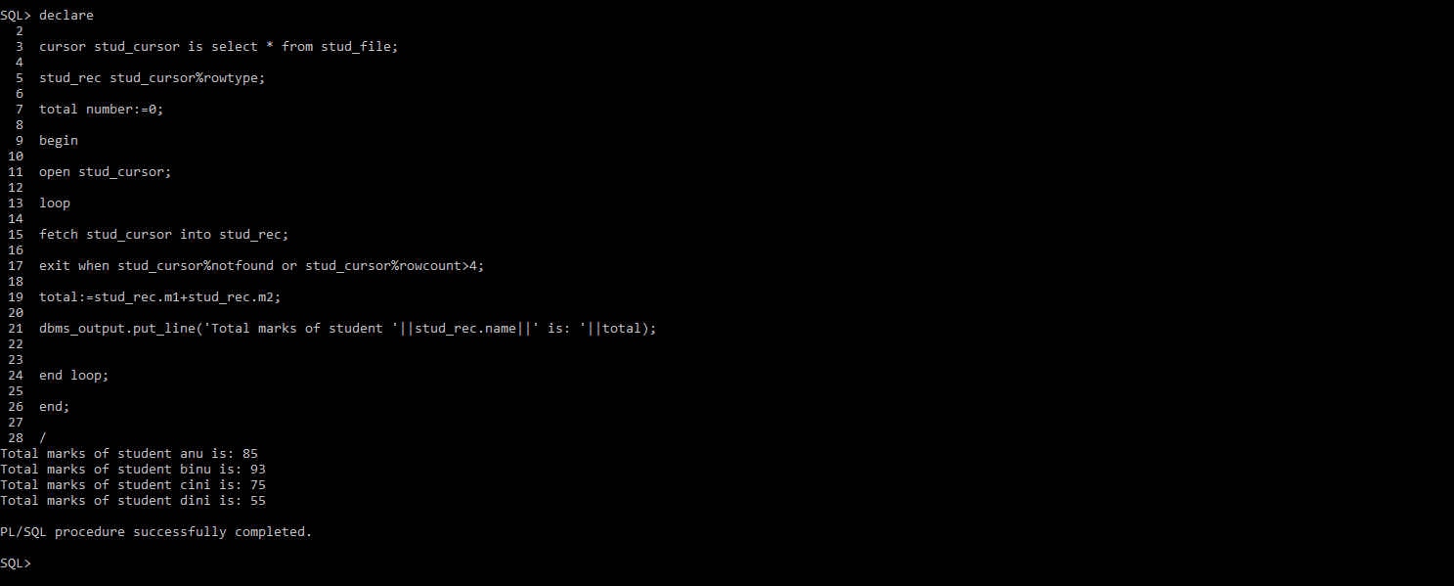

**4)**

create table stud_mark(sid number,total number);

create  or replace trigger stud_trig after insert on stud_file

for each row

declare

tot number:=0;

begin

tot:=:new.m1+:new.m2;

insert into stud_mark values(:new.sid,tot);

DBMS_OUTPUT.PUT_LINE('AFTER INSERT trigger activated:');

end;

/

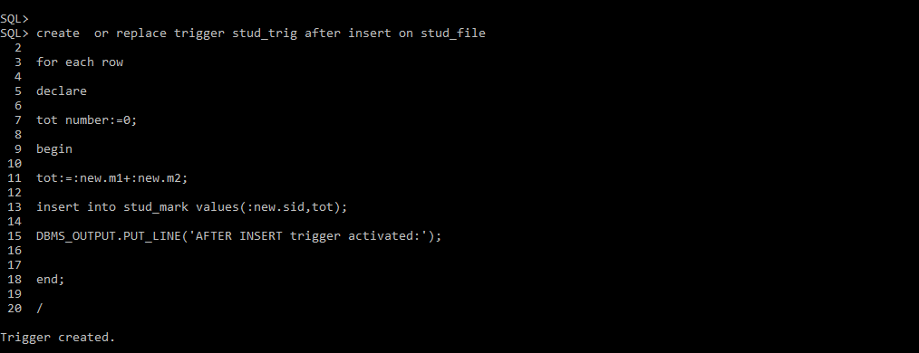

insert into stud_file values(5,'rani',40,45);

select * from stud_mark;

