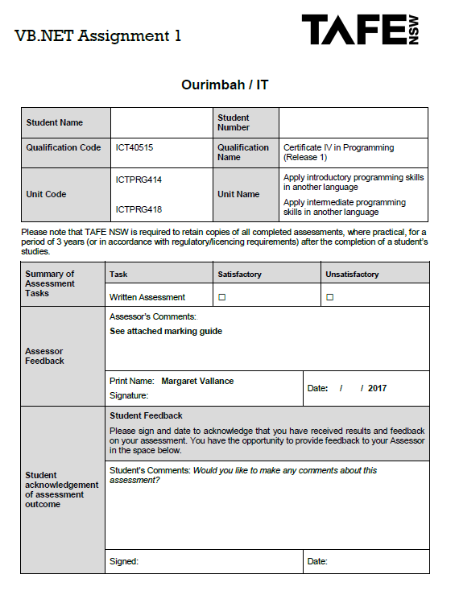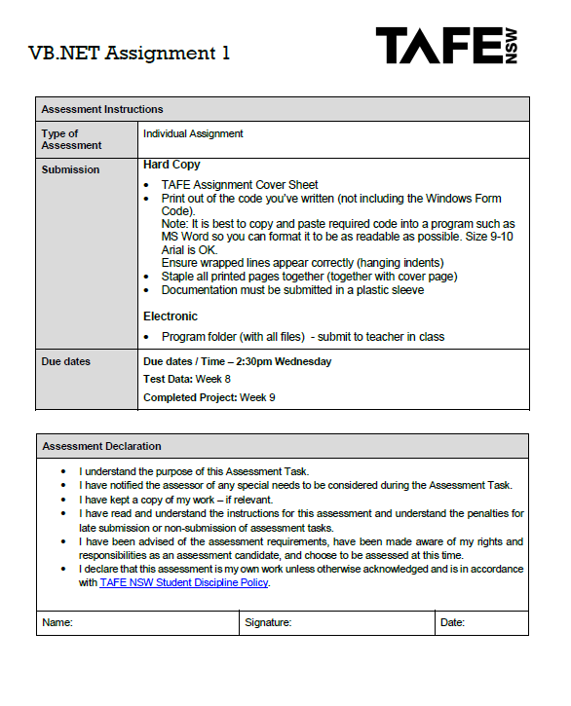

|  |  |  |  |  |  |  |  |  |  |  |  |
| --- | --- | --- | --- | --- | --- | --- | --- | --- | --- | --- | --- |
|  |  |  |  |  |  |  |  |  |  |  |  |
|  | Inputs |  |  |  |  |  | Outputs |  |  |  |  |
|  | Loan Amt | Rate | Years | First Home Buyer? | Armed Services? | Extra Services? | Actual Rate | Monthly Payment | Total Payment | Total Interest |  |
|  | 50,000 | 4 | 10 | y | V | F | 3 | $524.47 | $62,936.45 | $12,936.45 |  |
|  | 100,000 | 4.25 | 15 | n | AD | S | 4.25 | $768.95 | $138,410.11 | $38,410.11 |  |
|  | 570,000 | 5.5 | 10 | y | R | O | 4.5 | $5,949.06 | $713,886.72 | $143,886.72 |  |
|  | 1,000,000 | 6.25 | 30 | n | N | FS | 6.25 | $6,215.51 | $2,237,581.92 | $1,237,581.92 |  |
|  | 45,000 | 7 | 15 | y | N | FO | 6 | $463.07 | $83,352.40 | $38,352.40 |  |
|  | 45,000 | 7 | 15 | y | N | OO | 6 | $463.07 | $83,352.40 | $38,352.40 |  |
|  | 85,000 | 7.5 | 25 | n | V | SO | 6.75 | $645.61 | $193,682.44 | $108,682.44 |  |
|  | 125,000 | 7.75 | 30 | y | AD | FSO | 5.5 | $809.74 | $291,505.05 | $166,505.05 |  |
|  | 60,000 | 8 | 20 | n | R | n/a | 7.75 | $492.57 | $118,216.59 | $58,216.59 |  |
|  |  |  |  |  |  |  |  |  |  |  |  |
|  |  |  |  |  |  |  |  |  |  |  |  |

'Name: Martin Buchan

'Date: 23/08/2017

'Listing: Cert IV Programming VB.NET Assignment

'Purpose: Calculate Loan details from users inputs

'Main Loan Calculator class

Public Class LoanCalculator

Const OTHER As Integer = 500

Const FINANCE As Integer = 500

Const SERVICE As Integer = 200

Const VETERAN As Double = 0.75

Const ACTIVEDUTY As Double = 1.25

Const RESERVE As Double = 0.25

Const NONE As Double = 0.0

Const FIRSTHOME As Double = 1.0

'Opens the About Us dialog when the image is clicked

Private Sub PictureBox1_Click(sender As Object, e As EventArgs) Handles picInfo.Click

Dim AboutUs As New AboutUs()

AboutUs.ShowDialog()

End Sub

'adds content to the Repayment Years comboBox item when form loads

Private Sub LoanCalculator_Load(sender As Object, e As EventArgs) Handles MyBase.Load

Dim loanYears = 10

Do While loanYears <= 30

cmbRepaymentYears.Items.Add(loanYears)

loanYears += 5

Loop

cmbAnnualInterest.SelectedIndex = 0

cmbRepaymentYears.SelectedIndex = 0

End Sub

'Calculates the loan repayments and handles the 'compute' button click event

Private Sub btnCompute_Click(sender As Object, e As EventArgs) Handles btnCompute.Click

If Not CheckInput() Then

Exit Sub

End If

Dim loanAmount = CDbl(txtLoanAmount.Text)

Dim interestPrcnt = CDbl(cmbAnnualInterest.SelectedItem)

Dim loanLength = CDbl(cmbRepaymentYears.SelectedItem)

Dim firstHomeDiscount = CalcFirstHomeDiscount()

Dim aspDiscount = CalcAspDiscount()

Dim extraServices = CalcExtraServices()

Dim numPayments = loanLength * 12

Dim rate = interestPrcnt - aspDiscount - firstHomeDiscount

Dim monthlyPayment = Pmt((rate / 100) / 12, numPayments, -loanAmount, 0, 0) + (extraServices / 12)

Dim totalPayment = numPayments * monthlyPayment

Dim totalInterest = totalPayment - loanAmount

txtMonthlyPayment.Text = monthlyPayment.ToString("C")

txtTotalPayments.Text = CDbl(totalPayment).ToString("C")

txtTotalInterest.Text = CDbl(totalInterest).ToString("C")

txtRateUsed.Text = rate

End Sub

'Checks that there is an input in the main input fields

Private Function CheckInput() As Boolean

If txtLoanAmount.Text = "" Then

MessageBox.Show("Please Enter Loan Amount", "Important Message", MessageBoxButtons.OK)

txtLoanAmount.Select()

Return False

End If

Return True

End Function

'returns the FirstHome Discount if applicable

Private Function CalcFirstHomeDiscount() As Integer

Dim firstHomeDiscount = 0

If cxbFirstHome.Checked = True Then

firstHomeDiscount = FIRSTHOME

End If

Return firstHomeDiscount

End Function

'Calculates and returns the Armed Services Personel Discount if eligable

Private Function CalcAspDiscount() As Double

Dim aspDiscount = 0.0

If cmbRepaymentYears.Text >= 20 Then

If rdoVeteran.Checked = True Then

aspDiscount = VETERAN

ElseIf rdoActiveDuty.Checked = True Then

aspDiscount = ACTIVEDUTY

ElseIf rdoReserve.Checked = True Then

aspDiscount = RESERVE

ElseIf rdoNone.Checked = True Then

aspDiscount = NONE

End If

End If

Return aspDiscount

End Function

'Calculates and returns the cost of extra services required

Private Function CalcExtraServices() As Double

Dim indx = 0

Dim extraServices = 0

For i = 0 To lstExtraServices.Items.Count - 1

If lstExtraServices.GetSelected(i) Then

If i = 0 Or i = 6 Then

extraServices += OTHER

ElseIf i = 1 Or i = 2 Or i = 4 Or i = 9 Or i = 10 Then

extraServices += FINANCE

ElseIf i = 3 Or i = 5 Or i = 7 Or i = 8 Then

extraServices += SERVICE

End If

End If

Next

Return extraServices

End Function

'Resets inputs

Private Sub btnReset_Click(sender As Object, e As EventArgs) Handles btnReset.Click

txtLoanAmount.Text = ""

cmbAnnualInterest.SelectedIndex = 0

cmbRepaymentYears.SelectedIndex = 0

cxbFirstHome.Checked = False

rdoNone.Checked = True

lstExtraServices.ClearSelected()

txtMonthlyPayment.Text = ""

txtTotalPayments.Text = ""

txtTotalInterest.Text = ""

txtRateUsed.Text = ""

End Sub

'Closes program when close button is clicked

Private Sub btnClose_Click(sender As Object, e As EventArgs) Handles btnClose.Click

Me.Close()

End Sub

End Class

'Name: Martin Buchan

'Date: 23/08/2017

'Listing: Cert IV Programming VB.NET Assignment

'Purpose: Displays the 'About Us' information for the Loan Calculator program

Public Class AboutUs

Private Sub Form1_Load(sender As Object, e As EventArgs) Handles MyBase.Load

End Sub

End Class