Sachs

# Ground Truth

What is the ground truth? Several possibilities.

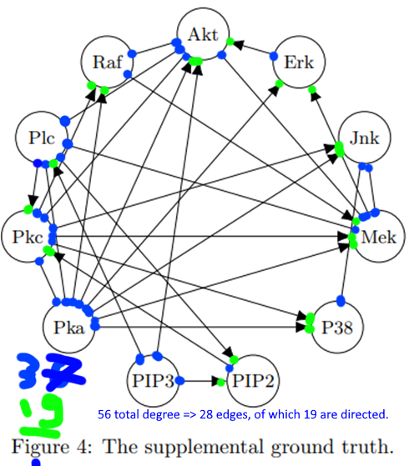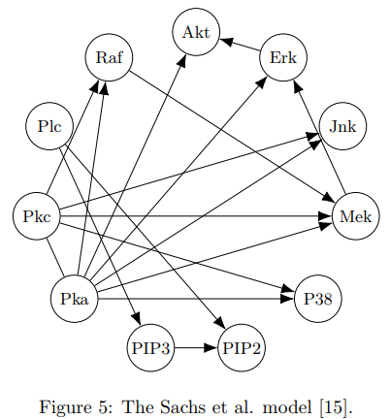*s = 17, one undirected.*

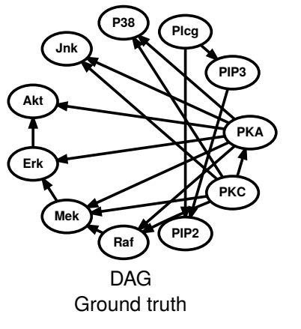 <https://www.cs.helsinki.fi/u/mkhkoivi/publications/AISTATS-2018.pdf>

**CDT Sachs data**, *s = 18* edges, bit strange most likely correct data.

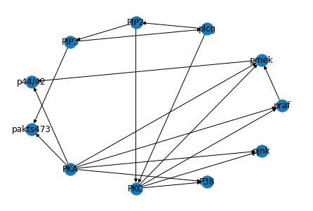



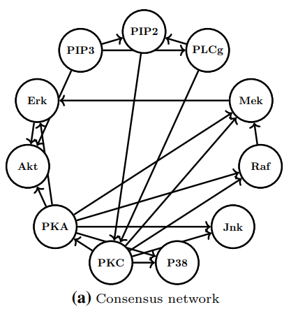

https://link.springer.com/content/pdf/10.1007/s10994-022-06145-4.pdf

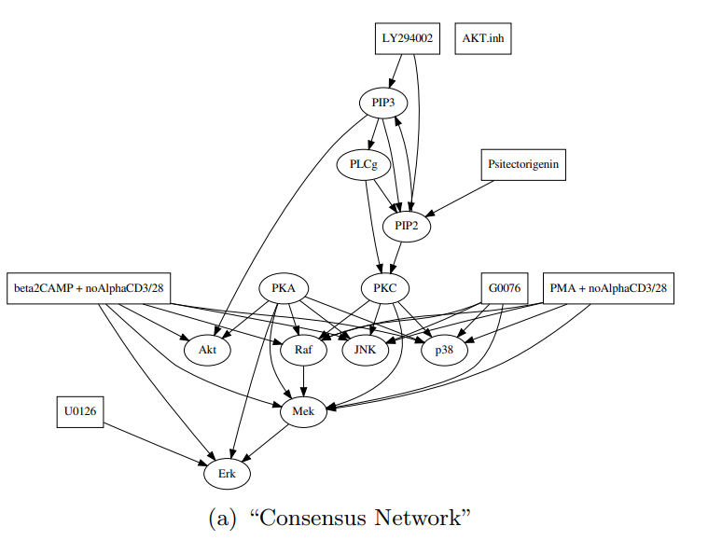

Mooij et al, same as biologists, except for PKA -> MEK



Biologists

# Data

Which dataset should be used? We know that *d = 11*, *n = 7,466, s = 20*.

In our experiments, FGS estimated 17 total edges with an SHD of 22 compared to 16 for NOTEARS with an SHD of 22.

20 arcs, estimates 16, SHD 22 -> *x* correct, 16 – *x* incorrect.

SHD = (20 – x)

*S = 17*

an SHD of 15 and 13 total edges

15 = *x* + 17 - x

# Results of Other Methods

In our experiments, FGS estimated 17 total edges with an SHD of 22 compared to 16 for NOTEARS with an SHD of 22.

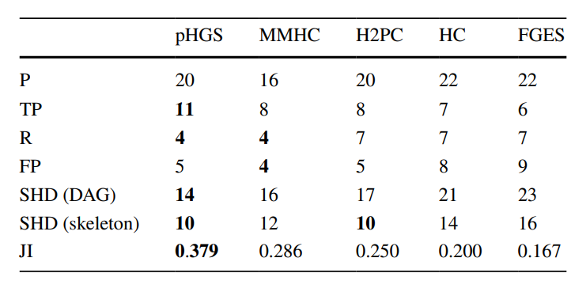

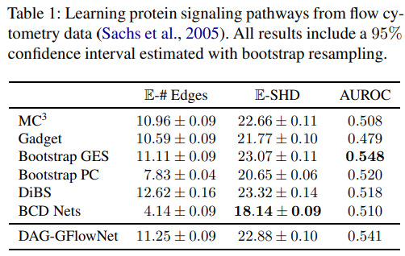

<https://arxiv.org/pdf/2202.13903.pdf#page=10&zoom=100,0,0>