**VBA-CHALLENGE SCREENSHOTS OF THE SOLUTION**

**YEAR 2018**

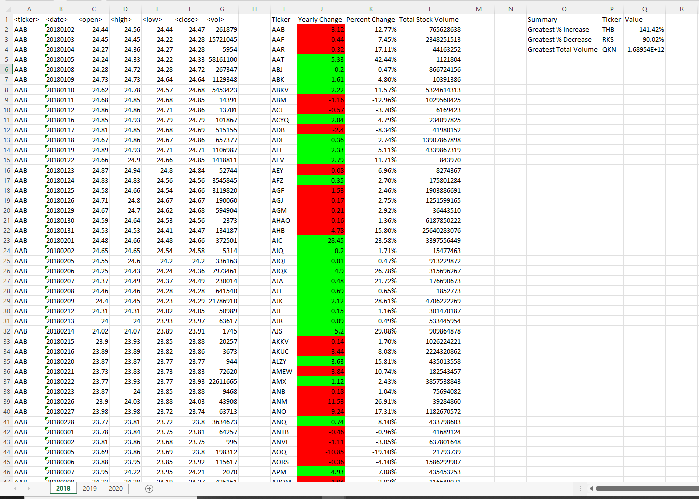

**YEAR 2019**

**YEAR 2020**

