**The completed TensorFlow SSSDS4 Model Testing**

* The converting work of SSSDS4 model (training) from Pytorch framework to TensorFlow framework has been done. The dataset used is “Mujoco/train_mujoco.npy" provided by the authors.
* Under the 300 "n_iters", 10 number of diffusion steps, small-scale experiment, the converted TF SSSDS4 model takes around 1 hour to complete the 4 batches testing data testing experiment. We have saved the testing results as .npy files on Google OneDrive in each of the batch testing (4 in total).
* The used model is loaded from the previous trained SSSD4 model at 300 iterations.
* 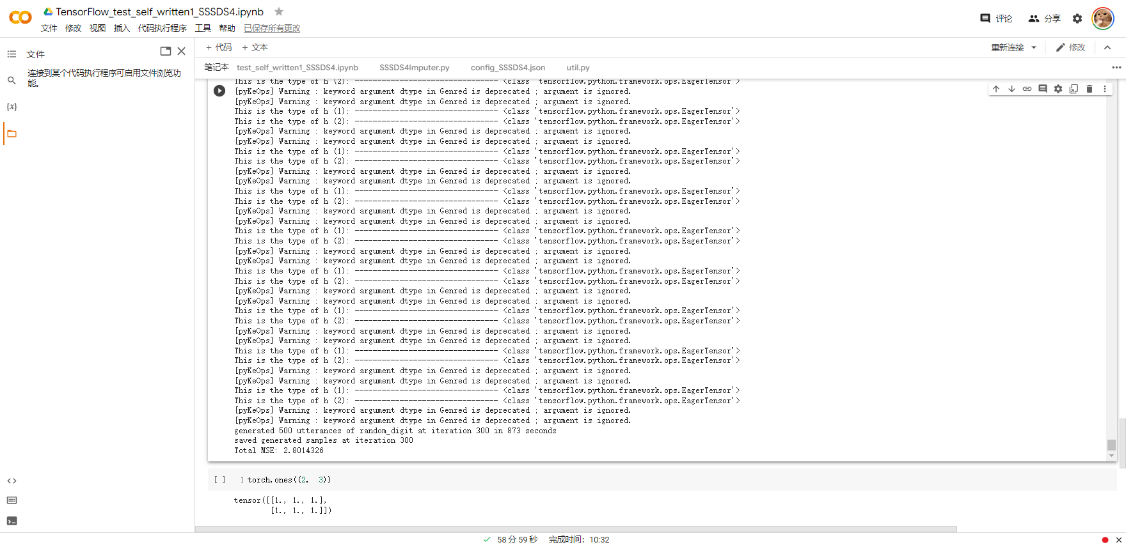

* In the next step, I will download the Yahoo Finance data to use this trained model to do imputing. After the results have been obtained, I will upload them to Github.
* Up to now, I have only used the whole sample diffusion ("only_generate_missing" = 0). I will continue to complete the partial sample diffusion ("only_generate_missing" = 1) in the future.