**Topic:**

I am interested in creating visualizations representing the health (physical and/or mental) status of U.S. citizens during a given timeframe.

*Link*: <https://www.cdc.gov/nchs/nhanes/index.htm>

**Dataset:**

All datasets will be taken from the Centers for Disease Control and Prevention (CDC). The National Center for Health Statistics contains extensive datasets storing information on demographics, diets, laboratory results, and data gathered from questionnaires. The latter contains interesting information on drug use, mental health, consumer behavior, psychologic disorders, physical activity, etc.

Each of these datasets contain a Respondent Sequence Number (SEQN) representing a unique participant identification number. I plan on using these SEQN to merge the datasets that interest me the most using SQL.

**Inspiration:**

Overall, I am interested in physical and mental health. More specifically, I am interested in variables (such as sleep, nutrition, and exercise) that affect cognitive performance. My goal is to create insightful visualizations to understand health data.

**Ideal Visuals:**

For example, the chart below shows an overall view of an individual’s health variables obtained from self-tracking devices, self-reports, and medical tests.

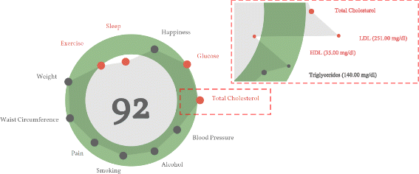

If possible, I would like to allow the user to select the SEQN and show visualizations for that individual in a meaningful way. Maybe, create a time-dependent visual with selectors as legends like the image below.

