# Website: Buy&Buy.com

## Database Design:

The following image shows the relational database model for the website. It consists of 5 tables which are discussed below:

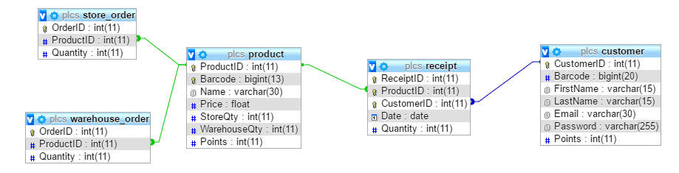

### Product:

It contains the main product catalog for the supermarket.

### Customer:

It contains the registered customers of the supermarket.

### Receipt:

It stores the list of products purchased by customers on each day.

### Store_Order:

The maximum quantity of each product present in store is 10. Whenever a purchase is made, the quantity of products in store decreases and eventually these products are ordered from warehouse. This table stores the products to be ordered from warehouse along with their quantity.

### Warehouse_Order:

The maximum quantity of each product present in warehouse is 50. Whenever the products are supplied to the store, the quantity in warehouse decreases and the products to be ordered from the supplier are stored in this table.

## Website Functionalities:

The website provides 2 interfaces, one for customers and another for the administration.

### Customer View:

Each customer is able to view his purchases and his profile, as shown below:

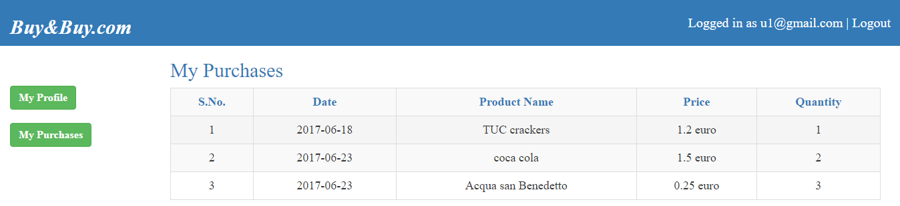 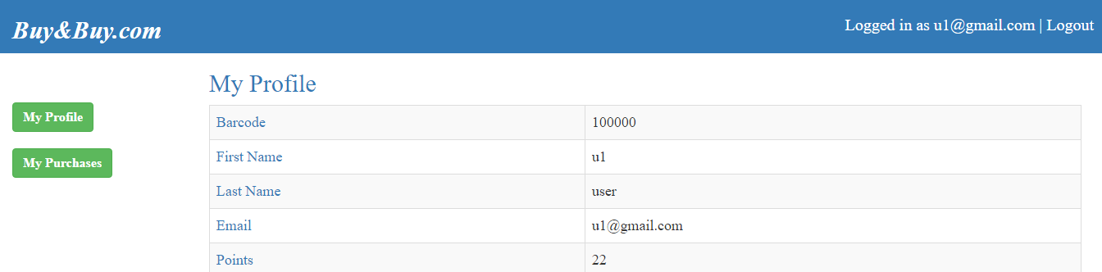

### Administration View:

The manager is able to perform the following actions:

1. View Customers
2. View Products
3. View Purchases
4. Add Product
5. Remove Product
6. Update Product

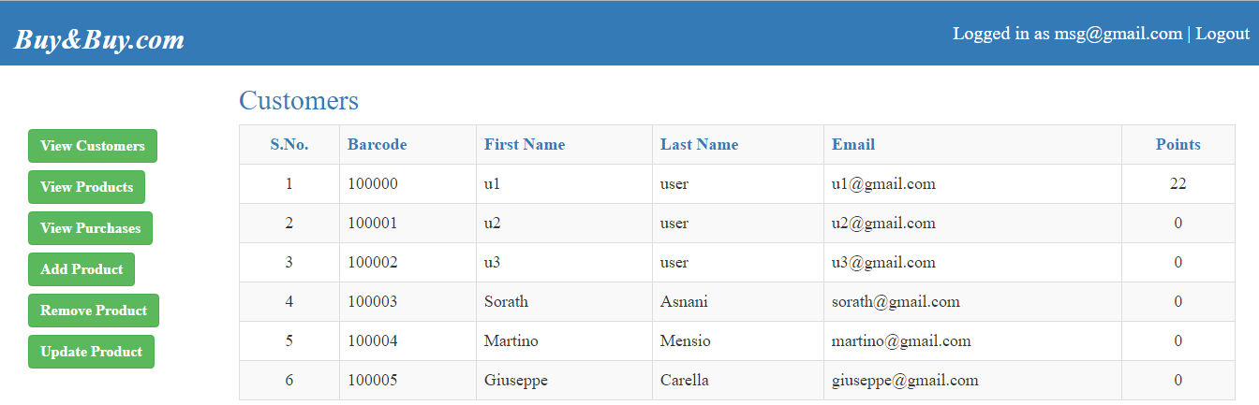

## Triggers:

The following functionalities are handled by introducing triggers into the database:

* Validation checks before registering new customers.
* Validation checks before inserting new products.
* Preparing the orders for store when a purchase is made.
* Preparing the orders for warehouse when the products are supplied to store from warehouse.
* Increasing the customer points when a purchase is done.