TEST SUMMARY REPORT

Project Name: Chowdeck Web Application

Version/Release: 1.0

Report Date: 02/04/2026

Prepared By: Martin Ikpe

Reviewed By:

Test Cycle: 2 days

Test Environment: QA (Chrome, Firefox, Edge)

1. Objective:

The objective of this testing cycle was to validate the functionality, usability, and compatibility of key features on the Chowdeck platform, including Store Navigation, Food Ordering, and Delivery Tracking.

2. Test Scope:

The following areas were covered during testing:
Features Tested:
Store Navigation
Food Ordering
Delivery Tracking

Types of Testing:
Functional Testing
Usability Testing
Compatibility Testing

Platforms Tested:
Web application (Desktop browsers)

3. Test Summary (Metrics)

Feature | Total Test Cases | Passed | Failed | Not Executed
Store Navigation | 11 | 10 | 1 | 0
Food Ordering | 13 | 10 | 1 | 2
Delivery Tracking | 10 | 1 | 0 | 9
Total | 34 | 21 | 2 | 11

4. Executive Summary

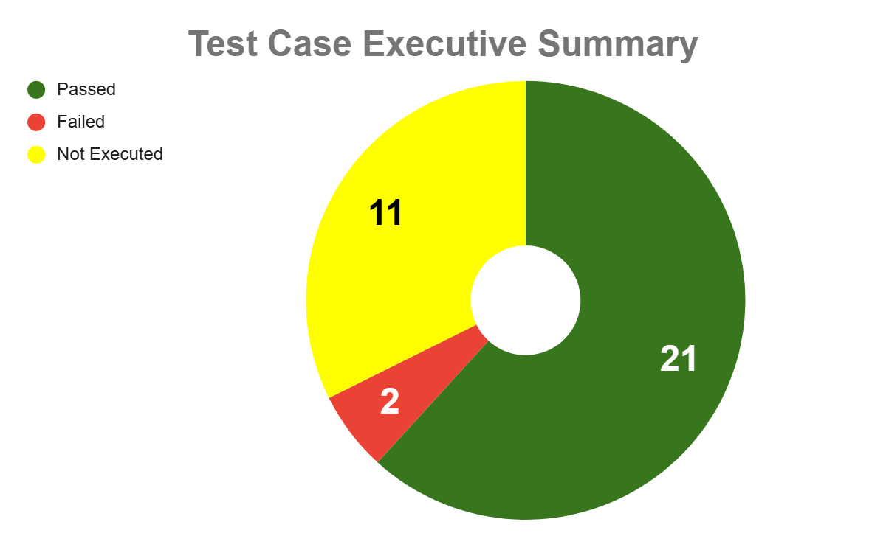
The test execution results show that out of a total of 34 test cases, 21 (61.8%) passed, 2 (5.9%) failed, and 11 (32.4%) were not executed. This indicates that while a majority of the executed tests were successful, a significant portion of test cases remains untested, which limits full visibility into the system’s quality. The low failure rate is positive, but the high number of unexecuted tests presents a potential risk to overall release confidence.

Key Insights
- Strong pass rate among executed tests indicates relative system stability.
- The low failure rate (2 cases) suggests that there are limited critical defects so far.
- A high unexecuted rate (32.4%) is a significant gap in test coverage.

4. Defect Summary

Defect Severity | Critical | High | Medium | Low | Count
Feature 1 |  |  | 1 |  | 1
Feature 2 |  | 1 |  |  | 1

6. Key Findings / Observations

* Some issues were found in the Food Ordering feature and navigation feature, particularly with the order page and layout responsiveness.
* Delivery tracking is pending due to some blockers

7. Recommendations

* Fix high-priority issues in the order page and store layout functionality before release.
* Conduct regression testing after bug fixes to confirm stability.

8. Conclusion

The application is **mostly stable**, with the majority of test cases passing successfully. However, a few critical and medium issues need to be resolved before production release. Once fixes are applied and retested, the application will be ready for deployment.

