####################### Awake - Geradeaus / Augen offen

filename men_forward.jpeg

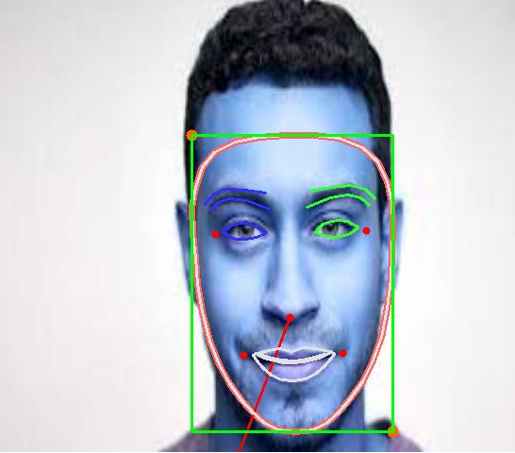

Azimuth Angle in degrees: (-69.4732949826784, -1.212537739656995)

Rot
[[-3.04274668]
[ 0.05354969]
[ 0.14664696]]
Tran
[[ 14.38069436]
[ 217.22710707]
[1532.41383204]]
NoseEndp
[[[225.59877266 610.49585119]]]

h 0
[0.05354969] [0.14664696]
v 0

Result: awake, face turned into straight direction, looking forward

-------------------------------------------------------------------------------------------------------------------
filename women_forward.jpeg

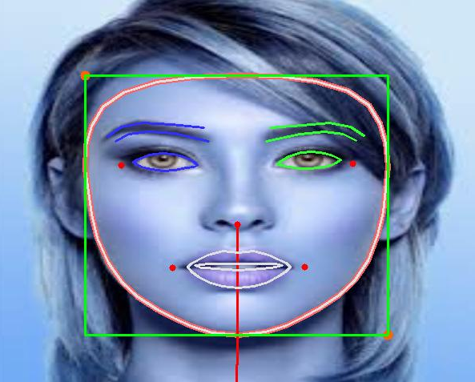

Azimuth Angle in degrees: (-89.85136067751914, -1.568202081219672)
Rot
[[-2.5766124 ]
[ 0.00969151]
[-0.00318891]]
Tran
[[ -7.82935998]
[ 126.68122692]
[1082.00003449]]
NoseEndp
[[[ 310.4759965 2024.8570173]]] [

h 0
[0.00969151] [-0.00318891]
v 0

Result: awake, face turned into straight direction, looking forward

-------------------------------------------------------------------------------------------------------------------

filename smiling_forward.jpeg

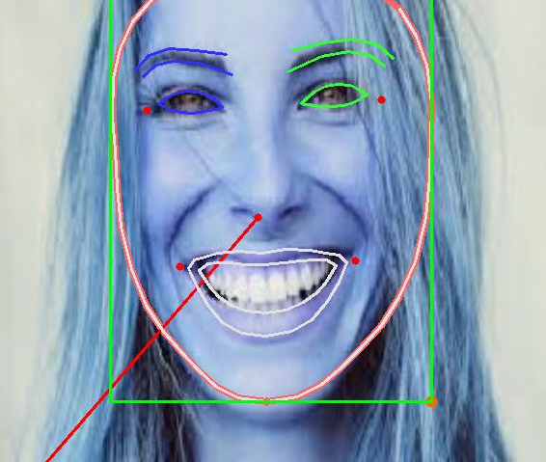

Azimuth Angle in degrees: (-49.22399097950752, -0.8591207135643948)

ROT
[[-2.9685174 ]
[ 0.04180109]
[ 0.11844103]]
Tran
[[ -39.8982631 ]
[ -36.60351896]
[1001.21113888]]
NoseEndp
[[[-3637.98384544 4787.42411252]]]

h 0
[0.04180109] [0.11844103]
v 0

Result: awake, face turned into straight direction, looking forward

####################### Drowsy - Geradeaus / Augen zu

filename child.jpeg

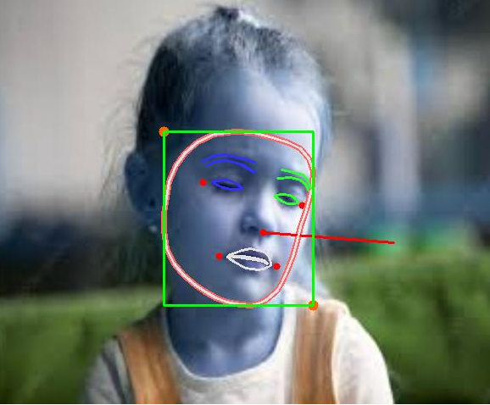

Azimuth Angle in degrees: (-175.22231136649648, -3.058206256300048)

Rot
[[-3.13790353]
[-0.28565392]
[-0.50328458]]
Tran
[[ 61.71035393]
[ 127.84449536]
[2330.16813855]]
NoseEndp
[[[494.30848911 289.89713536]]]

h 0
[-0.28565392] [-0.50328458]
v 0
Result: drowsy, face turned into straight direction, looking forward

-------------------------------------------------------------------------------------------------------------------
filename drowsy_forward.jpeg

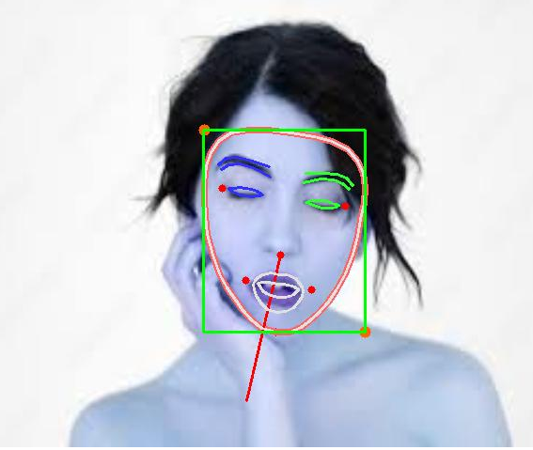

Azimuth Angle in degrees: (-77.16834629248456, -1.3468417211230146)
ROT
[[-2.89572669]
[-0.12381324]
[ 0.13652377]]
Tran
[[ 89.13835622]
[ 113.7181178 ]
[2131.675337 ]]
NoseEndp
[[[312.54235353 430.66928878]]]

h 0
[-0.12381324] [0.13652377]
v 0

Result: drowsy, face turned into straight direction, looking forward

####################### Distracted - down / Augen zu

filename distracted.jpeg
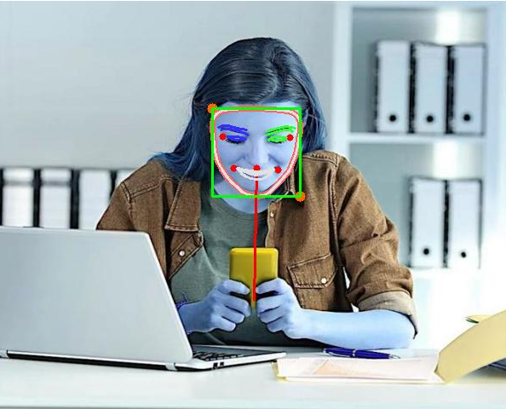

Azimuth Angle in degrees: (-88.90564274306001, -1.5516961894682002)

ROT
[[-2.26443953]
[-0.01132044]
[ 0.01887557]]
Tran
[[ 41.14967429]
[-245.97788799]
[3645.38058758]]
NoseEndp
[[[325.03340139 351.29929452]]] [

h 0
[-0.01132044] [0.01887557]
v 0
drowsy and looking straigt forward

####################### Distracted - down / Augen auf

filename boy_distracted..jpg

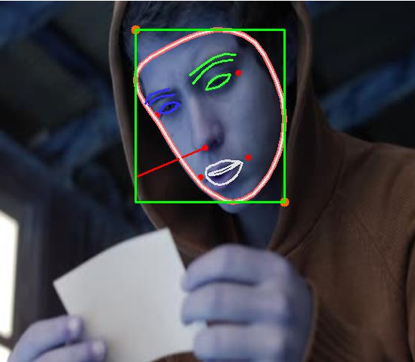

Azimuth Angle in degrees: (-23.13235476287866, -0.4037357543516248)

Rot
[[-0.82523822]
[-3.49521009]
[ 0.11708984]]
Tran
[[ -44.98459895]
[ 193.2572547 ]
[-2222.76489511]]
NoseEndp
[[[245.07361482 233.27129567]]]

h 0
[-3.49521009] [0.11708984]
v 99
awake and looking in straight direction, vertical pose not detectable

-------------------------------------------------------------------------------------------------------------------

filename girl_looking_down.jpg

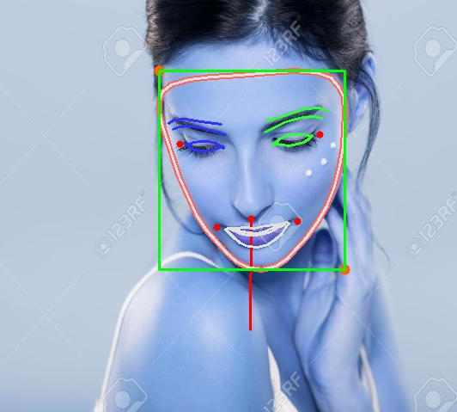

Azimuth Angle in degrees: (-89.85155562206792, -1.568205483643907)

Rot
[[-0.06681439]
[-2.91811058]
[ 0.99885684]]
Tran
[[-1.85947378e+02]
[ 4.37978727e-01]
[-1.92937981e+03]]
NoseEndp
[[[379.6639591 383.70300654]]]

h 0
[-2.91811058] [0.99885684]
v 99

Result: drowsy, face turned into straight direction, looking downward

####################### Sideview - straight / Augen auf

filename fromside.jpg

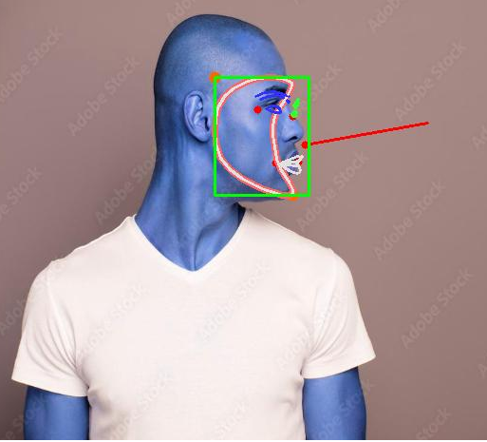

Azimuth Angle in degrees: (170.09285552165642, 2.9686803629719214)

Rot
[[ 0.06511962]
[-1.99719842]
[-0.26420904]]
Tran
[[ -217.25481785]
[ 449.59148613]
[-3737.08330243]]
NoseEndp
[[[492.66965196 146.35236092]]]

h -1
[-1.99719842] [-0.26420904]
v 99

Result: drowsy, face turned into left direction, looking forward

-------------------------------------------------------------------------------------------------------------------
filename sideview2.jpg
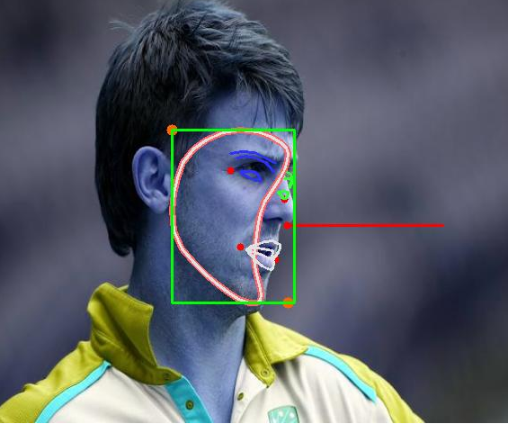

Azimuth Angle in degrees: (-179.74754376590226, -3.137186461087602)

Rot
[[-0.51019421]
[ 4.12082552]
[ 0.20985771]]
Tran
[[ -41.06084603]
[ -69.19197477]
[-2470.11819707]]
NoseEndp
[[[510.95364526 260.76647821]]]

Result: drowsy, face turned into left direction, looking forward

filename: sideview_right.jpg
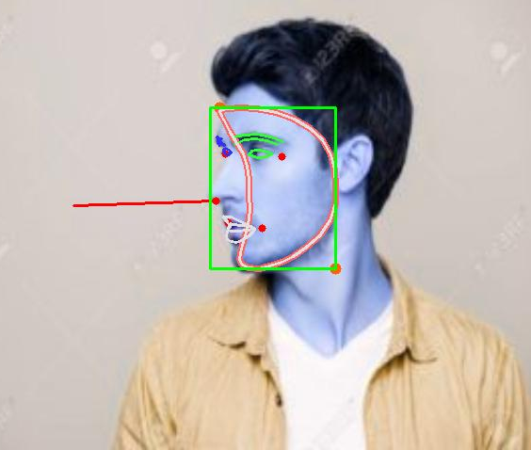

Azimuth Angle in degrees: (-2.1998525961366937, -0.038394670861130395)

Rot
[[ 0.02938148]
[ 2.13397595]
[-0.02947828]]
Tran
[[ 78.84364877]
[ 131.58076233]
[-2756.08002243]]
NoseEndp
[[[140.30704046 220.78865131]]]

h 1
[2.13397595] [-0.02947828]

Result: drowsy, face turned into right direction, looking forward

####################### Sideview awake - up / Augen auf

filename rightside.jpg

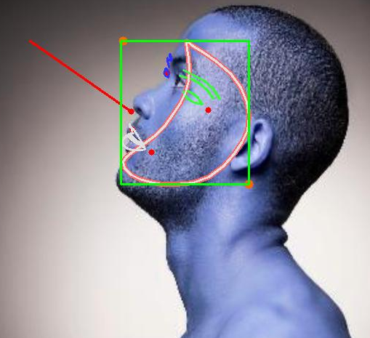

Azimuth Angle in degrees: (34.99294129262257, 0.6107420405133444)

Rot
[[-0.62676039]
[ 2.00594409]
[ 0.34026924]]
Tran
[[ 100.90271398]
[ 300.83320969]
[-2383.49644683]]
NoseEndp
[[[135.5840744 66.10553651]]]

h 1
[2.00594409] [0.34026924]
v 99

Result: awake, face turned into right direction, looking upward

####################### Frontview - up / Augen auf

filename men_looking_up.jpeg
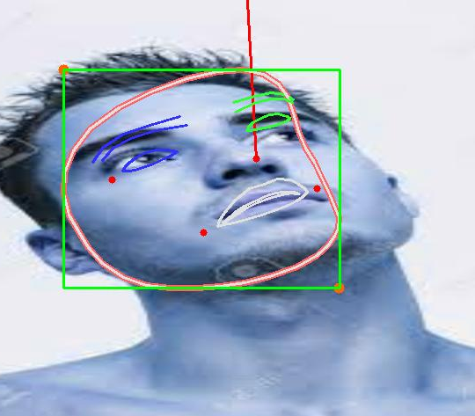

Azimuth Angle in degrees: (86.80409001890501, 1.5150171750274393)

Rot
[[ 2.35073791]
[-0.49659943]
[ 0.1218794 ]]
Tran
[[ 52.44641827]
[-157.54035003]
[1305.51511331]]
NoseEndp
[[[ 320.09533452 -695.84579829]]]

h 0
[-0.49659943] [0.1218794]
v 0

Result: awake, face turned into straight direction, looking upward

