Artificial-Intelligence
Application of AI methods for multimodal heart disease diagnostic
Abstract:
During the medical and healthcare profession there are always new advancements and technology being produced to allow for medical predictions to become more expected and resourceful.
Artificial Intelligence (AI) has emerged as a powerful approach for enhancing medical diagnosis through data-driven analysis. Machine learning models can identify complex patterns in patient data that may not be immediately apparent through conventional analysis.
Introduction:
Supervised learning methods are well suited to disease prediction tasks where labelled clinical datasets are available. Within this Coursework the focus of different AI techniques to diagnose heart diseases using both datasets to discover ways heart disease can be detected using both raw patient data[dataset1] and a mixture of x-ray images[dataset2] can allow outcomes to be recognized within all 3 tasks using deep learning and machine learning with various models as further references of accurateness.

Background:
The NHS (National Healthcare Service) are constantly undertaking different approaches to ease the pressure on their workforce and most importantly to improve their patient’s overall health as the common difficulties are understanding and evaluating the patients’ symptoms as physical tests aren’t always accurate, which leads to incorrect diagnosis and treatments being administered. The use of AI in the Healthcare profession can allow vast amounts of data to be investigated and analyzed to benefit the professionals to help the patients’ symptoms and provide the correct medical attention.
Machine learning is widely used in healthcare for disease prediction using supervised classification models trained on labelled patient data, including demographics and clinical measurements. These supervised classification models have been incorporated with tabular/raw patient data to allow predictions on diseases and symptoms to be discovered faster as opposed to regular in person methods. Binary classification is commonly used for disease screening to determine presence or absence, supporting early detection. Multiclass classification predicts disease severity levels, providing more detailed clinical insight but increasing model complexity.
Algorithms frequently applied to tabular medical data include Decision Trees for interpretability, Naïve Bayes for efficiency, Random Forests for improved accuracy, linear models such as SVMs, and Artificial Neural Networks for modelling non-linear relationships. Performance is evaluated using metrics such as accuracy, precision, recall and F1 score which are critical in medical contexts due to the risks of misclassification.
Although the recent applications that have been invented to support the medical industry these AI models aren’t always very accurate or reliable due to machine learning unpredictability and inputting images/data can have errors like image quality being unclear or class imperfections could persist leading to unreliable results. A systematic literature review by Hossein Sadr [2025] reports that machine learning methods can allow clarifications in heart disease diagnosis; although, results are only valid if data preprocessing , feature selection, evaluation methodology, and overall dataset quality are accurately provided.

Methodology and Data
Task 1
Dataset 1 contains structured patient health data, with a target label indicating heart disease severity from 0 to 4. Two models are developed: a binary classifier to detect the presence of heart disease and a multiclass classifier to predict severity levels. Data preprocessing includes handling missing values, encoding categorical features, and standardising numerical attributes. Several machine-learning models are trained and evaluated using accuracy, precision, recall, F1-score, and confusion matrices to compare performance.
Task 2
Dataset 2 consists of X-ray images across multiple disease categories. Six cardiovascular-related conditions are grouped as heart disease, while all others are treated as non-heart disease. Images are resized, normalised, and split into training, validation, and test sets using stratified sampling. A Convolutional Neural Network (CNN) is implemented to extract image features and perform classification. Model performance is evaluated using accuracy, precision, recall, and confusion matrices to assess classification balance.
Task 3
This task explores image quality enhancement using generative models. Gaussian noise is added to X-ray images to simulate poor image acquisition conditions. A denoising autoencoder is trained to reconstruct clean images from noisy inputs. The encoder compresses image information into a latent space, while the decoder reconstructs the image. Performance is evaluated visually and quantitatively using Mean Squared Error (MSE) and Root Mean Square Error (RMSE).

Analysis and Discussion
Task 1(a):
Throughout the binary task to identify the models that would achieve the highest accuracy was relatively a huge success based on all five models giving an accuracy rating of above 75%. The Naïve Bayes (Gaussian) was the most successful with a rating of 0.8696 (87%) whereas the lowest was Decision Tree which had a value of 0.7663 (77%), this difference could advocate the potential biased results in the training dataset1 for dissecting patients records.
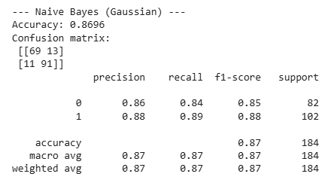
Figure 1: Binary Classification and Matrix for Naïve Bayes (Gaussian)
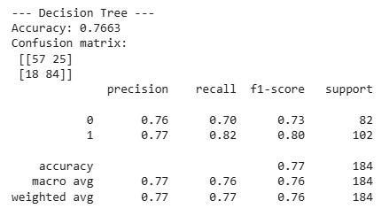
Figure 2: Binary Classification and Matrix for Decision Tree
Task 1(b):
The Multiclass (0-4) was deemed harder to distinguish the heart severity diseases mainly due to clashes between the severity categories, this was a reduction for higher disease classes. Linear SVM was overall the best accuracy rating of 0.5924 and Naïve Bayes had a result of 0.4457.

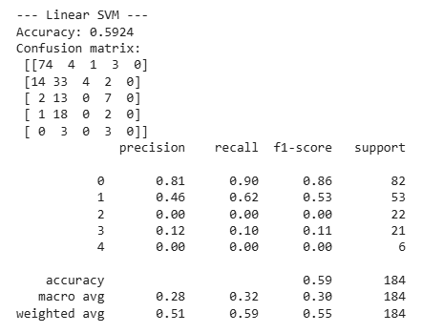
Figure 3: Linear SVM

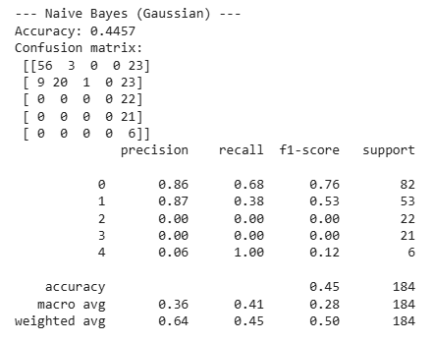
Figure 4: Naïve Bayes (Gaussian)

Task 2 X-ray images
Binary CNN was designed to distinguish the difference between Heart and Non-Heart related problems by examining X-ray images. Throughout this task the use of CNN classification between images was a middling success of 0.60 for the accuracy. This medical analysis has shown values that were unaccounted for possibly due to similarities between images. The matrix analyses the missing unaccounted images.
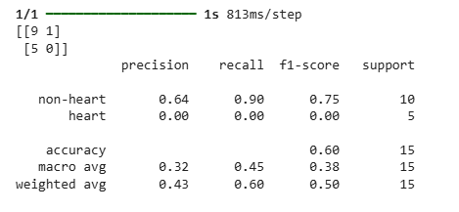
Figure 5: Matrix for CNN

Task 3:
The image reconstruction task was an implementation of Gaussian noise to various X-ray images to train a Keras Model to reconstruct original images back to their original form. The noise was added whilst maintaining the original structural integrity of the images using 100 epochs to control the loss of data and overall the images were reconstructed very similarly to the original, but the loss of data was evident, mainly due to the model being not very advanced or well distinguished. The results were good with Root-MSE of 0.155 and Relative-MSE of 0.2804
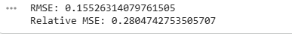
Figure 6: relative/root MSE
Conclusions and recommendations for the future
Throughout this coursework the use of different methods in both Deep Learning and Machine Learning have been evaluated to determine their usage for the medical and healthcare industries regarding how they are used to diagnose and predict data based on the input provided. During tasks 1, 2 and 3 it became clear of which models could become beneficial towards the medical professionals.
Robust preprocessing and data analyzation of tabular data amidst Dataset1 was seen as a huge success due to the valuations of accuracy being significantly high and almost reaching 100% accuracy based on the results of each model that was tested. These results can be seen as a huge beneficiary for healthcare as they were displayed with additional results that further identify they were calculated correctly.
However, with usage of multi file structures being presented encountered various misalignment and results which were incorrectly perceived as there was data leakage evident throughout the results when testing. During the analysis and discussions, the usage of data testing became a biased preposition of data as there wasn’t a diverse patient population (Mehrabi et al., 2021).
Within tasks the usage of various models could be deemed as very simple and not advanced enough for real world problems as their level of work was lesser than more advanced and popular high-end models. (Doshi-Velez & Kim, 2017), a decision by many healthcare professionals.
For the future of Machine and Deep learning technologies like Artificial Intelligence Models being used was very understandable to be very useful yet certainly there are huge needs for improvement on collecting and analyzing the data. Methods that should be implemented for future use are real world time monitoring to address and capture all health symptoms/conditions (Jameil, A. K., & Al-Raweshidy, H. 2025). Similarly, using combined models (ensemble) can provide a higher insight of accuracy. But overall, the most important future factor is a persistent prioritisation of patients data is maintained to ensure data isn’t leaked or displayed to systems or individuals that aren’t permitted to them, that may also be a mitigating factor to incorrect or mathematical biased related results. Jameil, A. K., & Al-Raweshidy, H. (2025).

Bibliography
Sadr, H. (2025). Unveiling the potential of artificial intelligence in revolutionizing disease diagnosis and prediction. European Journal of Medical Research. https://Unveiling the potential of artificial intelligence in revolutionizing disease diagnosis and prediction: a comprehensive review of machine learning and deep learning approaches | European Journal of Medical Research
University of Bradford. Lecture 5: Introduction to Classifications.
University of Bradford. Lecture 8: ML Deep Learning.
Doshi-Velez, F., & Kim, B. (2017). Towards A Rigorous Science of Interpretable Machine Learning. arXiv preprint arXiv:1702.08608. (Accessed: 14 January 2025).
Mehrabi, N., Morstatter, F., Saxena, N., Lerman, K., & Galstyan, A. (2021). A Survey on Bias and Fairness in Machine Learning. ACM Computing Surveys, 54(6), 1–35. (Accessed: 14 January 2025).
Jameil, A. K., & Al-Raweshidy, H. (2025). A digital twin framework for real-time healthcare monitoring: Leveraging AI and secure systems for enhanced patient outcomes. Discover Internet of Things, 5(1), 37-. https://doi.org/10.1007/s43926-025-00135-3
Jameil, A. K., & Al-Raweshidy, H. (2025). A digital twin framework for real-time healthcare monitoring: Leveraging AI and secure systems for enhanced patient outcomes. Discover Internet of Things, 5(1), 37-. https://doi.org/10.1007/s43926-025-00135-3
University of Bradford. Lecture 9: Generative Models.

