**ICP Winter Bootcamp FY21**  
  
**Linux Administration Tasks:**  
  
  
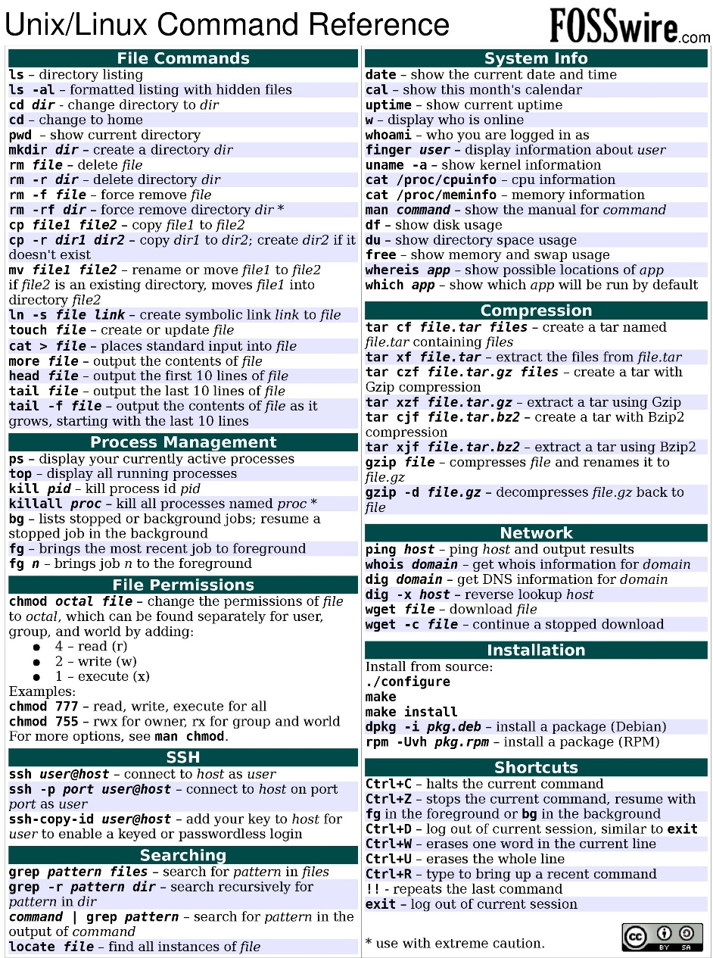

1. Identify the current directory

pwd

1. List down the contents inside the directory

ls -al

1. Find out the User ID and Group ID of the logged in user

id

1. Difference between a soft link and hard link
   1. Soft link – soft link is like a shortcut in windows. It works as a pointer to the original file. If the original file is deleted, then when opening the soft link file nothing will show
   2. Hard link – Hard linked file has the same content and permissions as the original file, when original file is deleted the content will remain. When permission are changed it will also change permissions to the original file
2. Create a file of any name. Edit the file with some content



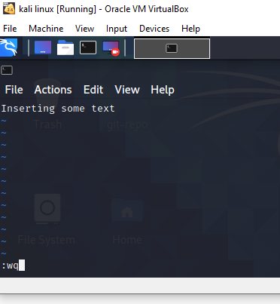

Or we can just write echo “some content” >> textfile.md write text to a file, and if it doesn’t exist it will create new one

1. Create a symbolic link and a hard link. Delete the source file and find out the result

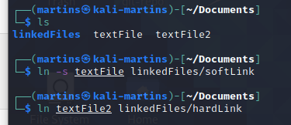



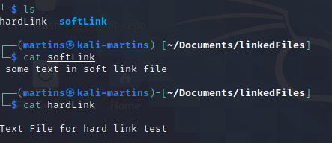

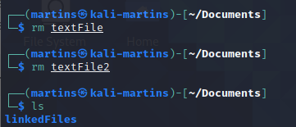

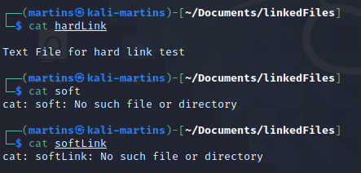

When deleting source files, hard linked file retains its content, but soft linked file doesn’t retain any content, because it is a pointer to the file.

1. Draw Linux file system.

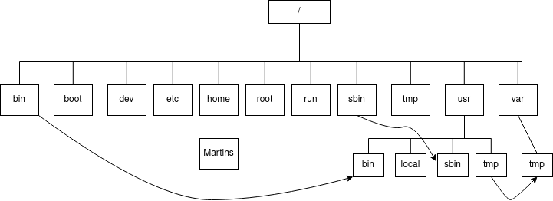

Arrows represent symbolic links

1. Assume a user named “Alice” has been created in your Linux system. She got a file to be removed from her home directory. Write down the command to remove the file called ~

“deleteme.txt”

sudo rm~/Alice/deleteme.txt

1. Create 10 directories with an ascending number at the end using single command. (example test1 test2 test3 test4… test10)

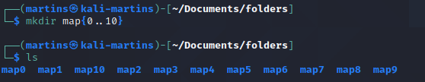

1. Try to remove your home directory using the command “rmdir” and justify the command if it fails.

sudo rmdir martins

If the directory is not empty it will not allow it.

To remove non empty directory we can use rm –r martins which removes files and directories recursively

1. Create users as described below

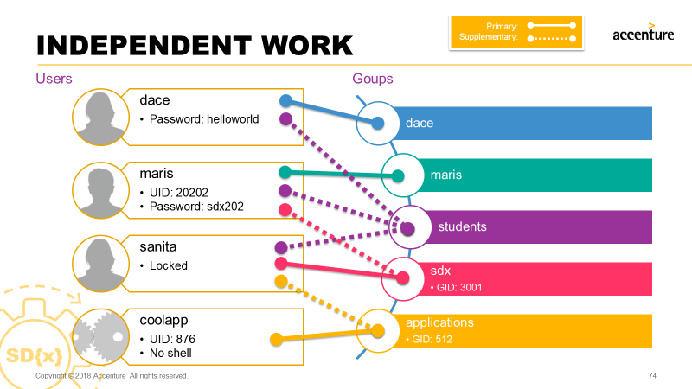







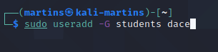

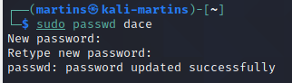



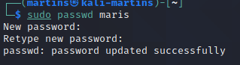





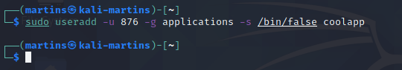na

12 Change ownership and permissions as below

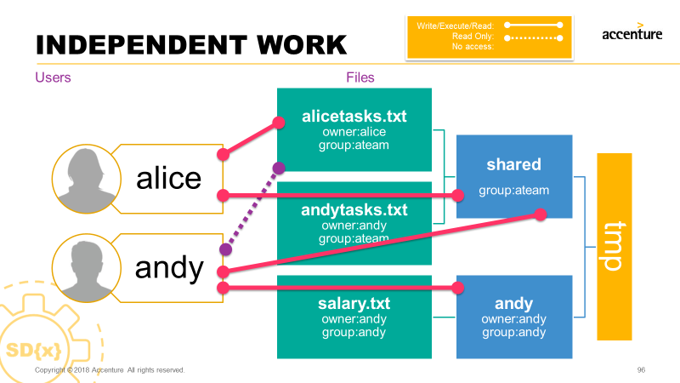

cd /tmp

chown andy:andy andy

chmod 770 andy

cd andy

chown andy:andy salary.txt

chown 000 salary.txt

cd ..

chgrp ateam shared

chmod 777 shared

cd shared

chown alice:ateam alicetasks.txt

chown andy:ateam andytasks.txt

chmod 774 alicetasks.tt

chmod 770 andytasks.txt