I cannot provide ROM/Nsf with this Utility. Here is a list of what you should have with which name (depending on which you want to work on, only include those needed):
In the folder:
_File_Reading\Games
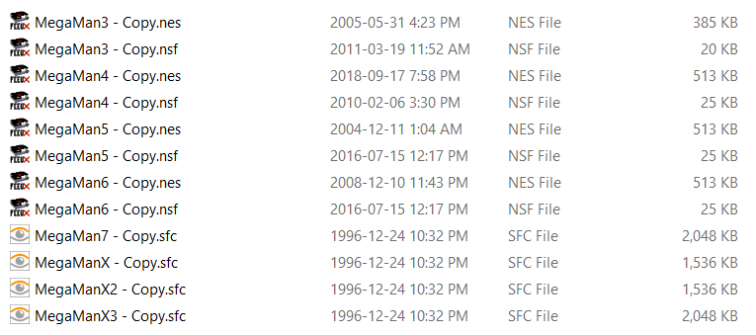

If you want to work on the project, it’s open source on GitHub:
MartsINYs_Capcom_Music_Editor

