

## **DEPARTMENT OF ELECTRONICS AND COMMUNICATION ENGINEERING OF KLE TECHNOLOGICAL UNIVERSITY**

## **HUBLI, KARNATAKA**

## **2022 – 2023**

**by**

1. **Sharatkumar S Kondikoppa - Final Year B.E**

**Email:** [**01fe19bec198@kletech.ac.in**](mailto:01fe19bec198@kletech.ac.in)

**Contact:7899513110**

1. **Suyash D Kori - Final Year B.E**

**Email:** [**01fe19bec200@kletech.ac.in**](mailto:01fe19bec200@kletech.ac.in)

**Contact:9945525158**

1. **D. Shreyas - Pre Final Year B.E**

**Email:** [**01fe20bec136@kletech.ac.in**](mailto:01fe19bec200@kletech.ac.in)

**Contact: 8105832178**

1. **Shobith Bankapur - Pre Final Year B.E**

**Email:** [**01fe20bec047@kletech.ac.in**](mailto:01fe20bec047@kletech.ac.in)

**Contact: 9916396303**

1. **S. Chandu - Pre Final Year B.E**

**Email:** [**01fe20bec328@kletech.ac.in**](mailto:01fe20bec328@kletech.ac.in)

**Contact: 9353653062**

1. **Prajwal T. P. - Pre Final Year B.E**

**Email:** [**01fe20bec218@kletech.ac.in**](mailto:01fe20bec218@kletech.ac.in)

**Contact: 9620728383**

**ACKNOWLEDGEMENT**

We would like to express our sincere gratitude towards Edutech India for organizing such a valuable internship program for us. We are grateful to KLE Technological University, School of Electronics and Communication Engineering for selecting us to be a part of this internship program.

We would like to extend our heartfelt thanks to Dr. Nalini Iyer, the Head of the Department, and Prof. Rohit Kalyani for their guidance and support in recommending us for this internship. Their encouragement and advice helped us gain valuable knowledge and experience in our field of study.

We are also grateful to our mentor, Prakash Kannaiah, for sharing his expertise and knowledge with us. His guidance and mentorship were invaluable in shaping our understanding of the industry and developing our skills.

Last but not least, we would like to thank the HR team at Edutech India for their constant support and assistance throughout the internship period. Their efforts helped to create a positive and conducive work environment, which facilitated our learning and development.

Once again, thank you to everyone who has contributed to our growth and development during this internship program.

-The Team

**ABSTRACT**

In this Internship we learnt about the basic understanding of self driving car and ADAS system also got to know about setup and basics of QUARC software .We interfaced the different Hardware system of Quanser Qcar ,Depth camera, LIDAR, Buzzer and Limitations of the system. Then we implemented some ADAS features such as ACC using Depth camera ,Forward collision warning system ,Automatic emergency braking and also we operated on the LIDAR, and got to know how to operate the Buzzers etc. Also worked on Automatic emergency braking and Forward collision warning using buzzer. At last we had a chance to discuss fleet management (V2V communication) and we further look ahead to work on it after going back to college.

In summary we got to explore almost every hardware system of Qcar and got hands-on experience with hardware and learnt different constraints of the hardware and how to overcome it.

**INDEX**

**SL.No Content**

1. Introduction
2. Topic covered

i. Difference between Self Driving cars and ADAS system

ii. Depth camera use in ACC(Adaptive cruise control)

Iii. Forward Collision warning system.

iii. Use of 2D-Lidar in ACC

1. Conclusion.

**Learning Objectives/Internship Objectives**

1. Gaining practical experience: One of the primary objectives of an internship is to apply theoretical knowledge gained in the classroom to real-world engineering projects. Internships provide an opportunity to work on practical tasks, understand industry practices, and develop hands-on skills.

2. Exploring a specific engineering discipline: Internships allow students to explore different areas of engineering and gain exposure to various sub-disciplines. This helps in narrowing down interests and identifying the field or industry that aligns with their passion and career goals.

3. Networking: Building professional connections is crucial for future career growth. Internships provide an excellent opportunity to network with professionals in the industry, including engineers, mentors, and potential employers. Networking can lead to valuable references, recommendations, and job opportunities in the future.

4. Developing teamwork and communication skills: Engineering projects often require collaboration and effective communication. Internships offer a chance to work in a team environment, interact with colleagues, and enhance interpersonal skills. Developing strong teamwork and communication skills is essential for success in engineering careers.

5. Learning industry-specific tools and software: Many engineering fields rely on specialized software and tools for design, analysis, and project management. Internships allow students to familiarize themselves with these industry-specific tools, which can be valuable assets when entering the job market.

6. Problem-solving and critical thinking: Engineering internships provide opportunities to tackle real-world problems and challenges. Through these experiences, students can enhance their problem-solving and critical thinking skills, learning to analyze issues, propose solutions, and make informed decisions.

7. Time management and project execution: Internships often involve working on specific projects or assignments with deadlines. Learning to manage time effectively, prioritize tasks, and deliver quality work within given timeframes is a crucial skill for engineering professionals.

8. Professional development: Internships offer a platform for personal and professional growth. Students can gain insights into the professional work environment, understand industry norms and ethics, and develop a professional demeanor.

Remember that internship objectives can be personalized based on your specific interests and career aspirations. It's essential to discuss your objectives with your internship supervisor or mentor to ensure you make the most of your internship experience.

**DAILY REPORT**

In this table we mentioned the topic or task we completed each day under the guidance of the mentor.

| DATE | DAY | NAME OF THE TOPIC |
| --- | --- | --- |
| 2/05/2023 | Tue | Basic understanding of SD and ADAS system,Installation of Quarc software |
| 3/05/2023 | Wed | Worked on Depth camera and got to know it’s use in ACC feature |
| 4/05/2023 | Thu | Implemented the code of ACC feature on the Qcar.Worked on Forward Collision warning output as Buzzer. |
| 5/05/2023 | Fri | Worked on the LIDAR sensor data processing and data extraction. |
| 6/05/2023 | Sat | Implemented the code on the Qcar about LIDAR and discussed fleet management. |

**INTRODUCTION**

Self-driving cars, also known as autonomous vehicles (AVs), are vehicles equipped with advanced technologies that enable them to operate and navigate without human intervention. These vehicles use a combination of sensors, algorithms, and artificial intelligence (AI) to perceive the surrounding environment, make decisions, and control the vehicle's movements.

One of the key components of self-driving cars is Advanced Driver Assistance Systems (ADAS). ADAS refers to a set of technologies and features designed to enhance vehicle safety and improve driving experience by assisting the driver in various ways. These systems can be found in both traditional human-driven vehicles and autonomous vehicles, acting as building blocks for the development of self-driving capabilities.

ADAS includes a wide range of features and technologies, such as:

Adaptive Cruise Control (ACC): ACC maintains a safe distance from the vehicle ahead by automatically adjusting the vehicle's speed. It uses sensors, such as radar or cameras, to detect the distance to the preceding vehicle.

Lane Departure Warning (LDW) and Lane Keep Assist (LKA): LDW uses cameras or sensors to monitor the vehicle's position within the lane. It alerts the driver if the vehicle unintentionally drifts out of the lane. LKA takes it a step further by actively steering the vehicle back into the lane.

Automatic Emergency Braking (AEB): AEB systems use sensors to monitor the road ahead and detect potential collisions. If a collision risk is detected, the system can automatically apply the brakes to mitigate or avoid the impact.

Blind Spot Detection (BSD): BSD systems use sensors to monitor the vehicle's blind spots, typically on the sides or rear. They provide visual or audible alerts to the driver if another vehicle is detected in the blind spot, helping prevent accidents during lane changes.

Parking Assistance: This feature assists drivers in parking their vehicles by providing guidance through visual or audio cues. It can also automatically control steering inputs during parallel parking.

Traffic Sign Recognition (TSR): TSR systems use cameras or sensors to detect and recognize traffic signs, such as speed limit signs, stop signs, and yield signs. The system then displays the detected information to the driver, enhancing their awareness.

Surround View Systems: These systems utilize multiple cameras positioned around the vehicle to create a bird's-eye view or 360-degree view of the surroundings. They help drivers navigate tight spaces and avoid obstacles during low-speed maneuvers.

It's important to note that while ADAS technologies provide assistance to drivers, they still require human attention and intervention. The development of fully autonomous self-driving cars is an ongoing area of research and development, with many companies and organizations working towards achieving that goal.

**TOPIC COVERED**

**Difference between Self driving cars and ADAS system.**

ADAS (Advanced Driver Assistance Systems) is not the same as a self-driving car, but it is a part of the technology that enables self-driving cars. ADAS refers to a suite of technologies designed to assist drivers in operating a vehicle more safely, including features such as automatic emergency braking, lane departure warning, and adaptive cruise control.

While these systems can take some of the workload off of drivers, they still require human intervention and oversight. Self-driving cars, on the other hand, are designed to operate without human intervention, relying on sensors, cameras, and advanced algorithms to navigate roads and make decisions.

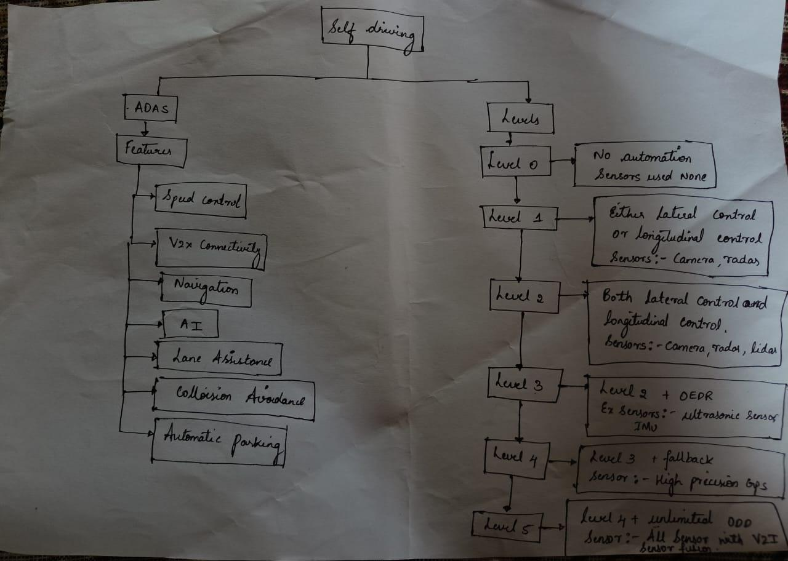

In summary, ADAS is a component of the technology that enables self-driving cars, but it is not the same as a fully autonomous vehicle.

**Depth camera use in ACC(Adaptive cruise control).**

Adaptive cruise control (ACC) is an advanced driver assistance system that automatically adjusts the speed of a vehicle to maintain a safe distance from the vehicle in front. It relies on sensors to detect the distance and speed of the vehicle in front and adjust the throttle or brakes accordingly. While radar and lidar sensors are commonly used in ACC systems, depth cameras are also gaining popularity due to their ability to capture both depth and color information.

Depth cameras, also known as time-of-flight cameras, use infrared light to create a depth map of the environment. This depth map can be used to detect the distance to objects, including other vehicles, pedestrians, and obstacles. In ACC systems, depth cameras can be used in conjunction with radar and lidar sensors to provide a more comprehensive view of the environment and improve the accuracy of distance and speed estimation.

The use of depth cameras in ACC systems has several advantages. Depth cameras are less affected by weather conditions such as rain, snow, and fog, which can impact the performance of radar and lidar sensors. They also have a wider field of view and can capture more information about the environment, which can improve the responsiveness of the ACC system and reduce the risk of collisions.

However, there are also some challenges associated with the use of depth cameras in ACC systems. Depth cameras may have lower resolution compared to radar and lidar sensors, which can affect the accuracy of distance and speed estimation. They also require more processing power to generate depth maps, which can increase the computational load on the ACC system.

Hardware details of the depth camera that is mounted on the Qcar.

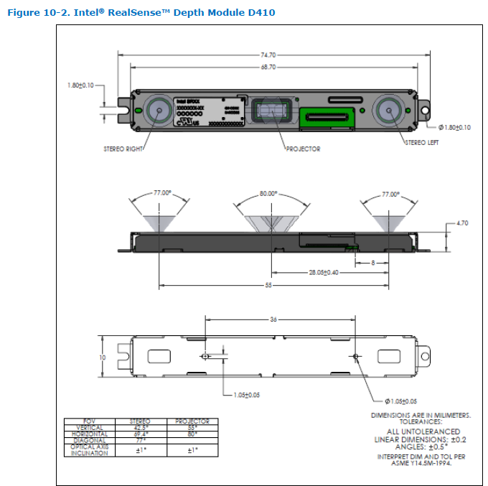

The depth camera we used gives output in 8 bit which gives output at 8 different levels of intensities from which the depth of the object can be calculated in the given region of interest.

The model we programmed has a variable region of Interest(ROI). Because when the vehicle is heading in a curve path the object in the front shifts its position if we don't shift the ROI of the depth camera the object will go undetected.

The fig.1 has a block known as Obstacledetection2 which helps in the detection of depth of the object which comes under the ROI.

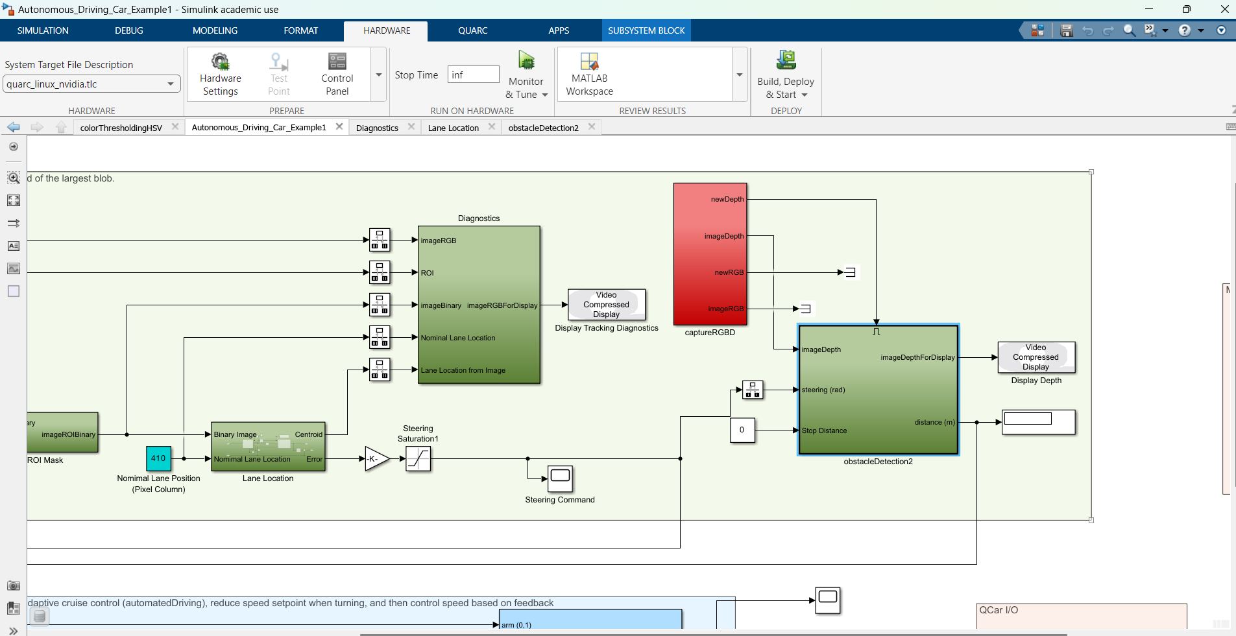

fig.2

In the figure I have written the code that 1st we take each frame that depth camera is produced and then divides the frames into 9 equal parts then we select the middle block and then *steering* is variable which consist of heading angle . As the vehicle turns to the right the ROI boundary starts to extend at right as steering value increases similarly at the left side too.

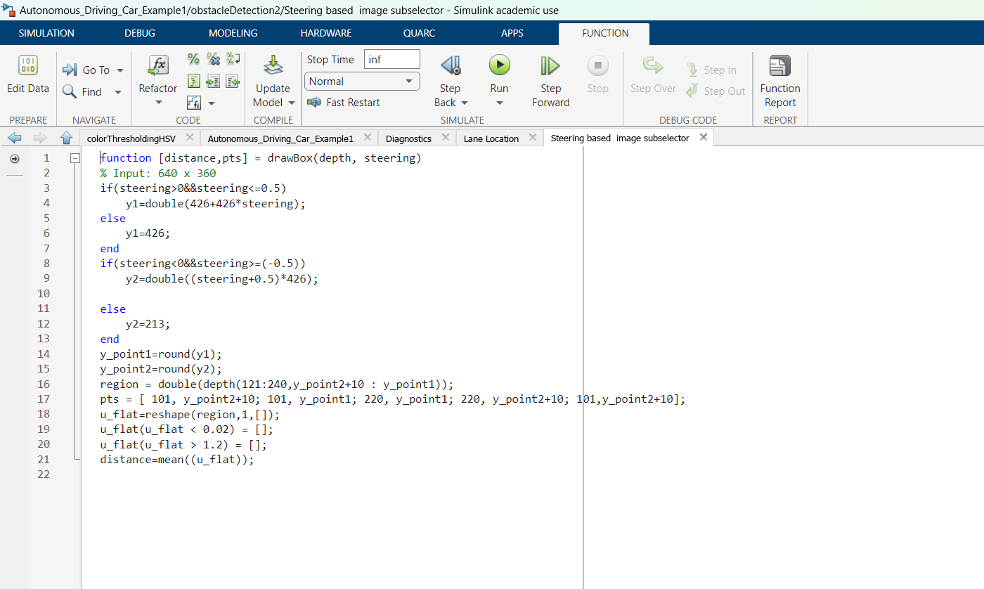

Fig.3

Overall, the use of depth cameras in ACC systems is a promising technology that can improve the safety and performance of vehicles on the road. As depth camera technology continues to evolve, it is likely that we will see more widespread adoption of this technology in the future.

**Forward Collision warning systems**

Using the above model we can build another application that is Forward collision warning system when the vehicle gets closer to the object by crossing the range of ACC or If the object approaches closer to the vehicle it can give the alert by playing Buzzer sound.

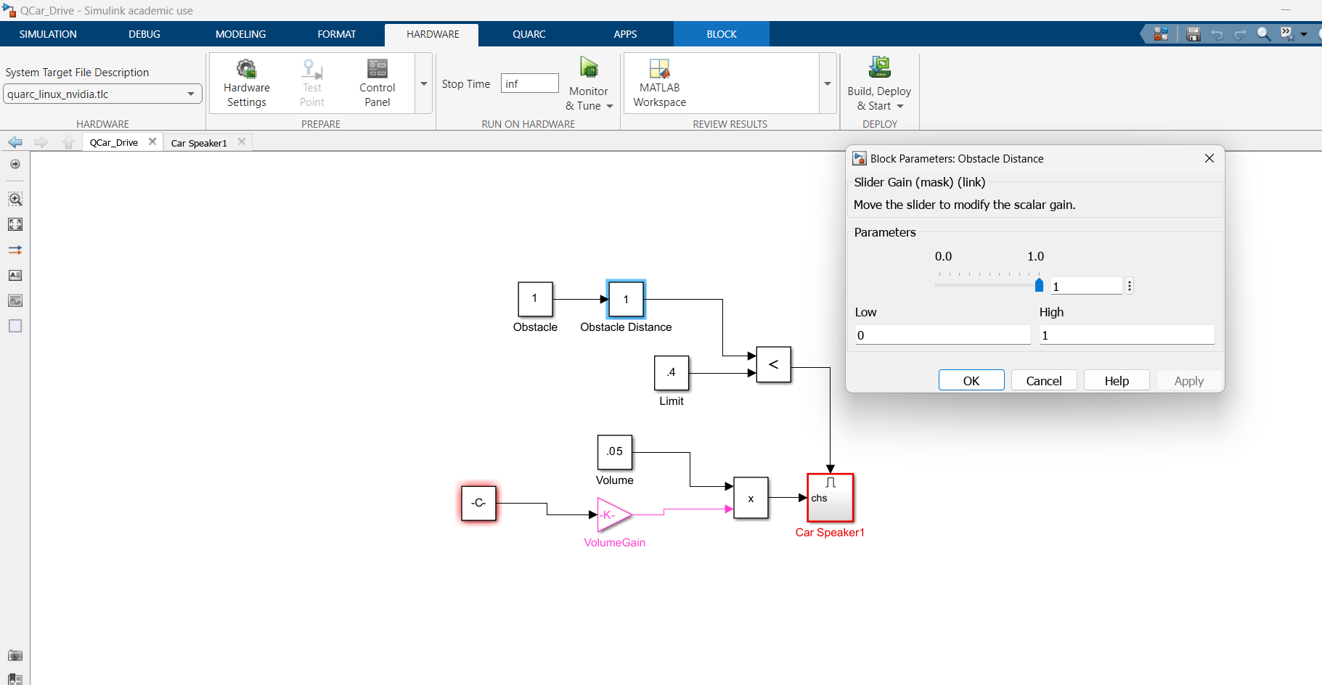

Fig.5

In Fig.5 we can see that there is a slider which produces the distance of the object as the object approaches towards the vehicle and crosses the threshold distance or safety distance the Buzzer gets on. As we know the depth camera also produces the distance of the object so we integrated this model with the ACC model as application of Forward collision warning system.

**Use of 2D-Lidar in ACC(Adaptive cruise control).**

Lidar (Light Detection and Ranging) sensors are an essential component in modern automotive technology. They use laser beams to scan the surrounding environment and create a 2D map of the objects in its field of view. One major challenge in designing lidar systems for vehicles is ensuring that the sensor has a sufficient view range to detect obstacles and hazards on the road ahead. However, in some cases, having a wide view range may not be ideal. For example, a lidar sensor with a wide field of view can also detect objects outside the immediate path of the vehicle, leading to false positives or unnecessary braking. To address this issue, I have implemented lidar systems with a reduced view range that covers the blind spots of the vehicle's front view. By limiting the sensor's field of view to only the critical areas, lidar sensors can provide more accurate and reliable data, reducing false positives and improving overall safety on the road.LIDAR used in Qcar has 2k-8k resolution, 10-15 Hz scan rate and 12m range.

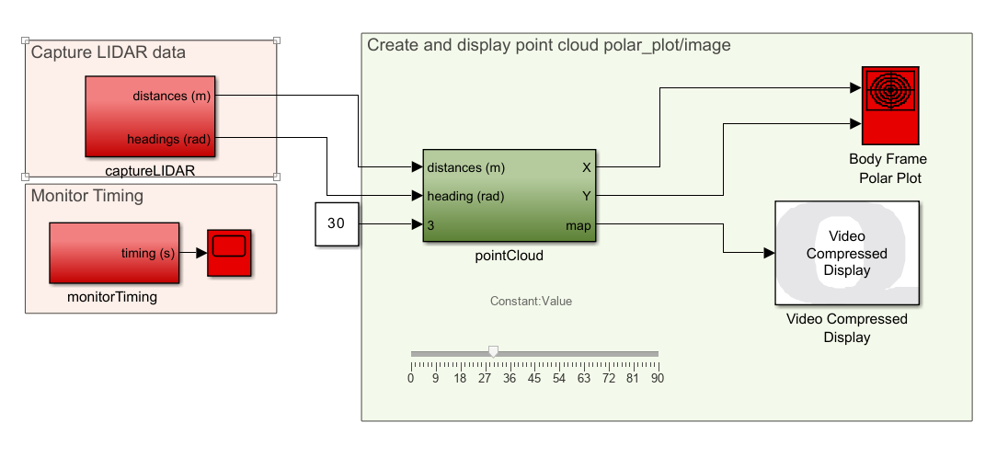

Fig.5

The Lidar is set to 30 Hz and 720 points per rotation and gives distances and heading angles of the obstacles around the Lidar.The output is in the form of column vector (720x1) and we can set the range for heading angles to be calculated.

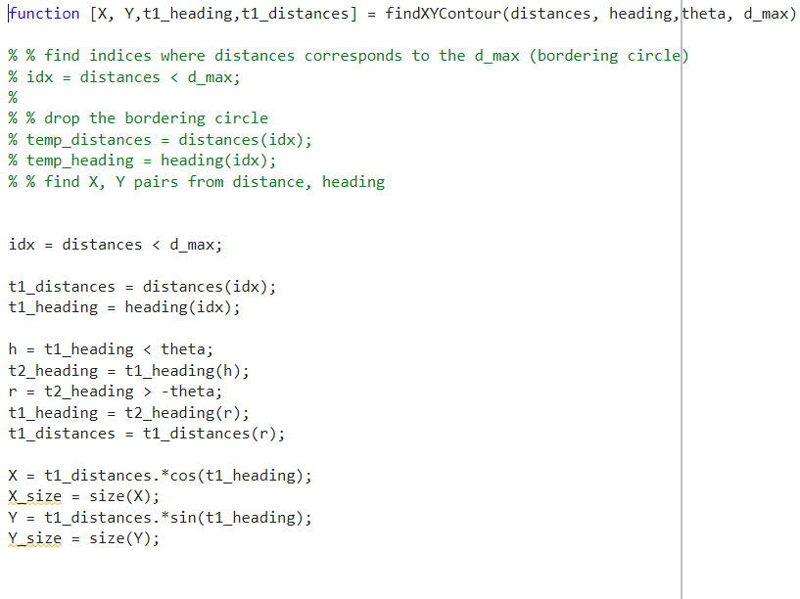

**Conclusion.**

In conclusion, our internship at EduTech India provided us with a valuable opportunity to gain practical experience and knowledge in the field of autonomous driving systems (ADAS) and self-driving technology. Through our work, we were able to distinguish the difference between ADAS and self-driving systems, and understand their respective benefits and limitations.

Moreover, we had the chance to delve into the implementation of various sensors in autonomous vehicles, including LiDAR, and depth camera sensors. This allowed us to understand the crucial role that each sensor plays in ensuring safe and efficient self-driving systems.

Overall, our internship experience at EduTech India equipped us with a strong foundation in ADAS and self-driving technology, which we believe will be valuable in our future careers. We are grateful for the opportunity to have worked with a team of knowledgeable and experienced professionals, and we look forward to applying our learnings in future endeavors.