 | SHA204 Firmware Library
 | Design
October 25, 2010 | 

Contents

1. Overview 2
1.1. Architecture 2
1.2. Library Layers 4
1.2.1. Communication Layer 4
1.2.2. Command Marshaling Layer 4
1.2.3. Application Interface Layer 4
2. Design 5
2.1. Physical Layer 5
2.1.1. Hardware Dependent I²C Functions 5
2.1.2. Hardware Dependent SWI Functions 5
2.1.3. Hardware Independent Functions 6
2.2. Communication Layer 7
2.3. Command Marshaling Layer 7
2.4. Timer Module 7
2.5. Application Interface 8
2.6. Errors 8

Overview
This document outlines the design of the SHA204 firmware library. This document contains enough detail to identify specific functionality and requirements to execute the coding process.
Both terms for the two-wire communication (clock and data), “TWI” and “I²C” that the device supports are interchangeable.

Architecture
The library consists of logical layers (see figure 1).
The applications layer shows the relationship between the customer application code and the library. An application layer uses usually only the top or two top layers (Command Marshaling and Communication layer) but it can also call functions in the Physical layer if desired. In the latter case, an application has to perform the tasks that usually the top two layers of the library perform: assemble a command and send it, poll for response, and verify the response (CRC check, status byte in response).
The Command Marshaling layer and / or the Command layer can be excluded. The customer’s application can use specific parts of the library depending on the complexity of the application and the code size constraints. For an embedded application where there are code constraints, the code should be written per the ATSHA204 datasheet and should communicate directly to the device via one of the communication methods available (TWI or Single-Wire).

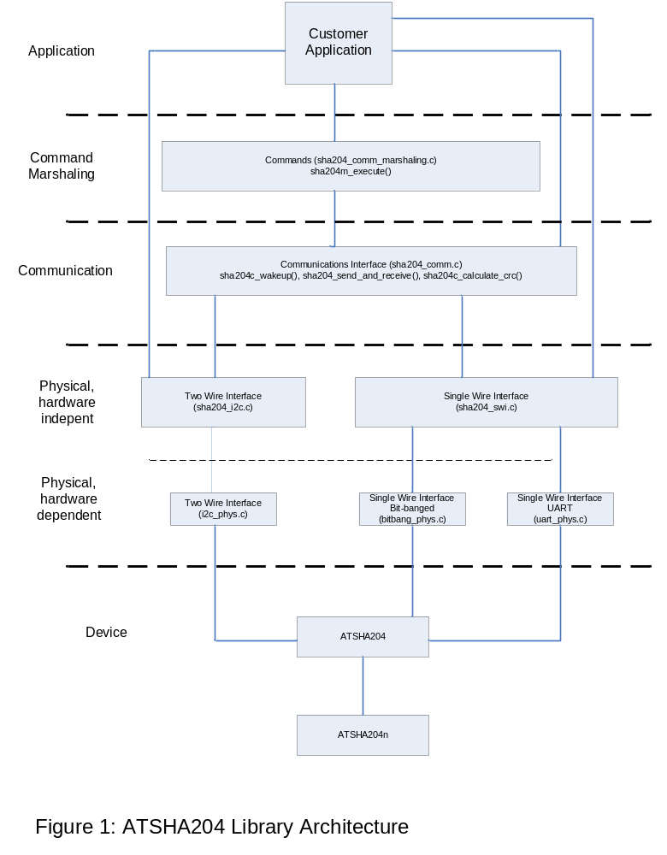

Library Layers

Communication Layer
The Communications and Physical Layer provide the conduit for data exchange between the ATSHA204 device and the application software. The Physical layer is divided further into a hardware independent part, a hardware dependent part, and a library specific to a microprocessor family which is not part of this SHA204 library. Three physical interfaces are contained in the source distribution of the ATSHA204 library: Inter-Integrated Circuit (I²C), Single Wire Interface (SWI) bit banged, and SWI using a UART.

Command Marshaling Layer
The ATSHA204 firmware Command Marshaling layer release will build on top of the communication layer to implement the device commands. One function will assemble all commands that are defined in the ATSHA204 datasheet into the correct byte streams expected by the ATSHA204 silicon. It can use a helper function for parameter checking, if enabled with a compilation switch. This function can reside on a micro processor that talks to the ATSHA204 silicon or in a higher level Windows application software that might for instance demonstrate ATSHA204 functionality.

Application Interface Layer
The ATSHA204 Firmware Application Library release will build on top of the Communication and Command libraries to package the device commands into application-level API’s. This phase will refine the libraries based on actual application usage. This function can reside on a micro processor that talks directly to the ATSHA204 silicon or can reside in higher level Windows application software that demonstrates ATSHA204 functionality.

Design

Physical Layer
This layer pertains to a specific implementation of the communications method on a specific microprocessor. It is this layer that prospective customers might have to modify for their target processor.
The target processor for the library development was the 8-bit AT90USB1287 CPU. This processor is also used on Atmel’s AT88CK101STK, AT88CK109STK development kits.
Each protocol will be implemented in two “C” modules that will be named as follows:
- i2c_phys.c (hardware dependent) and sha204_i2c.c (hardware independent)
- bitbang_phys.c (hardware dependent) and sha204_swi.c (hardware independent)
- uart_phys.c (hardware dependent) and sha204_swi.c (hardware independent)

To save code space, all implementations will implement a polling mechanism only, not an interrupt driven system.

Hardware Dependent I²C Functions
i2c_enable:
This function enables the I²C peripheral and sets the clock rate.
i2c_disable:
This function disables the I²C peripheral.
i2c_send_start:
This function generates a I²C Start condition.
i2c_send_stop:
This function generates a I²C Stop condition.
i2c_send_bytes:
This function sends the number of bytes specified.
i2c_receive_bytes:
This function receives the number of bytes specified.
i2c_receive_byte:
This function sends one byte. Implementing this function saves code space when reading the count byte.

Hardware Dependent SWI Functions
swi_enable:
This function implementation is different for bit-banging and UART. In the bit-banging version it sets the signal pin to the default I / O pin. In the UART version it enables the USART peripheral and sets the baud rate to 230,400 baud.
swi_set_device_id:
This function is different for bit-banging and UART. In the bit-banging version it selects an I / O pin. In the UART version it is just an empty function.
swi_set_signal_pin:
This function sets signal pin high or low dictated by the passed parameter.
swi_receive_bytes:
This function receives the number of bytes specified.
swi_send_bytes:
This function sends the number of bytes specified.
swi_send_byte:
This function sends one byte. Implementing this function saves code space. It is needed for sending a Sleep and Idle command.

Hardware Independent Functions
Modules sha204_i2c.c and sha204_swi.c pertain to the unique communications aspects of the ATSHA204 silicon. Functions in this module were separated from the low level specific microprocessor implementation so that developers using the library can clearly see the specifics of communicating with the ATSHA204 silicon on any of the three communication methods: SWI using UART, SWI using bit-banging, and I²C.
All hardware independent functions are defined in sha204_physical.h.

sha204p_init:
This function initializes the hardware by calling its hardware dependent counterpart (swi_enable or i2c_enable). The I²C implementation also sets the I²C address to a default address.

sha204p_set_device_id:
In the I²C implementation, this function sets the I²C address. In the SWI implementation it sets the signal pin by setting an array index into a pin array.
sha204p_wakeup:
This function generates a Wake-up token.
sha204p_idle:
This function puts the device into Idle mode.
sha204p_sleep:
This function puts the device into Sleep mode.
sha204p_reset_io:
This function resets the pointer to the I / O buffer of the device.
sha204p_resync:
This function tries to resynchronize lost communication without generating a Wake-up token.
sha204p_send_command:
This function sends a command to the ATSHA204.
sha204p_receive_response:
This function receives a response from the ATSHA204.

Communication Layer
Communication functions are implemented in sha204_comm.c
sha204c_wakeup:
This function wakes up the chip in preparation for a command sequence. In contrast to its counterpart function sha204p_wakeup it waits for a response to the Wake-up token.
sha204c_send_and_receive:
This function sends the command bytes specified in the ATSHA204 specification, delays, and then polls for a response from the silicon. Two time values are passed in as parameters, a delay after which polling should start and the maximum command execution time. If the response is in error or not received at all, this function will try several times more (configurable) to communicate to the silicon before passing an error back to the calling function.
sha204c_calculate_crc:
Before sending the command to the ATSHA204, sha204c_send_and_receive calls this function to place the CRC into the byte array / command to be sent. The CRC calculating function can be called from elsewhere if so desired.

Command Marshaling Layer
The Command Marshaling layer contains a function, sha204m_execute, which assembles and sends a command packet, receives its response, and checks its consistency. A second function that checks the parameters handed to sha204m_execute can be selectively compiled into the library. This layer is intentionally kept thin to save code space. It is anticipated that a more sophisticated implementation will reside somewhere above this library, or is tightly integrated with a SHA204 API.

Timer Module
The timer module contains two functions to help generate delays. They are implemented using loop counters instead of hardware timers to keep this module hardware independent as much a possible. The functions are still dependent on CPU clock and how fast a tight decrementing loop is executed on a particular target CPU. Therefore, the loops can be tuned with the help of defined macros inside the timer module timer_utilities.c.

delay_10us:
This function allows delaying for up to 2550 us in 10 us increments.
delay_ms:
This function allows delaying for up to 255 ms. Instead of hogging the CPU for long delays, a customer can implement this function using a timer interrupt or registering a call-back function. This way a system can tend to other tasks during the delay.

Application Interface

The API layer for the ATSHA204 library will be defined in a separate document.

Errors
Function return values are defined in sha204_lib_return_codes.h. All library functions except the ones in the hardware dependent modules return only these values.

Value | Meaning | Notes
0x00 | Success
0xD2 | Parse failure | Device status byte indicates bad byte format.
0xD3 | Command failure | Device status byte indicates any failure executing a command.
0xD4 | Bad status | Device status byte indicates CRC error.
0xD5 | Status unknown | device status byte unknown
0xE0 | Function failure | Function could not execute due to invalid state.
0xE1 | General failure | Unspecified error in function
0xE2 | Bad parameter | Parameter out of range
0xE3 | Invalid device id | Device id out of range
0xE4 | Invalid Size | Could not copy response because the receive buffer is too small, or count byte value is out of range.
0xE5 | Bad CRC | Incorrect CRC received
0xE6 | Rx failed | Received fewer bytes than expected but at least one.
0xE7 | Rx no response | Received not even one byte. This is okay when polling for a response.
0xE8 | Resynchronized with Wake-up | Resynchronization succeeded but only after generating a Wake-up token.
0xF0 | Communication failure | Communication with device fail
0xF1 | Timeout | Any timeout failure

