|  |  |  |  |
| --- | --- | --- | --- |
|  | 9/28/2012 |  | |
|  | |  | |
| RGB LED Matrix I2C Backpack  Drive an 8x8 matrix of RGB LEDs over I2C | | | |
|  |  | |  |
|  |  | | Logos Electromechanical |

RGB LED Matrix I2C Backpack

Drive an 8x8 matrix of RGB LEDs over I2C

# Introduction

We recently found a good source of cheap 8x8 RGB LED common anode matrix displays. However, these displays have thirty-two pins (8 common anodes and 24 cathodes), which makes them painful to wire. Displaying any sort of image requires multiplexing, which consumes processor resources and programming time. We needed a better solution.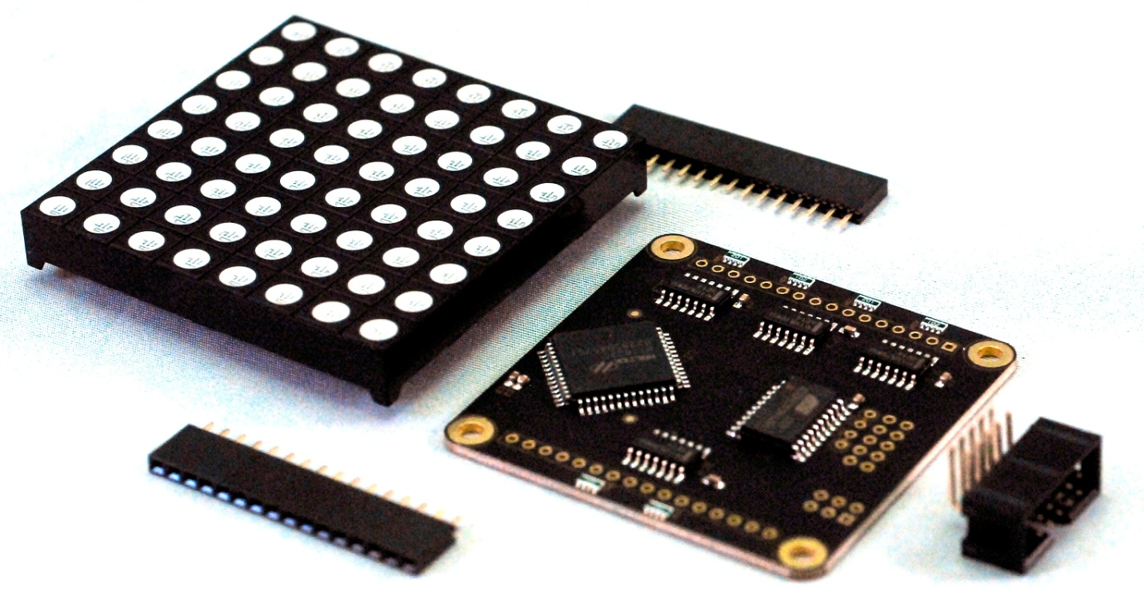

We were able to find a great driver chip that performs all of the required matrix functions. However, it speaks a strange dialect of SPI. Therefore, we added an ATtiny 2313 to provide an I2C interface that you can talk to with an Arduino or other microcontroller that has an I2C interface.

# Board Overview

The board contains eight integrated circuits – the ATtiny (U2) , the main driver chip (U1) and four hex inverters (IC1 – IC4) for driving the rows. The I2C interface connector solders on to the back of the board in order to avoid interfering with the display mounted to the front. 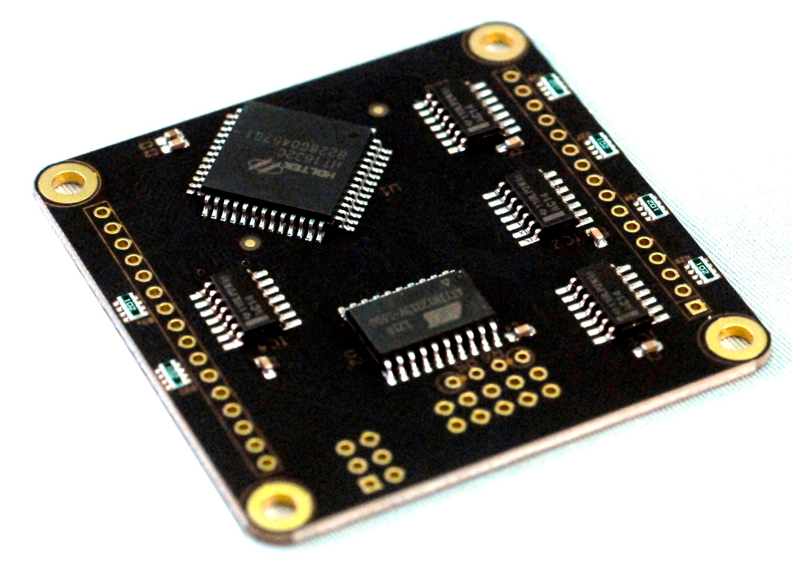

# Board Usage

## Assembly

* Insert the two sixteen pin female headers into the top (component) side of the board. This is most easily accomplished by plugging them into the RGB array and using that to align them upright. Solder them in place.
* Insert the ten pin male shrouded header into the back (no components) side of the board and solder it in place.
* Set the address as described below.

## Cable Pinout

The cable pinout is called out on the back side of the board. It is designed to interface with the line of I2C boards made by Snoot Labs, and therefore contains some pins that are extraneous to the use of this board.

|  |  |  |
| --- | --- | --- |
| Pin # | Pin Name | Pin Function |
| 1-3 | 5V | Logic and LED power |
| 4,6,8 | GND | Ground |
| 5 | SDA | I2C Data |
| 7 | SCL | I2C Clock |
| 9-10 | 3V3 | Not connected |

## Address Selection

The address is selected by the six jumpers on the back of the board. Depending on the desired value, the center terminal should be connected via a solder jumper to either the left (1) or right (0) terminal. These control the bottom six bits of the seven bit I2C address. The upper bit is always 1. Therefore, the possible I2C addresses range from binary b1000000 (hex 0x40) to binary b1111111 (hex 0x7f). If any jumper is left unmade, it defaults to a 1. Therefore, the default address of an otherwise un-configured board is 0x7f.

## Communication

Communication with the board is straightforward – send 24 bytes to the board over I2C. Each byte controls a single row of a single color. The first eight bytes control the red LEDs, the second eight bytes control the green LEDs, and the last eight bytes control the blue LEDs. The typical communication code under Arduino looks like this:

byte data[24];

Wire.beginTransmission(ADDRESS);

Wire.write(data, 24);

Wire.endTransmission();

This will transmit the contents of data to the board located at ADDRESS. The mapping of the transmitted bytes to the LEDs is as follows. Column numbers from the left, row numbers from the top.

| Byte | MSB | Bit 6 | Bit 5 | Bit 4 | Bit 3 | Bit 2 | Bit 1 | LSB |
| --- | --- | --- | --- | --- | --- | --- | --- | --- |
| 0 | Red(0,0) | Red(1,0) | Red(2,0) | Red(3,0) | Red(4,0) | Red(5,0) | Red(6,0) | Red(7,0) |
| 1 | Red(0,1) | Red(1,1) | Red(2,1) | Red(3,1) | Red(4,1) | Red(5,1) | Red(6,1) | Red(7,1) |
| 2 | Red(0,2) | Red(1,2) | Red(2,2) | Red(3,2) | Red(4,2) | Red(5,2) | Red(6,2) | Red(7,2) |
| 3 | Red(0,3) | Red(1,3) | Red(2,3) | Red(3,3) | Red(4,3) | Red(5,3) | Red(6,3) | Red(7,3) |
| 4 | Red(0,4) | Red(1,4) | Red(2,4) | Red(3,4) | Red(4,4) | Red(5,4) | Red(6,4) | Red(7,4) |
| 5 | Red(0,5) | Red(1,5) | Red(2,5) | Red(3,5) | Red(4,5) | Red(5,5) | Red(6,5) | Red(7,5) |
| 6 | Red(0,6) | Red(1,6) | Red(2,6) | Red(3,6) | Red(4,6) | Red(5,6) | Red(6,6) | Red(7,6) |
| 7 | Red(0,7) | Red(1,7) | Red(2,7) | Red(3,7) | Red(4,7) | Red(5,7) | Red(6,7) | Red(7,7) |
| 8 | Green(0,7) | Green(1,7) | Green(2,7) | Green(3,7) | Green(4,7) | Green(5,7) | Green(6,7) | Green(7,7) |
| 9 | Green(0,6) | Green(1,6) | Green(2,6) | Green(3,6) | Green(4,6) | Green(5,6) | Green(6,6) | Green(7,6) |
| 10 | Green(0,5) | Green(1,5) | Green(2,5) | Green(3,5) | Green(4,5) | Green(5,5) | Green(6,5) | Green(7,5) |
| 11 | Green(0,4) | Green(1,4) | Green(2,4) | Green(3,4) | Green(4,4) | Green(5,4) | Green(6,4) | Green(7,4) |
| 12 | Green(0,3) | Green(1,3) | Green(2,3) | Green(3,3) | Green(4,3) | Green(5,3) | Green(6,3) | Green(7,3) |
| 13 | Green(0,2) | Green(1,2) | Green(2,2) | Green(3,2) | Green(4,2) | Green(5,2) | Green(6,2) | Green(7,2) |
| 13 | Green(0,1) | Green(1,1) | Green(2,1) | Green(3,1) | Green(4,1) | Green(5,1) | Green(6,1) | Green(7,1) |
| 15 | Green(0,0) | Green(1,0) | Green(2,0) | Green(3,0) | Green(4,0) | Green(5,0) | Green(6,0) | Green(7,0) |
| 16 | Blue(0,0) | Blue(1,0) | Blue(2,0) | Blue(3,0) | Blue(4,0) | Blue(5,0) | Blue(6,0) | Blue(7,0) |
| 17 | Blue(0,1) | Blue(1,1) | Blue(2,1) | Blue(3,1) | Blue(4,1) | Blue(5,1) | Blue(6,1) | Blue(7,1) |
| 18 | Blue(0,2) | Blue(1,2) | Blue(2,2) | Blue(3,2) | Blue(4,2) | Blue(5,2) | Blue(6,2) | Blue(7,2) |
| 19 | Blue(0,3) | Blue(1,3) | Blue(2,3) | Blue(3,3) | Blue(4,3) | Blue(5,3) | Blue(6,3) | Blue(7,3) |
| 20 | Blue(0,4) | Blue(1,4) | Blue(2,4) | Blue(3,4) | Blue(4,4) | Blue(5,4) | Blue(6,4) | Blue(7,4) |
| 21 | Blue(0,5) | Blue(1,5) | Blue(2,5) | Blue(3,5) | Blue(4,5) | Blue(5,5) | Blue(6,5) | Blue(7,5) |
| 22 | Blue(0,6) | Blue(1,6) | Blue(2,6) | Blue(3,6) | Blue(4,6) | Blue(5,6) | Blue(6,6) | Blue(7,6) |
| 23 | Blue(0,7) | Blue(1,7) | Blue(2,7) | Blue(3,7) | Blue(4,7) | Blue(5,7) | Blue(6,7) | Blue(7,7) |