[TITLE]

Márton Kiss, MD

Table of contents

# Title page

   
   
 

[TITLE]

*[SUBTITLE]*

   
   
 

# Author’s declaration

   
   
 

I am the author of this report and confirm that to the best of my knowledge this report accurately describes the results of the study.

   
   
 

Marton Kiss, MD (signature): ………………………………

   
 

## Version Control

* v.0.1: First draft version

# List of abbreviations

* API - Active pharmaceutical ingredient
* AIC - Akaike’s Information Criterion
* BIC - Baysean Information Criterion
* ….

# Introduction

[…] It is my report template in Quarto. It has most Rmd features and can generate .docx. Table of Contents should be wrangled after that at the moment. PDF can be generated via Word (save as..). The auto-generated .html is nice too. Computationally intensive stuff should be referenced. None of this Vignette precompile nonsense I’ve been working so hard to implement :( Computationally intensive stuff should be referenced externally.

# Description of the study

[…]

# Data extraction

[…]

# Missing data

[…]

# Examples for quick reference

## Tables

Tables may be in a huxtable object for “seamless” word processing. The resulting table is ugly.

|  |  |  |  |
| --- | --- | --- | --- |
| **Characteristic** | **Setosa**, N = 50 | **Verginica**, N = 50 | **Versicolor**, N = 50 |
| These are the width of the petals | 0.20 (0.20 – 0.30) | 2.00 (1.80 – 2.30) | 1.30 (1.20 – 1.50) |
| These are the length of the petals | 1.50 (1.40 – 1.58) | 5.55 (5.10 – 5.88) | 4.35 (4.00 – 4.60) |
| These are the width of the sepals | 3.40 (3.20 – 3.68) | 3.00 (2.80 – 3.18) | 2.80 (2.53 – 3.00) |
| These are the length of the sepals | 5.00 (4.80 – 5.20) | 6.50 (6.23 – 6.90) | 5.90 (5.60 – 6.30) |
| This is a date column to illustrate transformations | 2022-01-01 to 2022-02-19 | 2022-04-11 to 2022-05-30 | 2022-02-20 to 2022-04-10 |
| dataset |  |  |  |
| Data | 50 (100) | 50 (100) | 50 (100) |
| Median (IQR); Range; n (%) | | | |

Having a custom ref. docx file, I played around with the formatting and cooked up something passable. Its not modifiable however.

IT IS BROKEN!!!!

You *will* face an issue where a package outputs a “marvellously formatted” html table which would be horrible for your use case. That is a promise, but don’t know how to handle it.

|  |  |  |  |
| --- | --- | --- | --- |
|  | These are the width of the petals | | |
| Predictors | Estimates | CI | p |
| (Intercept) | -0.09 | -0.20 – 0.02 | 0.109 |
| Character representation of the species: Verginica | 0.84 | 0.55 – 1.12 | **<0.001** |
| Character representation of the species: Versicolor | 0.44 | 0.23 – 0.64 | **<0.001** |
| These are the length of the petals | 0.23 | 0.16 – 0.30 | **<0.001** |
| Observations | 150 | | |
| R2 / R2 adjusted | 0.946 / 0.944 | | |

Plots are nothing fancy.

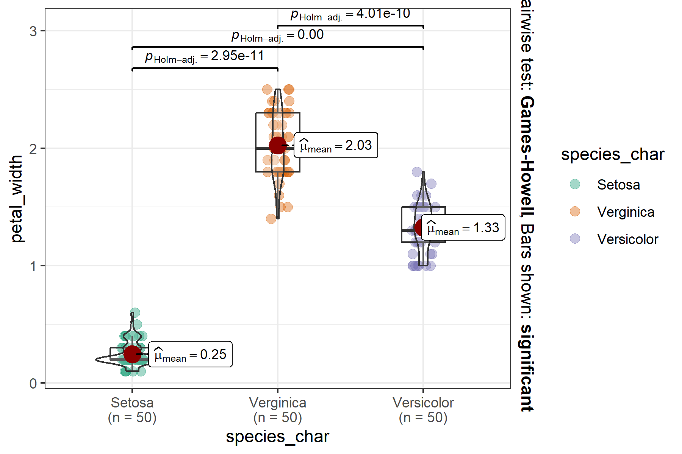

Text outputs; prints computationally intensive output loaded at the beginning.

3.14

# Remarks

### MD5 checksum of the database used

C:/OneDrive_DKM/-/Dinamikus Kiválóság Menedzsment - General/Stats_R/R/MartysProjectTemplate/inst/extdata/iris.xls “12fc1907987f269c7dfe8ce2ccf053d1”

### Other information regarding the document’s compilation

Analyses were conducted using the R Statistical language (version 4.3.1; R Core Team, 2023) on Windows 10 x64 (build 19045), using the packages lubridate (version 1.9.3; Grolemund G, Wickham H, 2011), gtsummary (version 1.7.2; Sjoberg D et al., 2021), ggplot2 (version 3.5.1; Wickham H, 2016), dplyr (version 1.1.4; Wickham H et al., 2023) and kableExtra (version 1.4.0; Zhu H, 2024).

## References

* Grolemund G, Wickham H (2011). “Dates and Times Made Easy with lubridate.” *Journal of Statistical Software*, *40*(3), 1-25. <https://www.jstatsoft.org/v40/i03/>.
* R Core Team (2023). *R: A Language and Environment for Statistical Computing*. R Foundation for Statistical Computing, Vienna, Austria. <https://www.R-project.org/>.
* Sjoberg D, Whiting K, Curry M, Lavery J, Larmarange J (2021). “Reproducible Summary Tables with the gtsummary Package.” *The R Journal*, *13*, 570-580. , <https://doi.org/10.32614/RJ-2021-053>.
* Wickham H (2016). *ggplot2: Elegant Graphics for Data Analysis*. Springer-Verlag New York. ISBN 978-3-319-24277-4, <https://ggplot2.tidyverse.org>.
* Wickham H, François R, Henry L, Müller K, Vaughan D (2023). *dplyr: A Grammar of Data Manipulation*. R package version 1.1.4, <https://CRAN.R-project.org/package=dplyr>.
* Zhu H (2024). *kableExtra: Construct Complex Table with ‘kable’ and Pipe Syntax*. R package version 1.4.0, <https://CRAN.R-project.org/package=kableExtra>.

### Time of compilation

2024-05-14 19:09:38.008023