Assignment 1 Deliverables

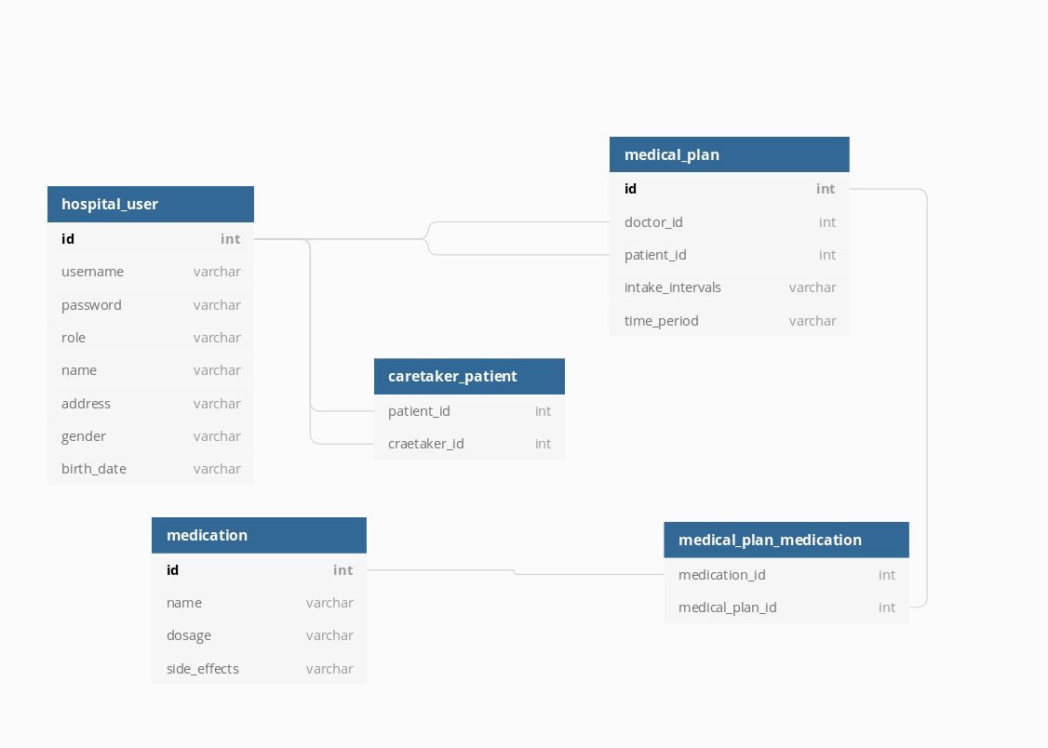1. DB design

2. Conceptual diagram

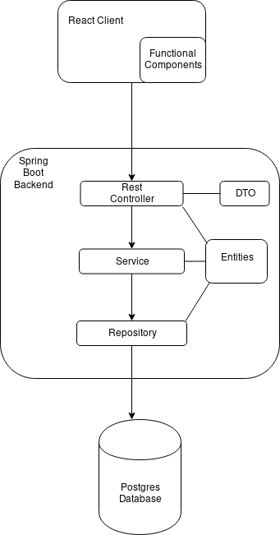

3.Deployment diagram

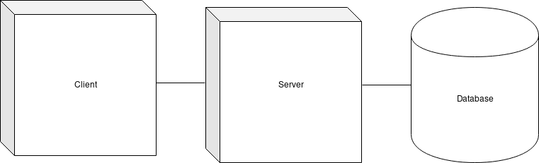

4. Readme

Client for medical management application. React typescript version.

* Clone the project from git
* Install Node.js
* Install dependincies via the console and npm install command
* Type npm start and press enter to start the client

Server

Back-end server for the medical management application. Implemented with Spring-boot and Hibernate. Facilitates connection to a postgreSQL based database.

* Clone the project from git
* Install postgreSQL
* Open maven and enable auto-import for dependices
* Wait for the dependincies to be installed
* Start the project