Mobile assistant for upcoming students

LICENSE THESIS

 | Graduate: | Alexandru Martuneac
 | Supervisor: | Sl. Dr. Eng. Anca Hangan

2020

DEAN, |  |  | HEAD OF DEPARTMENT,
Prof. dr. eng. Liviu MICLEA |  | Prof. dr. eng. Rodica POTOLEA

Graduate: Firstname LASTNAME

LICENSE THESIS TITLE

- Project proposal: Short description of the license thesis and initial data

- Project contents: (enumerate the main component parts) Presentation page, advisor's evaluation, title of chapter 1, title of chapter 2, …, title of chapter n, bibliography, appendices.

- Place of documentation: Example: Technical University of Cluj-Napoca, Computer Science Department

- Consultants:

- Date of issue of the proposal: November 1, 2018

- Date of delivery: February 18, 2020

Graduate: | ____________________________
Supervisor: | ____________________________

Declaraţie pe proprie răspundere privind
autenticitatea lucrării de licenţă

Subsemnatul(a)________________________________________________________________________________________________________________________, legitimat(ă) cu _______________ seria _______ nr. ___________________________
CNP _______________________________________________, autorul lucrării ____________________________________________________________________________________________________________________________________________________________________________________________elaborată în vederea susţinerii examenului de finalizare a studiilor de licență la Facultatea de Automatică și Calculatoare, Specializarea ________________________________________ din cadrul Universităţii Tehnice din Cluj-Napoca, sesiunea _________________ a anului universitar __________, declar pe proprie răspundere, că această lucrare este rezultatul propriei activităţi intelectuale, pe baza cercetărilor mele şi pe baza informaţiilor obţinute din surse care au fost citate, în textul lucrării, şi în bibliografie.
Declar, că această lucrare nu conţine porţiuni plagiate, iar sursele bibliografice au fost folosite cu respectarea legislaţiei române şi a convenţiilor internaţionale privind drepturile de autor.
Declar, de asemenea, că această lucrare nu a mai fost prezentată în faţa unei alte comisii de examen de licenţă.
In cazul constatării ulterioare a unor declaraţii false, voi suporta sancţiunile administrative, respectiv, anularea examenului de licenţă.

Data  _____________________ |  | Nume, Prenume  _______________________________
 |  | Semnătura

De citit înainte (această pagină se va elimina din versiunea finală):

- Cele trei pagini anterioare (foaie de capăt, foaie sumar, declaraţie) se vor lista pe foi separate (nu faţă-verso), fiind incluse în lucrarea listată. Foaia de sumar (a doua) necesită semnătura absolventului, respectiv a coordonatorului. Pe declaraţie se trece data când se predă lucrarea la secretarii de comisie.
- Pe foaia de capăt, se va trece corect titulatura cadrului didactic îndrumător, în engleză (consultaţi pagina de unde aţi descărcat acest document pentru lista cadrelor didactice cu titulaturile lor).
- Documentul curent a fost creat în MS Office 2007. Dacă folosiţi alte versiuni e posibil sa fie mici diferenţe de formatare, care se corectează (textul conţine descrieri privind fonturi, dimensiuni etc.).
- Cuprinsul începe pe pagina nouă, impară (dacă se face listare faţă-verso), prima pagina din capitolul Introducere tot aşa, fiind numerotată cu 1. Pentru actualizarea cuprinsului, click dreapta pe cuprins (zona cuprinsului va apare cu gri), Update field->Update entire table.
- Vizualizaţi (recomandabil şi în timpul editării) acest document după ce activaţi vizualizarea simbolurilor ascunse de formatare (apăsaţi simbolul π din Home/Paragraph).
- Fiecare capitol începe pe pagină nouă, datorită simbolului ascuns Section Break (Next Page) care este deja introdus la capitolul precedent. Dacă ştergeţi din greşeală simbolul, se reintroduce (Page Layout -> Breaks).
- Folosiţi stilurile predefinite (Headings, Figure, Table, Normal, etc.)
- Marginile la pagini nu se modifică (Office 2003 default).
- Respectaţi restul instrucţiunilor din fiecare capitol.

Table of Contents

Chapter 1. Introduction 1
1.1. Project context 1
1.2. Contents 1
Chapter 2. Project Objectives 3
2.1. Problem Statement 3
2.2. Product Position Statement 3
2.3. Stakeholders 3
2.3.1. Personnel responsible with planning of the admission 4
2.3.2. Upcoming student 4
2.3.3. Accommodation places 4
2.4. User description 4
2.5. Functional Requirements 4
2.6. Non-Functional Requirements 5
Chapter 3. Bibliographic Research 7
Chapter 4. Analysis and Theoretical Foundation 8
4.1. User Profile Analysis 8
4.2. Feature Analysis 8
4.2.1. Manage faculty admissions 9
4.2.2. Navigate to faculty location 12
4.2.3. Check required documents and fees for admission 14
4.2.4. Search for accommodation 19
4.2.5. Add accommodation reservation 20
4.2.6. Check calendar 22
Chapter 5. Detailed Design and Implementation 25
5.1. System architecture 25
5.2. Use of Technologies 26
5.2.1. Mobile Stack 26
5.2.2. Backend Server Stack 26
5.2.3. Web crawling Technologies 26
5.3. Server design and implementation 27
5.3.1. Database Layer 28
5.3.2. Persistance Layer 29
5.3.3. Service Layer 29
5.3.4. Presentation Layer 30
5.3.5. Seed 30
5.4. Client design and implementation 31
5.4.1. User Interface Design 31
5.4.2. Main Screens 31
5.4.3. Calendar Screen 38
5.5. Web Crawling and Scraping design and implementation 40
5.5.1. Web crawler 41
5.5.2. Web Scrapping 45
Chapter 6. Testing and Validation 50
6.1. Testing 50
6.2. Validation 52
6.2.1. Visibility of the system status 52
6.2.2. Match between system and the real world 52
6.2.3. Use control and freedom 52
6.2.4. Consistency and standards 52
6.2.5. Error prevention 52
6.2.6. Recognition rather than recall 53
6.2.7. Flexibility and efficiency of use 53
6.2.8. Aesthethic and minimalist design 53
6.2.9. Help users recognize, diagnose and recover from errors 53
6.2.10. Help and documentation 53
Chapter 7. User’s manual 54
7.1. Installation Guide 54
7.2. User’s Manual 54
Chapter 8. Conclusions 60
Bibliography 61
Appendix 1 (only if needed) 62

Introduction
In the following pages, the project and the motivation behind it will be presented. An summary regarding the problem addressed will be presented, together with what motivated the choice of the current subject, which is a Mobile Assistant for Upcoming Students.

Project context
From year to year, more and more high-schoolers graduate. They represent the majority of upcoming students to various universities and faculties across the country. Thus, most of the students are not local and therefore not accustomed to the cities in which they want to apply. Moreover, the admission process might happen to appear to some people overwhelming, due to the stress during that specific period. Issues like not being local to the city, not knowing where to stay during the admission period or having no clue regarding the fees and documents required can add up. Having a place where all the details are accessible at any time, would prove a great way for aiding the upcoming students during the admission process. Moreover, providing a way for managing their admissions schedule during the admission period could help the users to better organize themselves.
The websites of the universities and faculties can sometimes prove to be overwhelming to navigate to an inexperienced public. Relevant data for the admission process could be mistakenly avoided due to the upcoming student having to know where and what to search for.
The accommodation during the admission period is also crucial for upcoming students which are not locals of the city in which they apply to a faculty. Therefore, it would be simpler for the users to have at hand a way for searching for accommodation and to keep track of it.
Knowing what events are scheduled to happen in a day is meant to better organize the upcoming student and to raise the awareness towards what must be done. In this way, the user will be able to be prepared in advance for each day during the admission process.
Moreover, people from outside the city, need a way for navigating to the faculties, since they are not locals and do not know the city well.
All in all, the main impediments of the upcoming students during the admission process is what it required in order to apply to a faculty, how to find accommodation, what fees are required, how to reach the faculty and how to manage the admission schedule. These problems have been tackled in the following pages and solved by developing a system which allows its users to better manage the admission process.

Contents
The current paper presents the development process from the very beginning stage of analysis to the actual written code and working application.
Chapter 2 holds the stakeholders in the application, together with the functional and non-functional requirements. The problem for which the solution has been formulated is presented together with the objectives.
Chapter 3
Chapter 4 contains a detailed analysis of the features that were implemented together with an analysis of the target user.
Chapter 5 holds everything related to the development process. The architecture of the system is broken down, together with use cases, user interface design and the use of design patterns. Moreover, the actual implementation is detailed according to each component of the system.
Chapter 6 represents how the system was tested during and after the development.
Chapter 7 is used to provide a user manual together with the installation guide and the hardware and software requirements so the application can be run.
Chapter 8 contains the conclusions and achievements after the developing of the system. Moreover it presents some impediments together with further possible improvements that can be brought to the system.

Project Objectives

Problem Statement

As more and more universities offer educational programs, it becomes difficult for upcoming students to learn about the universities and make a decision. Furthermore, as the majority of students are not locals, this represents an impediment in applying to universities and getting admitted.

The problem of a variety of educational programs and difficult access to information regarding universities and their respective cities affects upcoming students and universities. Thus, the impact is a difficult admission process for upcoming students.

A successful solution would provide students with the educational programs of universities from a certain city and assist them during the admission process. This will include aiding students in reaching the universities, providing the calendar of admission for each university and help the students to search for accommodation for the period of admission.

Product Position Statement

The mobile assistant for upcoming students objective is to deliver an experience which will ease the process of university admission by offering the user a rich and compact solution for organizing the admission process during the admission period. The upcoming students will be able to not only search and discover educational programs, but also to look for accommodation and organize their schedule during the admission period for each university and faculty that they take part in the admission.

The target audience is the upcoming students, high-school graduates, who need to have a better experience during admissions.

The Mobile Assistant Application for Upcoming Students is a mobile application that helps upcoming students in the transition to university education while providing help for managing admissions. It offers help to upcoming students and also offers universities more visibility, unlike each university’s website information.

The product will improve the experience of the admission process for the upcoming student, during the admission period.

Stakeholders

Personnel responsible with planning of the admission
The current stakeholder is represented by the department entrusted with establishing admission programs for the university. Furthermore, it is responsible for creating the admission schedule and deciding the curricula to be covered.

Upcoming student
The current stakeholder represents also the user of the application.

Accommodation places
The current stakeholder is represented by the accommodation units available that provide accommodation during a certain period. They are responsible for providing accommodation during the admission period.

User description
The user is represented by the upcoming student which is a high-school graduate. Like any other high-school student, the transition from pre-university education to university education is harder. Managing to surf through the universities and their faculties can be challenging so keeping data together would make things simpler. Moreover, throughout the admission period, students will require accommodation. For some students it is not a problem, but for the ones that are not locals it can easily become one. Not being familiar to the city during the admission process can lead to making the whole process a lot harder than it actually is. Furthermore not knowing what documentation is required from the upcoming student is another impediment.
Considering all of the above mentioned, it is required to have an application that can ease admission process and aid the upcoming student as much as possible.
As far as responsibilities are concerned, the user must provide permissions to the application when he is prompted to.

Functional Requirements
From the above specified objectives and from the user description we can extrapolate the following functional requirements:
- The user must be able to be informed about what documents are required
- The user can search and keep track of accommodation during the admission period
- The user should be able to manage the currently participating admissions
- The user can keep track of the personal schedule
- The user can travel to the admission’s faculty
- The user can keep track of the fees for each faculty
The above mentioned functional requirements are deduced from the objectives and the user description, but we want to ensure a good functionality focused on the user. Therefore, while showing the intention to participate to a faculty admission, there is no way to exactly know whether or not the user actually signed up, the following requirements appear and are imminent:
- The user must confirm after the sign up period for a faculty that he or she actually signed up
- The user must be informed when two faculties admissions exams overlap

Confirmation from the user is a must have and so is the warning of the user, in case of an overlapping conflict between two admissions exams.

Non-Functional Requirements
The following non-functional requirements will be available for the system driving the application. Some are already met by the choice of architecture while others are not present but would be added in a future release.
The next two non-functional have already been met and they are represented by:

Maintainability
The person responsible for the maintenant of the whole system is the developer. The developer will make sure that everything runs smoothly and how it is supposed to work.

Extendibility
The application must be able to support further improvements and additions of
features to its functionality. Moreover, this will further translate into improving the experience of the user during the admission process.

Security
In order for the application to address the issues of security, authentication will be required with a password and username after creating an account. Moreover, an encryption mechanism is be used in order to hide sensitive user data.

Another non-functional requirement is the type of the application that the user will use. It must be a mobile one so the user will be able to access it at any time.

Unlike the two non-functional requirements mentioned above, the following ones are not yet present but would be a target for the future.

Performance
Ideally, the application performance is something to be taken into consideration. It could be measured by taking into consideration the following:
- Response time of the application
- Student’s efficiency in taking part in different admissions
- Ease of searching for accommodation according to the user needs
Unfortunately, the performance has not been measured.

Availability
Since the application can be accessed at any time by the users, it is mandatory to keep the system running 24h. In case of maintenance, it will be done while the application is least used in order to avoid as many issues as possible.
Scalability
The application must be able to keep data for a very large number of users. Also data about various faculties could be added in the future. Moreover, the sustaining of a system that can handle a large number of users and faculties will ensure a better product that will improbe the process during the admission period for the upcoming students.

Bibliographic Research
Bibliographic research has as an objective the establishment of the references for the project, within the project domain/thematic. While writing this chapter (in general the whole document), the author will consider the knowledge accumulated from several dedicated disciplines in the second semester, 4th year (Project Elaboration Methodology, etc.), and other disciplines that are relevant to the project theme.
Represents about 15% of the paper.
References will be included in the Bibliography section. The reference format must be IEEE, or similar. The introduction of new references in the Bibliography section, and their citation within the document text can be done manually (by obeying the format), but it is less recommended, or by using the tools mentioned in the last paragraphs of this chapter.
In the Bibliography section, there are examples of references to conferences or workshops articles [1], journal articles [2], and books [3]. References to applications or online resources (web pages) must include at least a short relevant description in addition to the link [4], and other information is available (authors, year, etc.). References that contain only the link to the online resource will be placed in the page footer.
Each reference must be cited within the document text, see example below (depending on the project theme, the presentation of a method/application can vary).
In paper [1] the authors present a detection system for moving obstacles based on stereovision and ego motion estimation. The method is … discus the algorithms, data structures, functionality, specific aspects related to the project theme, etc…. Discussion: pros and cons.
In chapter 4 of [3], the similar-to-my-project-theme algorithm is presented, with the following features…
Software and other tools managing bibliography for MS Word 2003, and usage instructions can be found at:
How to use JabRef (BibTeX) with Microsoft Word 2003
Bibtex4Word
BibWord makes it easier to create and manipulate Microsoft Word citation and bibliography styles
For MS Word 2007 and MS Word 2010, the integrated bibliography management system should be used, References, Citations & Bibliography. More information can be found in the online documentation of MS Office.

Analysis and Theoretical Foundation

User Profile Analysis
In the previous chapters the user has been described in a high-level way. On a lower level, the user is responsible for providing the application with permissions (for the navigation) and offer the required data asked by the application. When creating an account, the user will be prompted, besides the username and password, to select an initial filter which can be modified later if desired. Furthermore, the user will be responsible for choosing the faculties to take part in the admission.

Feature Analysis
The main goal of the application is to provide the user with a way for better managing the admission period and the correspondent schedule. As the user is not someone local to the city in which the faculty admission takes place, is it paramount that accommodation guidance should be offered. This means that the user must have a way for actually searching the accommodation and for making a reservation. Since reservations with APIs required special accounts, the idea was to provide the user with the already going admissions when searching for admissions. Once the faculty is selected, a number of accommodation places are presented. Instead of relying on APIs for making the reservation, the user is provided with details like phone number and website in order to make the reservation. Once a reservation is made, is must be introduced manually in the application.
The assumption that the user is not familiar with the city has been made. This means that the user requires guidance in reaching the desired faculties.
In order for the user to successfully sign-up to faculties, documents and the required fees should be provided, so the user can better organize the money and the required documentation.
For the user to keep track of everything, a calendar is required. It will be used to help the user make decisions about what must be done and when. It will hold events such as the check-in and check-out dates, sign-up periods, exam and results date.
The system will enable upcoming students to better manage their admission process and schedule. Due to not having access directly to the faculties databases, some assumptions will be made regarding to participating to admissions.
Whenever the user is before or during the sign-up period, the button “Participate” will be used to denote the interest in participating to the admission. The user can at all times change their mind regarding the participation until the sign-up period is over. Once the period passes, the user will be asked to confirm that he or she actually signed up for the admission. In case the answer is a negative one, the admission will not longer be available, since the sign-up period expired. If the answer is a positive one, the user will be able to see the admission and the next stages. Those next stages are represented by the period before and after the actual results.
The application will be split in three states:
- Before and during the sign-up period. The user can freely choose to show or not the intent for participating.
- After the sign-up period. The user must confirm that he or she actually signed-up for the admission.
- After the results. The user will be able to check whether he or she was admitted to the faculty.
For all of the following features and use cases, the primary actor will be the upcoming student.

Manage faculty admissions
Feature Description
Participation to faculty admissions and viewing of the currently participating admissions represents the most important feature of the application. This feature, allows an upcoming student to preview the available faculties admissions during their admission period. Furthermore, the user will be available to preview the already participating admissions.
Involved use-cases
The involved use-cases are represented by the management performed on the current faculties available to participate and also the currently participating ones.

- Participate to faculty admission
- Basic flow
Use-Case Start
The user presses the “admission” button for viewing faculty admissions.

Step 1
The user applies filters on the currently available faculty admissions.

Step 2
The user selects a faculty and clicks “Participate”.

Use-Case End
The user has correctly signed up to take part in a faculty admission.

- Alternative Flow
Start
The start of this flow will appear in the moment the system prompts that the currently selected admissions conflicts with an existing one (Step 2).

End
The system will not allow the user to participate to the currently selected faculty admission until the conflict is taken care of, by either removing the conflicting admission or by choosing not to participate to the currently selected faculty admission.

- Preconditions
The user must be identified and authenticated. In order for the system to correctly register the actions performed by the user, he or she must meet the previously mentioned requirements.

- Postconditions
The user has successfully added a new admission to the personal schedule. The system, based on the previously mentioned steps, will be able to register the admission of the user, making it available to the user whenever it is the case.

- Flow of events

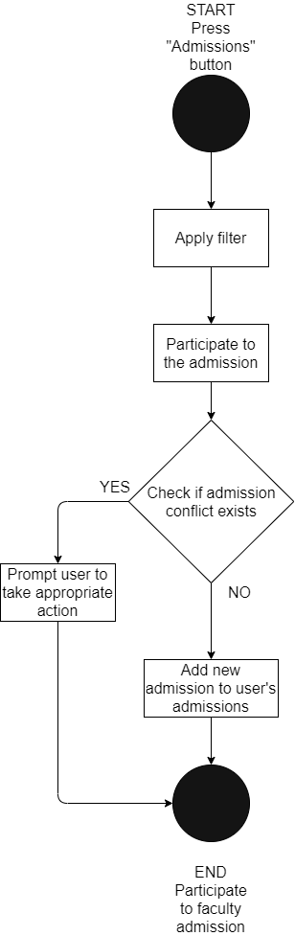
Figure 4.1 Participate to admission

- Remove participating faculty admission
  - Basic flow
Use-Case Start
The user presses the “admission” button for viewing faculty admissions.

Step 1
The user selects the already participating faculty admissions.

Step 2
The user presses the remove button for the faculty that he or she no longer wants to take part in the admission.

Use-Case End
The user has correctly removed a faculty admission from his or her faculty admissions’ participating list.

  - Alternative Flow
Start
The start of this flow will appear in the moment the user views the already participating faculty admissions (step 1) and goes back to the available faculty admissions.

End
The system will display the currently available faculty admissions instead of the already participating ones.

  - Preconditions
The user must be identified and authenticated. In order for the system to correctly register the actions performed by the user, he or she must meet the previously mentioned requirements.

  - Postconditions
The user has successfully removed the intention to participate to a specific faculty admission.

  - Flow of events

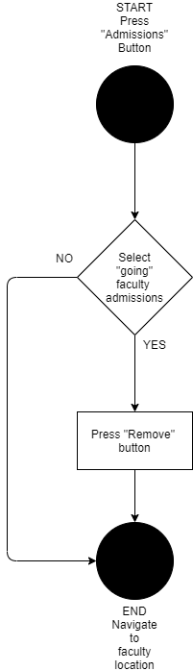

Figure 4.2 Remove faculty participation

Navigate to faculty location
Feature Description
Navigating to the faculty location is an important feature. It allows the upcoming student to better handle how to reach the desired faculty, especially if the person is not familiar to the city.

Involved use-cases
- Navigate to faculty
- Basic flow
Use-Case Start
The user presses the “admission” button for view faculty admissions.

Step 1
The user selects available faculties.

Step 2
The user presses on the “location” button for navigating.

Step 3
The user selects the destination.

Step 4
The user selects travelling by car.

Use-Case End
The user can see on the screen the directions to travel to the destination.

- Alternative Flow
No alternative flow is present for the current use-case.

- Preconditions
The user must be identified and authenticated. In order for the system to correctly register the actions performed by the user, he or she must meet the previously mentioned requirements.

- Postconditions
The user can view the path to the destination and can start moving towards it.

- Flow of events
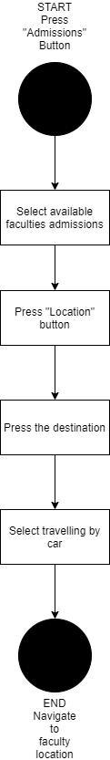
Figure 4.3 Navigate to faculty

Check required documents and fees for admission
Feature description
Checking the required documents for the admission period and keeping track of how many exemplaries are required is a must have to ensure that the upcoming student will know exactly what documents are expected. Furthermore knowing how much money will be required in order to sign up to different faculties will make the user to carefully choose the admissions.

Involved use-cases
- Check required documents
- Basic flow
Use-Case Start
The user presses the “admission” button for viewing the faculty admissions.

Step 1
The user selects available faculty admissions.

Step 2
The user presses the “documents” button.

Use-Case End
The user will be able to see what documents are required in order to participate to the admission.

- Alternative Flow
Start
The start of this flow is triggered when the user chooses the going admissions (step 1).

Step 1
User presses the ”documents” button.

End
The end of the alternative flow is when the user is displayed the total documents required for all the admissions currently participating.

- Preconditions
The user must be identified and authenticated. In order for the system to correctly register the actions performed by the user, he or she must meet the previously mentioned requirements.
For the alternative flow, the user must have at least one participating admissions because otherwise, the alternate flow will not be fully available.

- Postconditions
The user will see the required documents for a faculty admission, or the total number of documents required for all her or his participating admissions.

- Flow of events

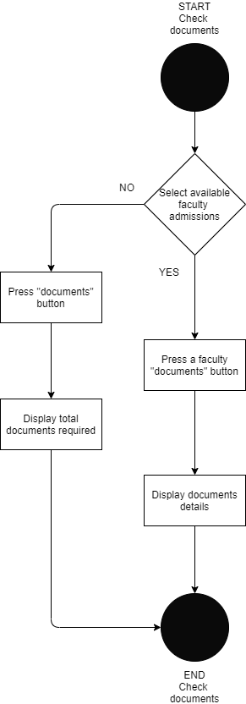
Figure 4.4 Check required documents

- Check admission fees
- Basic flow
Use-Case Start
The user presses the ”admission” button to view the faculty admissions.

Step 1
The user selects the ”going” admissions.

Step 2
The user presses the ”fees” button.

Use-Case End
The user is presented with the fees for the participating admissions.

- Alternative Flow
No alternative flow is present for the current use case.

- Preconditions
The user must be identified and authenticated. In order for the system to correctly register the actions performed by the user, he or she must meet the previously mentioned requirements.
Furthermore, in order to correctly view the fees, the user must have at least one participating admission.

- Postconditions
The user is displayed all the fees for all the participating admissions.

- Flow of events
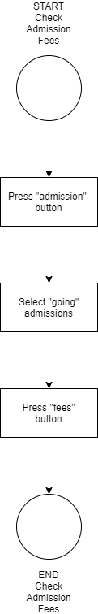

Figure 4.5 Check admission fees

Search for accommodation
Feature description
Being able to search for accommodation during the admission period is another important feature. The user will be able to search for accommodation close to the chosen already participating faculty admission.

Involved use-cases
- Check accommodation near faculty
- Basic flow
Use-Case Start
The use presses the ”accommodation” button.

Step 1
The user selects ”I don’t have accommodation”.

Step 2
The user selects a faculty from the already participating faculty admissions.

Step 3
The user selects an accommodation place.

Step 4
User presses the website button.

Use-Case End
The user will access the accommodation place website in order to make a reservation.

- Alternative Flow
Start
The start of this alternative flow is triggered when the user selects the telephone button.

End
The current alternative flow ends when the user is presented with the number of the accommodation place in the phone, ready to call.

- Preconditions
The user must be identified and authenticated. In order for the system to correctly register the actions performed by the user, he or she must meet the previously mentioned requirements.
Moreover, the user already has some faculty admissions participating.

- Postconditions
The user will be greeted with a screen holding the information requested.

- Flow of events
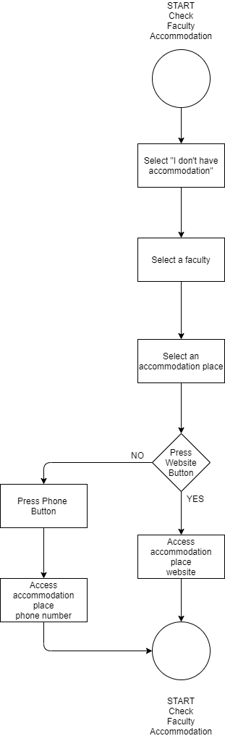
Figure 4.6 Check accommodation near faculty

Add accommodation reservation
Feature description
Keeping track of accommodation reservation during the admission period helps to ease the experience of the upcoming student.
By keeping track of the reservation, the upcoming student will know how to better organize.

Involved use-cases
- Add accommodation
- Basic flow
Use-Case Start
The use presses the ”accommodation” button.

Step 1
The user selects ”I have accommodation”.

Step 2
The user completes the required form.

Step 4
User confirms the data.

Use-Case End
The user has sucessfully added the recommendation for the admission period.

- Alternative Flow
Start
The user can at any time, after pressing ”I have accommodation” choose to exit the current screen and go back.

End
The alternative flow ends, when the user presses the ”Back” button and is greeted by the two options, ”I have accommodation” and ”I don’t have accommodation”.

- Preconditions
The user must be identified and authenticated. In order for the system to correctly register the actions performed by the user, he or she must meet the previously mentioned requirements.
Moreover, the user must correctly complete the form in order to correctly finalize the use-case.

- Postconditions
The user will be able to see details regarding the introduced accommodation details after confirming that everything is correct.

- Flow of events

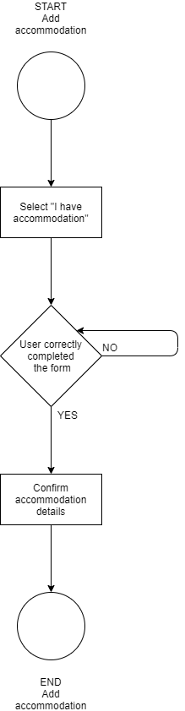
Figure 4.7 Add accommodation

Check calendar
Feature description
Being able to keep everything organized is crucial in order to make the admission period easier on the upcoming student. The current feature allows the user to check when the sign up period is, when the exam will be held and when the results will be posted. Furthermore, the user can view the check-in and check-out dates for the added accommodation.

Involved use-cases
- Check calendar
- Basic flow
Use-Case Start
The user presses on the ”calendar” button.

Step 1
Apply calendar filter.

Step 2
View the events per day.

Use-Case End
Press a day to view the details about the events in that day.

- Alternative Flow
Start
After pressing the ”calendar” button, the user can immediately choose to leave the ”calendar” screen.

End
The user no longer is on the ”calendar” screen, but on a different screen.

- Preconditions
The user must be identified and authenticated. In order for the system to correctly register the actions performed by the user, he or she must meet the previously mentioned requirements
Moreover, in order for the user to actually check for events, events such as upcoming admission sign-up dates, results, exams or check-in and check-out dates should be present.

- Postconditions
After the user selects a day, the detailed events for the day will be presented.

- Flow of events
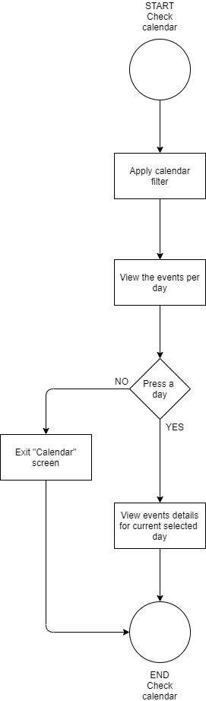

Figure 4.8 Check calendar

Detailed Design and Implementation

System architecture
When choosing the architecture for the system we must take into consideration that we have to serve multiple people (possibly at the same time). Moreover, since the target audience needs to have a way to interact with the system at all times, we will require a dedicated application. Also, the data which will be available to the user must be stored, therefore a database will be required.
Considering the above mentioned reasons we will opt for a client-server architecture. The communication between the client and the server will be facilitated by employing the use of the request/reply HTTP protocol. At all times, the client will be the one initializing the communication by requesting resources and the server will be the one providing them.
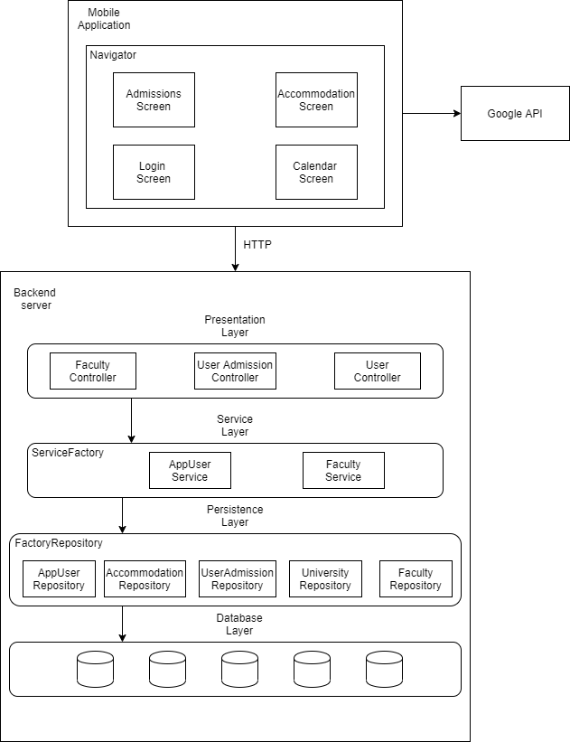
Figure 5.1 System architecture

Use of Technologies
When deciding which technologies are going to be used, their choice will affect everything regarding the system. The technology stack makes the system maintainable, scalable and dedicated to the functional requirements.
Taking into consideration the previously mentioned, the technology stack will be split into two, mobile stack and backend stack.
Furthermore, the technologies will be present along with their behind reasoning.

Mobile Stack
For development of the mobile client, the used technology is React-Native. It facilitates the development of mobile applications by employing the use of javascript, html and css. The result is an application which can cover different platforms (web) if the issue arrises and one that can be easier to maintain and scale.
In order to ensure best practices and take the application a step forward towards maintainability, typescript will be used. This superset of javascript allows to define types which will allow a maintainer what should be expected when performing different operations.
Furthermore, HTML and CSS will used in order to style the design of the mobile application.

Backend Server Stack
The technology employed for the development of the backend server will be Java Spring. The mentioned technology forces us to write an application in a specific manner. This is because we will make use of certain design patterns which will standardize the development. Another great aspect of using Spring is that it allows for dependency injection, facilitating low coupling and automatic instantiation of required objects. Furthermore, as the build tool, Maven being the most popular was employed. In order to further reduce the amount of boiler-plate code that must be generated, Lombok, a java library was used.
For the database, PostgreSQL is the technology chosen.It is ACID compliant, is open-source and benefits from a lot of community support.

Web crawling Technologies
For developing a web crawler that will successfully retrieve the faculties website’s relevant links Python will be the language of choice. It features a vast number of libraries which allow for a greater versatility, unlike other languages. For determining if a certain website page contains relevant data, a HTML parser will be used. After determining the relevant links, they will be used further in extracting and converting the relevant data by the use of a specfialized HTML parser, BeautifulSoup. The data will be converted into a new format, JSON. JSON format was chosen since it allows a better managing and maintainability of the system.

Server design and implementation
The backend of the system was implemented as mentioned previously by using Java and Spring framework. This allows for a design pattern driven development, making the design in concordance with GRASP and SOLID principles as close as possible.

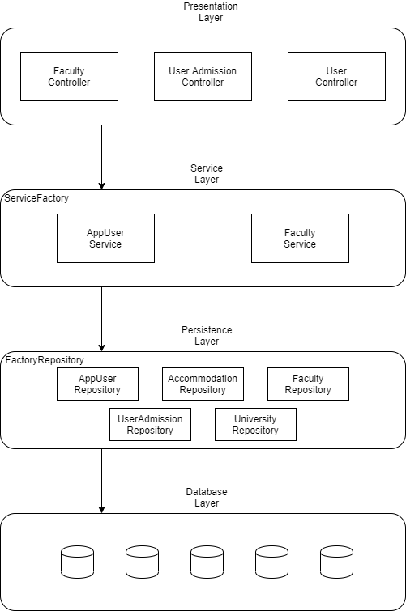
Figure 5.2 Layers architecure mapping

The server, is created by employing a layers architecture. It allows for separation of concerns and most importantly, isolation of layers. This means that changes in one layer, will have no impact on the other layers. Of course, this presents an impediment in scaling, due to having to add new components to each and every layer.
As in can be seen, the presentation layer instead of containing some UI, it holds the controllers, through which the backend server will ”present” the data according to the incoming requests.
Both the Service and Persistence Layer will make use of abstract factory pattern, in order to ensure openess to extension but closing to modification.
The Database Layer will be created by using Hibernate ORM.

Database Layer
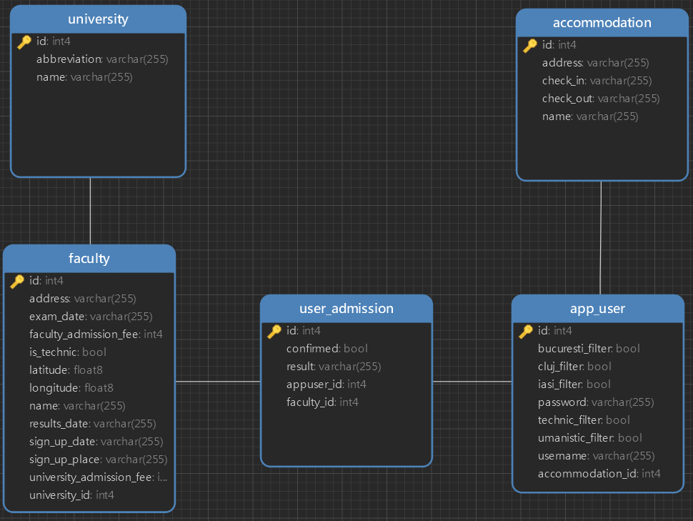
As mentioned above, the Database Layer was created by using Hibernate ORM. The tables of the database are created by using annotations in the POJO (plain old java object) representation of the domain objects. In this way, Hibernate knows which object should hold which attributes. This way of creating database tables uses no SQL queries provided by the programmer, but created and executed underneath by Hibernate based on the object definition.

Figure 5.3 Database design

Persistance Layer
The repository layer holds the operations which will be performed on the database layer. By applying repository pattern for each object from the domain, we will have multitude of repositories. Instead of writing specific SQL querries and execute them on the database, we let instead Hibernate to take care of this. Each repository will be defined as an interface which extends the interface Repository<T, Integer>. By doing so, hibernate will automatically provide a series of methods for performing actions on the database. Repository pattern is used to organize the methods which are responsible for performing operations on the persistence layer. It is used together with DAO to facilitate the operations on the database. By combining the two design patterns, we implement a Data Access Layer (DAL).
To make all the domain’s objects repositories accessible, an abstract factory pattern was used. This transfers the concern of using directly the required repositories to the factory which will hold all of them. By doing so, we ensure extendability. Should the need arrise, using new repositories is simple, since all we have to do is create them inside the factory repository. Moreover, by employing an abstract factory pattern, we ensure indirection, low coupling and high cohesion, according to GRASP principles. Indirection is achieved by having factoryRepository being the ”middle-man” between business logic and the operations performed on the database layer. Furthermore, low coupling is achieved since the business logic is not strongly related to each repository, but to the factory repository. Thus, high cohesion is achieved, each member of a class being strongly related.

Service Layer
The service layer holds all the methods responsible for the business logic. It employes the Spring’s dependency injection in order to use the factoryRepository. Thus, operations on the database will be called from here.
Moreover, the service layer holds two services, AppUserService and FacultyService. They were created in order to ensure high cohesion, according to GRASP principles. Furthermore, both of the services are used inside another abstract factory. It ensures, as mentioned previously, low coupling (this time between presentation layer and services), high cohesion and indirection.
The methods defined inside the service layer, will convert the results after operations on database, into the DTO representation of the domain objects. This is done so the presentation layer will not have to convert by itself to the required type each time the service methods are called. The Transfer Object pattern is used to create simple POJOs which are representation of the entities of the domain. The POJOs are serializabile so they can be transfered over the network. Also, while using Hibernate, it is a must to use DTOs (data transfer objects) due to the references made to represent the relation between entities of the domain. Moreover, this design pattern is used for further decoupling between the business logic layer and the presentation layer. The classes from the entities must not be used directly in the presentation layer, but the DTOs since they will be responsible for the conversion.

Presentation Layer
The presentation layer is the highest layer in all of the architecture. It holds the controllers responsible for ”presenting” the requested data and performing operations on the database, through the use of the service layer. Like the service layer using factory repository, the current layer uses a service factory.
The controllers are not just simple controllers, but REST controllers. REST controllers are a specialized type on controller. It simplifies the implementation of a controller, by getting rid of the cumbersome syntax.
By the nature of the controllers, we will make use of REST. In this way, we define a resource (a collection of data) and a resource identifier to identify that particular resource. For basic functionalites like CRUD, REST offers a series of verbs in order to distinguish endpoints with same name but different behaviour. As an example, in faculty controller, there are two different methods with the same signature and the same endpoint. The distinction between them will be made by which kind of verb was used when making the request (either POST or DELETE). In this way, we encapsulate the operations which are relevant to certain objects of the domains by not offering to the exterior a way to distinguish the endpoints, besides the REST verbs.
As mentioned before, the presentation layer will return DTO representation of the domain objects. This is due to Hibernate creating references which render the object domain useless for retrieving. More so, it is not good practice to retrieve over the network the whole domain object. It may contain certain details which are not needed, so creating a DTO is the better way.

Seed
In order to introduce the information regarding universities and their faculties admissions, a seed class was used. In the context of the Spring environment, it is a component (a general bean instatiated by Spring) and a command line runner. The latter is available since the class implements the interface CommandLineRunner. By implementing the interface, the current class must overwrite the method ”run”. The specified method is run once. Therefore it is a good fit for our need of introducing data into the database through the use of this method. The seed will have a factoryRepository, used to actually save the newly created instances from the data supplied. The data supplied to the seed is in JSON format. The conversion between JSON and domain objects is done by using a library named GSON. GSON allows the conversion between JSON and object domains to be seamless.
Furthermore, a second seed was employed. This one is responsible for adding other universities and their respective faculties. By the virtue of not having detailed data about the admission process and the admission period, the faculties are introduced manually. Maintaining an order for both the seeds is crucial. This is done by annotating one of the seeds with the following: @Order(Ordered.HIGHEST_PRECENDENCE). This ensures that the seed containing the annotation will be run before the other.

Client design and implementation
The mobile client of the system was implemented as mentioned previously by using React-Native, HTML and CSS. This allows for a web-based implementation which can be easily ported to a website. Also, the chosen technologies were picked in order to focus not only on the functional features of the mobile application, but also on the non-functional ones as well. Moreover, by using React-Native, the application is developed by using Expo, an open-source platform for creating and developing React-Native applications. The main advantage in the use of this technology is that a mobile phone emulator is not required. The application is run on the phone by the means of Metro, a tool for running apps in development without the need for emulators. The connection is done over the network.
Technologies like HTML and CSS greatly improve the development and the design of the user interface. Also, before the actual implementation, several mock-ups were made for each screen of the mobile application. The tool used for realizing the mock-ups was Figma. Web based tool, it offers a large range of features, useful for user interface design.

User Interface Design
Instead of an usual Material Design approach, the user interface was designed by employing Neumorphism. The main benefit of Neumorphism is that it makes the application to stand out. Every component offers a 3D effect, as if it extrudes from the background. The effect is achieved by having the geometric form, square, circle or rectangle have the same colour as the background. Furthermore, in order to make it visible, shadows are employed. There are two kinds of shadows, one lighter and one darker. The lighter shadow, represents the direction of the light source. Due to similar colour to the background and the shadows to highlight the shape of the form it gives an impression similar to bas-relief.
The colour theme of the application is a dark one, in order to reduce the strain on the user eyes, whenever the application is used.
The buttons used were also done in Figma, by applying the previously mentioned technique. They are the results of combining different icons such as Feather Icons with shapes such as circles, rectangles and squares.

Main Screens
Since the application is representing the client from a Client-Server architecture, the application has two states. One is when the user is logged out and can either log in or sign up. The other state is when the user is logged in can has access to the functionalities of the application.
The main screens are managed by a stack-navigator. It represents a component which holds the actual screens to navigate to, and a name associated with each screen. It has three components, Login, SignUp and Home. The Home component is the most important and represents where the user will land after successfully logging in.
The Home component is responsible for performing the required animations on the buttons and for switching between the screens. Moreover, it represents an intermediary between different screens for passing data from one screen to another, whenever it is the case. Furthermore the population of the application with user data from the backend is performed by this component whenever it is rendered. It employs an useEffect which by specifying empty square brackets as the second argument and the actual function to be executed as the first one. The empty square brackets are used to denote that the function specified in the useEffect is to be called after the component is ready to be displayed. The first argument of the useEffect is the function to be executed. The HTTP requests are performed by using the library axios. Instead of using an approach based on resolving promises with ”then” , we used an async and await method. The async is used to denote that a function will have an asynchronous call made. The await keyword is used whenever the call is made in order to stop the javascript thread from executing and wait for the return of the promise from the HTTP call. The function to be executed inside the useEffect is an arrow function, different from a normal function. Directly denoting it async and making asynchronous calls will not solve the problem, due to the compiler indicating possible errors whenever calls are made. Directly using async and await on an arrow function in an useEffect can lead to synchronicity issues. The problem is solved by employing the use of an IFFE. It represents a special type of function: Immediately Invoked Function Expression. The function will be called as soon as it is defined. Therefore the way to use async and await is to define an arrow function which performs the required requests. The defined function is embraced by normal brackets and then followed immediately by a call operation. In this way the synchonicity issue is removed. Moreover, whenever multiple requests are to be performed,they can be performed in parallel by using the all method from the axios library. The current component is also responsible for sending the filter of the user to the backend, in order to be persisted.
The Home component is composed from two parts:
- Top container – it holds the way to switch between the different screens. It contains suggestive buttons for each individual screen. By default, after logging in, the main screen is the admission one, which is visible by the presence of the faculties, filters, available and going tabs and the bigger button with blue inside color. The button with blue inside color is bigger than the rest of the buttons as a way of letting the user how to differentiate between the screens. Whenever another button is pressed, the current one reduces its dimesions and changes the color to red, in order to denote an off state. Thus, the currently pressed one will enlarges its size and change the color to blue.
The animation was done in the following manner: each button will have a separate value for the size and width of the image. A separate functional is responsible for handling the user input on the buttons and performing the required operations. Whenever a button different when the current one is pressed, the specific button is enlarged and the other buttons are shrinked back to their initial size. This is done by defining two styles for the button, one general and one inline which holds the sizes. Being inside an Animated.View, this means that the transition will be made as smooth as we want it without the need to specify extra gimmicks. Moreover whenever a button is pressed the state of the button changes. This state is achieved by changing the images of the icons when the user clicks. This not only changes the color and sizes of the button, but also triggers the apparation of a new screen.
- Middle container – it holds the actual screens that are to be presented to the upcoming student. Furthermore, depending on what functionality each screen provides, it will be further split into other containers. The map view specificaly, is split into three parts: the MapContainer, the MiddleContainer and the BottomContainer. The MapContainer has the role of holding the actual map and the markers which will be rendered. The MiddleContainer is used in tandem with the BottomContainer, in order to faciltiate the presence of certain cards which are required for different features. This is done in order to ensure a consistent layout.

Admission Screen
This is the first screen that the user is greeted after successfully logging in. The current screen is marked by the bigger blue circle with a book inside, at the top of the application. From this screen the user can either choose to see all the available faculties according to the filter or the already going admissions. The filter can be changed at any time and it is memorised whenever there is a change. This means that if the user will log out of the application, the last applied filter on faculties will still be available. Whenever the user filters the available faculties, the choices are between the three major cities in Romania which are renowned for their academic programs. Moreover, the faculties are split in technical and humanistic
All the faculties are displayed one under the other. Each faculty will have three buttons: documents, location and participate. In order to reduce the number of duplicate data and therefore the memory required for holding all the faculties in the mobile application, all the faculties are composed from two lists:
- User going admissions – represents all the currently participating faculty admissions of the user. In case the user has no admissions marked as intended to participate, the list will be empty.
- Faculty admissions – represents all the faculty admissions currently available. This list is updated when the user decides to participate to a faculty admission, or whenever the user choose to remove an admission from his “going” ones. For implementation, the task has been delegated to the “Admissions” component. Whenever the user clicks on the participate or the cancel button, a function is called which differentiates between the two and proceeds with the required actions. In case the user has deleted a participation or has decided to participate to a faculty admission, this function will take care to update the local “cache” and persists the modifications to the backend immediately. This facilitates a better handling of the available resources.
The documents button when pressed will display to the user the required documents for the current faculty. These documents include diplomas, photos, etc. Their total number is calculated by taking into consideration how many going faculty admission the user has. By having more than one admission, we have to calculate how many photos are required and which extra documents are needed. The extra photos are calculated by simple taking the requirements for a faculty (3 photos) and multiply by how many faculties did the user show an interest in taking part in the admission. Moreover, when participating to more than one faculty admission, the receipts which attest the deposition of the BAC diploma and the report card are a must have for participating in the others admissions. They are also calculated by adding two extra fields to the required documents.
The location button when pressed by the user will ask for permission to access the current location of the phone through the GPS. The user can either decline or accept to give permissions. Once the user has approved the use of GPS, the screen will transition into a new state, one in which a map is visible. From there, the current position of the user will be marked on the map with a blue marker. The destination will be represented by a red marker on the map. Furthermore, the red marker represents the location of the currently selected faculty. After clicking on the red marker, the user will have to choose between three navigation modes: driving, walking or bicycle. Moreover, the journey estimated travel time will be indicated under each option for navigation. After choosing one of the travel modes, on the map, a route on the map will appear and guide the user to reach to destination. Whenever the upcoming student needs or wants to exit navigation, a press on the admission screen will redirect the user to all the available faculties. It was implemented by keeping in mind that several destinations would be required in the future, therefore it does not just use two locations to display them on the map. It uses instead a location (the current position) and an array of destinations, which for our particular case (a faculty) will be of size one. Moreover, depending on how many elements there are in the destination array, the current location will either be the one of the user (by asking for permissions) or a different position (used later, in another feature).
The participate button is used by the user in order to show intention of participating to a faculty admission. After pressing, the admission will be visible from the going tab, just above the filter. Moreover, whenever the user presses “Participate”, the application will look after any existing faculties with an intention from the user to participate that conflict with the current one. In case the exam dates are in the same day, the user is warned and has two courses of actions available:
- Choose not to participate to the current admission
- Choose to participate to the current admission, after removing the conflicting admission
The filters on the current faculties are straight forward. Depending on what the user chooses, the action is visible in real time. Moreover, whenever no filter is present, the application will present by default all the faculties available from each university the three major cities. Also, the filters will also be available from the going admissions.
The going admissions is where the current faculty admissions with intentions to participate by the user are present. From this tab, the user can at any time access how to reach the faculty location and to remove the intention to participate to the selected faculty. Moreover, two extra functionalities are present in the current tab. The user can view which fees are required for each individual faculty. This is accessible by pressing the fees button. Furthermore, by showing intent to participating to different faculty admissions, the user will have to let the BAC diploma and the report card to a faculty. Therefore, it will be expected from the user to present to the other faculties the receipts attesting the deposition of the originals. An automatic total of the required documents is presented to the user whenever the documents button is pressed. It is present near the fees button.
Each faculty will be visible before and during its sign-up period. This means that after the sign-up period expires, the user cannot participate if he or she did not do so. If the upcoming student has signed-up and did not change his or her mind, the user will be prompted to confirm to which faculties did he or she actually sign up. Faculties that are not confirmed, are never visible again and the confirmed ones will change their state.
The above mentioned change of state for the faculties not confirmed is done in the following manner. Whenever a faculty component is ready to be rendered, the current date will be taken. The current date will be further compared with the end of the sign-up period. In case the current day is greater than the last day of signing-up, the faculty will not be displayed. Otherwise, it is visible.
Once the sign-up period is over, the user will have, from the going tab a button check results. On the results day, the user will be able to press the button and to check whether or not he or she managed to be admitted. Moreover, the funding way will be specified as well, be it tax or tax-free.

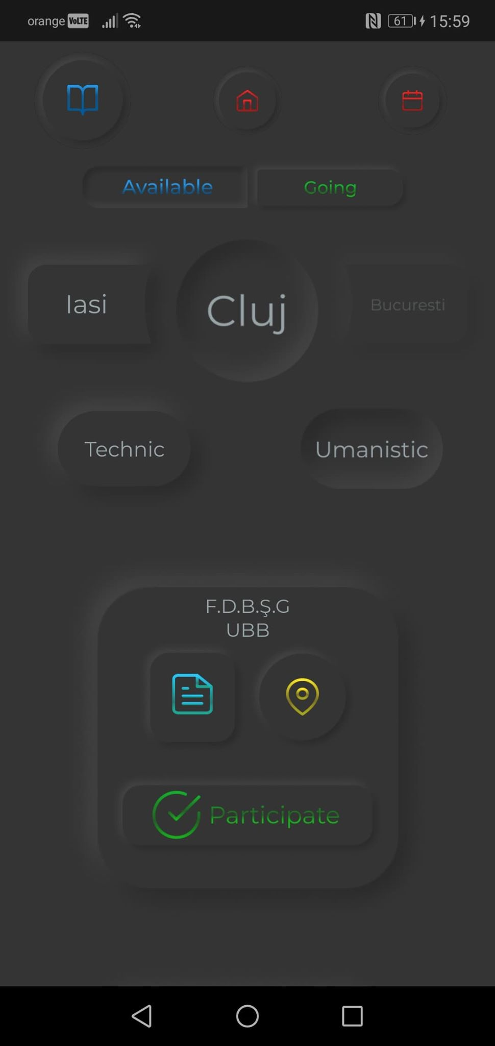
Figure 5.4 Admissions Screen

Accommodation Screen
The current screen allows the upcoming student to search for accommodations and also faciltiates a way for managing an already existing one. The current screen has two states, one before introducing an actual accommodation reservation and one after introducing the reservation.
Before introducing an actual accommodation reservation, the user is greeted by a question and two buttons: ”I have accommodation” and ”I don’t have accommodation”.
”I don’t have accommodation” button is used to help the user search for accommodation near the desired faculty. By pressing the button, the user is presented with the already participating faculties. Taping either one of them, will redirect the user to a map. On this map, the location of the faculty is displayed by the blue marker, while the accommodation places are displayed by red markers. For displaying on a map the location of the accommodation places and of the faculty, the component used for faculty location previously mentioned is reused. Therefore, instead of passing to the maps component the faculty location as destination, it is used as the current location. Depending on the current location, a function is employed to take care of searching for accommodation places near-by. This is performed by utilizing Google’s API for Places, specifying the range radius (a reasonable distance from the faculty would be 2 km), the type of the place to be searched (accommodation) and the data that we want to retrieve. Regarding the data we required, it is composed from the coordinates (latitude and longitude), the name, address, website and the phone number of the accommodation place. Each and every accommodation place together with its details is placed into an array and send to the map component. In the map component, the current location is the faculty position and the destinations are represent, as previously mentioned, by the accommodation places. For each accommodation place, we employ the use of Google’s API for Directions, which will calculate the exact distance to the faculty. Moreover, once the user taps on a red marker, representing an accommodation place, a card will be displayed.
The displayed card holds the data regarding the accommodation place that was tapped. The name of the unit, the street and distance to the faculty is mentioned. Moreover, the user will now have two options for contacting the accommodation place:
- Tap on the Phone icon
Tapping on the phone icon, will allow the user to access and call the accommodation place. This is done directly on the user phone by automatically inserting the accommodation place telephone number on the phone. The phone number was procured by employing, as previously mentioned, the use of the Google’s API for Places. The insertion of the phone number on the user’s phone to call the accommodation place has been implemented by using Linking, provided by the Expo Platform. Linking is a helper method for accessing deep links inside the phone. This is done by specifying the type of linking required. In our case, for introducing the phone number of the accommodation place, tel was used. The keyword tel, followed by double-colon and the phone number will access the phone’s keyboard and introduce the number. Now, what the user has to do is to press the call button or to do whatever he or she seems fit (memorize the number for a later call regarding a reservation). Since the link is strictly done by only introducing the phone number in order for the user to only press the call button, no permissions are required. The linking does not access personal data such a phone agenda or other contacts.
- Tap on the Website icon
Tapping on the website icon, will allow the user to access the website of the accommodation place. This is done similarly to accessing the phone number of the accommodation place. As previously mentioned, linking is the method for implementing this functionality. Besides the keyword ”tel” used above, the Expo Platform provide other keywords which help us in linking to the desired location. The used keyword for accessing the website is either ”http” or ”https”. Some websites will have a secure connection and some won’t. This issue is addressed and solved by utilizing the Google’s API for places. When requesting the website of an accommodation place, the API will automatically return the actual, up-to-date one. Since the URL for websites includes either the keywords “http” or “https” followed by a double-colon, all we have to do now it to access the URL through the Linking helper method. This method of accessing of the phone’s web-browser does not require extra permissions.
“I have accommodation” button is used to provide the user with a way to keep track of the accommodation reservation. By pressing it, the upcoming student is redirected to a form which must be completed. The form will contain details such as the name of the accommodation place, the address, check-in and check-out date. Moreover, the user will also have available two buttons, one for confirming the reservation and one for exiting the current form. By exiting, the user will be back to the question regarding accommodation and the two buttons, “I have accommodation” and “I don’t have accommodation”. The form is used by the user, once he or she confirms the actual reservation with the accommodation place. Moreover, the user is not constrained to stay only in the recommended places. Most definitely, there will be some upcoming students that have relatives or acquaintances in a particular city. In this case, the user can consider the staying at those persons by actually considering the staying as in accommodation.
When completing the accommodation form, the user will have to manually introduce the data. All the fields are mandatory and the specific format is present (especially for check-in and check-out dates).
Whenever an error occurs by not respecting the format, a red message will be displayed underneath the input. Most errors will happen in the check-in and check-out dates. The specific format is used for checking a range variety of possible errors that can arise. Besides not respecting the format, a user can wrongly introduce the check-in date by specifying a date in the past. The check-in date must respect the specific format of dd/mm and also be made starting from the current day. On the other hand, the check-out date must also respect the specific format previously mentioned and to be at least a day after the check-in. In this way, no reservations can be made with check-in and check-out in the same day.
Once everything is according to the formats, the user will press the green arrow button. Now, whenever the user will access the accommodation screen, the details of the upcoming reservation will be present, including the name of the accommodation, the address, check-in and check-out date.

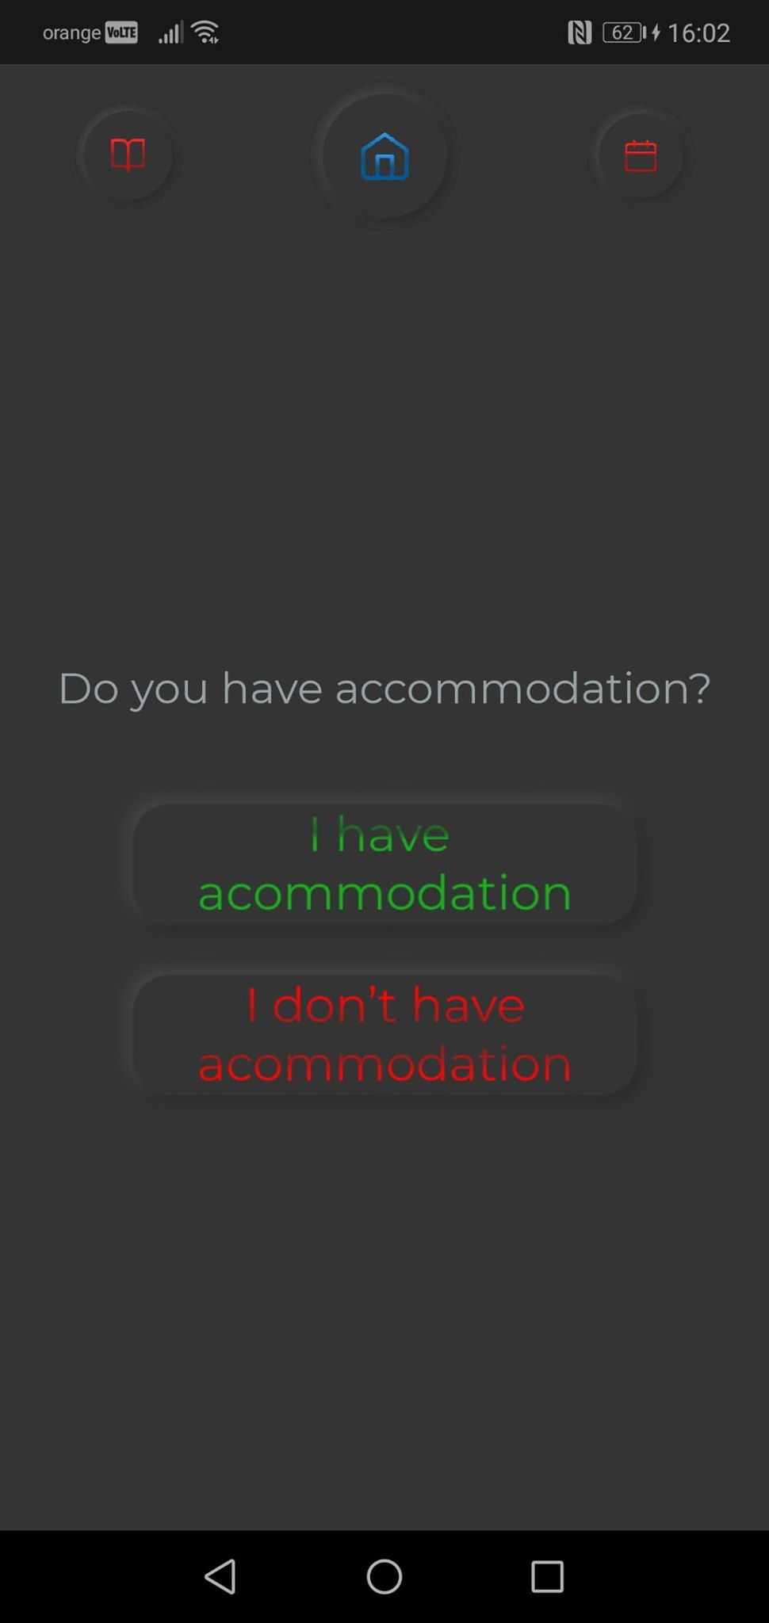
Figure 5.5 Accommodation Screen

Calendar Screen
The current screen allows the upcoming student a way for managing his or her schedule during the admission period. The screen is accessible by tapping on the rightmost button, the one with a mini-calendar. Once the user is on the calendar screen, a long list with numbers will appear. The list represents the days of the current month. Each entry of the list is composed from two sections:
- Left section – represented by a square. It holds a number, representing the day of the month.
- Right section – represented by a rectangle. It holds the data according to the user’s actions
The right section of an element of the list is the most importnt. It holds the schedule of the user on the specified day. The schedule of the user, will change according to participating or not to different faculty admissions. Whenever the user will show an interest in participating to a faculty admission, by going to the calendar, all the important stages of the admissions are presented across different days. If the sign up period of a faculty admission is spread across multiple days or even across different periods (a few days consecutively, then a break and again a few days), on each day the user will be able to see that the schedule will include it. Moreover, the exam and results date are also present and can be visible on their respective days. Furthermore, the check-in and check-out dates, specified previously, will also be present in the calendar. In order not to overwhelm the user, only a certain part of a day is presented together will all the others days. To view the whole schedule for a day, the user has to tap on the desired day. Then, a pop up will appear holding all the specific matters.
To reduce the effort of browsing through the days and searching for the current day from the user, filters were implemented. When the user enters, the current filter will be the current month. The choices are composed from the current month (default), the current week and the current day. The current week was introduced in order for the user to better prepare and organize for the admissions. The current day was introduced, as previously mentioned to give the user a fast path to what must be done in that day.
Each day of the month will have two states, represented by a change of colors. The day in green represents today and the ones in white are represented by all the others. This gives the user a way for orientating himself or herself among the days, be them either for the current week, or the whole month.
For implementing the calendar, a list of specific items was used to hold each and every day of the current month. This specific type is ”CalenderEntryProps”. It holds optional props for modifying content and other specific details such as which color should the current day have, what is the description, which day number does it hold. The ”CalendarEntryProps” is populated by the use of another data type, called ”CalendarDay”. This data type holds a dictionary, having as key the current day as a number and as value the description for that very day. For correctly introducing data into the dictionary, specific functions were employed, specialized in adding certain details. This means that three functions were employed:
- addToCalendar – adds into a dictionary the details about a single day
- addSignUpDatesToCalendar – function for specifcally adding the signUpPeriod to the calendar. It is used when first rendering the screen. Certain faculty admissions will have two different intervals in which the signUp will be held, therefore it is mandatory to add both the intervals to the calendar. This is done by splitting each interval and feeding it to the currently mentioned function.
- addAccommodationToCalendar – function responsible for adding the accommodation of the user. The accommodation is passed by props and then send to the current function for further processing. The check-in and check-out dates will be parsed and introduced into the dictionary.
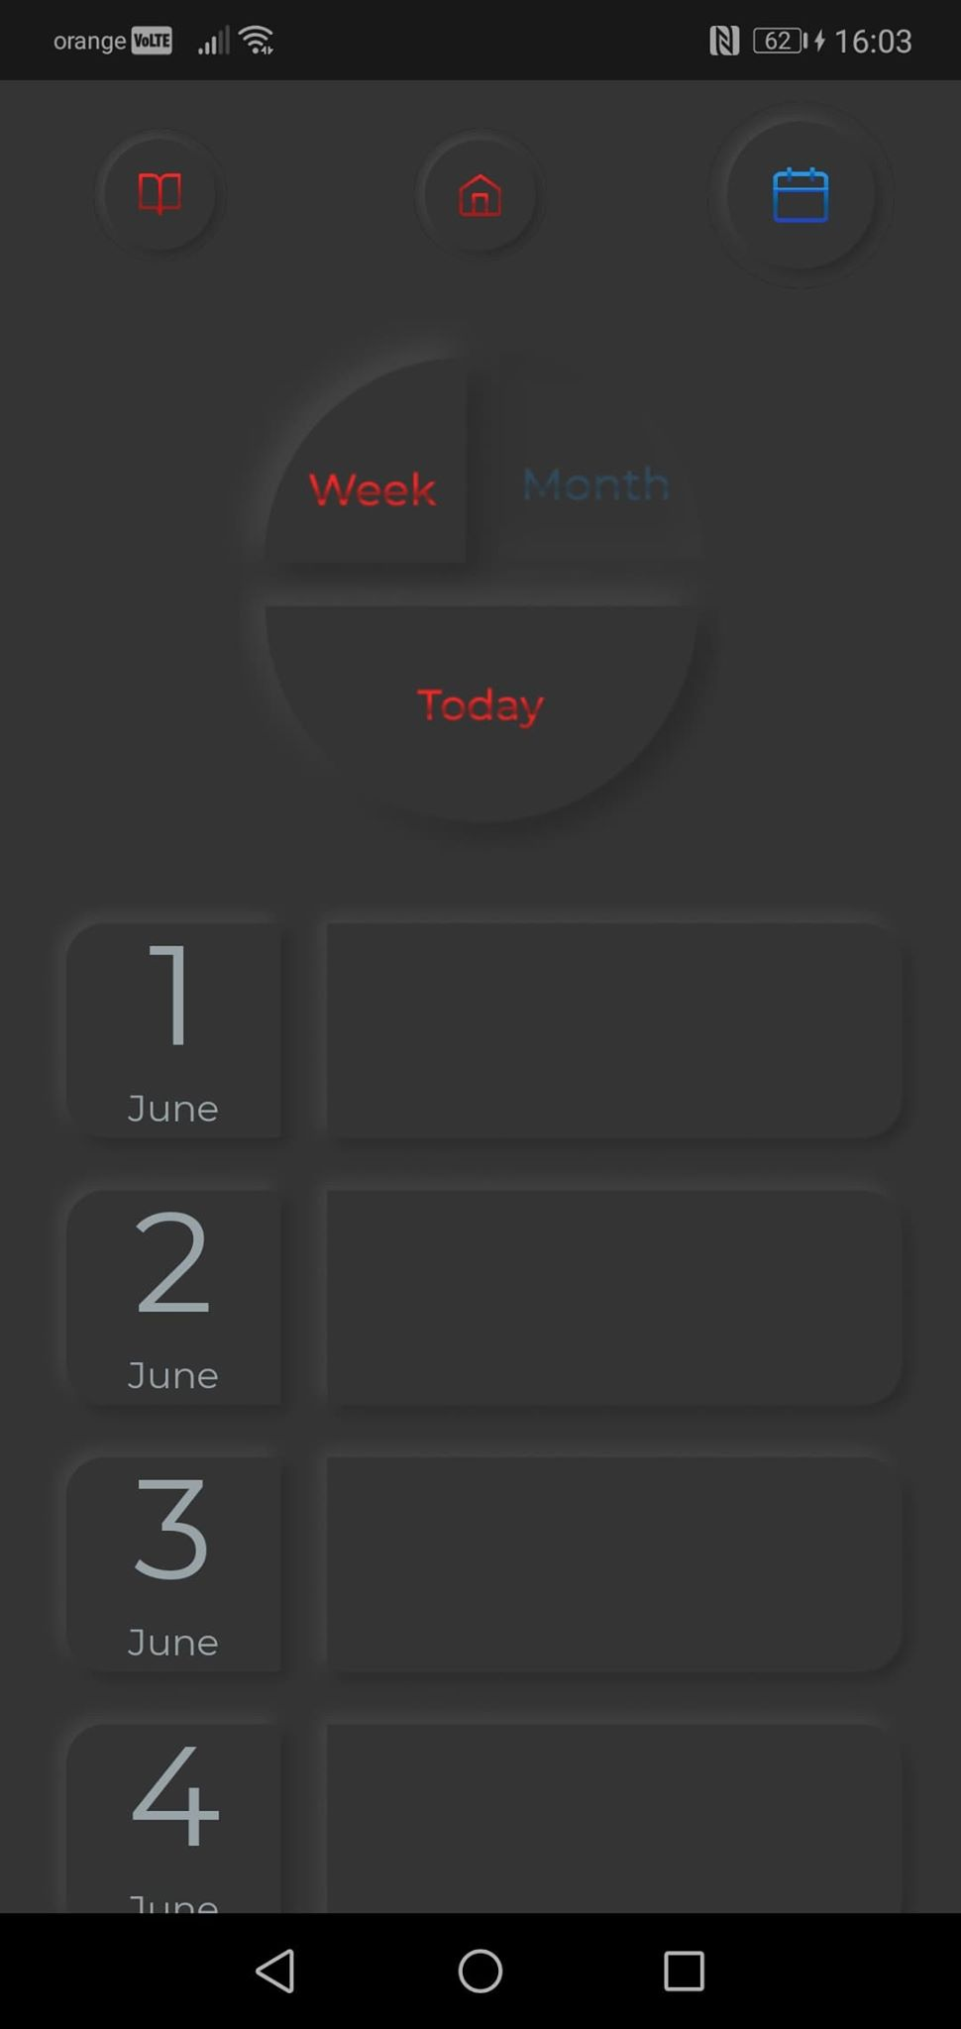
Figure 5.6 Calendar Screen

Web Crawling and Scraping design and implementation
One of the challenges encountered during the development process of the system was the data acquisition. This has been implemented by employing both a web crawler and a web scrapper. The web crawler is a specialized program in finding and deciding if the web page contains relevant data suited to the needs. On the other hand, a web scrapper is employed when specific data from a webpage must be extracted. Web crawling employs a small part of web scraping in the sense that the links that lead to other websites will be extracted.
The basis for web crawling was studied from “thenewboston”. By doing so, a skeleton was presented, which was adapted to suit the requirement for searching relevant links from the faculty’s website. The skeleton holds all the basic input/output operations for modifying the seed of the web crawler and the actual retrieval of the page utilizing a HTML parser. From necessity, the web crawler was built upon an already existing skeleton, representing the most basic form. Handling of the tags and the logic behind what the page must contain in order to classify it as a relevant link was added. Without this, the open source web crawler employed would just search for all the links from a website, starting from the homepage. The Figure 5.3 holds the overall web crawler conceptual diagram. As it can be seen from the figure, the red component is the one where improvements were made in order to suite the requirements.
The web scraping part was made from the scratch. It is responsible for actually accessing the webpages crawled earlier and starting the data extraction process. Depending on the website, certain impediments were meet during this process but were eventually resolved.

Web crawler
As mentioned previously the web crawler was based upon an open-source skeleton provided by ”thenewboston”. This skeleton holds all the basic operations which together form a web crawler. The operations are among the following: reading from and writting to a file, creating folders in case they don’t exist, delete data from and appending content to a file. Moreover, it contains other functions which retrieve the HTML of a webpage by using a HTML parser. As mentioned previously, the bare-bones frame offered searches the whole website for discovering and saving all the webpages from it. This skeleton is somewhat powerful and has a certain degree of flexibility in the sense that custom rules can be applied in order to visit or not links from a website. By manipulating what links can be followed through or not by the web crawler, we can specifically search for certain webpages which we know they contain relevant data. The specific criteria what a webpage must meet in order to be a valuable candidate is to contain certain keywords. These keywords are analyzed before hand and fed into the web crawler. By doing so, we remove redudant searches through webpages that do not contain any relevant information at all.
Most websites have a large number of links available at each webpage. These links may not always lead to another page on the current website. Therefore, it is mandatory to constrain the web crawler from searching in a completly solution-less environment which happens when going outside the current website. The skeleton mentioned previously, also contains a functionality for preventing the web crawler from redundant searches outside the website.
Moreover, the searching and classification of webpages from a website can prove to be cumbersome, here and there tedious due to the large number of possible links. Therefore, it benefits from a parallel implementation.
Below is a diagram, highlighting the architecture and structure of the web crawler, applied for the our neccessities.
The web crawler was employed for UBB and TUCN faculties.
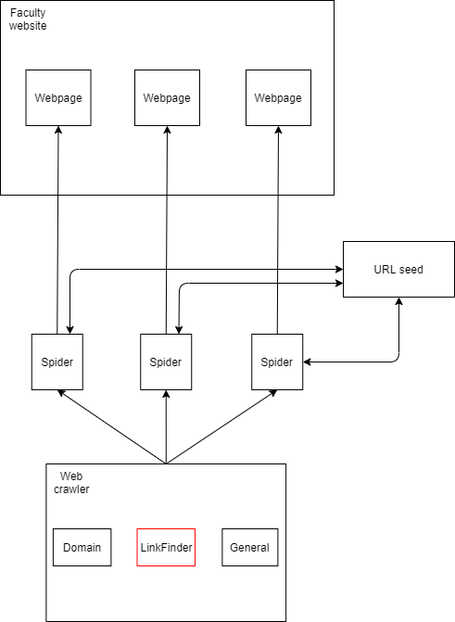
Figure 5.3 Web crawling architecture

Web crawling TUCN
Web crawling TUCN was a straight-foward process. The domain of the website is present in the same order on each webpage which contains links with relevant data about the admission process and period. Therefore, the web crawler will not omit the relevant webpages during the crawling process and will esure full-pass of the website’s available links.
The actual specific implementation of the web crawler was done at the LinkFinder level. The LinkFinder level is responsible for analyzing a webpage and deciding if it fits the criteria of being a page worth considering as holding relevant data. Worth considering is mentioned with the meaning that some links will play the role of the ”middle-man” between the home page of the website and the rest of the links. For example, while crawling the utcluj website, links such as ”https://www.utcluj.ro/admitere/licenta/” contain nothing related to the admission of each faculty, besides the links which lead to them. The link was further extracted and used to search and access each faculty’s admission webpage. When providing a concrete implementation to the handle_starttag method, the following were taken in considerations:
- Only HTML tags representing links are relevant – as it is known, ”link” and ”a” are used for specifying paths to certain resources. They are followed by hyperlinks that lead to other locations. This is why the focus was on those two HTML tags.

- Only admissions to bachelor level – from the non-functional requirements, the main one was the focus on the bachelor degree. This is so, because the target user of the application is represented by high-school graduates which are the upcoming students.

- Only admissions in Cluj-Napoca – this has been one of the main non-functional requirements from the initial stages of the system. Also this has been the case since at the time of the web crawler development only faculties in Cluj had already information regarding the admission process and period.

By considering the above specfied, when searching for web pages containing details about faculty admissions period and process, certain faculties were ommitted. These faculties are from a different city, e.g. Baia-Mare, or represent certain extensions. Therefore they were not taken into consideration since the scope of the application is to focus on the three major university centers which are Cluj-Napoca, Iasi and Bucharest. No impediments were met during this process, besides the actual process of discovering the keywords that must be contained into URLs to consider a webpage relevant for further data processing and extraction.

def handle_starttag(self, tag, attrs):
if tag == 'a' or tag == 'link':
for (attribute, value) in attrs:
if attribute == 'href':
url = parse.urljoin(self.base_url, value)
if 'admitere' and 'licenta' in url:
if 'cunbm' not in url and 'extensii' not in url:
self.links.add(url)

Web crawling UBB
Similar with the web crawler for TUCN, the same skeleton for web crawling was employed. The finding of the keywords which signal webpages with relevant data and the navigation throughout the website has proven to be one of the impediments, mentioned in the following:
- Changing of the URL structure – on the UBB website, when going to Bachelor Degree and then to admission, we are redirected to a new webpage. This webpage will serve as intermediary between the home page and the webpages for each of the faculties within the university. Instead of a classical appoach for constructing URLs for different webpages within a website by concatenating an identifier to the website’s domain, here the ”admission” playes the role of a subdomain of the website. Therefore it does not obbey to the rule assumed in the skeleton of the webcrawler. This has lead to inconsistencies and dead-ends while crawling the website. Moreover, it would sometime take the webcrawler a very long time until stopping and sometimes it would not even stop due to the links which were created again and again in an incorrect way. The problem has been solutioned by bypassing the parsing of the website domain and feeeding the webcrawler, the admission page directly. In this way, the web crawler would not embog while trying to discover new links. Moreover, since the crawler is right on the page containing the links, no search overhead through all the links will be present.

- Lengthy URLs – some URLs in the website, have a great number of characters. Some of them hold relevant data while others contain data about past admission processes and periods. Also, while processing the links, webpages such as the of the people responsible for the admission process were shown up, which are irrelevant for our goal. Moreover, some faculties which hold a very large variety of specializations also have the same characteristic, a lengthy URL. This does not only proved to be a cumbersome way for processing the URLs, but also it interfered with the data that will be further extracted. This detail is elaborated below.

- Language identifier in the URL – the UBB website can be displayed in different languages. While crawling, this has proved to be a problem, since the web crawler would search for any link and would return the ”admission” intermediary into a different language, e.g english or hungarian, and it would make the further data processing and extraction harder.

- Multitude of specializations for each faculties with different periods and requirements – A great deal of faculties are present. From those faculties, a handful of them have a large number of specializations which would add to the data processing and extraction an extra layer of complexity. This is so, because for each specilization from that faculty, a different time period is used for the admission schedule. The problem was not that the faculty had more periods in which the admission process is held for all the specialization, but the break up of each individual specilization with separate admission periods. This would interefere with the other data held by the system, details about a faculty’s admission process and period, not for each specialization. For this reason, faculties with a great variety of specialization were omitted, since a totally different concept and data model would be required.
The above impediments have been solved by modification to the:
- LinkFinder level – like the web crawler for TUCN, the focus was also on the ”a” and ”link” HTML tags. Morever, once the link has been found it is concatenated to the current website URL and the validation begins. If it’s length is less than 65(in order to avoid multiple specialization faculties, other irrelevant links) and actually contains the website (in our case the admission page URL) it is added to the relevant links.

def handle_starttag(self, tag, attrs):
if tag == 'a' or tag == 'link':
for (attribute, value) in attrs:
if attribute == 'href':
url = parse.urljoin(self.base_url, value)
if 'https://admitere.ubbcluj.ro/ro/licenta' in url and len(url) < 65:
self.links.add(url)

- Domain processing level – instead of using the domain processing of the web crawler, it has been avoided due to the issues mentioned above. Also, instead of passing the UBB home page to the web crawler, the page which is the intermediary between it and each faculty admission website, has been used as starting point. This ensures consistency for construction of the webpages URLs while also making sure the web crawler will not get stuck trying to process a not so commond resource identifier, through subdomains.

Web Scrapping
In this section, the actual data retrieval and transformation into JSON format will be performed. For each faculty, TUCN and UBB, there is a web scrapper which is responsible for the process. They have been separated due to differences in the websites. Different approaches were employed for data extraction, since one of the methods doesn’t work on the other website and then other method is too slow to be used in both of them. Further below, the process for data extraction and conversion for each university will be presented.

TUCN Web scrapper
The process for data extraction and conversion starts by accessing the URLs which were crawled at the previous stage. The scrapper must access each webpage, search for the relevant data and transform it into a desired format. Below, the inner workings of the web scrapper is detailed by the use of a diagram.
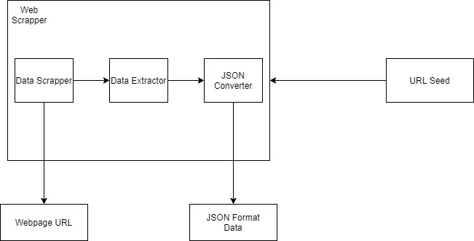

Figure 5.4 TUCN Web Scrapper

As mentioned before, the links which are the intermediary between the website mainpage and the admissions page and the page with rules were also included since they respect the format. In this stage, they are removed by employing the use of Python’s NumPy syntax.
urls = urls[2:]
del urls[-1]

In order to extract and convert the data from each URL, a comprehension list was used in order to apply the operations to each and every URL.
converted_json_data = [scrape_data_from_url(url) for url in urls if 'regulament' not in url]
The comprehension list is a powerful Python feature that allows to create a list by performing a certain operation for each element from another list depending or not on some conditions that must be met.
Now starts the scrapping process which is composed from:
- Scrapping the HTML tags containing relevant information – this is the part when each URL is opened by the HTML parser. The parser used is BeautifulSoup, since it allows methods for accessing nested HTML with ease. The HTML of the webpage was matched against several RegExes. The RegExes hold all the relevant keywords which help us to find the specific data that we want to extract from the page. Moreover, after applying the RegExes, for each element the parent of the parent tag must be accessed in order to extract the data. In some cases, an extra parent must be checked. Furthermore, when searching through the results after applying the RegExes, the parser will also introduce certain empty elements. These elements are avoided by counting how many items have already data extracted from them. Moreover, only one address of the faculty has been considered in case there are two.This has been done by splitting after ”Cluj-Napoca” and concatenating it. This solves the problem by eliminating the second address of the faculty. Once all of them are processed, the data as an array of strings is passed further for conversion.

for elem in soup(text=re.compile(
r'Înscrieri:|Afişarea rezultatelor iniţiale|Proba de concurs|Înscrierea candidaţilor:|Taxa de înscriere')):
part = elem.parent.parent

data.append(part.text if 'Etapa' in part.text else part.parent.text)
if current_information_processed == 4:
break
current_information_processed += 1

data[0] = data[0].split('Cluj-Napoca')[0] + 'Cluj-Napoca'
# [print(data) for data in data]

partial_data = convert_json_format(data, url)

- Extracting the relevant data from the HTML – at this point, the dictionary which holds the attributes for the JSON format is created. Moreover, certain data can be accessed immediately, such as the taxes.

taxes = values[len(values) - 1]
values = values[:-1]

Once the taxes have been identified, they are removed from the array, in order to facilitate the introduction in the dictionary.
Moreover, before the actually introducing the data in the dictionary, we must extract only the relevant details by using the following method:

extracted_data = input_data
if 'Înscrierea' in input_data:
extracted_data = re.findall('[0-9]+-[0-9]+', input_data)
extracted_data = functools.reduce(lambda x, y: x + ' ' + y, extracted_data)
elif 'Înscrieri' in input_data:
extracted_data = input_data.split(':')[1][1:]
if '(' in extracted_data:
extracted_data = re.sub('\s{1}\(.+\),', '', extracted_data)
elif 'şi' in extracted_data:
extracted_data = extracted_data.split('şi')[0] + 'Cluj-Napoca'
elif 'Proba' in input_data or 'Afişarea' in input_data:
extracted_data = re.findall('[0-9]+', input_data)
if len(extracted_data) > 1:
extracted_data = extracted_data[0]
return extracted_data
”Înscrierea” and ” Înscrieri” are very similar but they are used to denote two completely different attributes. The first one represents the actual admission period and the latter represents the address where the sign up will take place.
The method processes each element from the passed array by the use of a comprehension list.

values = [extract_relevant_data(value) for value in values]

As it can be seen, different transformations are performed, depending on which keyword is present in the element currently being processed.
Aftewards, the processed details and the dictionary’s keys are iterated through in parallel with the use of a zip:

for key, value in zip(keys, values):
data_dictionary[key] = value

- Addition of extra details required – after the data was extracted from the webpage, further details must be added. These details are the latitde, longitude and name of the faculty. The latitude and longitude are obtained by using the Google API for Geodecoding. It takes as parameter the address and returns the coordinates. The faculty name has been extracted from the webpage URL. The taxes, now must be split into two categories: ”universityAdmissionFee” and ”facultyAdmissionFee”. They are both processed from the taxes extracted right at the beginning of the method.

- Conversion to JSON format – once all the data was introduced, the dictionary is returned. Furthermore, by the used of the list comprehension, each dictionary is used to create an array. This array is written in a file, which will later be used by the backend server.

file = open('utcn.json', 'w')
json.dump(converted_json_data, file, indent=4)

UBB Web scrapper
Similar to the TUCN web scrapping, a similar process was used also for UBB with a few mentions. Unlike the TUCN website, the UBB employs javscript functionality to display each detail that is required to us. Those details include admission date, sign up period, results date, etc. Javascript means that using a simple HTML parser like BeautifulSoup will not be effective. The main reason as to why it won’t work is because events must be applied on buttons in order to display the data. Or this is not possible by simply using a parser. The solution was the use of Selenium. It is a tool for automation of web testing. Since it provides the capabilities to open browsers and ”press” buttons, it is the right tool.
The scrapper starts by getting the urls from the web crawler. In order to actually access an URL, the options for the webdriver are specified.

opts = webdriver.ChromeOptions()
opts.headless = True

The webdriver chosen is Chrome and the headless option is set to true, in order to run the browser in the background, not being visible. For parsing the HTML, BeautifulSoup was also used as in the previous scrapper.
Unlike the previous website, the relevant data extraction was easier. The big chunk of data that contains the details is passed to a method which takes care of the extraction. The extraction process involves RegExes and returning a string as result.
Choosing which URLs hold faculty admissions was crucial. This has been achieved by using a method which avoids certain keywords: ”cazare”, ”alte_categorii”, ”programe”, ”educatie_fizica”. Moreover, the URLs had to respect the length of 39 characters, in order to avoid the Teology faculties, which are many.
Similar to the TUCN web scrapper, the data has been solved in a dictionary and written to a file in JSON fornat.

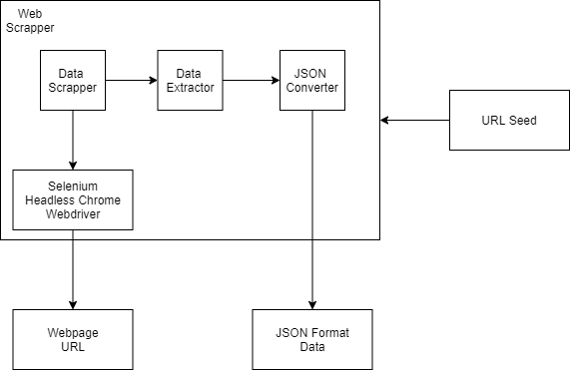

Figure 5.6 UBB Web Scrapping

Testing and Validation
In the current chapter, as the name suggests, testing and validation have been covered. They represent one of the most crucial aspects in the development of the system. In order, the web crawler, web scrapper, backend and client were tested in order to ensure the expected behavior. Each use case for all the components, which together represent the system, have been tested to offer an experience to the user through the functionalities available at hand. This ensures correctness and that the application is ready to be used by the user.

Testing
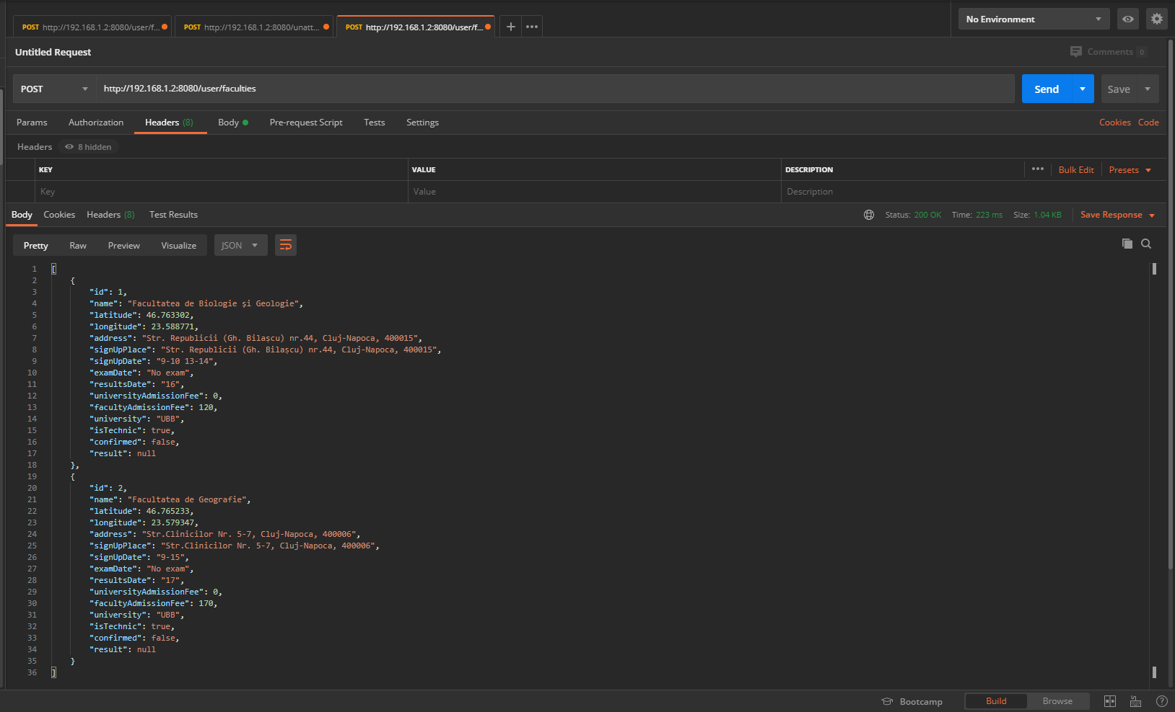
Figure 6.1 Endpoint testing

In order to ensure correct functionality of the backend implementation of the features, Postman was used. It allows for sending HTTP requests, which are used in order to make sure that everything works like it was planned. Moreover, if some unexpected results are generated, here they will be visible. As it can be seen in Figure 6.1, the endpoints were called directly across the network. This was due to the mobile application having to transmit requests over the network and not locally. It has been done over the network since the application has been developed by using Expo, which allows for direct use in a mobile device, without the need for emulators whatsoever. For the above figure, the feature corresponding to finding the faculty admissions that a user wants to participate, has been considered. From the result, the user has only two participating admissions, which is correct, according to the seed which populates the user with just two.
For the backend, each and every functionality has been tested by the use of Postman. In this way, expected behavior has been ensured through endpoint testing. Moreover, by doing so, we make sure that the server is visible, running, can be accessed by different consumers and can provide resources whenever they are requested.
The mobile application was tested component by component. This means, that certain parts have been tested more than once, in order to ensure the intended functionality. Moreover, end to end testing has been done by actually utilizing the application for its intended purpose. Manual testing has been the method chosen, since unexpected bugs could be identified quicker. A quicker discovery of bugs has lead to a fast response in relation to them, thus resulting in an early fix before they become a bigger problem.

Mobile application tests
Screen | Goal of the test | Results
Admissions | Manage available and going admissions | OK
Admissions | Check required documents | OK
Admissions | Check required fees | OK
Admissions | Navigate to faculty | OK
Accommodation | Search for accommodation | OK
Accommodation | Manage accommodation | OK
Calendar | Apply calendar filters | OK
Calendar | View partial schedule | OK
Calendar | View full schedule | OK

The web crawlers have been tested several times before actually committing the results to the web scrappers. This has been so, since many issues arose during development such as simply trying to parse the HTML of a website or certain issues due to how the parse implementation works in the given environment.
The web scrappers have gone through several iterations before meeting the final requirement for the data model which holds faculty admissions. Tests were done together with the backend in order to ensure that everything runs properly.

Validation
As there is a lack of upcoming students which are graduating high school, the application has been validated by taking into consideration the Heuristics formulated by Jakob Nielsen. They are guidelines for developing a great user interface design which is intuitive, simple, concise and attractive.

Visibility of the system status
Users must be informed at any time about what is going on while using the system through the use of appropriate feedback. As an example, whenever the user has a conflict between two admissions, a notification is popping up. Moreover, certain areas could be improved such as offering the user a successful message, whenever participation to a faculty admission is happening.

Match between system and the real world
Instead of system oriented terms, the system should use concepts familiar to the user. Thus, making information appear in logical and natural order. The use of suggestive icons denotes each kind of category to each functionalities are tied to. As an example, for accommodation a house is used and for faculties, a book.

Use control and freedom
This translates to supporting undo and redo functionalities. The user might choose system functionalities by mistake and will need an ”emergency” exit button. For certain functionalities like, adding or removing a faculty admission, the user can at any time change their mind. Moreover, while introducing the accommodation the user can go back and search for a different one. Unfortunately, no functionality for undoing the currently introduced accommodation has been implemented yet.

Consistency and standards
Users should not have to wonder if different words or situations perform the same thing. As an example, the required documents functionality is considered. Not depending on the context, the button will perform the same thing, provide the same functionality and the user does not have to think before that the button might do something different.

Error prevention
As the same suggests, a good design should be first considered, which completly eliminates the problem from occuring. In case this is not possible, error-prone conditions must be checked and offer the user a confirmation options. A good example for this heuristic, is the entering of the accommodation. The user is warned if a field is not correctly completed and is not allowed to complete the action before the problems are solved.

Recognition rather than recall
Instead of relying on the users memory, the instructions for use should be visible at all times. Accommodation is one of the examples which respects this principle. Instead of introducing the format of the dates in the placeholder of the input, thus relying on the memory of the user, it is present just below the name of the field. In this way, the user can see at all times in which manner should the field be completed.

Flexibility and efficiency of use
Actions which facilitate speed up of the interactions for expert users in a way not hindering inexperiences users. Unfortunately, in the current application this is not the case since shortcuts for certain actions are not present.

Aesthethic and minimalist design
Information which is not needed or is rarely used should not interfere with relevant information. This is the case, considering the given mobile application, since the users are not bombarded with irrelevant information at any steps.

Help users recognize, diagnose and recover from errors
Error messages should be presented in plain text, not in codes, indicating clearly the problem and suggesting solutions. Taking as example the entering of an accommodation, the user is warned by plain text right under the text input. The solution is morphed with the message.

Help and documentation
Even though the system should be used without the need for documentation, it may be necessary to offer help and documentation. It should be easy to search, focused on the user’s task, provide the steps and not be too large. Unfortunately, the application does not ship with an existing user’s manual on the mobile application, but there is one which is written and provides all the steps and details for performing each of the actions available through the system.

User’s manual

Installation Guide
At the current stage, in order for the application to be installed the user will require the source code and the Expo application on their phone. Moreover, Node.js is required in order to successfully compile and run it. Furthermore, an internet connection is required. The laptop which runs the application and the phone must be on the same network in order for them to work. Once the Expo environment is started, QR code will appear which must be scanned and will start the application on the user’s phone.
Moreover, to successfully run the application the following software requirements must be met:
- PostgreSQL database
- Java SDK 11
- Python 3.8
- IDE for starting the server
First the web crawler must be run in order for the webpages to be gathered. Second, the web scrapper is run to extract and transform the data. Lastly the Java Spring Boot application is run in order to facilitate the connection to the database for data persistence and to allow the connection between the mobile application.

User’s Manual
The mobile application has some hardware and software resources that must be met in order for the application to run. The requirements are not very demanding, meaning that an average phone use should be able to run the application. They are represented by a mobile phone with an Android version of at least 4.1. Moreover, a laptop is required to run the server. Also, an internet connection is required for the data to be successfully collected and introduced into the system, and to be accessible from the mobile application.
Below, the main screens of the application are presented, together with instructions for each one. They are presented in a chronological order.

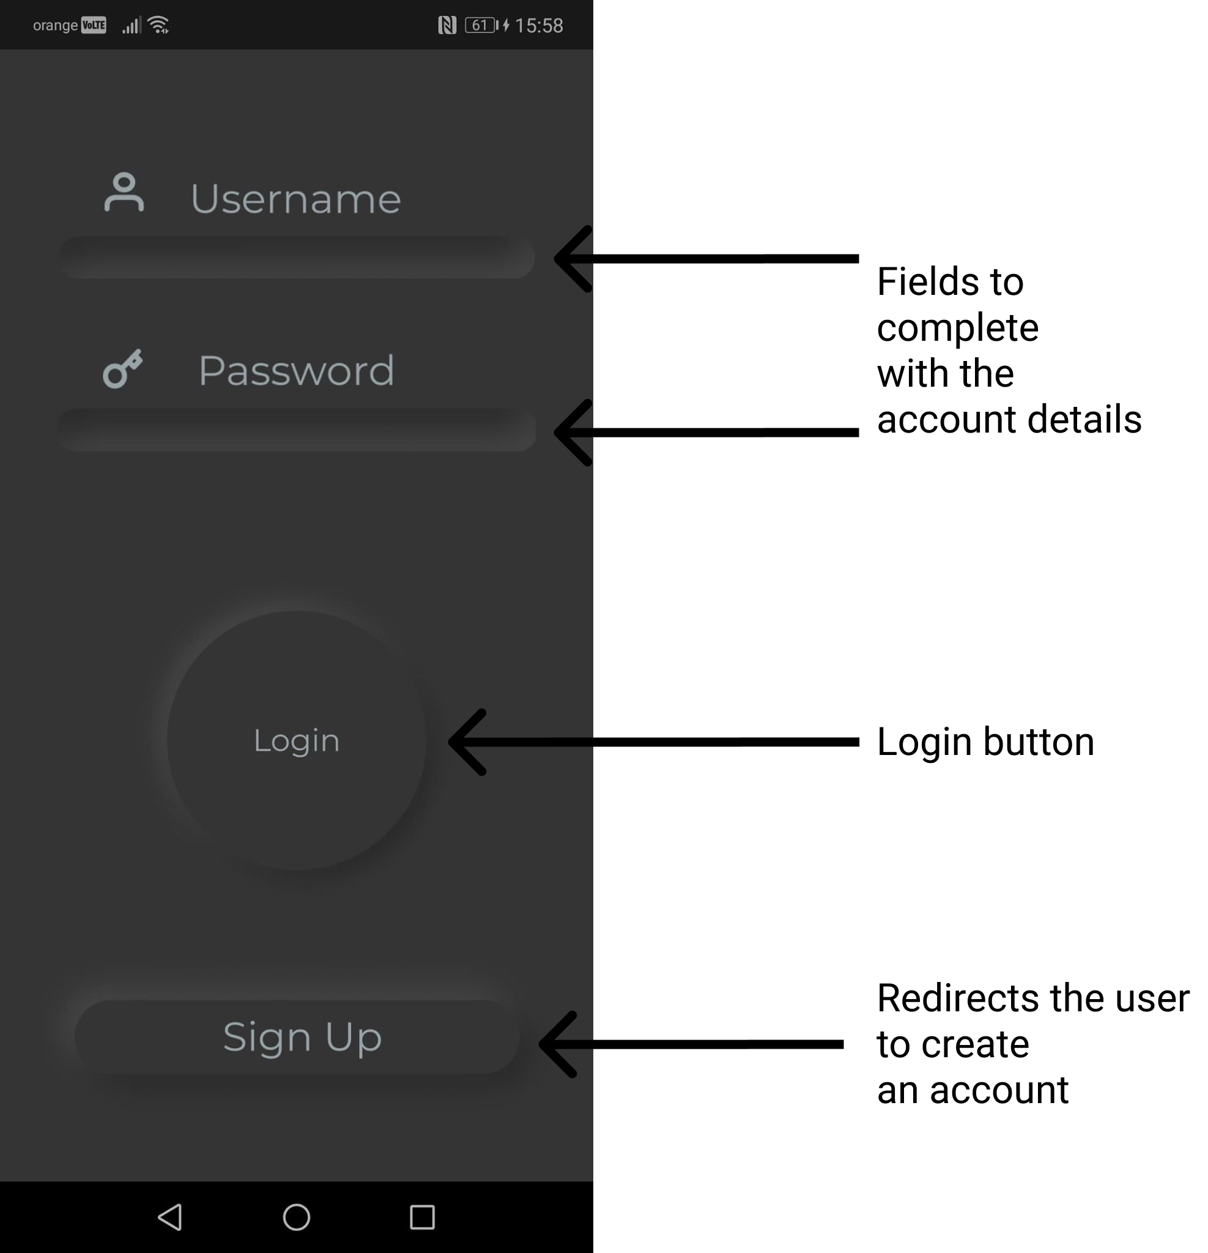

Figure 7.1 Login Screen
This is the first screen that the user is greeted. The username and password are required in order to login and have access to the functionalities of the application. In case an account does not exist the Sign Up button will facilitate the creation of a new account.

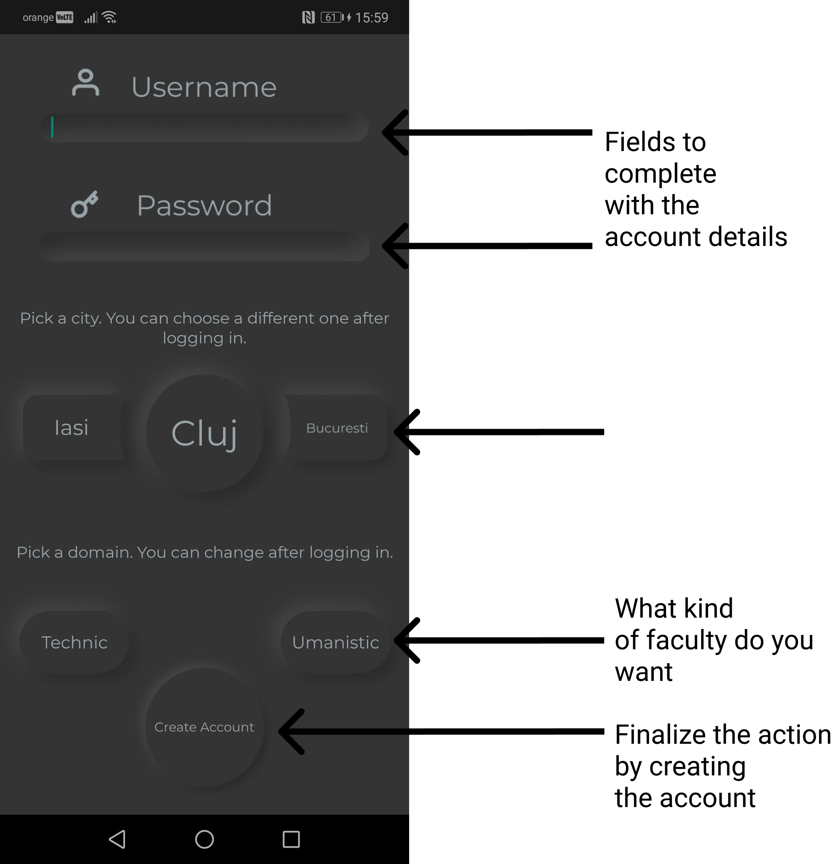

Figure 7.2 Sign up screen

This is the follow up from the previous Sign Up button. As it can be seen, a username and password must be chosen. Moreover, an initial filter is required initially, though it can be later changed once logged in. The action is finalized by pressing on the Create Account button which will also trigger a redirect to the Login Page.

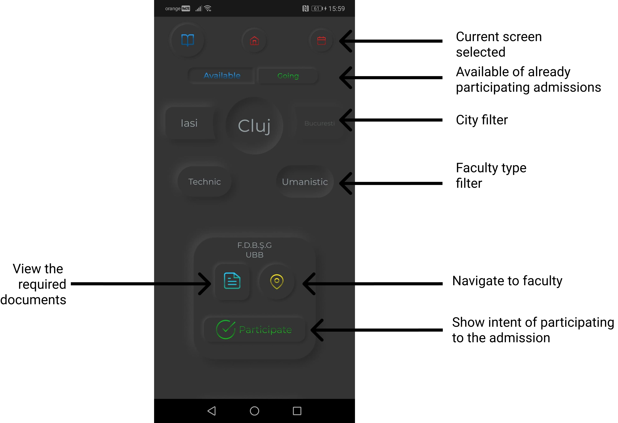
Figure 7.3 Admission screen

After log in, the admission screen is visible. By pressing on one of the top three buttons, the current screen will change. Moreover, two buttons Available and Going are present. Pressing them will change what admission will be visible (either already going or the ones available for participating). Moreover the filters chosen when creating the account are available and can be changed at any time. For each faculty, navigation to the faculty, the required documents and showing the intent of participating to the admission are available, according to the figure 7.3.

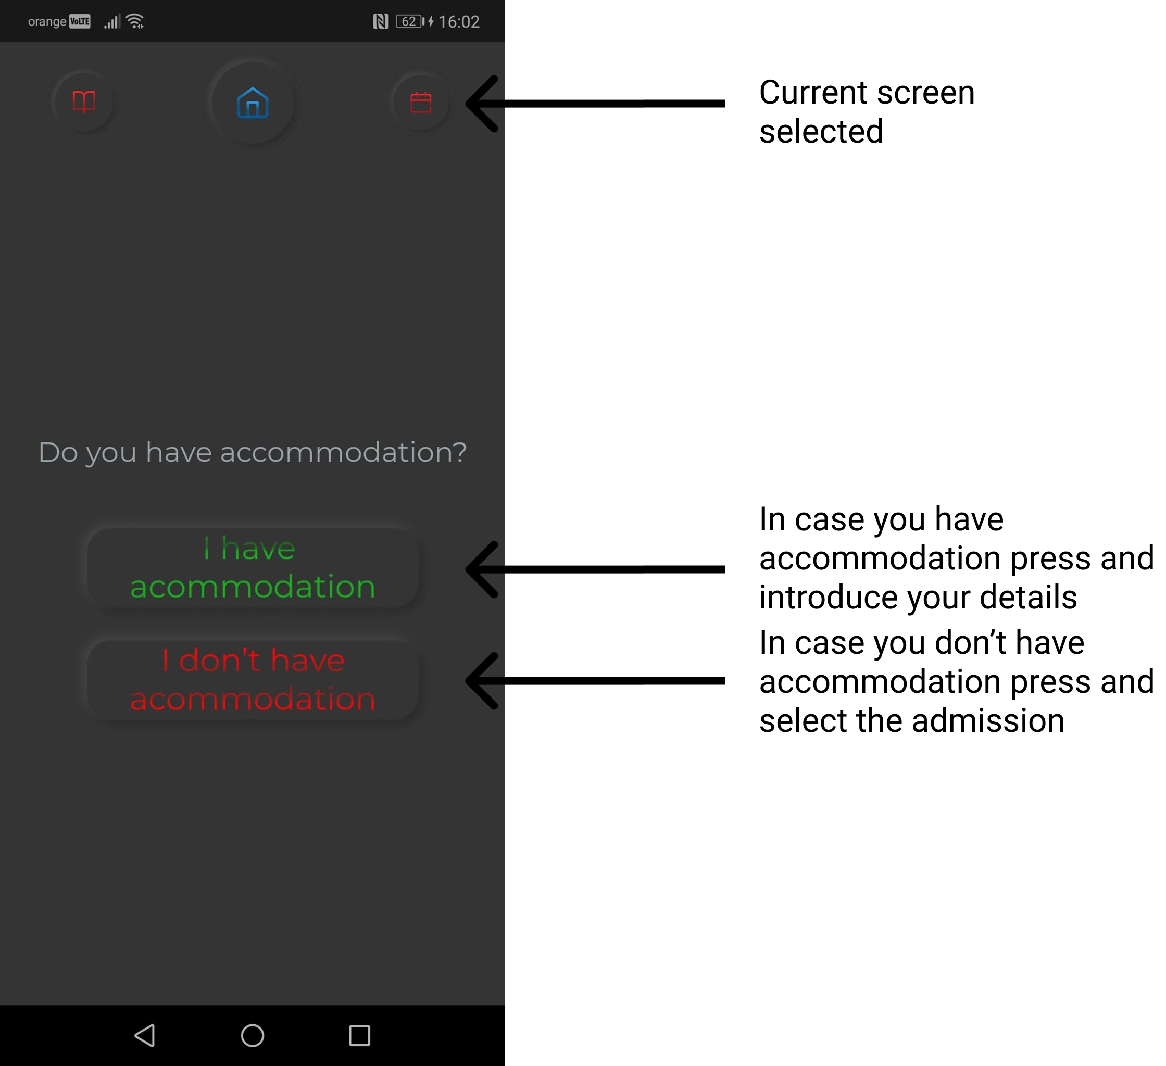
Figure 7.4 Accommodation screen

Once the user is logged in, the current displayed screens can be changed. This is achieved by tapping on one of the three buttons from the top. Once on the accommodation screen, the user is asked two questions. Depending on them, the screen will change according to the given answer. The new screens will require new input from the user which will be specified in both the cases.

The last screen is the calendar one. According to the figure 7.5, the user will have the possibility to better filter the calendar days by applying predefined filters. Moreover, for each day, the schedule will be displayed in the boxes. Tapping a day will present the whole schedule for that day, not just the partial one displayed on the small box. The current day is denoted by a green color of the text of the day.

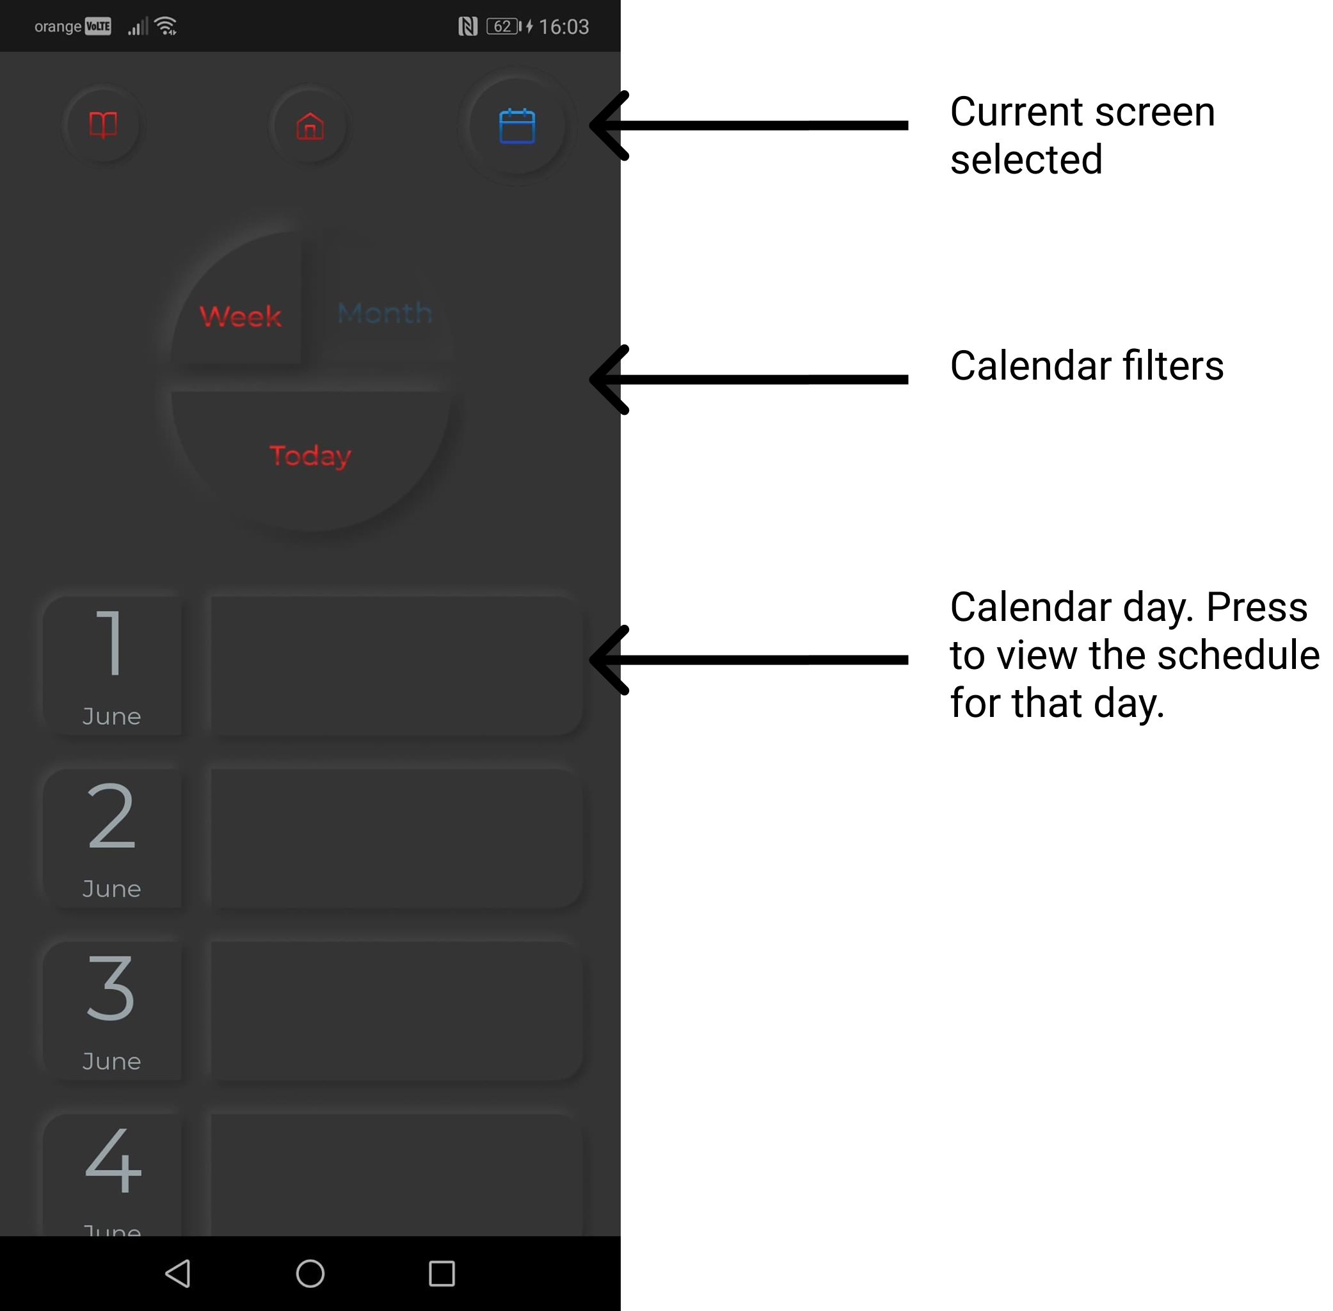
Figure 7.5 Accommodation screen

Conclusions
The processing of developing the system has been quite a challenging while also being a rewarding one as well. All the challenges encountered during the development process have been either successfully faced or let for further improvements. From the main achievements, the following have been developed:
- Mobile client which allows the user to interact with the system.
- Backend server which exposes REST services to the client.
- Web crawler and web scrapper which are used for data acquisition
More important, some goals were achieved such as:
- Provide the user with an attractive mobile application to better manage the personal schedule during the admission process
- Development of backend server based on Layers architecture with REST exposed services
- Retrieve data from website based on an automated process
- Better understanding of UI and UX design
- Improvement in knowledge regarding Javascript and React
Another experiment that was ran by accident was development on two different operating systems. A great portion of development was based on an Arch-based Linux distribution called Manjaro. Out of the box, no problem were present and everything ran perfectly. Most of the problems were present when development took place in Windows 10. Especially Expo, had configuration problems that were not present in the Linux based operating system. With extra digging, the problems have been solved.

For further improvements, a great number of features could be added to the system overall.
For the mobile application, extra features could be added such as statistics regarding the number of students already signed up, last years numbers regarding students admitted tax-free, what curricula is required for the admission, etc. Moreover, the web crawler and scrapper could be further improved by coming up with a generalization, in order to extract data from all the faculties websites that are provided. As a further improvement, not only university education programs from Romania could be available, but from all over the world. Also, the mobile application could also support a light theme to provide a greater visibility in case the application is used in high luminosity environments. Online sign-up is also a feature that could be successfully implemented, allowing the student to upload the required documents for the admission online.

Bibliography

[1] A. Bak, S. Bouchafa, and D. Aubert, "Detection of independently moving objects through stereo vision and ego-motion extraction," in IEEE Intelligent Vehicles Symposium (IV), San Diego, USA, 2010, pp. 863-870.
[2] A. Chambolle and T. Pock, "A First-Order Primal-Dual Algorithm for Convex Problems with Applications to Imaging," Journal of Mathematical Imaging and Vision, vol. 40, pp. 120-145, 2011.
[3] R. C. Gonzalez and R. E. Woods, Digital Image Processing. Second Edition.: Addison-Wesley Longman Publishing Co., Inc., 2001.
[4] Ajax Tutorial, http://www.tutorialspoint.com/ajax/.

Appendix 1 (only if needed)
…
Relevant code sections
…
Other relevant info (proofs etc.)
…
Published papers (if any)
etc.

