**A**

***PROJECT REPORT***

***ON***



**BLOOD BANK MANAGEMENT**

**Developed By : Maru Bhautik**

**Submitted To...**

**Geetanjali group of computer science and commerce**

**Saurashtra University Rajkot**

**[2021- 2022]**

**Guided by**: Prof . Kishorsinh vala

ACKNOWLEDGEMENT

It is mater of great pleasure of us to get this opportunity expressing our deep and sincere of Prof. Kishorsinh vala for giving us precious guidance, inspiration and great support while developing the software are especially thanks for it to them.

We are also thankful to out reserve and learned faculties. Whose inspiration , guidance and generous support gave us sufficient strength to prepare the project during the long technical input in the form books and study material and influencing our thinking. We acknowledge extends by them for giving us information and clarifying our doubts and obligatory.

Only the token of the "thanks" cannot appreciate of project valuable contribution and assistance provide by these wonderful people, by this token gesture are least we can do.

PREFACE

The project work there is a wide difference between theory and practical. If one has only theoretical background of any subject , one would not succeed in pawn-in , therefore it is necessary to any subject , to have adequate practical knowledge of connected subject . As we know B.C.A and it is totally practical field. with only theoretical knowledge one neither success the peak position.

In the B.C.A course , designed by "Saurashtra University" they have designed the course in such a manner with which student can get both the theoretical and practical knowledge perfectly.

In my project "**Blood Management** " , I have covered all necessary information and I have tried our best to represent this project in such a way that it make easy to understand.

INDEX

|  |  |
| --- | --- |
| **NO.** | **Description** |
| 1. | Introduction of project |
| 2. | Project Profile |
| 3. | Project Requirement |
| 4. | Data Flow Diagram |
| 5. | ER Diagram |
| 6. | Screen Shot |
| 7. | Future Requirement Of Project |
| 8. | Limitation Of Project |
| 9. | Bibliography |

INTRODUCTION OF PROJECT

The main aim of developing this system is to provide blood to the people who are in need of blood. The number of persons who are in need of blood are increasing in large number day by day. Using this system user can search blood group available in the city and he can also get contact number of the donor who has the same blood group he needs. In order to help people who are in need of blood

So if the blood group is not available in the blood bank user can request the donor to donate the blood to him and save someone life.

Using this bank management system people can register himself or herself who want to donate blood. To register in the system they have to enter their contact information like address mobile number etc.

Blood Bank management system is to provide services for the people who are in need of blood by getting help from the donors who are interested in donating blood for the people. There are main modules in this system.

PROJECT PROFILE

* **Project Title** : Blood Management
* **Front end** : JAVA
* **Back End**  : My SQL
* **Operating** : System Windows 7 or any Other
* **Academic year** : 2021-22
* **Developed by** : Maru Bhautik B.
* **Guided by** : Prof . Kishorsinh vala
* **Submitted To** :Geetanjali College of

Computer Science &

Commerce(BBA)

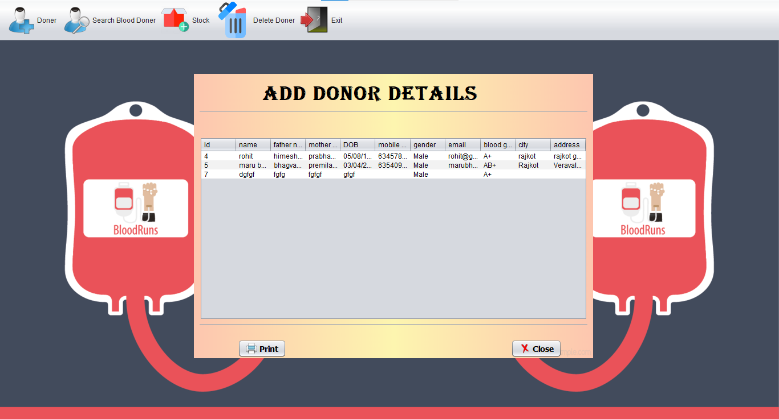

PROJECT REQUIREMENT

* **Hardware Requirement:-**
* RAM (1 GB)
* Hard Disk (20 GB)
* **Software Requirement & OS:**-
* Windows 7 and any other
* Java Version 1.8
* Xammp
* My SQL Database

DFD

* 0 Level Data flow Diagram

ER Diagram

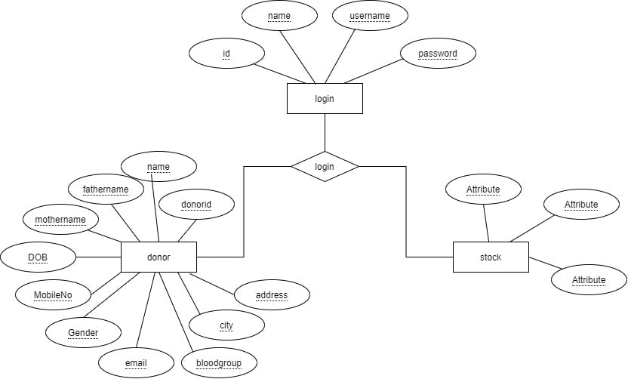

data dictionary

* **Donor table**

By using this table admin can add donor

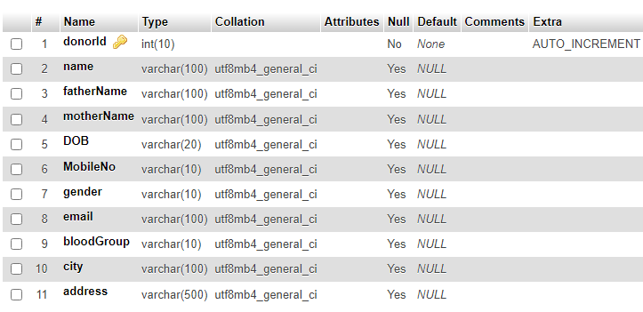

* Stock table

By using this table admin can manage blood stock

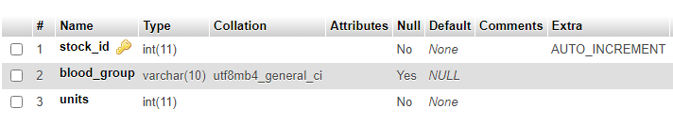

Screen shot

**Login page**

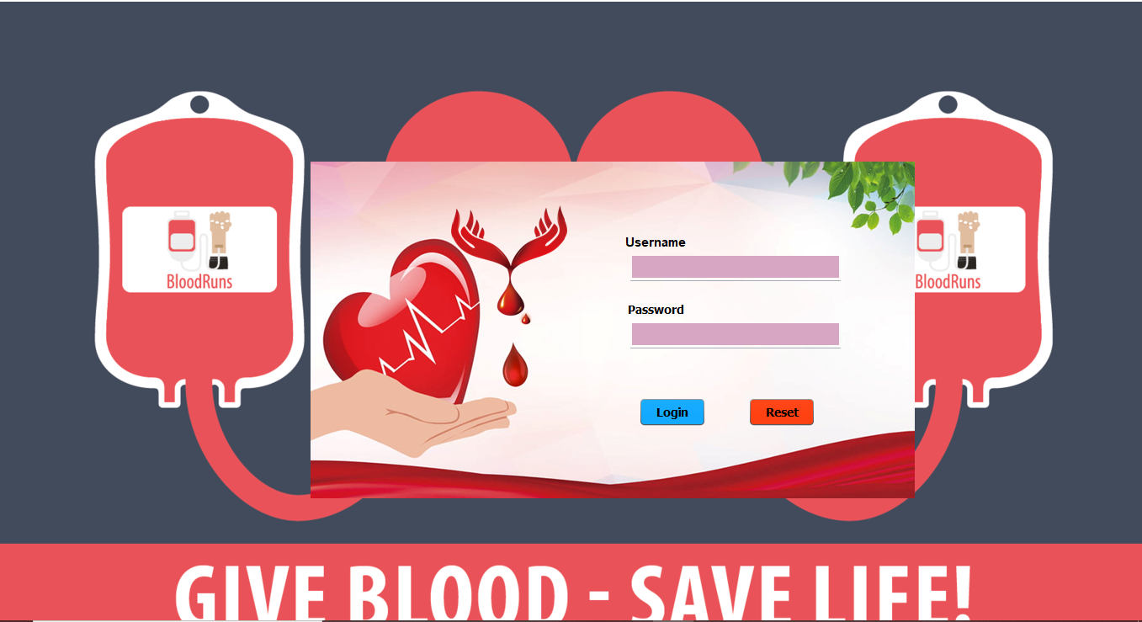

* **By this page admin can login in software .**
* **If Username and password is correct then it will go to the home page.**

**Home page**

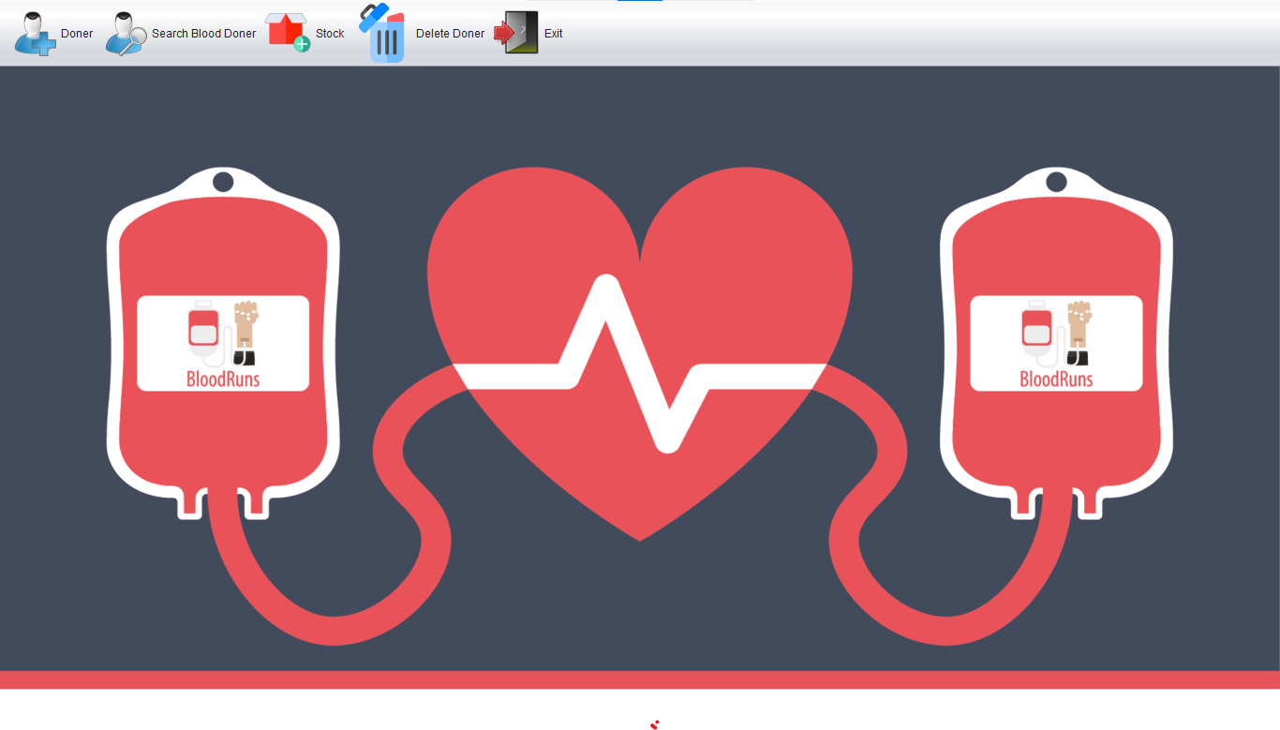

**Future Requirement of project**

* **This is our home page.**
* **In this page admin can manage donor details ,stock manage and search donor by location.**

**Add new Donor page**

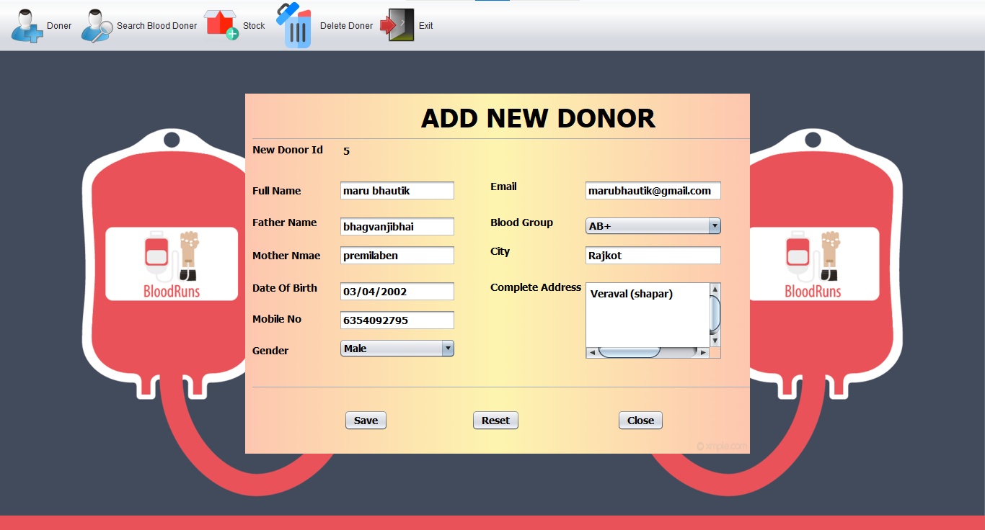

**Location : Home page > donor > add new donor**

* **A add new donor page can add new blood donor add details.**
* **That detail will name ,father name Date of birth, Mobile no etc..**

**Update page**

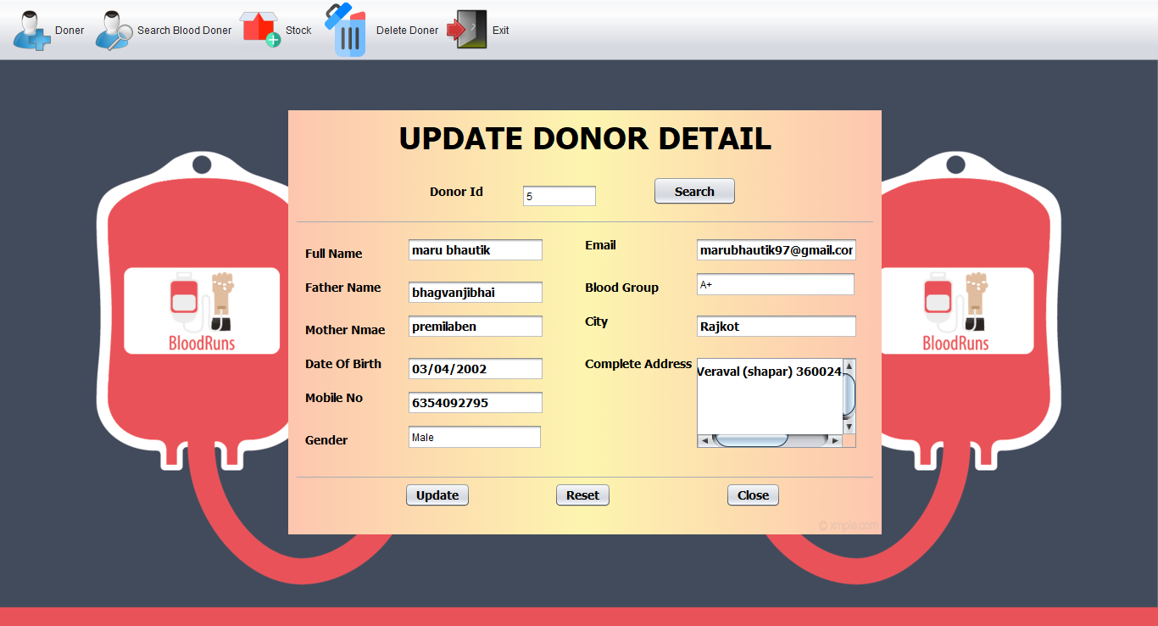

**Location : Home page > donor > Update Donor Details**

* **Update page is Update for a donor details.**
* **This can page update a details in a database.**

**.**

**Add Donor Details page**



**Location : Home page > donor > Add Donor Details**

* **A page show a donor details for admin.**
* **It show a all donor details.**

**Search Blood Donor(Location) page**

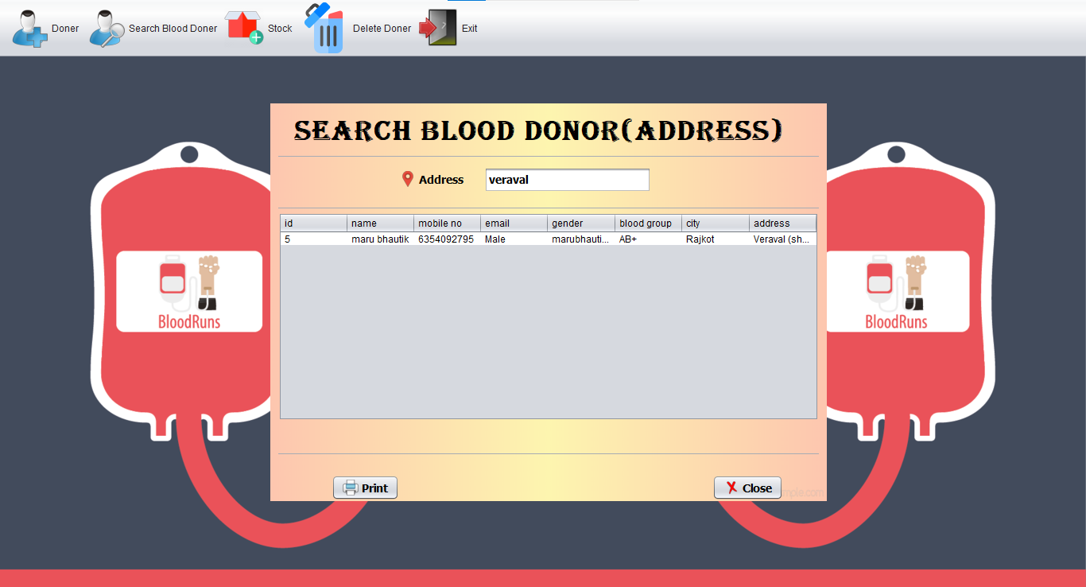

**Location : Home page > Search > Location**

* **This page Search blood donor in a address.**
* **It can patient easy to search blood donor an contact a blood donor .**

**Search Blood Donor(Blood Group) page**

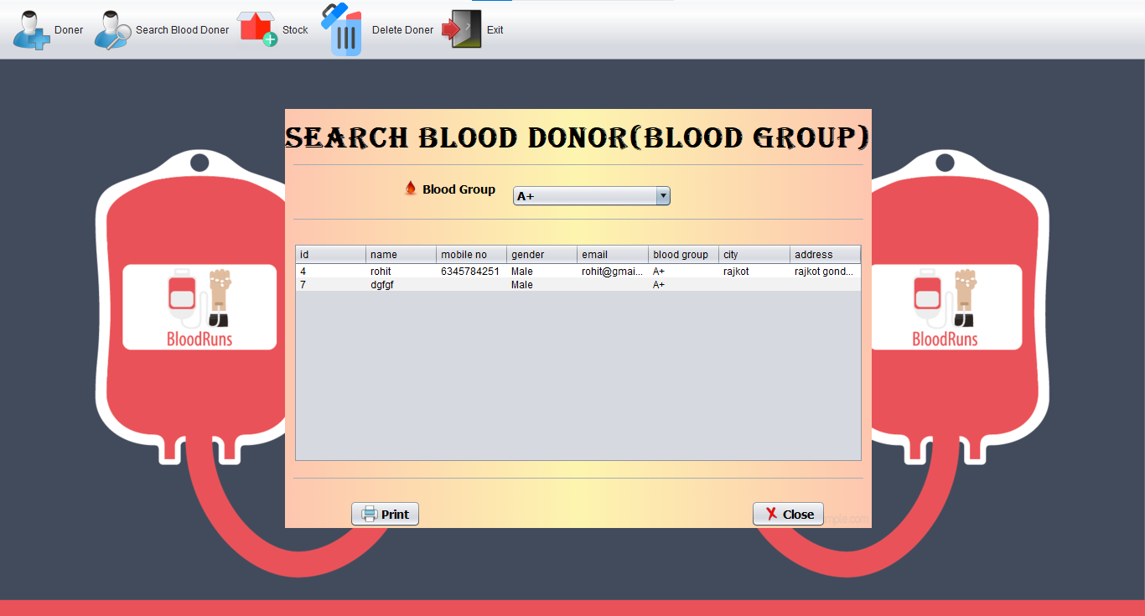

**Location : Home page > Search> Blood Group**

* **This page Search blood donor in a Blood group.**
* **It can patient easy to search blood donor by a blood group.**

**Increase page**

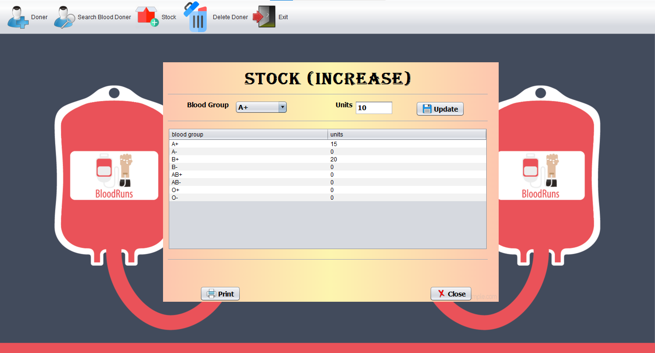

**Location : Home page > Stock > Increase**

* **This page is admin can stock increase a blood.**
* **It can show blood stock and unit.**

**Decrease page**

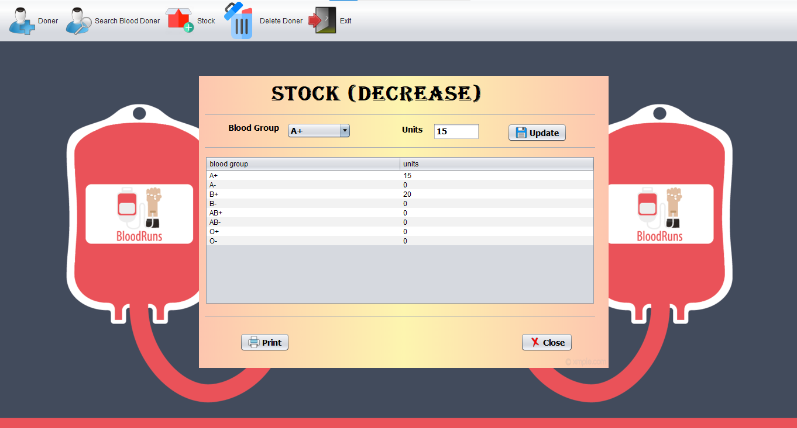

**Location : Home page > Stock > Decrease**

* **This page is admin can stock Decrease a blood.**
* **It can show blood stock and unit.**

**Details page**

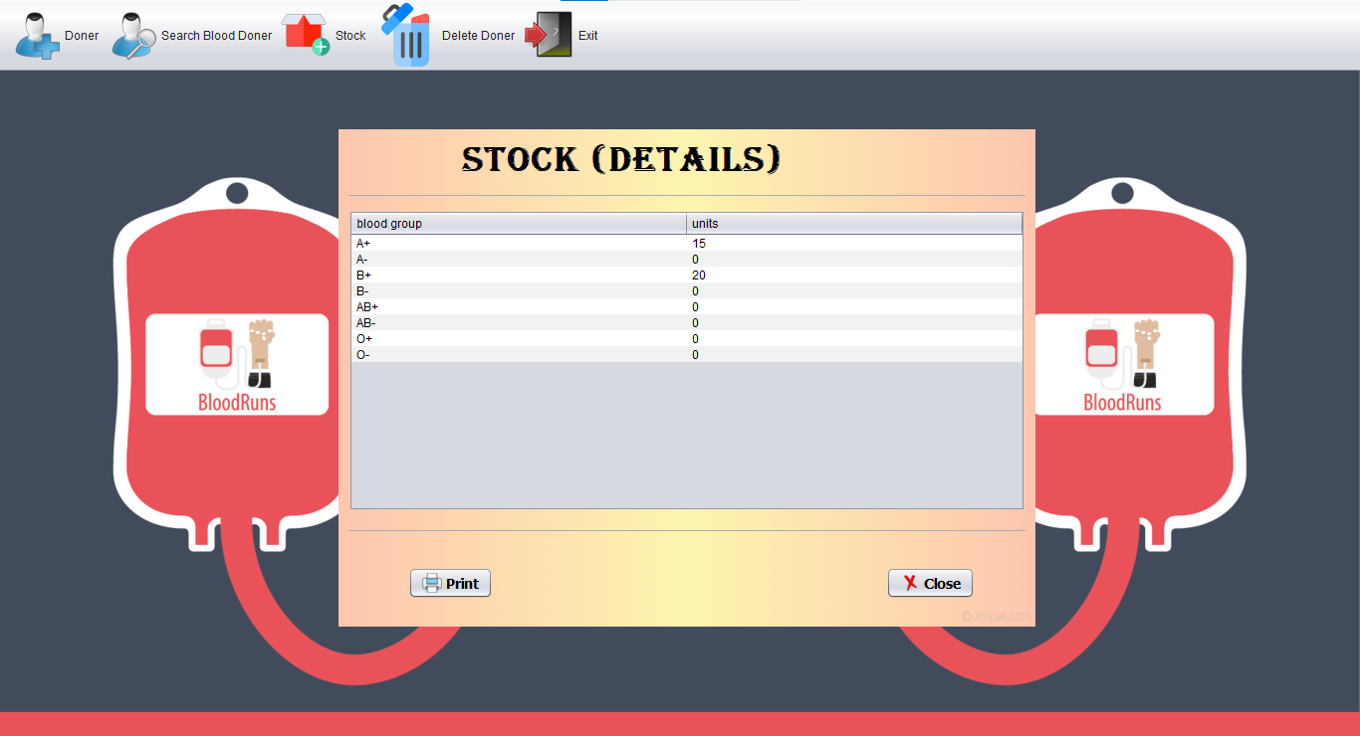

**Location : Home page > Stock > Detail**

* **A page show a blood group and unit details.**
* **This page can access a admin**

**Delete page**

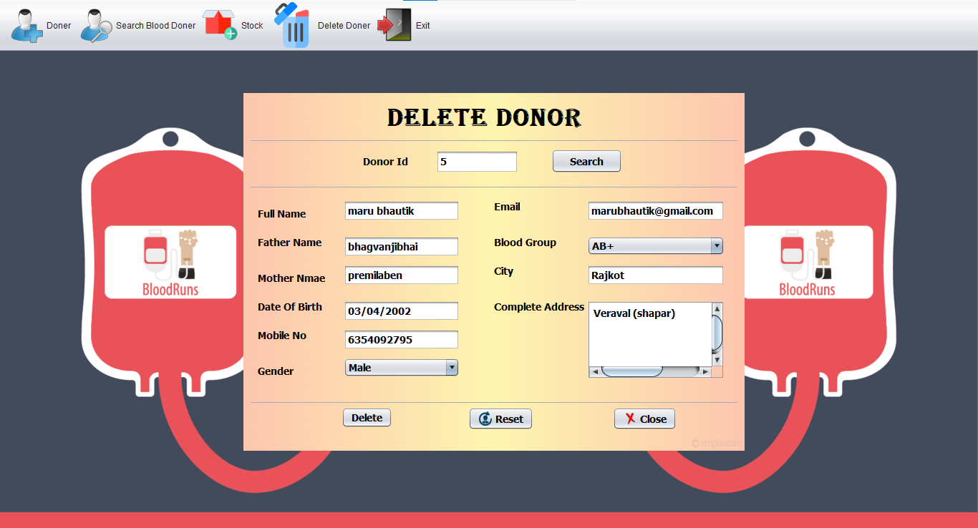

**Location : Home page > Delete > Delete**

* **The blood donor database status scan be false.**
* **It cannot be a donor delete data.**

**Future Requirement of project**

* **There is some Functionality and features of project**
  + 1. More Stable Screen Resolution
    2. License Key
    3. Client’s Login with deferent Manu
    4. More Stable

Limitation of project

* There is limitation of the Project
  + 1. Screen Resolution
    2. application cannot delivery blood at home.
    3. it doesn't have online appointment feature.

**Webliography**

* www.stackoverflow.com
* www.javatpoint.com
* Google
* YouTube