Classification Assignment  
www.hopelearning.net Hope AI admin@hopelearning.net  
**Problem Statement or Requirement:**A requirement from the Hospital, Management asked us to create a predictive  
model which will predict the Chronic Kidney Disease (CKD) based on the  
several parameters. The Client has provided the dataset of the same.

1.) Identify your problem statement  
2.) Tell basic info about the dataset (Total number of rows, columns)  
3.) Mention the pre-processing method if you’re doing any (like converting  
string to number – nominal data)  
4.) Develop a good model with good evaluation metric. You can use any  
machine learning algorithm; you can create many models. Finally, you  
have to come up with final model.  
5.) All the research values of each algorithm should be documented. (You  
can make tabulation or screenshot of the results.)  
6.) Mention your final model, justify why u have chosen the same.

1.Problem Statement Identification

Title: Chronic Kidney Disease Predictor

Numerical data set so Machine Learning,

Clear required input and output. So, supervised learning

Target is categorical output. So, its Classification

2.Basic Info of Dataset

Total no of rows – 399

Total no of columns – 25

3.Pre-processing-

One Hot Coding Method – to convert string to number- nominal data

Standard Scaler

4.Good Model with Evaluation Metric

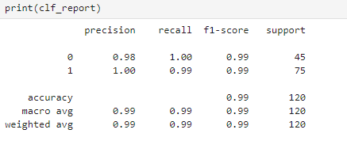

roc_auc_score for the best parameter: {'multi_class': 'auto', 'penalty': 'l2', 'solver': 'lbfgs'} 1.00

5. All research values for all algorithm

|  |  |  |
| --- | --- | --- |
| **Classification Algorithm** | **f1 score** | **roc_auc_score** |
| Logistic Regression | 0.99 | 1 |
| SVM | 0.98 | 1 |
| Random Forest | 0.98 | 1 |
| Decision Tree | 0.97 | 0.97 |
| K Nearest Neighbors | 0.96 | 1 |

6. my final model is Logistic Regression.

This model has the best f1 score and roc_auc_score compared to the other model. That’s why this is the best model

GitHub Link for source code: [GitHub](https://github.com/Marudhanayagam4/Chronic_Kidney_Disease_Predictor/tree/main/Assignment_Predict_CKD_Classification)