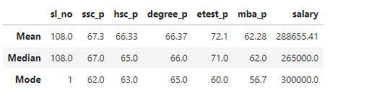

The Analysis shows the average (Mean), median, mode of students’ scores from SSC to MBA, along with their salaries after placements.

1. **Average Performance:**

* SSC, HSC, Degree and MBA scores hover around the mid-60s, indicating an average performance level across these academic stages.
* The etest_p score is relatively higher, suggesting that students performed well in the employability test.

1. **Outliers in Salary:**

* There seems to be an outlier in the salary data because the mean (288655.41) is significantly higher than the median (265000). This indicates that a few students might have exceptionally high salaries, skewing the average upwards.

1. **Mode Values:**

* The mode shows the most frequently occurring scores:
  + SSC: 62
  + HSC: 63
  + Degree: 65
  + Etest: 60
  + MBA: 56.7

Overall, the data indicates that the students performed fairly consistently across their academic journey, with the notable improvement in employability test (etest_p). However, the salary distribution shows variability, indicating that while most students have an average salary, a few might earn significantly more.