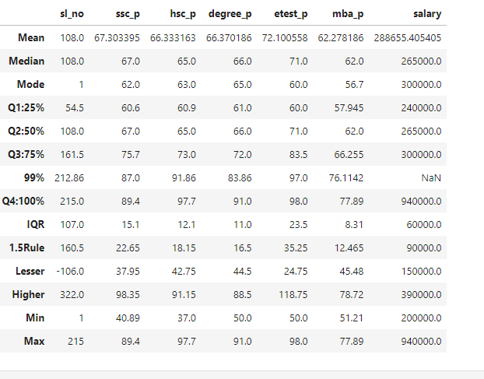

**For hsc_p:**

* **IQR Calculation**: IQR = Q3 - Q1
* **Lesser Outlier Value**: Q1 - 1.5 * IQR = 42.75
* **Greater Outlier Value**: Q3 + 1.5 * IQR = 91.15
* **Outliers Identified**:
  + Minimum value 37 is less than 42.75 (Lesser Outlier), indicating a lesser outlier.
  + Maximum value 97 is greater than 91.15 (Greater Outlier), indicating a greater outlier.

**For degree_p:**

* **Greater Outlier Value**: Q3 + 1.5 * IQR = 88.5
* **Outliers Identified**:
  + Maximum value 91 is greater than 88.5 (Greater Outlier), indicating a greater outlier.

**For salary:**

* **Greater Outlier Value**: Q3 + 1.5 * IQR = 390000
* **Outliers Identified**:
  + Maximum value 940000 is greater than 390000 (Greater Outlier), indicating a greater outlier.

**Conclusion:**

The dataset has outliers in:

* hsc_p with both lesser and greater outliers.
* degree_p and salary with greater outliers.