|  |  |  |  |  |  |  |
| --- | --- | --- | --- | --- | --- | --- |
|  |  |  | **AMERICAN INTERNATIONAL** | | | |
|  |  |  | **UNIVERSITY-BANGLADESH** | | | |
|  |  |  | **Faculty of Science and Technology** | | | |
|  |  |  |  |  | | |
|  |  |  |  | **Assignment Cover Page** | | |
|  |  |  | | | |  |
|  | Assignment Title: | Assignment on Automated Testing Tool | | | |  |
|  |  |  |  |  |  |  |
|  | Assignment No: | 01 |  |  | Date of Submission: | 8 August 2023 |
|  |  |  | | | |  |
|  | Course Title: | Software quality and testing | | | |  |
|  |  |  |  |  |  |  |
|  | Course Code: | CSC4271 |  |  | Section: | A |
|  |  |  |  | |  |  |
|  | Semester: | Summer | 2022-23 | | Course Teacher: | Abhijit Bhowmik |
|  |  |  |  |  |  |  |



**Declaration and Statement of Authorship:**

1. I/we hold a copy of this Assignment/Case-Study, which can be produced if the original is lost/damaged.
2. This Assignment/Case-Study is my/our original work and no part of it has been copied from any other student’s work or from any other source except where due acknowledgement is made.
3. No part of this Assignment/Case-Study has been written for me/us by any other person except where such collaborationhas been authorized by the concerned teacher and is clearly acknowledged in the assignment.
4. I/we have not previously submitted or currently submitting this work for any other course/unit.
5. This work may be reproduced, communicated, compared and archived for the purpose of detecting plagiarism.
6. I/we give permission for a copy of my/our marked work to be retained by the Faculty for review and comparison, including review by external examiners.
7. I/we understand thatPlagiarism is the presentation of the work, idea or creation of another person as though it is your own. It is a formofcheatingandisaveryseriousacademicoffencethatmayleadtoexpulsionfromtheUniversity. Plagiarized material can be drawn from, and presented in, written, graphic and visual form, including electronic data, and oral presentations. Plagiarism occurs when the origin of them arterial used is not appropriately cited.
8. I/we also understand that enabling plagiarism is the act of assisting or allowing another person to plagiarize or to copy my/our work.



* *Student(s) must complete all details except the faculty use part.*
* Please submit all assignments to your course teacher or the office of the concerned teacher.

Group Name/No.:

|  |  |  |  |  |  |
| --- | --- | --- | --- | --- | --- |
|  | **No** | **Name** | **ID** | **Program** | **Signature** |
|  |  |  |  |  |  |
|  | 1 | Md. Maruf Mia | 19-41786-3 | BSc [CSE] |  |
|  |  |  |  |  |  |
|  |  |  |  |  |  |
|  |  |  |  |  |  |
|  |  |  |  |  |  |
|  |  |  |  |  |  |
|  |  |  |  |  |  |
|  |  |  |  |  |  |
|  |  |  |  |  |  |



***Faculty use only***

FACULTYCOMMENTS

**Marks Obtained**

**Total Marks**

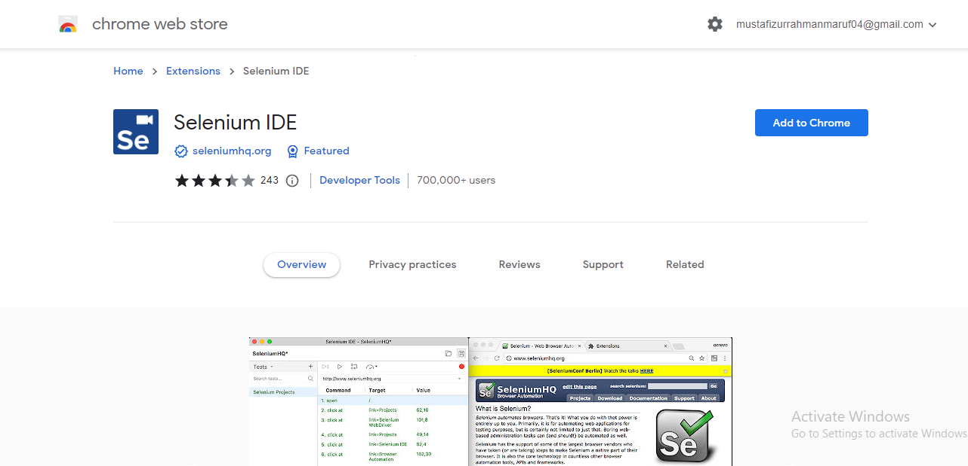

Figure1 : Installing SELENIUM IDE

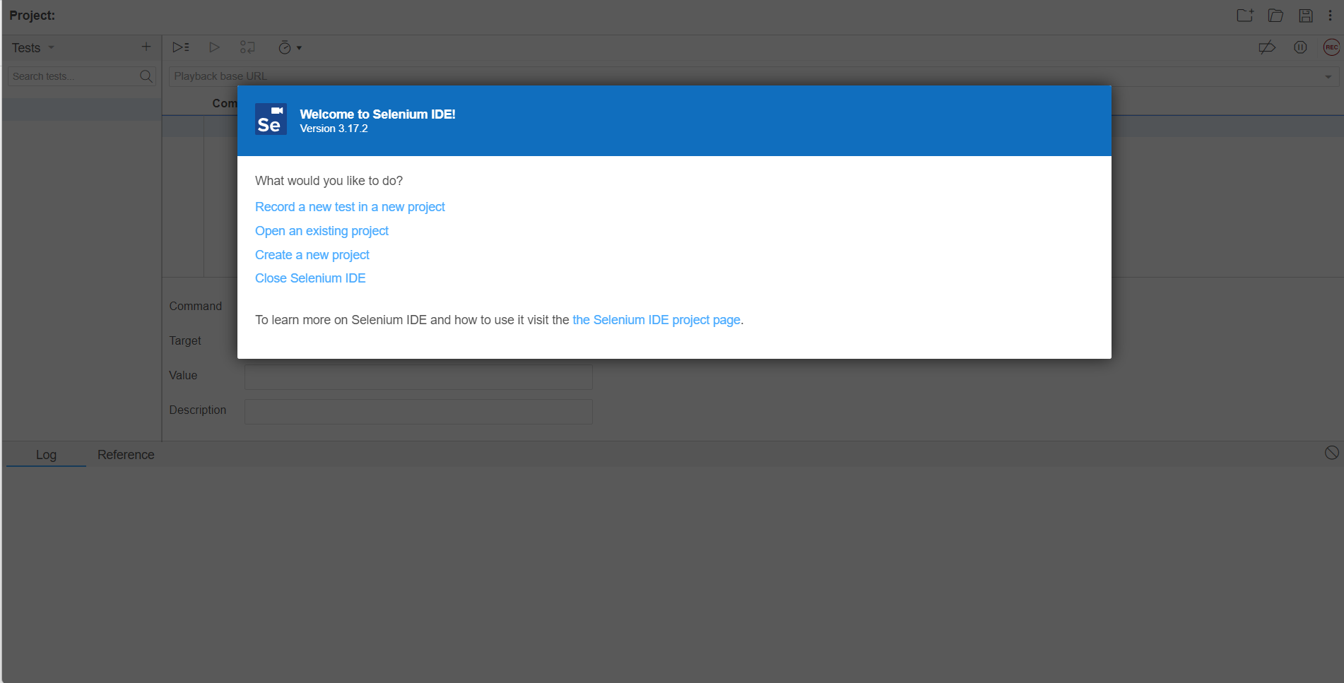

Figure 2 : Creating New Project

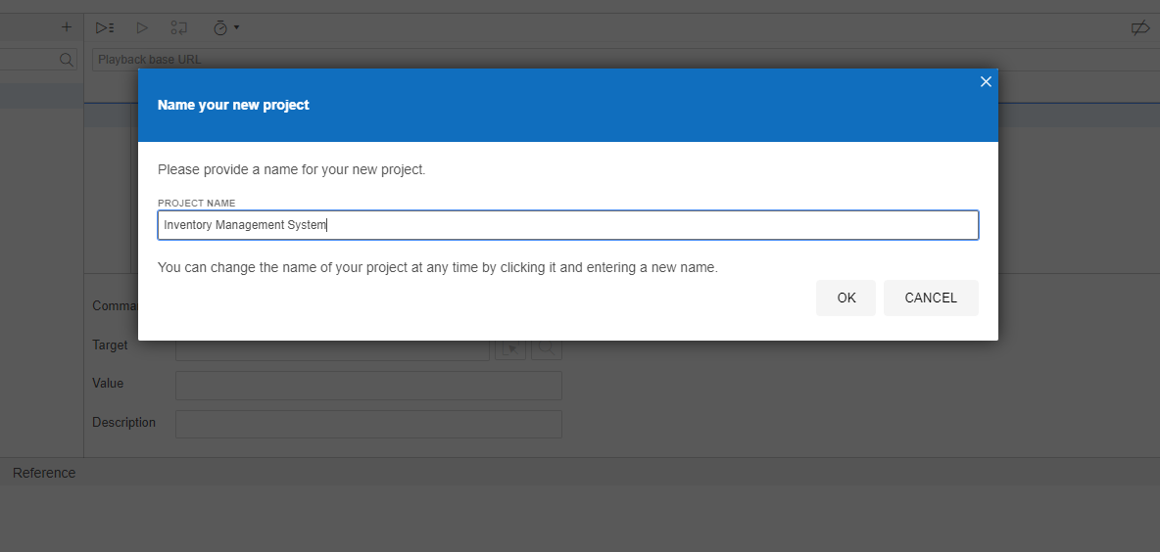

Figure 3 : Setting Up Project name

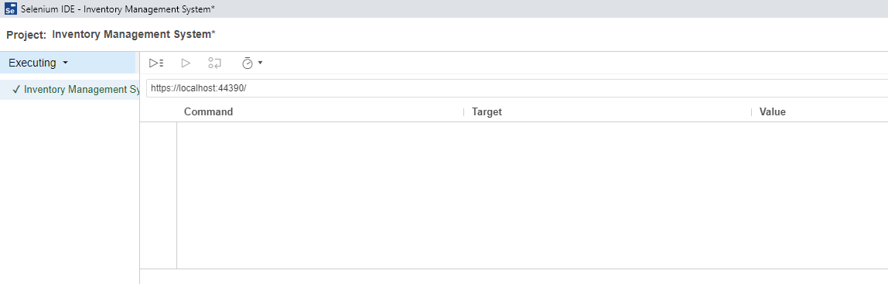

Figure 4 : Providing Project URL

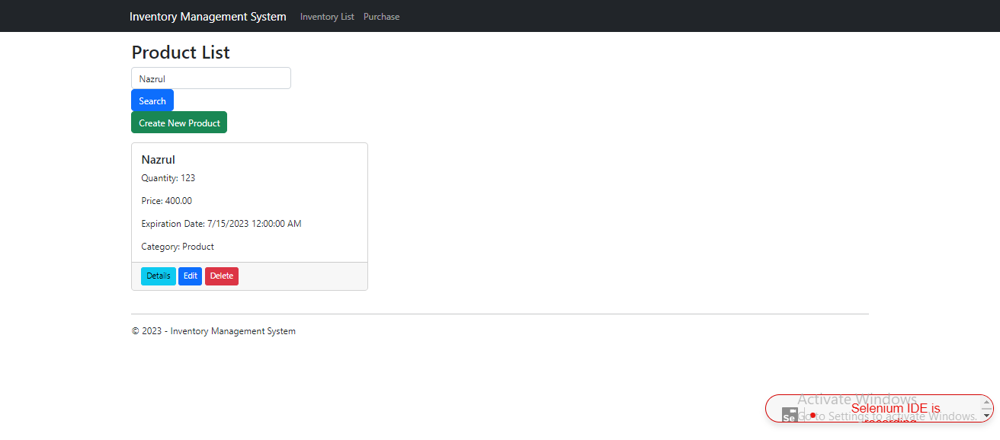

Figure 5 : Search Module

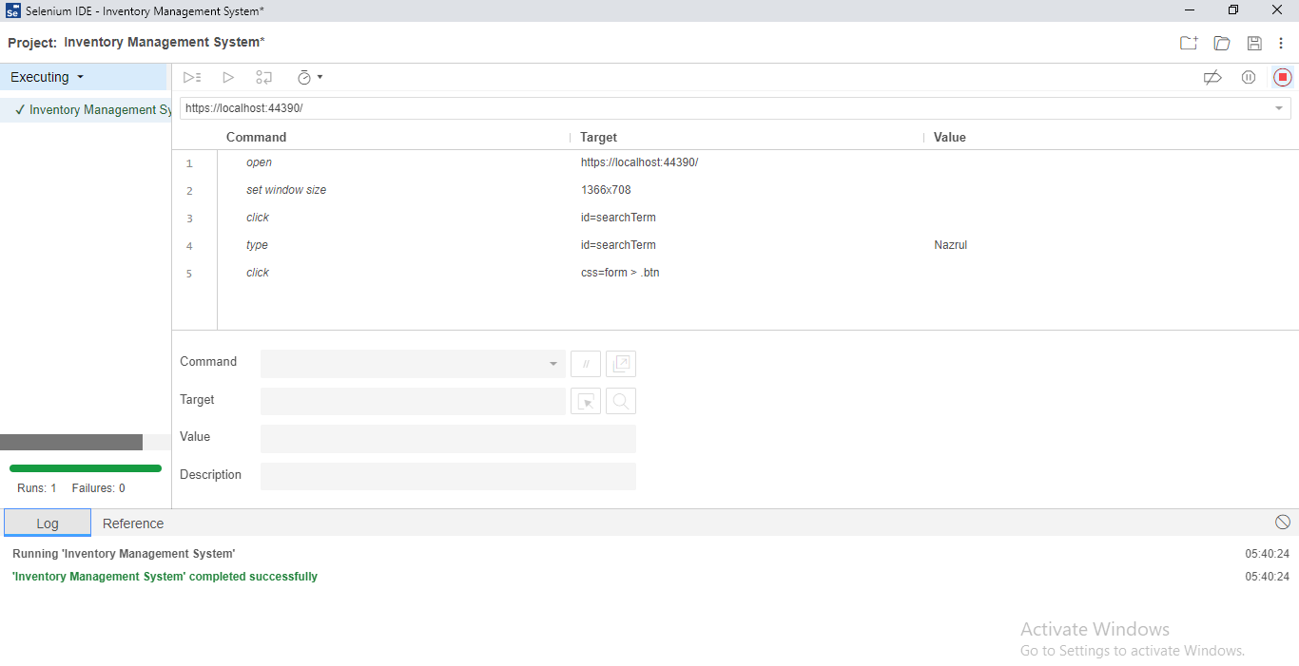

Figure 6: Setting command, target and value

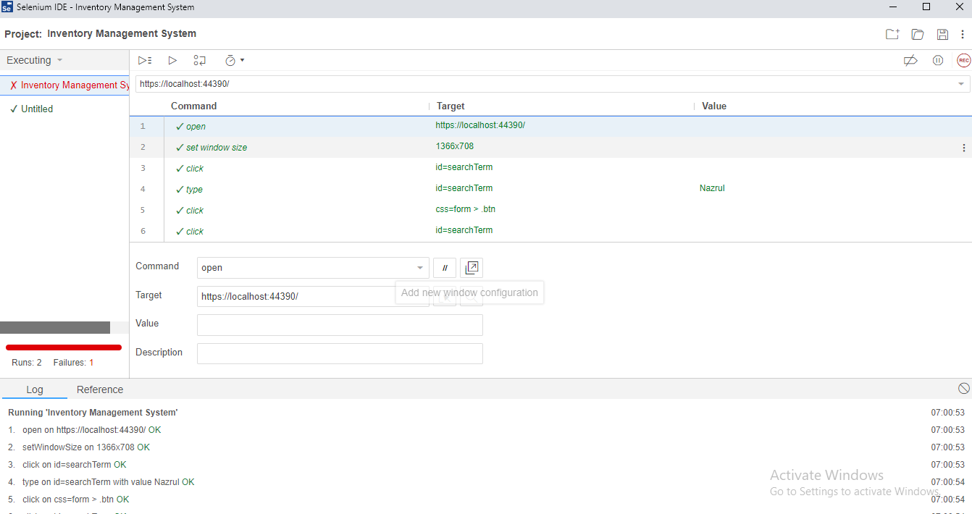

Figure 7 : Value assigning and validation

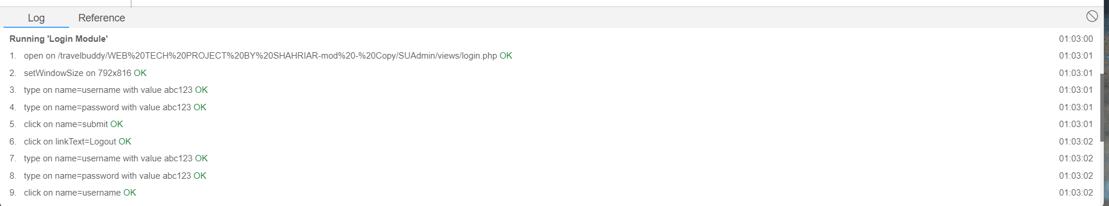

Figure 8: Test Result

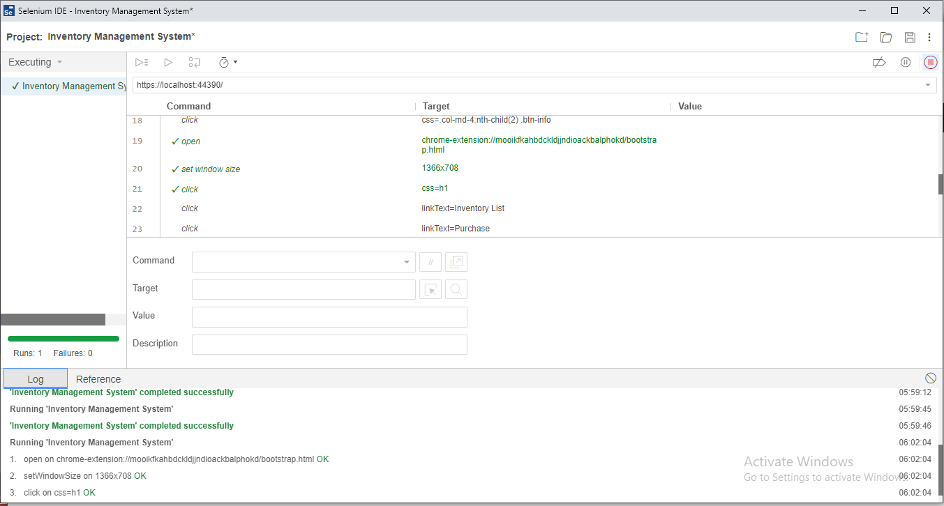

Figure 9: Command giving

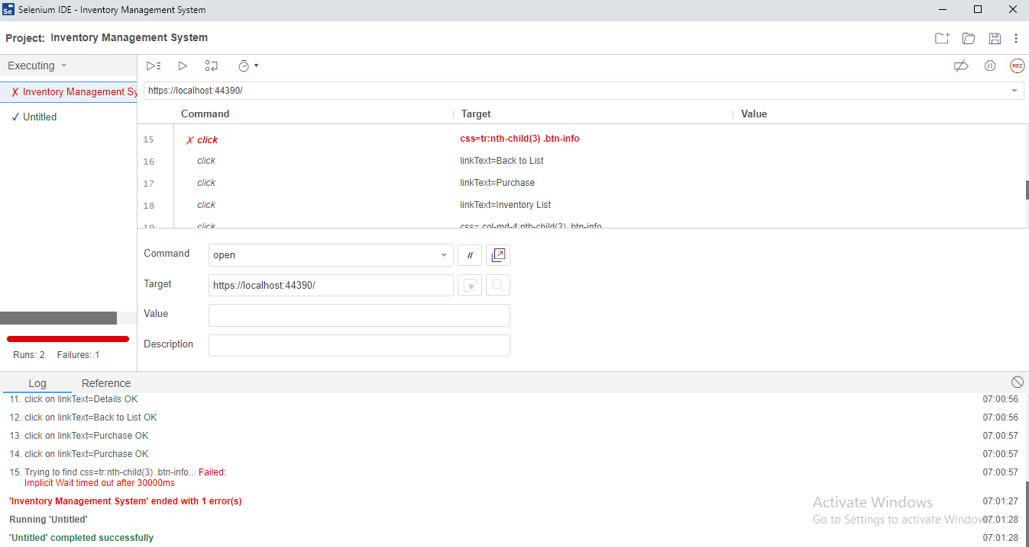

Figure 10: Wrong Value Return and Error findings

**Description:** Initially, Selenium IDE was installed. Subsequently, a new project was created, followed by the creation of the Search Module. The Search Module successfully passed the tests. Afterward, another module was taken on, but unfortunately, that module failed.