**E-Learning System**

CSE 308: Software Engineering and Information System Design Sessional (Use-Case)

**Group no. : 06**

**1005062**

**1005065**

**1005071**

**1005072**

**1005074**

SUB SYSTEMS

1. Exam Subsystem
   1. Question Management Sub subsystem
   2. Schedule Management Sub subsystem
   3. Appearing Exam Sub subsystem
   4. Marks Management Sub subsystem
2. Registration Subsystem
3. Information Management Subsystem
4. Virtual Classroom Subsystem
5. Forum Subsystem
   1. QUESTION MANAGEMENT

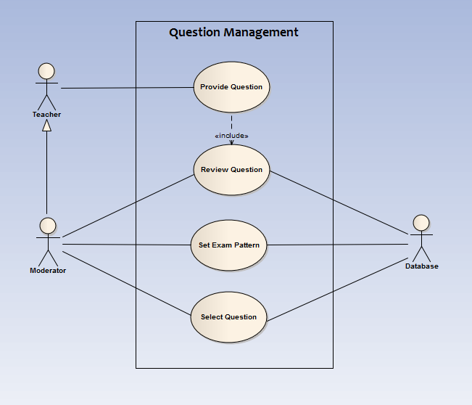

**Fig 1.1: Use-case diagram for ‘Question Management’ sub-sub-system of the ‘Exam sub-system’**

**Glossary**

|  |  |
| --- | --- |
| **Use cases name** | **Actors** |
| 1.Provide Question | Teacher, Moderator, Database |
| 2. Review Question | Moderator, Database |
| 3.Set Exam Pattern | Moderator, Database |
| 4.Select Question | Moderator, Database |

|  |  |
| --- | --- |
| **Use-case ID** | 1.1.1 |
| **Use-case name** | **Provide Question** |
| **Description** | Approved teachers and moderators will provide questions for the exams. |
| **Priority** | Essential |
| **Primary actors** | 1. Teachers 2. Moderators |
| **Secondary actors** | -none- |
| **Trigger** | The teacher or moderator decides to set question. |
| **Preconditions** | The designated actors must be signed in to the system with a valid id. |
| **Post conditions** | The provided questions are taken and forwarded to the review use-case. |
| **Conclusion** | The use-case concludes its functions when the primary actors submit the question after accomplishment. |
| **Implementation** | The system will provide the particular actor a suitable interface to put the question in a definite field. |

**Flow of Actions:**

|  |  |
| --- | --- |
| **Actor’s action** | **System Response** |
| 1. Primary actor will sign in to the system. | 1. System will allow to sign in if it is a valid id. |
| 1. Primary actor will choose to set question. | 1. System will provide the appropriate interface for setting questions. |
| 1. Then the actor will set the questions as per the earlier choices and attributes. | 1. None. |
| 1. After completing the question, the primary actor will submit them. | 1. The system will keep the questions and wait for the moderators to check whether they are eligible. |

**Alternative Actions:**

1.a If the primary actor’s id is invalid the system ask him/her to register.

3.a If the questions do not meet the requirement of the preset question format, the system will prompt the actor to reset the question.

|  |  |
| --- | --- |
| **Use-case ID** | 1.1.2 |
| **Use-case name** | **Review question** |
| **Description** | Check the questions provided from the ‘Provide Question’ use-case and approve the eligible questions. |
| **Priority** | Essential |
| **Primary actors** | 1.Moderators |
| **Secondary actors** | 1. Database |
| **Trigger** | The moderator chooses to moderate the submitted questions. |
| **Preconditions** | The designated actors must be signed in to the system with a valid id and there must be pending questions to review. |
| **Post conditions** | The provided questions are checked and stored in the database if they are up to the mark and the question provider will be notified. |
| **Conclusion** | The use-case concludes its functions when the primary actor approves or rejects the question. |
| **Implementation** | The system will provide the particular actor a suitable interface to review questions. |

**Flow of Actions:**

|  |  |
| --- | --- |
| **Actor’s action** | **System Response** |
| 1. Primary actor will sign in to the system. | 1. System will allow the actor to sign in if it is a valid id. |
| 2. Primary actor will choose to review the pending questions. | 2. System will provide the appropriate interface and the pending questions’ list. |
| 3. Then the actor will select the question and review. | 3. None. |
| 4. After completing the action the actor will give his/her consent. | 4. If the consent is YES then the question is stored into the database. Otherwise the system will reject it. |

**Alternative Actions:**

1.a If the primary actor’s id is invalid the system rejects the access request.

2.a If there is no pending questions, the use-case will notify the moderator and terminate.

|  |  |
| --- | --- |
| **Use-case ID** | 1.1.3 |
| **Use-case name** | **Set Exam Pattern** |
| **Description** | Moderators will decide the pattern of the exam |
| **Priority** | Essential |
| **Primary actors** | 1. Moderators |
| **Secondary actors** | 1. Database |
| **Trigger** | The moderator decides to set exam pattern. |
| **Preconditions** | The designated actor must be signed in to the system with a valid id. |
| **Post conditions** | The provided exam pattern is taken and stored in the database. |
| **Conclusion** | The use-case concludes its functions when the primary actor submits the exam pattern after accomplishment. |
| **Implementation** | The system will provide the particular actor a suitable interface to define the pattern in a definite field. |

**Flow of Actions:**

|  |  |
| --- | --- |
| **Actor’s action** | **System Response** |
| 1. Primary actor will sign in to the system. | 1. System will allow to sign in if it is a valid id. |
| 1. Primary actor will choose to set exam pattern. | 2. System will provide the appropriate interface for setting questions. |
| 1. Then the actor will set the exam pattern for a particular exam. | 3.None. |
| 1. After setting the pattern, the primary actor will submit them. | 4. The system will store the pattern in the database. |

**Alternative Actions:**

1.a If the primary actor’s id is invalid the system refuses him/her to access the system.

3.a If the pattern does not meet the requirement of the preset exam pattern format, the system will prompt the actor to fill necessary fields properly.

|  |  |
| --- | --- |
| **Use-case ID** | 1.1.4 |
| **Use-case name** | **Select Questions** |
| **Description** | Moderators will select the questions for the scheduled exams. |
| **Priority** | Essential |
| **Primary actors** | 1. Moderators |
| **Secondary actors** | 1. Database |
| **Trigger** | The moderator |
| **Preconditions** | The designated actors must be signed in to the system with a valid id. |
| **Post conditions** | The questions will be preserved for the upcoming exam and its access will be restricted. |
| **Conclusion** | The use-case concludes its functions when the primary actors select all the questions. |
| **Implementation** | The system will provide the particular actor a suitable interface to select from the approved questions. |

**Flow of Actions:**

|  |  |
| --- | --- |
| **Actor’s action** | **System Response** |
| 1. Primary actor will sign in to the system. | 1. System will allow actor to sign in if it is a valid id. |
| 2. Primary actor will choose to select question | 2. System will provide the appropriate interface for selecting questions. |
| 3. Then the actor will select the questions as per the upcoming exam. | 3. None. |
| 4. After completing selecting the questions, the primary actor will submit them. | 4. The system will store the questions and restrict the viewing of question until the scheduled exam. |

**Alternative Actions:**

1.a If the primary actor’s id is invalid the system ask him/her to register.

3.a If the selected question set do not meet the requirement of the preset question pattern, the system will prompt the actor to reset the question set.

1.2 SCHEDULE MANAGEMENT

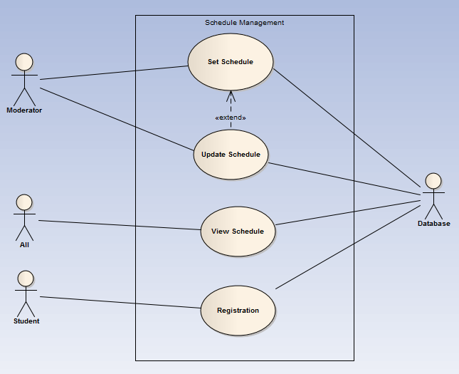

**Fig 1.1: Use-case diagram for ‘Schedule Management’ sub-sub-system of the ‘Exam sub-system’**

**Glossary**

|  |  |
| --- | --- |
| **Use cases name** | **Actors** |
| 1. Set Schedule | Moderator, Database |
| 2. Update schedule | Moderator, Database |
| 3.View schedule | All visitors |
| 4.Registration | Student, Database |
| **Use-case ID** | 1.2.1 |
| **Use-case name** | **Set Schedule** |
| **Description** | Moderators will set schedule for the exams. |
| **Priority** | Essential |
| **Primary actors** | 1.Moderators |
| **Secondary actors** | 1.Database |
| **Trigger** | The moderator decides to set schedule. |
| **Preconditions** | The designated actors must be signed in to the system with a valid id. |
| **Postconditions** | The provided schedule are taken and respective teachers and students will be notified. |
| **Conclusion** | The use-case concludes its functions when the primary actors submit the schedule after accomplishment. |
| **Implementation** | The system will provide the particular actor a suitable interface to set the schedule in a definite field. |

**Flow of Actions:**

|  |  |
| --- | --- |
| **Actor’s action** | **System Response** |
| 1. Primary actor will sign in to the system. | 1.System will allow to sign in if it is a valid id. |
| 2.Primary actor will choose to set schedule. | 2.System will provide the appropriate interface for setting schedule. |
| 3.Then the actor will set the schedule and submit it. | 3.System will keep the schedule and notify teachers and students. |

**Alternative Actions:**

1.a If the primary actor’s id is invalid the system ask him/her to register.

3.a If any field of the schedule format is not filled system will request the primary actor to setting it properly.

|  |  |
| --- | --- |
| **Use-case ID** | 1.2.2 |
| **Use-case name** | **Update Schedule** |
| **Description** | Moderators can update schedule for the exams if necessary. |
| **Priority** | Essential |
| **Primary actors** | 1.Moderators |
| **Secondary actors** | 1.Database |
| **Trigger** | The moderator decides to update schedule. |
| **Preconditions** | The designated actors must be signed in to the system with a valid id and there must be an existing schedule. |
| **Post conditions** | The updated schedule are taken and respective teachers and students will be notified. |
| **Conclusion** | The use-case concludes its functions when the primary actors submit the schedule after accomplishment. |
| **Implementation** | The system will provide the particular actor a suitable interface to set the schedule in a definite field. |

**Flow of Actions:**

|  |  |
| --- | --- |
| **Actor’s action** | **System Response** |
| 1. Primary actor will sign in to the system. | 1. System will allow to sign in if it is a valid id. |
| 2.Primary actor will choose to update schedule. | 2.System will provide the appropriate interface for updating schedule. |
| 3.Then the actor will reset the schedule and submit it. | 3.System will keep the schedule and notify teachers and students. |

**Alternative Actions:**

1.a If the primary actor’s id is invalid the system ask him/her to register.

2.a If there is no existing schedule the system will prompt for setting a schedule.

3.a If any field of the schedule format is not filled system will request the primary actor to setting it properly.

|  |  |
| --- | --- |
| **Use-case ID** | 1.2.3 |
| **Use-case name** | **View Schedule** |
| **Description** | All visitors can view schedule for the exams. |
| **Priority** | Essential |
| **Primary actors** | 1.All visitors |
| **Secondary actors** | 1.Database |
| **Trigger** | The visitor decides to see schedule. |
| **Preconditions** | There must be an existing schedule. |
| **Postconditions** | none |
| **Conclusion** | none |
| **Implementation** | The system will provide the particular actor a suitable interface to view the schedule . |

**Flow of Actions:**

|  |  |
| --- | --- |
| **Actor’s action** | **System Response** |
| 1. Primary actor will choose to view schedule. | 1. System will provide the appropriate interface for viewing schedule. |

**Alternative Actions:**

1.a If there is no existing schedule the system will notify this.

|  |  |
| --- | --- |
| **Use-case ID** | 1.2.4 |
| **Use-case name** | **Registration** |
| **Description** | Registered students of the system will register for the scheduled exam. |
| **Priority** | Essential |
| **Primary actors** | 1.Registered students. |
| **Secondary actors** | 1.Database |
| **Trigger** | The primary actor decides to register for the exam. |
| **Preconditions** | There must be an existing schedule and primary actor must be already registered. |
| **Postconditions** | The student will be notified that he/she is enlisted for the upcoming exam. |
| **Conclusion** | When the student submits his registration . |
| **Implementation** | The system will provide the particular actor a suitable interface to register . |

**Flow of Actions:**

|  |  |
| --- | --- |
| **Actor’s action** | **System Response** |
| 1. Primary actor will sign in to the system. | 1. System will allow to signin if it is a valid id. |
| 1. Primary actor will choose to register. | 1. System will provide the appropriate interface for registration. |
| 1. Primary actor will submit his registration. | 1. System will notify that his registration is complete. |

**Alternative Actions:**

1.a If there is no valid id the system will prompt for registration to the system .

3.a If any of the registration is not format wise system will request the primary actor to setting it properly.

1. REGISTRATION



**Fig 2: Use case Diagram for Registration subsystem**

**Glossary**

|  |  |
| --- | --- |
| **Use cases name** | **Actors** |
| 1.Assign Moderator | Admin, Database |
| 2.Fill Student form | Student, Database |
| 3.Sign Out | Admin, Moderator, Teacher, Student, Database |
| 4.Sign in | Admin, Moderator, Teacher, Student, Database |
| 5.Fill Teacher Form | Teacher, Database |
| 6.Verification | Moderator, Database |

|  |  |
| --- | --- |
| **Use-case ID** | 2.1 |
| **Use-case name** | **Assign Moderator** |
| **Description** | Admin assigns moderator |
| **Priority** | Essential |
| **Primary actors** | 1. Admin |
| **Secondary actors** | 1. Database |
| **Trigger** | None |
| **Preconditions** | None |
| **Post conditions** | None |
| **Conclusion** | When the admin press create moderator button |
| **Implementation** | The moderators are created by this use case. |

**Flow of Actions:**

|  |  |
| --- | --- |
| **Actor’s action** | **System Response** |
| 1. Admin fill up the form for necessary information for the moderator and press create moderator button | 1. If there is any error in the form, then it will be informed to the admin 2. If the form is correctly filled up, in the database the information of the moderator is inserted. 3. If the insertion successful then It will be informed to the admin and an email will be sent to the moderator 4. If there is any problem then it will be informed to the moderator |

**Alternative Actions:**

**1.a** If any field is empty , system will request for it.

|  |  |
| --- | --- |
| **Use-case ID** | 2.2 |
| **Use-case name** | **Fill Student form** |
| **Description** | The new student fill up the registration form |
| **Priority** | Essential |
| **Primary actors** | 1. Student |
| **Secondary actors** | 1. Database |
| **Trigger** | When sign up as student button is pressed |
| **Preconditions** | None |
| **Post conditions** | None |
| **Conclusion** | When the student fill up the form correctly and press submit button |
| **Implementation** | An student account is created |

**Flow of Actions:**

|  |  |
| --- | --- |
| **Actor’s action** | **System Response** |
| 1. The new student fill up the form for necessary information and press submit button | 1. If there is any error in the form, then it will be informed to the student 2. If the form is correctly filled up, in the database the information of the student is inserted. And it will be informed to the student. |

**Alternative Actions:**

**1.a** If any field is empty , system will request for it.

|  |  |
| --- | --- |
| **Use-case ID** | 2.3 |
| **Use-case name** | **Sign out** |
| **Description** | The user sign out |
| **Priority** | Essential |
| **Primary actors** | 1. Admin 2. Student 3. Teacher 4. Student |
| **Secondary actors** | 1. Database |
| **Trigger** | When the user press sign out button |
| **Preconditions** | The user must be signed in |
| **Post conditions** | None |
| **Conclusion** | When the database notifies that the user successfully signed out. |
| **Implementation** | The user can sign out so that the private information of the user cannot be seen by others. |

**Flow of Actions:**

|  |  |
| --- | --- |
| **Actor’s action** | **System Response** |
| 1. The user press sign out button. | 1. The session and cookie of the browser of the user changes. 2. In the database also the information of sign out is received and notified. |

**Alternative Actions:**

None.

|  |  |
| --- | --- |
| **Use-case ID** | 2.4 |
| **Use-case name** | **Sign in** |
| **Description** | The user sign in |
| **Priority** | Essential |
| **Primary actors** | 1. Admin 2. Student 3. Teacher 4. Student |
| **Secondary actors** | 1. Database |
| **Trigger** | When the user press sign in button |
| **Preconditions** | None |
| **Post conditions** | None |
| **Conclusion** | When the response of database regarding sign in comes to the browser of the user and the session and cookie status changed. |
| **Implementation** | To write anything in the blog and forum, Sign in is a must.  The admin can edit the profile, View everything in the site.  The Moderator edit the profile, can verify new teacher, can verify questions.  The teacher can edit profile. set question and provide study material  The student can edit profile and give exam. |

**Flow of Actions:**

|  |  |
| --- | --- |
| **Actor’s action** | **System Response** |
| 1. The user selects in which mode he/she wants to sign in. | 1. If he/she selects admin mode the page for admin mode comes. If he/she selects moderator mode the page for moderator mode comes. If he/she selects student mode the page for student mode comes. If he/she selects teacher mode the page for teacher mode comes. |
| 1. The user enter username and password and press submit button. | 1. If the username and password is wrong then the user is notified that the username and password is wrong. If the username and password is correct then the database send response of sign in to the user and the session and cookie status user’s browser is changed. |

|  |  |
| --- | --- |
| **Use-case ID** | 2.5 |
| **Use-case name** | **Fill Teacher form** |
| **Description** | The new teacher fill up the registration form |
| **Priority** | Essential |
| **Primary actors** | 1. Teacher |
| **Secondary actors** | 1. Database |
| **Trigger** | When sign up as teacher button is pressed |
| **Preconditions** | None |
| **Post conditions** | The form is saved in the server and send to the moderator for verification |
| **Conclusion** | When the teacher fill up the form correctly and press submit button |
| **Implementation** | The information of the teacher is send to the moderator for verification. If the verification successful then teacher account is created |

**Flow of Actions:**

|  |  |
| --- | --- |
| **Actor’s action** | **System Response** |
| 1. The new teacher fill up the form for necessary information and press submit button | 1. If there is any error in the form, then it will be informed to the teacher 2. If the form is correctly filled up, in the database the information of the teacher is kept for verification. And the form will be send to the moderator for verification |

**Alternative Actions:**

1.a If any field is empty , system will request for it.

|  |  |
| --- | --- |
| **Use-case ID** | 2.6 |
| **Use-case name** | **Verification** |
| **Description** | The moderator verifies the teacher |
| **Priority** | Essential |
| **Primary actors** | 1. Moderator |
| **Secondary actors** | 1. Database |
| **Trigger** | When the teacher submit the form |
| **Preconditions** | The teacher submit form for verification |
| **Post conditions** | None |
| **Conclusion** | When the moderator approve or disapprove the teacher |
| **Implementation** | If the moderator approve the teacher then the teacher can perform his/her act as teacher .If not then he/she cannot perform his/her act as a teacher. This verification is required because there is possibility of fake teacher |

**Flow of Actions:**

|  |  |
| --- | --- |
| **Actor’s action** | **System Response** |
| 1. The moderator receives the teacher’s information | 1. The moderator will check the validity of the information. If the provided information is correct then the moderator will approve him as teacher. Otherwise he/she will be disapproved by the moderator |

**Alternative Actions:**

none

3 INFORMATION MANAGEMENT



**Fig 3: Use-case diagram for ‘Information management’**

**Glossary**

|  |  |
| --- | --- |
| **Use cases name** | **Actors** |
| 1.View Statistics | Admin, Moderator, Teacher, Student, Others |
| 2.View Public Profile | Admin, Moderator, Teacher, Student, Others |
| 3.View and edit own profile | Admin, Moderator, Teacher, Student |
| 4.Talk to us | Admin, Moderator, Teacher, Student, Others |

|  |  |
| --- | --- |
| **Use-case ID** | 3.1 |
| **Use-case name** | **View Statistics** |
| **Description** | Everyone can see the statistics. |
| **Priority** | Optional |
| **Primary actors** | 1. Teachers 2. Student 3. Admin 4. Moderator 5. Others |
| **Secondary actors** | 1.Database |
| **Trigger** | When View Statistics Button is pressed |
| **Preconditions** | None |
| **Post conditions** | None |
| **Conclusion** | When the user go to another process |
| **Implementation** | The users can see the statistics. |

**Flow of Actions:**

|  |  |
| --- | --- |
| **Actor’s action** | **System Response** |
| 1. The primary actor press view statistics button. | 1. User interface with statistics will be shown. |

**Alternative Actions:**

none

|  |  |
| --- | --- |
| **Use-case ID** | 3.2 |
| **Use-case name** | **View Public Profile** |
| **Description** | Everyone can see the public profile of a teacher or student. |
| **Priority** | Essential |
| **Primary actors** | 1. Teachers 2. Student 3. Admin 4. Moderator 5. Others |
| **Secondary actors** | 1.Database |
| **Trigger** | When View public profile Button of a student or teacher is pressed |
| **Preconditions** | None |
| **Post conditions** | None |
| **Conclusion** | When the user go to another process |
| **Implementation** | The users can see the public profile of a teacher or student |

**Flow of Actions:**

|  |  |
| --- | --- |
| **Actor’s action** | **System Response** |
| 1. The primary actor search a particular student or teacher and want to see the public profile | 1. The public profile of the student or teacher will be shown |

**Alternative Actions:**

**1.a** if requested teacher or student id is not existed, system will notify it .

|  |  |
| --- | --- |
| **Use-case ID** | 3.3 |
| **Use-case name** | **View and Edit own profile** |
| **Description** | The student, teacher or moderator can view and edit own information. |
| **Priority** | Optional |
| **Primary actors** | 1. Teachers 2. Student 3. Admin 4. Moderator 5. Others |
| **Secondary actors** | 1.Database |
| **Trigger** | When View My Profile Button is pressed |
| **Preconditions** | The actor must be signed in |
| **Post conditions** | None |
| **Conclusion** | When the actor press save Button after editing |
| **Implementation** | The actor can view and edit own profile |

**Flow of Actions:**

|  |  |
| --- | --- |
| **Actor’s action** | **System Response** |
| 1. The primary actor press view my profile | 1. The profile of that actor will be shown |
| 1. The primary actor press edit button | 1. The primary actor can edit the profile |
| 1. The primary actor press save button | 1. The changes made by user is saved |
| 1. The primary actor press cancel button | 1. The changes is not saved |

**Alternative Actions:**

**1.a** if requested teacher or student id is not existed, system will notify it .

**3.a** if any required field is empty ,system will prompt for it.

|  |  |
| --- | --- |
| **Use-case ID** | 3.4 |
| **Use-case name** | **Talk to us** |
| **Description** | If there is any suggestion to improve the process, or if there is any problem faced by the user, or If the researcher wants any particular information. Then the user can ask the question. |
| **Priority** | Optional |
| **Primary actors** | 1. Teachers 2. Student 3. Admin 4. Moderator 5. Others |
| **Secondary actors** | 1.Database |
| **Trigger** | When Talk to us Button is pressed |
| **Preconditions** | The actor must be signed in |
| **Post conditions** | None |
| **Conclusion** | When the primary actor press send or cancel button |
| **Implementation** | The message will be sent to admin |

**Flow of Actions:**

|  |  |
| --- | --- |
| **Actor’s action** | **System Response** |
| 1. The primary actor press talk to us button | 1. The user interface for talk to us will be shown |
| 1. The primary actor press send button | 1. The message will be send to admin |
| 1. The primary actor press cancel button | 1. The changes will not be send to the admin |
| 1. The admin replies or take necessary steps | 1. The message will be send to the person who ask question or give suggestion. |

4. Virtual Classroom

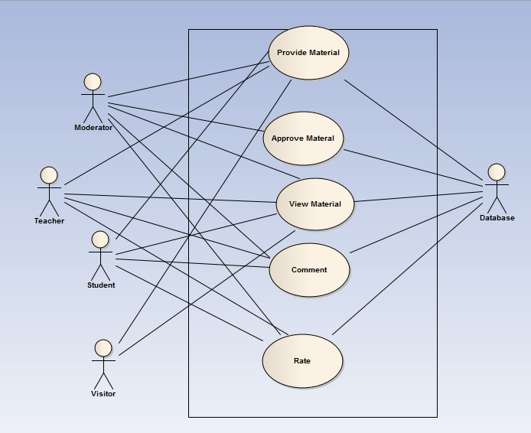**Fig 4: Use-case diagram for ‘Virtual Classroom system’**

**Glossary**

|  |  |
| --- | --- |
| **Use Case Name** | Actors |
| 1.Provide Material | Teachers, Students, Moderators, Visitors, Database |
| 2.Approve Material | Moderators, Admins, Database |
| 3.View Material | Students, Teachers, Visitors, Database |
| 4.Comment | Registered Users, Database |
| 5.Rate | Registered Users, Database |

|  |  |
| --- | --- |
| **Use-case ID** | 4.1 |
| **Use-case name** | **Provide Material** |
| **Description** | Provide study material of any kind. |
| **Priority** | High |
| **Primary actors** | Teachers , Students , Authorized Experts |
| **Secondary actors** | Database |
| **Trigger** | Teachers or any registered users decide to provide material. |
| **Preconditions** | The data provider must be logged in. |
| **Post-conditions** | The file is be sent to moderators and Admins . |
| **Conclusion** | Notify that data file is successfully stored. |
| **Implementation** | Provide a window to enter data. |

**Flow of Actions:**

|  |  |
| --- | --- |
| **Actor’s action** | **System Response** |
| 1. The provider can upload any format of data file including text , video and others by clicking on provide material option of virtual classroom. | 1. A window appears to enter data. |
| 1. The provider must confirm before uploading any material that it is not harmful to others (doesn’t contain any type of violence ). | 1. System will show a dialog box where the confirmation is written with an accept button. |
| 1. After confirmation, the data file will be sent to the admins and then to the moderators and will not be available on site until their reports | 1. System will close the window. The provider will be notified via message that file has been successfully uploaded to the server. |

|  |  |
| --- | --- |
| **Use-case ID** | 4.2 |
| **Use-case name** | **Approve Material** |
| **Description** | Moderate the materials |
| **Priority** | High |
| **Primary actors** | Moderators , Admins |
| **Secondary actors** | 1. Database |
| **Trigger** | The Admin starts the task to moderate the submitted files. |
| **Preconditions** | A data file has been uploaded and waiting for approval to appear on the site. |
| **Post-conditions** | A file is appeared on the site after approval. |
| **Conclusion** | When Moderator approves a material to be uploaded on the site. |
| **Implementation** |  |

**Flow of Actions:**

|  |  |
| --- | --- |
| **Actor’s action** | **System Response** |
| 1. Admins will receive the materials that has been uploaded by individuals | 1. Upload the materials as they are only accessible by Admins and moderators and notify the admins only. |
| 2. Any material that does not relate to study or contain any violence or adultery will be discarded and the individuals requested to upload them will be blocked. | 1. Garbage the specific items. |
| 3. The admins will categorize the rest of the materials and make a list called ‘Waiting list’ according to subject and level. | 3. Store the list. |
| 5. Moderators will be notified via message that a list of items has been sent for approval. | 5. Send the moderators a message. |
| 6. When the moderators will receive the list , an auto message is sent to the sender admin that list is received. | 6. Send a message. |
| 7. Moderator will check the waiting list what materials are waiting for his approval. | 7. Maintain the modified list. |
| 8. Moderator will see the materials and decide as it is eligible to be on the site or not. | 8. Serve the materials to the moderators from database as each item is clicked on the list by the moderators. |
| 9. In this stage if any moderator is unable for some reason then he can pass the task of moderation to any other moderator or admin with a message. | 9. None. |
| 10.If any material is not considered by the moderators to be uploaded then they send the material to garbage | 10. Garbage the selected items. |
| 11. If any material is approved then the material appears on site categorized by subjects and level. | 11. Receive the materials with id by which they are classified according to subject and choice. |

|  |  |
| --- | --- |
| **Use-case ID** | 4.3 |
| **Use-case name** | **View Material** |
| **Description** | User clicks to see study materials |
| **Priority** | High |
| **Primary actors** | 1. Any users |
| **Secondary actors** | 1. Database |
| **Trigger** | Any user or visitor clicks to see study materials. |
| **Preconditions** | A file has been appeared on the site after approval. |
| **Post-conditions** | The data how many times a material has been watched or downloaded has been saved. |
| **Conclusion** | User returned to the window containing list. |
| **Implementation** | A database will store the data how many times a material has been seen or downloaded by whom. |

**Flow of Actions:**

|  |  |
| --- | --- |
| **Actor’s action** | **System Response** |
| 1. Moderators, Admins, Registered  teachers and students will see an option named view material along with provide material after clicking on virtual classroom. | 1. None. |
| 2. Any other who is not registered will only see the option view material after clicking on virtual classroom. | 2. None. |
| 3. After clicking on view material a list of materials will appear categorized according to subjects and then level. | 3. Show a list of materials. |
| 4. After clicking on a material, anyone will be able to view or download that file. | 4. Provide a window when a material is clicked on. The window will show that material running on. Provide a button named download in that window by clicking which any file can be downloaded. |
| 5. After seeing or downloading that material the user will close the window and will return to the previous one. | 1. Closes the new window. The previous window is returned. |

|  |  |
| --- | --- |
| **Use-case ID** | 4.4 |
| **Use-case name** | **Comment** |
| **Description** | Only registered users can comment on a material. |
| **Priority** | Medium |
| **Primary actors** | 1. Students 2. Teachers 3. Moderators |
| **Secondary actors** | 1. Database |
| **Trigger** | Students and teachers comment after watching a material. |
| **Preconditions** | A material has been showed or downloaded by a user and the user is logged in. |
| **Post-conditions** | The comment is stored in the database. |
| **Conclusion** | A comment appears on the comment list. |
| **Implementation** | Provide a button named comment with each material along with previous comments list. |

**Flow of Actions:**

|  |  |
| --- | --- |
| **Actor’s action** | **System Response** |
| 1. An option along with all the materials will appear named comment. | 1. None. |
| 1. When a user will click on comment, a text box will appear. | 1. Show a blank text box. |
| 3. After typing on that box, when a user clicks on the submit button the comment is saved on the database and appears on the comment list of that material. | 3. None. |

**Alternative Actions:**

**2.a** If the user is not registeredthena dialog box appears containing the message that user must be logged in.

|  |  |
| --- | --- |
| **Use-case ID** | 4.5 |
| **Use-case name** | **Rate** |
| **Description** | Students, Teachers and Visitors will rate a comment or material as they wish. |
| **Priority** | Medium |
| **Primary actors** | 1.Teachers  2.Students  3.Experts  4.Unregistered Visitors |
| **Secondary actors** | 1.Database |
| **Trigger** | Students/Teachers will rate a material after they have seen it. |
| **Preconditions** | A material has been showed or downloaded by a user and the user is logged in. |
| **Post-conditions** | The rate submitted by user has been saved in the database and calculated maximum rating is appeared. |
| **Conclusion** | After rating once, the rate is unavailable again for any users. |
| **Implementation** | The rate option will appear once for every user and disappear after using once. |

**Flow of Actions:**

|  |  |
| --- | --- |
| **Actor’s action** | **System Response** |
| 1. An option along with all the materials or comments will appear named rate. | 1. None. |
| 2. When a user will click on rate, a number filed will appear with one up and one down arrow. | 2. None. |
| 3. Preset number is zero, but one can rate as wish by clicking up and down arrow. | 3. Scroll the number field with up and down arrow. |
| 4. Then when user presses enter, the rated number will be saved in the database. | 4. Send the number to the database. |
| 5.The rate rated by maximum users will appear then. | 5. The system will auto query on the database, extract all the submitted numbers and will calculate the number submitted by maximum users. |

**Alternative Actions:**

1.a When a person, not registered try to rate, a dialog box appears containing the message that user must be signed in to rate.

5. FORUM

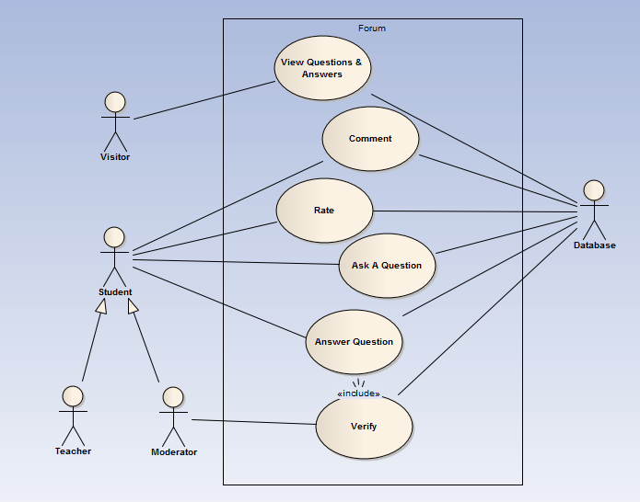

**Fig 5: Use-case diagram for ‘Forum system’**

**Glossary**

|  |  |
| --- | --- |
| **Use cases name** | **Actors** |
| 1.Ask a Question | Teachers, Student, Database |
| 2. Answer Question | Teachers, Student , moderators ,Database |
| 3.Verify Answer | Moderator, Database |
| 4.Comment | Teacher, Student, Moderator, Database |
| 5. Rate | Teacher, Student, Moderator, Database |
| 6. View Questions and Answers | Visitors |

|  |  |
| --- | --- |
| **Use-case ID** | 5.1 |
| **Use-case name** | **Ask a Question** |
| **Description** | Teachers or student can ask a question. |
| **Priority** | Essential |
| **Primary actors** | 1. Teachers 2. student |
| **Secondary actors** | Database |
| **Trigger** | The teacher or student decides to ask a question |
| **Preconditions** | The designated actors must be signed in to the system with a valid id. |
| **Postconditions** | The provided questions are taken and will be stored in database. |
| **Conclusion** | The use-case concludes its functions when the primary actors submit the question. |
| **Implementation** | The system will provide the particular actor a suitable interface for asking a question in a definite field. |

**Flow of Actions:**

|  |  |
| --- | --- |
| **Actor’s action** | **System Response** |
| 1. Primary actor will sign in to the system. | 1. System will allow to sign in if it is a valid id. |
| 1. Primary actor will choose to ask a question. | 1. System will provide the appropriate interface for asking a question. |
| 1. Then the actor will ask a question. | 1. None. |
| 1. After asking a question, the primary actor will submit them. | 1. After submitting the question the question will be stored in database. |

**Alternative Actions:**

1.a If the primary actor’s id is invalid the system ask him/her to register or to enter valid id.

|  |  |
| --- | --- |
| **Use-case ID** | 5.2 |
| **Use-case name** | **Answer Question** |
| **Description** | Teacher, student or moderators can answer a question. |
| **Priority** | Essential |
| **Primary actors** | 1.Teachers  2.Student  3.Moderators |
| **Secondary actors** | 1. Database |
| **Trigger** | Teachers, student or moderators choose to answer a question. |
| **Preconditions** | The designated actors must be signed in to the system with a valid id and choose to answer a question. |
| **Postconditions** | The provided answers are stored in the database and wait for moderator to verify it. |
| **Conclusion** | The use-case concludes its functions when the primary actor submit answer of a question and stored in database. |
| **Implementation** | The system will provide the particular actor a suitable interface to answer a question and provide question list. |

**Flow of Actions:**

|  |  |
| --- | --- |
| **Actor’s action** | **System Response** |
| 1. Primary actor will sign in to the system. | 1. System will allow the actor to sign in if it is a valid id. |
| 2. Primary actor will choose to answer a question. | 2. System will provide the appropriate interface and question list. |
| 3. Then the actor will select the question and answer it. | 3. None. |
| 4. After completing the action the actor will submit his/her answer. | 4. After submitting answer of a question system will store the answer of the specific question in the database. |

**Alternative Actions:**

1.a If the primary actor’s id is invalid the system rejects the access request and ask the actor to enter valid id.

2.a If there is no questions, the use-case will notify the actor and terminate.

|  |  |
| --- | --- |
| **Use-case ID** | 5.3 |
| **Use-case name** | **Verify Answer** |
| **Description** | Moderators will verify answer. |
| **Priority** | Essential |
| **Primary actors** | 1.Moderators |
| **Secondary actors** | 1. Database |
| **Trigger** | Moderators choose to verify answer. |
| **Preconditions** | The designated actors must be signed in to the system with a valid id and there must be pending answer to verify. |
| **Postconditions** | The verified answers are stored in the database. |
| **Conclusion** | The use-case concludes its functions when the primary actor verify answer of a question and stored in database. |
| **Implementation** | The system will provide the particular actor a suitable interface to verify answers and provide pending answers list. |

**Flow of Actions:**

|  |  |
| --- | --- |
| **Actor’s action** | **System Response** |
| 1. Primary actor will sign in to the system. | 1. System will allow the actor to sign in if it is a valid id. |
| 2. Primary actor will choose to verify answer. | 2. System will provide the appropriate interface and pending answer list. |
| 3. Then the actor will select the answer and verify it. | 3. None. |
| 4. After completing the action the actor will submit his/her verification. | 4. After submitting verification of a answer, system will store the answer with if it is eligibile otherwise discard it. |

**Alternative Actions:**

1.a If the primary actor’s id is invalid the system rejects the access request and ask the actor to enter valid id.

2.a If there is no pending answer, the use-case will notify the actor and terminate.

|  |  |
| --- | --- |
| **Use-case ID** | 5.4 |
| **Use-case name** | **Comment** |
| **Description** | Teachers, student or moderator will comment in the forum. |
| **Priority** | Essential |
| **Primary actors** | 1. Teachers 2. Student 3. Moderators |
| **Secondary actors** | 1. Database |
| **Trigger** | Actor decides to comment |
| **Preconditions** | The designated actor must be signed in to the system with a valid id. |
| **Postconditions** | Comments will be stored in database. |
| **Conclusion** | The use-case concludes its functions when the primary actor submits the comments. |
| **Implementation** | The system will provide the particular actor a suitable interface to perform comment operation. |

**Flow of Actions:**

|  |  |
| --- | --- |
| **Actor’s action** | **System Response** |
| 1. Primary actor will sign in to the system. | 1. System will allow to sign in if it is a valid id. |
| 1. Primary actor will choose to set comment in a particular answer or question. | 2. System will provide the appropriate interface for setting questions. |
| 1. Then the actor will set the comment for a particular question and answer. | 3.None. |
| 1. After setting the comment, the primary actor will submit them. | 4. The system will store the comment for particular question or answer in the database. |

**Alternative Actions:**

1.a If the primary actor’s id is invalid the system refuses him/her to access the system and ask him to enter valid id or to register.

|  |  |
| --- | --- |
| **Use-case ID** | 5.5 |
| **Use-case name** | **Rate** |
| **Description** | Actor will select a question or answer to rate. |
| **Priority** | Essential |
| **Primary actors** | 1. Teachers 2. Student 3. Moderators |
| **Secondary actors** | 1. Database |
| **Trigger** | Primary actor decides to rate a question or answer. |
| **Preconditions** | The designated actors must be signed in to the system with a valid id. |
| **Postconditions** | The rated mark will be stored in the database. |
| **Conclusion** | The use-case concludes its functions when the primary actor rate a question or answer. |
| **Implementation** | The system will provide the particular actor a suitable interface to rate a particular question or answer. |

**Flow of Actions:**

|  |  |
| --- | --- |
| **Actor’s action** | **System Response** |
| 1. Primary actor will sign in to the system. | 1. System will allow actor to sign in if it is a valid id. |
| 2. Primary actor will choose to rate a question or answer | 2. System will provide the appropriate interface for rating question or answer. |
| 3. Then the actor will select the rating mark for particular question or answer. | 3. None. |
| 4. After selecting a rating mark for a particular question or answer primary actor will submit it. | 4. The system will store the rating mark in database for that particular question or answer. |

**Alternative Actions:**

1.a If the primary actor’s id is invalid the system ask him/her to register or to enter valid id.

|  |  |
| --- | --- |
| **Use-case ID** | 5.6 |
| **Use-case name** | **View Questions and Answers** |
| **Description** | Any visitor can view questions and it’s answers. |
| **Priority** | Essential |
| **Primary actors** | 1.Visitors |
| **Secondary actors** | 1.Database |
| **Trigger** | Primary actors decides to see questions and it’s answers. |
| **Preconditions** | None |
| **Postconditions** | None |
| **Conclusion** | The use-case concludes its functions when the primary actors exits view Questions and Answers. |
| **Implementation** | The system will provide the particular actor a suitable interface to view questions and it’s answers. |

**Flow of Actions:**

|  |  |
| --- | --- |
| **Actor’s action** | **System Response** |
| 1.primary actor will choose to see the questions and answers | 1.system will allow the actor to see question list. |
| 2.actor will select a question from the question list. | 2.system will allow the actor to see the question and it’s answers. |

**Alternative Actions:**

1.a If there is no question, the use-case will notify the actor and terminate.