**E-Learning System**

CSE 308: Software Engineering and Information System Design (Collaboration & Class Diagram)

**Group no. : 06**

**1005062**

**1005065**

**1005071**

**1005072**

**1005074**

SUB SYSTEMS

1. Exam Subsystem
   1. Schedule Management Sub subsystem
   2. Question Management Sub subsystem
   3. Marks Management Sub subsystem
2. Registration Subsystem
3. Information Management Subsystem
4. Virtual Classroom Subsystem
5. Forum Subsystem

1.1 SCHEDULE MANAGEMENT

“Set schedule” use case

Collaboration Diagram for use case “set schedule”

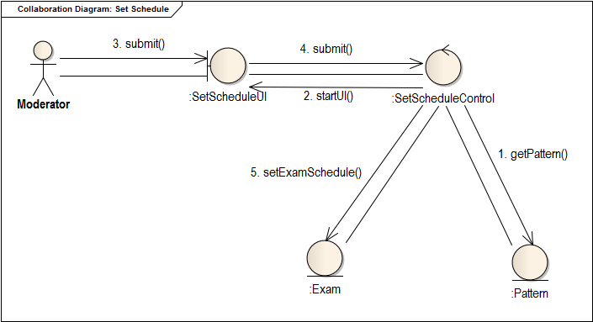

Class Diagram for use case “set schedule”

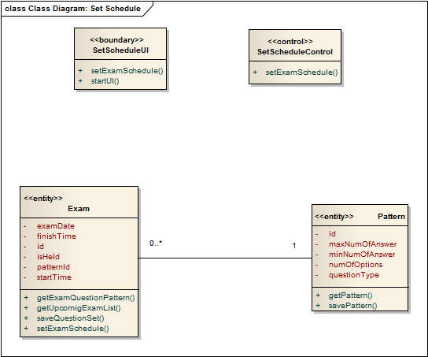

“Update schedule” use case

Collaboration Diagram for use case “Update Schedule”

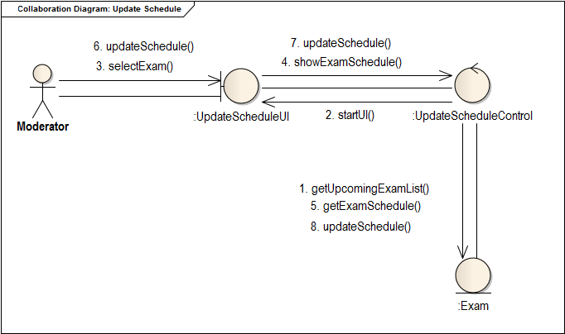

Class Diagram for use case “Update Schedule”

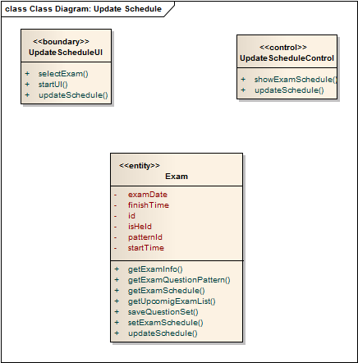

“View Schedule” use case

Collaboration Diagram for use case ”View Schedule”

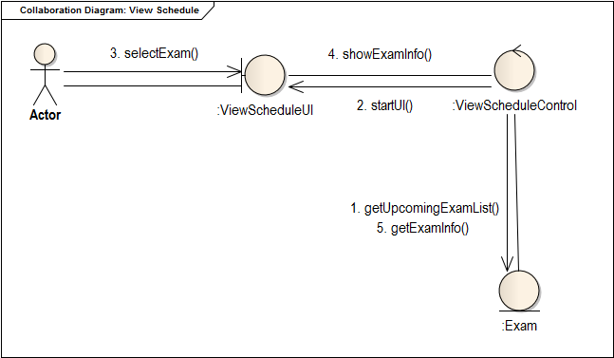

Class Diagram for use case “View Schedule”

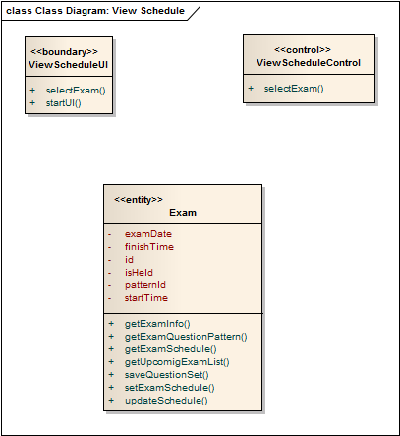

“Registration” use case

Collaboration Diagram for use case ”registration”

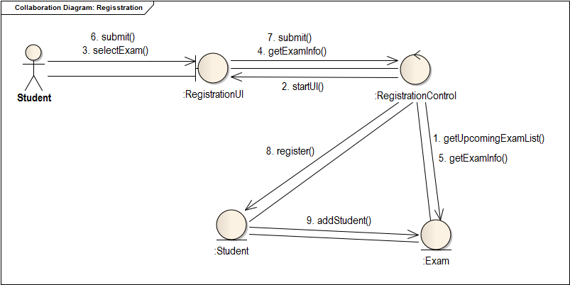

Class Diagram for use case “registration”

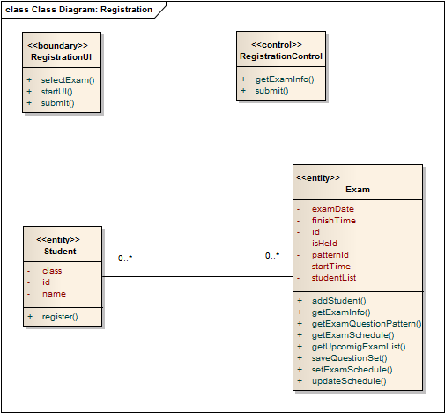

“Appear Exam” use case

Collaboration Diagram for use case “Appear Exam”

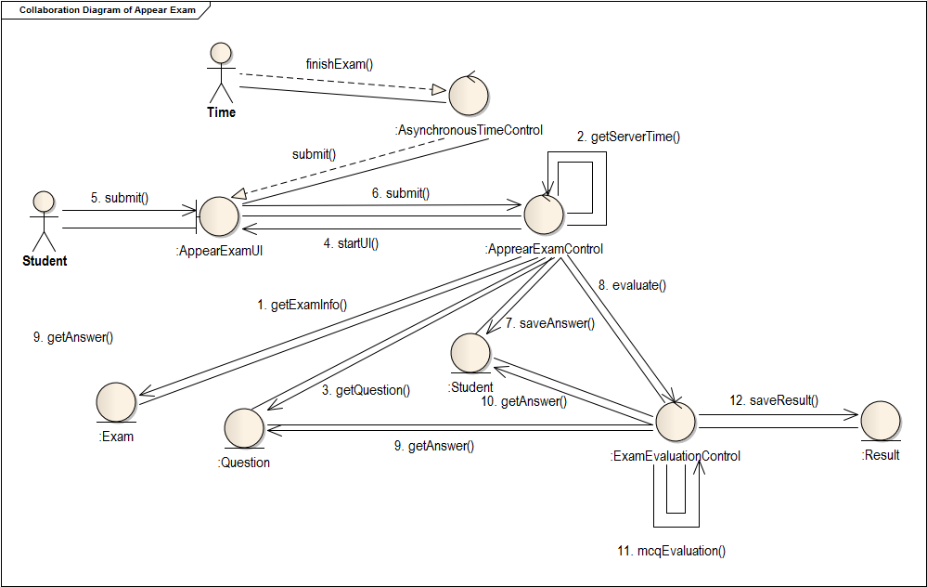

Class Diagram for use case “Appear Exam”

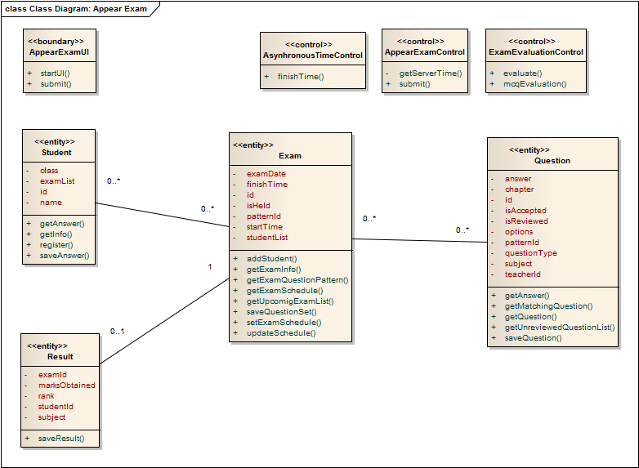

1.2 QUESTION MANAGEMENT

“Provide Question” use case

Collaboration Diagram for use case ”Provide Question”

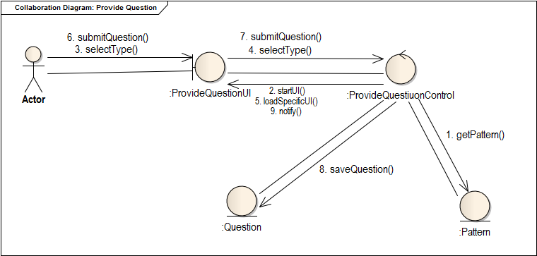

Class Diagram for use case ”Provide Question”

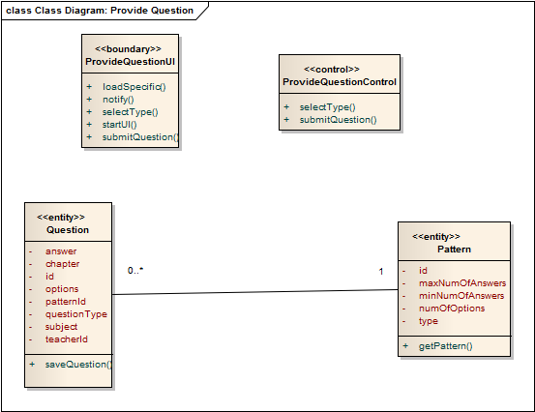

“Review Question” use case

Collaboration Diagram for use case ”Review Question”

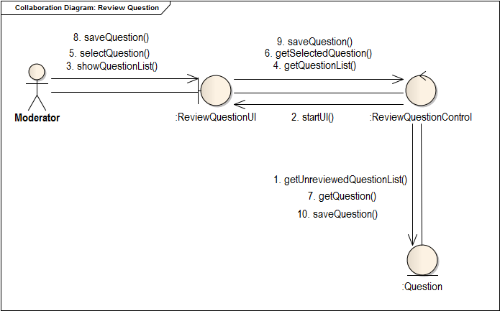

Class Diagram for use case ” Review Question”

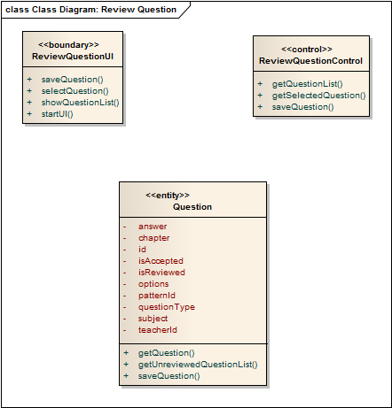

“Select Question” use case

Collaboration Diagram for use case ”Select Question ”

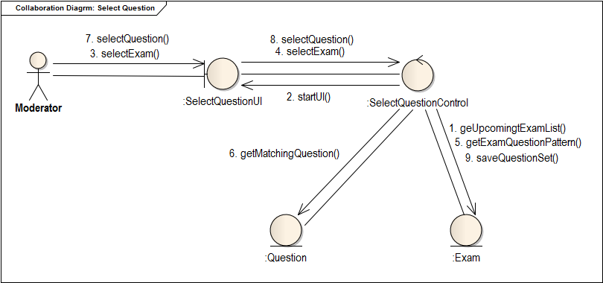

Class Diagram for use case ”Select Question ”

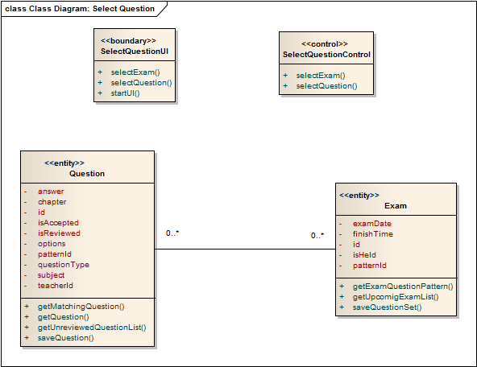

“Set Pattern” use case

Collaboration Diagram for use case ”set pattern”

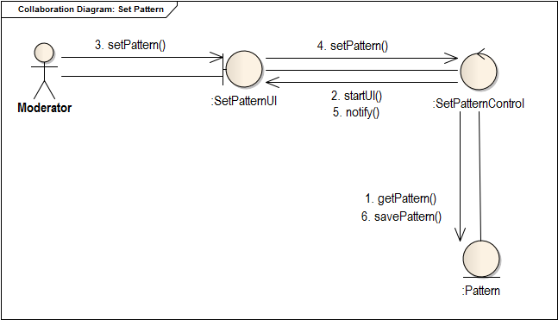

Class Diagram for use case ” set pattern”

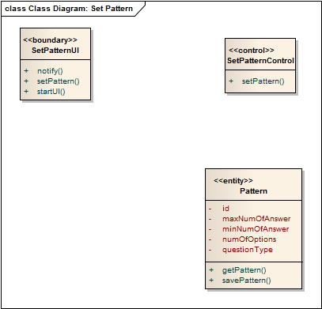

1.3 RESULT MANAGEMENT

“Descriptive Exam Evaluation” use case

Collaboration Diagram for use case “Descriptive Exam Evaluation”

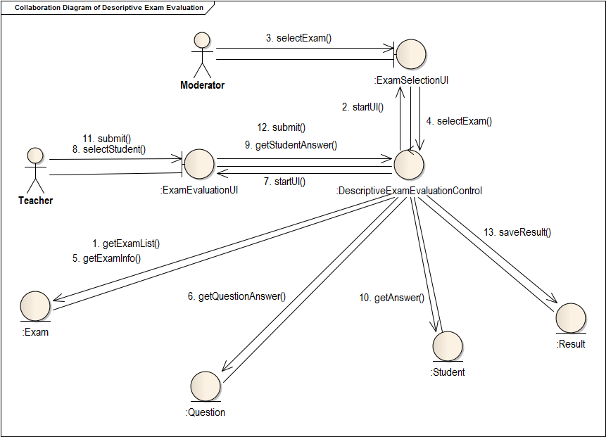

Class Diagram for use case ” Descriptive Exam Evaluation”

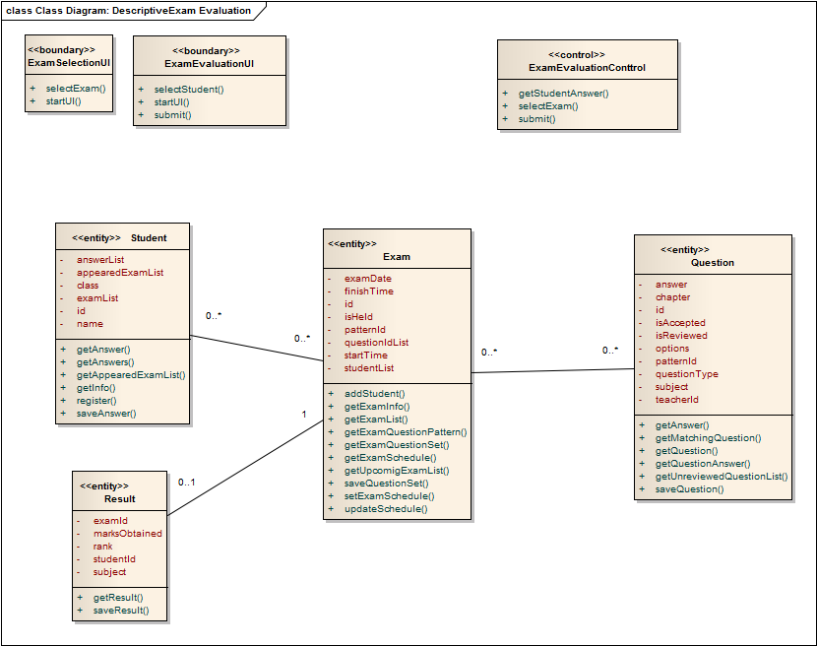

“Ask For scrutiny” use case

Collaboration Diagram for use case ”Ask for scrutiny”

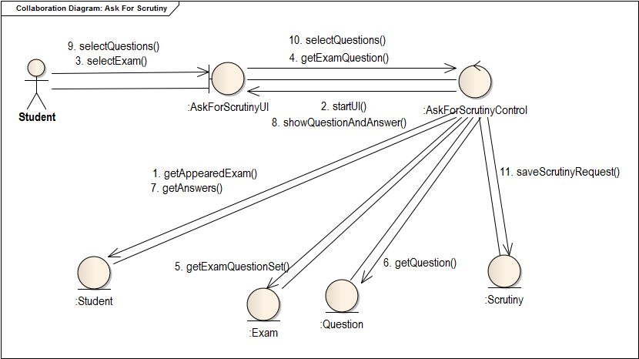

Class Diagram for use case ” Ask for scrutiny”

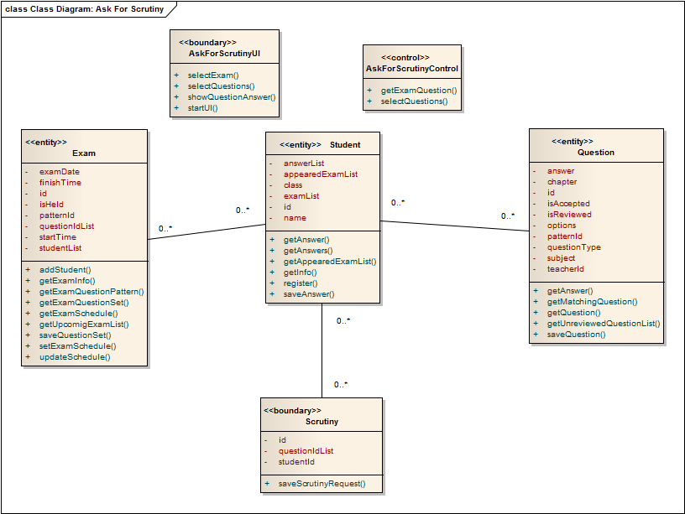

“Scrutiny” use case

Collaboration Diagram for use case “Scrutiny”

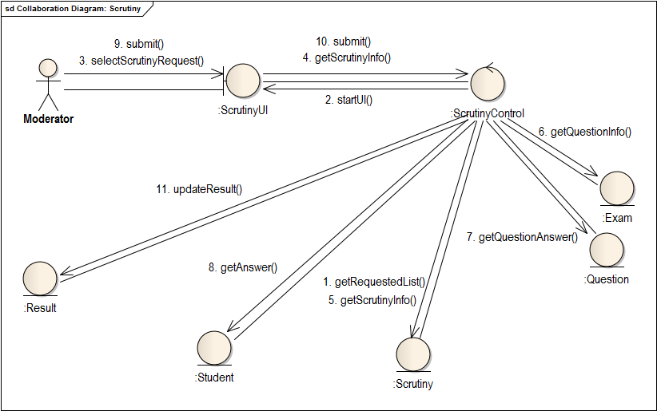

Class Diagram for use case ” Scrutiny”

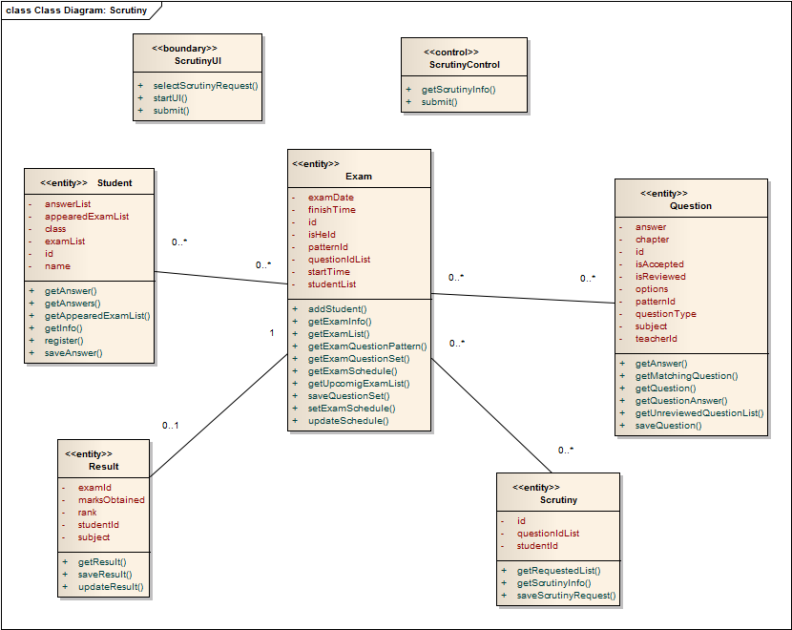

“View Result” use case

Collaboration Diagram for use case ”View Result”

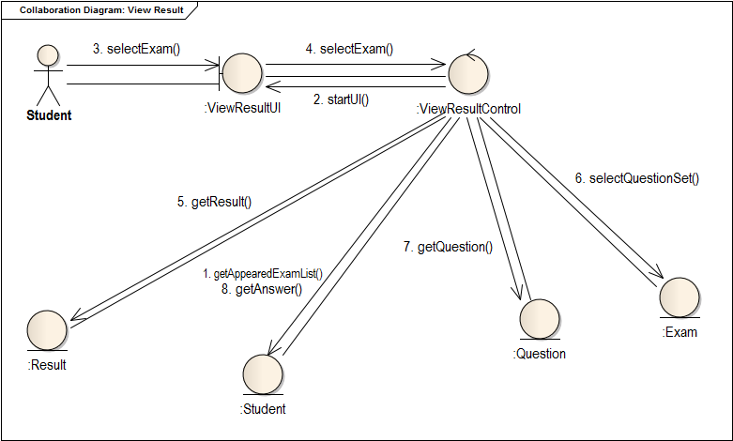

Class Diagram for use case ” View Result”

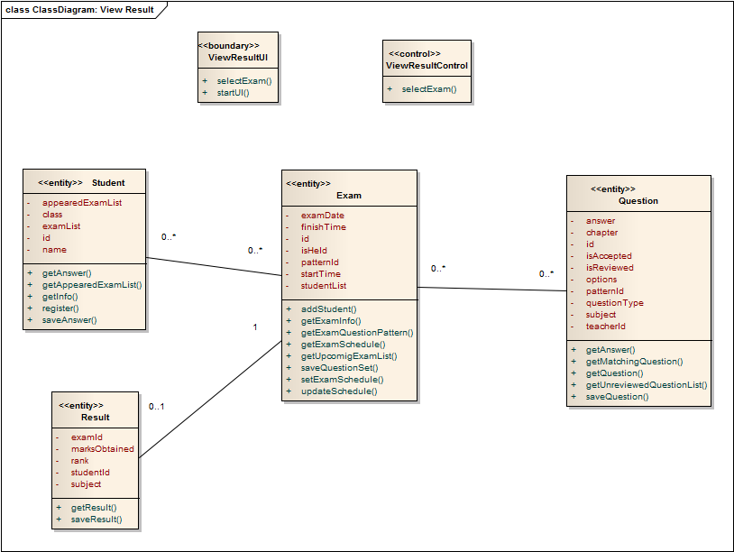

2. REGISTRATION SUB SYSTEM

“Assign moderator” use case

Collaboration Diagram for use case ”Assign Moderator”

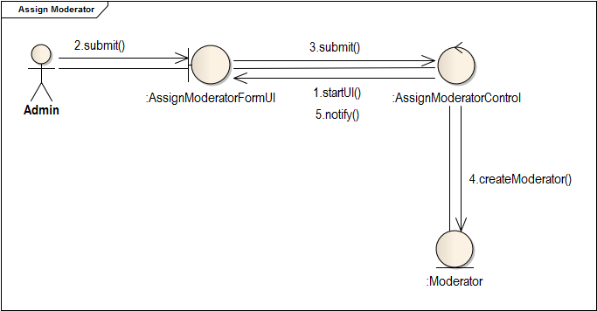

Class Diagram for use case ” Assign Moderator”

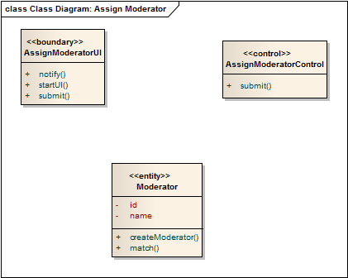

“Fill Student Form” use case

Collaboration Diagram for use case ” Fill Student Form”

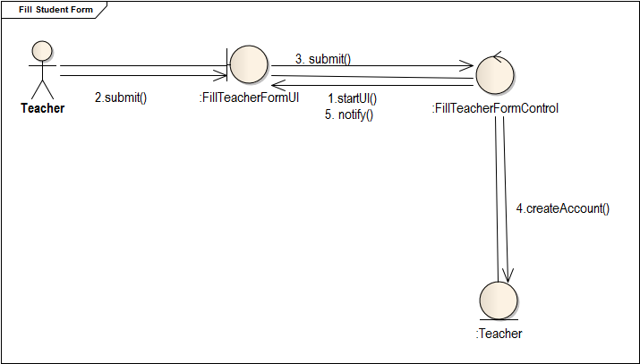

Class Diagram for use case ” Fill Student Form”

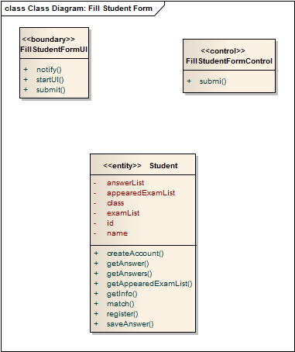

“Fill Teacher Form” use case

Collaboration Diagram for use case ” Fill Teacher Form”

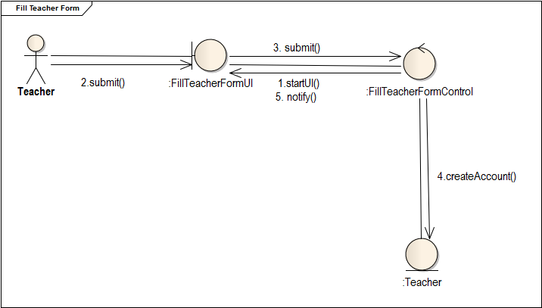

Class Diagram for use case ” Fill Teacher Form”

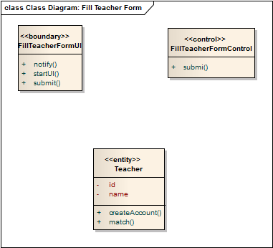

“Sign In” use case

Collaboration Diagram for use case ” Sign In”

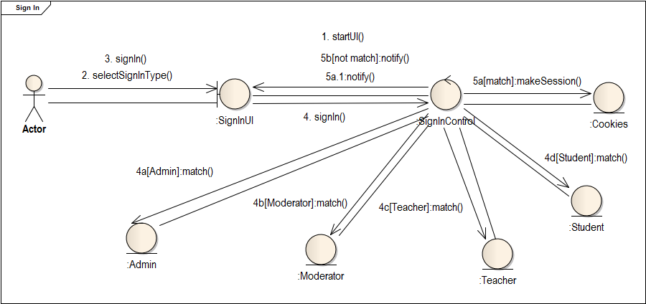

Class Diagram for use case ” Sign In”

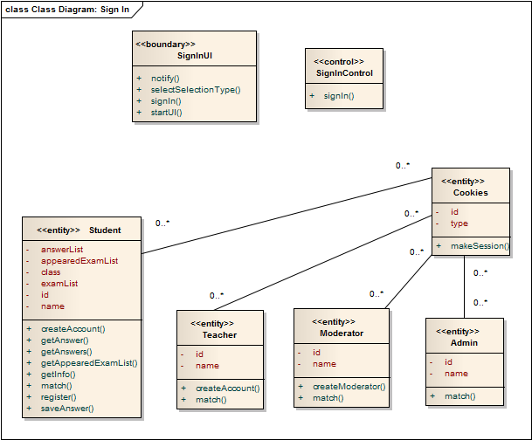

“Sign Out” use case

Collaboration Diagram for use case ” Sign Out”

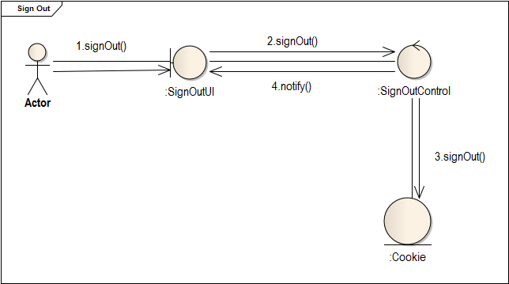

Class Diagram for use case ” Sign Out”

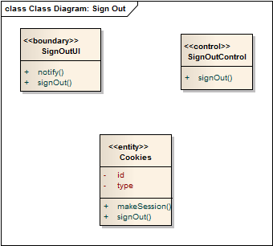

“Verify Teacher” use case

Collaboration Diagram for use case ” Verify Teacher”

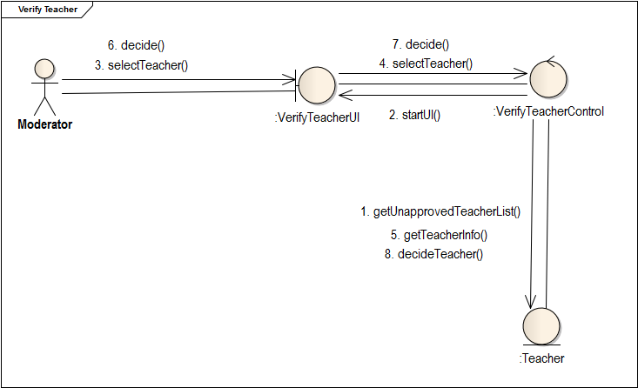

Class Diagram for use case ” Verify Teacher”

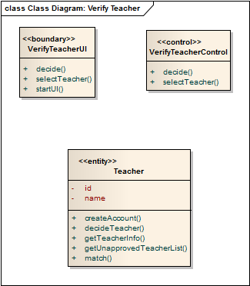

3. INFORMATION SUBSYSTEM

“View Public Profile” use case

Collaboration Diagram for use case ” View Public Profile”

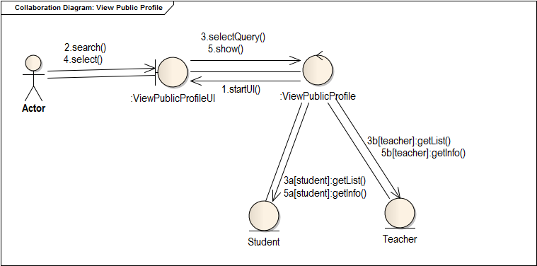

Class Diagram for use case “View Public Profile”

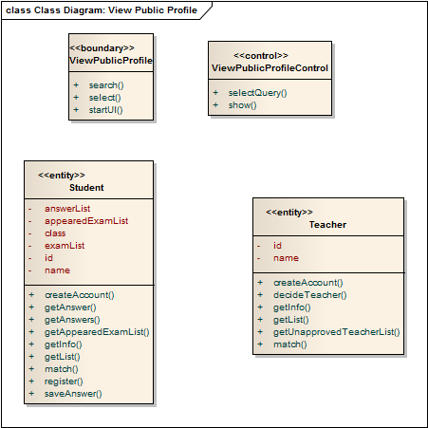

“Talk to us” use case

Collaboration Diagram for use case ” Talk to us”

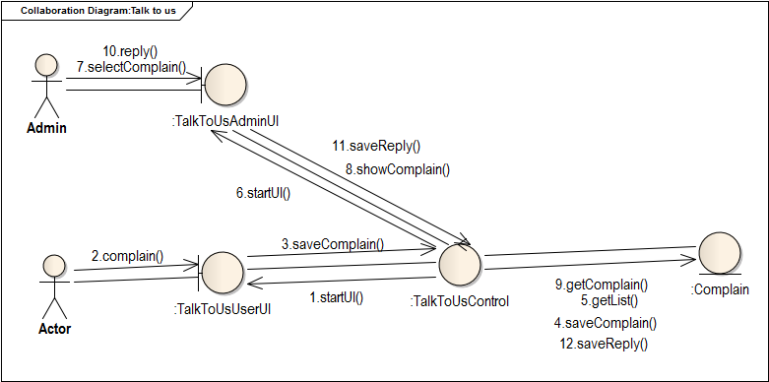

Class Diagram for use case “Talk to us”

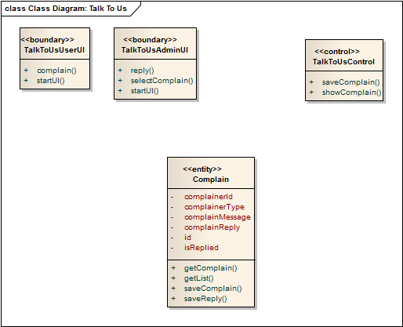

“View and edit own profile” use case

Collaboration Diagram for use case ” View and edit own profile”

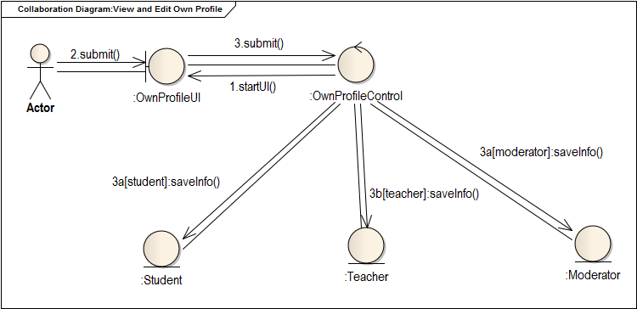

Class Diagram for use case ” View and edit own profile”

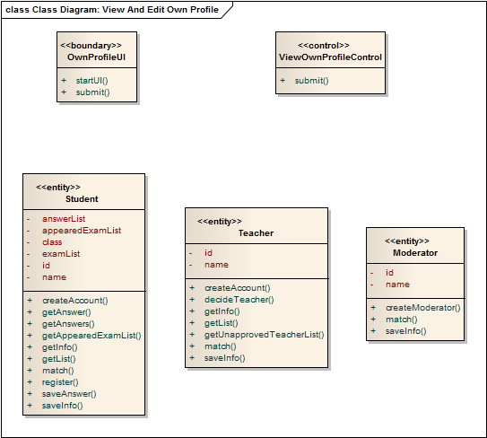

“View Statistics” use case

Collaboration Diagram for use case “View Statistics”

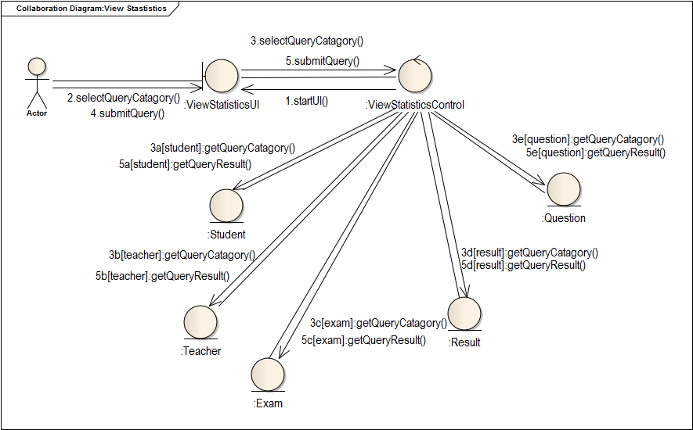

Class Diagram for use case ” View Statistics”

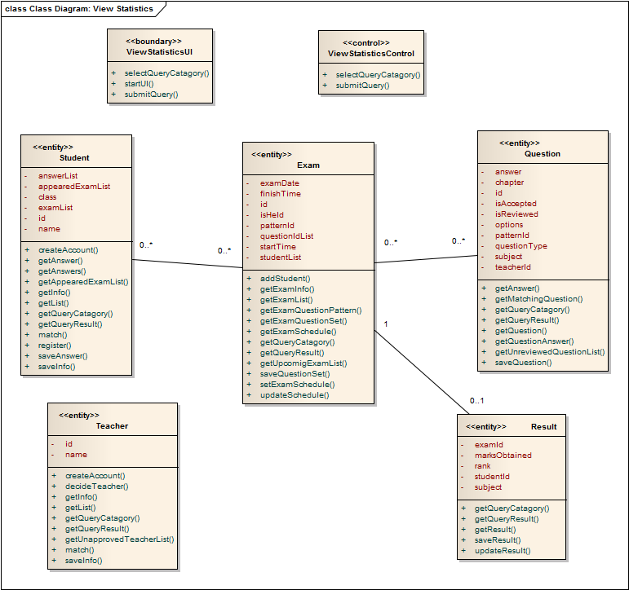

4. FORUM SUB SYSTEM

“Ask A Question” use case

Collaboration Diagram for use case “Ask A Question”

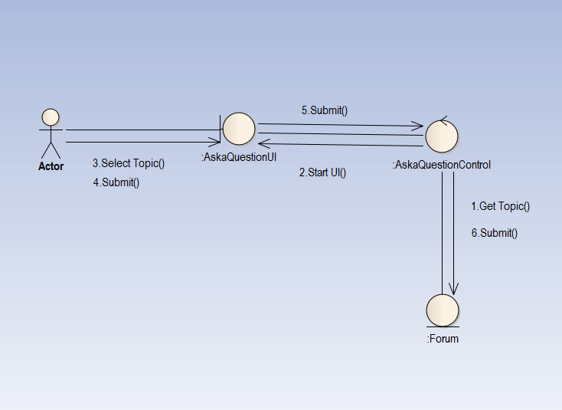

Class Diagram for use case “Answer A Question”

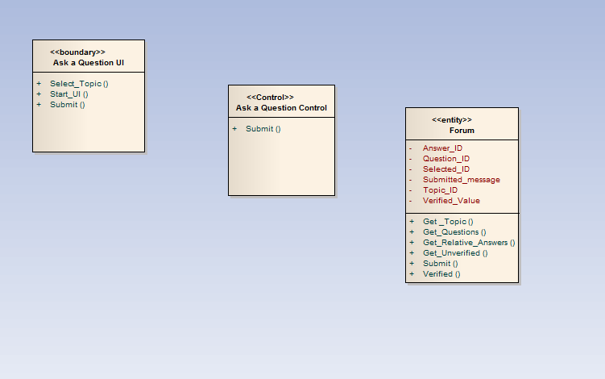

“Answer A Question” use case

Collaboration Diagram for use case “Answer A Question”

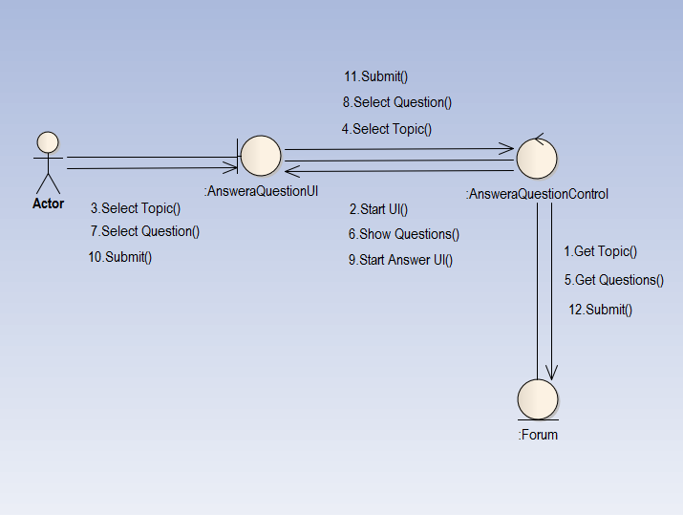

Class Diagram for use case “Answer A Question”

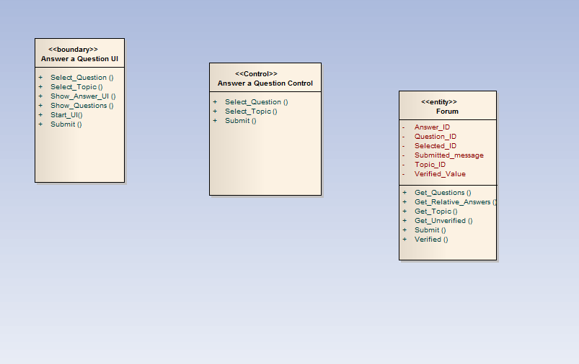

“Comment” use case

Collaboration Diagram for use case “comment”

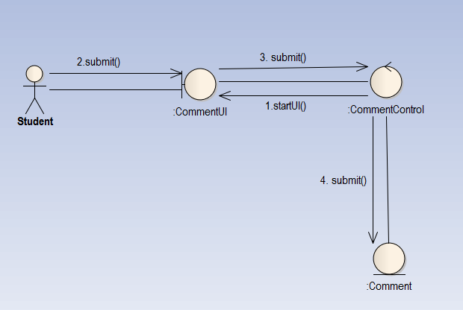

Class Diagram for use case “Comment ”

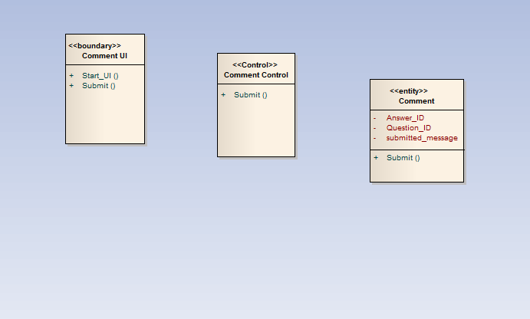

“Rate” use case

Collaboration Diagram for use case “rate”

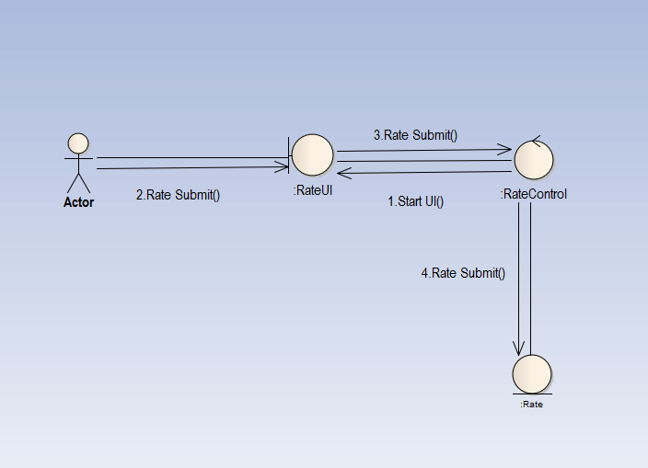

Class Diagram for use case “Rate ”

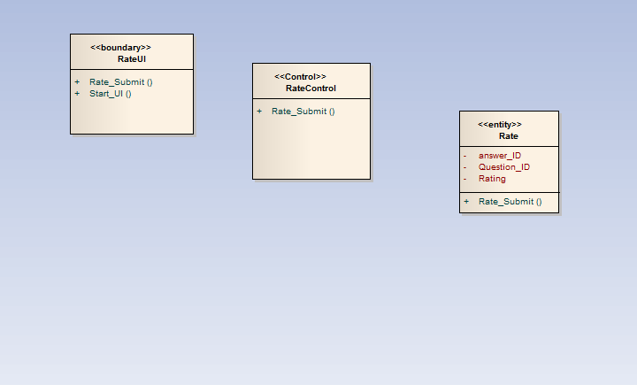

“Verify” use case

Collaboration Diagram for use case “Verify”

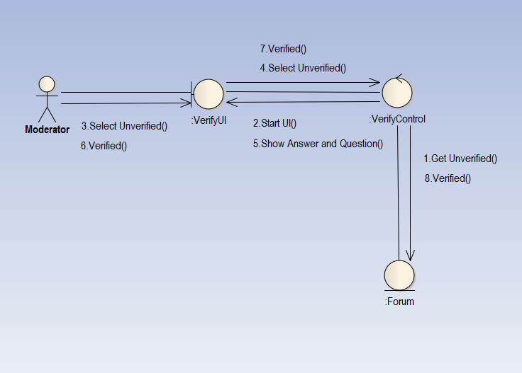

Class Diagram for use case “Verify ”

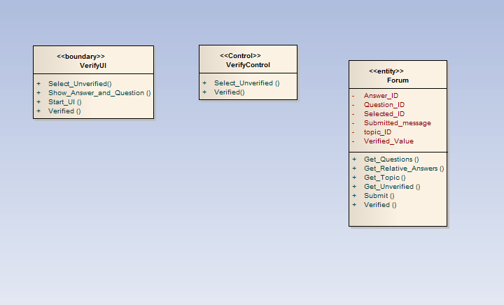

“View Question and Answer” use case

Collaboration Diagram for use case “View Question and Answer”

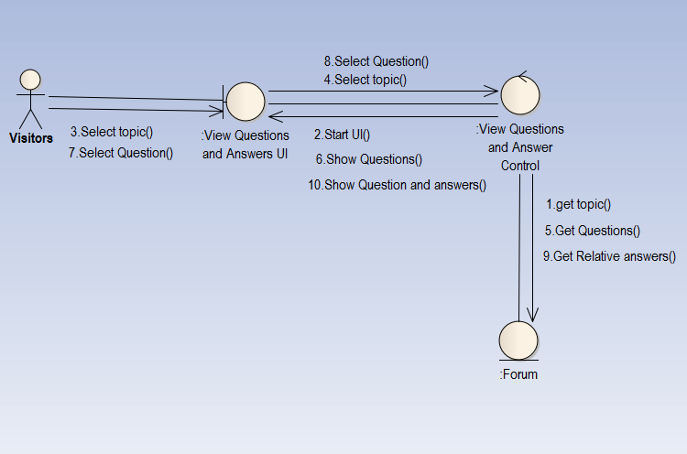

Class Diagram for use case “View Question and Answer ”

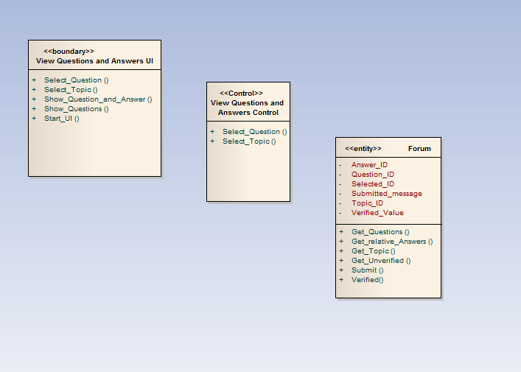

5.DIGITAL CLASSROOM

“Provide material” use case

Collaboration Diagram for use case “Provide material”

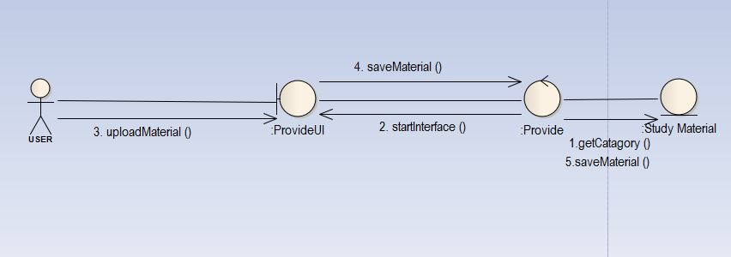

Class Diagram for use case “Provide material”

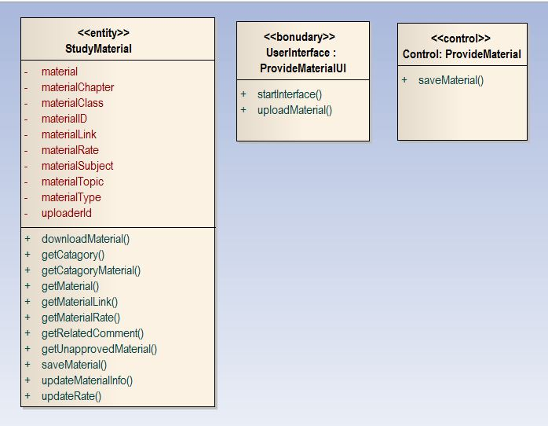

“Approve material” use case

Collaboration Diagram for use case “Approve material”

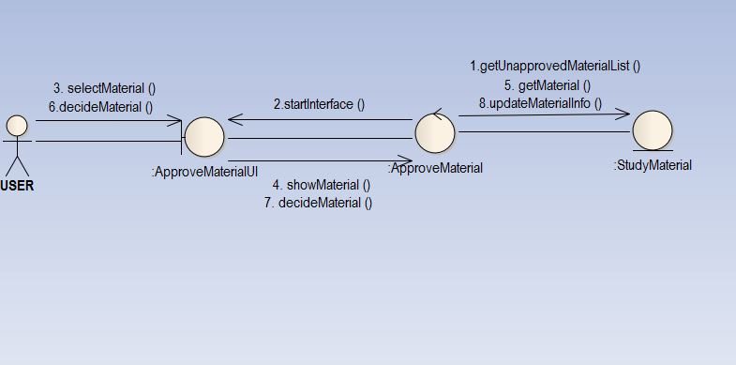

Class Diagram for use case “Approve material”

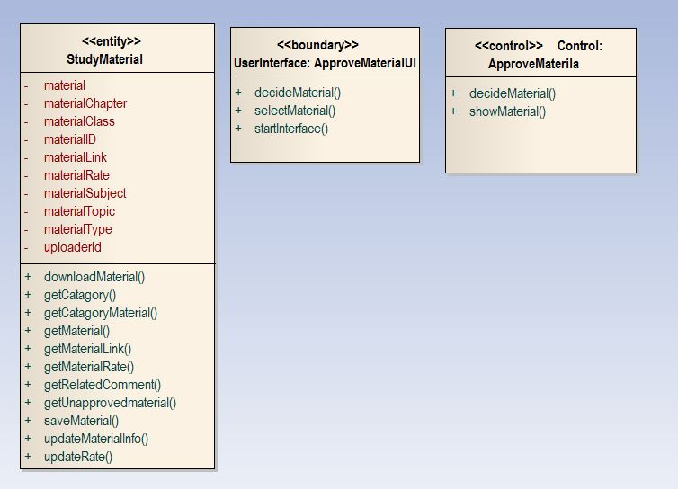

“View material” use case

Collaboration Diagram for use case “View material”

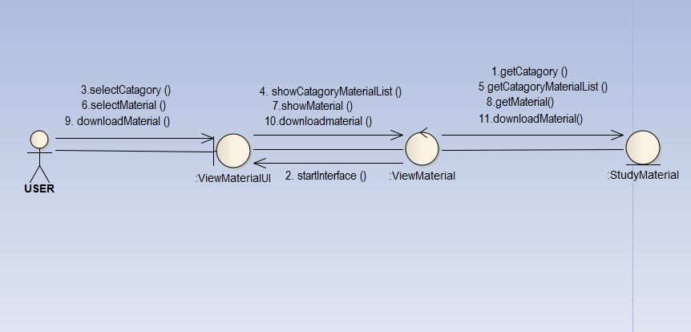

Class Diagram for use case “View material”

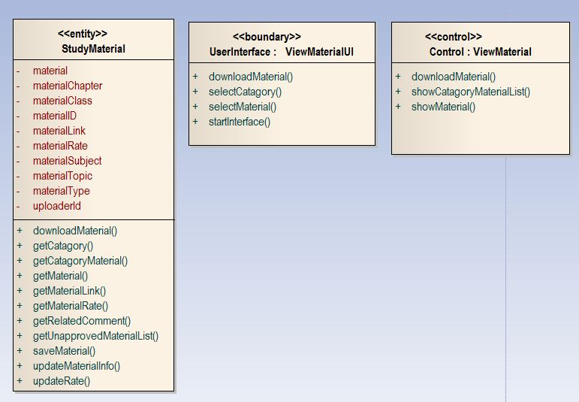

“Comment” use case

Collaboration Diagram for use case “Comment”

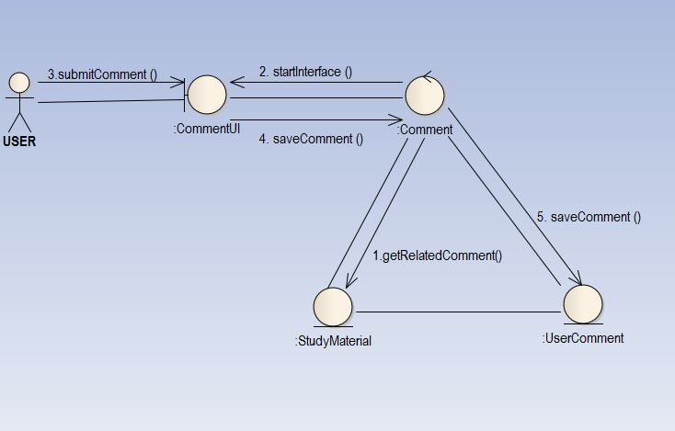

Class Diagram for use case “Comment”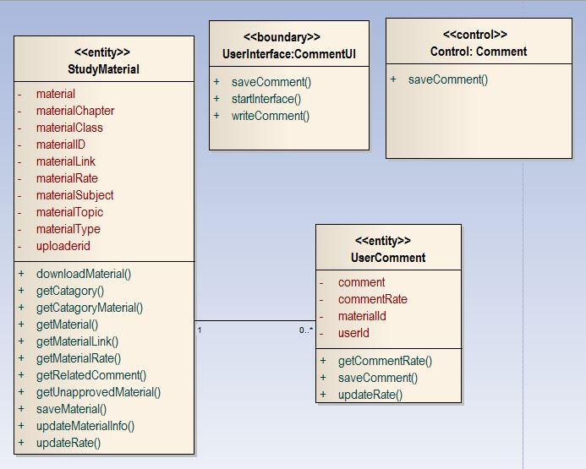

“Rate” use case

Collaboration Diagram for use case “Rate”

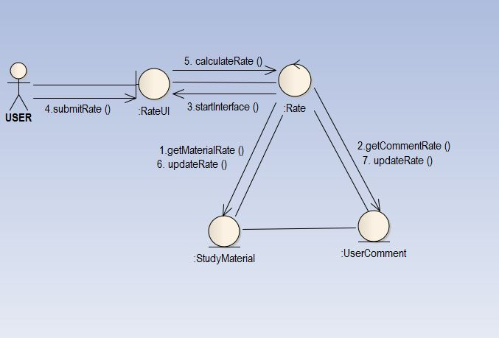

Class Diagram for use case “Rate”

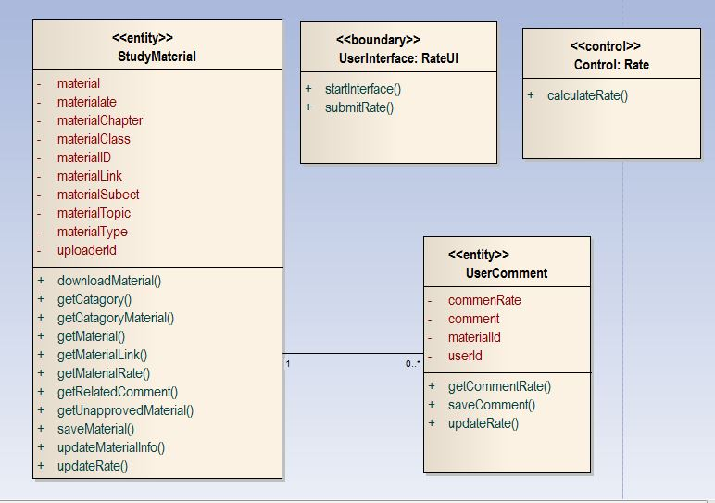

………THE END………