**E-Learning System**

CSE 308: Software Engineering and Information System Design (ER-Diagram, Triggers, Procedures)

**Group no. : 06**

**1005062**

**1005065**

**1005071**

**1005072**

**1005074**

SUB SYSTEMS

1. Exam Subsystem
   1. Schedule Management Sub subsystem
   2. Question Management Sub subsystem
   3. Marks Management Sub subsystem
2. Registration Subsystem
3. Information Management Subsystem
4. Virtual Classroom Subsystem
5. Forum Subsystem

**1.ERD of the entire system**

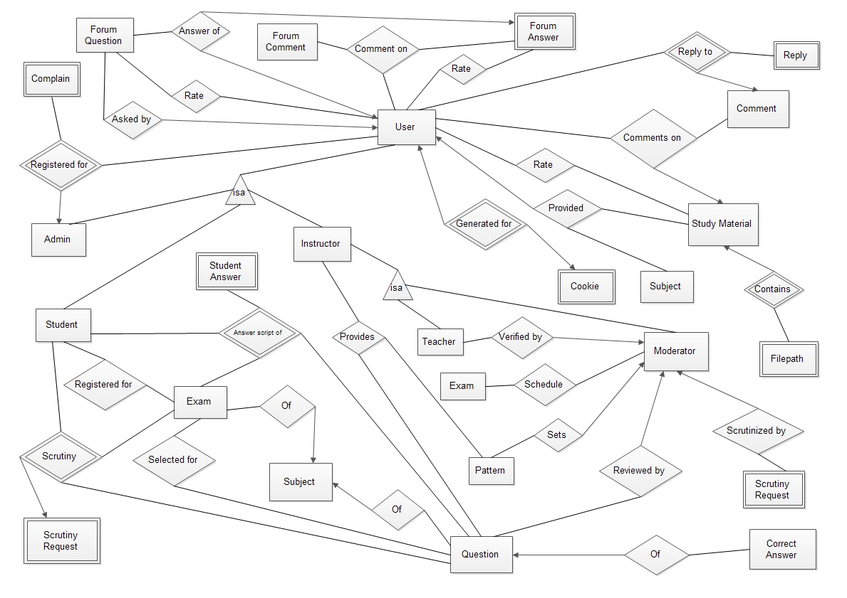

**1.1 ERD of the USER part**

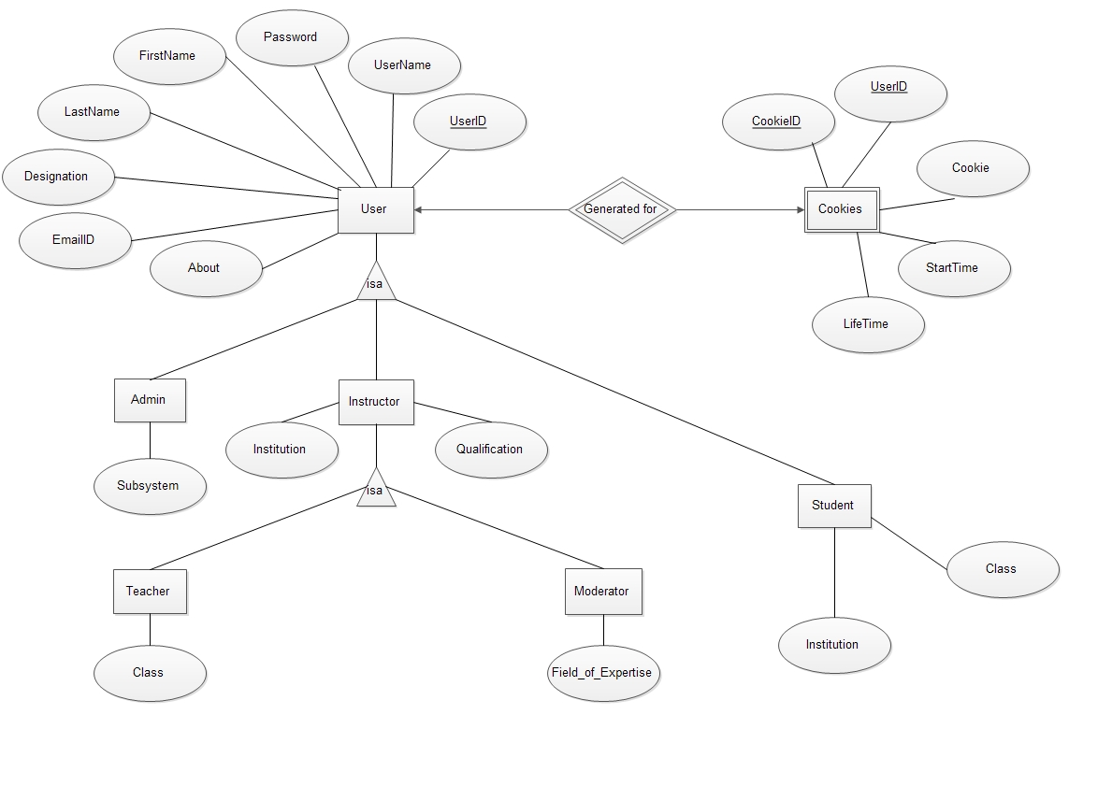

**1.2 Schedule, Pattern and Exam portion of ERD**

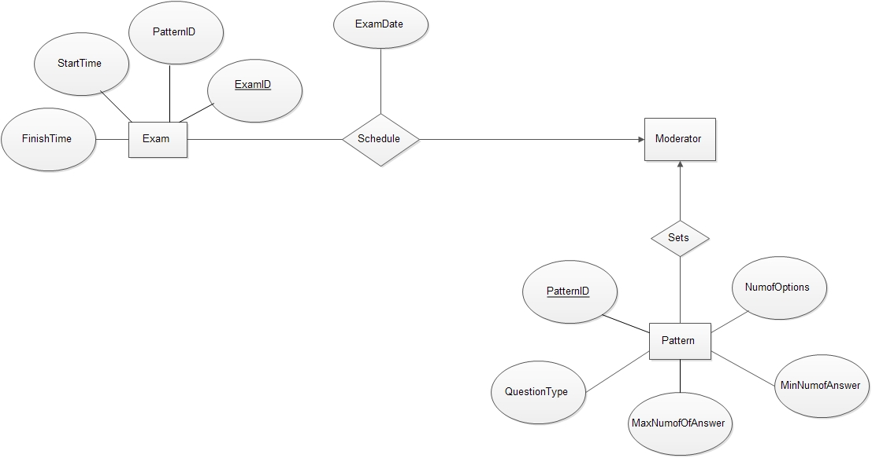

**1.3 Exam and Question part of ERD**

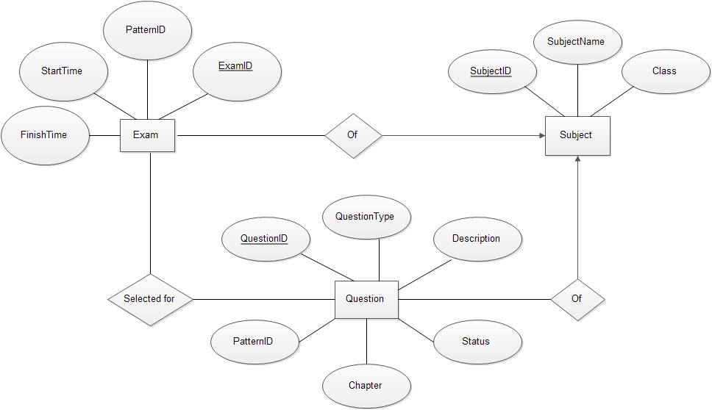

**1.4 Result, Exam and Scrutiny part of the ERD**

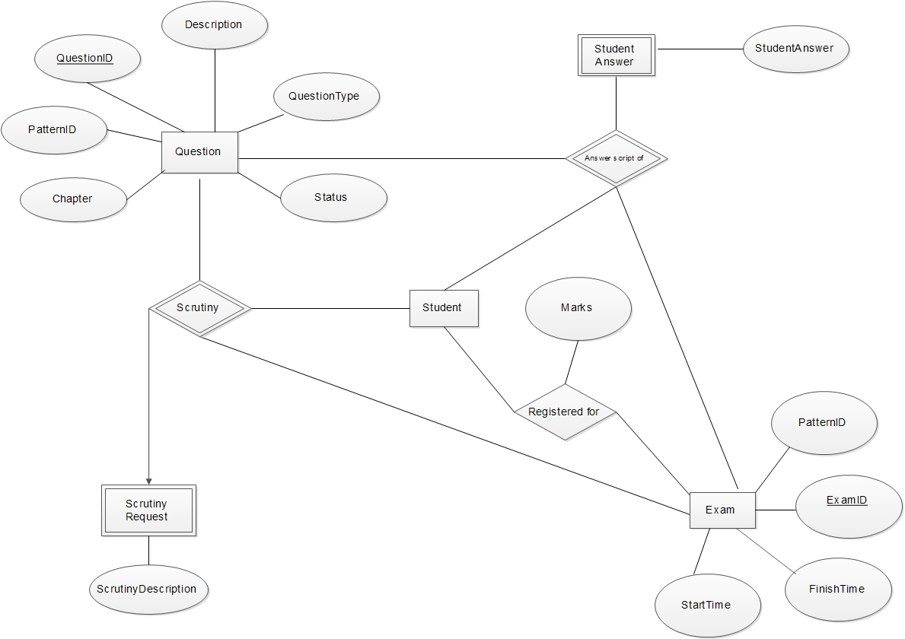

**1.5 Moderator, Teacher and Scrutiny part of ERD**

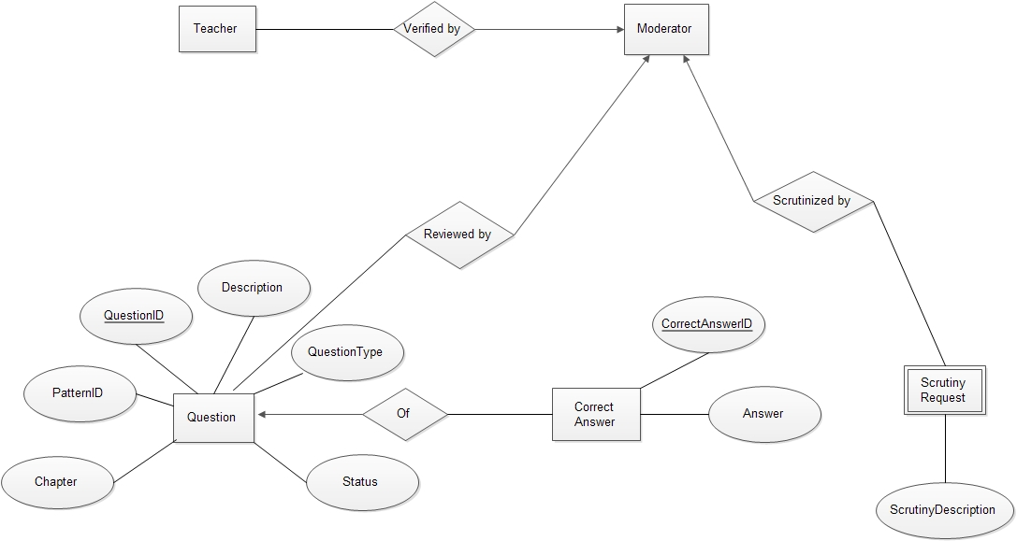

**1.6 Study Material part of the ERD**

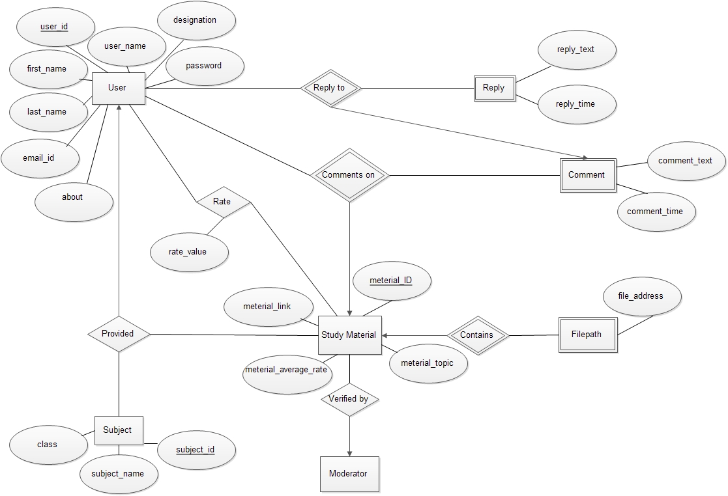

**1.7 Forum part of the ERD**

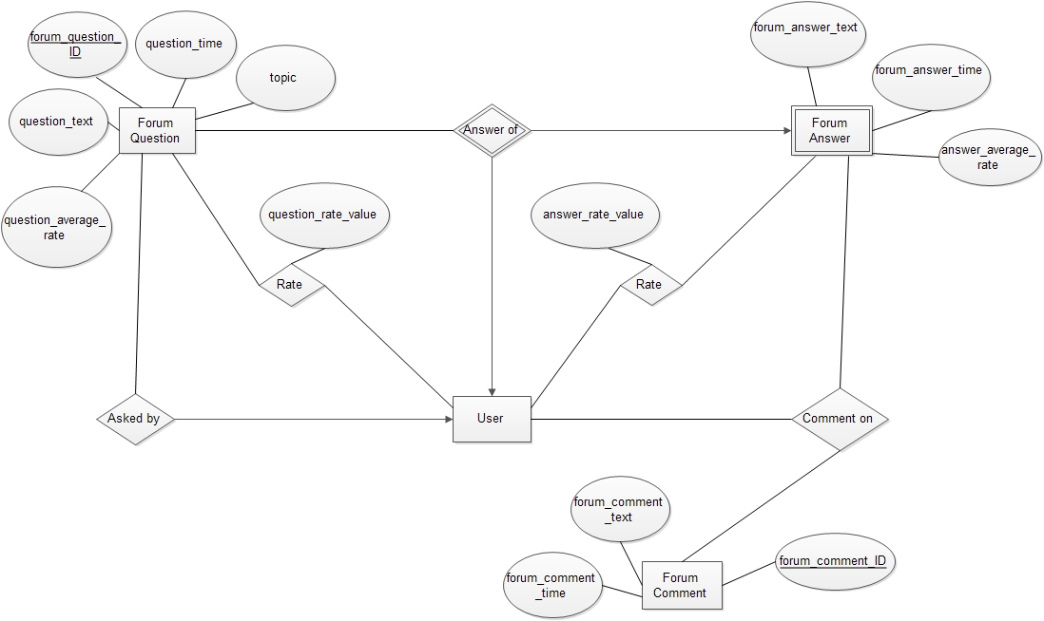

**1.8 Complain and Talk to Us**

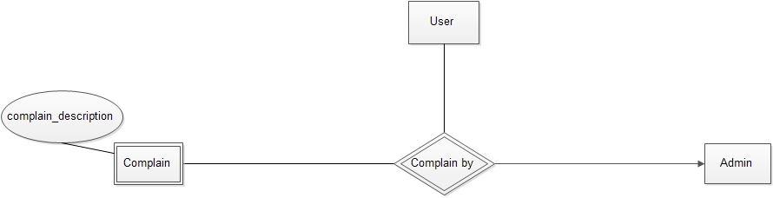

**2. Tables**

**2.1 User**

|  |  |
| --- | --- |
| Table: Exam | |
| Attribute’s name | Datatype |
| **User_ID** | Varchar2(20) |
| User_name | Varchar2(50) |
| First_Name | Varchar2(50) |
| Last_Name | Varchar2(50) |
| Password | Varchar2(20) |
| Designation | Varchar2(20) |
| EmailID | Varchar2(50) |
| About | Varchar2(1000) |
| Institution | Varchar2(20) |
| Class | Number |
| Qualification | Varchar2(20) |
| Subsystem | Varchar2(20) |

**2.2 Exam**

|  |  |
| --- | --- |
| Table: Exam | |
| Attribute’s name | Datatype |
| **Exam_ID** | Varchar2(20) |
| Pattern_ID | Varchar2(20) |
| Start_Time | date |
| Finish_Time | date |

**2.3 Pattern**

|  |  |
| --- | --- |
| Table: Pattern | |
| Attribute’s name | Datatype |
| **Pattern_ID** | Varchar2(20) |
| Question_Type | Varchar2(20) |
| Num_of_Options | Number |
| Max_Num_of_Options | Number |
| Min_Num_of_Options | Number |

**2.4 Subject**

|  |  |
| --- | --- |
| Table: Subject | |
| Attribute’s name | Datatype |
| **Subject_ID** | Varchar2(20) |
| Subject_name | Varchar2(20) |
| Class | Number |

**2.5 Question**

|  |  |
| --- | --- |
| Table: Question | |
| Attribute’s name | Datatype |
| **Question_ID** | Varchar2(20) |
| Pattern_ID | Varchar2(20) |
| Question_Type | Varchar2(20) |
| Description | Varchar2(1000) |
| Chapter | Number |
| Status | Varchar(5) |

**2.6 Forum Question**

|  |  |
| --- | --- |
| Table: Forum Question | |
| Attribute’s name | Datatype |
| **Forum_question_ID** | Varchar2(20) |
| Question_time | Date |
| Topic | Varchar2(10) |
| Question_text | Varchar2(500) |
| Question_average_rate | Number(2) |
| Question_user_ID | Varchar2(20) |

**2.7 Question Rate**

|  |  |
| --- | --- |
| **Table: Question_Rate** | |
| Attribute’s name | Datatype |
| **Forum_question_ID** | Varchar2(20) |
| **User_ID** | Varchar2(20) |
| Question_rate_value | Number(2) |

**2.8 Answer Rate**

|  |  |
| --- | --- |
| Table: Answer_Rate | |
| Attribute’s name | Datatype |
| **Forum_answer_ID** | Varchar2(20) |
| **User_ID** | Varchar2(20) |
| answer_rate_value | Number(2) |

**2.9 Forum Answer**

|  |  |
| --- | --- |
| Table: Forum_Answer | |
| Attribute’s name | Datatype |
| **Forum_question_ID** | Varchar2(20) |
| **User_ID** | Varchar2(20) |
| Forum_answer_text | Varchar2(500) |
| Forum_answer_time | Date |
| Answer_average_rate | Number(2) |

**2.10 Forum Comment**

|  |  |
| --- | --- |
| Table: Forum_comment | |
| Attribute’s name | Datatype |
| **Forum_comment_ID** | Varchar2(20) |
| Forum_comment_text | Varchar2(100) |
| Forum_comment_time | Date |

**2.11 Comment On**

|  |  |
| --- | --- |
| Table: Comment_on | |
| Attribute’s name | Datatype |
| **Forum_question_ID** | Varchar2(20) |
| **Comment_user_ID** | Varchar2(20) |
| **Answer_user_ID** | Varchar2(20) |

**3.Triggers**

|  |  |  |  |  |
| --- | --- | --- | --- | --- |
| Trigger Name | | MCQ Exam Evaluation | | |
| Time of Execution | | After inserting all the mcq answers in the students’ answer table. | | |
| Actions | | | | Remark |
| Commands | Attributes | | Tables |
| INSERT | Marks | | Result | Automated trigger to insert the result of a student of a particular exam that he/she registered. |
| Trigger Name | | **Last Visit** | | |
| Time of Execution | | After a user logs out. | | |
| Actions | | | | Remark |
| Commands | Attributes | | Tables |
| UPDATE | Last_Visit_Time | | User | Keeps record of the time of a particular user’s last visit in the system. |

|  |  |  |  |  |
| --- | --- | --- | --- | --- |
| Trigger Name | | **RateCalculation** | | |
| Time of Execution | | After inserting rate of a material. | | |
| Actions | | | | Remark |
| Commands | Attributes | | Tables |
| UPDATE | AverageRate,  TotalUser | | Studymaterial | When a user rates a material , overall rate of the material will be updated according to total rate and user number |
| Trigger Name | | **Update Result** | | |
| Time of Execution | | When an answer of question table is changed | | |
| Actions | | | | Remark |
| Commands | Attributes | | Tables |
| UPDATE | mark | | result | When a moderator changes a wrong answer(if any) all the result of the exams including that question will be updated. |

**4. Procedures**

|  |  |  |
| --- | --- | --- |
| **Procedure Name** | **Cookie Generation** | |
| Time of Execution | When a user logs in. | |
| Input | UserID, UserPassword. | |
| Output | Cookie to the browser. | |
| Apply On | Cookies | |
|  | | |
| **Actions** | | **Remarks** |
| INSERT into COOKIES values(cookie, userID, time) | | When a user tries to log into the system at first the system search for a match of use id and user password as provided by the user in the user table. If a valid account is found then a cookie is generated and saved in the cookies table. Also a corresponding cookie is sent to the user’s browser. |

|  |  |  |
| --- | --- | --- |
| **Procedure Name** | **User Registration** | |
| Time of Execution | When a user signs up in the system. | |
| Input | FirstName, LastName, UserID, Password, email, contact | |
| Output | Success message to the user. | |
| Apply On | User | |
|  | | |
| **Actions** | | **Remarks** |
| INSERT into USER values(UserID,, Pasword, FirstName,LastName, email, contact) | | At the time of registration a user provides his information regarding his name and contact and choose password and userid for logging in. Then his information are stored in the USER table of the system database to pull necessary data later on. |

|  |  |  |
| --- | --- | --- |
| **Procedure Name** | **Storing Question** | |
| Time of Execution | When an Instructor category user submits question. | |
| Input | Question, PatternID, Chapter, Type | |
| Output | none | |
| Apply On | Question | |
|  | | |
| **Actions** | | **Remarks** |
| INSERT into Question values(QuestionID, Description, PatternID, Chapter, Type) | | After a moderator or a teacher submits a question, the necessary information are passed to the system and an entry is created in the Question table. |

|  |  |  |
| --- | --- | --- |
| **Procedure Name** | **Select Question** | |
| Time of Execution | Moderator select question for an exam | |
| Input | Pattern id, Questionid, eid | |
| Output | none | |
| Apply On | Selectedfor table | |
|  | | |
| **Actions** | | **Remarks** |
| Insert into Selectedfor values(Questionid)  Insert into Exam values(patternid) where examid=eid | | When a moderator selects a question changes occur in selectedfor table and in exam table patternid will be set. |

**……………. The End …………....**