**E-Learning System**

CSE 308: Software Engineering and Information System Design (Graphical User Interface design)

**Group no. : 06**

**1005062**

**1005065**

**1005071**

**1005072**

**1005074**

SUB SYSTEMS

1. Exam Subsystem
   1. Schedule Management Sub subsystem
   2. Question Management Sub subsystem
   3. Marks Management Sub subsystem
2. Registration Subsystem
3. Information Management Subsystem
4. Virtual Classroom Subsystem

**1. Exam**

When a moderator sets schedule

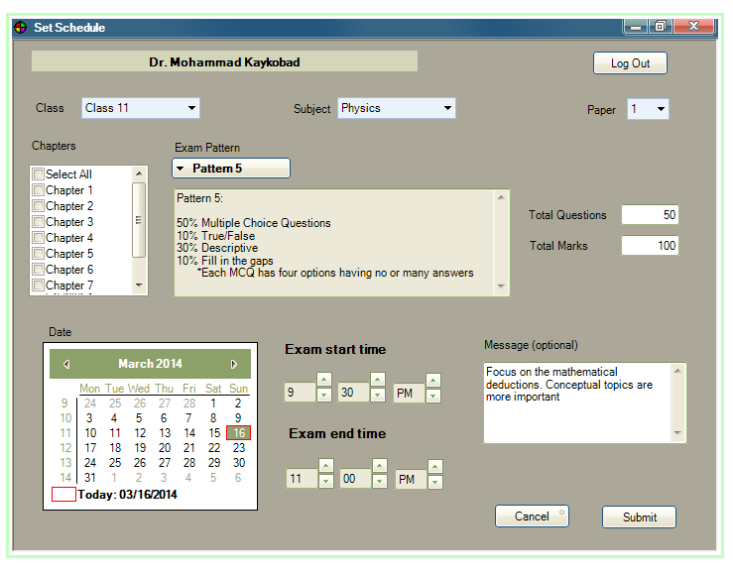

When a teacher sets a Question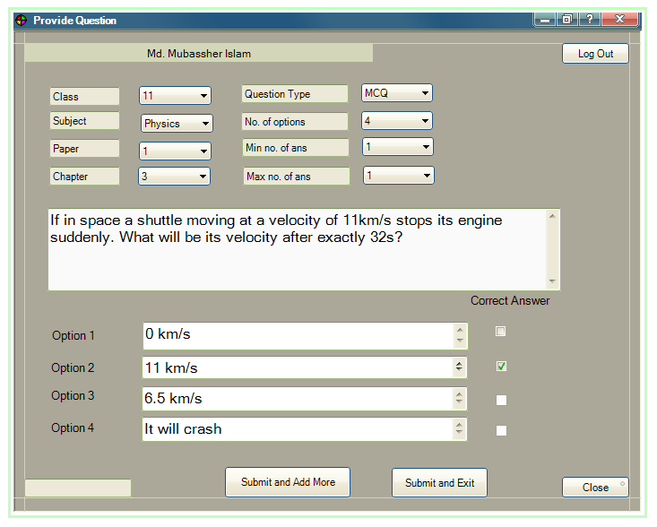

When a teacher sets a Descriptive Question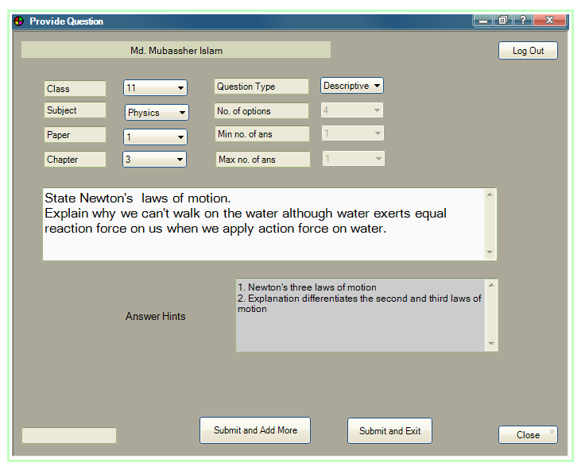

When a student views schedule (not logged in) 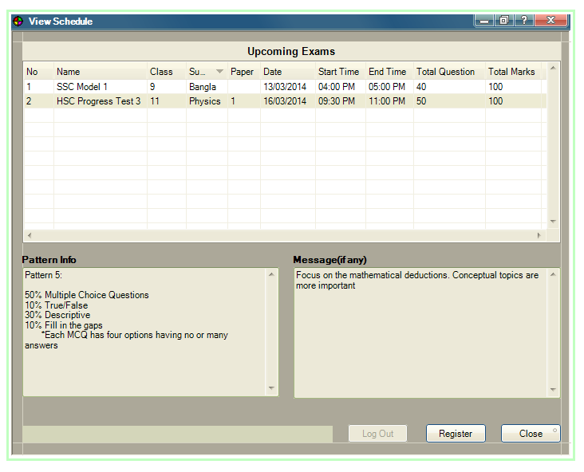

When a student views schedule (logged in) 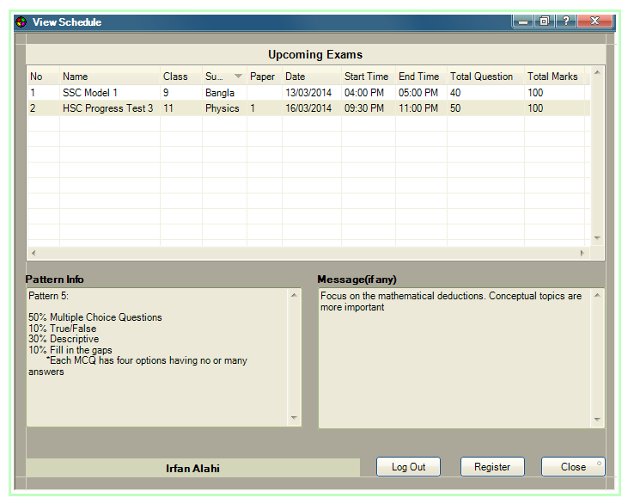

When a student registers for an Exam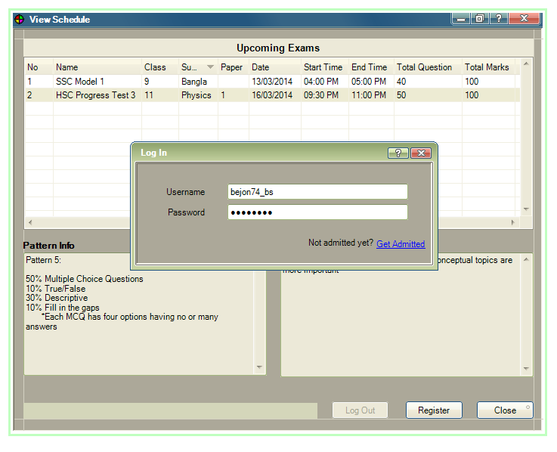

When a student appears in an Exam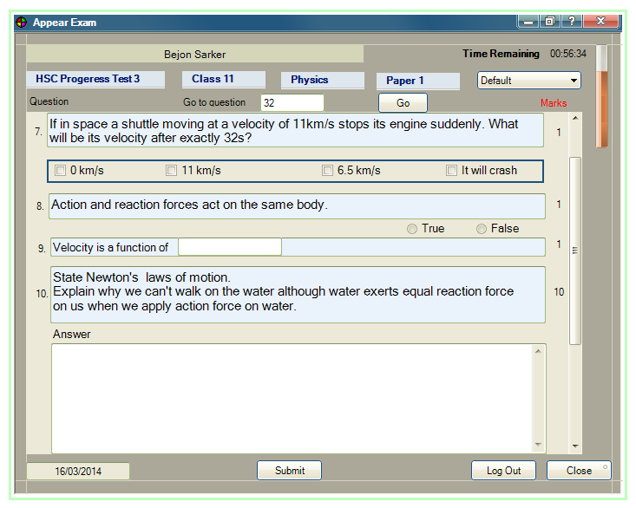

When a student views a Result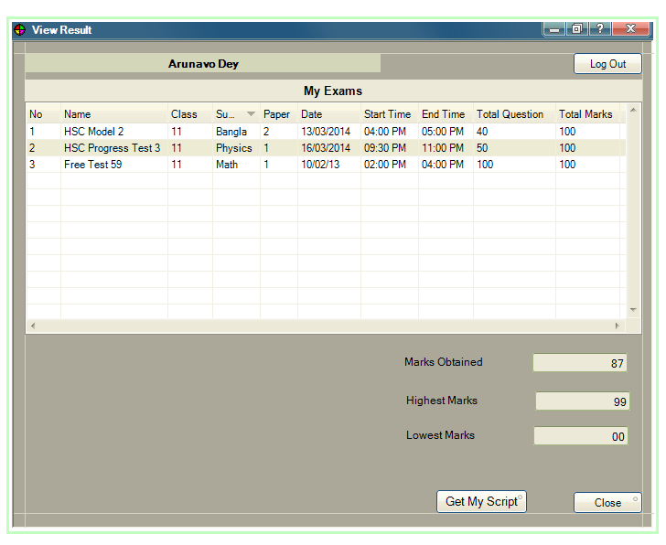

**2. Registration**

When a student signs up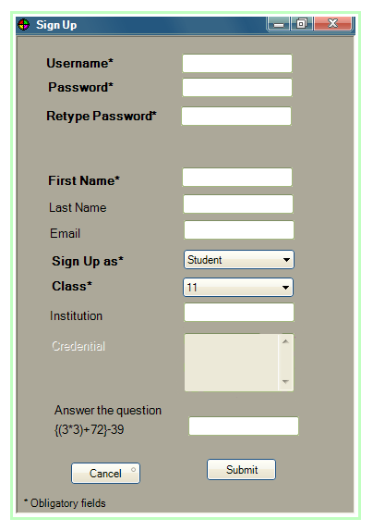

When a teacher signs up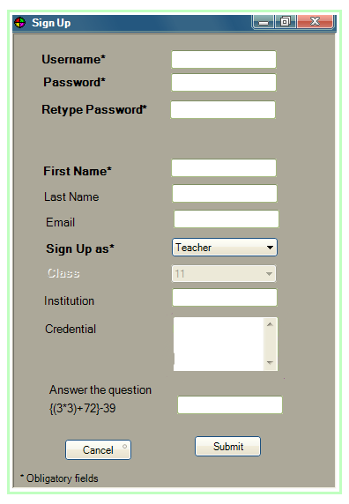

When a moderator verifies a teacher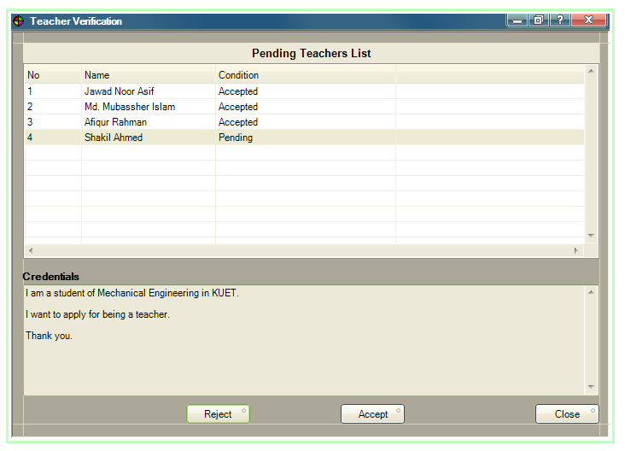

**3. Information**

User Profile : Student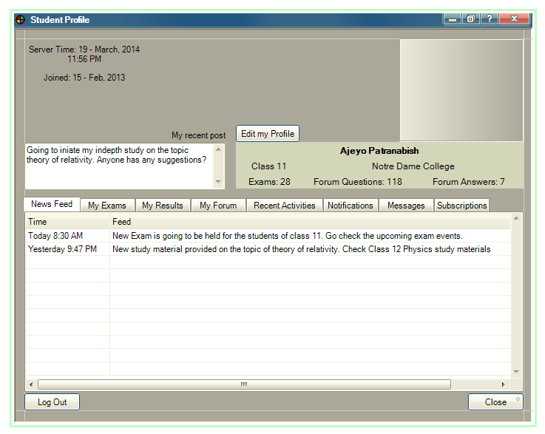

User Profile : Teacher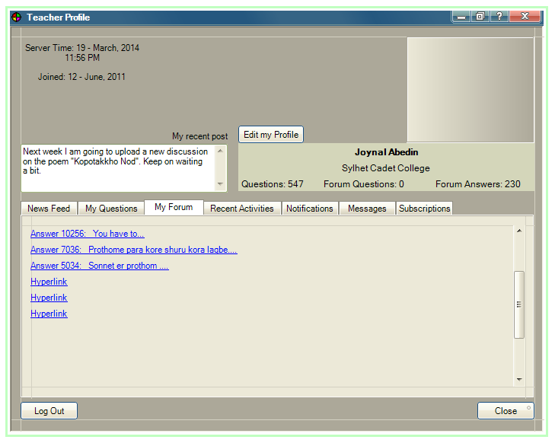

User Profile : Moderator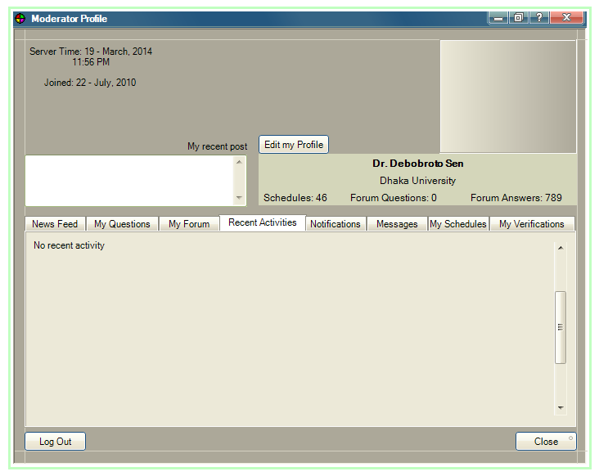

**4. Virtual ClassRoom**

**View For All Users**

**When an user enters**

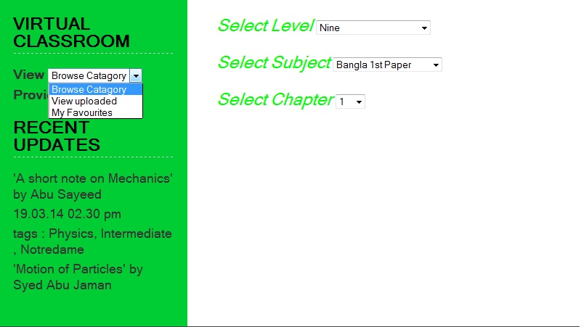

**When an user selects**

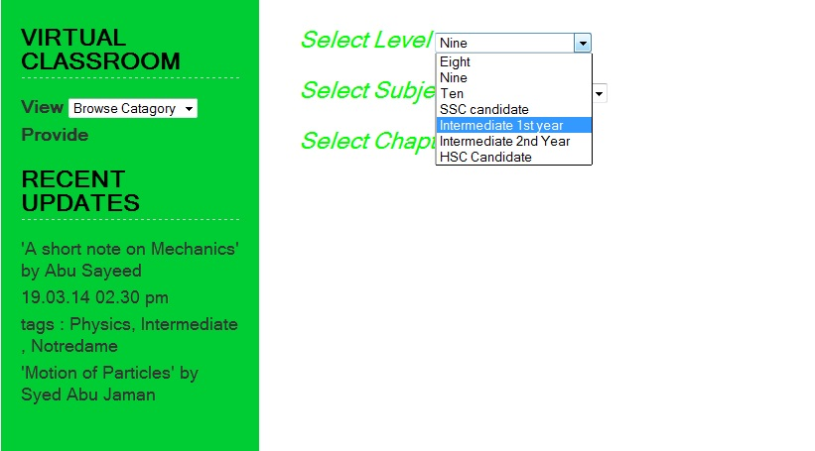

**When an user selects**

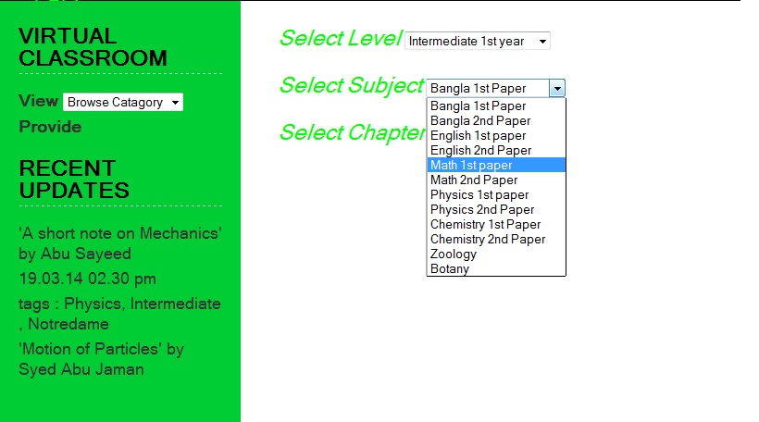

**When an user selects**

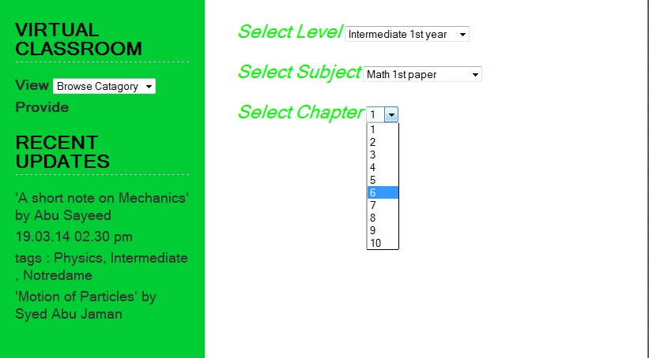

**When an user selects**

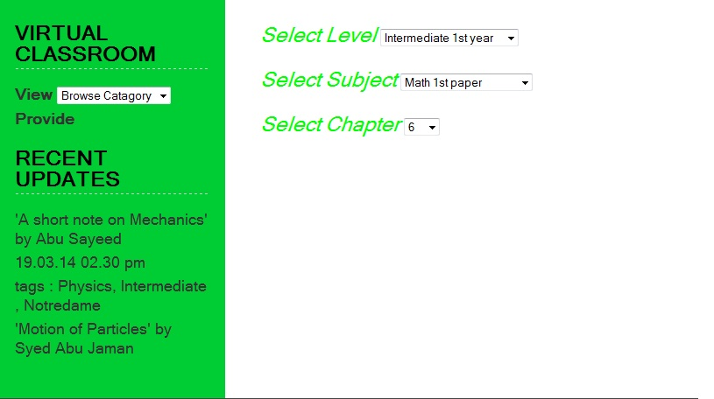

**What an user sees**

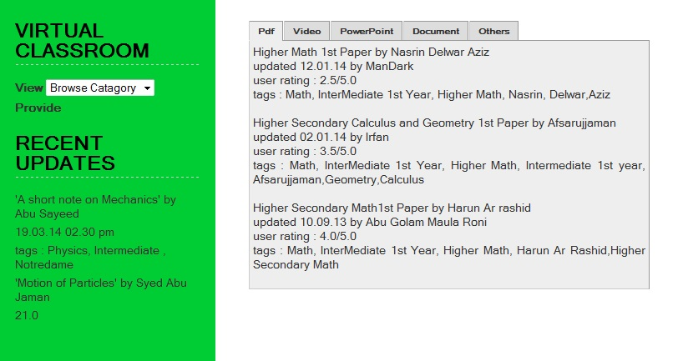

**Provide is only For Registered Users**

**In Case of Provide**

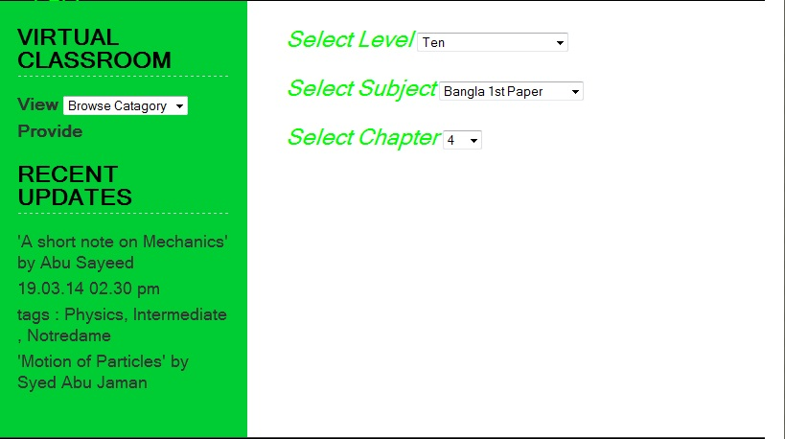

**An user enters Data**

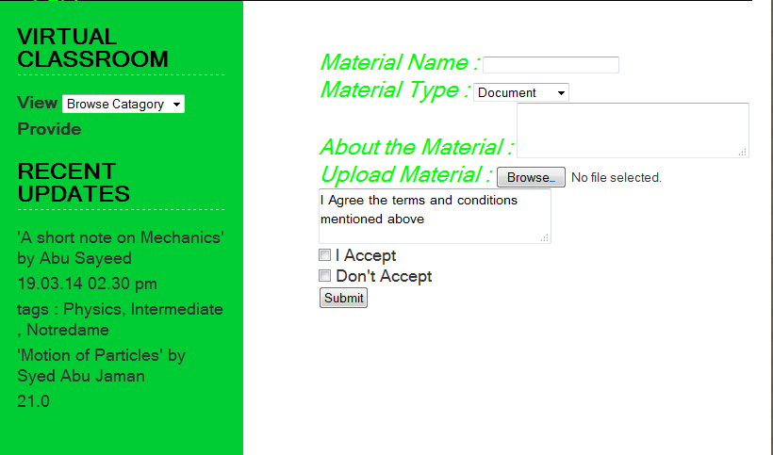

**An user enters Data**

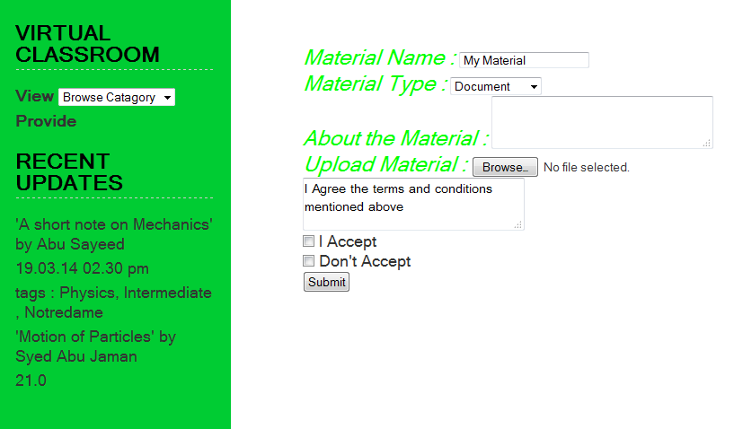

**An user enters Data**

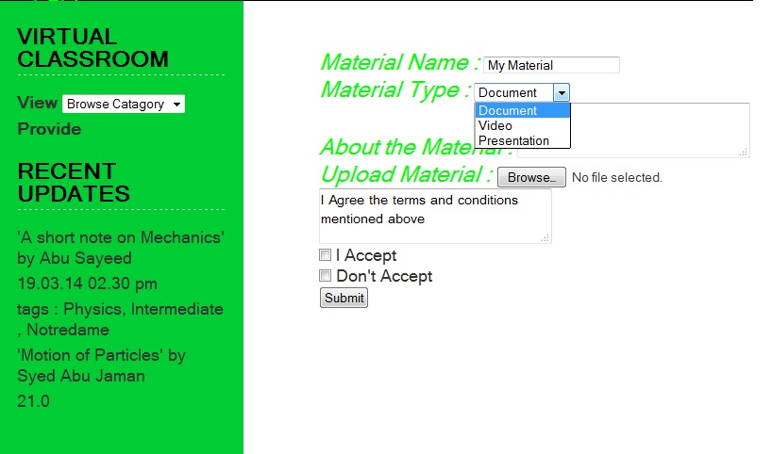

**An user enters Data**



**An user enters Data**

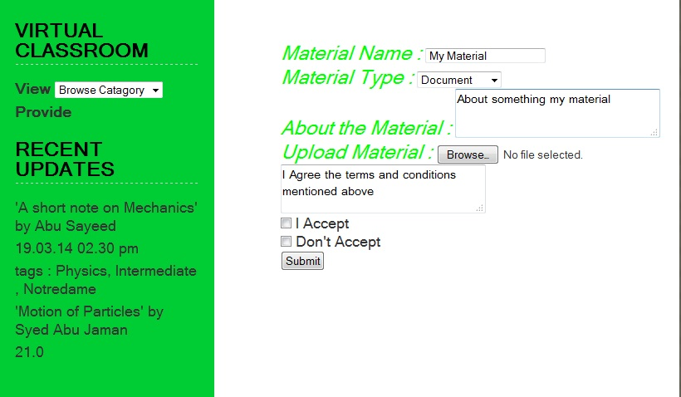

**An user enters Data**

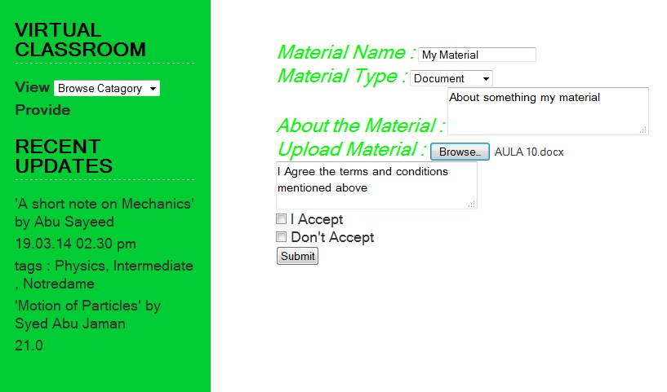

**An user enters Data**

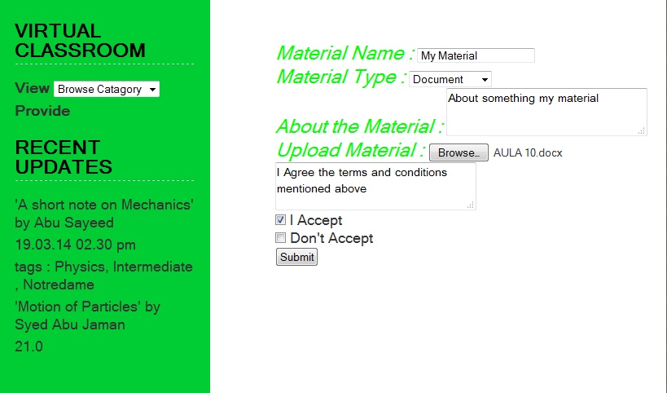

**An user enters Data**

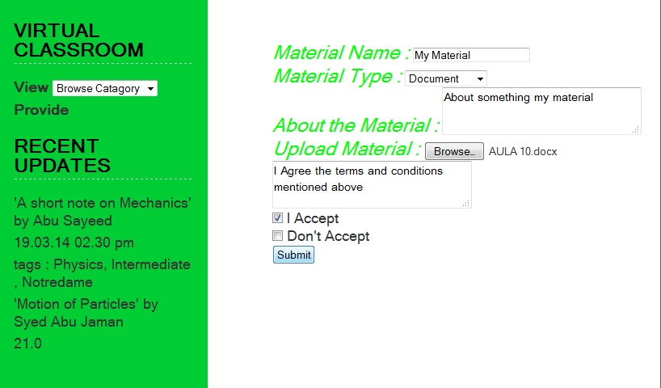

**After Uploading Data**

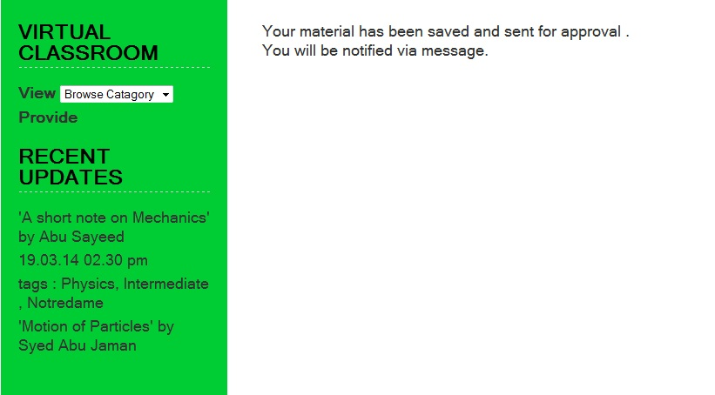

**If an unregistered user Clicks Provide**

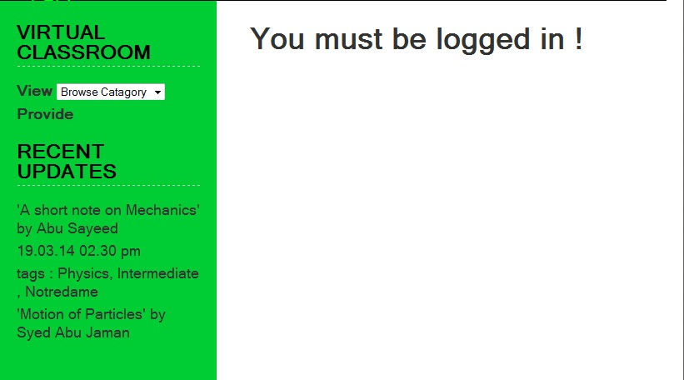

**Getting the Materials**

* <https://github.com/MarufHamidi/ISD_Project>
* <https://github.com/ArunavoDey/ISD_Project>
* <https://github.com/IrfanAlahi/ISD_Project>
* [https://github.com/MubassherIslam/ISD_Project](https://github.com/ArunavoDey/ISD_Project)
* [https://github.com/BejonSarker/ISD_Project](https://github.com/ArunavoDey/ISD_Project)

Thank you