# ABSTRACT

The WildTracer is a cross-platform mobile application for collecting, reporting, and posting accurate, real-time, wildlife trafficking information and status. The app is enabled with functionalities for managing an unlimited number of trafficking areas due to its scalable, cloud-based design architecture. It supports trafficking area geolocation and mapping via on-board Google Maps. Users of the app can post live information from trafficking sites by utilizing buttons within the app’s interface to indicate trafficking routes and species or text messaging via the app. WildTracer also enables its users to view both real-time and historical activities of all trafficking information in the phone’s messaging history. The benefits from the successful deployment of WildTracer include more accurate and timely trafficking information for preventing wildlife trafficking, trafficking route information, inspections, monitoring and safety analysis.

**Key Words**

Data collection—mobile applications—wildlife trafficking —communication systems—work zones

Table of Contents

ABSTRACT 2

EXECUTIVE SUMMARY 4

Background 4

Objectives 4

Methodology 4

Key Outcomes 5

CHAPTER 1. INTRODUCTION 6

CHAPTER 2. LITERATURE REVIEW: MOBILE PHONE APPS IN WILDLIFE CONSERVATION 7

CHAPTER 3. DEVELOPMENT OF THE APP 9

A. Spatial Awareness 10

B. Support/Resource Requests 10

C. Reporting and Messaging 10

D. User Interface Representation 10

Description of Features and the Approach 11

CHAPTER 4. FIELD TESTING AND DATA COLLECTION 17

1. Geolocation Accuracy 17

2. User-Friendliness 18

3. Scalability 18

CHAPTER 5. RESULTS AND DISCUSSION 18

Key Milestones 22

Benefits and Opportunities 23

Limitations of the App and Recommendations for Future Development 24

REFERENCES 25

# EXECUTIVE SUMMARY

## Background

Wildlife trafficking is a major problem in Bangladesh, with animals being illegally hunted and traded for their fur, meat, and other valuable parts. To combat this illegal trade, the WildTracer app was designed which enables accurate and timely communication of wildlife trafficking related activities and improves animal safety. The app includes the features of alerting central helpline number, local forest station, local members of the action team and the local people of the route being used for wildlife trafficking. Such information also facilitates forest safety analysis by enabling the synchronization of trafficking incident data. With the increase in computing power of portable electronic devices, such as smartphones, smart wildlife trafficking information exchange can be accomplished in a simple and cost-effective manner.

## Objectives

The objective of this research project was to design, develop, and deploy the WildTracer app, a cross-platform mobile application for collecting and reporting information on real-time wildlife trafficking activities. This included development of requirement specifications for the app, prototype design, and field testing.

Prototype design was central to this project, as the goal of this project was to provide a tangible software as deliverable that is ready for launching in the market. The field testing was important for demonstrating the app in a live and demanding environment.

## Methodology

WildTracer was developed using Java in Android Studio, one of the most popular open-source, mobile application development framework. The research team followed a modular design approach to enable seamless future expansion of the app by other agencies. WildTracer consists of three main modules, as shown in Figure: frontend, backend, and server.

The frontend module allows users to connect and interact with the app via a graphical user interface (GUI). A variety of layouts and user interface elements, including flat lists, grid and scroll views, buttons were used to improve the user friendliness of the frontend module.

The backend module is responsible for storing all information provided by users in a scalable manner. AsyncTaskLoader and NetworkUtils were used to design and deploy a real-time, cloud-based database to support the backend. The server module is managed by cloud, which visualizes all the information on a dashboard. This helps to archive the data and perform administrative operations.

Server

Backend

Frontend

Figure 1. Frontend, Backend, and server modules of WildTracer

## Key Outcomes

The outcome of this project is a fully-functional mobile application for wildlife trafficking activity monitoring. The app is enabled with functionalities for managing an unlimited number of trafficking activities and areas. WildTracer currently supports automatic trafficking area geolocation and mapping via on-board Google Maps. Users of the app can post live activities from the sites utilizing buttons within the app’s interface to indicate trafficking routes and activities, and/or text messaging via the app. The app also enables users to view both real-time and historical activities of all trafficking routes and activities. Ideally, the app is designed to store trafficking-zone activity information on the phone’s storage system when there is no internet access. The locally stored data could later be pushed to the frontend and backend after the user re-enters an area with Wi-Fi access. The key components of WildTracer are shown in Figure 2.

# CHAPTER 1. INTRODUCTION

Wildlife trafficking environments can be very dynamic in nature, depending on the characteristics of a particular site. The illegal trafficking of tiger and its parts seem to be a common phenomenon in Bangladesh [1]. The population of tigers in Bangladesh has plummeted alarmingly, with an estimate of less than 250 tigers reported in 2015 [11]. The wildlife trade is estimated to be around USD 91–258 billion worldwide, posing huge threat to the global biodiversity [9]. A study report on the wildlife trade in Bangladesh published by Cambridge University reveals that trade in wildlife has been taking place openly in 13 districts of the country [10]. Due to the lack of monitoring, these wild animals are being caught from different parts of the country and then brought to Dhaka and Chittagong. The animals are then trafficked to different countries including India, Myanmar, Thailand, Malaysia, Laos, Singapore and China. Frequently trafficked animals include Bengal tiger, Lojjaboti Banor (Bengal slow loris), Mukhpora Hanuman (Capped Languir), takkhak (Tokay gecko), reptiles and snakes. In the late 2022, police reportedly recovered hoolock gibbons, which are critically endangered in Bangladesh [12].

Lack of information, proper monitoring, and time of day are just some of the factors that affect the safety and efficiency of the prevention of wildlife trafficking in Bangladesh. Under certain circumstances, wildlife trafficking prone sites can change rapidly once monitoring and controlling is set up and work has begun. For example, if a route is less popular among the local people, capacity is restricted and trafficking incidents can increase quickly. This is especially true in forest areas with low communication and infrastructure facilities where a trafficking can become inevitable. Therefore, timely information about trafficking occurrences is needed to properly document and take proper actions against the phenomena.

In addition, weekly meeting schedules, even week-ahead planning and preparation, should constantly be adjusted for adjusting resource allocation, work progress, weather, and other circumstances. What is planned in advance is often not realized in the same way. Finding an easy way to track the dynamic start and due implementation of trafficking-zone activities helps with both the real-time and the long-term management of trafficking zones.

The objective of this research project was to design, develop, and deploy the WildTracer app, a cross-platform mobile application for collecting and reporting real-time wildlife trafficking activity information. This included development of requirement specifications for the app, prototype design, and field testing.

Specification of the requirements was needed because the app is intended to be used by multiple trafficking areas of Bangladesh, and trafficking areas could differ in their desired wildlife trafficking related information content, format, and delivery medium. Prototype design was central to this project, as the goal of this project was to provide a tangible software deliverable that is close to being market ready. Prototype design was accomplished through hardware platform specification, software interface design, software sub-component design, and backend service development. Field testing was important to demonstrate the app in a live and demanding environment.

# CHAPTER 2. LITERATURE REVIEW: MOBILE PHONE APPS IN WILDLIFE CONSERVATION

Bangladesh has a highly diversified forest ecosystem, but is suffering from deforestation, forest deterioration, biodiversity loss, and destruction of ecosystems and habitats. The country is also crippled with high rates of forest crime, including wildlife trafficking. Bangladesh has been a ground for illegal poaching and exporting exotic animals to India.

To assist protected area and wildlife managers to better monitor, evaluate and manage patrolling activities, an innovative management tool named SMART (Spatial Monitoring and Reporting Tool) was designed. The Government of Bangladesh deployed SMART patrolling in the Sundarbans – the world’s largest mangrove forest – in September 2017. Although guidelines were developed, they did not cover plain land forest or hill forest monitoring in the country.

In response, FAO in partnership with the Bangladesh Forest Department and the International Union for Conservation of Nature (IUCN), developed a SMART patrolling toolkit for these types of forest. The toolkit has been piloted in four protected areas of Cox’s Bazar and will be used for management of hill and plain land forest across Bangladesh.

SMART includes field data collection and computer-based management. From installation of the data collection to management and reporting, all the steps are illustrated in the extended version of the diagram ‘SMART Patrolling: A toolkit for better forest management’. A SMART desktop database would ideally be located where decisions made about deploying resources for patrolling and monitoring are made. Data collected by field teams should have inherent value for the management of the conservation area.

The mobile data collection component of SMART uses CyberTracker, a third- party platform created to simplify the collection. SMART mobile data collection leverages the functionality of CyberTracker to eliminate the need for field observations to be recorded separately from GPS data.

CyberTracker uses a GPS-enabled mobile device (e.g., smartphone or personal digital assistant) to collect both observations (text or icon-based data entry and digital images) and GPS data in a single unit. After a patrol returns to the office, observations and GPS data are transferred directly into the SMART database in a semi- automated process. [3]

There are many different estimates of the value of illicit wildlife trafficking worldwide. According to the Wildlife Conservation Society, unreported and unregulated fisheries trade alone are estimated to be between $4.2 billion and $9.5 billion per year. Illicit wildlife trafficking is estimated to be between $7.8 billion and $10 billion per year, and illegal timber trade is estimated as much as $7 billion per year.

Combining these numbers, all illicit wildlife trafficking, including fisheries and timber, comprise the fourth largest global illegal trade after narcotics, human trafficking and counterfeit products. And this continues to grow as international criminal networks engaging in drugs and human trafficking get more involved to supplement their income.

“A lot of times where we start with the lower-level facilitators and shippers, you know there's this whole supply chain of organized crime,” HSI’s Harbin said. [4]

The Wildlife Conservation Society with funding from the Department of Defense Legacy program launched wildlifealert.com a pilot app for use on iOS and Android phones and tablets by U.S. military police providing customs duty in Afghanistan and the Middle East. The app features a diagnostic key to walk users through a series of questions about products made from wildlife that they have encountered while on duty. The app narrows the field of potential matches and provides details on each species to assist with a final decision. The app currently features ~75 species traded in the region, all cats from around the world, some common species that may be disguised as threatened or endangered species or commonly traded, and a guide to ID ivory, antlers, and bone. This tool is an important component to support the National Strategy to Combat Wildlife Trafficking. [5]

The WildScan app is part of Born Free USA’s initiative to aid wildlife law enforcement in West and Central Africa. Born Free USA has partnered for many years with governments in the region to provide trainings and educational resources for law enforcement officials, including printable species identification guides, in-person and digital training workshops, and posters and other public awareness materials. The WildScan app includes the following features:

✓ Photos and information for 500 protected species in the West Africa region

✓ Information on local animal protection laws

✓ Instant reporting option to alert law enforcement of wildlife trafficking, contributing to broader information sharing on wildlife crime in the region

✓ Available in English, French, and Portuguese to ensure it is accessible in the major languages spoken in West Africa. [6]

The release of Wildlife Sentinel fills a critical gap in the aviation sector’s response to wildlife trafficking. Annual surveys issued by the International Air Transport Association (that has guided the development of the app) have consistently indicated that airlines want a dedicated, anonymous illegal wildlife trade reporting system that allows personnel to report suspicious passengers, staff, baggage and cargo to law enforcement. [7]

# CHAPTER 3. DEVELOPMENT OF THE APP

To develop a useful mobile application, a series of interviews were conducted to understand public needs during an emergency. These interviews were carried out with a group of first responders consisting of volunteers from Bogura and Bandarban. The interview questions were designed to identify the most common requirements during wildlife trafficking emergencies. Based on the information collected during these interviews and from various media resources, an initial set of base features for the application was planned. These features were centered around the sharing of voice, text, location, and data, with an emphasis on error-proofing the input and transmission and archiving of this data.

### A. Spatial Awareness

Foremost, it was essential that the application provide locational information to the user, enabling basic situational awareness. A user needs to be able to identify their own location, and find the locations of other team members or meeting places quickly and easily. The locations of dangerous or suspicious activities, or other areas in need of emergency support should also be available to users through the application. Locations disseminated by this service should be errorproof, to prevent false locational information from interfering with successful operations.

### B. Support/Resource Requests

The ability to request support or resources in the event of criminal activity, personal injury, or product selling highly among desired capabilities from interviewed first responders. Broadcasting these types of requests to all local members and officials involved in an event provides an efficient way of reaching all available personnel, spanning multiple organizations (Law Enforcement, Fire, etc.).

### C. Reporting and Messaging

Similar to requesting support or resources to help mitigate adverse wildlife trafficking events, the capability of reporting and collaborating via messages or voice was identified as a top priority from these interviews. This capability would enhance situational awareness for mobile local responsible personnel, while laying the foundation for future work in leveraging mobile technologies.

### D. User Interface Representation

To make the application interactive, different controls have been used and designed using the layout files. Following are the important controls that are designed and used in this application:

1. Text View: The text view component belongs to the view group as a part of GUI. It displays the text or content view of any activity to the user and allows them to edit.
2. Edit Text: This allows itself to be editable in the text box.
3. Button: One of the important components in which the application needs. It is mainly associated with action when the user clicks it. We can represent the button using any text which holds the action class on it.
4. Image Button: Suppose, if we want to have an image for the button which we have designed, we can include using this control by adding the source or path of the image file within the tags in the layout file.
5. List View: This is a key component under the view group which helps in displaying the information about anything when we click the action button. It also allows us to scroll through the screen and have a look about the information displayed. Using the list adapter, the content is pulled from the database.
6. Checkbox: It is the control component which allows us to use or make use of the function by just clicking on the check box button. When we include check box widget in the application, we can see a small box in the screen on which we can check it and it will be selected.

## Description of Features and the Approach

To allow for future expansion and integration of the app, WildTracer app was designed using a modular design process. The current design consists of two main modules: a frontend UI module and a backend module.

WildTrace app frontend consists of four main components (shown in Figure 2): Home screen, Lists, Map View, and Making Call.

**1. Home Screen:** If a user wants to use the WildTracer app, we must download the application, install and register it by providing the number to the central system. Once, he registers, the registered information is stored in the server and can be validated. After installing the information, the app will need to connect to the server to download and install the required lists and the route information on the map. The home screen allows to access the current location and send the locational information to the local members and the server by just clicking on the red button.

**2. List View:** The below Figure 2c, is the list views which help in finding whether the species was trafficked before or not, Route was used before or not and meeting places for meeting for any particular reason. This could help the users in saving time by directly clicking on the item. Search items help in finding the item directly.

**3. Map View:** The WildTracer app’s map screen displays all trafficking routes available on the database. From this screen, users can add new routes, update existing routes with new information, and perform geolocation. This view also hosts a search engine for filtering the routes based on the trafficking activities taking place on the location.

The Map View displays the locations of all geolocated routes or locations on a map. Users can also access the current location from this screen.

**4. Send Message:** Send message is made in an easy step to avoid hassle in this application. The user can just click the button and the message will be send to all the entitled authorities. If the user wishes to add more information, he can just type and add the additional information and click the button once he is done. Once the message is sent, confirmation screen is displayed, which shows the message as shown in the Figure 2d.

The message will be stored in the server as well to add the additional or new information to the existing database to update them. User can see the message from the messaging history of his phone.

5. Making Call: The emergency call button will enable direct voice recording to the helpline number for all WildTracer app users. It can be used to provide information of all trafficking zones or trafficking prone wildlife being monitored by the app, recent or past activity status of the local team responsible for the particular area, the last time the information was updated, etc.

|  |  |  |
| --- | --- | --- |
|  |  |  |
| 1. Home Screen | 1. **Current Location**   SMS current location with the internet and location access. | 1. **Choose Options**   Select option from preloaded data. |
|  |  |  |
| 1. **Send SMS**   Confirm the SMS content and send to the receiver with a tap of the button. | 1. **Instant SMS**   Receiver receive the SMS instantly. | 1. **Instant Call**   Receiver receives the call instantly. |

|  |
| --- |
|  |
| 1. **Map Location**   View current location on map |

Figure 2: Main components of WildTracer app.

Wildlife trafficking requires increased adoption of mobile devices and applications to enhance incident and emergency response. These applications must support sever based data communication, and operate in disconnected, interrupted, and low-bandwidth communication environments. Our app was built along with a website. This shows the analysis of the information collected from the user responses and archives the data for future analysis and further implementation in algorithms.

We also focused on leveraging the computational power of the mobile device for processing, exploitation and dissemination of shared wildlife trafficking information; developing algorithms and techniques to maximize effectiveness in poor communication environments; and developing a central integration of all the areas.

WildTracer app’s backend has three main functionalities: authenticate users, provide storage for user data, and manage a real-time database.

The dashboard uses a sign in option to authenticate the admin to login with valid credentials. The dashboard shows the statistical analysis of the database stored in the server and the website consists of the databases of the messages archived, members of the local team and routes as shown in Figure 3.

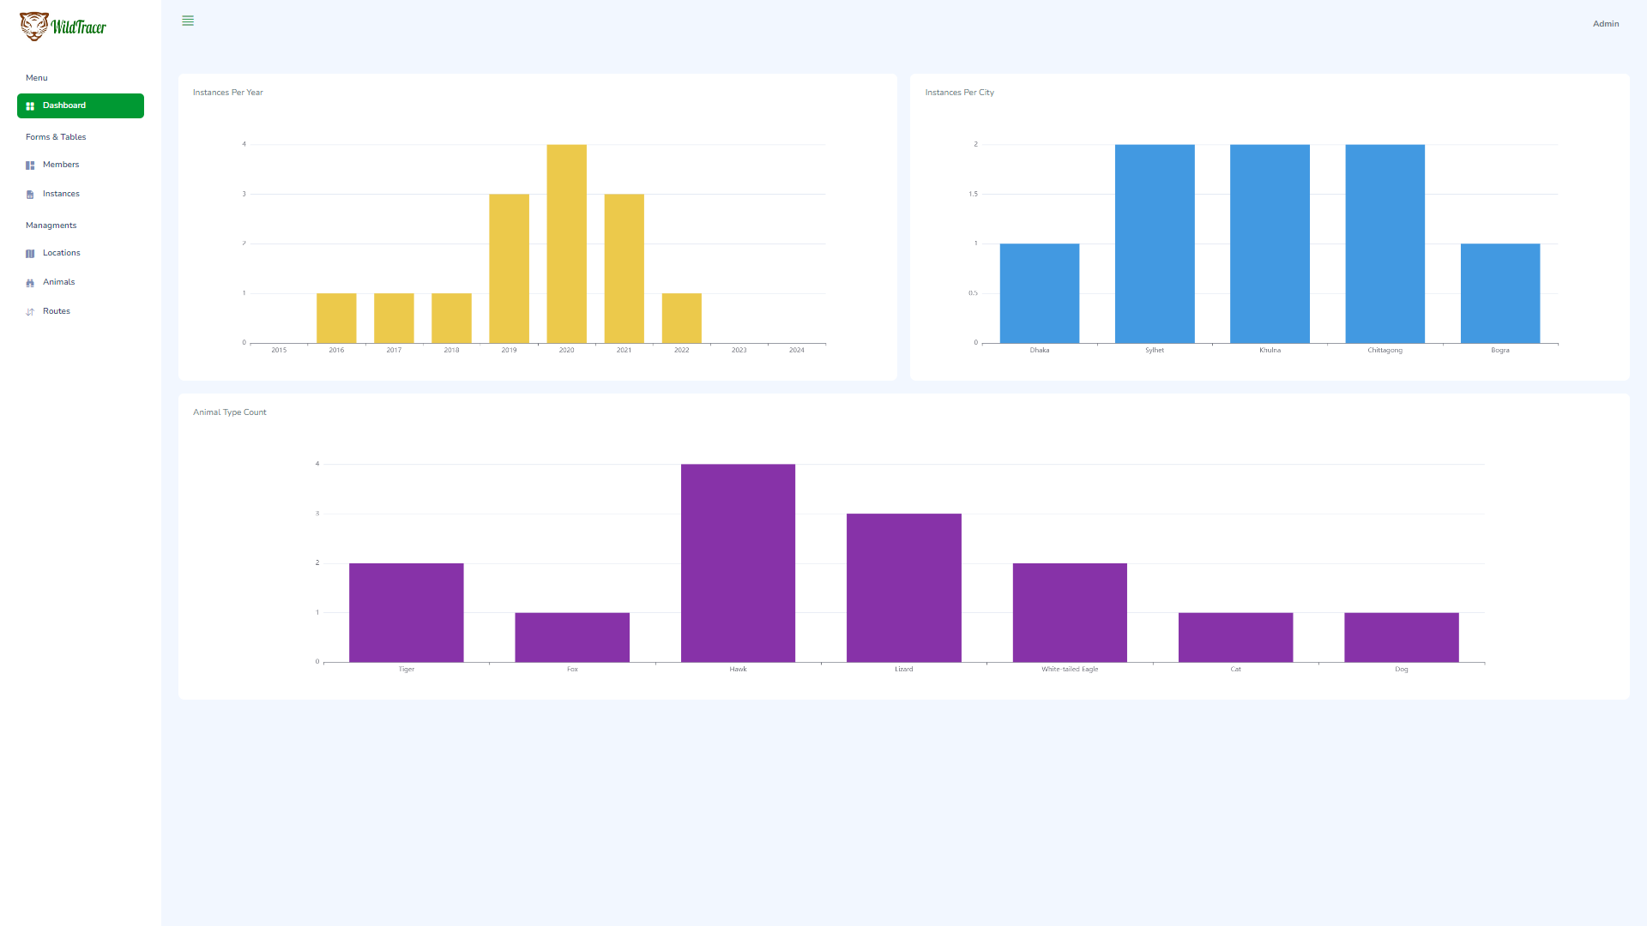

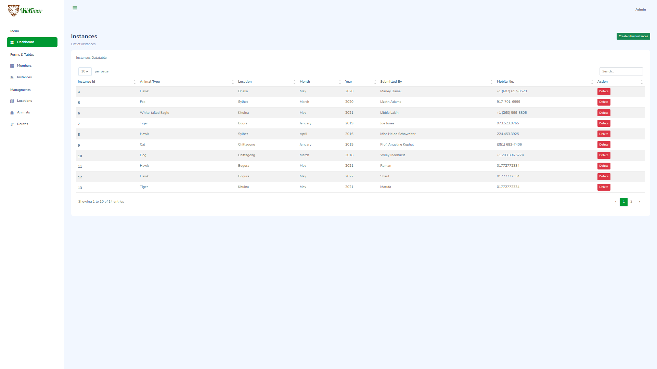

Figure 3: Dashboard of the Website.

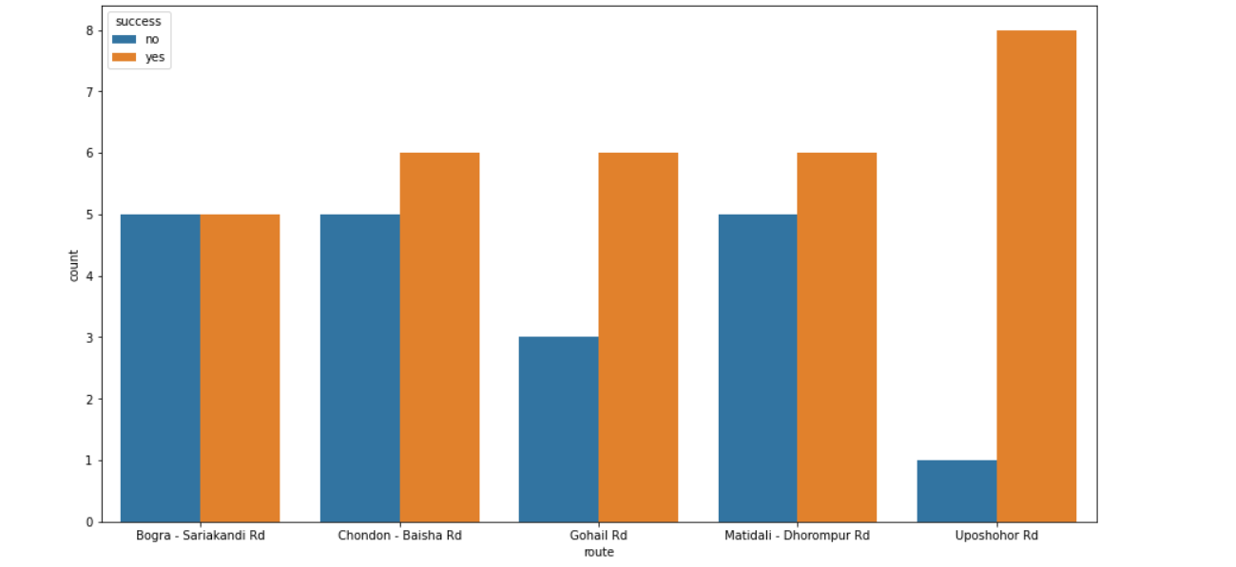The archived data was used in a machine learning algorithm using Python programming language. These algorithm is used to predict which routes are most commonly used for a specific wildlife trafficking. We derived a list of most widely used routes for trafficking a specific species of wildlife as shown in Figure 4.

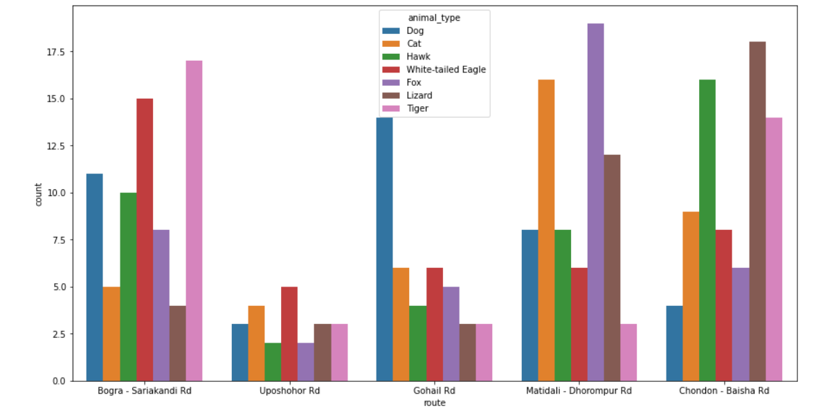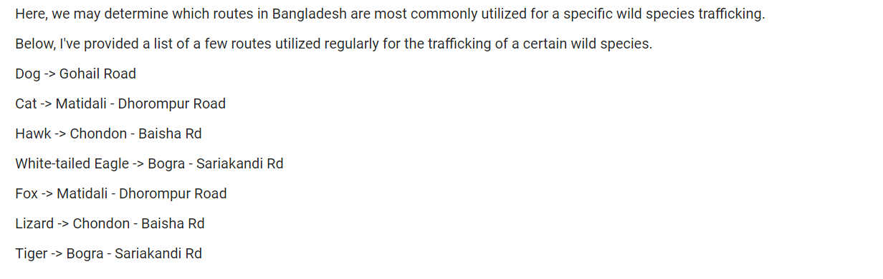   
Figure 4: Statistical analysis of Machine learning.

# CHAPTER 4. FIELD TESTING AND DATA COLLECTION

In order to use the app for field testing, we first compiled and tested WildTracer within Bogura. Locations of the selected sites are displayed from the WildTracer Map View in Figure 2.

The key metrics used to evaluate WildTracer during field testing are:

1. Geolocation accuracy
2. User-friendliness
3. Scalability

### 1. Geolocation Accuracy

Although WildTracer uses satellite imagery maps to enable users to verify the accuracy of the locations of trafficking-zones; it was necessary to evaluate the expected range of accuracies depending on the location characteristics of the trafficking zone. The accuracy of GPS coordinates provided by the app was therefore compared with ground truth coordinates manually extracted from Google Maps.

It was also observed that the type of phone (Android or iPhone) influenced the geolocation accuracies very slightly. Android phones generally had higher accuracies and the GPS values recorded were more stable compared to those from iPhones.

### 2. User-Friendliness

To evaluate the user-friendliness of the app, the researchers surveyed several professionals and students who had some knowledge on wildlife trafficking activities. Each user was primarily briefed on the purpose of the app and then allowed to navigate the app without any further assistance from the development team. A user-friendliness score was assigned based on the components the user was able to use.

Overall, the most challenging aspect of the interface for the users to navigate was swiping left or right on a flat list to geolocate or edit a message. The remaining components were quite straightforward to navigate.

### 3. Scalability

To evaluate the scalability of the app, the researchers monitored the latency between user activity post time and the activity broadcast time as the size of the WildTracer database. All the activities by users could be viewed by other users of the app within a second.

# CHAPTER 5. RESULTS AND DISCUSSION

The current project designed, developed, and deployed a fully functional cross-platform mobile application, WildTracer, for collecting and communicating wildlife trafficking zone-related activities.

Users of the app can post live activities from trafficking zones by utilizing buttons within the app’s interface to indicate trafficking incidents and area activities, or text messaging via the app. WildTracer also enables its users to view both real-time and historical activities of all danger zones with the help of centralized administration.

A usability study of the mobile application was conducted with participants familiar with this kind of emergency trafficking activities. Future studies will strive to expand the user validation group. Each subject was asked to sign a confidentiality form and participants were provided free snacks per interview.

During the test, the subjects were asked to perform different tasks on the medium fidelity prototype on an android phone. The number of clicks each subject required to complete each task was recorded, as well as the time it took them to complete each task. The order in which the tasks were given to each subject was randomized in order to avoid any ordering effect. The subjects were monitored while performing the tasks, and the student organizers read the tasks, recorded the number of clicks, and timed each task as shown in Figure 5.

After completing the tasks, each user was asked the following questions:

* Which community would you prefer to notify first when experiencing an emergency or crime?

1. Police
2. Family
3. Friends
4. Nearest person around you
5. Other

* Do you agree that requesting for help using mobile phone during critical situation (kidnapping, robbery, mugging, etc.) is difficult due to the panic situation?

1. Yes
2. No

* If there's an app that will send emergency message to your selected contacts during emergency/crime situation, without you having to type in the message, will you download and use it?
  + 1. Yes
    2. No
* How much do you think the application help reduce the time taken for you to request for help during emergency?

1. No
2. 30 – 50%
3. 51% - 80%
4. 81% and above

* How do you rate the ease of this application towards the aspect of personal safety?

1. Complicated
2. Moderate
3. Easy
4. User Friendly

The results from the post-test questionnaires showed that the user group participants found the concepts of the system to be favorable and useful in performing their tasks as first responders. Often during conversations with the participants, they openly discussed potential situations where such a system would have been beneficial. The WildTracer app users deemed the application interface to be sufficiently intuitive for navigation and use by any first responder, from complete novices to proficient Android users. All users completed all assigned tasks without major concerns or confusion as shown in Figure 6.

The developed mobile Android application was deemed intuitive to learn and operate. First responders were able to quickly use the application without any prior instruction. Many of the features in the application were found to be useful, with the map feature universally deemed the most impactful [7].

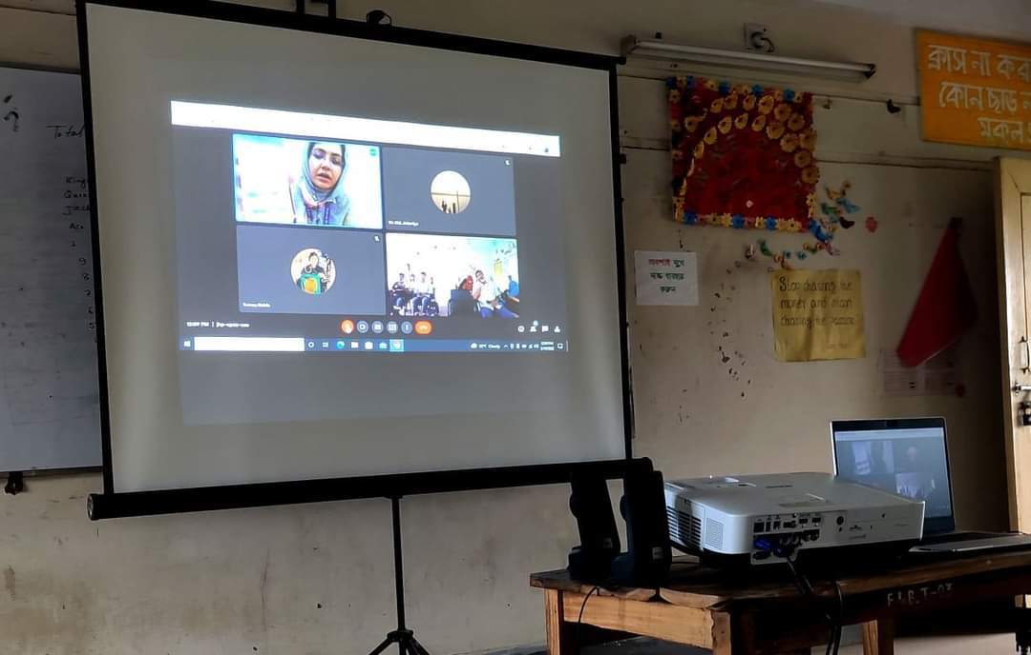 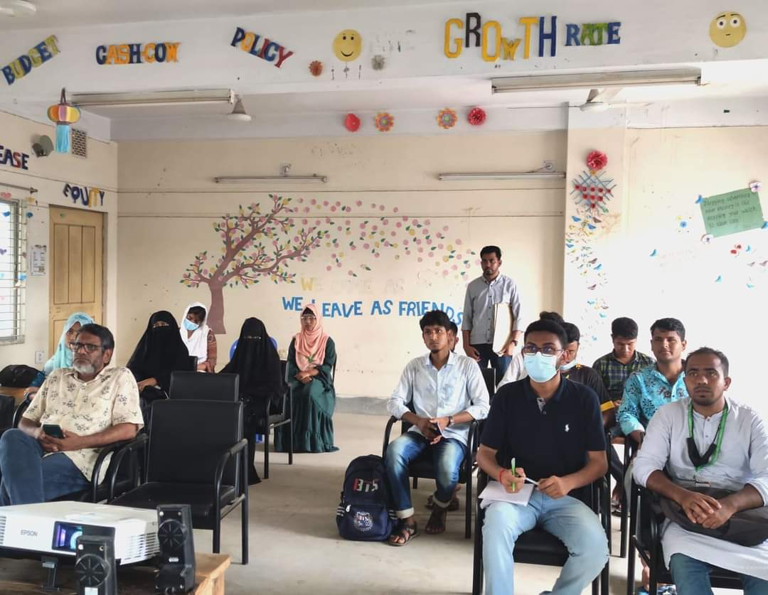

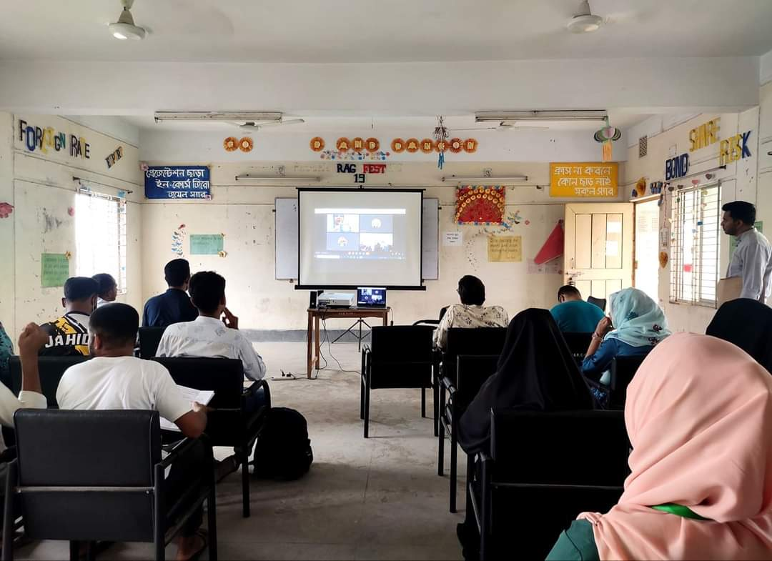 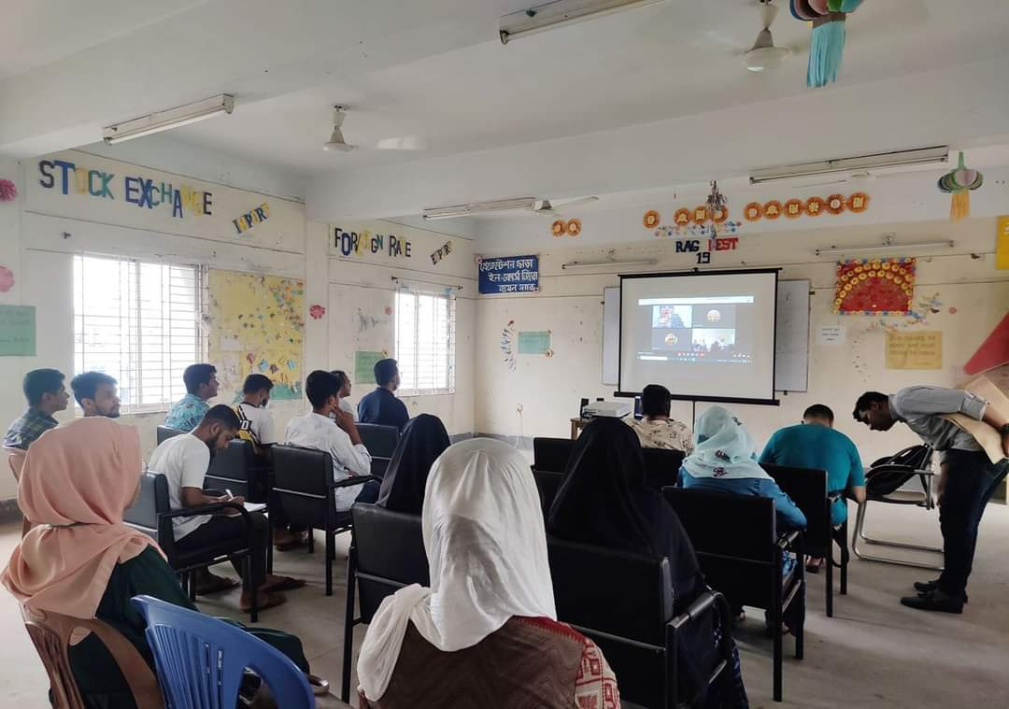

Figure 5: Survey on WildTracer app.

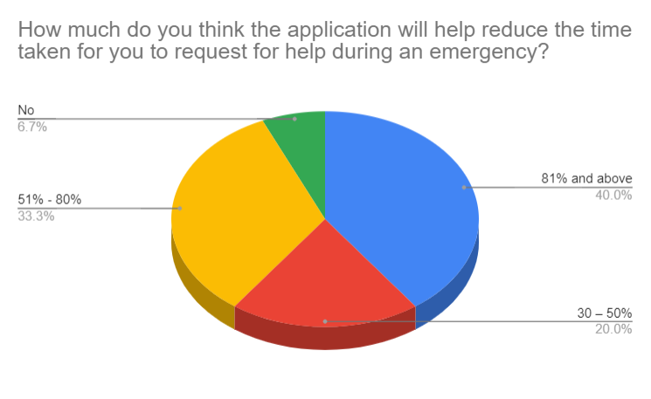 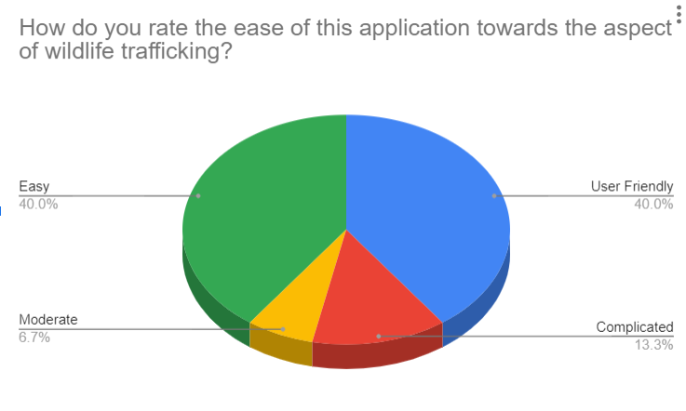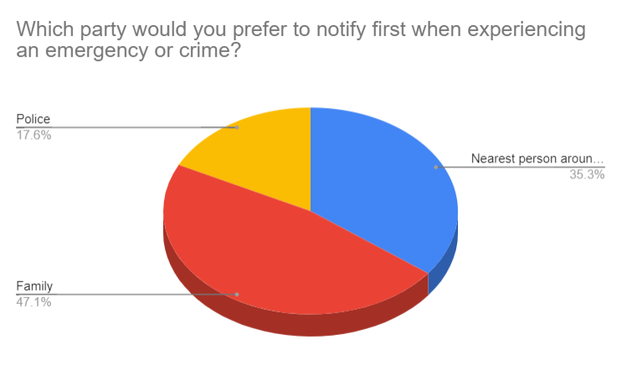 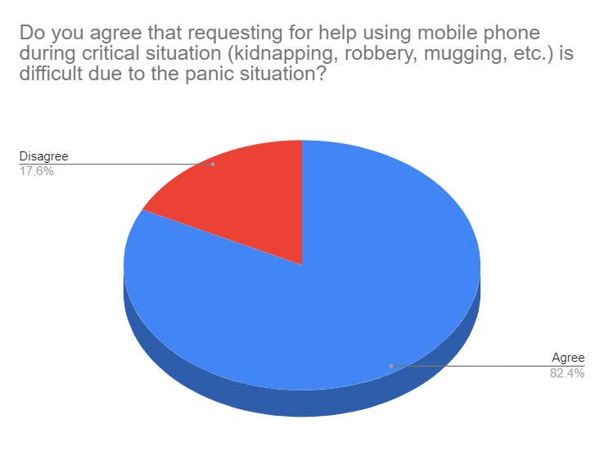 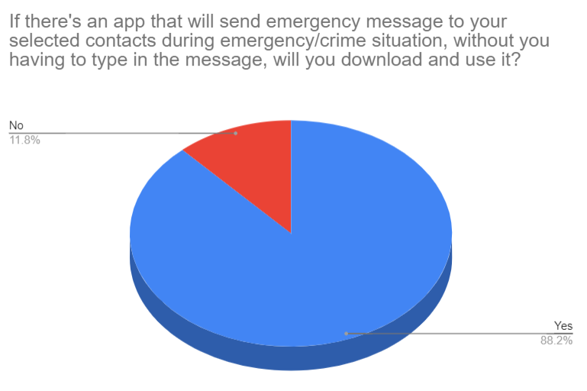

Figure 6: Survey Results.

Statistic above shows that 88.2% of the respondents would download and use the proposed mobile application due to its ability to send emergency message to pre-stored contacts. Another 11.8% of the respondents were not very confident of the ability of the proposed mobile application. 40% of the respondents believed the app would help them respond in emergencies at 81% and above efficiency. While 33.3% of them believed the efficiency would be 51% - 80%. Therefore, we can conclude that the public is strongly concern of notifying the local people when they are witnessing a trafficking situation and using the app for time efficiency. This statistic strengthens the public view on how important it is to notify locals during emergency situation at least 51% - 80% and above efficiency as stated in the previous questions above.

## Key Milestones

The table below shows the milestones of this study:

|  |  |  |
| --- | --- | --- |
| **No.** | **Deliverables/Activities** | **Duration** |
|  | Title Selection and Proposal | June 2021 |
|  | Project Approval | July 2021 |
|  | Problem Identification and Feasibility Study | August 2021 |
|  | Extended Proposal | August 2021 |
|  | Requirements Gathering | September 2021 |
|  | Process and System Modelling | October 2021 |
|  | Interface Design | November 2021 |
|  | Interim Report | January 2022 |
|  | Proposal Defense | February 2022 |
|  | Architecture and System Design | October 2021 |
|  | System Complete | January 2022  App and other resources available at: <https://github.com/Marufa2018/WildTracer> |
|  | Progress Report | May 2022 |
|  | Usability Testing | May 2022 |
|  | Survey | May 2022 - January 2023 |
|  | Final Dissertation | March 2023 |

## Benefits and Opportunities

One benefit of using WildTracer app is for monitoring trafficking related information and preventing them. The accuracy of the information stems from the fact that the information is originating from a local representative who is at the actual trafficking site and has first-hand knowledge of the situation. The information is broadcast instantaneously to multiple parties that have an interest in the information, including the helpline number, local coordinator and committee members, local forest station, and various authorities, if appropriate. This broadcast also results in more accurate and timely information being passed to third parties, such as forest police who will use this information to plan actions or to navigate through the danger prone areas.

From the project management and contracting perspectives, WildTracer app documents the timestamp when the incident is occurring. This is especially important for certain types of areas or routes involving incentives/disincentives used in high-impact trafficking zones.

WildTracer can also help improve coordination among different parties or even within organizations. For example, local group can better coordinate with forest police and other authorities using the app. After the WildTracer data are downloaded and archived, they become a valuable source of dynamic trafficking-zone information that is currently lacking. For example, animal-based safety analysis, such as trafficking-zone risk modeling, requires the integration of trafficking-zone information with crash information. However, this integration is often difficult because dynamic trafficking status is not available. Therefore, WildTracer provides both real-time and long-term benefits.

Modern smartphones are remarkable in terms of their portability and their enormous capabilities. The miniaturization of electronics has enabled the integration of multiple components into a single device instead of needing multiple devices that consume space and power. Even more impressive is the fact that the integration is also logical, meaning that information can be shared by all components via the software kernel.

The dizzying array of technology available on smartphones include high-resolution displays, touchscreens, microprocessors, accelerometers, gyroscopes, global positioning systems (GPS), cameras, infrared detectors, environmental sensors, switches, radio-frequency identification (RFID), Bluetooth, Wi-Fi, and, of course, cellular voice and data communications. By further processing raw sensor data, many more types of information, such as heart rate, quick response (QR) codes, and fingerprints can also be recognized by smartphones.[2]

WildTracer will communicate dynamic trafficking-zone information, but with more detail and more timely information. This project focused on communicating valuable trafficking information to local authorities, helpline number and archival data systems.

## Limitations of the App and Recommendations for Future Development

The first and most obvious limitation of the app is its over-reliance on internet access. A sizeable number of construction work areas in many states may be in dead zones where internet access is limited. The app will not function in such areas. Ideally, the app could be re-designed to store work-zone activity information on the device’s storage system when there is no internet access. The locally stored data could later be pushed to the frontend and backend after the user re-enters an area with internet access.

A second development that could be relevant in subsequent releases is live video streaming and/or archiving of work-zone activities. The current app does not have streaming capabilities, neither does it store video information. However, video feeds could increase the size of the WildTracer database at an exponential rate. This will increase the cost of cloud storage and require new database designs to enable the app to scale as the size of the data uploads increase. The implementation of the app can be extended further by utilizing the archive generated from storing data on wildlife trafficking, which will be greatly useful for research and development.

With the modular design approach adopted to develop WildTracer, such new extentions could be carried out seamlessly. In addition, the app could be enabled with a chat area, where trafficking-zone members could communicate and seek approval for unplanned activities. All chat messages could be stored to enrich the WildTracer database for documenting work-zone activities on a particular day. The app could be replicated to monitor women and children trafficking and enhance their security nationwide.

Finally, it is recommended that the concerted efforts be made to integrate WildTracer with key data management systems, 999, etc. A restless API could be developed to allow agencies and developers to query and explore the WildTracer database in real-time.

Future updates to and developments for WildTracer will address the mentioned limitations of the current application.

# REFERENCES

1. Uddin N, Enoch S, Harihar A, Pickles RS, Ara T, Hughes AC. Learning from perpetrator replacement to remove crime opportunities and prevent poaching of the Sundarbans tiger. Conservation Biology. 2022 Nov 21:e13997.
2. Adu-Gyamfi, Y., Sun, C., Edara, P., & Farzaneh, A. (2019). *Smart Work Zone Activity App (SWiZAPP)* (No. InTrans Project 19-535). <https://trid.trb.org/view/1918751>.
3. ICT's (February 15, 2022). *Summary of the SMART patrolling – A toolkit for better forest management in Bangladesh*. <https://www.aesanetwork.org/summary-of-the-smart-patrolling-a-toolkit-for-better-forest-management-in-bangladesh/>.
4. *Wildlife trafficking: Why battling this illicit trade is crucial*. ICE. (n.d.). Retrieved March 7, 2023, from <https://www.ice.gov/features/wildlife>.
5. *WCS response mobile app to ID illegal wildlife products*. Wildlife Trade. (n.d.). Retrieved March 7, 2023, from <https://wildlifetrade.wcs.org/WCS-Response/Mobile-App.aspx>.
6. *WildScan*. Born Free USA. (2020, October 14). Retrieved March 7, 2023, from <https://www.bornfreeusa.org/campaigns/wildlife-trade/wildscan/>.
7. *New Mobile reporting app is helping combat corruption and wildlife trafficking in the aviation industry*. Wildlife Trade News from TRAFFIC. (n.d.). Retrieved March 7, 2023, from <https://www.traffic.org/news/new-mobile-reporting-app-is-helping-combat-corruption-and-wildlife-trafficking-in-the-aviation-industry/>.
8. Erickson, P., Weinert, A., Breimyer, P., Samperi, M., Huff, J., Parra, C., & Miller, S. (2013, November). Designing public safety mobile applications for disconnected, interrupted, and low bandwidth communication environments. In *2013 IEEE International Conference on Technologies for Homeland Security (HST)* (pp. 790-796). IEEE.
9. Hughes AC, Lechner AM, Chitov A, Horstmann A, Hinsley A, Tritto A, Chariton A, Li BV, Ganapin D, Simonov E, Morton K. Horizon scan of the belt and road initiative. Trends in Ecology & Evolution. 2020 Jul 1;35(7):583-93.
10. Unprotected wildlife | The Financial Express <https://thefinancialexpress.com.bd/views/opinions/unprotected-wildlife>
11. CITES CoP18, Doc. 71.1, p. 13 (2019), Species specific matters: Asian big cats (Felidae spp.): Report of the Secretariat.
12. Trafficking and habitat loss spell doom for Bangladesh’s western hoolock gibbons https://news.mongabay.com/2022/12/trafficking-and-habitat-loss-spell-doom-for-bangladeshs-western-hoolock-gibbons/Accessed: 2023-03-21