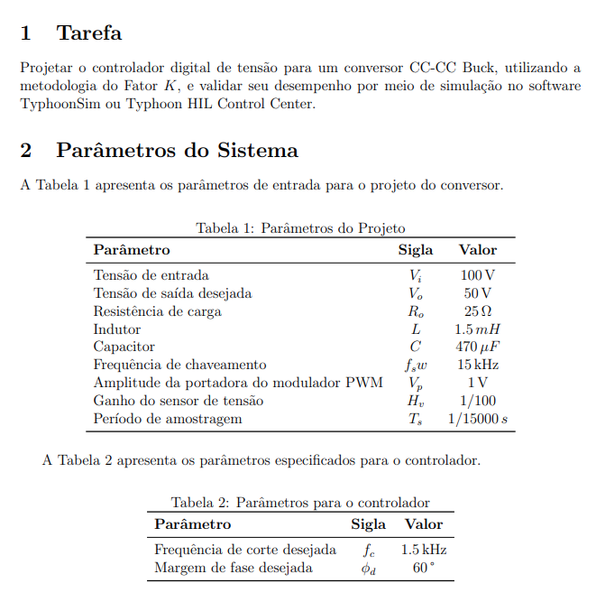
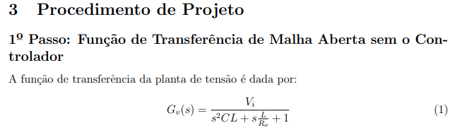
$$Gv\left(s\right)=\frac{1,42*{10}^{8}}{s^{2}+ 85s+1,42*{10}^{6}}$$
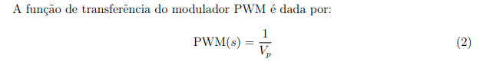
$$PWM\left(s\right)=\frac{1}{1}$$
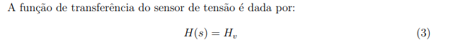
$$H\left(s\right)=\frac{1}{100}$$
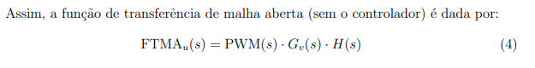
$$FTMA_{u}\left(s\right)=\frac{1418439,7}{s^{2}+ 85s+1,42*{10}^{6}}$$
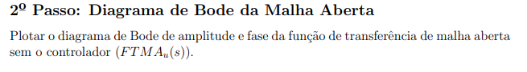
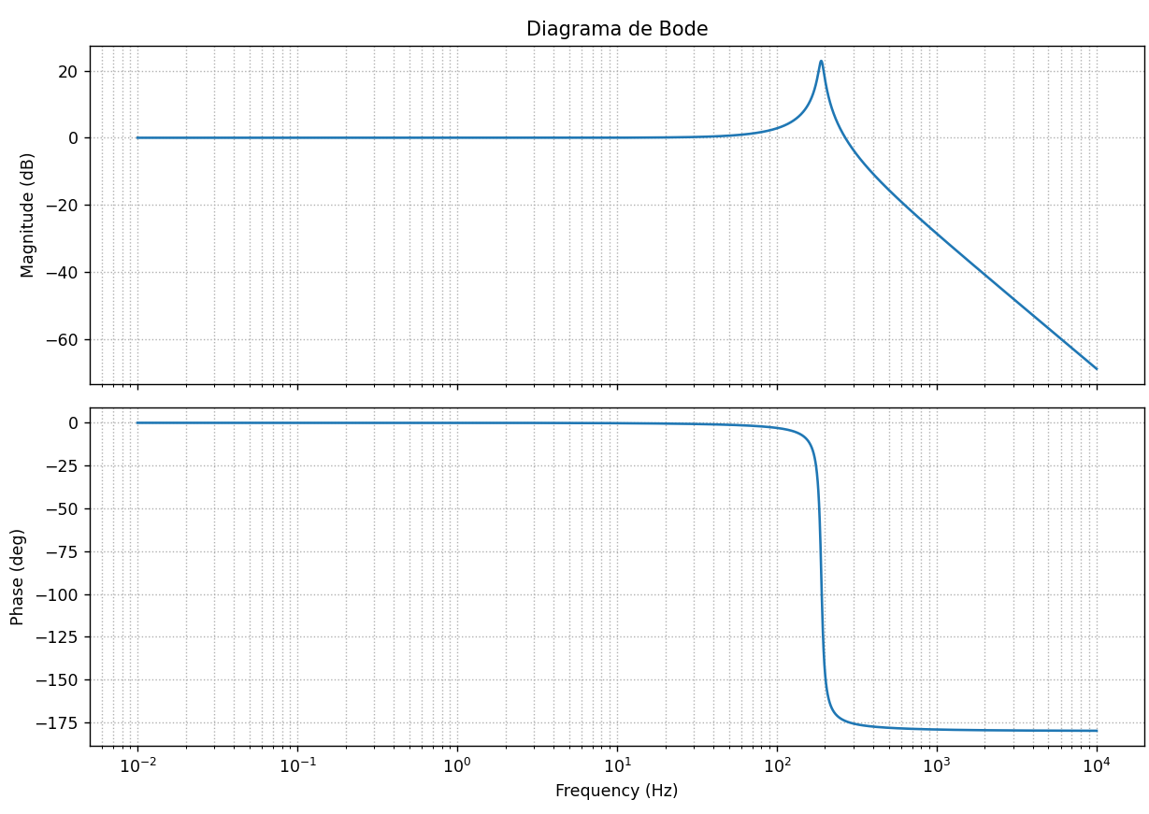
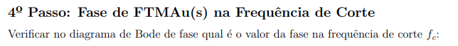
$$FaseFc=-179,4°$$
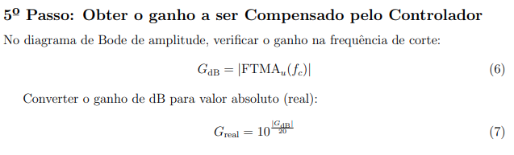
$$Gdb=35.8$$
$$G_{real}=61,66$$
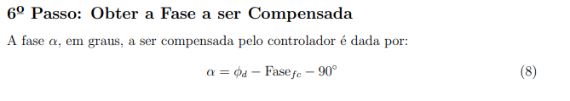
$$α=149,4°$$
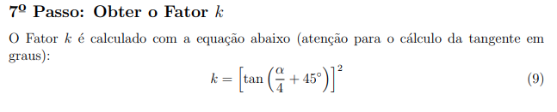
$$k=55,43$$
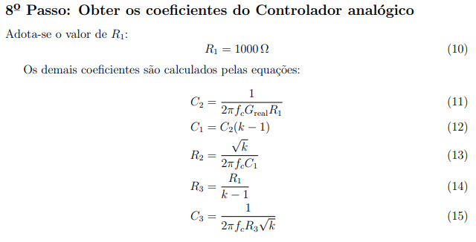
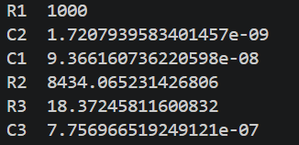
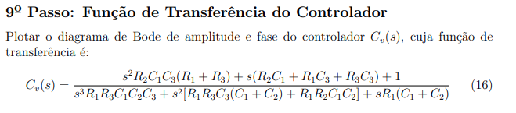
$$C_{v}\left(s\right)=\frac{2,7*{10}^{11}s^{2}+6,9*{10}^{14}s+4,3*{10}^{17}}{s^{3}+1,18*{10}^{9}s^{2}+4,15*{10}^{13}s}$$
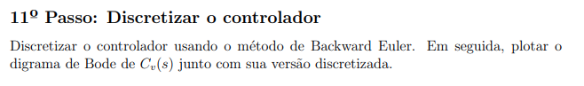
Para discretizar, basta substituir s pelo seu equivalente na tabela:
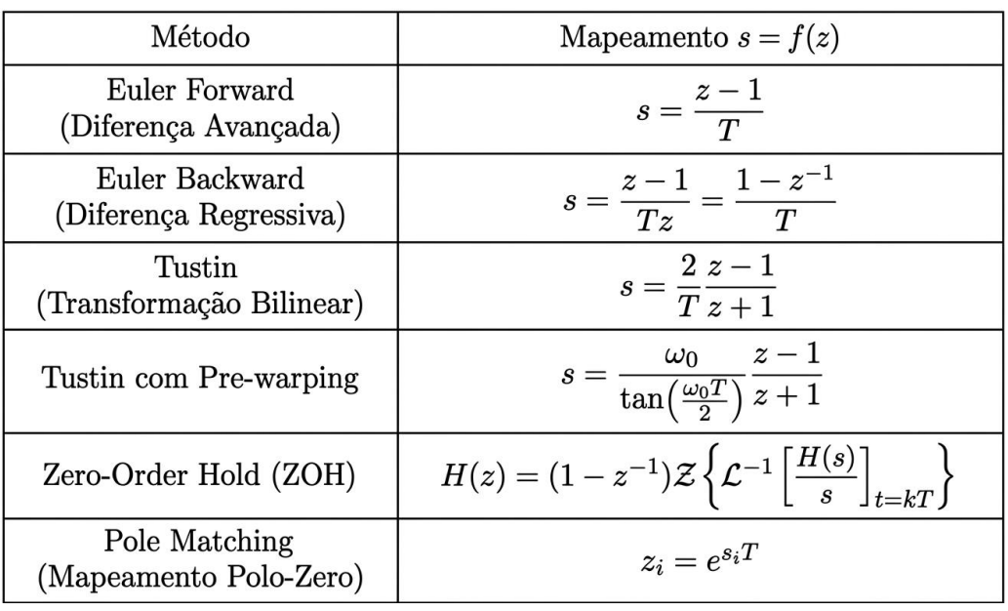

$$C_{z}=\frac{80,835-149,09z^{-1}+68,74z^{-2}-3,2*{10}^{-14}z^{-3}}{1-1,3z^{-1}+0,3z^{-2}-3,796*{10}^{-6}z^{-3}}$$
