






MACHINE LEARNING

Sign Language Detection and Voice Assistance System

Submitted on : 30/11/2025
Submitted by:
Maruthi V Kamath (2023UG000124)
Hamza Ali Ahmed (2023UG000142)
Prajwal (2024UG100002)
Manjushree M R (2023UG000175)

Contents

S. No. | Heading | Page No.
1. | INTRODUCTION | 3
2. | ABSTRACT | 4
3. | PROBLEM DEFINITION | 4
4. | OBJECTIVES OF THE PROJECT | 5
5. | SCOPE OF THE PROJECT | 6
6. | METHODOLOGY | 7
6.1 | Data Collection and Dataset Description | 8
6.2 | Feature Extraction: using Mediapipe | 9
6.3 | Preprocessing | 10
6.4 | Model Selection and Comparison | 11
6.4.1 | KNN (K-Nearest Neighbors) | 12
6.4.2 | Random Forest | 13
6.4.3 | SVM (Support Vector Machine): Chosen Model | 14
6.5 | Model Training | 16
6.6 | Model Evaluation | 17
6.7 | Deployment | 18
7. | RESULTS AND DISCUSSION | 19
8. | LIMITATIONS | 20
9. | FUTURE ENHANCEMENTS | 21
10. | CONCLUSION | 22

- INTRODUCTION:
Communication plays a vital role in our daily lives, but some individuals are unable to speak, and others have difficulty seeing properly. People who cannot speak have to use hand signs to express what they want to convey. The problem is that most people do not understand these signs, which makes communication difficult. People who are blind also cannot see these signs, so for the blind to understand the mute they need a tool that can speak the message out loud.
Today, technology can help solve these problems. Using a device with a camera and our trained machine learning model we can look at a person’s hand sign, understand it, and convert it into text or voice. This makes communication easier for everyone irrespective of their disabilities.
In our project, we created a user-friendly website that can detect hand signs shown to the camera of the device being used, and convert sign language into english text and read out the message for us. If a person shows a sign in front of the camera, the system will identify it and pronounce the word. This helps people who cannot speak communicate their message. It also helps people who cannot see because they can hear the spoken output. Our goal is to make communication easier, faster, and more comfortable for everyone who needs help.

- ABSTRACT:
This project focuses on helping people who cannot speak or see by creating a website that can detect hand signs and speak out the message. Many people with speech disabilities use sign language to communicate, but most people do not understand these signs, which creates a communication gap. At the same time, people who are visually impaired cannot see the signs and need audio support. To solve these problems, our project uses machine learning model and a camera to recognize hand gestures in real time. When a user shows a sign in front of the camera, the system captures the image, processes it, and predicts the correct letter or word using a trained model. The detected output is then shown on the screen and also converted into speech using a text-to-speech tool. The entire system is built into a user-friendly website so that anyone can easily use it without much technical knowledge. The main aim of this project is to make communication easier and more accessible for people with disabilities, reduce their dependence on others, and provide a fast, low-cost solution that works in real-life situations.
- PROBLEM DEFINITION:
Many people around us face difficulties while communicating because they cannot speak, cannot hear, or cannot see properly. People who cannot speak usually use hand signs to express their thoughts, but the problem is that most people do not understand sign language. For example, imagine a person who cannot speak wants to ask for a glass of water. They may show a hand sign, but if the other person does not know the meaning of that sign, they will not understand what the person needs. In the same way, a visually impaired person cannot see the hand signs shown by others, so they cannot understand the message. This creates a big communication gap and makes daily life very hard for them. To solve this problem, our project aims to create a simple system that can look at a hand sign in real time, understand what the sign means, and convert it into text and speech. This way, a person who cannot speak can show a sign, and the website will say the word out loud. A blind person can also understand the message because they can hear the audio. The main objective of our project is to make communication easy, quick, and independent for people who are deaf, mute, or visually impaired by giving them a tool that everyone can use without having to learn sign language.

- OBJECTIVES OF THE PROJECT
The main objective of this project is to create a system that helps people with communication disabilities by recognizing hand signs and converting them into text and speech. To achieve this, the project focuses on the following goals:
- To recognize hand signs in real time: The system should capture the user’s hand sign through the camera and detect it instantly using machine learning.
- To convert the detected sign into text: After identifying the sign, the system must display the correct letter or word on the screen so that others can understand the message easily.
- To convert the text into speech: For people who are visually impaired, the system will speak the output using a text-to-speech tool, making communication audio-based and more accessible.
- To build a simple, user-friendly website: The website should be easy to use, with a clean layout, so that even people without much technical skills can operate it comfortably.
- To reduce communication barriers: The system aims to help people who are deaf, mute, or visually impaired communicate smoothly in daily life without depending on others.
- To provide a low-cost and efficient solution: The project focuses on using free and open-source tools so that the solution can be used by anyone without expensive hardware or software.
- To support inclusiveness and accessibility: The project aims to promote equal communication opportunities for people with disabilities and use technology to make lives easier for everyone.
- SCOPE OF THE PROJECT
The scope defines what the project can do and what areas it focuses on:

1. The project focuses on detecting single-hand ASL alphabet signs.
- Only one hand is used, and alphabets are recognized.

2. The system works using webcam input.
- Users can show the sign in front of the camera.

3. Hand landmarks are extracted using Mediapipe’s hand tracking module.
- The project is limited to 21 landmarks per hand.

4. The classification model used is SVM (Support Vector Machine).
- Deep learning models like CNNs are not included.

5. The output provided is text and speech.
- The predicted letter is displayed on the screen and spoken using TTS.

6. The website interface is simple and user-friendly.
- It is designed only for basic detection and display, not for advanced UI features.

7. The system aims to help people with speech, hearing, or visual disabilities communicate easily.

8. The project uses free, open-source tools only.
- This includes Python, Mediapipe, OpenCV, SVM, and pyttsx3.
6. METHODOLOGY
The methodology of this project follows a simple machine learning pipeline to convert the hand signs into meaningful output. First of all, we collected raw RGB images of ASL hand gestures in which each image contains only a single-hand sign. We did not use images to train the model but first extracted the 21 keypoints of each hand image using the MediaPipe. A single landmark gives x, y, and z coordinates. Thus, we have a total of 63 numerical features per image. Further, these were stored in a CSV file, and as such no pre-processing like filtering, normalization, or grayscale conversion was applied. Then, we experimented with several ML models like KNN, Random Forest, and SVM. Among these, by comparison, SVM outperformed for our 63-feature dataset and therefore we chose it as our final model. SVM Classifier is trained based on extracted features, and this trained model has been saved to use for prediction.
We then tested the model on unseen images, looking at its accuracy, confidence levels, and misclassifications. Certain gestures, like 'M' and 'N', were often confused since positions of the fingers for both are quite similar. In real-time, the webcam continuously captures frames, Mediapipe detects hand landmarks, and the SVM model predicts the sign in an instant. A Text-to-Speech feature was also added so the predicted output can be spoken aloud, hence making the system useful for visually impaired users. This straightforward yet effective methodology allowed us to develop a low-cost and accessible system that recognizes hand signs both from images and live video.
6.1 Data Collection and Dataset Description
To build a high-quality and diverse dataset for our American Sign Language (ASL) recognition project, we collected and combined two different Kaggle datasets to ensure wide coverage of real-world variations and clear gesture representations. The first dataset consisted of around 3000 real-time ASL images captured in a variety of natural conditions, including different lighting setups, background textures, camera angles, skin tones, and hand positions, making it highly valuable for training a model that can perform well in practical scenarios. The second dataset contained about 70 clean images taken against a plain black background, offering noise-free samples with clear hand contours and sharply defined gesture boundaries. To improve the overall quality and avoid unnecessary repetition, we refined the larger dataset by reducing it to 1500 images per category, carefully selecting only the most diverse and informative samples while removing duplicates and low-quality images. We then merged this curated subset with the clean-background dataset to create a consolidated dataset that captures both real-world complexity and controlled clarity. This combination ensured that our final dataset was not just large in size but also rich in variety, balanced across categories, and capable of representing all kinds of scenarios that users might experience, ultimately helping us build a more accurate and reliable ASL-to-text and speech recognition system.
After gathering the images, we did not directly use the raw images for model training. Each image went through Mediapipe Hands, which identified key landmarks of 21 on the hand. Since each landmark is described by x, y, and z coordinates, this means we then have a total of 63 numeric features for every given image. These values of extracted landmarks were stored in a CSV file and used as our real dataset for the training of our machine learning model. This made the process more efficient since the model learned from structured numerical features rather than full images.

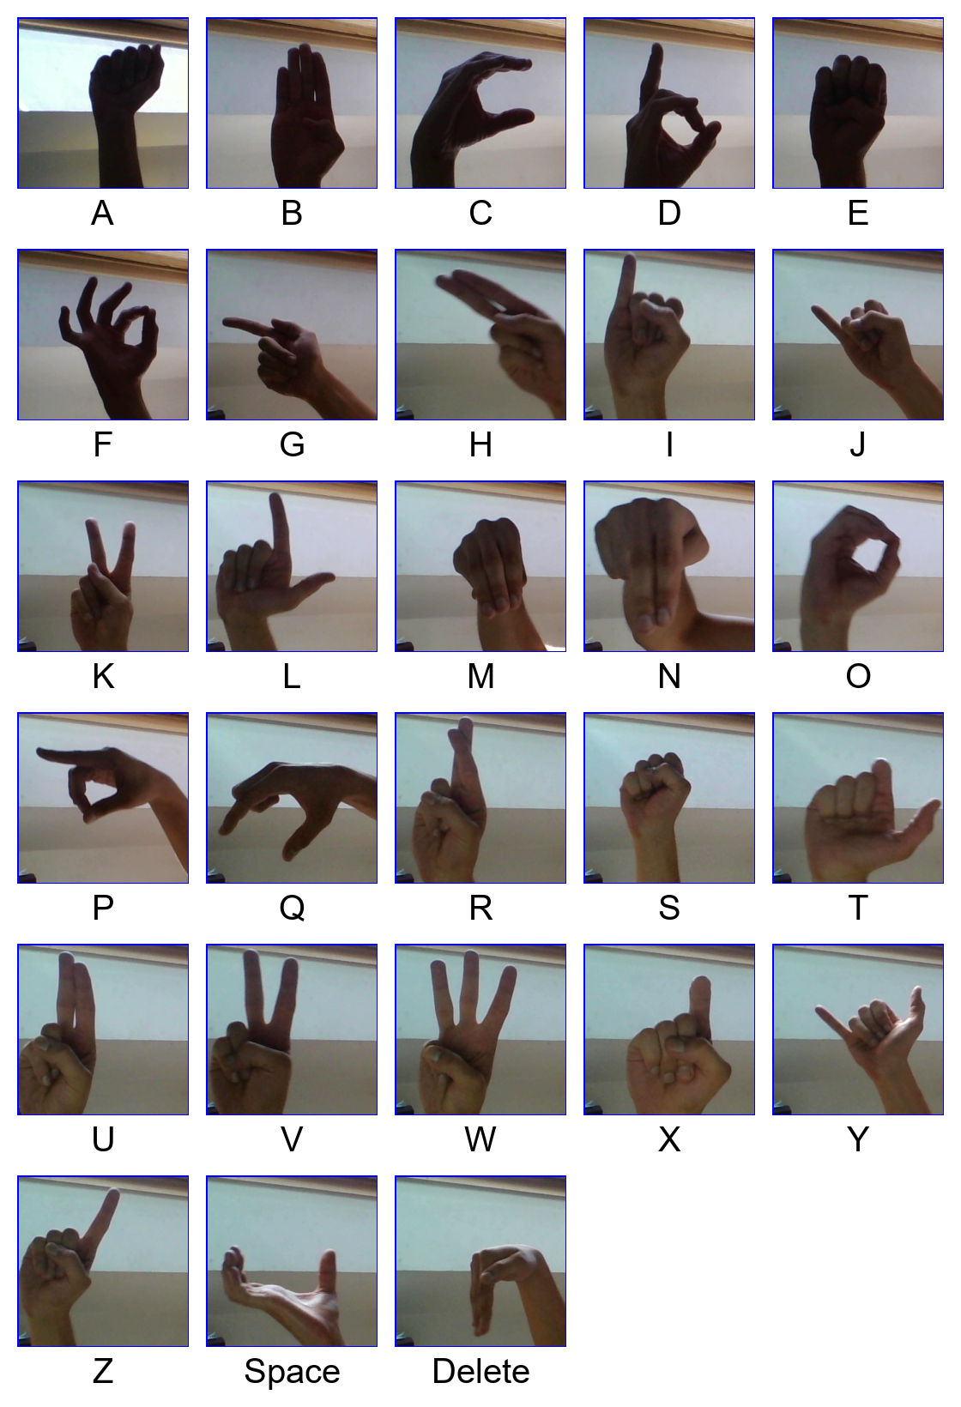
Sources of data-
https://www.kaggle.com/datasets/grassknoted/asl-alphabet
https://www.kaggle.com/datasets/ayuraj/asl-dataset

6.2 Feature Extraction: using Mediapipe
Feature extraction has an important role in our project since raw images are not directly fed into the machine learning model. Instead, we used a powerful computer vision library, Mediapipe Hands, provided by Google to extract useful information from each image. When any ASL hand gesture image is input into the Mediapipe estimator, it parses the image for the detection of the hand region. Thereafter, it identifies 21 key landmark points on the hand. These include the tip and joint positions of all fingers along with the base points of the palm. Each landmark provides three types of information: its X-position (horizontal location), Y-position (vertical location), and Z-depth (how close or far the point is from the camera). As a result, every image is converted into a set of 63 numerical values (21 landmarks × 3 coordinates).
These 63 values represent the shape, structure, and orientation of the hand precisely. Thus, from a machine learning point of view, these are of high utility. Since capturing is related to the geometry between finger joints, the model will find it much easier to distinguish between the letters, even in case of variation in the size of the hand or light conditions. For these, we extracted features from all images and stored them in a CSV file that then became our dataset which we used to train the classification model. This greatly simplifies the learning process because the model does not need to process full images or complex pixel data, but learns directly from clean and structured positions of the landmarks, improving both training efficiency and the accuracy of the predictions.

6.3 Preprocessing
Preprocessing is generally one of the most crucial steps involved in any machine learning project. This is because raw images may have a considerable level of noise, background clutter, variations in lighting, or variations in size and orientation. Preprocessing involves mainly converting an image into grayscale, normalizing all images to a single fixed-size dimension, filtering, outlier elimination, scaling numerical values, or normalization of the dataset. The various steps discussed in the preprocessing stage help to make the data uniform and ensure a model can learn from it effectively.
However, none of these preprocessing operations was done in our project, and the decision was made on purpose. The major reason is that our project relies purely on the landmark coordinates extracted by Mediapipe instead of raw pixel data. Mediapipe automatically detects the hand, segments it out, and provides accurately normalized coordinates of 21 landmarks. These coordinates already represent the geometric structure of a hand without being affected by image background, lighting variations, or hand size. Since Mediapipe outputs clean and structured numerical features, additional preprocessing operations like filtering or normalization have very limited benefit.
In addition, no preprocessing methods were needed, such as image resizing, cropping, or grayscale conversion, as the model never even saw the raw image, using only the 63 numerical features created by Mediapipe. Even operations like removing outliers or scaling values were unnecessary because Mediapipe maintains consistent coordinate ranges across images. The only implicit data cleaning that occurred was that images where Mediapipe failed to detect a hand were automatically excluded, ensuring high-quality input for the model.

6.4 Model Selection and Comparison
We experimented with machine learning techniques to identify the best model for classifying ASL hand signs. Our dataset includes 63 attributes derived from Mediapipe landmarks; therefore we required a model effective, for structured moderately sized numerical data. We tested three models: K-Nearest Neighbors (KNN), Random Forest, and Support Vector Machine. After comparing their performances, we chose SVM as our final model because it outperformed the others in terms of accuracy and stability.

6.4.1. KNN (K-Nearest Neighbors)
KNN is the straightforward method that predicts outcomes by evaluating the distance between data points. In our situation though it did not achieve results since the dataset contained 63 dimensions and KNN struggles with high-dimensional data a challenge referred to as the curse of dimensionality. Additionally KNN has prediction speed because every new instance must be compared to all existing training samples. The accuracy of KNN was inconsistent, unable to differentiate ASL letters with nearly identical landmark positions. Consequently this rendered it inappropriate for our classification task.
6.4.2. Random Forest
At first Random Forest demonstrated results compared to KNN. This method utilizes decision trees and merges their results to make a prediction. It is also effective in managing data. Nonetheless Random Forest is prone to overfitting when dealing with landmark-based data. Overfitting here implies the model retains the training data excessively and performs poorly on data. Because ASL signs demand recognition of finger placements Random Forest could not reliably identify signs such as M, N and other comparable gestures. Therefore, this inconsistency is the reason behind its unreliability for real-time detection.

6.4.3. SVM (Support Vector Machine): Chosen Model
SVM surpassed both KNN and Random Forest regarding accuracy, reliability and robustness. The reasons behind SVM being the choice are that the data is numeric and organized with a moderate feature count (63). The RBF kernel employed in SVM aids in distinguishing patterns by forming a non-linear separation between categories. Such non-linearity can be especially beneficial for ASL signs, where subtle variations in finger placement might signify letters. SVM offers generalization, resists overfitting and therefore provides consistent predictions for both image and webcam data. The confidence scores produced by the SVM improved dependability in detection scenarios. Reason for selecting SVM Among the models considered SVM proved to be the performer for this task as it consistently outperformed other methods, in accuracy, robustness and real-world applicability. During testing SVM achieved the accuracy and effectively handled all 63 landmark features even among ASL letters that appear quite similar. It proved effective for a dataset of medium scale, a range in which deep learning models tend to underperform as they need thousands of training samples. Additionally employing the RBF kernel in SVM enabled the model to capture hand gesture patterns by forming non-linear separations between categories thereby enhancing the overall classification accuracy. Through testing it was discovered that SVM resisted overfitting better than Random Forest and provided far more dependable predictions than KNN, which struggled with high-dimensional data and sluggish processing. SVM consistently delivered reliable outcomes even during real-time webcam trials making it ideal for practical use. By considering all aspects of performance and accuracy, generalization ability, and real-world reliability, it was decided that SVM was the most effective and appropriate model for recognizing ASL hand signs in this project.

6.5 Model Training
After extracting the 63 features from each ASL image the following step was to train the machine learning model. These numerical features served as input to a Support Vector Machine (SVM) classifier, selected because of its results in model assessments. The RBF (Radial Basis Function) kernel was utilized, being well-suited for datasets exhibiting a relationship between features and output classes. In ASL gestures small changes in finger positioning can lead to signs, which makes the RBF kernel valuable, for the model to accurately identify these subtle variations.
During the training process we enabled the probability=True setting to allow the model to assess prediction certainty. This certainty measure became vital later during detection as the system avoids reporting predictions it's unsure about. We fine-tuned hyperparameters such as C and gamma. The C parameter controls overfitting by deciding how strictly the model separates classes while the gamma parameter specifies the extent of influence each training instance exerts. Adjusting these parameters enhanced the model’s generalization capability. Minimized classification errors, for signs.
Once the training process reached a stable accuracy and consistent performance across classes, the final trained model was saved into a file named svm_mediapipe.pkl. Saving the model ensures that it does not need to be retrained every time. Instead, this file can be loaded instantly during image-based testing or webcam detection. Both the website interface and the real-time prediction system use this saved model to recognize ASL signs efficiently. This trained SVM model forms the core intelligence of the entire application.

6.6 Model Evaluation:
Once the training of our SVM model was finished we had to assess how effectively it works with data. To achieve this we evaluated the model using images—images excluded from the training set. This allows us to determine if the model can identify hand signs rather than simply recalling those it learned during training. The initial metric we examined was the accuracy score indicating the percentage of predictions. A high accuracy indicates that the model has successfully captured the patterns in the dataset.

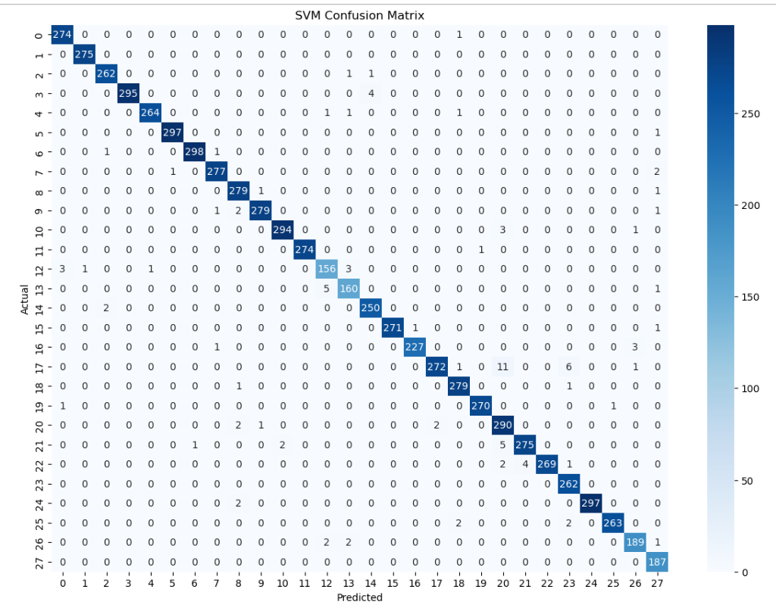
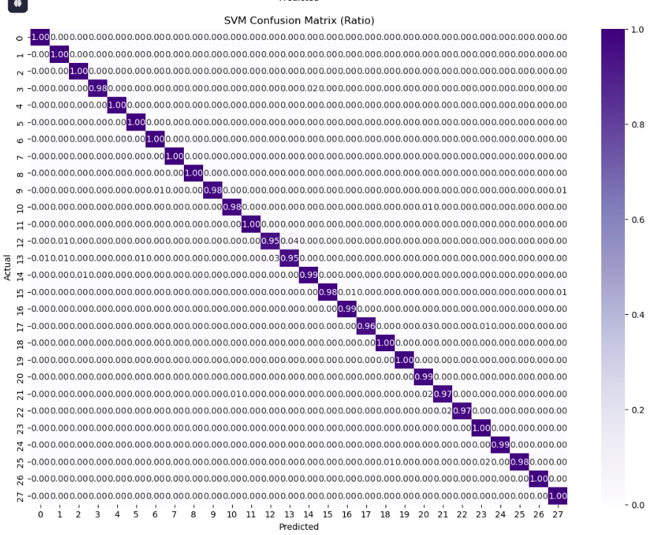
We also analyzed the confusion matrix providing a comprehensive view of the model's performance. The matrix reveals which ASL letters were accurately identified and which ones were mistaken for letters. This gave us insight into the model’s points and areas for improvement. A prominent observation was the mix-up, between the letters M and N. These gestures look alike differing solely in the placement of one finger. The hand landmark points lie near one another so although the images appear distinct to us the numerical coordinates are nearly the same. As a result the SVM model struggled to distinguish M from N, a challenge that can be taken up in further improvisations as a part of future scope.
To evaluate the model’s effectiveness in conditions we conducted tests using the webcam in real-time. In this configuration the camera continuously recorded frames. Mediapipe immediately identified landmarks. The SVM model subsequently predicted the sign for each frame. Throughout the testing we observed that the system performed excellently when the illumination was strong the background was uncluttered. The hand was positioned clearly in front of the camera. The forecasts were rapid and consistent with the confidence percentage assisting in eliminating poor-quality predictions. Nonetheless in light or when the hand was distant or angled the precision decreased a bit. This indicated that although the model's dependable its effectiveness remains influenced by the camera input quality.
Overall, the evaluation results showed that the SVM model is capable of recognizing ASL letters accurately and works effectively in both image-based input and real-time webcam mode, with only minor errors in visually similar signs. This proves that the model is suitable for practical use in sign recognition applications.
6.7 Deployment :
Deployment refers to the way our project is utilized in scenarios once the model training is complete. Our system was implemented through two stage methodology: real-time prediction using a webcam and text-, to-speech conversion.
We additionally implemented the system for real-time operation with a webcam offering increased interactivity. In this setup the webcam continuously records video frames. Mediapipe identifies the hand in each frame. Immediately retrieves landmark points. The SVM model continuously forecasts the letter long as the hand remains in view. To prevent the system from repeating the letter verbally multiple times it only vocalizes when the predicted sign differs. This approach makes the system more fluid and less irritating to use during real-time evaluation. The instant mode allows users to interact immediately without the requirement to upload pictures.
A further crucial element of deployment is text-to-speech (TTS). Once the model forecasts a letter pyttsx3 is utilized by the system to vocalize the letter. This functionality is primarily included to assist impaired individuals who are unable to see the output on the display. TTS enables them to comprehend which gesture is being represented or what the model recognized. Additionally the system is configured to avoid repeating the sound unless the gesture genuinely changes.

8. RESULTS AND DISCUSSION:
The outcomes of our project distinctly demonstrate that the SVM model is proficient, in detecting ASL hand gestures. Upon evaluating the model with images it attained high precision indicating it accurately recognized the majority of the signs. This robust performance is largely attributed to Mediapipe delivering clear landmark points for each hand image, which facilitated the SVM model in grasping the precise form and arrangement of fingers. These dependable landmarks significantly contributed to the models ability to differentiate between the letters. While conducting testing with the webcam the system operated seamlessly. Provided there was lighting and the hand was distinctly visible to the camera the predictions were quick, consistent and precise. This demonstrates that the model is applicable not in controlled image experiments but also, in genuine real-world scenarios.
Although the model showed performance overall certain difficulties were noted. The frequent mistake occurred when the model attempted to distinguish between the letters M and N. These two ASL signs are highly alike differing solely by a finger placement with hand landmarks that appear nearly the same. Even humans can find these signs tricky to differentiate at a glance. Due to the proximity of their landmark coordinates the model sometimes incorrectly identifies one, as the other. Although this constraint existed the overall system proved dependable and easy to use. The Text- to-Speech (TTS) functionality enabled the output to be accessible for individuals to view the screen enhancing the systems inclusivity. Furthermore the webcam-driven mode increased interactivity and convenience by permitting users to convey messages through live hand signals. Overall, the results show that our approach is effective, fast, and useful for recognizing basic ASL alphabet signs, especially in well-lit and simple environments.
9. LIMITATIONS:
- It does not support large vocabulary or full sentence recognition.
- Not a full ASL translation system: The system can detect alphabets and a few gestures but cannot understand continuous sign language or complex expressions.
- Supports only single-hand signs: Gestures that require both hands are not recognized.
- Similar gestures cause confusion: Signs such as M and N look very similar, so the model sometimes misclassifies them.
- Lighting-sensitive: Accuracy decreases in poor lighting or when shadows cover the hand.
- Hand position matters: Predictions are less accurate if the hand is too close, too far, tilted, or partially visible.
- Limited gesture dataset: Since training was done only on alphabets, the system cannot identify a wide range of signs.

10. FUTURE ENHANCEMENTS
- Add support for two-hand ASL gestures: Many ASL signs require both hands, which the current system cannot detect.
- Improve sentence-level recognition: The webcam can recognize a wide range of individual words, but it still cannot interpret full sentences or continuous signing.
- Better segmentation of continuous signing: Add a mechanism to detect when one word ends and the next word starts during fast hand movements.
- Advanced deep learning models: Use CNNs, LSTMs, or Transformers to improve accuracy, especially for similar or complex gestures.
- Add grammar correction and language modeling: Once multiple words are detected, the system can arrange them into meaningful sentence structures.
- Mobile app development: Build a portable Android/iOS version so users can access the system anywhere.
- Multilingual speech output: Speak recognized words in different languages(more than two languages) (Kannada, Hindi, Tamil, etc.).
- Bigger and more diverse dataset: Train on more hand samples with different lighting, backgrounds, skin tones, and camera angles for stronger real-world performance.
- Faster and more stable real-time detection:Improve speed and stability of word recognition in low-light or noisy background conditions.
- Hardware deployment: Implement the system on Raspberry Pi or edge devices for low-cost portable assistive communication tools.

11. CONCLUSION:
In summary this project effectively developed a system capable of identifying American Sign Language (ASL) hand gestures through live webcam input. Utilizing Mediapipe for hand landmark detection and SVM for sign classification the system accurately recognizes ASL letters and several whole words. Additionally the Text-to-Speech functionality enhances accessibility by providing output for users who cannot view the screen benefiting visually impaired individuals. In general the project is straightforward, affordable and user-friendly demonstrating that machine learning can serve as an aid for individuals facing communication challenges.
Although the existing version primarily detects single-hand signs along with letters or words it nonetheless offers a solid and dependable base for upcoming developments. By enhancing features such as incorporating two- gesture detection, interpreting complete sentences, boosting real-time precision and building a mobile application—the system can evolve into a comprehensive ASL translation device. In the future, this project has the potential to help millions of people communicate more easily and break the communication gap between hearing, speech, and visually impaired individuals.

