M KARTHIKEYAN

IT - B

**CC – 1**

**QUESTION– 1**

Package CC1;

import org.openqa.selenium.By;

import org.openqa.selenium.WebDriver;

import org.openqa.selenium.firefox.FirefoxDriver;

import io.github.bonigarcia.wdm.WebDriverManager;

public class CC1QS1 {

public static void main( String[] args ) throws InterruptedException

{

WebDriverManager.firefoxdriver().setup();

WebDriver driver = new FirefoxDriver();

driver.manage().window().maximize();

driver.navigate().to("https://www.saucedemo.com/");

driver.manage().window().maximize();

driver.findElement(By.xpath("//*[@id=\"user-name\"]")).sendKeys("standard_user");

driver.findElement(By.xpath("//*[@id=\"password\"]")).sendKeys("secret_sauce");

driver.findElement(By.xpath("//*[@id=\"login-button\"]")).click();

driver.findElement(By.xpath("//*[@id=\"add-to-cart-sauce-labs-backpack\"]")).click();

String cartNum = driver.findElement(By.xpath("/html/body/div/div/div/div[1]/div[1]/div[3]/a/span")).getText();

if (cartNum.equals("1")) {

System.out.println("Successfully Added to the cart");

}

driver.findElement(By.xpath("/html/body/div/div/div/div[1]/div[1]/div[3]/a")).click();

String prodStr = "Sauce Labs Backpack";

if(driver.findElement(By.xpath("/html/body/div/div/div/div[2]/div/div[1]/div[3]/div[2]/a/div")).getText().equals(prodStr));

{

System.out.println("User can view the contents of the cart");

}

driver.findElement(By.xpath("//*[@id=\"checkout\"]")).click();

if(driver.findElement(By.xpath("/html/body/div/div/div/div[1]/div[2]/span")).getText().equals("Checkout: Your Information")) {

System.out.println("Your information form is displayed");

}

driver.findElement(By.xpath("//*[@id=\"first-name\"]")).sendKeys("KARTHIKEYAN");

driver.findElement(By.xpath("//*[@id=\"last-name\"]")).sendKeys("M");

driver.findElement(By.xpath("//*[@id=\"postal-code\"]")).sendKeys("60001");

driver.findElement(By.xpath("//*[@id=\"continue\"]")).click();

if(driver.findElement(By.xpath("/html/body/div/div/div/div[1]/div[2]/span")).getText().equals("Checkout: Overview")) {

System.out.println("Product overview page is displayed");

}

System.out.println("Name of the product: " + driver.findElement(By.xpath("/html/body/div/div/div/div[2]/div/div[1]/div[3]/div[2]/a/div")).getText());

System.out.println("Price of the product: " + driver.findElement(By.xpath("/html/body/div/div/div/div[2]/div/div[1]/div[3]/div[2]/div[2]/div")).getText());

if(driver.getTitle().equals("Swag Labs")) {

System.out.println("Title matched");

}

if(driver.getCurrentUrl().equals("https://www.saucedemo.com/checkout-step-two.html")) {

System.out.println("URL matched");

}

}

}

**Output :**

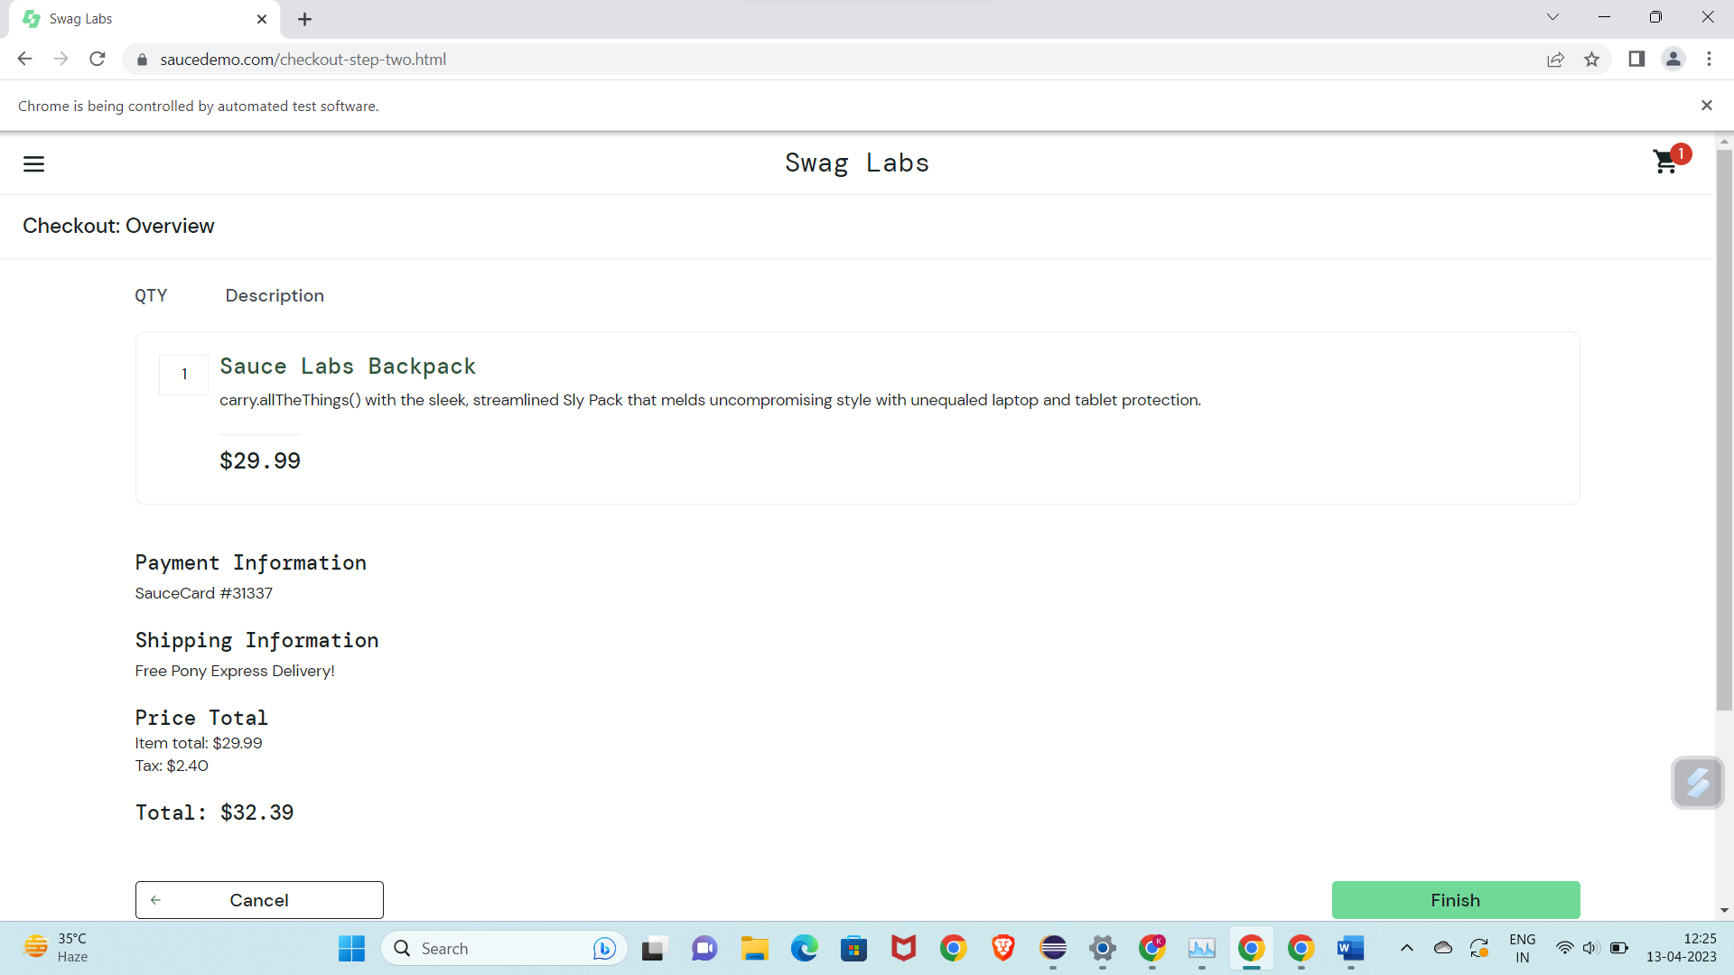

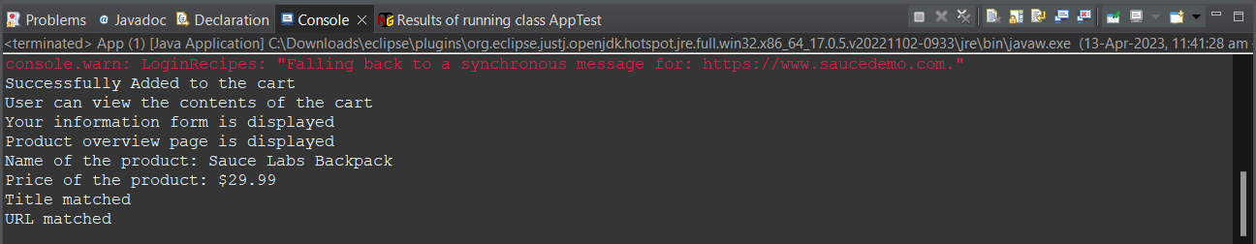

**QUESTION– 2**

Package CC1;

import org.openqa.selenium.By;

import org.openqa.selenium.WebDriver;

import org.openqa.selenium.WebElement;

import org.openqa.selenium.firefox.FirefoxDriver;

import org.openqa.selenium.support.ui.Select;

import io.github.bonigarcia.wdm.WebDriverManager;

public class CC1QS2{

public static void main( String[] args ) throws InterruptedException

{

WebDriverManager.*firefoxdriver*().setup();

WebDriver driver = new FirefoxDriver();

driver.manage().window().maximize();

driver.navigate().to("https://www.saucedemo.com/");

driver.manage().window().maximize();

WebElement txtBoxl=driver.findElement(By.*xpath*("//*[@id=\"user-name\"]"));

txtBoxl.sendKeys("standard_user");

WebElement txtBox2=driver.findElement(By.*xpath*("//*[@id=\"password\"]"));

txtBox2.sendKeys("secret_sauce");

driver.findElement(By.*xpath*("//*[@id=\"login-button\"]")).click();

String txt1=driver.findElement(By.*xpath*("//*[@id=\"item_4_title_link\"]/div")).getText();

System.***out***.println(txt1);

driver.findElement(By.*xpath*("//*[@id=\"header_container\"]/div[2]/div/span/select")).click();

driver.findElement(By.*xpath*("//*[@id=\"header_container\"]/div[2]/div/span/select/option[2]")).click();

String txt2=driver.findElement(By.*xpath*("//*[@id=\"item_3_title_link\"]/div")).getText();

System.***out***.println(txt2);

driver.findElement(By.*xpath*("//*[@id=\"header_container\"]/div[2]/div/span/select")).click();

driver.findElement(By.*xpath*("//*[@id=\"header_container\"]/div[2]/div/span/select/option[3]")).click();

String txt3=driver.findElement(By.*xpath*("//*[@id=\"item_2_title_link\"]/div")).getText();

System.***out***.println(txt3);

driver.findElement(By.*xpath*("//*[@id=\"header_container\"]/div[2]/div/span/select")).click();

driver.findElement(By.*xpath*("//*[@id=\"header_container\"]/div[2]/div/span/select/option[4]")).click();

String txt4=driver.findElement(By.*xpath*("//*[@id=\"item_5_title_link\"]/div")).getText();

System.***out***.println(txt4);

Thread.*sleep*(5000);

}

}

**Output:**

