Task 1

Link : http:// http://3.110.88.194/

Final Output:

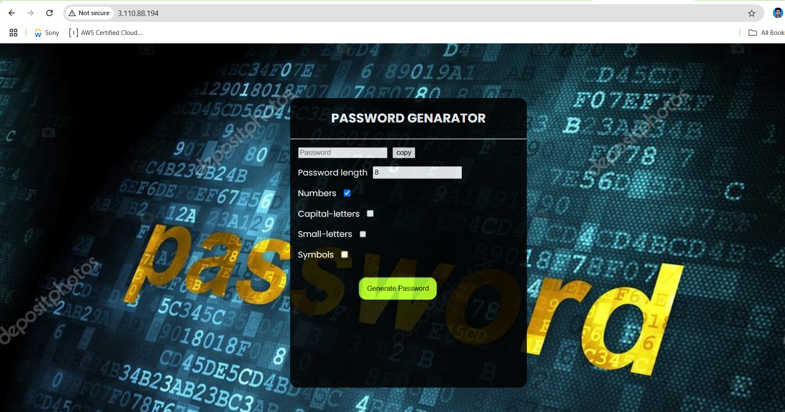

Task 2

Link : http:// http://43.204.142.216/

Final Output:

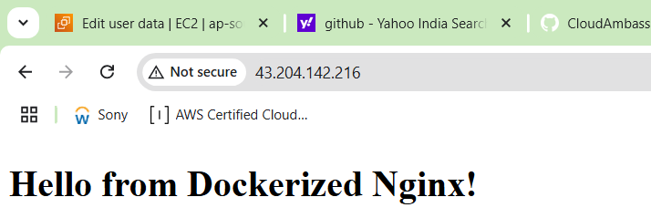

Server Details:-

Task 1 Server

Server Name : App_server