Working diagram.

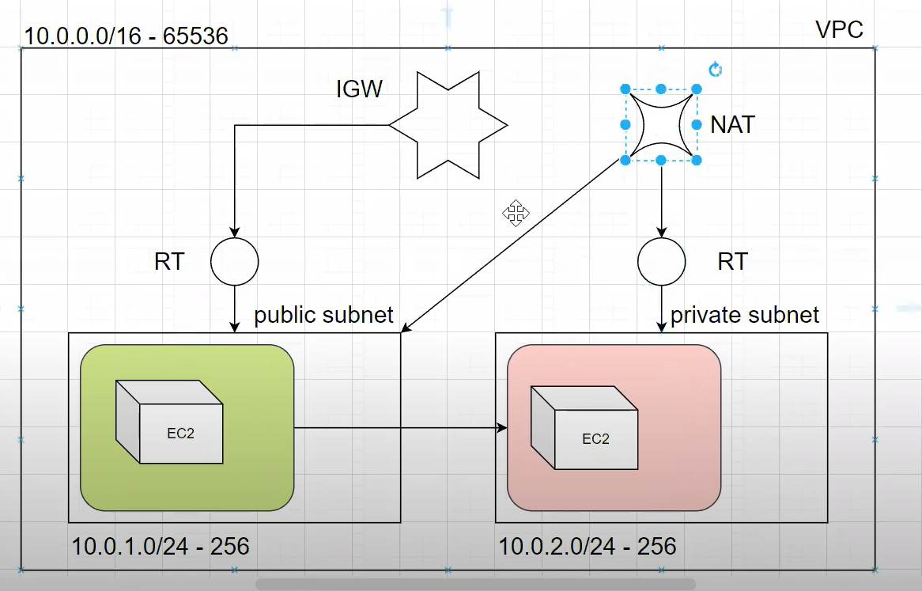

VPC – 1

Subnet – pub

Route tables

Internet Gateway

NAT Gateway

Security Groups

