BossRater

Team 6

Sri Maruti Ram Kumar Avantsa

Tayseer Edouni,

Jeremy Mann,

Akshay Pawar,

Pragya Tak

1. **Project Scope**

BossRater is an application built for employees so that they may leave constructive feedback for their bosses (rating and feedback). BossRater is meant to be used within a company’s private network (not available for world wide web). There is no account creation (bosses cannot determine which employee wrote which feedback). Users can search for bosses by searching for their name in the search bar (this will filter all the feedback and display only the feedback with matching names). Employees may either like or dislike a rating by giving a thumbs up or a thumbs down.

1. **Tools/Software Used**

BossRater uses the json-server tool (creates a local json server for simple data POST/GET requests). BossRater does not use any other backend platform (mainly due to the lack of account creation). BossRater uses Twitter’s Bootstrap (getbootstrap.com) for basic CSS formatting. Ionicons (<http://ionicons.com/)> was used for icons within the web application. Fontawesome (<http://fontawesome.io/)> was used to import custom fonts within the web application.

**3.0 Installation & Configuration Documentation**

1.

This project requires the usage of a json server.

To install the json-server tool, enter the following command in command line/terminal

"npm install -g json-server"

or if using OSX or UNIX

"sudo npm install -g json-server"

2. Open Atom (or another text editor)

Save file as "feedbackdb.json" and in the main project directory

Enter the following text and then save and close the file:

{

"feedbackData": [

{

"bossName": "Test Name",

"bossDepartment": "Test Department",

"bossFeedback": "TestFeedback",

"rating": "10",

"upvotes": "0",

"downvotes": "0",

"id": "BkhZsNPhl"

}

]

}

3. When in the main directory of the project (where feedbackdb.json is located).

Enter the following into the command line /terminal:

"json-server --port=3002 --watch feedbackdb.json"

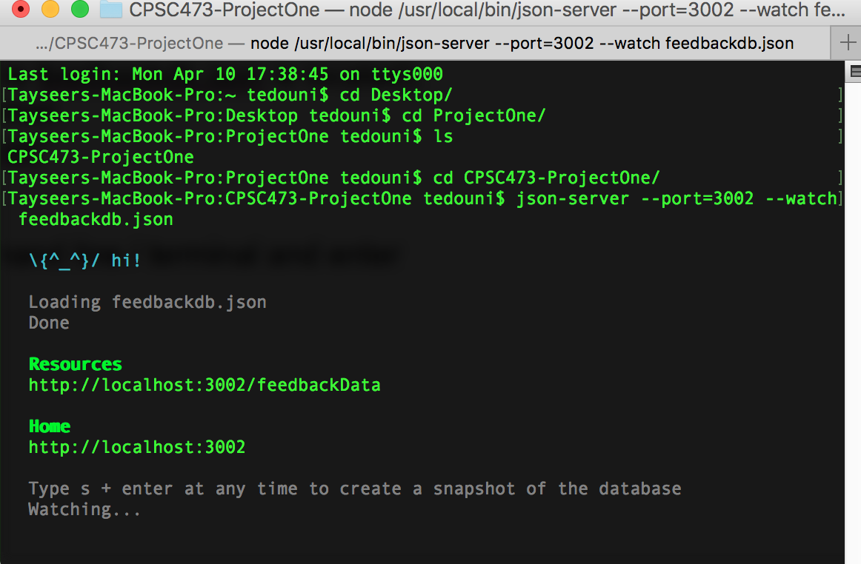

4. The final step is to install and run browser-sync.

In order to install browser-sync, open the command line / terminal and enter

the follwing command:

"npm install -g browser-sync"

or if using OSX or UNIX

"sudo npm install -g browser-sync"

While within the project’s main directory, enter the following command in command line / terminal:

browser-sync start --server -- files "stylesheets/*.css, scripts/*.js, *.html"

It will launch the website locally. Make sure that this is done after the json server is already running.

**4.0 User Documentation**

1. Main page

When the user first loads the webpage they will see the below screenshot. Here they will have the option to scroll through all available ratings and to like or dislike a rating (by clicking on thumbs up or thumbs down).

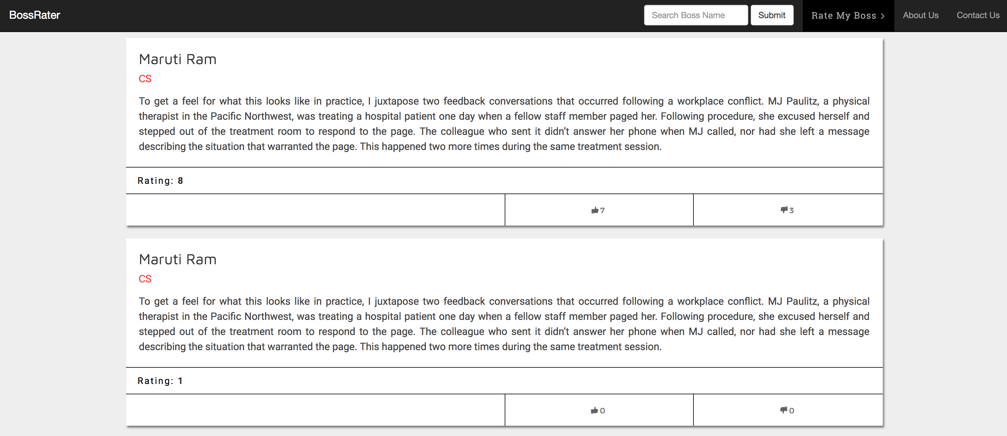

1. Searching/Filter for Boss  
     
   For a user to search for a specific boss, they will need to click on the search bar (near the header of the page). They will need to enter the name of their boss (capitalization and spelling need to be correct). The webpage will then display only the ratings with that specified boss name.

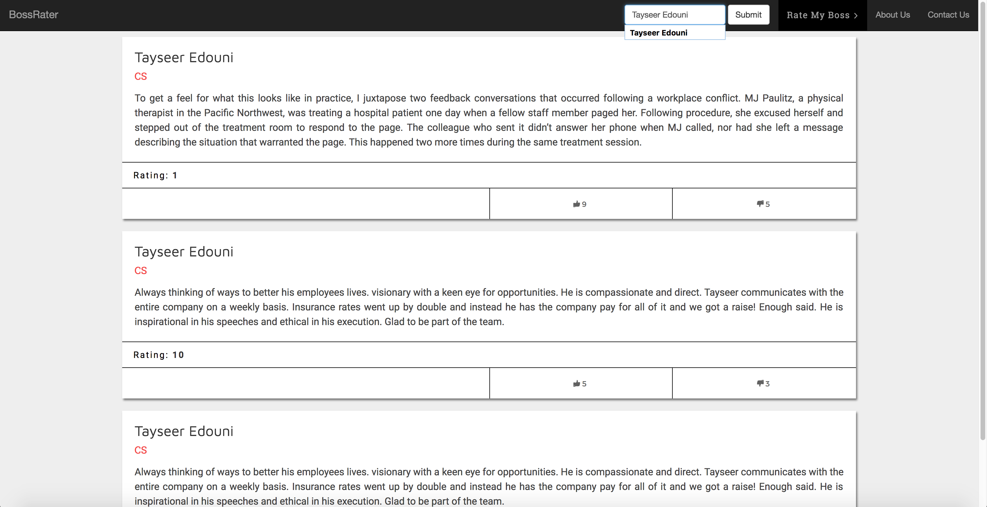

1. Posting a Rating/Review

For a user to submit a rating/review of their boss, they need to first click on “Rate My Boss”, which is next to the search field. The feedback field will then pop up with a yellow background.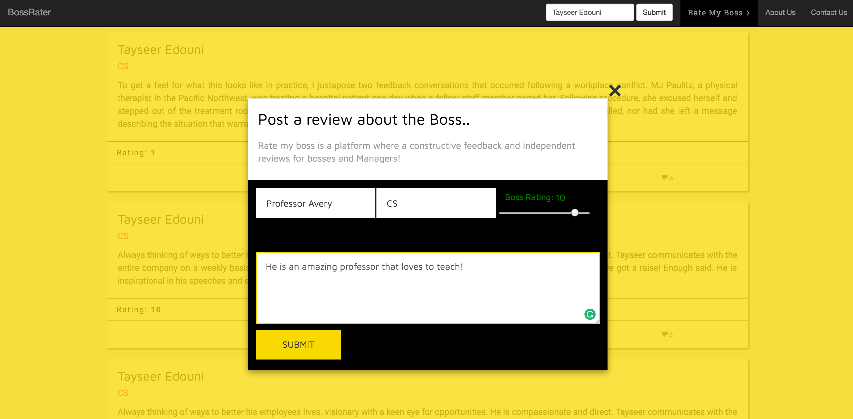

When the user has submitted their review/rating, the page will reload with their review/rating at the top of the list.

