**Task -2**

**Server connection -EC2**

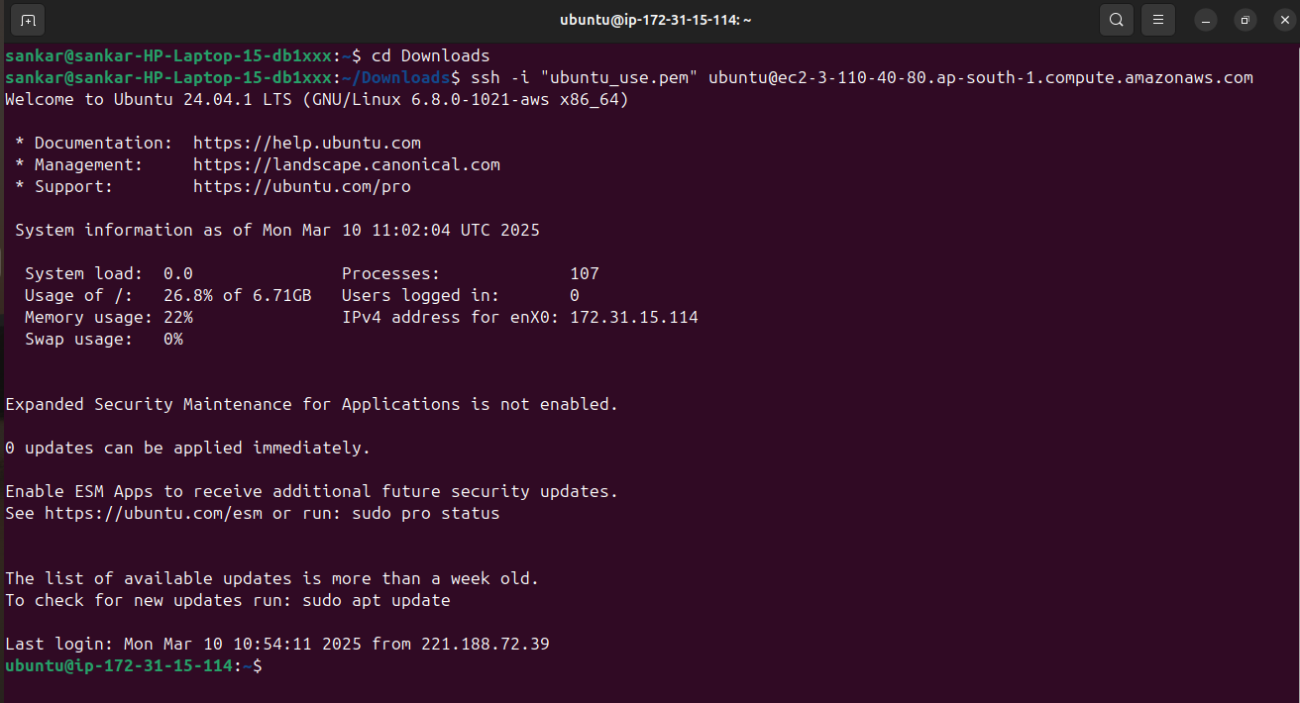

**File permission set command**

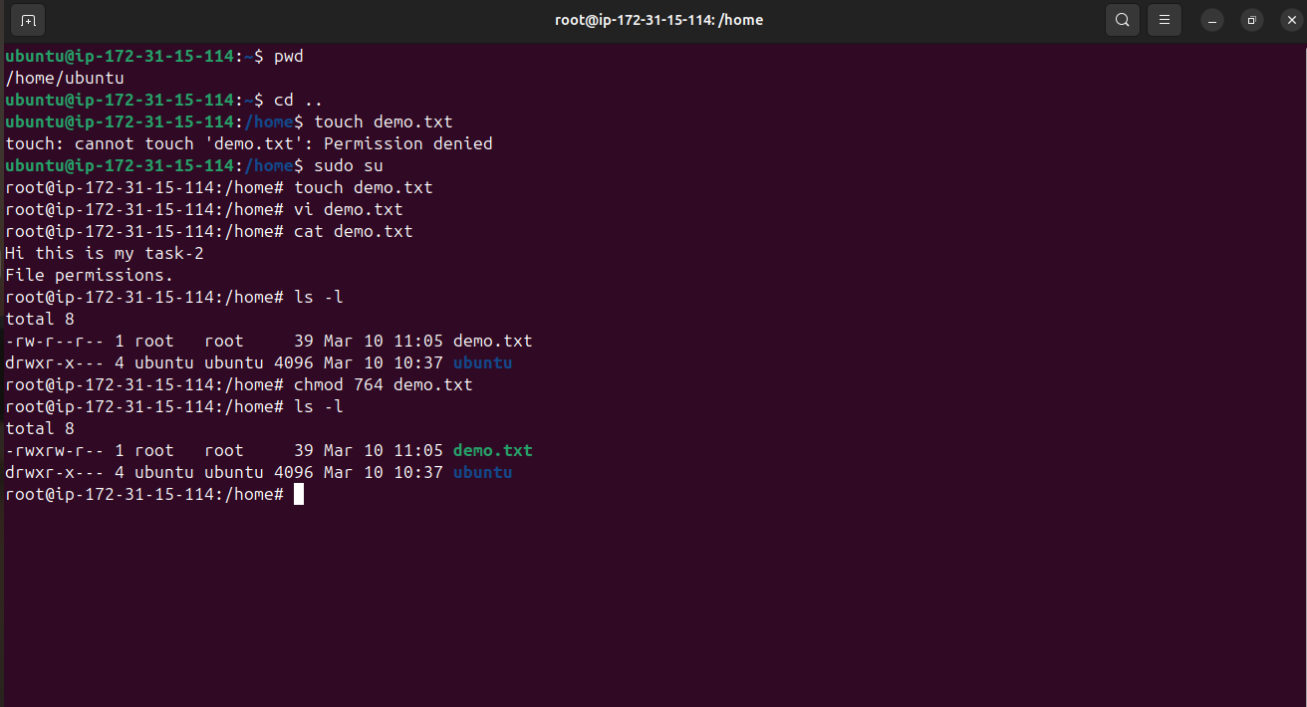

**File permission to users - Check (Supporting images)**

User names used here :

1. owner_user – read / write / execute

2. group_user – read / write

3. Others – read

