Created vpc- my-vpc

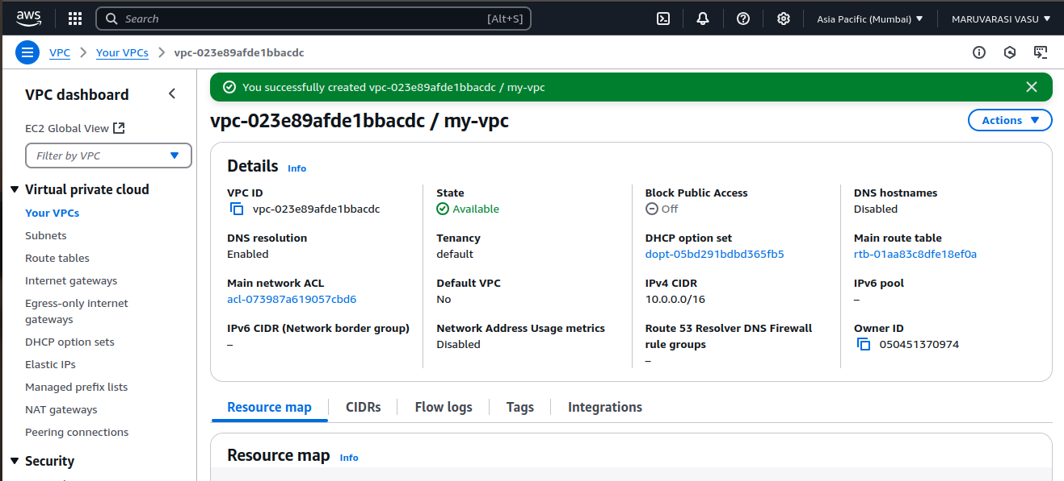

created 2 subnets

my-subnet -01 – public subnet

my-subnet -02 – private subnet

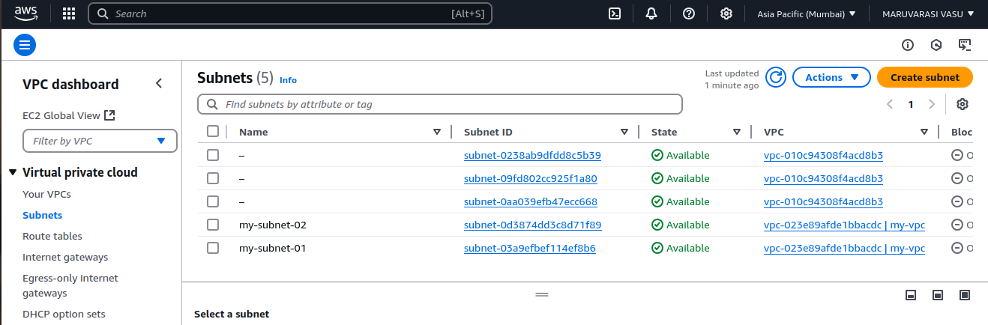

connected to internet gateway (my-igw)

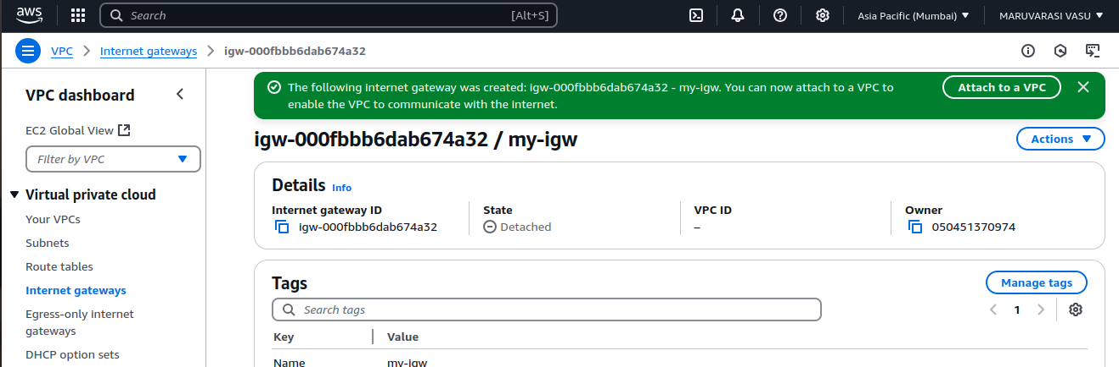

Attached internet gateway to vpc- (my-igw : my-vpc)

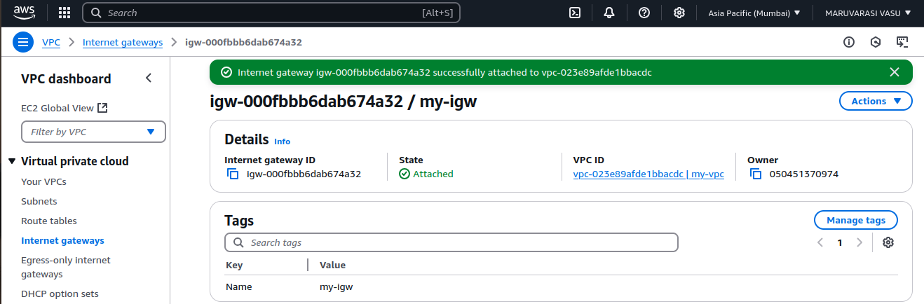

created routing table

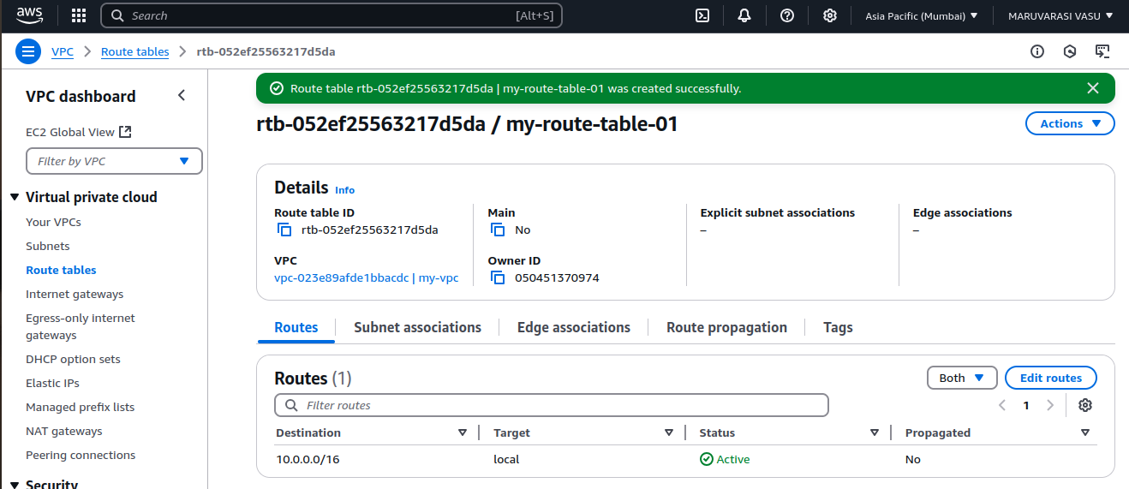

subnet Association- public subnet (my-subnet-01)

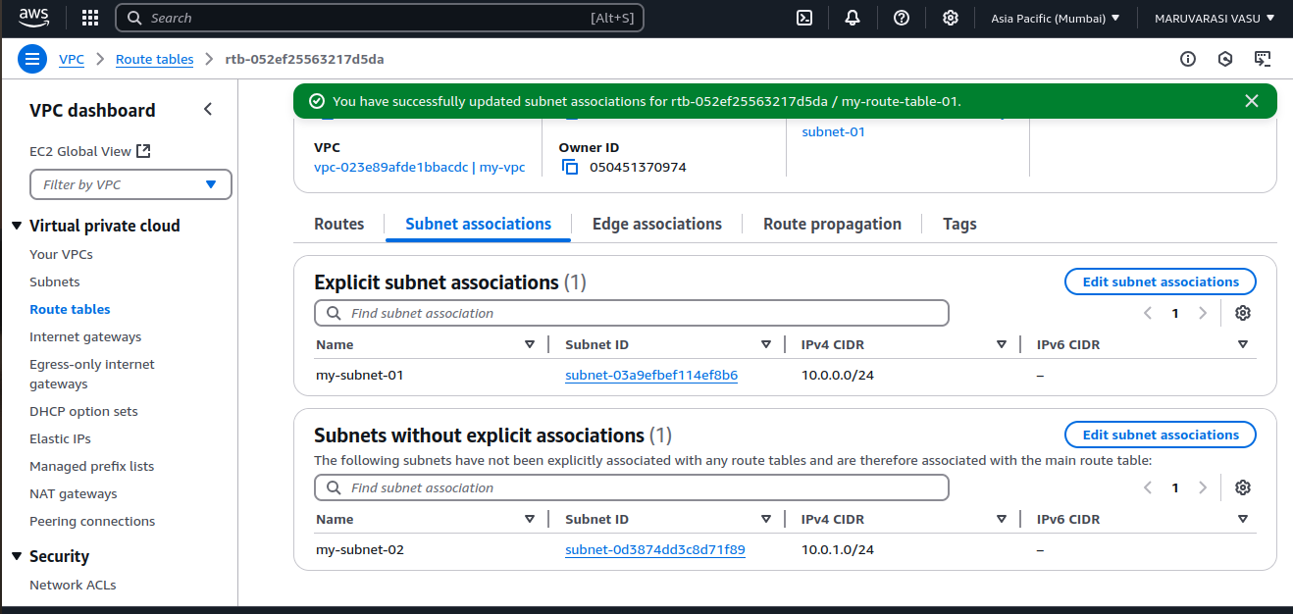

updated routes

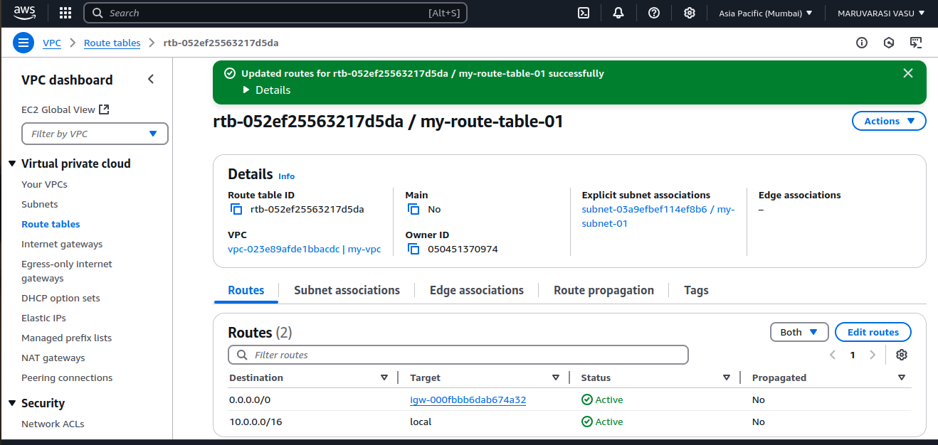

Map:

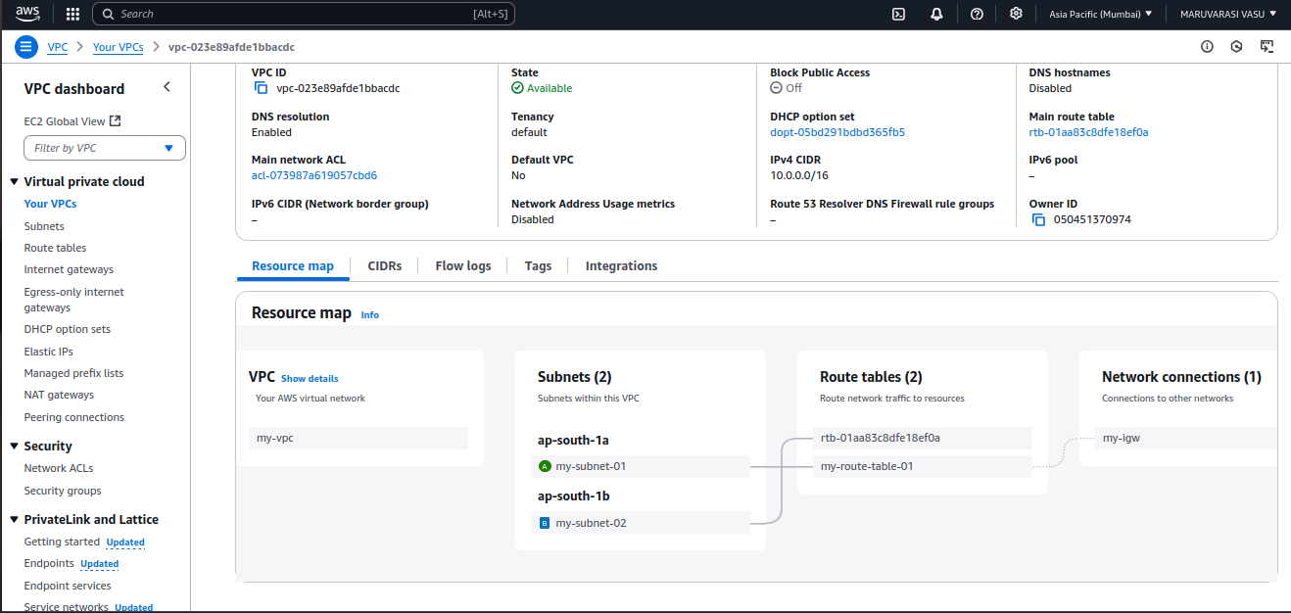

created instances public and private:

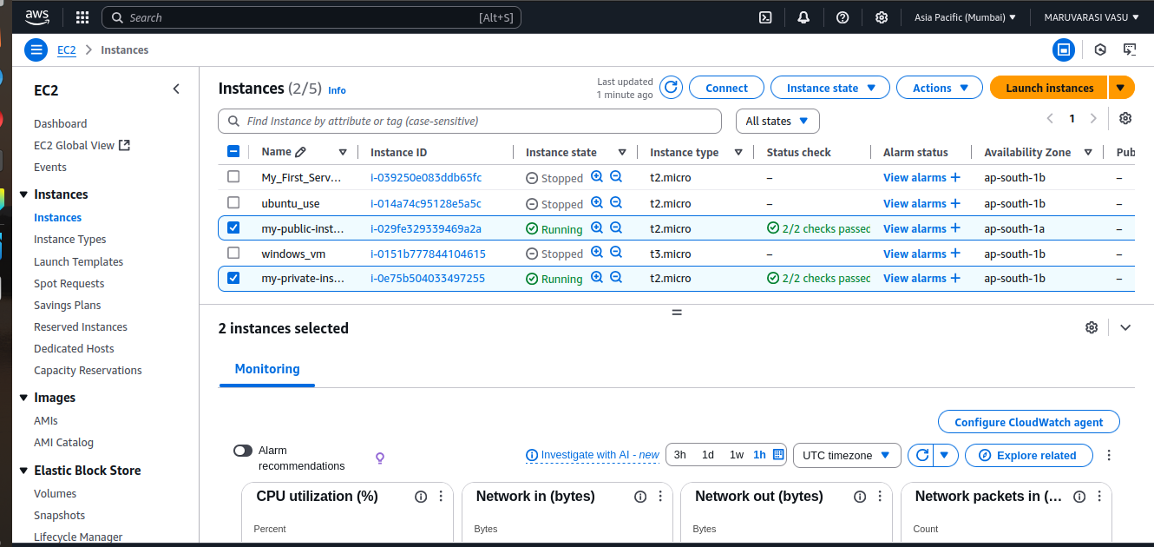

connected a linux ec2 instance – vpc and public subnet

checked google server for connectivity.

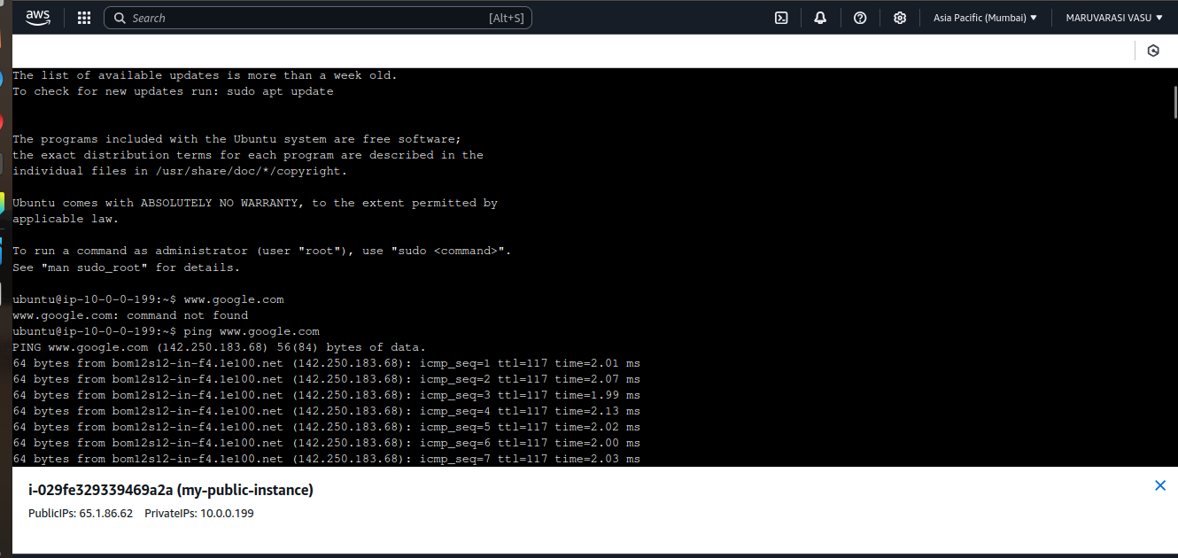

Git bash

