Welcome to the Enterprise IT Onboarding Process
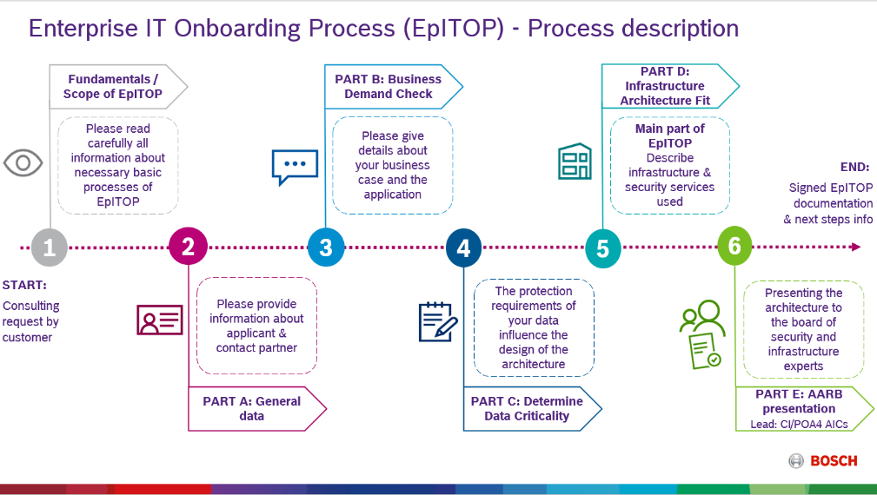 | This document is intended to  prepare the onboarding of applications to the Bosch Enterprise IT. The “Enterprise IT Onboarding Process” (EpITOP) is embedded into the IT@Bosch landscape.  Scope: Check on-prem and cloud integration infrastructure architectures to fit into overall Bosch EIT by concentrating on security, operations and infrastructure aspects.  More Info: EpITOP: Step by Step

Content
1 Fundamentals / Scope of EpITOP 2
2 PART A – General Data 3
2.1 Applicant information 3
2.2 CI Contact Partner 3
3 PART B – Business Demand Check 4
3.1 Business demand / application details 4
3.2 Application Operation 4
4 PART C – Determine Data Criticality 4
5 PART D – Infrastructure Architecture Fit 5
5.1 IT Infrastructure Service Check (a-d) 5
5.2 IT Security Check (a-d) 6
5.3 Cloud connection details (c) 8
5.4 Network Zones Architecture (a-d) 8
6 PART E – Application Architecture Review Board (AARB) 9
7 Revision History 11

Fundamentals / Scope of EpITOP
Section to be read by contact partner for this EpITOP

The Enterprise IT Onboarding Process is based on several guidelines and processes at Bosch:
- Security Engineering Process (for developers, project managers)
The Security Engineering Process is mandatory for development of Bosch products at RB since the end of 2016 – including CI software projects.


- Architecture work stream (for customer architect)
Follow the C/IDA “Architecture Work Stream” methodology for evaluating the architecture (especially part 1 Question Zero Template and part 4 guidelines for the “Architecture Check”)

- Data security classes (for Master of Data)
A description on how to assign security classes can be found in the Bosch Connect blog entry Five Minutes for Security Classes

- IT security guidelines and central directives
The central directives CD 07900 and CD 02900 contain requirements for all IT systems. Based on these CDs, further information and measures can be found in the EISA (Bosch Enterprise IT Security Architecture). For manufacturing topics CD 04602-002 and for engineering topics CD 07151 are mandatory, too.

- Security zone concept (for IT architects)
The Security Zone Architecture is a reference implementation of the security control “EISA-COM-105 - Segregation in Networks”. The project SecureBCN is targeting in segmenting the BCN.
Zone managers have to be defined.

- Implementation Guides (IMG) for cloud environment
Please make sure that you follow the official RB implementation guides (IMG) to ensure security within your cloud environment.

All lines marked with a red star * are mandatory fields.

PART A – General Data
Section to be filled by contact partner for this EpITOP + AIC

Please provide information about contact partners (name & department) for your project / request and application. Additionally please provide contact partner details about planned application operation.

Applicant information

* Contact Partner for this EpITOP: | Felix Langanki (LoP2/TEF7)
* Date: | 07.10.2022
* Project Manager/Customer: | Felix Langanki (LoP2/TEF7)
* Application/Product Service (PSO)/Solution Owner  (according to EAM LeanIX Application Fact Sheet) | Felix Langanki (LoP2/TEF7)
* Responsible Master of Data (HoD): | Felix Langanki (LoP2/TEF7)
* Responsible Application/Solution/Product Architect: | Felix Langanki (LoP2/TEF7)

CI Contact Partner

* Responsible CI/BTx Consultant (first contact partner for demands & contacting architect): | Click or tap here to enter text.
* Responsible Application Infrastructure Consultant (AIC): | Click or tap here to enter text.
* Documentation JSD link: (will be added by AIC): | Click or tap here to enter text.
* Documentation SharePoint file link: (will be added by AIC): | Click or tap here to enter text.

PART B – Business Demand Check
Section to be filled by contact partner for this EpITOP + Business Consultant

Please provide details about your business case, application and general architecture

Business demand / application details

* Name of Application / Solution / Product: | DC-AE Portainer Cluster
* Detailed description of Business Demand/Application or changes of architecture: | Docker Cluster solution for hosting of smaller application and solutions within the plants (LoP2)  (Please explain target & purpose of demand and planned architecture)
Link to former EpITOP documentation or security zone folder documentation: | Click or tap here to enter text.  (Please fill, in case of architectural change/extension)
* Link to EAM Lean IX Application Fact Sheet: | Click or tap here to enter text.

Application Operation

* Who will operate the application?

☐ | IoT Application Operation Center (IAOC)
☒ | The Application/Product manager named above (chapter 2.1)
☐ | An external partner / supplier: Please name external company
☐ | Other, e.g. for ITM: Click or tap here to enter text.

PART C – Determine Data Criticality
Section to be filled by contact partner for this EpITOP + GB/DSO

Data security class needs to be defined by the Master of Data (MoD). If MoD requires any help in defining the data security class, the responsible Data Security Partner (DSP) is able to support (please refer to RB-GF 105, chapter 4.2.4.).

C-SC 3 / I-SC 3 data and management systems are not allowed to be reachable from the internet directly and must be separated by network zones (EISA-COM-105.6).

The responsible MoD confirms:
- The security classes have been defined according to CD-02900-001 (if necessary with the help of DSP) and the highest protection class of data is stated.
- It has been checked that no violation against currently valid local data privacy acts occur. Please consider the local country laws e.g. for Germany currently the BDSG.
- The security architecture and the operational concept has been fully designed to meet the requirements above.

* C-SC (confidentiality): 1 | * A-SC (availability): 3 | * I-SC (integrity): 0

PART D – Infrastructure Architecture Fit
Section to be filled by contact partner for this EpITOP + AIC (if necessary, CI capability architect / CI/ISI X-Team)

In addition to this document, a business case architecture needs to be provided. Please use the EpITOP architecture template in MS Visio.

CI Service Specifications can be found here. Please check, if CI Service Level Agreements (SLA) match your application requirements regarding availability (redundancy, 24/7 support, etc.), integrity and confidentiality.

IT Infrastructure Service Check (a-d)

* Please select all products/services which are needed for your application operation – either CI/PI-operated or self-operated:
Category | Service | CI/PI standard service used |  | self-operated by customer
Web Services | Java Hosting | ☐ | CI/PIC3 | ☐
 | Tomcat Hosting | ☐ | CI/PIC3 | ☐
 | LAMP Hosting | ☐ | CI/PIC3 | ☐
 | IIS Hosting | ☐ | CI/PIC3 | ☐
Another web service (please specify and name service operator):
Click or tap here to enter text.
Databases | MS SQL | ☐ | CI/PIA1 | ☐
 | Oracle | ☐ | CI/PIA2 | ☐
 | MySQL | ☐ | CI/PIC4 | ☐
 | MongoDB | ☐ | CI/PIC4 | ☐
Another database service (please specify and name service operator):
Click or tap here to enter text.
File Service for applications | SMB3 (Windows based) | ☐ | CI/PIA4 | ☒
 | NFSv4 (Linux based) | ☐ | CI/PIA4 | ☐
 | FileShare 4 Manufacturing | ☐ | CI/PIA4 | ☐
Another file service (please specify and name service operator):
Click or tap here to enter text.
Servers | Server (Hardware / VMWare) | ☐ | CI/PIB / CI/PII | ☐
 | Operating System: Windows | ☐ | CI/PIB / CI/PII | ☐
 | Operating System: Linux (based) | ☐ | CI/PIB / CI/PII | ☒
 | Container infrastructure: Docker | ☐ | CI/PIB / CI/PII | ☐
 | Container infrastructure: OpenShift | ☐ | CI/PIC2 | ☐
Another server types, e.g. appliance (please specify and name service operator):
Click or tap here to enter text.
Loadbalancer | Load balancing used | ☐ | CI/PIN4 | ☐
Web Application Firewall (WAF)  EISA-COM-104 | Web Application Firewall Service (WAF) | ☐ | CI/PIN1 | ☐
Other infrastructure services | Please specify all other services which are used by your application and are not listed above (name and service operator):  Click or tap here to enter text.  Click or tap here to enter text.

IT Security Check (a-d)

* Please indicate required IT security services, which are needed for your business demand:
Category | Standard Service |  | Service owner
User authentication  services    EISA-ACC-201.2 | Decision Matrix CI/PWI2  ☐ user access – with Bosch AD account  ☐ user access – without Bosch AD account
 | WAM (Bosch internal/external – with Bosch AD account)
 |  | IV-user / http Header | ☐ | CI/PWI2
 |  | LTPA | ☐ | CI/PWI2
 |  | JSON Web Token (JWT) | ☐ | CI/PWI2
 | AzureAD (Bosch internal/external – with Bosch AD account)
 |  | Protocol SAML2.0 | ☐ | CI/PWI2
 |  | Protocol OIDC | ☐ | CI/PWI2
 |  | Access from public internet required | ☐ | CI/PWI2
 | Direct connection to Bosch BCD (Bosch internal access – with Bosch AD account)
 |  | Kerberos | ☐ | CI/PWI2
 | CIAM (Bosch external access – without Bosch AD account):  CIAM SingleKey ID |  | ☐ | Bosch.IO
User authorization  service  EISA-ACC-201.2 | Identity Management (IdM) |  | ☐ | CI/PWI1
 | Active Directory Security Groups (AIM conform) |  | ☐ | CI/PWI2
 | LDAPs |  | ☒ | CI/PWI2
Proxy Server to the  Internet (fill 5.4 for  c. CIA use case)  EISA-COM-103 | Please type in URL or IP address of destination in the internet:  Click or tap here to enter text.
 | HTTPS Proxy4Server |  | ☒ | CI/PWV1
 | SFTP/SSH Proxy |  | ☐ | CI/PWV1
Other protocols (please specify port, transport layer and description):
Click or tap here to enter text.
Access from internet to Bosch (fill 5.4 for  c. CIA use case)  EISA-COM-103, EISA-ACC-103, EISA-ACC-104 | API Management Gateway |  | ☐ | CI/POI3
 | Enterprise Message Bus (Solace/Kafka) |  | ☐ | CI/POI2, CI/PDP2
 | SAP PI |  | ☐ | CI/POI1
Another connection service (please specify and name service operator):
Click or tap here to enter text.
Administration path for servers    EISA-ACC-202 | SSH PSM Proxy (only for Linux Systems, details) |  | ☐ | CI/PWI2
 | Shared Jump Host (only applicable for SFTP, SSH, SCP, RDP) |  | ☐ | CI/PIB1
 | Individual Jump Host  - Protocol: Click or tap here to enter text. |  | ☐ | CI/PIB1
 | Remote Shopfloor Access (for MFZ zones) |  | ☐ | CI/PPB1
Other security services | Please specify all other services which are used by your application and are not listed above (name and service operator):  Click or tap here to enter text.  Click or tap here to enter text.
Existing/Mixed security zones  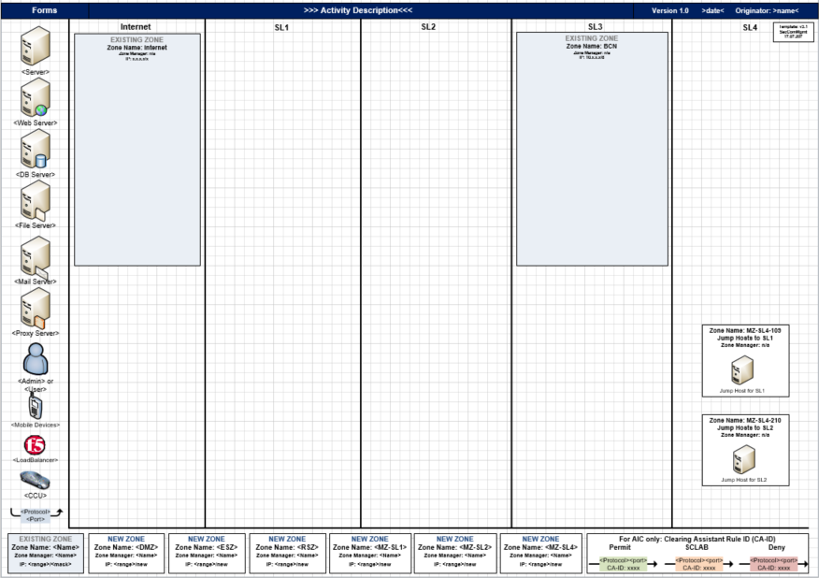  EISA-COM-105 | Please name all existing security zones, which are in use to fulfill your business  demand:  Click or tap here to enter text.  If an existing or mixed zone is used, the security requirements must match the existing application(s) in that zone
In case you need new security zones at Bosch to realize your application architecture, please fill out the
upcoming rows and provide more details.
Please notice that this information must be identical to the ITSP request you will create.
Details about NEW security zones:
Zone managers (at least 2 people)  only real persons / Bosch employees | Click or tap here to enter text.  Click or tap here to enter text. | Click or tap here to enter text.  Click or tap here to enter text. | Click or tap here to enter text.  Click or tap here to enter text.
Name of new zone (max. 12 characters, no layer or type or location shortcut) | Click or tap here to enter text. | Click or tap here to enter text. | Click or tap here to enter text.
Location of zone  Data center (DC) locations | Select | Select | Select
Zone Layer / Network type  Central Zone Types (CZT)  Migration Zone Type (MZT)  Decentralized Zone Types (DZT)  Cloud Layer (CL) | Select | Select | Select
Required Active Directory | Select | Select | Select
Network Size | Select | Select | Select

* Operator Self Check:
☐ | Customer is informed that they have to conduct the Operator Self Check every year for all self-operated levels (web server, application, server,...) according to CD 02900-001 A.18.2.3. & CD2900-021. The document should be available before Go-live.

Cloud connection details (c)

* Name of cloud provider(s): | Click or tap here to enter text.
* Cloud Onboarding WorkON number: | Click or tap here to enter text.
* Status of Cloud Onboarding WorkON: | ☐ Open  ☐ In progress  ☐ Finished
* Target/Destination URL: | Click or tap here to enter text.
Subscription ID (if existing): | Click or tap here to enter text.

* Please indicate required IT security services, which are needed for your business demand:
Connection details to Cloud  EISA-COM-103 | HTTPS Proxy4Server | ☒ | CI/PWV1
 | SFTP/SSH Proxy | ☐ | CI/PWV1
 | Standard Internet Proxy for clients | ☐ | CI/PWV1
 | Secure Cloud Connect | ☐ | CI/PIN1
Other protocols (please specify port, transport layer and description):
Click or tap here to enter text.
Connection details from Cloud to on-prem  EISA-COM-103, EISA-ACC-103, EISA-ACC-104 | API Management Gateway | ☐ | CI/POI3
 | Enterprise Message Bus (Solace/Kafka) | ☐ | CI/POI2, CI/PDP2
 | SAP PI | ☐ | CI/POI1
 | SAP Cloud Platform Integration (CPI) (SAP Cloud Connector) | ☐ | CI/POI1,  CI/POP4
Another connection service (please specify and name service operator):
Click or tap here to enter text.

Network Zones Architecture (a-d)
Section to be filled by AIC

* Please prepare your network architecture for your business case. Use standard Visio sheet: How-to-fill Visio and Word template)
AIC will place the finalized network
architecture here after consulting.

PART E – Application Architecture Review Board (AARB)
Section to be filled by AIC, signature to be provided by contact partner for this EpITOP

The “Application Architecture Review Board (AARB)” evaluated the EpITOP document and it’s corresponding
application architecture in regards to:
- Business demand
- Data Criticality
- Infrastructure Architecture Fit

AARB assessment:
The assessment of the request is based on the fundamental guidelines listed in chapter 1 and the knowledge
domains of AARB board members.

Disclaimer: The requester is still responsible for being compliant to Bosch regulations, e.g. C/ISP central directive. AARB assessment does not prevent any currently unseen or future security risks of the whole application
environment.

* Date of AARB session: Click or tap here to select date.

* Minutes:
Click or tap here to enter text.

* Recommendations / Conditions / Reason for Result:
Click or tap here to enter text.

* Assessment:
Select

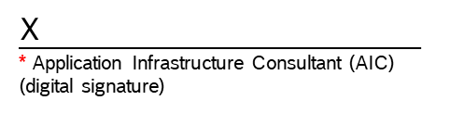

The applicant (see chapter “Customer Information”) confirms:
(save document as PDF and sign digitally)

Security Zone Architecture relevant processes (please refer to Security Zones | Security Zones Processes) and EISA controls (please refer to Bosch Enterprise IT Security Architecture (EISA)) have been identified, read and accepted. The customer must comply with the requirements of EISA and Security Engineering Process (SEP) for the operation of their applications.

The signatory agrees that the AARB feedback in chapter 6 | PART E of EpITOP will be implemented according to RBGF177 and RBGF105.

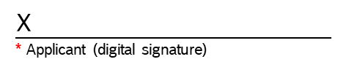

Revision History

Issue | Date | Editor | Description of Amendment
4.4 | 20.01.2022 | CI/POA4 – Hickl | Corrected links, changed T&R to JSD, reworked New Zone 5.3 to be better aligned with ITSP
4.3 | 26.08.2021 | CI/POA4 - Iseler | Updates of roles and department names based on CI reorganization. Operator Self Check added and EISA table removed. Signature text for applicant adjusted.
4.2 | 05.03.2021 | CI/OSA4 - Iseler | Add question about application operation and did small corrections.
4.1 | 04.12.2020 | CI/OSA4 - Iseler | Many adjustments made (reorder chapter 1 & 2, rename roles) and services added in chapter 5.
4.0 | 20.08.2019 | CI/OSA4 - Iseler | Change version number from 1.5 to 4.0 so that Visio architecture file and EpITOP document have same version number
1.5 | 09.08.2019 | CI/OSA4 - Iseler, Morof | General information on top, update links, rephrase AARB statement, include feedback of CI/ISI4 and C/IDS-GE
1.4 | 26.04.2019 | CI/OSA4 - Iseler | Shorten chapters and text
1.3 | 01.06.2018 | CI/ISI4 - Eitel | Added text for Step 4
1.2 | 30.04.2018 | CI/ISI4 - Eitel | Change order and naming, rework text
1.1 | 16.04.2018 | CI/OSA4 - Iseler | Change order of steps, rework text
1.0 | 12.04.2018 | CI/OSA4 CI/ISI4 | Initial version

