|  |  |
| --- | --- |
| **TakeHomeCase Case** | Description: LogoBINUS-University |
| *Web Design and Programming* |
| **Periode Berlaku** Semester Genap 2022/2023  ***Valid on*** *Even Year 2022/2023* | **Software Laboratory Center**  **Assistant Recruitment 25-2** |

## Materi

*Material*

* Material A
* Material B

## Soal

*Case*

**MisVord**

It all started with an idea. Kolin loves to talk to *'yap'* and realized the world needs a better, more chill place to do just that. After a flash of inspiration, the concept for **MisVord** was born. We're not just building another chat app, we're creating a go-to hangout for friends. We need a developer who can connect with this vision and build the MisVord website with passion and skill. Let's make something amazing together using **PHP**, **JS**, **CSS**, **HTML**, **AJAX**, **Web Socket** and **XAMPP.**

* **General Requirements**
* Always store API Keys and credentials in secure environment variables, not hardcoded in your code
* Don’t use inline CSS
* Pooling system is not allowed, use WebSocket for Realtime chat
* Password must be salted
* **General Components**
* **Server Side Section**
  + Display all the servers joined by the current user
  + Display ‘+’ button to add new server
  + Display Discover button to redirect to the **Explore Page**
* **Profile Detail Information Modal**
* Must be in modal state
* Display profile picture, username, joined to discord date
* **Landing Page**

Develop navigation system for **the 'Featured Cards,' 'Success Stories,'** and **'Nitro Premium'** content areas. This system should allow users to **horizontally scroll** through sections, utilizing a **snap scroll mechanism** for precise positioning.

Figure 1.Navigation system

* **Hero Section**
  + **Scramble Text**

Visual text animation effect where the characters **appear randomly or "scrambled" before settling into their final**, unscrambled form. Creating the illusion that the text is being decoded, decrypted, or reconstructed from digital noise. Furthermore, an interactive enhancement can be implemented where **hovering over the now unscrambled text reinitiates the scrambling effect.**

Figure 2. Scrambling text

Figure 3. "Y" and "R" hovering char scrambling text (after the scramble text done)

* + **Motto Generation**

Display your generation motto in the format **'Motto' ~ 25-2**, incorporating **simple animation.**

Figure 4. Motto text

* + **Parallax Effect**

Implement a **parallax effect** for the given **assets**, ensuring their dynamic movement tracks the **cursor's position**

Figure 5. Motto text

* + **Authentication Button**

Implement an **authentication button** with conditional display and hover-activated menu functionality.

* **Unauthenticated State:** If the user is not logged in, render a **placeholder user icon**. Upon hover display 'Login to Misvord' should appear, and clicking the button should redirect to the **Login page**.

Figure 6. Unauthenticated state

* **Authenticated State:** If the user is logged in, display the **current user's name**. Upon hover, a **dropdown menu** containing **'Home' and 'Logout'** links should be revealed.

Figure 7. Authenticated state

* **Featured Cards Section**

Implement a display of six cards. Each card should incorporate a **3D hover animation** and a **localized particle effect** that dynamically follows the cursor's **position when within the card's area.**

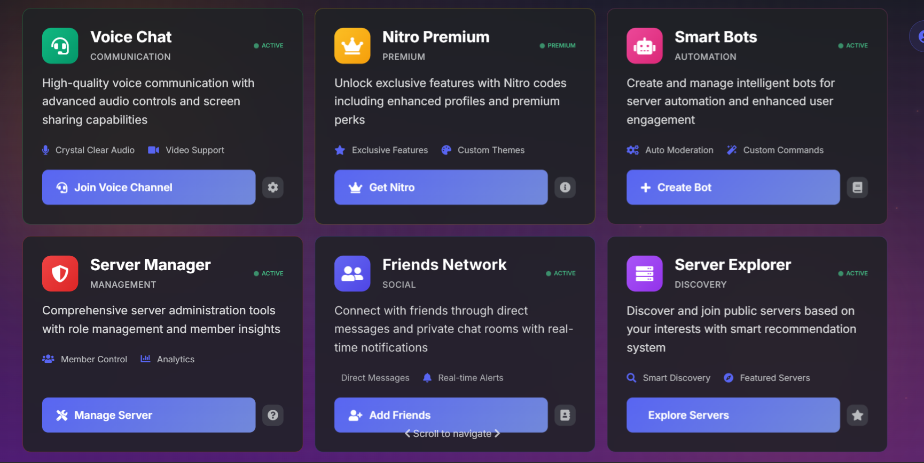Figure 8. Featured cards section

Figure 9. 3D card effect

Figure 10. Mouse particle effect

* **Nitro Premium Section**

Implement a visual arrangement featuring a **central circular element, branded with a 'nitro'** **image,** **encircled by six hexagonal components** and **title** besides it. When the central circle is **hovered, each hexagon** should execute an **outward expansion animation**. Additionally, enable **drag-and-drop functionality** for the central circle, ensuring the **hexagons maintain their relative positions by tracking its movement.**

Figure 11. Nitro premium section

* + **Scramble Text**
  + Visual text animation effect
* **Authentication Page**
* **Login Section**
  + Email and password fields are required.
  + Email address must be unique to each account.
  + Implement a custom-built CAPTCHA.
  + The user must solve the CAPTCHA correctly to proceed.
  + Implements login via google authentication
* **Register Section**
  + Email and password fields are required.
  + Email address must be unique to each account.
  + Implement your own custom-built CAPTCHA system.
  + The user must solve the CAPTCHA correctly to proceed.
  + Implements register via google authentication
* **Forgotten Account Section**
* **Home Page**
* **Friend Section** 
  + Display 3 tabs (Online, All, Add Friend)
  + **Online Tab**

Display the current **online users** with its **current activity status**

* + **All Tab**

Display all users with their current activity status, for offline users display “offline” as their status

* + **Add Friend Tab**

Display a **form input** asking for a **MisVord username,** this action will store a request to targeted user as a friend request

* **Nitro Section**
  + Contains a welcome section that will include the **Subscribe** and **Gift Nitro** button
* **Direct Message Section** 
  + Display a chronologically sorted list of the current user's past conversations, with each entry redirecting to their respective **Direct Message Page**.
* **Direct Message Page**
* Display the target user chat profile such as **username**, **display name**, **pronouns**, **about me**, **member since, profile picture**
* If the user is not friends with the current user in chat, provide an **add friend** button, **block** button, and a **report spam** button
* Display the **mutual servers** and **mutual friends**
* Provide **invite to server** that **shows all the servers** that the target user chat **has not yet joined**
* Implements all the requirements in the **General Chat Feature**
* **General Chat Feature**
* User can send messages in **Realtime**
* Users can **reply to the message**
* Users that **sent the message** can **edit the message** and **delete the message**
* Users can **react** to the message with an **emoji**
* Users can send **GIF, Image, Video,** and **Files**
* Provide rich text, the **@** format will link to the respective tagged user’s page, and the **```{message}```** will give formatting to the text
* **Server Page**
* **Hero Section**
  + **Scramble Text**
* **Server Setting Page**
* **Hero Section**
  + **Scramble Text**
* **User Setting Page**
* **Hero Section**
  + **Scramble Text**
* **Explore Page**
* **Hero Section**
  + **Scramble Text**
* **Admin Page**
* **Hero Section**
  + **Scramble Text**
* **Explore Page**
* **Hero Section**
  + **Scramble Text**
* **Landing Page**
* **Hero Section**
  + **Scramble Text**
* **Easter Egg**
* **Hero Section**
  + **Scramble Text**

Please run the EXE file to see the sample program.

## Komponen Penilaian

*Scoring Component*

|  |  |  |
| --- | --- | --- |
| No | Component | Weight |
| 1 | Component A | 50 |
| 2 | Component B | 50 |