**MF 803 Homework 1**  
Due: Wednesday, September 18th, by 6:30pm

**Xinyu Guo**

[**xyguo@bu.edu**](mailto:xyguo@bu.edu)

**U03375769**

**1. Historical Analysis of Sector ETFs**

1. **Data Downloading and Processing**

Download ETF Data from Yahoo Finance using package yfinance. The time range is from January 1st 2010 to September 13th 2019. Head of price data is shown as follows:

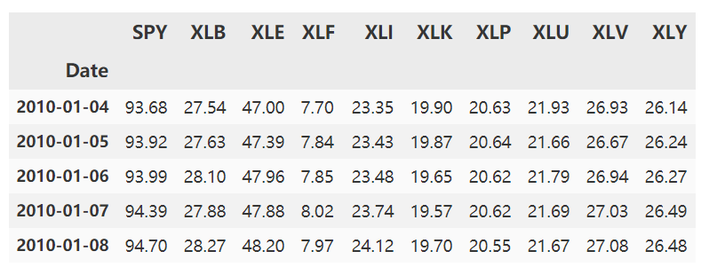

1. **The annualized return and standard deviation of each ETF**

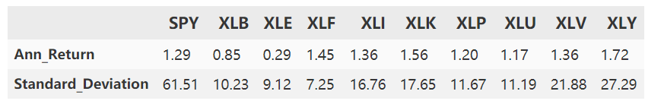

1. **Covariance and Correlation**

The covariance matrix of daily returns:

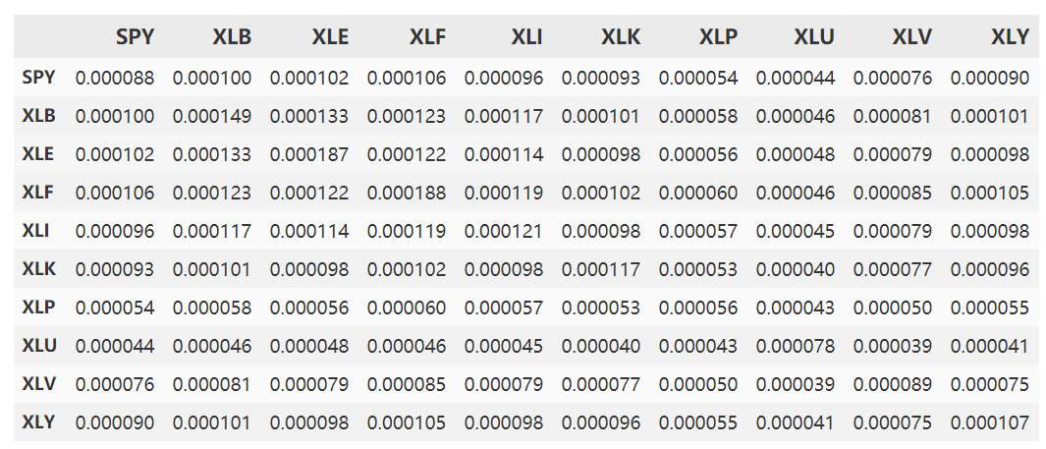

The covariance matrix of monthly returns:

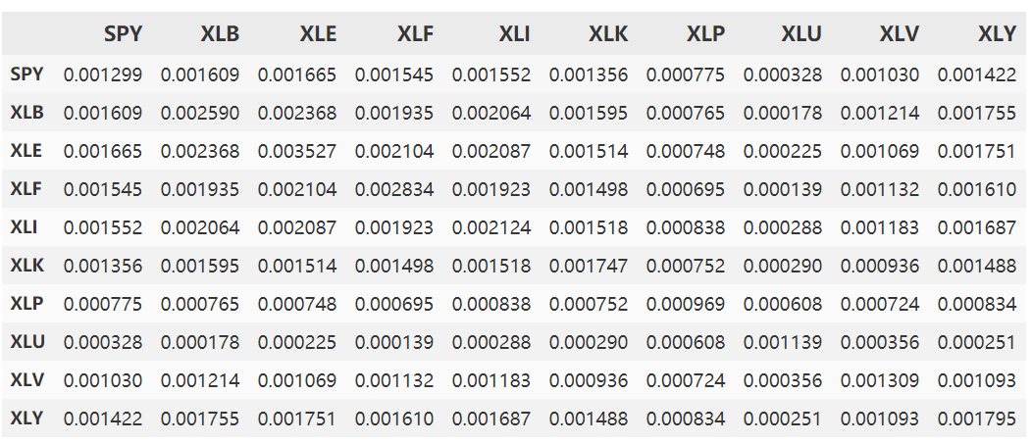

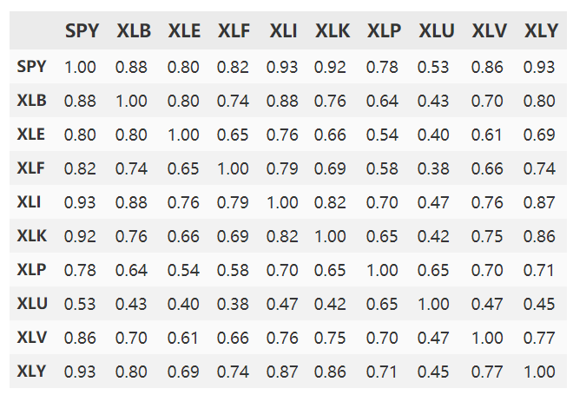

The correlation matrix of Daily Returns:

The correlation matrix of Monthly Returns:

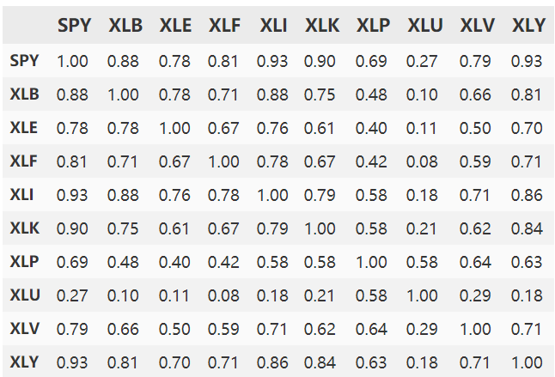

Difference of Monthly and Daily Correlation Matrix:

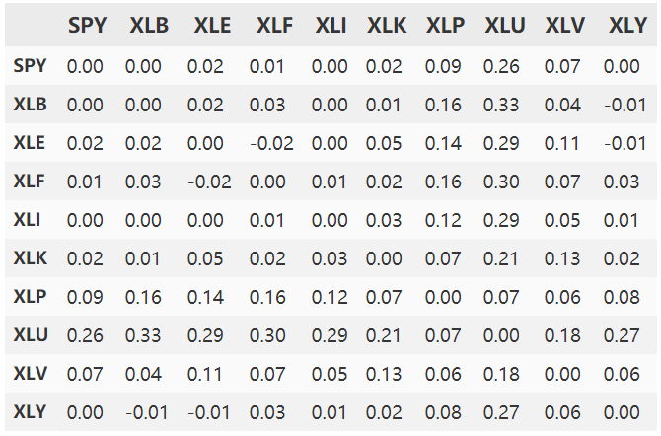

From the matrixes above, we can see that the difference of monthly and daily correlations of return is mostly tiny. Specifically, the difference is bigger in the coefficients of symbol XLU, which means Utility sector’s correlation with market and other sectors is more sensitive to the period of return.

1. **Rolling correlation**

Rolling 90-day correlation of each sector ETF with the S&P index:

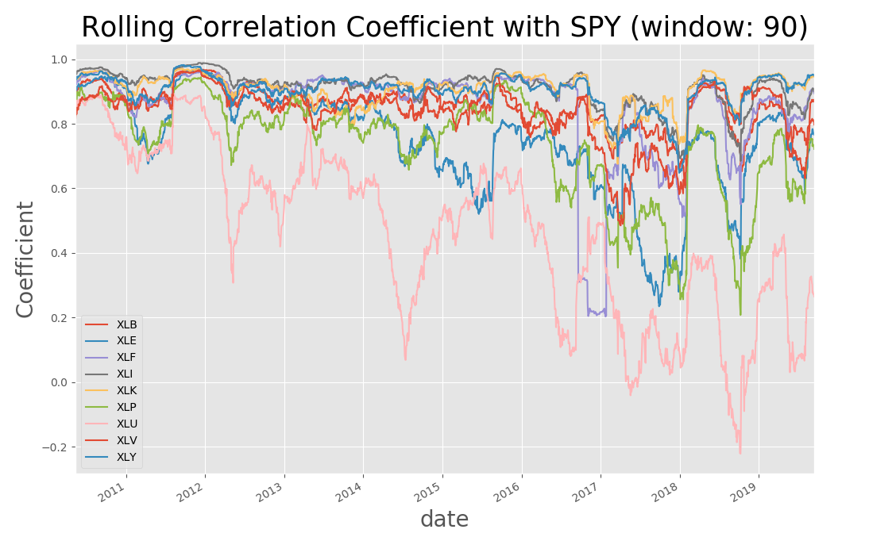

From the figure above, we can see the rolling coefficients of most sectors are stable before 2016. However, they suffered a great variation after 2016, possibly due to the great global market crush in 2015. Besides, the rolling correlation of Utility sector is highly unstable across all time. This again reflects that Utility sector has a relatively low and variant correlation with whole market.

1. **Beta**

Whole-period beta calculated by CAPM:

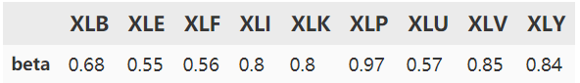

Rolling beta with window of 90:

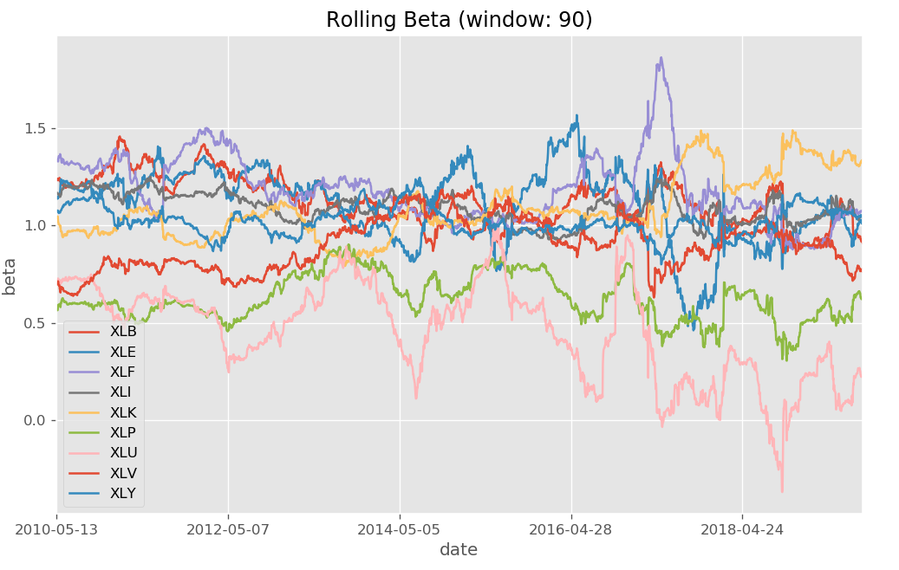

From the figure above, we can conclude that the rolling betas of these sectors are mostly stable. Again, Utility sector is more volatile compared with other sectors.

Comparing the results of rolling beta with rolling correlation, we can easily see that they have a similar trend. That is because the nature of linear regression model used in our problem is to find the linear relationship of sectors and market, which is just what correlation coefficient reflects.

1. **auto-correlation of each ETF**

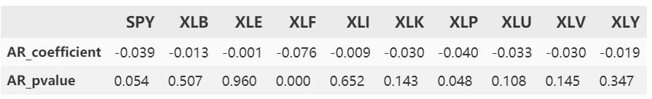

From the result above, we can conclude that the absolute value of all the auto regressive coefficients are less than 0.1. This could be considered as a good evidence that shows there doesn’t exist auto-correlation in these return data, though some regression results fail to pass the hypothesis tests. The result comforts to our common sense, because the return series of financial market is always considered to be random walk, generally with no significant relation with the past return data.

**2. Exotic Option Pricing via Simulation**

1. **Generate simulated paths of asset price**

Set simulated time as 1000, step as 250. The plot of the simulated paths is as follows:

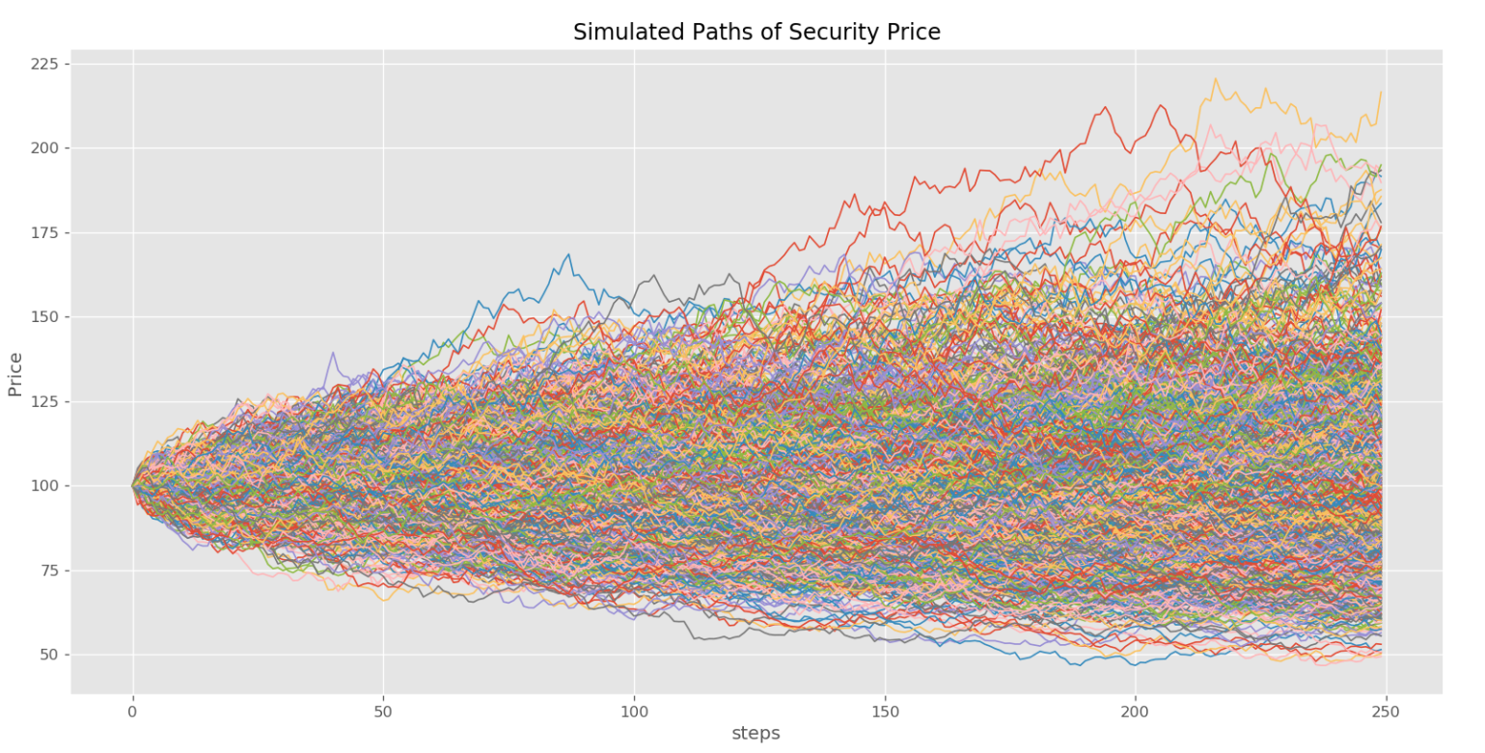

The mean of the terminal value of these paths is: 101.98

The variance of the terminal value of these paths is: 680.06

The simulated paths are consistent with the underlying dynamic, since they all have a obvious tendency that the price of the next day depends on the price of last day, with a plus of random walk.

1. **Calculate the payoff of a European put option**

the mean of the payoffs: 9.35

the standard deviation of the payoffs: 12.28

The histogram of payoff of European put option is shown as follows:

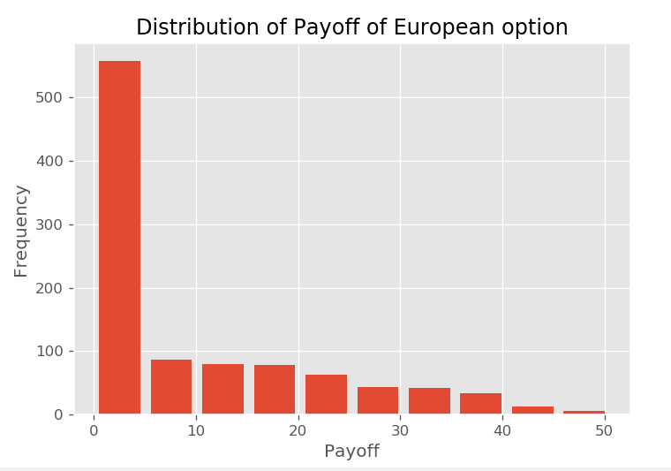

1. **Simulated price of European put option**

Simulated approximation to the price of European put option is: 9.35

(Since the discounted rate is 0 here, the price is just same as the mean payoff)

1. **Compare the simulated price of European Option with BSM price**

Price of European Option calculated by BSM is: 9.91

Difference of the two types of prices: 0.56

As we can see, the difference generated by two types is tiny. Actually, with the simulation times increasing, the difference becomes smaller, which means that two prices would eventually converge.

1. **Calculate the simulated payoff of fixed strike lookback put option**

The histogram of payoff of lookback put option is shown as follows:

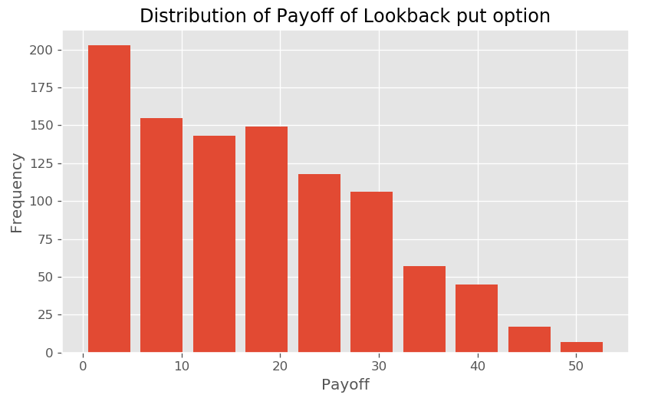

The simulated payoff of fixed strike lookback put option is: 17.18

The simulated price of fixed strike lookback put option is: 17.18

Compared with European put option, lookback put option has a higher percentage of non-0 values.

1. **Calculate the premium for the extra optionality embedded in the lookback option**

The premium is: 7.83

1. **Price of options with different volatility**

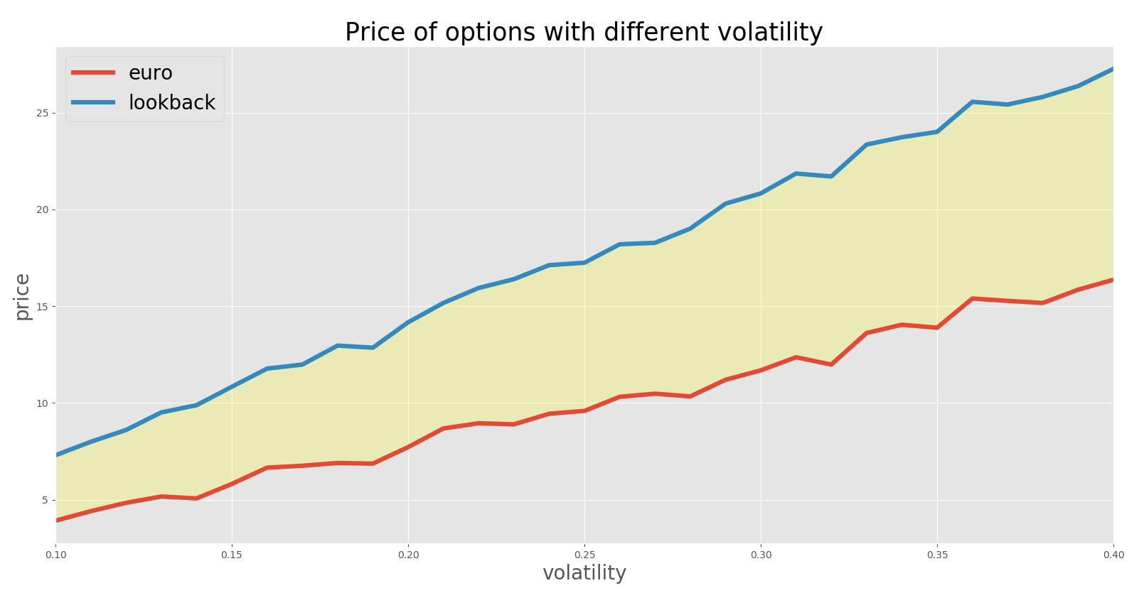By using different volatility from 0.1 to 0.4 with step of 0.01, I get 30 different pairs of prices. The results are shown as follows:

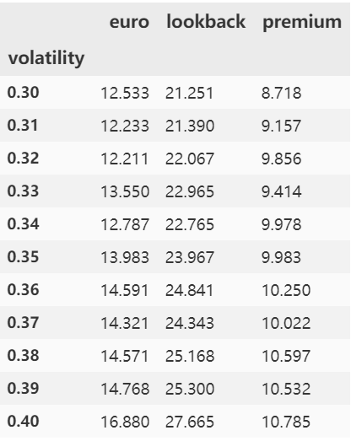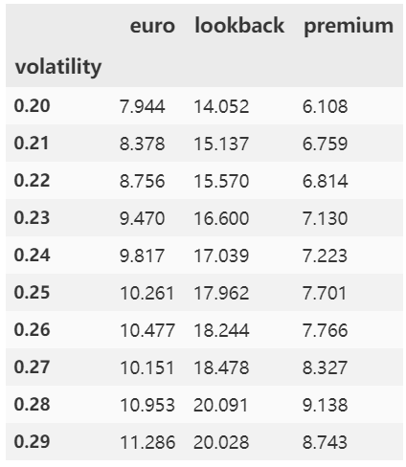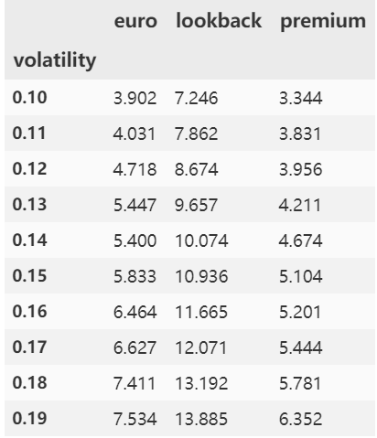

From the results, we can conclude that the prices of both european option and lookback option would increase with the volatility. This situation accords with our cognition and pricing model.

Also, the premium grows with the increase of volatility, which implies volatility has a greater impact on price of lookback option and these two options’ growth rate with volatility is not same.