**MF 803 Homework 2**  
Due: Wednesday, September 25th, by 6:30pm

**Xinyu Guo**

[**xyguo@bu.edu**](mailto:xyguo@bu.edu)

**U03375769**

**1. Sector ETF Factor Modeling**

1. **Data Downloading and Processing**

Download Fama-French factors Data from Ken French’s website. The time range is from January 1st 2010 to July 31th 2019. Head of factor data is shown as follows:

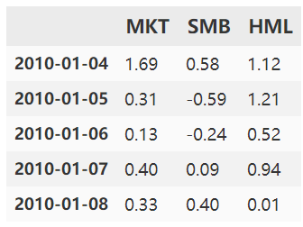

1. **Covariance and Correlation of Factors**

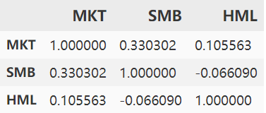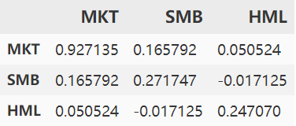

The tables above are covariance (left) and correlation matrix (right) of the factor returns over the entire time period. From the tables, we can see the factors are highly uncorrelated. This satisfies our common recognition of Fama-French three factors because the model will have the problem of [multi-collinearity](javascript:;) if these factors have high correlations. Compared with the correlations of ETF return in HM1, factor returns present a much lower correlation.

1. **Rolling Correlation**

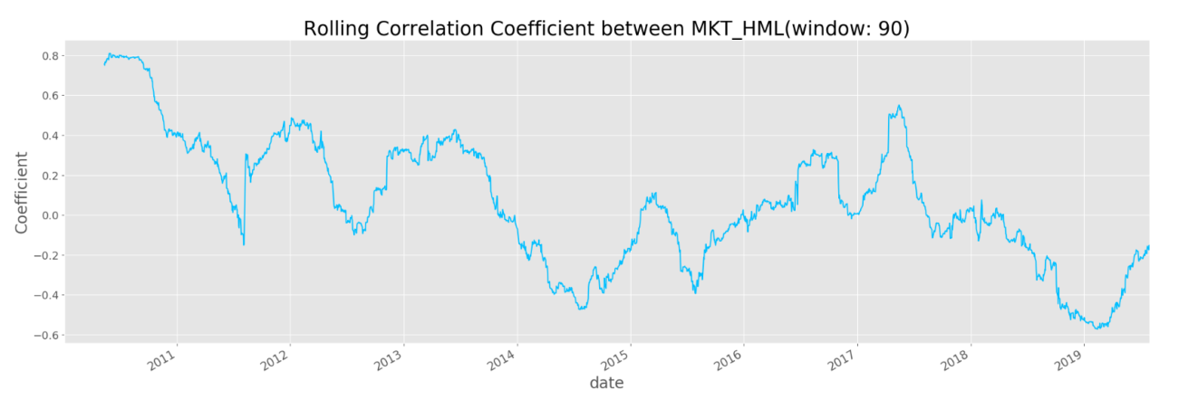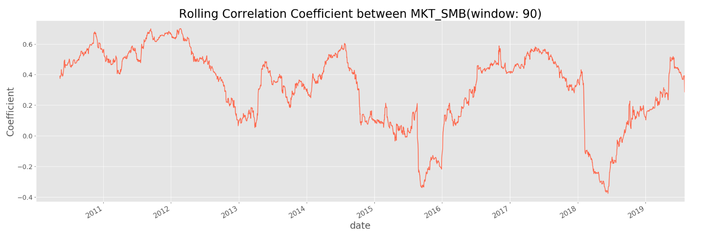

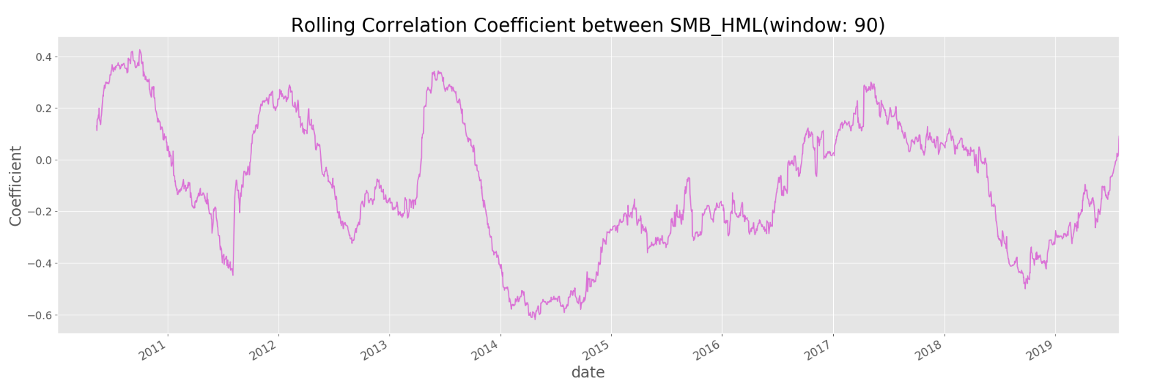

From the graphs above, we can see the rolling correlations are highly unstable. And they are also more volatile than the correlations of the ETFs from HM1

1. **Normality Test for factor returns**



# The test results (p_value) of normality using [Kolmogorov-Smirnov test](https://www.cnblogs.com/arkenstone/p/5496761.html) is shown in the table above. According to the test rule, if p_value is bigger than the significant level (0.05), then the tested series follows normal distribution. Thus, from the results, we could see that none of the three factor returns follows normal distribution.

1. **Multi-factor Regression**

Whole-period betas calculated by Multi-factor Model:

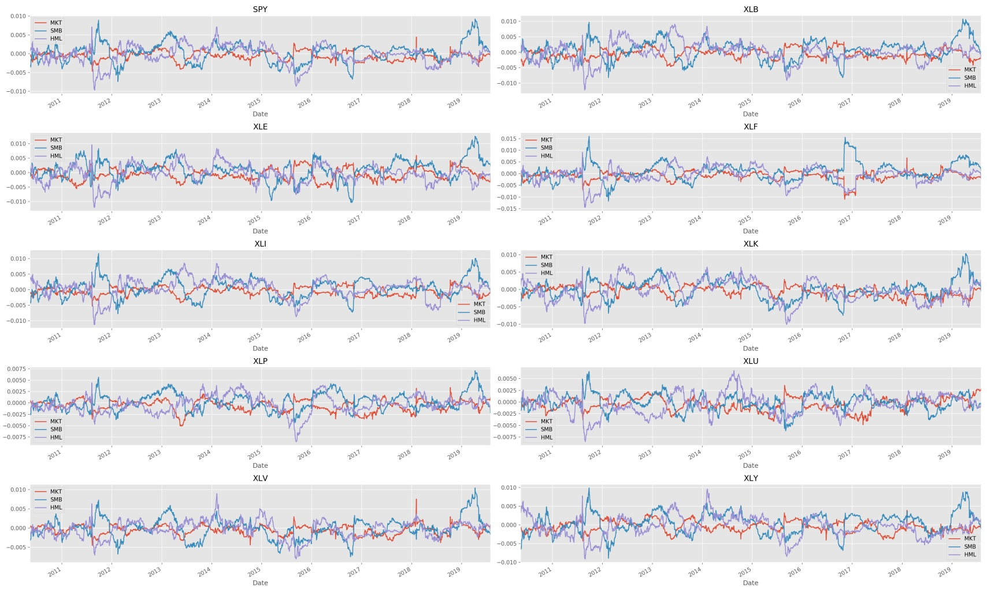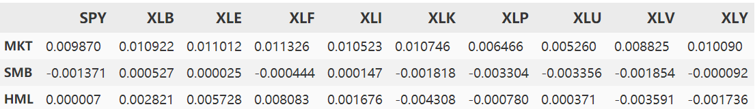

From the figures above that picture the trends of rolling betas of the ETFs, we can conclude that the Market factor’s rolling betas are most stable, while SMB and HML betas present a more unstable trends. However, compared with the single factor beta, these factors are more stable. This is mainly because, by including two other irrelevant factors, the multi-regression breaks the returns of ETFs into more separate parts, which presents more accurate information about the resource of the returns. On the contrary, in the single factor model, the model implies that the return of ETF is totally a result of the market variation while the return is actually determined by a variety of factors.

1. **Computation of residuals**

The mean and variance of the daily residuals of each ETF:

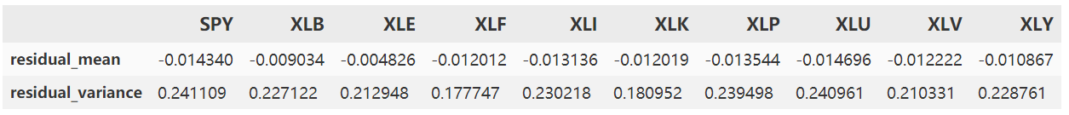

KS-test of the residuals of each ETF:



From the results above, we can conclude that none of the residual series of these ETFs follow normal distribution because all of p_value of KS-test are smaller than 0.05. This means it does not satisfies one of the basic assumptions of linear regression, which requires that the residual needs to be independent, follow normal distribution and have the same variance. Thus, using this model is actually not appropriate.

Besides, we can also measure whether the residuals have same variance by simply plotting the residuals. If the residuals have varying volatility within the samples, it means residuals don’t have the same variance.

**2. Exotic Option Pricing via Simulation**

1. **Generate simulated paths of asset price**

Set simulated time as 1000, step as 250. The plot of the simulated paths generated by Bachelier model is as follows:

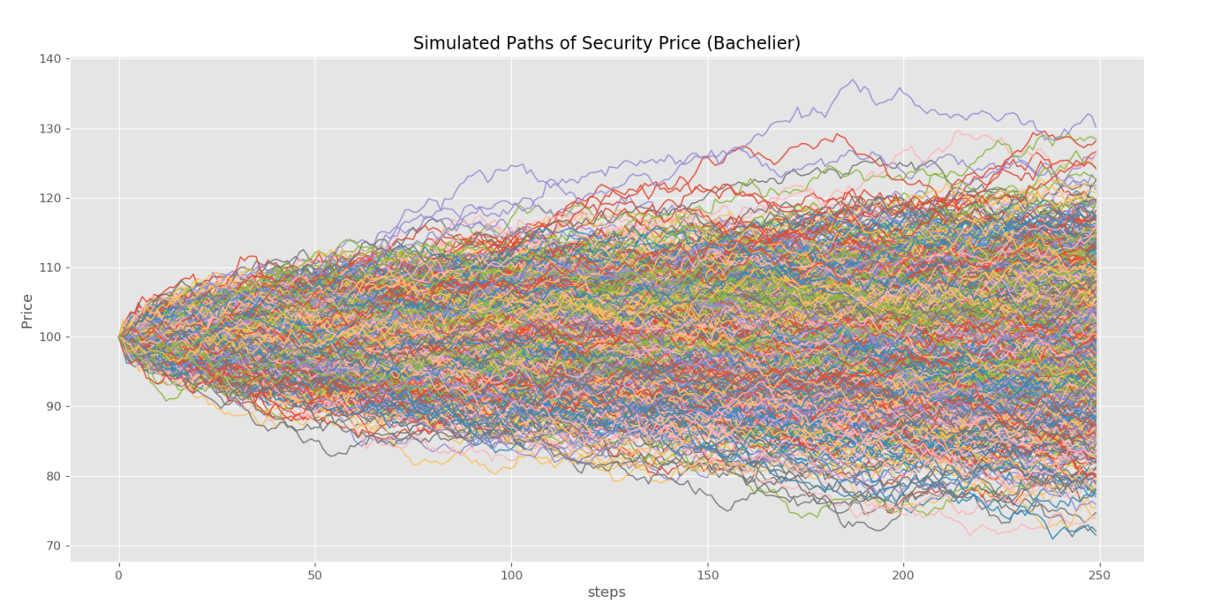

1. **Histogram of the ending values of asset price**

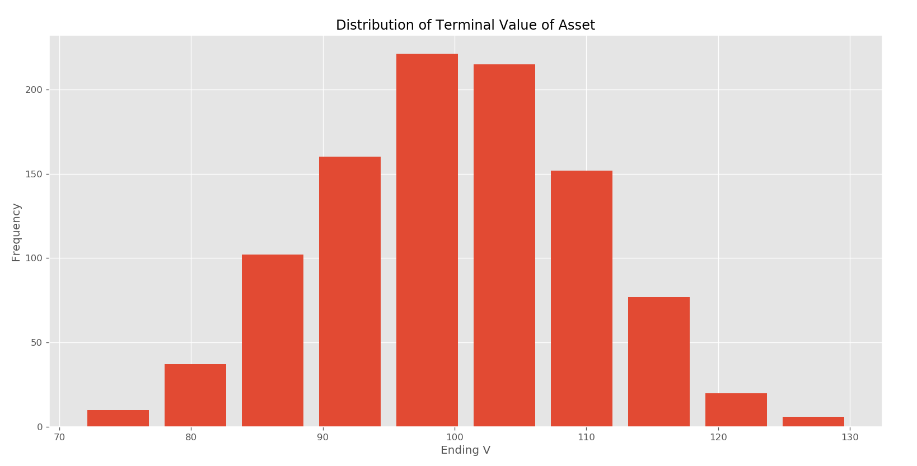

Testing the normality for asset ending values by QQplot:

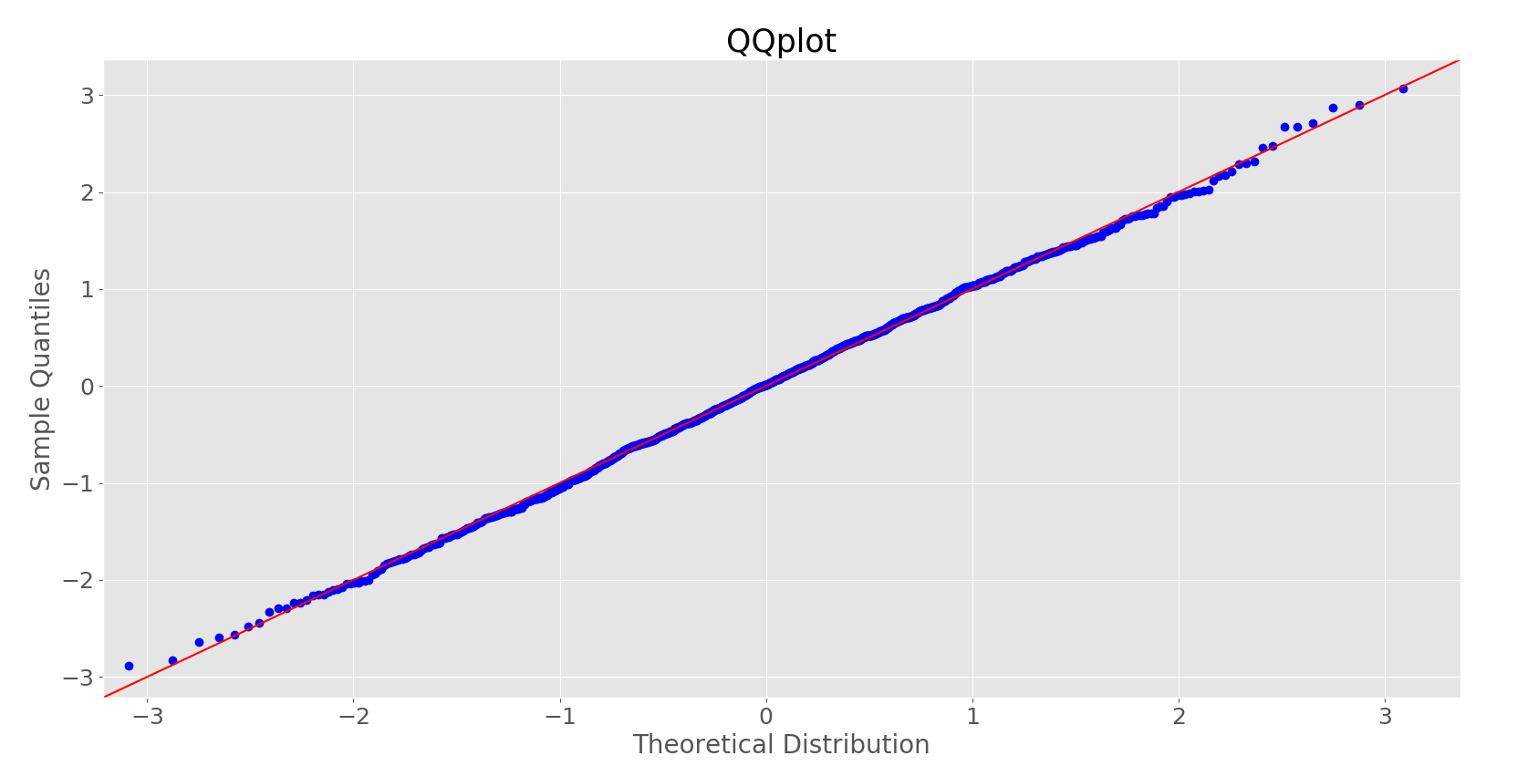

According to the graph, we can see the samples mainly drop on the red line. Thus, the series

of ending values is normally distributed.

1. **Simulated price of Lookback put option**

Simulated approximation to the price of lookback put option is: 7.59

(Since the discounted rate is 0 here, the price is just same as the mean payoff)

This price is smaller than the Black-Scholes model price obtained in HM1

1. **The delta of the lookback option**

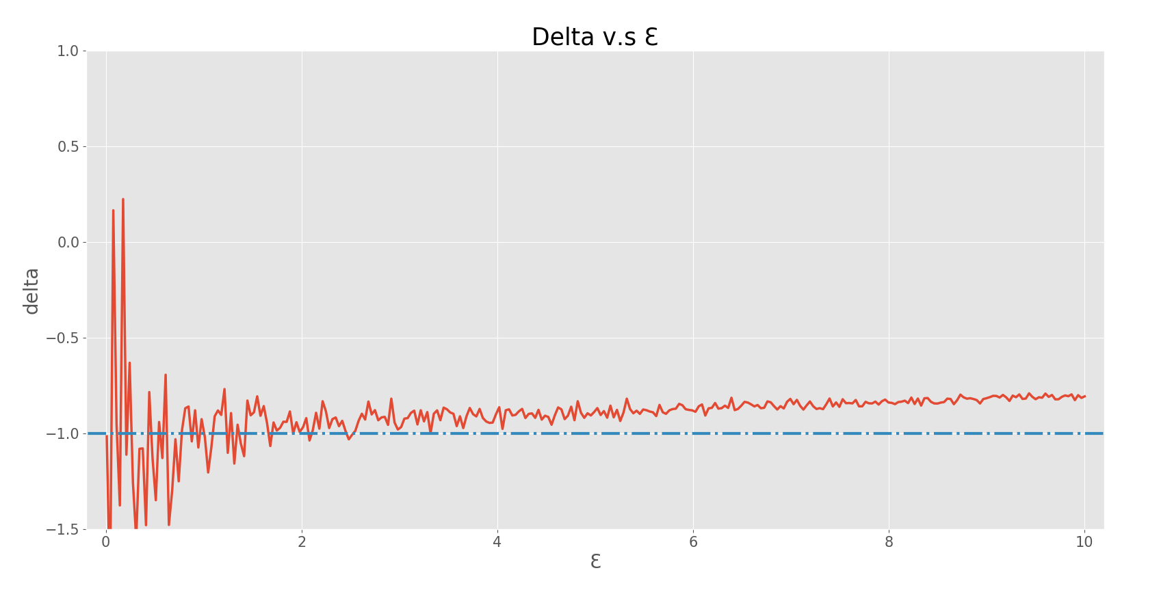

From the graph above, we can see delta is mostly close to -1, which corresponds with the theory that delta of at-the-money put option should approximate -1. However, delta would present extreme values when Ɛ approaches 0, and gradually increases as Ɛ grows. So, we con conclude that when Ɛ approaches 0, the error would be biggest, and the best Ɛ should be in the range from 2 to 4.